REQUIREMENTS NOT MET
N/A
VIDEO FILE LINK
https://youtu.be/rpC7A5a1pqg?si=Bnq_GcIWdXSCJ1YV
PROBLEMS ENCOUNTERED
N/A
FUTURE WORK/APPLICATIONS
We have installed Quartus, and could use it to develop BDF’s and Waveforms, we have also learnt how to use Adobe Scanner or equivalent (CamScanner in my case), and learnt the basic procedures for future laboratories.
PRE-LAB QUESTIONS OR EXERCISES
- What minimum lab average is required to be eligible to pass the course?
  - Students must achieve at least a 65% weighted average in labs to be eligible to pass the course.
- How much time can you expect to spend on future pre-lab assignments?
  - 6-12 hours of allocated time per pre-lab is recommended.
- When are your prelab submissions due in Canvas?
  - At least 15 minutes before the beginning of our lab.
- How late can you arrive for lab and still be allowed to take the lab quiz?
  - You must arrive before the lab begins, if you do not you will not be allowed to take the quiz.
- How late can you arrive for lab and still be admitted?
  - You must arrive to lab within the first twenty minutes to be admitted.
- How many labs are you allowed to drop without an excuse?
  - _{One lab.}
- _{Can any lab be dropped?}
  - _{Any except Lab 6.}
- If you decide to drop a lab, are you required to turn in any pre-lab materials for that lab? If so, when is it due?
  - You should still submit the pre-lab on time.
PRE-LAB REQUIREMENTS (Design, Schematic, ASM Chart, VHDL, etc.)
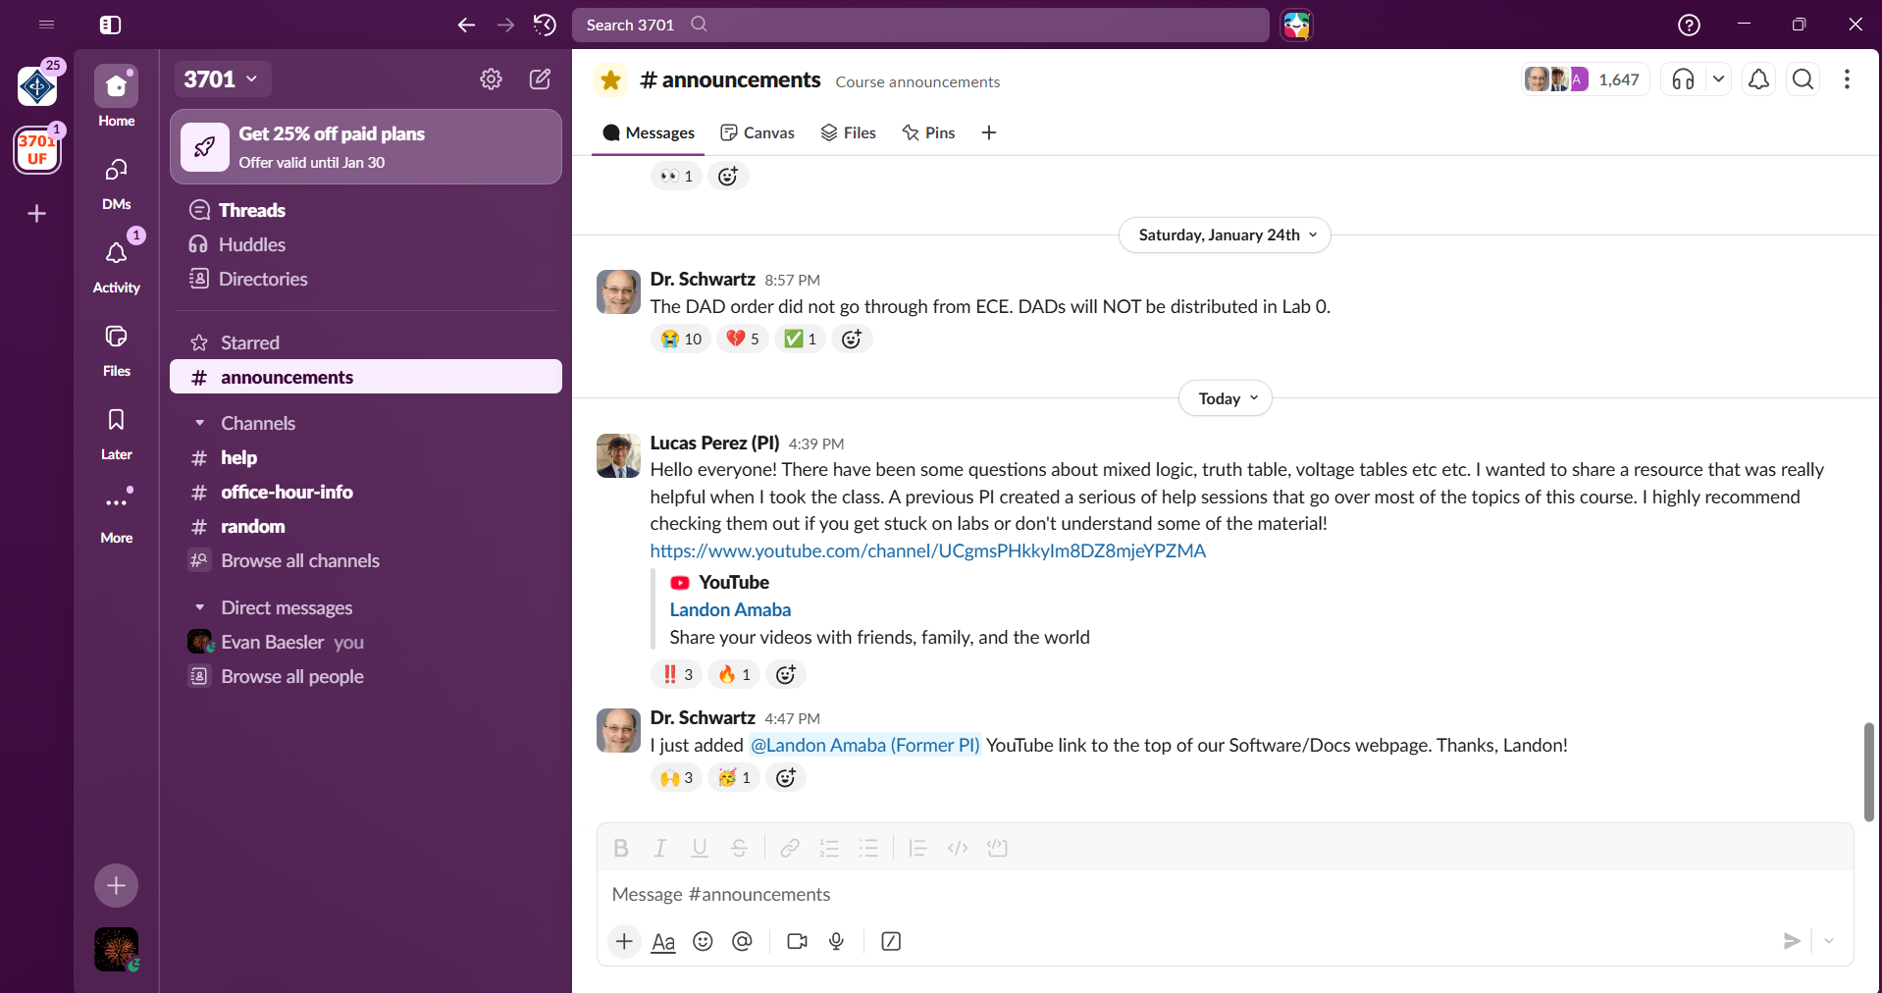
Figure 1: Screenshot of Slack #announcements page.
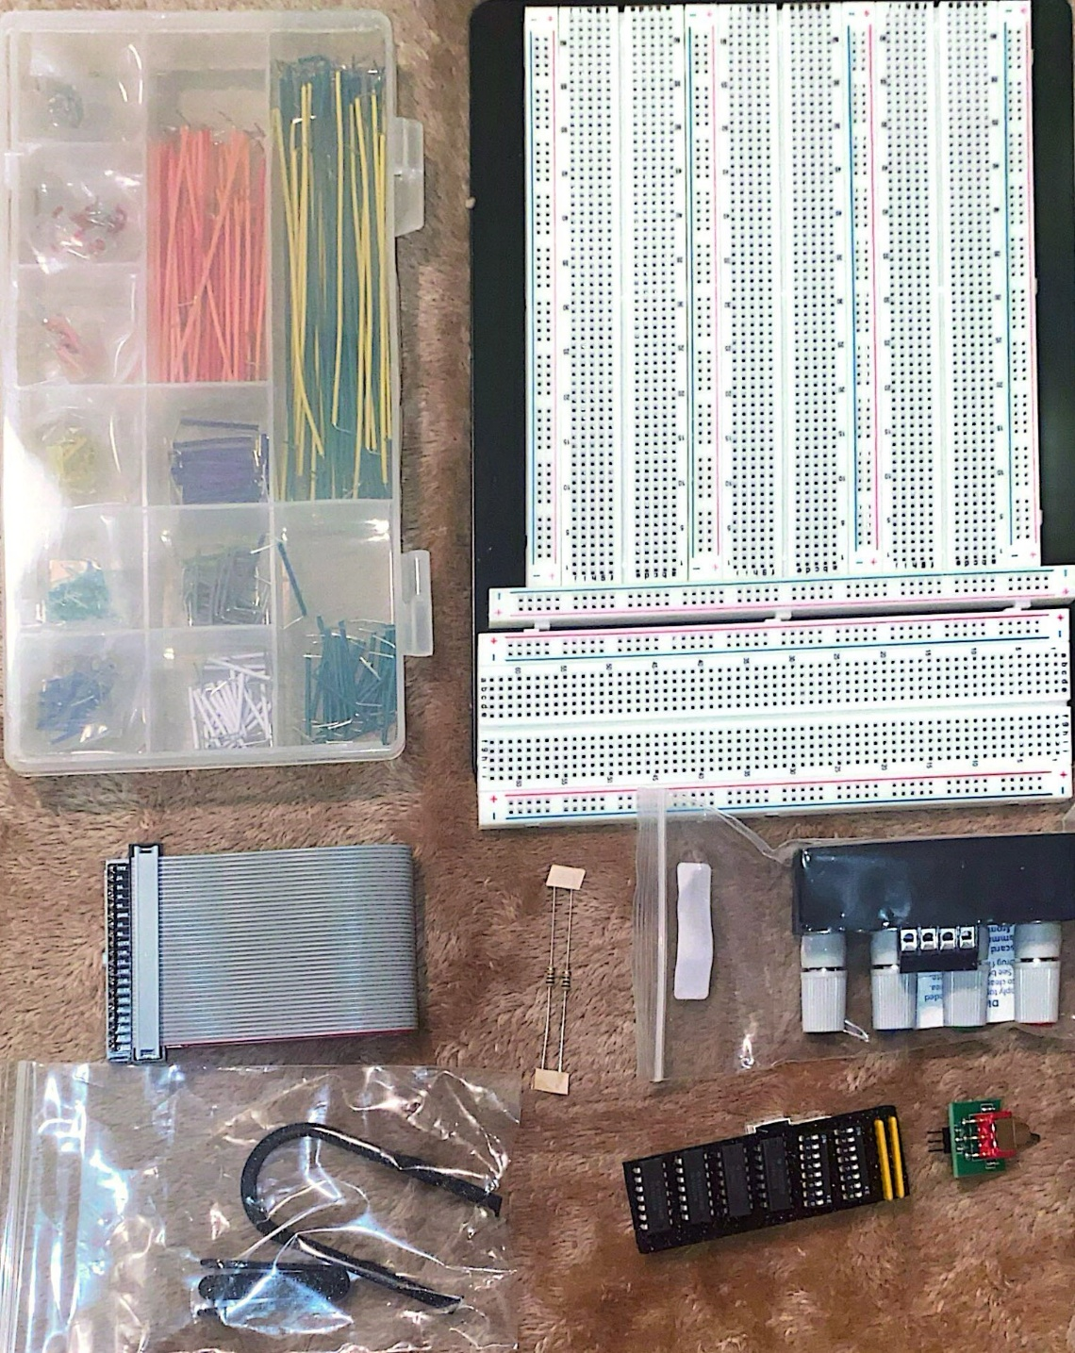
Figure 2: Picture of Components for EEL3701

