REQUIREMENTS NOT MET
N/A
VIDEO FILE LINK
N/A
PROBLEMS ENCOUNTERED
Learning how logic tables vs voltage tables differ, implementation of circuits on the breadboard (thank you Landon!), and optimization of logic ckts using minimal chips and gates.
FUTURE WORK/APPLICATIONS
This lab allowed us to make basic logic circuits, that could be used to make simple decisions, such as an on/off switch, it also taught us how to wire these in low activation and high activation. We should be able to take multi-input logic constraints and generate an output based on desired calculations.

PRE-LAB QUESTIONS OR EXERCISES
Section 1: Parts 1 & 2a
- Using only AND/OR gates (NO BUBBLES) and level shifters, draw V = /[(A+/B)*/(/C*D)].
- a. Using only positive logic gates and level shifters, draw V = /[(A+/B)*/(/C*D)].
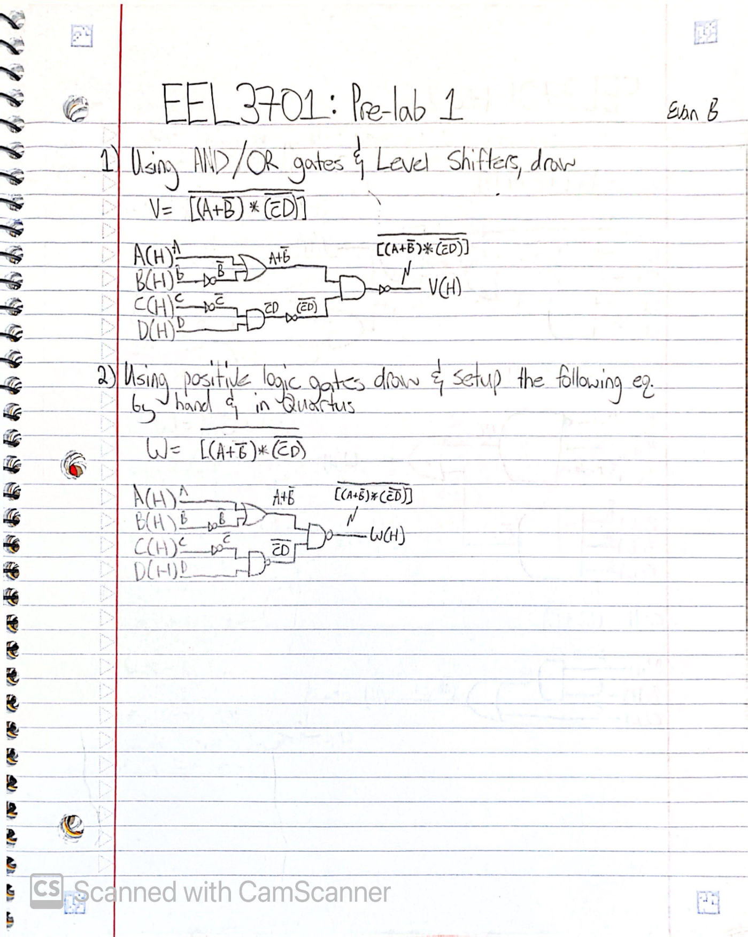
Figure 1: Hand-drawn logic diagrams V = W = /[(A+/B) * /(/C*D)] with varying constraints.
Section 1: Part 2b:
Draw the Quartus schematic of W, using only positive logic gates and active-high inputs/outputs.
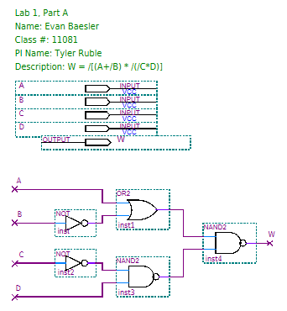
Figure 2: Quartus BDF of W = /[(A+/B) * /(/C*D)]
Section 1: Part 3
Create a logic and voltage table for the respective logic formula.
Table 1: Truth Table for W = /[(A+/B)*/(/C*D)]
A | B | C | D | /B | /C | A+/B | (/C*D) | /(/C*D) | (A+/B)*/(/C*D) | W = /[(A+/B)*/(/C*D)]
0 | 0 | 0 | 0 | 1 | 1 | 1 | 0 | 1 | 1 | 0
0 | 0 | 0 | 1 | 1 | 1 | 1 | 1 | 0 | 0 | 1
0 | 0 | 1 | 0 | 1 | 0 | 1 | 0 | 1 | 1 | 0
0 | 0 | 1 | 1 | 1 | 0 | 1 | 0 | 1 | 1 | 0
0 | 1 | 0 | 0 | 0 | 1 | 0 | 0 | 1 | 0 | 1
0 | 1 | 0 | 1 | 0 | 1 | 0 | 1 | 0 | 0 | 1
0 | 1 | 1 | 0 | 0 | 0 | 0 | 0 | 1 | 0 | 1
0 | 1 | 1 | 1 | 0 | 0 | 0 | 0 | 1 | 0 | 1
1 | 0 | 0 | 0 | 1 | 1 | 1 | 0 | 1 | 1 | 0
1 | 0 | 0 | 1 | 1 | 1 | 1 | 1 | 0 | 0 | 1
1 | 0 | 1 | 0 | 1 | 0 | 1 | 0 | 1 | 1 | 0
1 | 0 | 1 | 1 | 1 | 0 | 1 | 0 | 1 | 1 | 0
1 | 1 | 0 | 0 | 0 | 1 | 1 | 0 | 1 | 1 | 0
1 | 1 | 0 | 1 | 0 | 1 | 1 | 1 | 0 | 0 | 1
1 | 1 | 1 | 0 | 0 | 0 | 1 | 0 | 1 | 1 | 0
1 | 1 | 1 | 1 | 0 | 0 | 1 | 0 | 1 | 1 | 0
Table 2: Voltage Table for W = /[(A+/B)*/(/C*D)]
A(H) | B(H) | C(H) | D(H) | W(H)
L | L | L | L | L
L | L | L | H | H
L | L | H | L | L
L | L | H | H | L
L | H | L | L | H
L | H | L | H | H
L | H | H | L | H
L | H | H | H | H
H | L | L | L | L
H | L | L | H | H
H | L | H | L | L
H | L | H | H | L
H | H | L | L | L
H | H | L | H | H
H | H | H | L | L
H | H | H | H | L
S
ection 1: Part 4
Create a functional simulation of the circuit in Quartus.
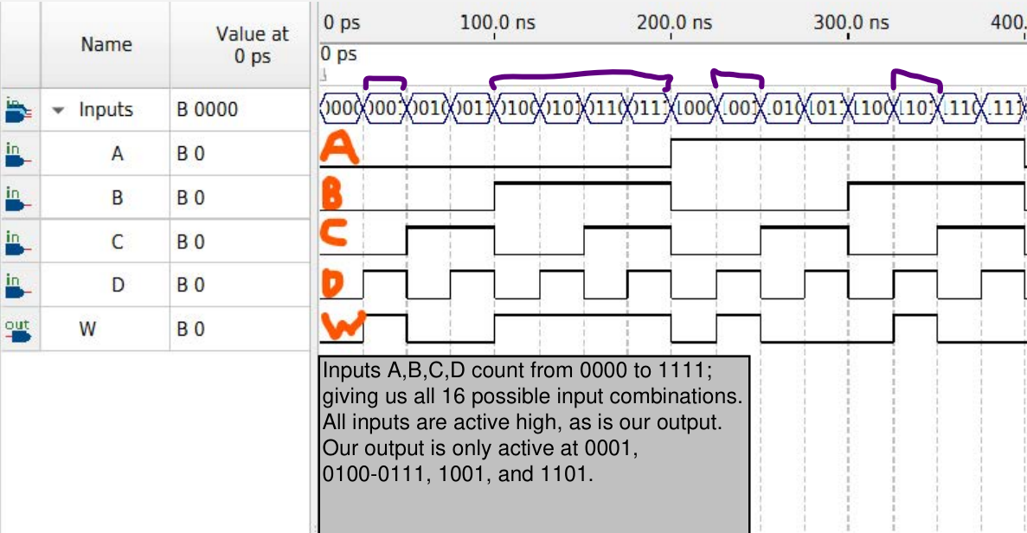
Figure 3: Quartus Functional Simulation of W = /[(A+/B)*/(/C*D)]

Section 1 Part 5:
Confirm that your voltage table matches the Quartus simulation.
As we can see from our table, our inputs and output are all active high; which would mean for A,B,C,D,W, a L is a 0 and a H is a 1 for AD & W:
- 0001 LLLH W(H) = H (output)
- 0100 LHLL W(H) = H (output)
- 0101 LHLH W(H) = H (output)
- 0110 LHHL W(H) = H (output)
- 0111 LHHH W(H) = H (output)
- 1001 HLLH W(H) = H (output)
Table 3: Voltage Table for Quartus Simulation Verification
A(H) | B(H) | C(H) | D(H) | W(H)
L | L | L | L | L
L | L | L | H | H
L | L | H | L | L
L | L | H | H | L
L | H | L | L | H
L | H | L | H | H
L | H | H | L | H
L | H | H | H | H
H | L | L | L | L
H | L | L | H | H
H | L | H | L | L
H | L | H | H | L
H | H | L | L | L
H | H | L | H | H
H | H | H | L | L
H | H | H | H | L

Section 3 Part 1:
Draw X = /[(A+/B)*/(/C*D)] using any gates and activation levels, do not simplify.
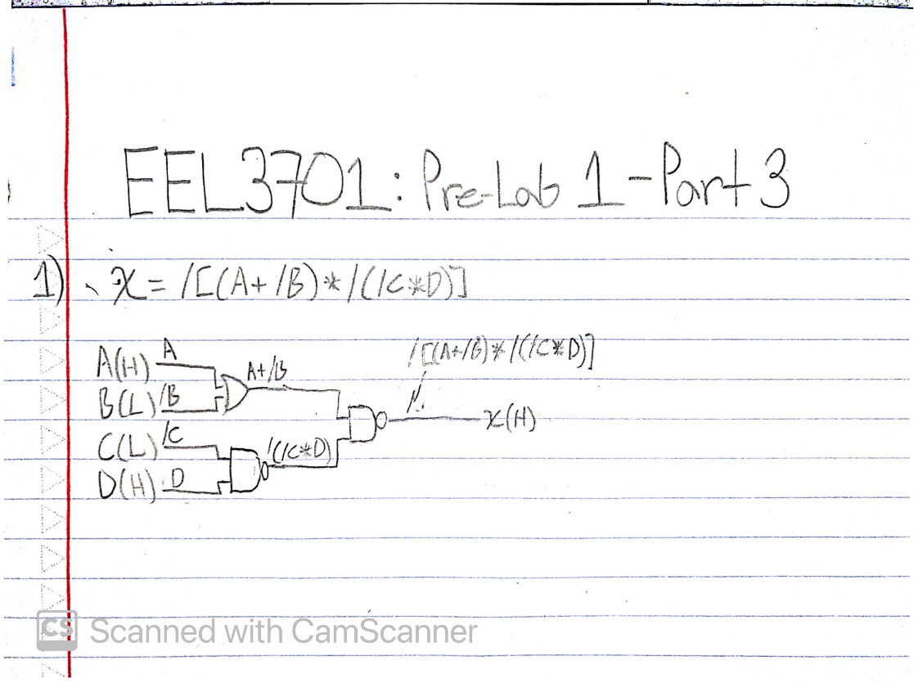
Figure 4: X = /[(A+/B)*/(/C*D)] drawn using any input/output level and gates.
Section 3 Part 3:
Generate a logic table, voltage table, Quartus diagram, and annotated functional simulation.
Table 4: Truth Table for X = /[(A+/B)*/(/C*D)]
A | B | C | D | /B | /C | A+/B | (/C*D) | /(/C*D) | (A+/B)*/(/C*D) | W = /[(A+/B)*/(/C*D)]
0 | 0 | 0 | 0 | 1 | 1 | 1 | 0 | 1 | 1 | 0
0 | 0 | 0 | 1 | 1 | 1 | 1 | 1 | 0 | 0 | 1
0 | 0 | 1 | 0 | 1 | 0 | 1 | 0 | 1 | 1 | 0
0 | 0 | 1 | 1 | 1 | 0 | 1 | 0 | 1 | 1 | 0
0 | 1 | 0 | 0 | 0 | 1 | 0 | 0 | 1 | 0 | 1
0 | 1 | 0 | 1 | 0 | 1 | 0 | 1 | 0 | 0 | 1
0 | 1 | 1 | 0 | 0 | 0 | 0 | 0 | 1 | 0 | 1
0 | 1 | 1 | 1 | 0 | 0 | 0 | 0 | 1 | 0 | 1
1 | 0 | 0 | 0 | 1 | 1 | 1 | 0 | 1 | 1 | 0
1 | 0 | 0 | 1 | 1 | 1 | 1 | 1 | 0 | 0 | 1
1 | 0 | 1 | 0 | 1 | 0 | 1 | 0 | 1 | 1 | 0
1 | 0 | 1 | 1 | 1 | 0 | 1 | 0 | 1 | 1 | 0
1 | 1 | 0 | 0 | 0 | 1 | 1 | 0 | 1 | 1 | 0
1 | 1 | 0 | 1 | 0 | 1 | 1 | 1 | 0 | 0 | 1
1 | 1 | 1 | 0 | 0 | 0 | 1 | 0 | 1 | 1 | 0
1 | 1 | 1 | 1 | 0 | 0 | 1 | 0 | 1 | 1 | 0
Table 5: Voltage Table for X = /[(A+/B)*/(/C*D)] with active-high A,D,X and active-low B,C
A(H) | B(L) | C(L) | D(H) | X(H)
L | L | L | L | H
L | L | L | H | H
L | L | H | L | H
L | L | H | H | H
L | H | L | L | L
L | H | L | H | L
L | H | H | L | L
L | H | H | H | H
H | L | L | L | L
H | L | L | H | L
H | L | H | L | L
H | L | H | H | H
H | H | L | L | L
H | H | L | H | L
H | H | H | L | L
H | H | H | H | H

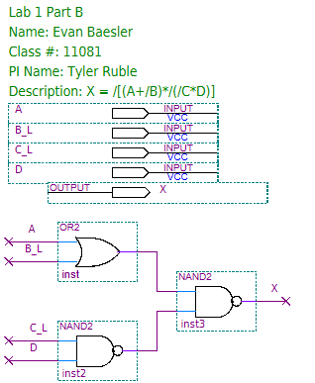
Figure 5: Quartus BDF of X = /[(A+/B)*/(/C*D)]
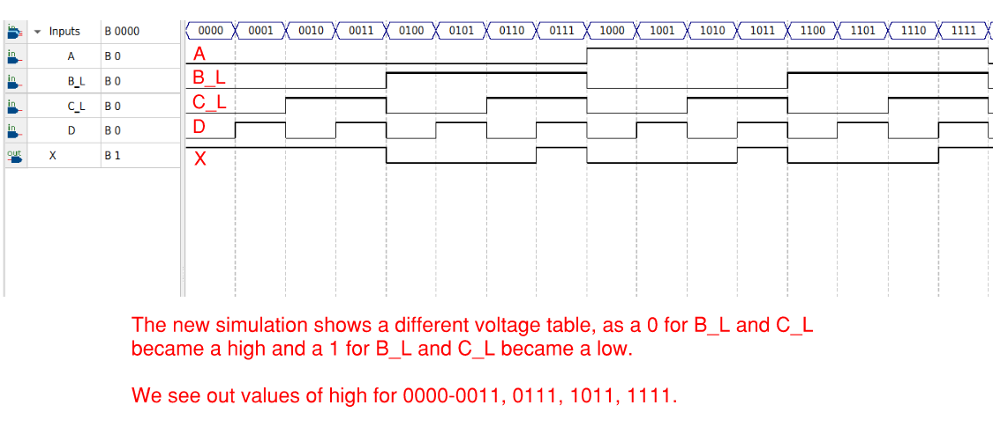
Figure 6: Quartus Simulation with B_L and C_L
Section 4:
Combine previous parts BDF, use the four inputs and derive the active-low from active-high using level shifters. Confirm simulation outputs match voltage tables above.

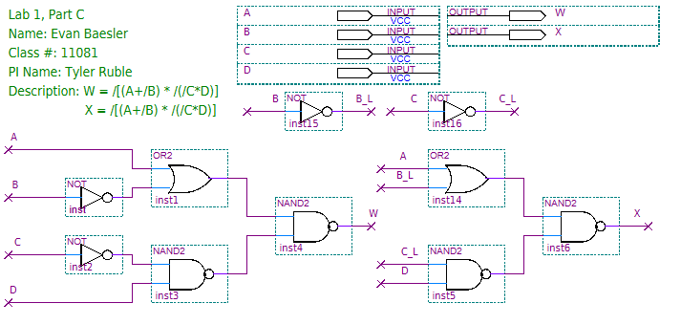
Figure 7: Combined Quartus BDF for W = X = /[(A+/B) * /(/C*D)]
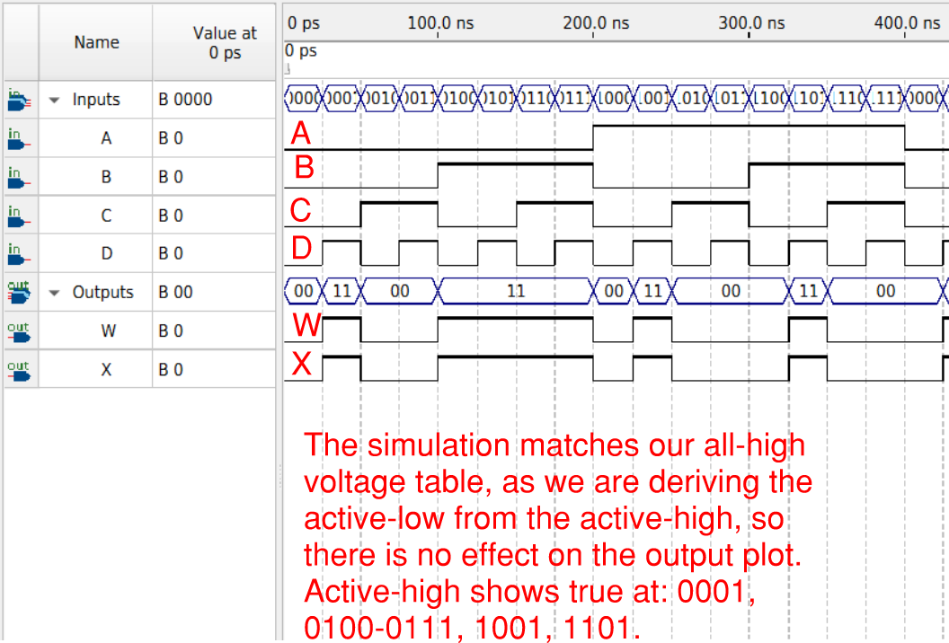
Figure 8: Section 4 Functional Simulation for W = X = /[(A+/B)*/(/C*D)]

Section 5 Part 1:
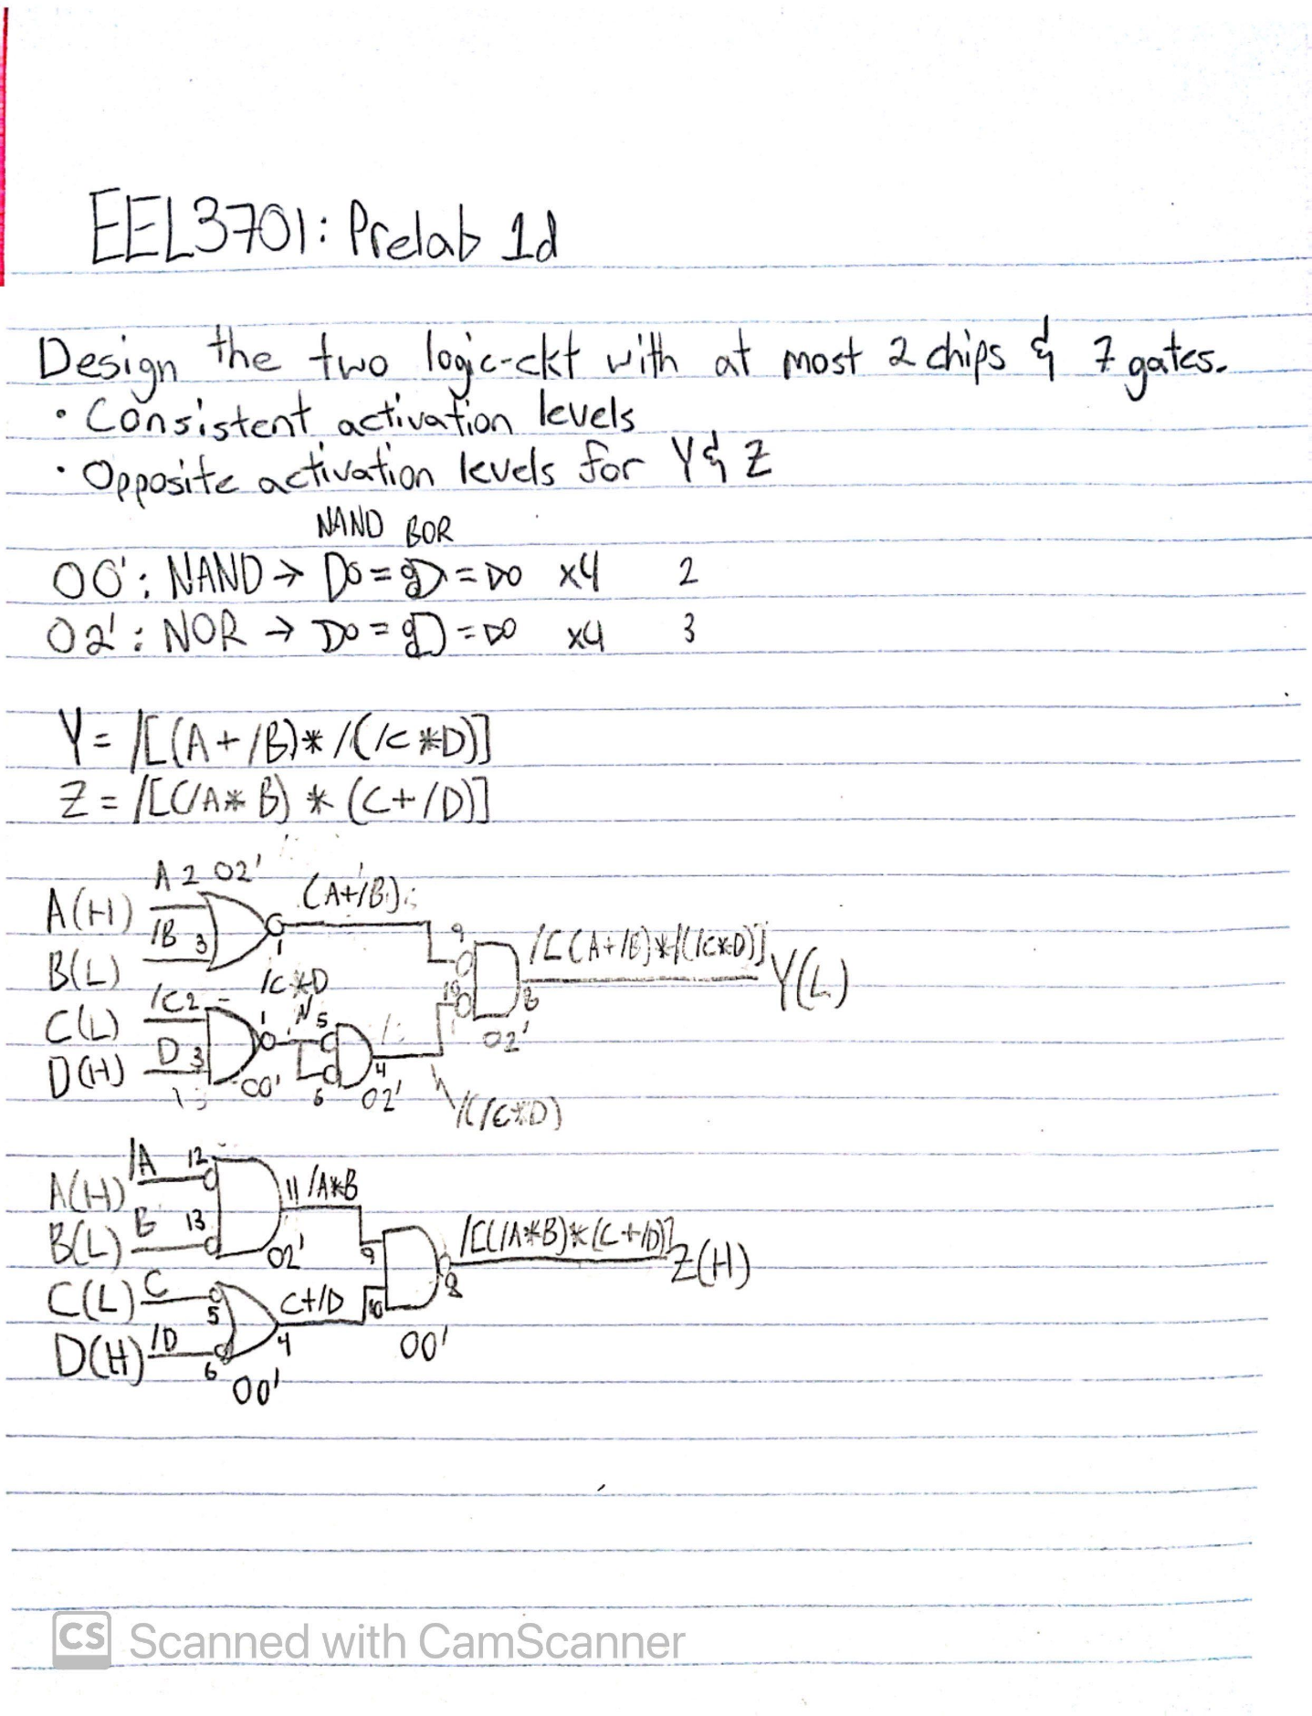
Figure 9: Drawn Schematics for Y = /[(A+/B)*/(/C*D)] and Z = /[(/A*B)*(C+/D)], with consistent activation levels and opposite activation levels for both outputs.
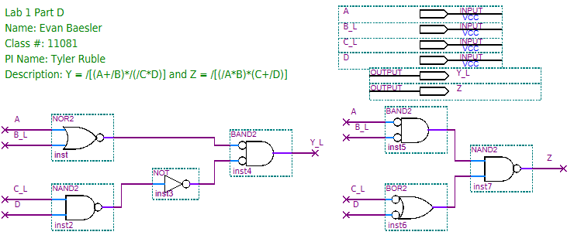
Figure 10: Section 5 Quartus BDF for Y = /[(A+/B)*/(/C*D)] and Z = /[(/A*B)*(C+/D)]

Section 5 Part 2
Table 6: Truth Table for Y = /[(A+/B)*/(/C*D)]
A | B | C | D | /B | /C | (A+/B) | (/C*D) | /(/C*D) | [(A+/B)*/(/C*D)] | Y = /[(A+/B)*/(/C*D)]
0 | 0 | 0 | 0 | 1 | 1 | 1 | 0 | 1 | 1 | 0
0 | 0 | 0 | 1 | 1 | 1 | 1 | 1 | 0 | 0 | 1
0 | 0 | 1 | 0 | 1 | 0 | 1 | 0 | 1 | 1 | 0
0 | 0 | 1 | 1 | 1 | 0 | 1 | 0 | 1 | 1 | 0
0 | 1 | 0 | 0 | 0 | 1 | 0 | 0 | 1 | 0 | 1
0 | 1 | 0 | 1 | 0 | 1 | 0 | 1 | 0 | 0 | 1
0 | 1 | 1 | 0 | 0 | 0 | 0 | 0 | 1 | 0 | 1
0 | 1 | 1 | 1 | 0 | 0 | 0 | 0 | 1 | 0 | 1
1 | 0 | 0 | 0 | 1 | 1 | 1 | 0 | 1 | 1 | 0
1 | 0 | 0 | 1 | 1 | 1 | 1 | 1 | 0 | 0 | 1
1 | 0 | 1 | 0 | 1 | 0 | 1 | 0 | 1 | 1 | 0
1 | 0 | 1 | 1 | 1 | 0 | 1 | 0 | 1 | 1 | 0
1 | 1 | 0 | 0 | 0 | 1 | 1 | 0 | 1 | 1 | 0
1 | 1 | 0 | 1 | 0 | 1 | 1 | 1 | 0 | 0 | 1
1 | 1 | 1 | 0 | 0 | 0 | 1 | 0 | 1 | 1 | 0
1 | 1 | 1 | 1 | 0 | 0 | 1 | 0 | 1 | 1 | 0

Table 7: Voltage Table for Y = /[(A+/B)*/(/C*D)]
A(H) | B(L) | C(L) | D(H) | Y(L)
L | L | L | L | L
L | L | L | H | L
L | L | H | L | L
L | L | H | H | L
L | H | L | L | H
L | H | L | H | H
L | H | H | L | H
L | H | H | H | L
H | L | L | L | H
H | L | L | H | H
H | L | H | L | H
H | L | H | H | L
H | H | L | L | H
H | H | L | H | H
H | H | H | L | H
H | H | H | H | L

Table 8: Truth Table for Z = /[(/A*B)*(C+/D)]
A | B | C | D | /A | /D | (/A*B) | (C+/D) | [(/A*B)*(C+/D)] | Z = /[(/A*B)*(C+/D)]
0 | 0 | 0 | 0 | 1 | 1 | 0 | 1 | 0 | 1
0 | 0 | 0 | 1 | 1 | 0 | 0 | 0 | 0 | 1
0 | 0 | 1 | 0 | 1 | 1 | 0 | 1 | 0 | 1
0 | 0 | 1 | 1 | 1 | 0 | 0 | 1 | 0 | 1
0 | 1 | 0 | 0 | 1 | 1 | 1 | 1 | 1 | 0
0 | 1 | 0 | 1 | 1 | 0 | 1 | 0 | 0 | 1
0 | 1 | 1 | 0 | 1 | 1 | 1 | 1 | 1 | 0
0 | 1 | 1 | 1 | 1 | 0 | 1 | 1 | 1 | 0
1 | 0 | 0 | 0 | 0 | 1 | 0 | 1 | 0 | 1
1 | 0 | 0 | 1 | 0 | 0 | 0 | 0 | 0 | 1
1 | 0 | 1 | 0 | 0 | 1 | 0 | 1 | 0 | 1
1 | 0 | 1 | 1 | 0 | 0 | 0 | 1 | 0 | 1
1 | 1 | 0 | 0 | 0 | 1 | 0 | 1 | 0 | 1
1 | 1 | 0 | 1 | 0 | 0 | 0 | 0 | 0 | 1
1 | 1 | 1 | 0 | 0 | 1 | 0 | 1 | 0 | 1
1 | 1 | 1 | 1 | 0 | 0 | 0 | 1 | 0 | 1

Table 9: Voltage Table for Z = /[(/A*B)*(C+/D)]
A(H) | B(L) | C(L) | D(H) | Z(H)
L | L | L | L | L
L | L | L | H | L
L | L | H | L | L
L | L | H | H | H
L | H | L | L | H
L | H | L | H | H
L | H | H | L | H
L | H | H | H | H
H | L | L | L | H
H | L | L | H | H
H | L | H | L | H
H | L | H | H | H
H | H | L | L | H
H | H | L | H | H
H | H | H | L | H
H | H | H | H | H

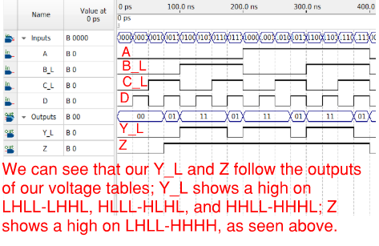
Figure 11: Functional Simulation of Y = /[(A+/B)*/(/C*D)] and Z = /[(/A*B)*(C+/D)]
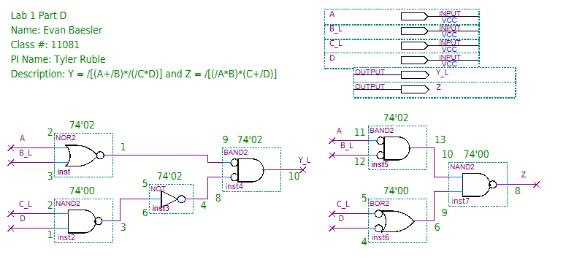
Figure 12: Quartus Pin-out for Y = /[(A+/B)*/(/C*D)] and Z = /[(/A*B)*(C+/D)]
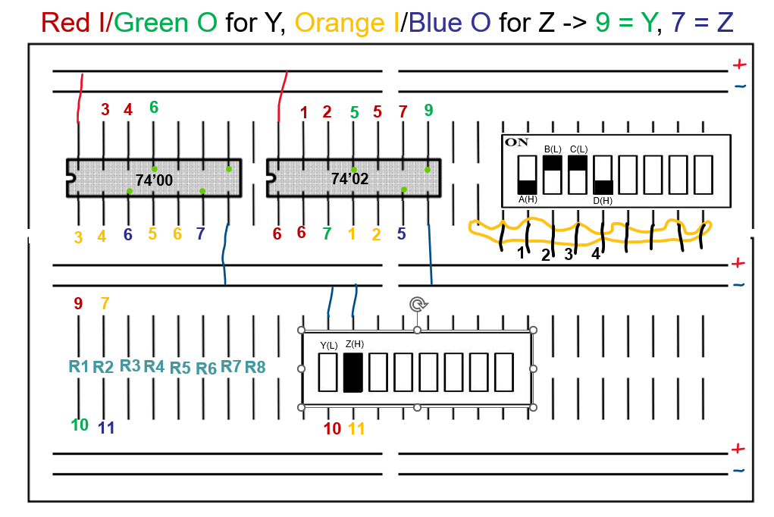
Figure 13: Breadboard Diagram for Y = /[(A+/B)*/(/C*D)] and Z = /[(/A*B)*(C+/D)]
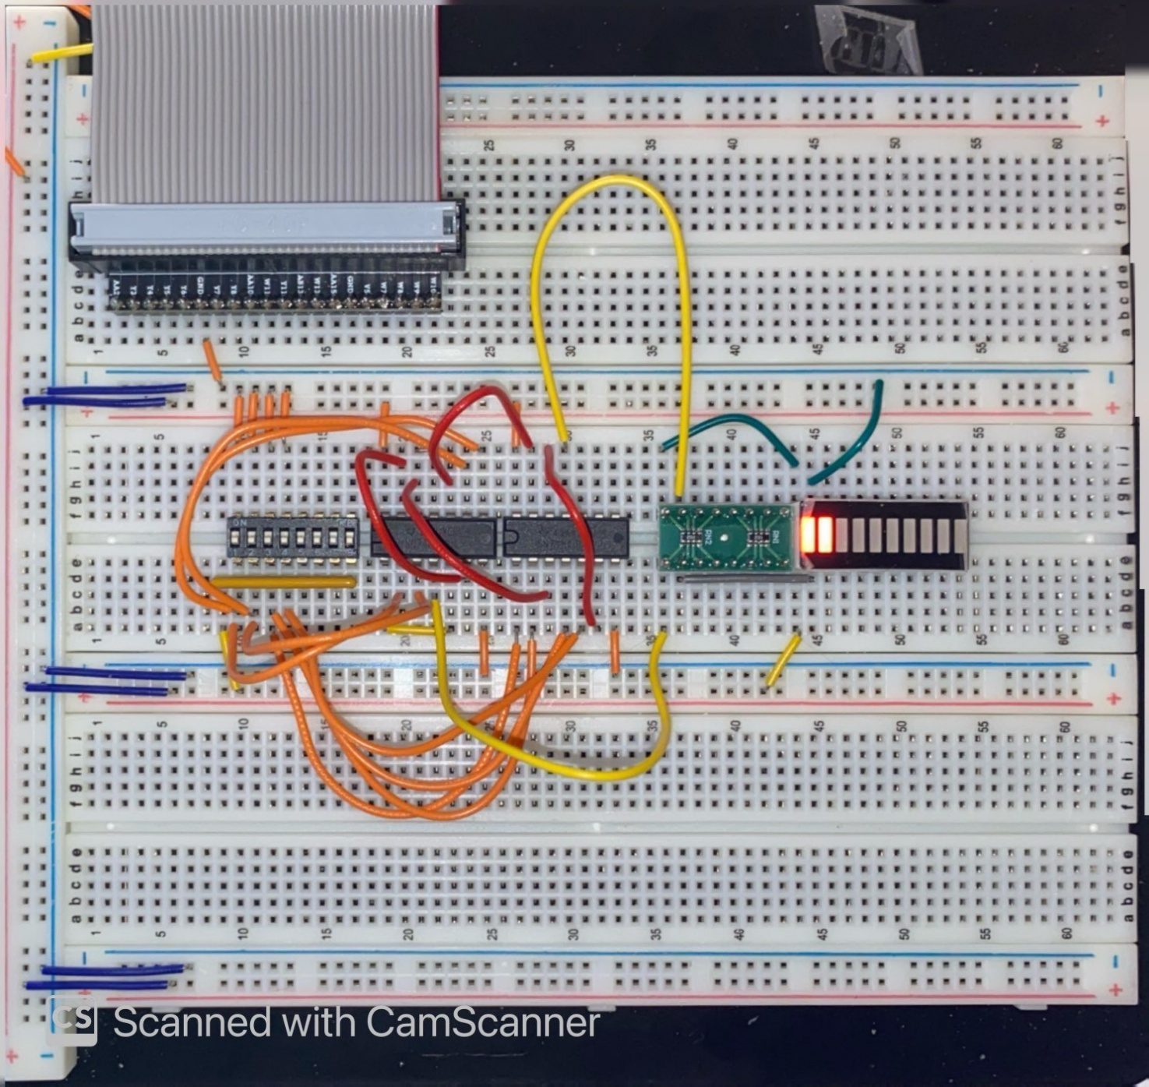
Figure 14: Breadboard of 7400' and 7402' logic circuits.
PRE-LAB REQUIREMENTS (Design, Schematic, ASM Chart, VHDL, etc.)
Each section of the pre-lab requirements should be completed separately, and in order. Include each of the following items in order. Note that some of these items will not apply to every lab. Anything scanned or copied must be clear and legible.
- Logic equations. (Note that logic equations do not contain activation levels.)
- All tables and figures should have captions with Figure/Table numbers and a description of for which part of the lab it references, e.g., Table 3: Truth Table for Part B.
- Truth tables and voltage tables (and/or next-state truth tables).
- When applicable, include Karnaugh Maps (i.e., K-Maps).
- Include hand-drawn circuits (when required). Label all input and output activation-levels and intermediate equations in the circuits.
- Include screenshots of the BDF designs of circuits.
  - Label all input and output activation-levels, i.e., use _L suffix for active-low signals and no suffix for active-high signals. Add chip and pin numbers to any schematic that will be constructed.
  - Images should be large enough so that inputs, outputs, labels, and parts are clearly visible and distinguishable to any reader.
  - Each BDF should have the following info on the top left corner (similar to the top right of this page):
Last Name, First Name
Lab #, Part #
Class #
PI Name:
Description: (short description of what is to be accomplished in the design; perhaps an equation)
  - In Windows, I use the Snipping Tool, which is now built into Windows. Just type “snip” in the Windows search box and then select Snipping Tool.
- When necessary, include ASM Charts. These can be hand-drawn, but clear and legible. We recommend that you use resources like https://www.draw.io/ to create computer-generated ASMs.
- Truth tables or next-state truth tables should have the following characteristics.
  - Can be either typed or hand-written and scanned (must be clear and legible)
  - Must be in counting order (i.e., inputs of 000, 001, 010, 011, …, 111)
  - Clearly distinguish inputs from outputs (see the example below that uses a thick line)
  - If you are designing a state machine or a controller, clearly indicate and separate signal values both before the clock and after the clock (i.e., Q1 and Q1⁺, respectively)
  - Tip: divide rows into consecutive groups of 4 (or 2 or 8) to make it easier for both you and your PI to read.
  - Example
A | B | C | Y
0 | 0 | 0 | 0
0 | 0 | 1 | 0
0 | 1 | 0 | 0
0 | 1 | 1 | 1
1 | 0 | 0 | 0
1 | 0 | 1 | 0
1 | 1 | 0 | 1
1 | 1 | 1 | 0
Table: Caption for above table. It should reference the part of the lab, e.g.,
“Table 3: Truth Table for Part B.”
- Voltage tables should have the following characteristics.
  - Must be in counting order (i.e., inputs of LLL, LLH, LHL, … , HHH)
  - Use similar formatting to truth tables (described above)
  - Example
A(H) | B(H) | C(L) | Y(L)
L | L | L | H
L | L | H | H
L | H | L | L
L | H | H | H
H | L | L | H
H | L | H | H
H | H | L | H
H | H | H | L
- Include meaningfully annotated functional simulations.
  - Using the grouping tool, group as many signals together as possible (when it makes sense to group them)! If you are simulating a basic logic equation, group all the inputs together. If you are simulating a circuit that includes MSI elements, group signals of the form X_{N – 0}. The most-significant bit should appear first, ending with the least-significant bit. If you are simulating an ALU, group the buses together as just described.
  - Not every row of your voltage table must be annotated in the waveform simulation, but your choices of rows that you annotate must be encompassing
  - If you are designing a state machine or a controller, your CLK signal should appear at the top of your inputs and outputs. The general order is CLK -> Reset -> state bits -> inputs -> outputs.
  - Tip: Use Microsoft Paint to annotate your waveforms. An alternative is to print out the waveforms, annotate them by hand, then scan and upload
  - Hint: Consider a truth table where the output is true in significantly less cases than it is false (or vice versa). If the output signal is active-high, it would be wise to annotate only the cases where the output voltage is HIGH.
- Include every line of VHDL programs, including both architecture and behavior sections.
- Include every line of any MIF files. If these are associated with assembly language programs, you can either put the assembly code as comments or separately include assembly language programs

