REQUIREMENTS NOT MET
N/A
VIDEO FILE LINK
https://youtu.be/lf14VnVAcK0?si=UlVwC0SdvP7_AuV1
PROBLEMS ENCOUNTERED
I had Soor help me through Slack and realized that I was doing POS wrong, I was assuming that we were saying a variable was true when it was 1, but through his help found that is only true for SOP, for POS we look for where the variables are 0 to be true.
FUTURE WORK/APPLICATIONS
This is the most practical so far, 7-segment LEDs are used all around the world, for appliances, watches, anything that can count, etc. You could use these 7-segment decoder to convert from binary to hexadecimal, drive a display, which are fundamental skills in electronics.
PRE-LAB QUESTIONS OR EXERCISES
SECTION 1
Q1:
Table 1: Truth Table for 2-input MUX
S0 | D0 | D1 | Y
0 | 0 | - | 0
0 | 1 | - | 1
1 | - | 0 | 0
1 | - | 1 | 1

Row 1: (/S0 * D0) = 1
Row 3: (S0 * D1) = 1
SOP: Y = (/S0 * D0) + (S0 * D1)
Row 2: (/S0 + /D0) = 0
Row 4: (S0 + /D1) = 0
POS: Y = (/S0 + /D0) * (S0 + /D1)

Table 2: K-Map for 2-input MUX.
(S0)/(D0*D1) | 00 | 01 | 11 | 10
0 | 0 | 0 | 1 | 1
1 | 0 | 1 | 1 | 0

Groupings
For Red: /S0 + /D0 Zeroes
For Orange: /S0 * D0 Ones
For Green: S0 + /D1 Zeroes
For Blue: S0 * D1 Ones

SOP: Y = (/S0*D0) + (S0*D1) Ones
POS: Y = (/S0 + /D0) * (S0 + /D1) Zeroes

ALREADY SIMPLIFIED!
Table 3: Truth Table for 2-input MUX.
D0 | D1 | S0 |  | /S0 | (/S0*D0) | S0*D1 | Y
0 | 0 | 0 |  | 1 | 0 | 0 | 0
0 | 0 | 1 |  | 0 | 0 | 0 | 0
0 | 1 | 0 |  | 1 | 0 | 0 | 0
0 | 1 | 1 |  | 0 | 0 | 1 | 1
1 | 0 | 0 |  | 1 | 1 | 0 | 1
1 | 0 | 1 |  | 0 | 0 | 0 | 0
1 | 1 | 0 |  | 1 | 1 | 0 | 1
1 | 1 | 1 |  | 0 | 0 | 1 | 1

Table 4: Voltage Table for 2-input MUX.
D0(L) | D1(H) | S0(H) |  | Y(L)
L | L | L |  | L
L | L | H |  | H
L | H | L |  | L
L | H | H |  | L
H | L | L |  | H
H | L | H |  | H
H | H | L |  | H
H | H | H |  | L
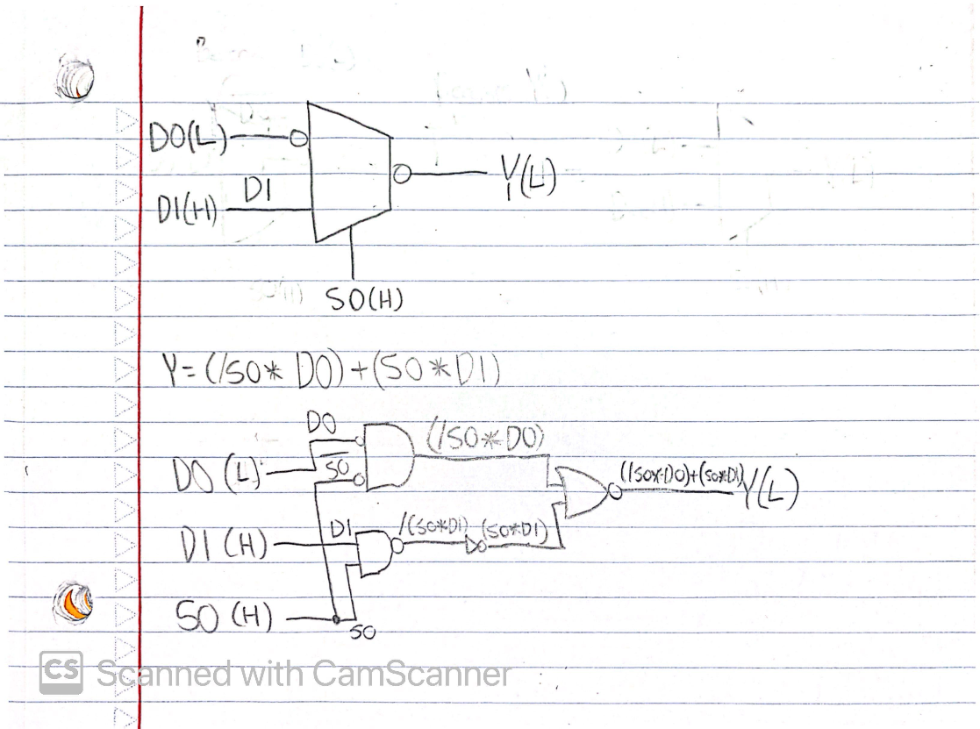
Figure 1: MUX Functional Block Diagram & Circuit Block Diagram

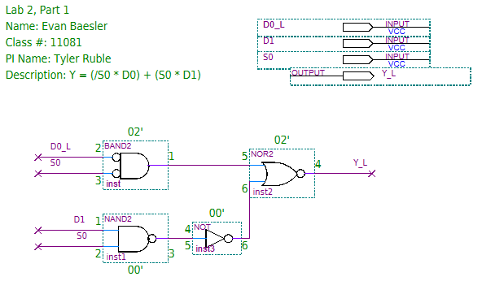
Figure 2: Quartus Wiring Diagram for Y = (/S0 * D0) + (S0 * D1)
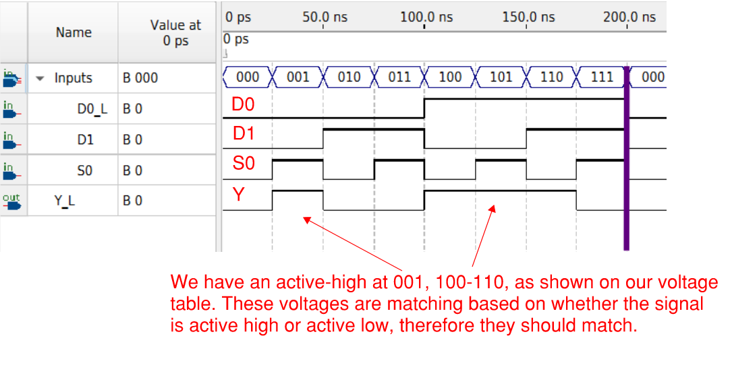
Figure 3: Annotated Waveform for Y = (/S0 * D0) + (S0 * D1)

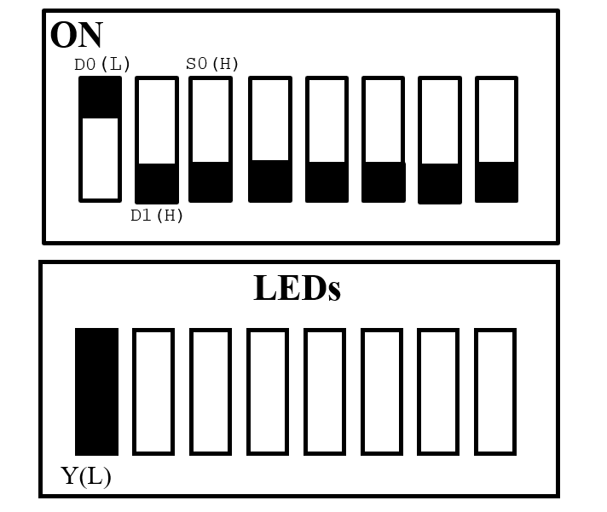
Figure 4: Switch & LED Diagram (at HHH.)
SECTION 2
Table 5: Truth Table for 4-input MUX with wildcards.
S0 | S1 | D0 | D1 | D2 | D3 | Y
0 | 0 | 0 | - | - | - | 0
0 | 0 | 1 | - | - | - | 1
0 | 1 | - | 0 | - | - | 0
0 | 1 | - | 1 | - | - | 1
1 | 0 | - | - | 0 | - | 0
1 | 0 | - | - | 1 | - | 1
1 | 1 | - | - | - | 0 | 0
1 | 1 | - | - | - | 1 | 1
Row 2: /S0 * /S1 * D0 = 1
Row 4: /S0 * S1 * D1 = 1
Row 6: S0 * /S1 * D2 = 1
Row 8: S0 * S1 * D3 = 1
SOP Y = (/S0*/S1*D0) + (/S0 * S1 * D1) + (S0 * /S1 * D2) + (S0 * S1 * D3)

Row 1: (/S0 + /S1 + /D0) = 0
Row 3: (/S0 + S1 + /D1) = 0
Row 5: (S0 + /S1 + /D2) = 0
Row 7: (S0 + S1 + /D3) = 0
POS Y = (/S0 + /S1 + /D0) * (/S0 + S1 + /D1) * (S0 + /S1 + /D2) * (S0 + S1 + /D3)

Table 6: Voltage Table for 4-input MUX with wildcards.
S0(H) | S1(H) | D0(L) | D1(H) | D2(H) | D3(H) | Y(H)
L | L | L | - | - | - | H
L | L | H | - | - | - | L
L | H | - | L | - | - | L
L | H | - | H | - | - | H
H | L | - | - | L | - | L
H | L | - | - | H | - | H
H | H | - | - | - | L | L
H | H | - | - | - | H | H

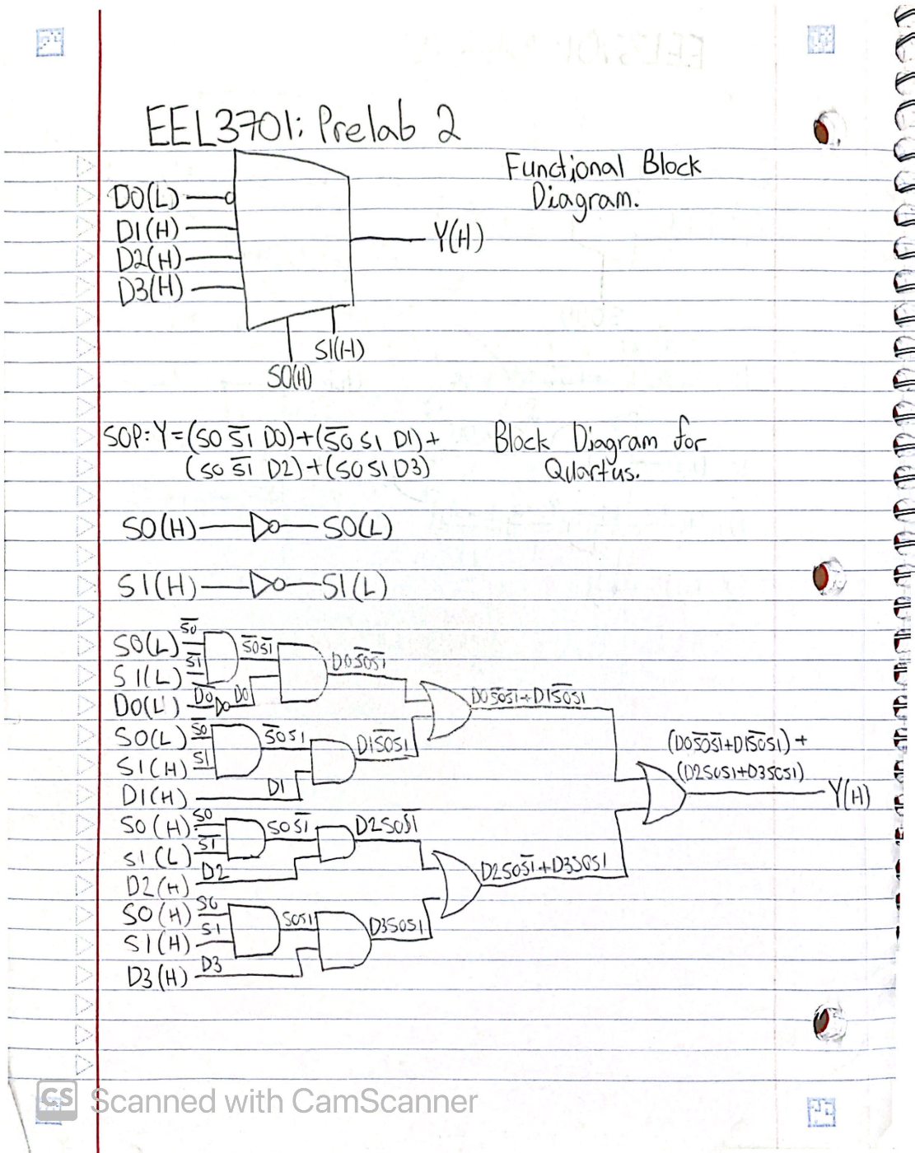
Figure 5: Functional Block Diagram and Circuit Design for 4-input MUX.
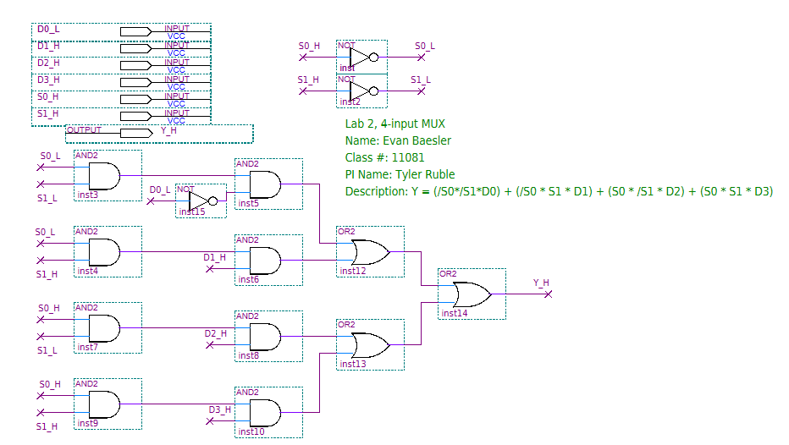
Figure 6: Quartus Circuit Diagram for a 4-input MUX.
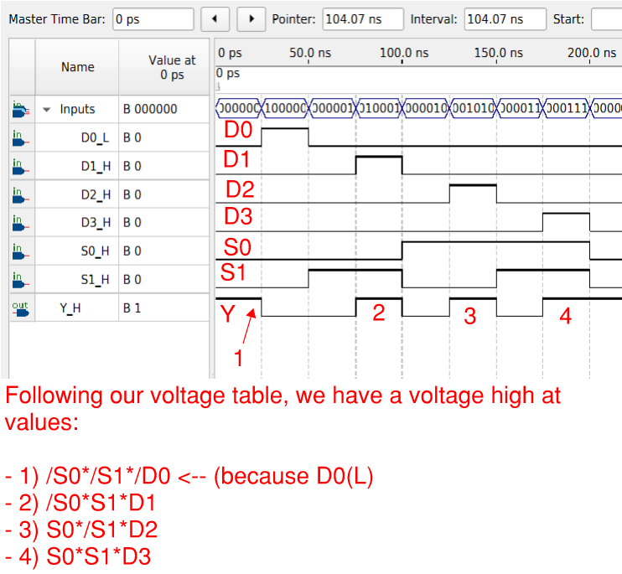
Figure 7: Quartus Waveform Simulation for 4-input MUX.
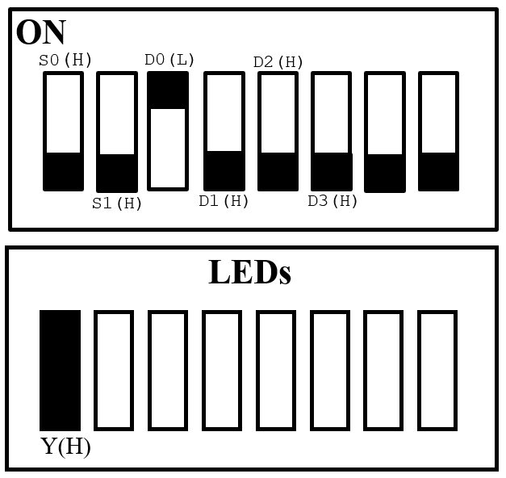
Figure 8: LED & Switch Legend for 4-input MUX.

SECTION 3
Table 7: Truth Table for Hex to 7-Segment Decoder
T | X3 | X2 | X1 | X0 | A | B | C | D | E | F | G | LEGEND
0 | 0 | 0 | 0 | 0 | 1 | 1 | 1 | 1 | 1 | 1 | 0 | 0
0 | 0 | 0 | 0 | 1 | 0 | 1 | 1 | 0 | 0 | 0 | 0 | 1
0 | 0 | 0 | 1 | 0 | 1 | 1 | 0 | 1 | 1 | 0 | 1 | 2
0 | 0 | 0 | 1 | 1 | 1 | 1 | 1 | 1 | 0 | 0 | 1 | 3
0 | 0 | 1 | 0 | 0 | 0 | 1 | 1 | 0 | 0 | 1 | 1 | 4
0 | 0 | 1 | 0 | 1 | 1 | 0 | 1 | 1 | 0 | 1 | 1 | 5
0 | 0 | 1 | 1 | 0 | 1 | 0 | 1 | 1 | 1 | 1 | 1 | 6
0 | 0 | 1 | 1 | 1 | 1 | 1 | 1 | 0 | 0 | 0 | 0 | 7
0 | 1 | 0 | 0 | 0 | 1 | 1 | 1 | 1 | 1 | 1 | 1 | 8
0 | 1 | 0 | 0 | 1 | 1 | 1 | 1 | 1 | 0 | 1 | 1 | 9
0 | 1 | 0 | 1 | 0 | 1 | 1 | 1 | 0 | 1 | 1 | 1 | A
0 | 1 | 0 | 1 | 1 | 0 | 0 | 1 | 1 | 1 | 1 | 1 | b
0 | 1 | 1 | 0 | 0 | 1 | 0 | 0 | 1 | 1 | 1 | 0 | C
0 | 1 | 1 | 0 | 1 | 0 | 1 | 1 | 1 | 1 | 0 | 1 | d
0 | 1 | 1 | 1 | 0 | 1 | 0 | 0 | 1 | 1 | 1 | 1 | E
0 | 1 | 1 | 1 | 1 | 1 | 0 | 0 | 0 | 1 | 1 | 1 | F
1 | - | - | - | - | 1 | 1 | 1 | 1 | 1 | 1 | 1 | TEST

SOP(A):
T + (/T*/X0*/X1*/X2*/X3) + (/T*/X0*X1*/X2*/X3) + (/T*X0*X1*/X2*/X3) + (/T*X0*/X1*X2*/X3) + (/T*/X0*X1*X2*/X3) + (/T*X0*X1*X2*/X3) + (/T*/X0*/X1*/X2*X3) + (/T*X0*/X1*/X2*X3) + (/T*/X0*X1*/X2*X3) + (/T*/X0*/X1*X2*X3) + (/T*/X0*X1*X2*X3) + (/T*X0*X1*X2*X3)
POS(A):
(T+/X0+X1+X2+X3)*(T+X0+X1+/X2+X3)*(T+/X0+/X1+X2+/X3)*(T+/X0+X1+/X2+/X3)
= T*(/X0+X1+X2+X3)*(X0+X1+/X2+X3)*(/X0+/X1+X2+/X3)*(/X0+X1+/X2+/X3)
SOP(B):
T + (/T*/X0*/X1*/X2*/X3) + (/T*X0*/X1*/X2*/X3) + (/T*/X0*X1*/X2*/X3) + (/T*X0*X1*/X2*/X3) + (/T*/X0*/X1*X2*/X3) + (/T*X0*X1*X2*/X3) + (/T*/X0*/X1*/X2*X3) + (/T*X0*/X1*/X2*X3) + (/T*/X0*X1*/X2*X3) + (/T*X0*/X1*X2*X3)
POS(B):
(T + /X0 + X1 + /X2 + X3) * (T + X0 + /X1 + /X2 + X3) * (T + /X0 + /X1 + X2 + /X3) * (T + X0 + X1 + /X2 + /X3) * (T + X0 + /X1 + /X2 + /X3) * (T + /X0 + /X1 + /X2 + /X3)
= T * (/X0 + X1 + /X2 + X3) * (X0 + /X1 + /X2 + X3) * (/X0 + /X1 + X2 + /X3) * (X0 + X1 + /X2 + /X3) * (X0 + /X1 + /X2 + /X3) * (/X0 + /X1 + /X2 + /X3)
SOP(C):
T + (/X0*/X1*/X2*/X3) + (X0*/X1*/X2*/X3) + (X0*X1*/X2*/X3) + (/X0*/X1*X2*/X3) + (X0*/X1*X2*/X3) + (/X0*X1*X2*/X3) + (X0*X1*X2*/X3) + (/X0*/X1*/X2*X3) + (X0*/X1*/X2*X3) + (/X0*X1*/X2*X3) + (X0*X1*/X2*X3) + (X0*/X1*X2*X3)

Table 8: Voltage Table for 4-input MUX
T(L) | X3(H) | X2(H) | X1(H) | X0(H) | A(L) | B(L) | LEGEND
L | - | - | - | - | L | L | TEST
H | L | L | L | L | L | L | 0
H | L | L | L | H | H | L | 1
H | L | L | H | L | L | L | 2
H | L | L | H | H | L | L | 3
H | L | H | L | L | H | L | 4
H | L | H | L | H | L | H | 5
H | L | H | H | L | L | H | 6
H | L | H | H | H | L | L | 7
H | H | L | L | L | L | L | 8
H | H | L | L | H | L | L | 9
H | H | L | H | L | L | L | A
H | H | L | H | H | H | H | b
H | H | H | L | L | L | H | C
H | H | H | L | H | H | L | d
H | H | H | H | L | L | H | E
H | H | H | H | H | L | H | F

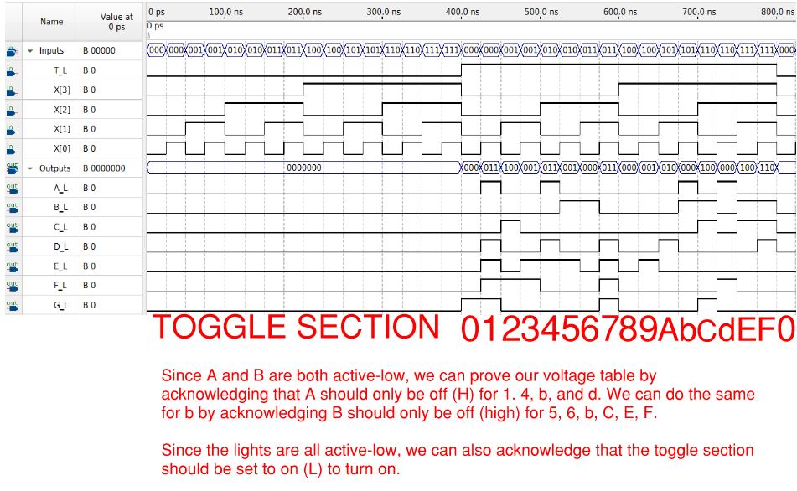
Figure 9: Annotated 7-Segment Display Quartus Waveform Simulation.

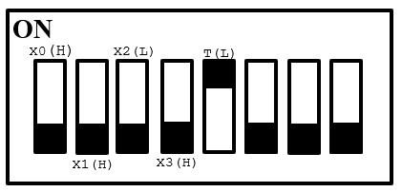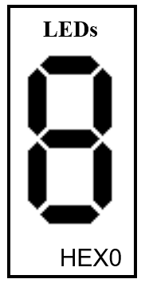
Figure 10: Switch & LED Legends for Hex to 7-Segment Display
SECTION 4
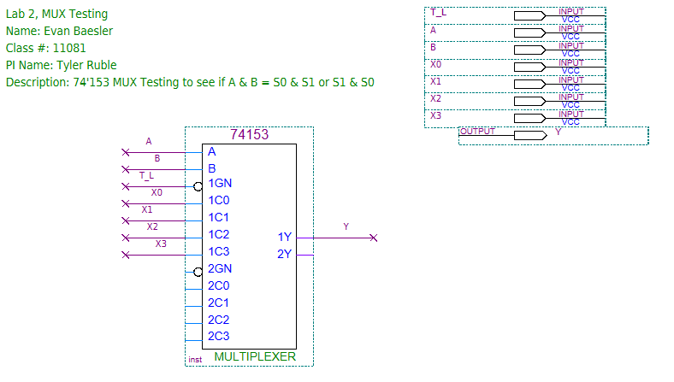
Figure 11: Quartus Diagram of 74153 Testing
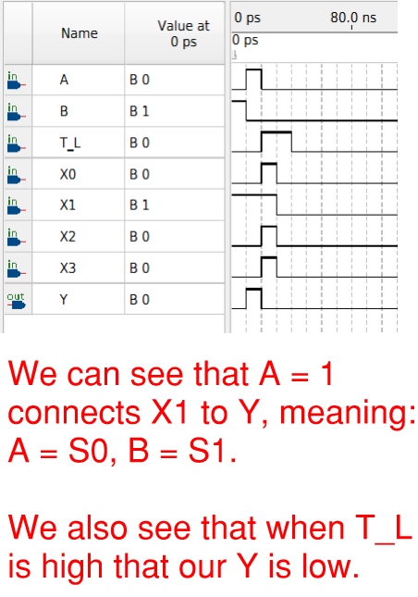
Figure 12: Test of 74'153 in Quartus Waveform.
Formula: F = W(/X + XYZ) + /(/W + Z)
Table 9: Truth Table for F = W(/X+XYZ)+/(/W+Z)
W | X | Y | Z | /X | XYZ | /X + XYZ | W(/X+XYZ) | /W | /W+Z | /(/W+Z) | F
0 | 0 | 0 | 0 | 1 | 0 | 1 | 0 | 1 | 1 | 0 | 0
0 | 0 | 0 | 1 | 1 | 0 | 1 | 0 | 1 | 1 | 0 | 0
0 | 0 | 1 | 0 | 1 | 0 | 1 | 0 | 1 | 1 | 0 | 0
0 | 0 | 1 | 1 | 1 | 0 | 1 | 0 | 1 | 1 | 0 | 0
0 | 1 | 0 | 0 | 0 | 0 | 0 | 0 | 1 | 1 | 0 | 0
0 | 1 | 0 | 1 | 0 | 0 | 0 | 0 | 1 | 1 | 0 | 0
0 | 1 | 1 | 0 | 0 | 0 | 0 | 0 | 1 | 1 | 0 | 0
0 | 1 | 1 | 1 | 0 | 1 | 1 | 0 | 1 | 1 | 0 | 0
1 | 0 | 0 | 0 | 1 | 0 | 1 | 1 | 0 | 0 | 1 | 1
1 | 0 | 0 | 1 | 1 | 0 | 1 | 1 | 0 | 1 | 0 | 1
1 | 0 | 1 | 0 | 1 | 0 | 1 | 1 | 0 | 0 | 1 | 1
1 | 0 | 1 | 1 | 1 | 0 | 1 | 1 | 0 | 1 | 0 | 1
1 | 1 | 0 | 0 | 0 | 0 | 0 | 0 | 0 | 0 | 1 | 1
1 | 1 | 0 | 1 | 0 | 0 | 0 | 0 | 0 | 1 | 0 | 0
1 | 1 | 1 | 0 | 0 | 0 | 0 | 0 | 0 | 0 | 1 | 1
1 | 1 | 1 | 1 | 0 | 1 | 1 | 1 | 0 | 1 | 0 | 1

SOP:
(W*/X*/Y*/Z)+(W*/X*/Y*Z)+(W*/X*Y*/Z)+(W*/X*Y*Z)+(W*X*/Y*/Z)+(W*X*Y*/Z)+(W*X*Y*Z)

POS:
(W+X+Y+Z)*(W+X+Y+/Z)*(W+X+/Y+Z)*(W+X+/Y+/Z)*(W+/X+Y+Z)*(W+/X+Y+/Z)*(W+/X+/Y+Z)*(W+/X+/Y+/Z)*(/W+/X+Y+/Z)

SOP K-MAP
Table 10: K-Map to simplify function F
WX \ YZ | 00 | 01 | 11 | 10
00 | 0 | 0 | 0 | 0
01 | 0 | 0 | 0 | 0
11 | 1 | 0 | 1 | 1
10 | 1 | 1 | 1 | 1

W*/Z
W*/X
W*Y
F = W(/X+Y+/Z)
Table 11: Truth Table for Simplified F = W(/X+Y+/Z)
W | X | Y | Z | /X | /Z | /X+Y+/Z | F
0 | 0 | 0 | 0 | 1 | 1 | 1 | 0
0 | 0 | 0 | 1 | 1 | 0 | 1 | 0
0 | 0 | 1 | 0 | 1 | 1 | 1 | 0
0 | 0 | 1 | 1 | 1 | 0 | 1 | 0
0 | 1 | 0 | 0 | 0 | 1 | 1 | 0
0 | 1 | 0 | 1 | 0 | 0 | 0 | 0
0 | 1 | 1 | 0 | 0 | 1 | 1 | 0
0 | 1 | 1 | 1 | 0 | 0 | 1 | 0
1 | 0 | 0 | 0 | 1 | 1 | 1 | 1
1 | 0 | 0 | 1 | 1 | 0 | 1 | 1
1 | 0 | 1 | 0 | 1 | 1 | 1 | 1
1 | 0 | 1 | 1 | 1 | 0 | 1 | 1
1 | 1 | 0 | 0 | 0 | 1 | 1 | 1
1 | 1 | 0 | 1 | 0 | 0 | 0 | 0
1 | 1 | 1 | 0 | 0 | 1 | 1 | 1
1 | 1 | 1 | 1 | 0 | 0 | 1 | 1

Table 12: Voltage Table for Simplified F = W(/X+Y+/Z)
W(L) | X(H) | Y(H) | Z(H) | F(H)
L | L | L | L | H
L | L | L | H | H
L | L | H | L | H
L | L | H | H | H
L | H | L | L | H
L | H | L | H | L
L | H | H | L | H
L | H | H | H | H
H | L | L | L | L
H | L | L | H | L
H | L | H | L | L
H | L | H | H | L
H | H | L | L | L
H | H | L | H | L
H | H | H | L | L
H | H | H | H | L

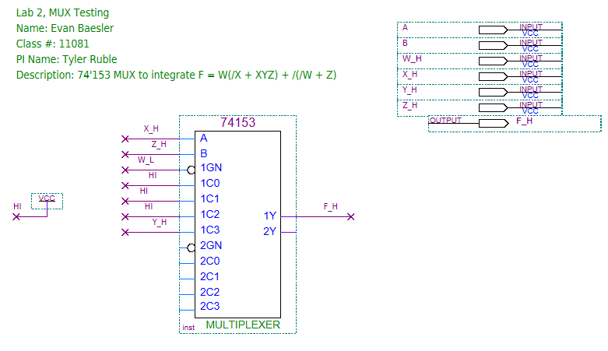
Figure 13: Quartus Diagram for F = W(/X+Y+/Z)
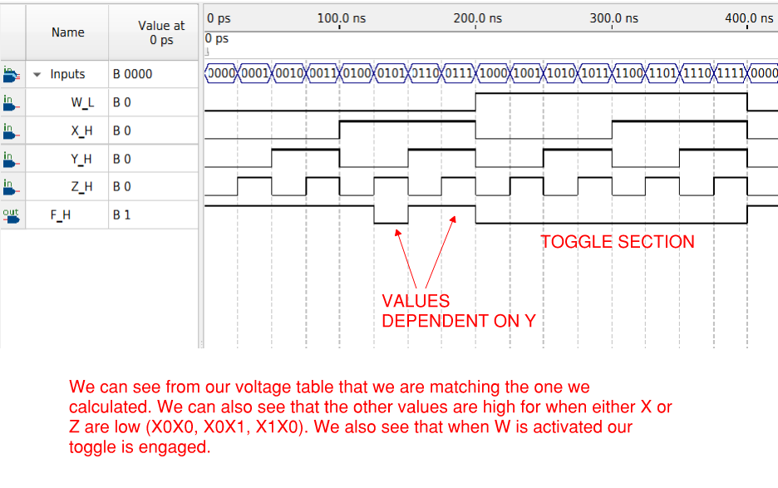
Figure 14: Annotated Quartus Waveform for 4-input MUX and F = W(/X+Y+/Z)

