REQUIREMENTS NOT MET
- N/A
VIDEO FILE LINK
https://youtube.com/shorts/_I65pF8lryo?feature=share
PROBLEMS ENCOUNTERED
- Understanding how to derive inputs from outputs, took a bit!
FUTURE WORK/APPLICATIONS
We can now create counters starting from any position using state machines, creating a feedback loop, this could be used to create arithmetic logic units (ALUs) in the future.

PRE-LAB QUESTIONS OR EXERCISES
<insert copy of pre-lab exercises/questions from lab document, as well as an answer directly following each of the exercises/questions (if not applicable, write “N/A”)>
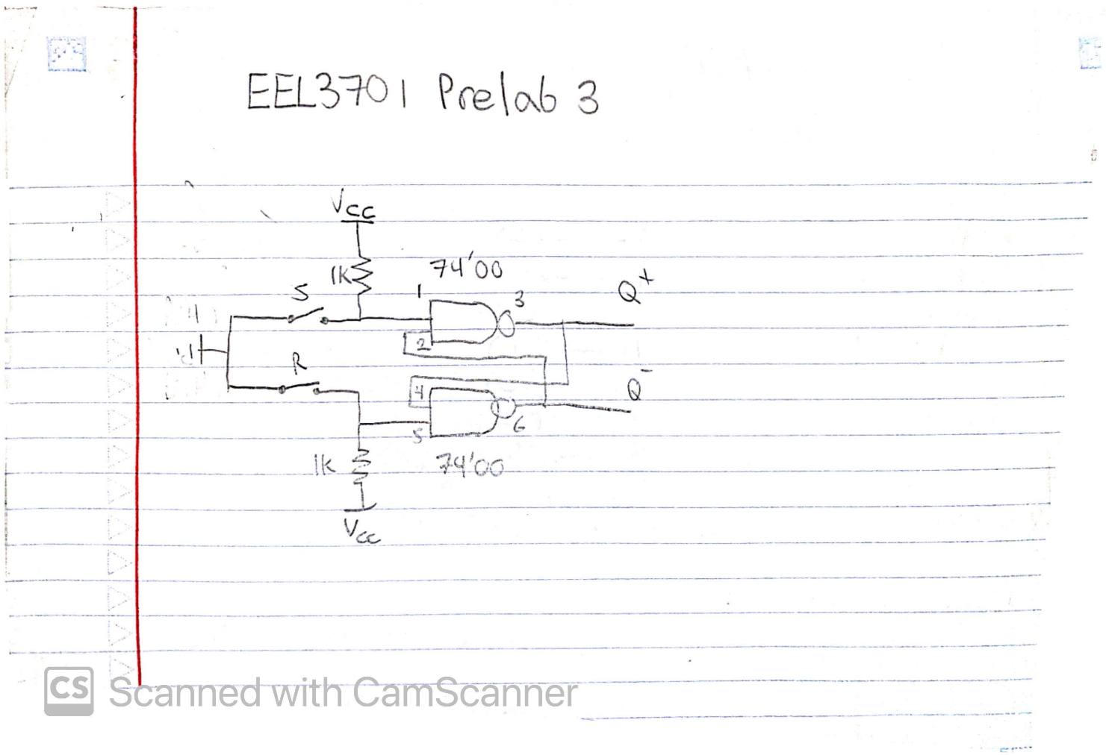
Figure 1: Proposed Debounce Switch Circuit Pinout
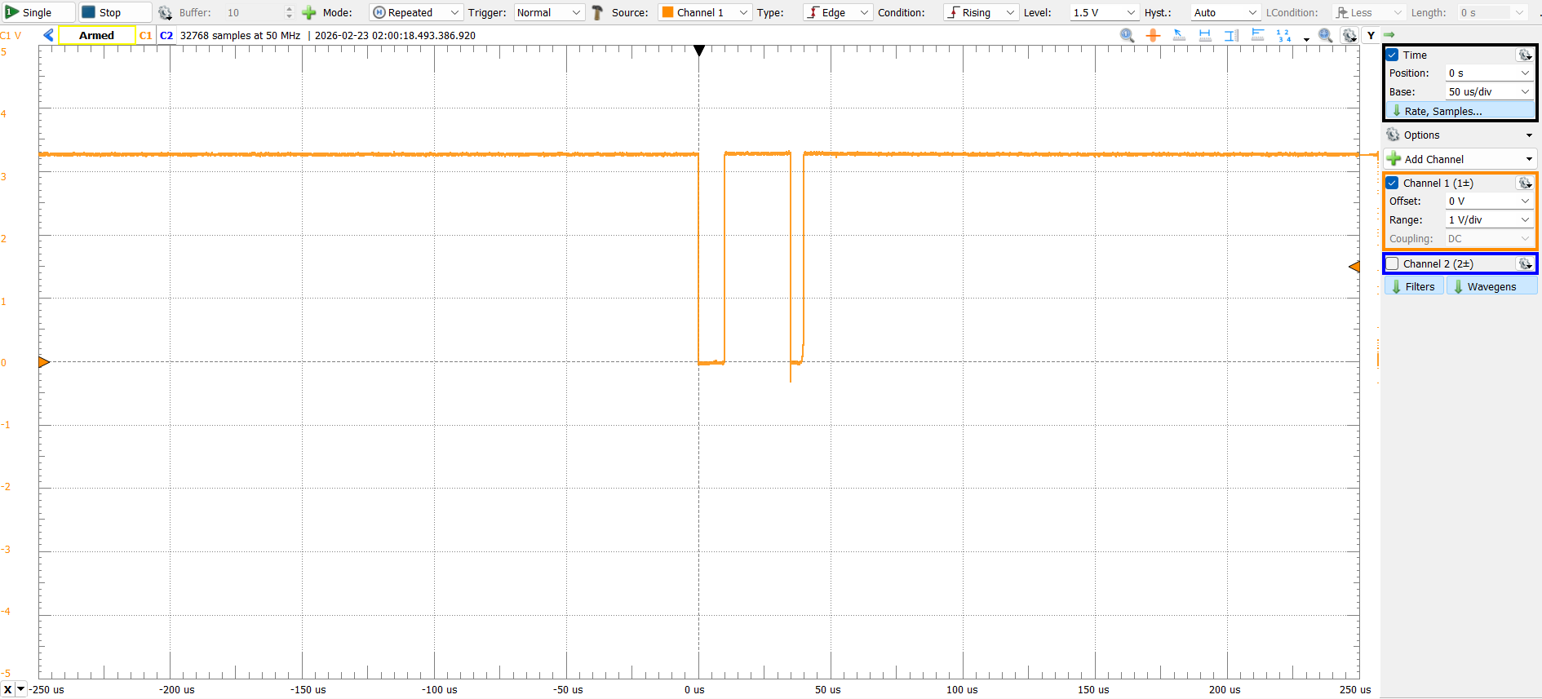
Figure 2: Non-debounced Switching Response
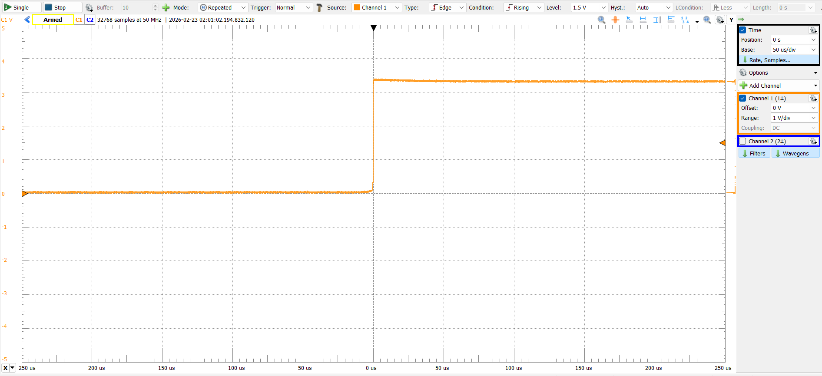
Figure 3: Non-debounced Switching Response 2
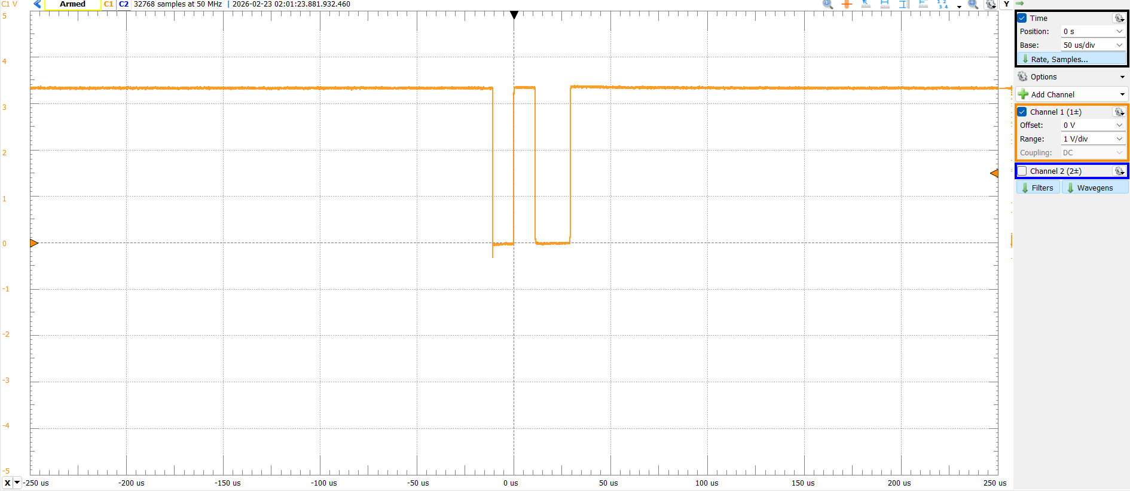
Figure 4: Non-debounced Switching Response 3
Since the clock looks for a rising edge, some of these would cause errors, the first and third image would cause at least two switches per, and are likely to fail more often.
Debounced after this point
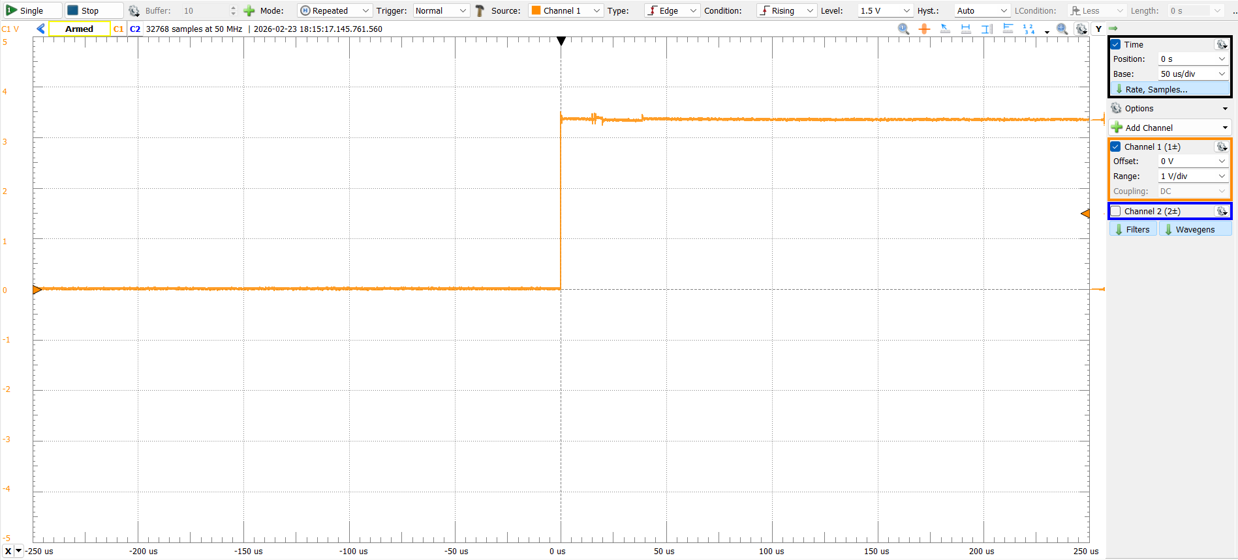
Figure 5: Debounced Switch Response
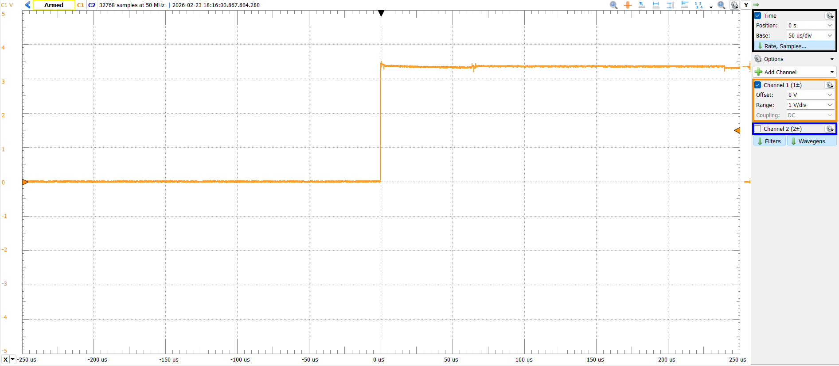
Figure 6: Debounced Switch Response 2
The debounced circuit shows more consistency, and because it never drops past the threshold, the clock never sees a rising edge outside of the initial switching behavior.
Table 1: Next-state truth table for 2-bit Counter
Q1 | Q0 | Q1+ | Q0+
0 | 0 | 0 | 1
0 | 1 | 1 | 1
1 | 1 | 1 | 0
1 | 0 | 0 | 0

Table 2: D-flip flop Di = Qi⁺ truth table
Q1 | Q0 | D1 | D0
0 | 0 | 0 | 1
0 | 1 | 1 | 1
1 | 1 | 1 | 0
1 | 0 | 0 | 0

MPOS(D1):
(Q0+Q1)*(Q0+/Q1)
MSOP(D1):
(Q0*Q1)+(Q0*/Q1)

MPOS(D0):
(/Q0+/Q1)*(/Q0+Q1)
MSOP(D0):
(/Q0*/Q1)+(/Q0*Q1)

D0:
Table 3: K-Map for D0
Q1\Q0 | 0 | 1
0 | 1 | 1
1 | 0 | 0
D0 = /Q1

D1:
Table 4: K-Map for D1
Q1\Q0 | 0 | 1
0 |  | 1
1 |  | 1
D1 = Q0
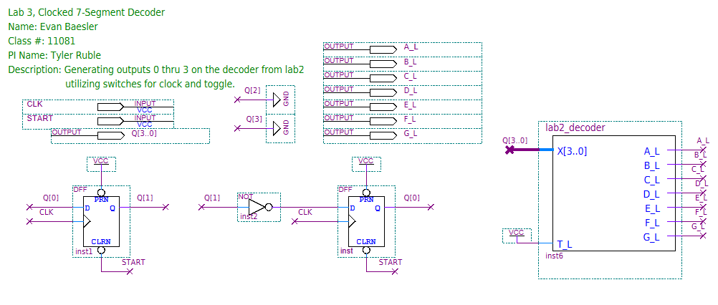
Figure 7: Two-bit counter Quartus BDF
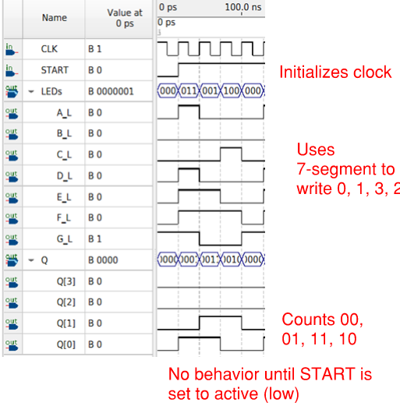
Figure 8: Annotated Quartus Waveform for 2-bit Counter
Outputs: 0,1,3,2,0,1,3,2,0,1
These outputs match the expected and show a working debounce.

Table 5: Truth Table for 3-bit Counter with Forward & Back
F | B | Q2 | Q1 | Q0 | Q2⁺ | Q1⁺ | Q0⁺ | Sp.
0 | 0 | 0 | 0 | 0 | 0 | 0 | 0 | 0
0 | 0 | 0 | 0 | 1 | - | - | - | -
0 | 0 | 0 | 1 | 0 | 0 | 1 | 0 | 1
0 | 0 | 0 | 1 | 1 | 0 | 1 | 1 | 0
0 | 0 | 1 | 0 | 0 | 1 | 0 | 0 | 0
0 | 0 | 1 | 0 | 1 | - | - | - | -
0 | 0 | 1 | 1 | 0 | - | - | - | -
0 | 0 | 1 | 1 | 1 | 1 | 1 | 1 | 1
0 | 1 | 0 | 0 | 0 | 0 | 1 | 1 | 0
0 | 1 | 0 | 0 | 1 | - | - | - | -
0 | 1 | 0 | 1 | 0 | 1 | 1 | 1 | 1
0 | 1 | 0 | 1 | 1 | 1 | 0 | 0 | 0
0 | 1 | 1 | 0 | 0 | 0 | 1 | 0 | 0
0 | 1 | 1 | 0 | 1 | - | - | - | -
0 | 1 | 1 | 1 | 0 | - | - | - | -
0 | 1 | 1 | 1 | 1 | 0 | 0 | 0 | 1
1 | 0 | 0 | 0 | 0 | 1 | 1 | 1 | 0
1 | 0 | 0 | 0 | 1 | - | - | - | -
1 | 0 | 0 | 1 | 0 | 1 | 0 | 0 | 0
1 | 0 | 0 | 1 | 1 | 0 | 0 | 0 | 0
1 | 0 | 1 | 0 | 0 | 0 | 1 | 1 | 0
1 | 0 | 1 | 0 | 1 | - | - | - | -
1 | 0 | 1 | 1 | 0 | - | - | - | -
1 | 0 | 1 | 1 | 1 | 0 | 1 | 0 | 1
D0 = Q0⁺, D1 = Q1⁺, D2 = Q2⁺

Bolded Terms are Do Not Cares (-) turned into 1 or 0
For B = 0, D0:
Table 6: D0 K-Map for B = 0
F*Q2 \ Q1*Q0 | 00 | 01 | 11 | 10
00 | 0 | 0 | 1 | 0
01 | 0 | 0 | 1 | 0
11 | 1 | 1 | 0 | 0
10 | 1 | 1 | 0 | 0

For B = 1, D0:
Table 7: D0 K-Map for B = 1
F*Q2 \ Q1*Q0 | 00 | 01 | 11 | 10
00 | 1 | 0 | 0 | 1
01 | 0 | 0 | 0 | 0
11 | 0 | 0 | 0 | 0
10 | 0 | 0 | 0 | 0

K-Map Simplification (MSOP):
D0 = (/B*F*Q1) + (/B*/F*Q1*Q0) + (B*/F*/Q2*/Q0)
D0 = (F*/Q1) + (/F*/B*Q0) + (B*/Q2*/Q0)

For B = 0, D1:
Table 8: D1 K-Map for B = 0
F*Q2 \ Q1*Q0 | 00 | 01 | 11 | 10
00 | 0 | 0 | 1 | 1
01 | 0 | 0 | 1 | 1
11 | 1 | 1 | 1 | 1
10 | 1 | 1 | 0 | 0
For B = 1, D1:
Table 9: D1 K-Map for B = 1
F*Q2 \ Q1*Q0 | 00 | 01 | 11 | 10
00 | 1 | 1 | 0 | 1
01 | 1 | 1 | 0 | 1
11 | 1 | 1 | 0 | 1
10 | 1 | 1 | 0 | 1

K-Map Simplification (MSOP):
D1 = (/B*/F*Q1) + (/B*F*/Q1) + (/B*F*Q2) + (B*/Q1) + (B*Q1*/Q0)
D1 = (B*/Q0) + (F*/Q1) + (F*Q2) + (/F*/B*Q1)

For B = 0, D2:
Table 10: D2 K-Map for B = 0
F*Q2 \ Q1*Q0 | 00 | 01 | 11 | 10
00 | 0 | 0 | 0 | 0
01 | 1 | 1 | 1 | 1
11 | 0 | 0 | 0 | 0
10 | 1 | 0 | 0 | 1

For B = 1, D2:
Table 11: D2 K-Map for B = 1
F*Q2 \ Q1*Q0 | 00 | 01 | 11 | 10
00 | 0 | 0 | 1 | 1
01 | 0 | 0 | 0 | 0
11 | 0 | 0 | 0 | 0
10 | 0 | 0 | 0 | 0

K-Map Simplification (MSOP):
D2 = (/B*/F*Q2) + (/B*F*/Q2*/Q0) + (B*/F*/Q2*Q1)
D2 = (/F*/B*Q2) + (B*/Q2*Q1) + (F*/Q2*/Q0)

For B = 0, Sp:
Table 12: Sp K-Map for B = 0
F*Q2 \ Q1*Q0 | 00 | 01 | 11 | 10
00 | 0 | 0 | 0 | 1
01 | 0 | 0 | 1 | 1
11 | 0 | 0 | 1 | 1
10 | 0 | 0 | 0 | 0
For B = 1, Sp:
Table 13: Sp K-Map for B = 1
F*Q2 \ Q1*Q0 | 00 | 01 | 11 | 10
00 | 0 | 0 | 0 | 1
01 | 0 | 1 | 1 | 1
11 | 0 | 0 | 0 | 1
10 | 0 | 0 | 0 | 1

K-Map Simplification (MSOP):
Sp = (/B*Q2*Q0) + (/F*/B*Q1*/Q0) + (B*/F*Q2*Q0) + (B*Q1*/Q0)
Sp = (Q2*Q0) + (/F*Q1*/Q0)

Summary:
D0 = (F*/Q1) + (/F*/B*Q0) + (B*/Q2*/Q0)
D1 = (B*/Q0) + (F*/Q1) + (F*Q2) + (/F*/B*Q1)
D2 = (/F*/B*Q2) + (B*/Q2*Q1) + (F*/Q2*/Q0)
Sp = (Q2*Q0) + (/F*Q1*/Q0)

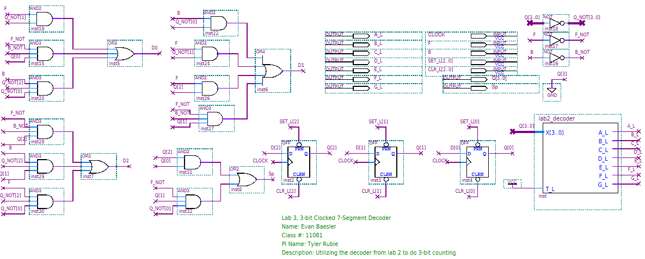
Figure 9: Quartus 3-bit Counter Circuit Diagram
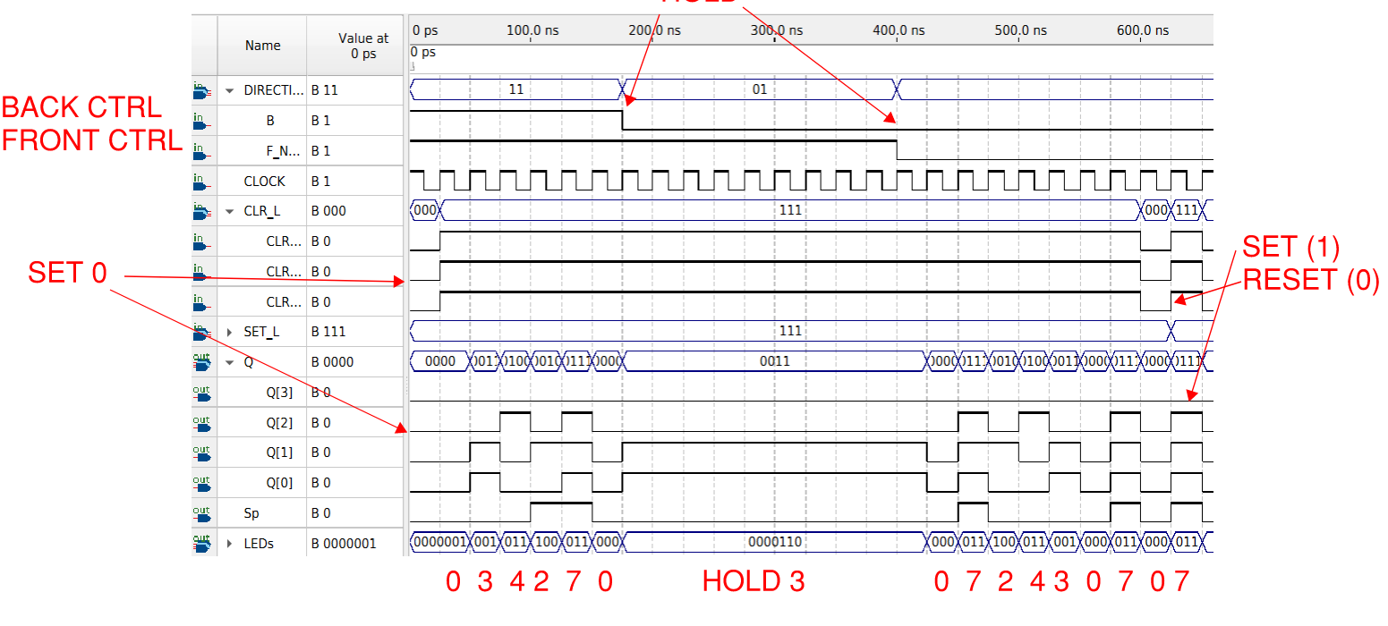
Figure 10: Annotated Quartus Waveform Simulation for 3-bit Counter
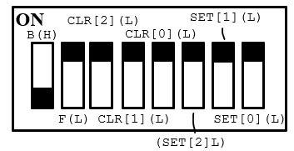
Figure 11: Switch Legend for 3-bit counter

Next States for 001:
F | B | Next State
0 | 0 | 001
0 | 1 | 000
1 | 0 | 110
1 | 1 | 110
Next States for 101:
F | B | Next State
0 | 0 | 111
0 | 1 | 011
1 | 0 | 010
1 | 1 | 010
Next States for 110:
F | B | Next State
0 | 0 | 110
0 | 1 | 010
1 | 0 | 010
1 | 1 | 010

Q1 | Q0 | T1 | J0 | K0 | Q1+ | Q0+
0 | 0 | 0 | 1 | - | 0 | 1
0 | 1 | 1 | - | 0 | 1 | 1
1 | 1 | 0 |  | 1 | 1 | 0
1 | 0 | 1 | 0 | - | 0 | 0

Q1 | Q0 | J0 | K0 | Q0+
0 | 0 | 1 | - | 1
0 | 1 | - | 0 | 1
1 | 1 | - | 1 | 0
1 | 0 | 0 | - | 0

J0 = (/Q1)
K0 = (Q1)
Q0+ = (/Q0*J0) + (Q0*/K0)

Q1 | Q0 | T1 | Q1+
0 | 0 | 0 | 0
0 | 1 | 1 | 1
1 | 1 | 0 | 1
1 | 0 | 1 | 0

T = Q1 XOR Q0
Q1+ = (/Q1*T1) + (Q1*/T1) Q1 XOR T1

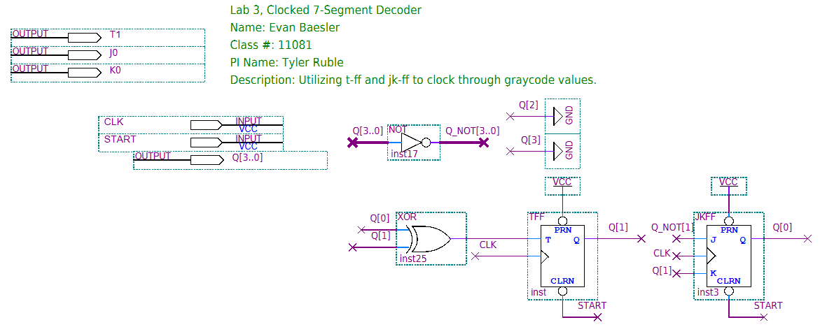
Figure 12: Quartus BDF for tff and jkff counter
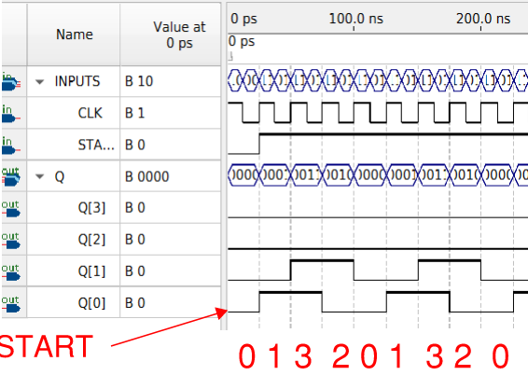
Figure 13: Annotated Quartus Waveform for tff and jkff counter

