REQUIREMENTS NOT MET
N/A
VIDEO FILE LINK
https://youtube.com/shorts/YlnWWnNcygU?si=WH5EoAzmUNSY7Gze
PROBLEMS ENCOUNTERED
Understanding outputs of my registers, told to focus on output by PI.
FUTURE WORK/APPLICATIONS
With a controller, we can make a CPU and eventually build the backbone of modern computing.
PRE-LAB QUESTIONS OR EXERCISES
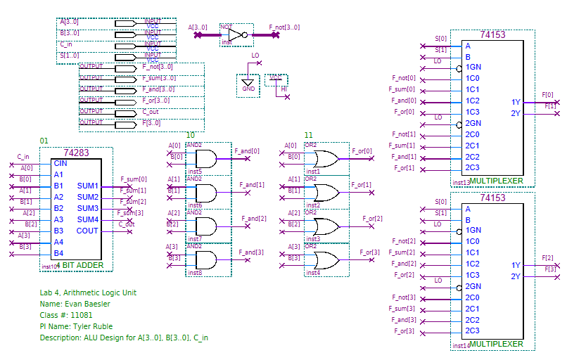
Figure 1: ALU Quartus BDF Design

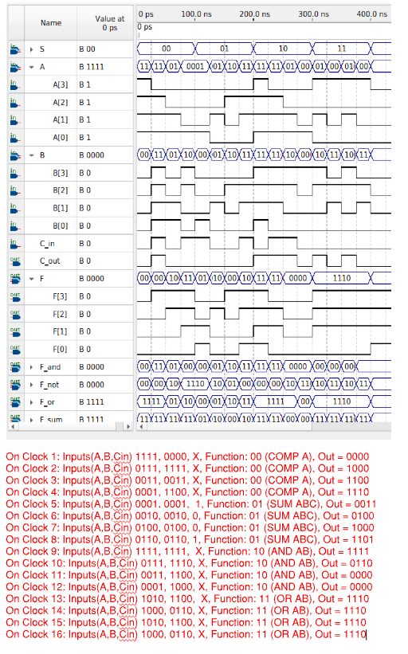
Figure 2: Annotated Quartus ALU Waveform
‘
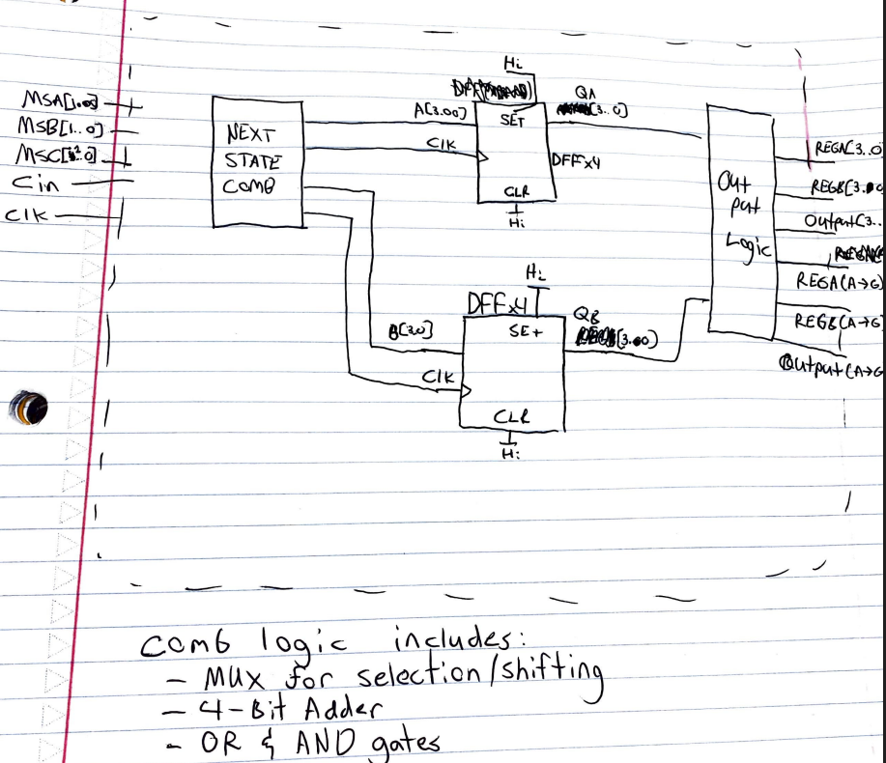
Figure 3: Functional Block Diagram for RALU
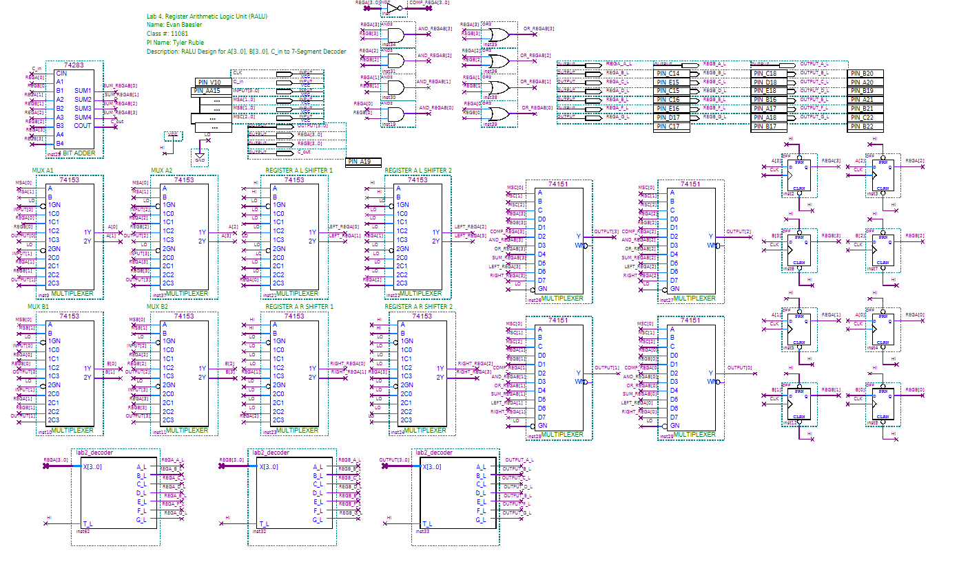
Figure 4: RALU Quartus BDF Design

Table 1: Controls to test all RALU functions.+
MSA | MSB | MSC | Input | Cin | RegA | RegB | Output | RegA+ | RegB+ | Output+ | Cout+ | Description
00 | 10 | 000 | 1010 | 0 | X | X | X | 1010 | X | 1010 | 0 | Load 1010 onto REGA
01 | 00 | 001 | 0011 | 0 | 1010 | X | 1010 | 1010 | 0011 | 0011 | 0 | Load 0011 onto RegB
11 | 10 | 011 | X | 0 | 1010 | 0011 | 0010 | 0010 | 0011 | 0010 | 0 | Bit-wise AND, store in REGA
00 | 10 | 000 | 0001 | 0 | 0010 | 0011 | 0010 | 0001 | 0011 | 0001 | 0 | Load 0001 onto REGA
01 | 00 | 001 | 0110 | 0 | 0001 | 0011 | 0110 | 0001 | 0110 | 0110 | 0 | Load 0110 onto RegB
01 | 11 | 100 | X | 0 | 0001 | 0110 | 0110 | 0001 | 0110 | 0111 | 0 | Bit-wise OR, store in RegB
00 | 10 | 000 | 0101 | 0 | 0001 | 0110 | 0111 | 0101 | 0110 | 0101 | 0 | Load 0101 onto REGA
01 | 11 | 010 | X | 0 | 0101 | 0110 | 0101 | 0101 | 1010 | 1010 | 0 | Comp. REGA and store in RegB
00 | 10 | 000 | 1000 | 0 | 0101 | 1010 | 1010 | 1000 | 1010 | 1000 | 0 | Load 1000 onto REGA
01 | 00 | 001 | 0011 | 0 | 1000 | 1010 | 1000 | 1000 | 0011 | 0011 | 0 | Load 0011 onto RegB
11 | 10 | 101 | X | 0 | 1000 | 0011 | 0011 | 1011 | 0011 | 1011 | 0 | Sum REGA & REGB and store on REGA
00 | 10 | 000 | 0110 | 0 | 1011 | 0011 | 1011 | 0110 | 0011 | 0110 | 0 | Load 0110 onto REGA
01 | 11 | 111 | X | 0 | 0110 | 0011 | 0110 | 0110 | 0011 | 0011 | 0 | Shift REGA to the right and store on REGB
00 | 10 | 110 | 0110 | 0 | 0110 | 0011 | 0011 | 0110 | 1100 | 1100 | 0 | Shift REGA to the left and store on REGB

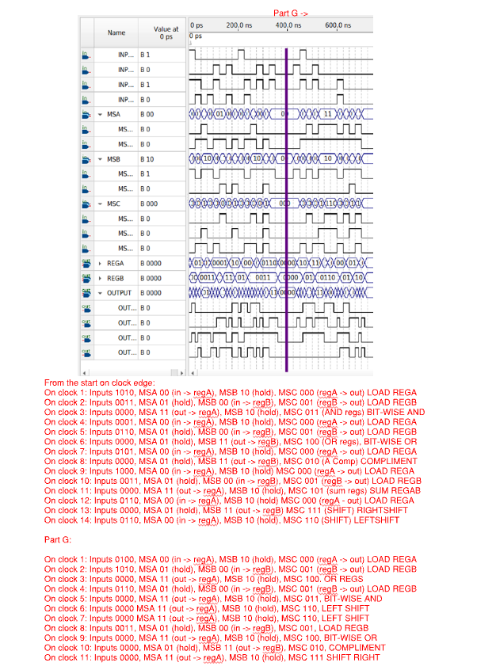
Figure 5: Annotated Quartus RALU Waveform for 4a-g

Table 2: Table for Implementation of Q4g
MSA | MSB | MSC | Input | Cin | RegA | RegB | Output | RegA+ | RegB+ | Output+ | Cout+ | Description
00 | 10 | 000 | 0100 | 0 | X | X | X | 0100 | X | 0100 | 0 | Load 4 to REGA
01 | 00 | 001 | 1010 | 0 | 0100 | X | 0100 | 0100 | 1010 | 1010 | 0 | Load $A to REGB
11 | 10 | 100 | X | 0 | 0100 | 1010 | 1010 | 1110 | 1010 | 1110 | 0 | OR REGA and REGB
01 | 00 | 001 | 0110 | 0 | 1110 | 1010 | 1110 | 1110 | 0110 | 0110 | 0 | Load 6 to REGB
11 | 10 | 011 | X | 0 | 1110 | 0110 | 1110 | 0110 | 0110 | 0110 | 0 | AND REGA and REGB
11 | 10 | 110 | X | 0 | 1110 | 0110 | 0110 | 1100 | 0110 | 1100 | 0 | Shift Left REGA
11 | 10 | 110 | X | 0 | 1100 | 0110 | 1100 | 1000 | 0110 | 1000 | 0 | Shift Left REGA
01 | 00 | 001 | 0011 | 0 | 1000 | 0110 | 1000 | 1000 | 0011 | 0011 | 0 | Load 3 to REGB
11 | 10 | 100 | X | 0 | 1000 | 0011 | 0011 | 1011 | 0011 | 1011 | 0 | OR REGA and REGB
01 | 11 | 010 | X | 0 | 1011 | 0011 | 1011 | 1011 | 0100 | 0100 | 0 | Comp. REGA
11 | 10 | 111 | X | 0 | 1011 | 0100 | 0100 | 0010 | 0100 | 0010 | 0 | Shift Right REGA

PRELAB QUESTIONS:
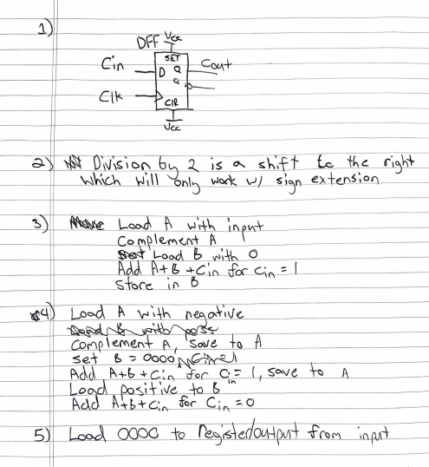
Figure 6: Q1-5 from Prelab Questionsu

