REQUIREMENTS NOT MET
- N/A
VIDEO FILE LINK
https://youtube.com/shorts/t7zGID5FI_g?si=RPE3gLnGu-ci8uR2
PROBLEMS ENCOUNTERED
N/A
FUTURE WORK/APPLICATIONS
A traffic light controller by itself is useful, and can be used to safely allow emergency vehicles through intersections immealyately , we also use VHDL for the first time, which is MUCH faster to design in than a BDF overall. This will allow us to develop counters and more complex logic faster than before.
PRE-LAB QUESTIONS OR EXERCISES
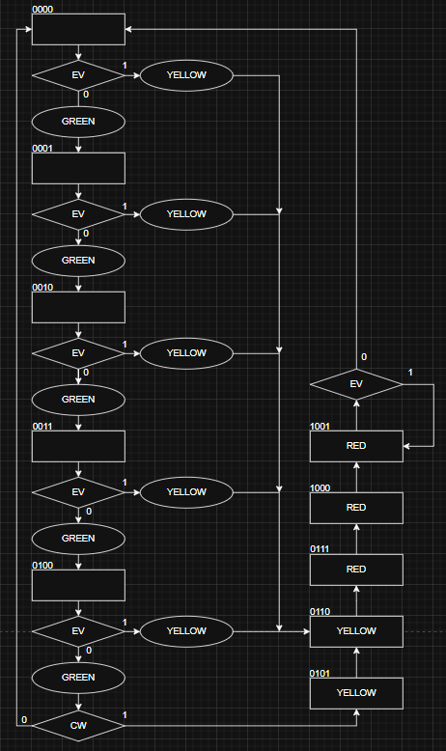
Figure 1: ASM Chart for Traffic Light Controller

Table 1: Truth Table for Traffic Light Controller
EV | CW | Q3 | Q2 | Q1 | Q0 | Q3+ | Q2+ | Q1+ | Q0+ | D3 | D2 | D1 | D0 | RED | YELLOW | GREEN
0 | - | 0 | 0 | 0 | 0 | 0 | 0 | 0 | 1 | 0 | 0 | 0 | 1 | 0 | 0 | 1
0 | - | 0 | 0 | 0 | 1 | 0 | 0 | 1 | 0 | 0 | 0 | 1 | 0 | 0 | 0 | 1
0 | - | 0 | 0 | 1 | 0 | 0 | 0 | 1 | 1 | 0 | 0 | 1 | 1 | 0 | 0 | 1
0 | - | 0 | 0 | 1 | 1 | 0 | 1 | 0 | 0 | 0 | 1 | 0 | 0 | 0 | 0 | 1
0 | 0 | 0 | 1 | 0 | 0 | 0 | 0 | 0 | 0 | 0 | 0 | 0 | 0 | 0 | 0 | 1
0 | - | 0 | 1 | 0 | 1 | 0 | 1 | 1 | 0 | 0 | 1 | 1 | 0 | 0 | 1 | 0
0 | - | 0 | 1 | 1 | 0 | 0 | 1 | 1 | 1 | 0 | 1 | 1 | 1 | 0 | 1 | 0
0 | - | 0 | 1 | 1 | 1 | 1 | 0 | 0 | 0 | 1 | 0 | 0 | 0 | 1 | 0 | 0
0 | - | 1 | 0 | 0 | 0 | 1 | 0 | 0 | 1 | 1 | 0 | 0 | 1 | 1 | 0 | 0
0 | - | 1 | 0 | 0 | 1 | 0 | 0 | 0 | 0 | 0 | 0 | 0 | 0 | 1 | 0 | 0
0 | 1 | 0 | 1 | 0 | 0 | 0 | 1 | 0 | 1 | 0 | 1 | 0 | 1 | 0 | 0 | 1
- | - | 1 | 0 | 1 | - | - | - | - | - | - | - | - | - | 0 | 0 | 0
- | - | 1 | 1 | - | - | - | - | - | - | - | - | - | - | 0 | 0 | 0
1 | - | 0 | 0 | 0 | 0 | 0 | 1 | 1 | 0 | 0 | 1 | 1 | 0 | 0 | 0 | 1
1 | - | 0 | 0 | 0 | 1 | 0 | 1 | 1 | 0 | 0 | 1 | 1 | 0 | 0 | 0 | 1
1 | - | 0 | 0 | 1 | 0 | 0 | 1 | 1 | 0 | 0 | 1 | 1 | 0 | 0 | 0 | 1
1 | - | 0 | 0 | 1 | 1 | 0 | 1 | 1 | 0 | 0 | 1 | 1 | 0 | 0 | 0 | 1
1 | - | 0 | 1 | 0 | 0 | 0 | 1 | 1 | 0 | 0 | 1 | 1 | 0 | 0 | 0 | 1
1 | - | 0 | 1 | 0 | 1 | 0 | 1 | 1 | 0 | 0 | 1 | 1 | 0 | 0 | 1 | 0
1 | - | 0 | 1 | 1 | 0 | 0 | 1 | 1 | 1 | 0 | 1 | 1 | 1 | 0 | 1 | 0
1 | - | 0 | 1 | 1 | 1 | 1 | 0 | 0 | 0 | 1 | 0 | 0 | 0 | 1 | 0 | 0
1 | - | 1 | 0 | 0 | 0 | 1 | 0 | 0 | 1 | 1 | 0 | 0 | 1 | 1 | 0 | 0
1 | - | 1 | 0 | 0 | 1 | 1 | 0 | 0 | 1 | 1 | 0 | 0 | 1 | 1 | 0 | 0
1 | - | 1 | 0 | 1 | - | - | - | - | - | - | - | - | - | 0 | 0 | 0
1 | - | 1 | 1 | - | - | - | - | - | - | - | - | - | - | 0 | 0 | 0

D LOGIC
D3 = (not Q3 * Q2 * Q1 * Q0) + (Q3 * not Q2 * not Q1 * not Q0) + (EV * Q3 * not Q2 * not Q1)
D2 = AC'D' + AC'E' + C'D'EF + C'DE'F + C'DEF' + BC'DE'
= (EV * not Q3 * not Q2) + (EV * not Q3 * not Q1) + (not Q3 * not Q2 * Q1 * Q0) + (not Q3 * Q2 * Q1 * not Q0) + (CW * not Q3 * Q2 * not Q1)
D1 = C'E'F + C'EF' + AC'D' + AC'E’
= (not Q3 * not Q1 * Q0) + (not Q3 * Q1 * not Q0) + (EV * not Q3 * not Q2) + (EV * not Q3 * not Q1)
D0 = A'C'D'F' + A'D'E'F' + C'DEF' + A'BC'F' + ACD'E'
= (not EV * not Q3 * not Q2 * not Q0) + (not EV * not Q2 * not Q1 * not Q0) + (not Q3 * Q2 * Q1 * not Q0) + (not EV * CW * not Q3 * not Q0) + (EV * Q3 * not Q2 * not Q0)
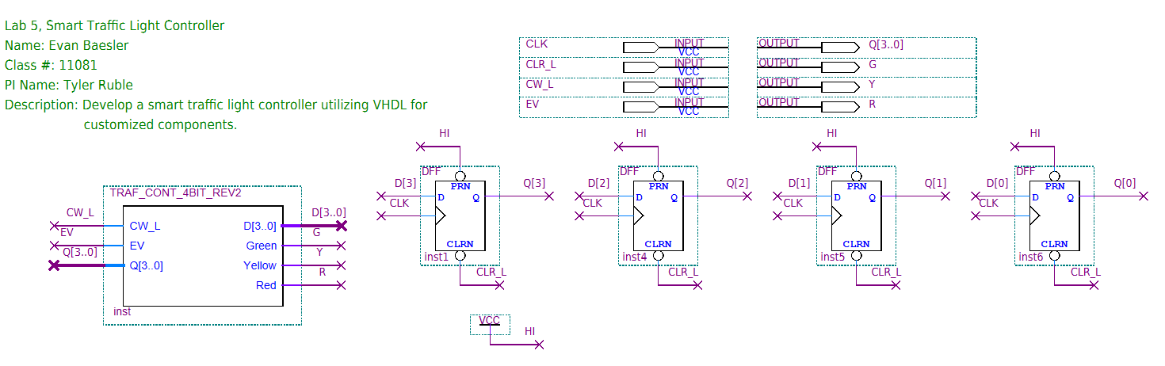
Figure 2: Quartus BDF for Traffic State Controller
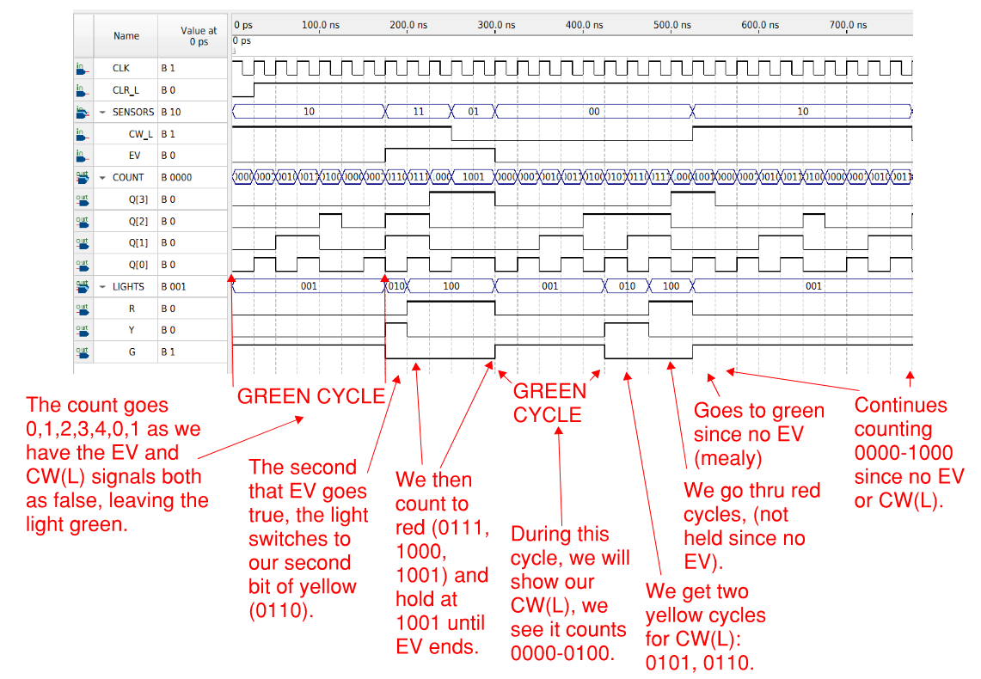
Figure 3: Annotated Simulation of Traffic Controller
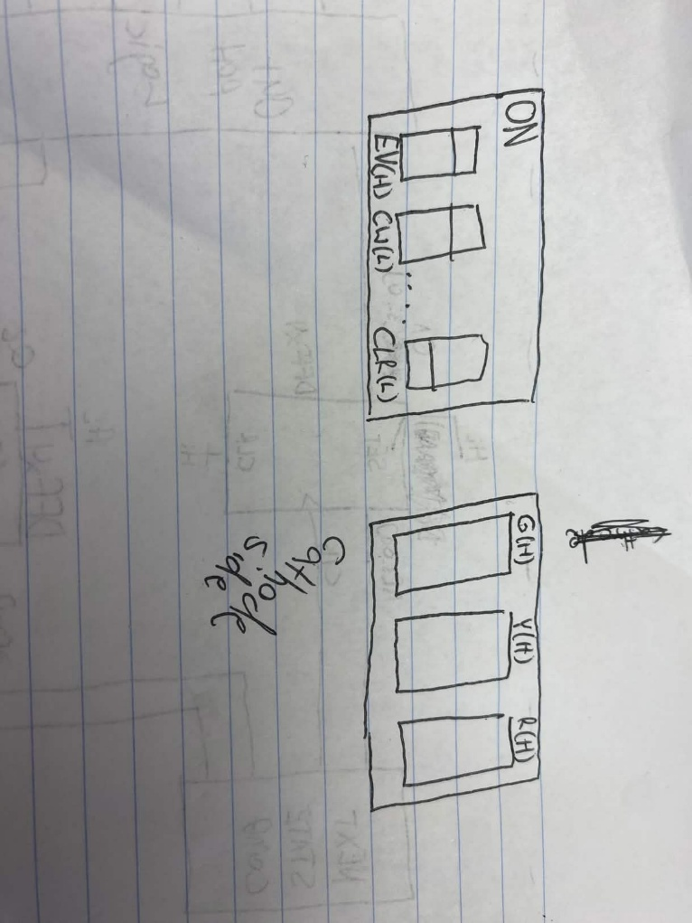
Figure 4: Switch and LED Diagrams

