REQUIREMENTS NOT MET
- N/A
VIDEO FILE LINK
https://youtube.com/shorts/CrQSTtrQYsw?si=2mAoPXEItRjvJJvM
PROBLEMS ENCOUNTERED
N/A
FUTURE WORK/APPLICATIONS
CPU’s are the backbone of microprocessors, and in return computers, automation, and could power all sorts of modern electronics. We could make an automated math loop, create a loop for an LED display, etc.

PRE-LAB PART 1 EXERCISES
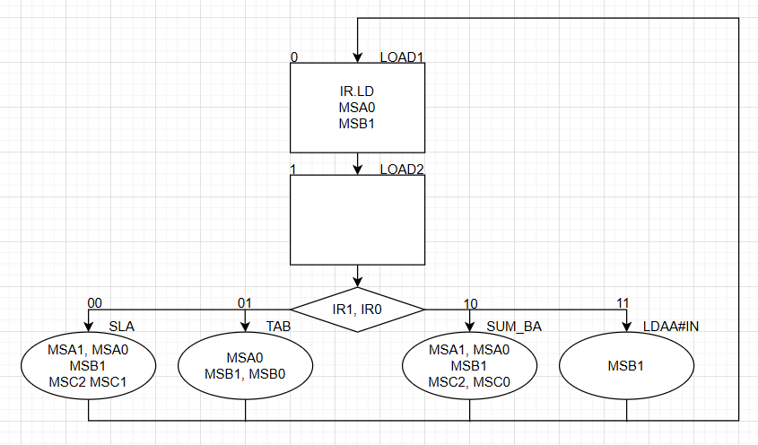
Figure 1: ASM for Lab 6 Part 1
Table 1: NSTT for Quartus CPU Design Part 1
IR[1] | IR[0] | Q | Q+ | MSA[1] | MSA[0] | MSB[1] | MSB[0] | MSC[2] | MSC[1] | MSC[0] | IR.LD
- | - | 0 | 1 | 0 | 1 | 1 | 0 | 0 | 0 | 0 | 1
0 | 0 | 1 | 0 | 1 | 1 | 1 | 0 | 1 | 1 | 0 | 0
0 | 1 | 1 | 0 | 0 | 1 | 1 | 1 | 0 | 0 | 0 | 0
1 | 0 | 1 | 0 | 1 | 1 | 1 | 0 | 1 | 0 | 1 | 0
1 | 1 | 1 | 0 | 0 | 0 | 1 | 0 | 0 | 0 | 0 | 0

Preliminary: Lab 4 reused and slightly modified to remove decoders from BSF (added a TON of messy outputs)
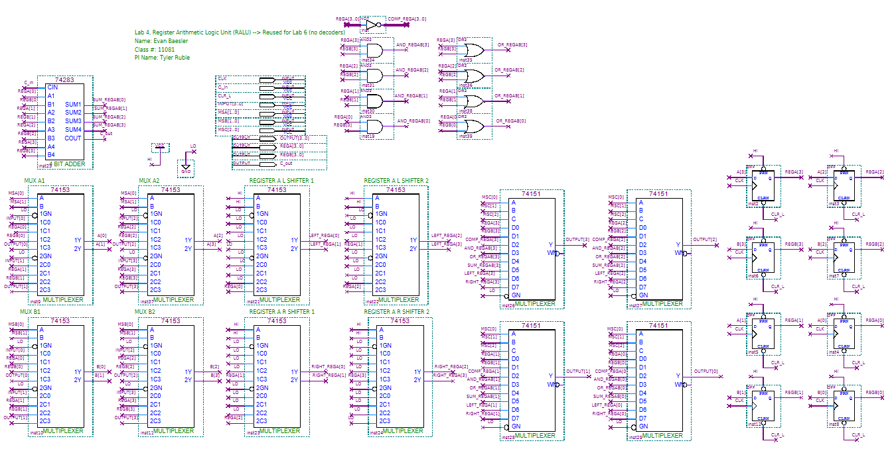
Figure 2: Lab 6 RALU BDF (reused Lab 4)

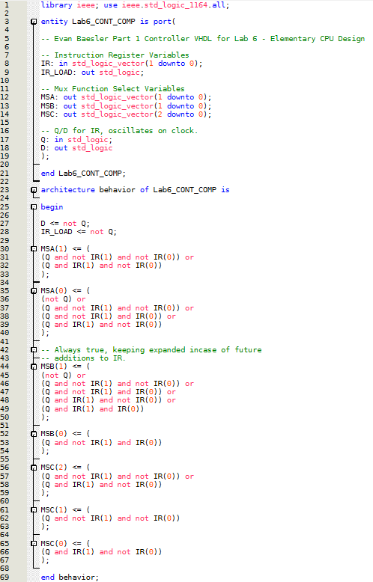
Figure 3: Lab 6 Part 1 Controller VHDL
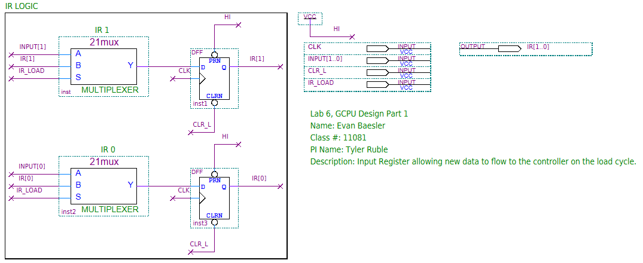
Figure 4: Quartus BDF for Input Register
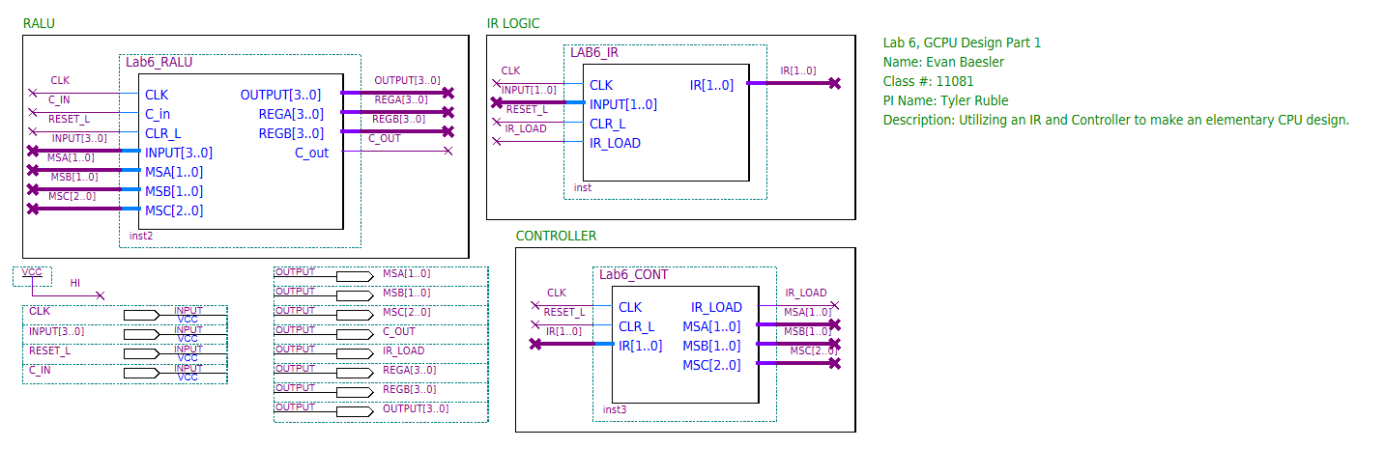
Figure 5: Quartus BDF Schematic for Lab 6 Part 1
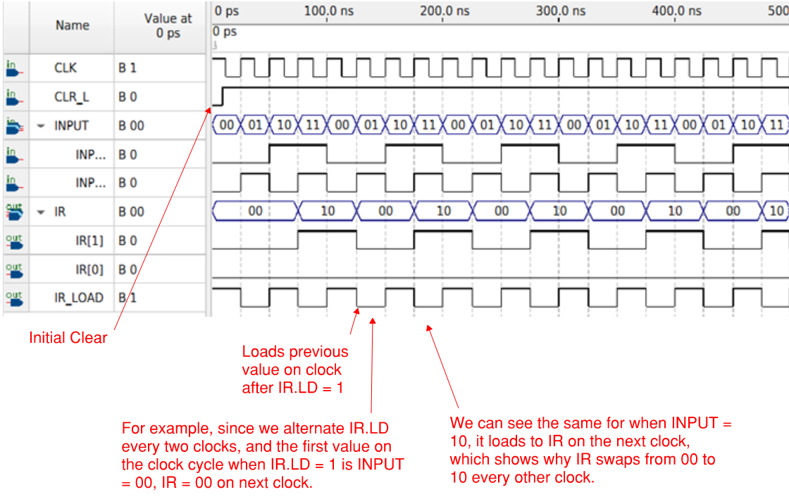
Figure 6: IR.LD Quartus Simulation, showing values being loaded when IR_LOAD is high.

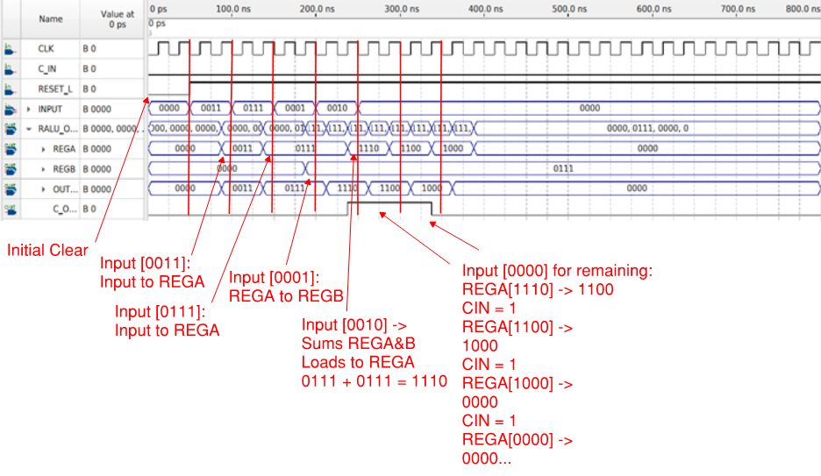
Figure 7: Lab 6 Part 1 - Quartus Waveform Simulation

PRE-LAB PART 1 QUESTIONS
- Why did we require the new instruction register in this design?
  - We use the instruction register to control the input of commands so that they do not interrupt another command before it can be fully executed.
- In this section of the lab, you are setting the INPUT bus by hand. If you wanted to read or fetch this value from memory, what could you add to do this automatically for you every CLK cycle?
  - We would use a program counter and a ROM as done in later in Part 2, which would fetch values from a range of ROM registers and run those through our controller. The program counter iterates while the ROM stores and pushes data.
- How could you add more instructions (i.e., 8 instead of 4) to the controller?
  - By increasing the amount of bits to our input register (4 -> 8, 2 bits -> 3 bits), which would give us more combinations to give to the controller, which gives us more controls.

PRE-LAB PART 2 EXERCISES
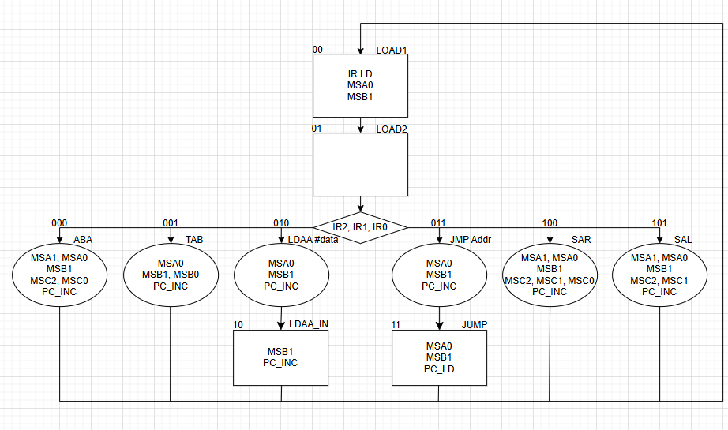
Figure 8: ASM for Lab 6 Part 2

Table 2: NSTT for Lab 6 Part 2
IR2 | IR1 | IR0 | Q1 | Q0 | Q1+ | Q0+ | MSA1 | MSA0 | MSB1 | MSB0 | MSC2 | MSC1 | MSC0 | IR_LD | PC_INC | PC_LD
- | - | - | 0 | 0 | 0 | 1 | 0 | 1 | 1 | 0 | 0 | 0 | 0 | 1 | 0 | 0
0 | 0 | 0 | 0 | 1 | 0 | 0 | 1 | 1 | 1 | 0 | 1 | 0 | 1 | 0 | 1 | 0
- | - | - | 1 | 0 | 0 | 0 | 0 | 0 | 1 | 0 | 0 | 0 | 0 | 0 | 1 | 0
- | - | - | 1 | 1 | 0 | 0 | 0 | 1 | 1 | 0 | 0 | 0 | 0 | 0 | 0 | 1
0 | 0 | 1 | 0 | 1 | 0 | 0 | 0 | 1 | 1 | 1 | 0 | 0 | 0 | 0 | 1 | 0
0 | 1 | 0 | 0 | 1 | 1 | 0 | 0 | 1 | 1 | 0 | 0 | 0 | 0 | 0 | 1 | 0
0 | 1 | 1 | 0 | 1 | 1 | 1 | 0 | 1 | 1 | 0 | 0 | 0 | 0 | 0 | 1 | 0
1 | 0 | 0 | 0 | 1 | 0 | 0 | 1 | 1 | 1 | 0 | 1 | 1 | 1 | 0 | 1 | 0
1 | 0 | 1 | 0 | 1 | 0 | 0 | 1 | 1 | 1 | 0 | 1 | 1 | 0 | 0 | 1 | 0
1 | 1 | 0 | 0 | 1 | X | X | X | X | X | X | X | X | X | X | X | X
1 | 1 | 1 | 0 | 1 | X | X | X | X | X | X | X | X | X | X | X | X

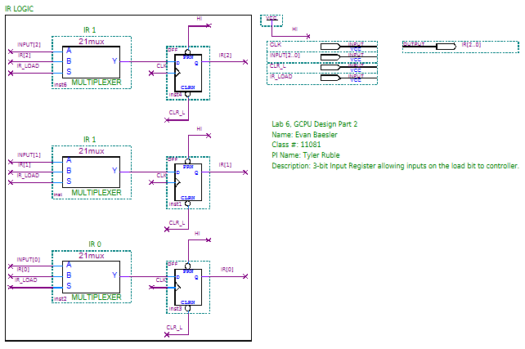
Figure 9: Lab 6 Part 2 3-bit Input Register BDF

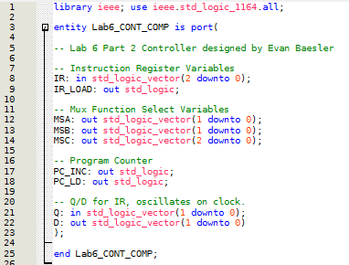
Figure 10: Lab 6 Part 2 Controller VHDL Part 1

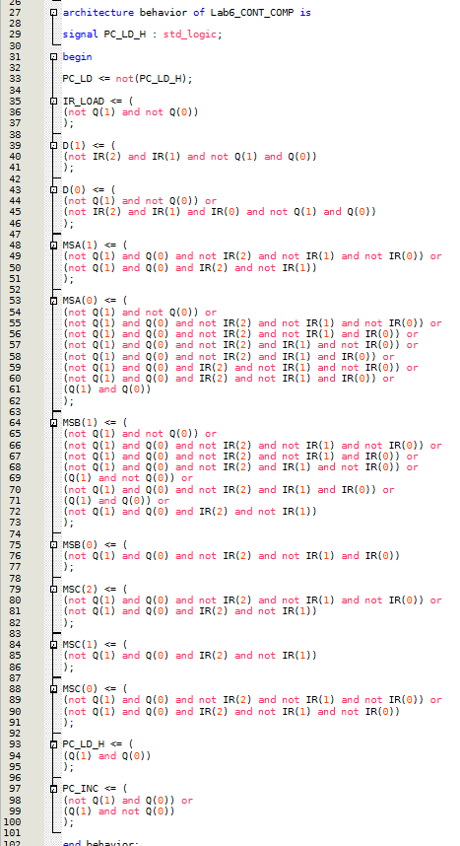
Figure 11: Lab 6 Part 2 Controller VHDL Part 2
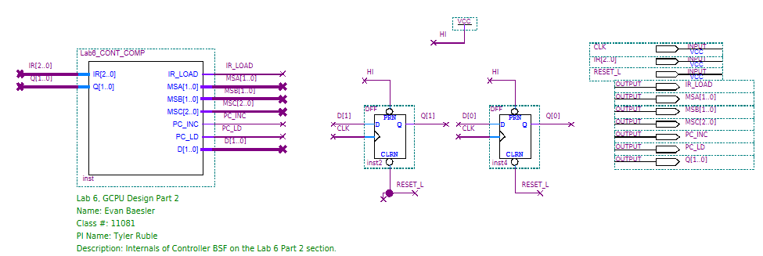
Figure 12: Lab 6 Part 2 Controller Internals BDF
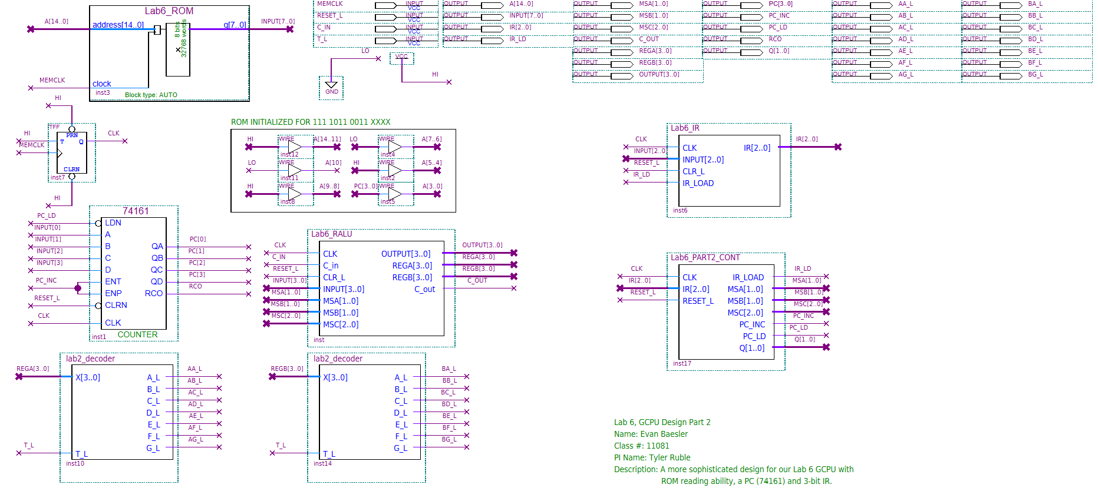
Figure 13: Lab 6 Part 2 CPU BDF utilizing 74161 Program Counter and Quartus .mif ROM

Table 3: Programming Table for ROM .mif
Addr. |  | Mach Codes | A | B | A | B | A | B | A | B
$7B30 | LDAA #3 | 02, 03 | 3 | 0
$7B32 | TAB | 01 | 3 | 3 | 5 | 5 | 2 | 2 | 3 | 3
$7B33 | LDAA #7 | 02, 07 | 7 | 3 | 7 | 5 | 7 | 2 | 7 | 3
$7B35 | ABA | 00 | A | 3 | C | 5 | 9 | 2 | A | 3
$7B36 | SAL | 05 | 4 | 3 | 8 | 5 | 2 | 2 | 4 | 3
$7B37 | SAL | 05 | 8 | 3 | 0 | 5 | 4 | 2 | 8 | 3
$7B38 | ABA | 00 | B | 3 | 5 | 5 | 6 | 2 | B | 3
$7B39 | SAR | 04 | 5 | 3 | 2 | 5 | 3 | 2 | 5 | 3
$7B3A | JMP #2 | 03, 02 | 5 | 3 | 2 | 5 | 3 | 2 | 5 | 3
$7B3C | LDAA #$B | 03, 11
$7B3E | ABA | 00
$...

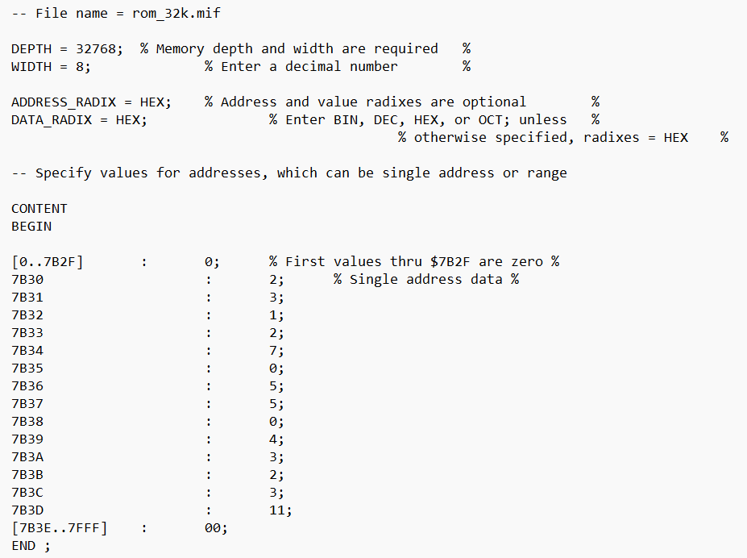
Figure 14: Code from .mif File
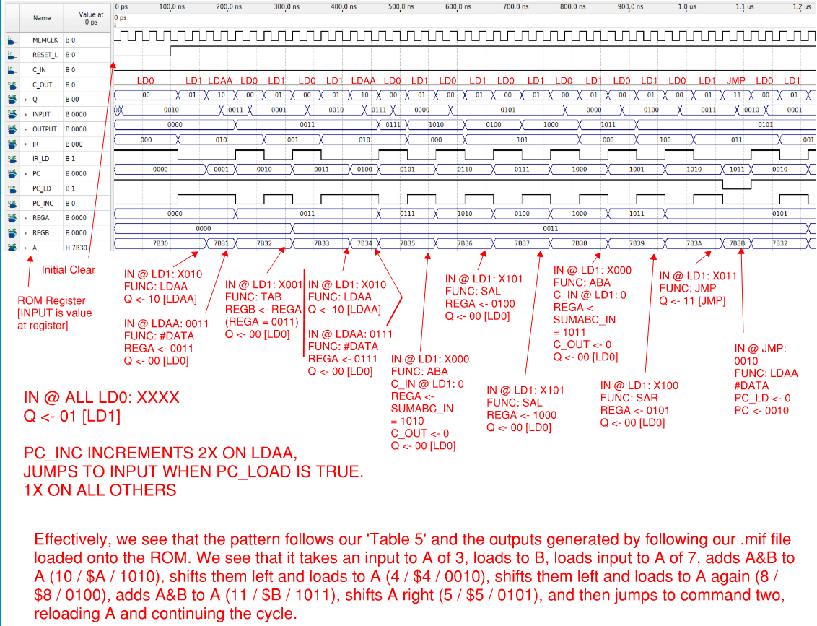
Figure 15: Annotated Quartus Waveform Simulation for Lab 6 Part 2
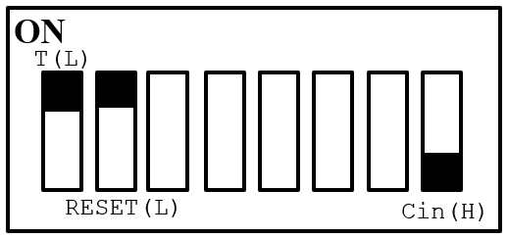
Figure 16: Switch Diagram for Lab 6 Part 2

PRE-LAB PART 2 QUESTIONS
- Why do we need the extra states in the LDAA and JMP instruction paths?
  - One state loads the function, the next loads the data for that function. For LDAA, we first tell the system we are going to load A with a value, then we choose a value to load A with. For JMP, we tell the system we are going to jump, and then we tell it what command to jump to.
- What do you need to do to the address lines to get your program to start at the address $16E0 (instead of $7B30)?
  - For $7B30, we initialized our ROM by converting the hex to binary -> 111 1011 0111 XXXX, where XXXX is set to 0 via reset. To change this we do the same method, which results in 001 0110 1110 XXXX. We set the defined bits to VCC and GND respectively, and set X’s to Reset_L.

