REQUIREMENTS NOT MET
- N/A
VIDEO FILE LINK
https://youtu.be/9NDKh_dyTkw?si=J35rxo81L2_9OJpW
PROBLEMS ENCOUNTERED
- N/A
FUTURE WORK/APPLICATIONS
The biggest thing that this final lab shows is how to start using CPU’s to be more functional, while originally we had to choose mux selects and manually put our inputs with a DAD board, we then added a controller, making it much easier to do a function, and finally we have taken it a step further by allowing EPROM and SRAM to control our inputs, which has taken the process of selecting multiplexers and then input codes to a simple chart of machine codes, allowing s to hand assemble a program.
This lab was actually kind of sick.

PRE-LAB QUESTIONS OR EXERCISES

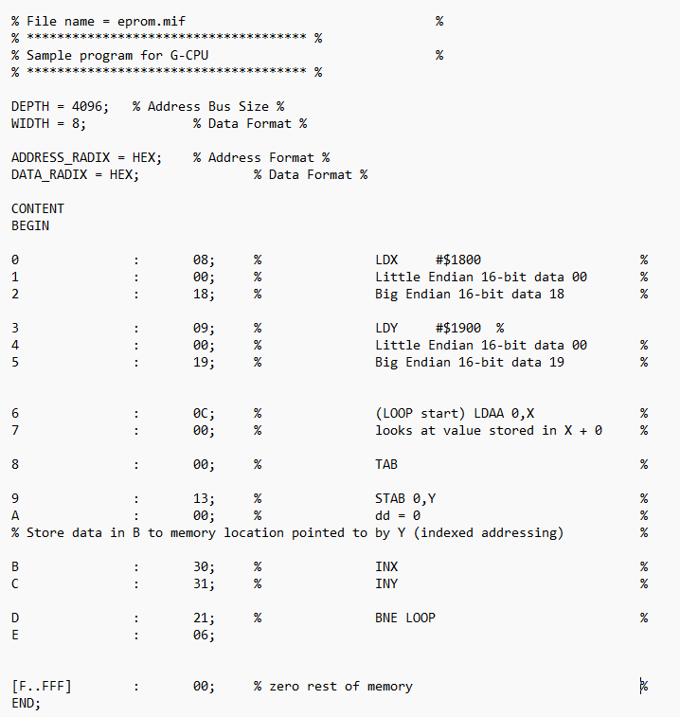
Figure 1: .mif file for Part 1 EPROM.
In our EPROM, we are doing the following:
- Loading the value $1800 to X
- Loading the value $1900 to Y
- Starting a loop
- Loads A with the value in address X + 0 (to X)
- Stores the value in A to B
- Stores the value of B to the address Y + 0 (to Y)
- Increments X & Y, loops if A != 0.
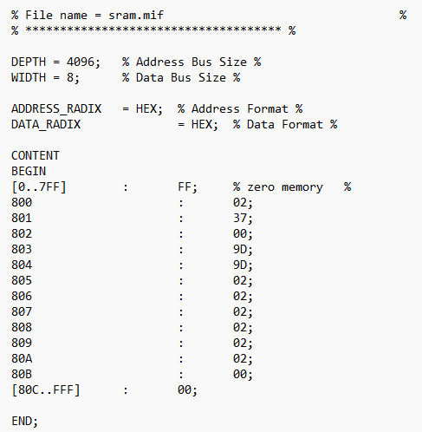
Figure 2: Given SRAM for Part 1.

Table 1: Example Run of Given EPROM and SRAM
Address(es) [$] | Opcodes [$] | Instruction | A [$] | B [$] | X [$] | Y [$] | Z | N | PC [$] | Comments
0000-0002 | 08 00 18 | LDX #$1800 | 00 | 00 | 1800 | 0000 | 1 | 0 | 0003 | Loads 1800 to X
0003-0005 | 09 00 19 | LDY #$1900 | 00 | 00 | 1800 | 1900 | 1 | 0 | 0006 | Loads 1900 to Y
0006-0007 | 0C 00 | LDAA $00, X | 02 | 00 | 1800 | 1900 | 0 | 0 | 0008 | Loads value in SRAM at $800 (02) to A
0008 | 00 | TAB | 02 | 02 | 1800 | 1900 | 0 | 0 | 0009 | Loads value in A to B
0009-000A | 13 00 | STAB $00, Y | 02 | 02 | 1800 | 1900 | 0 | 0 | 000B | Stores register B value to Y at register $1900
000B | 30 | INX | 02 | 02 | 1801 | 1900 | 0 | 0 | 000C | Increments X
000C | 31 | INY | 02 | 02 | 1801 | 1901 | 0 | 0 | 000D | Increments Y
000D-000E | 21 06 | BNE $06 | 02 | 02 | 1801 | 1901 | 0 | 0 | 0006 | Checks if Z = 1, loops if not.
0006-0007 | 0C 00 | LDAA $00, X | 37 | 02 | 1801 | 1901 | 0 | 0 | 0008 | Loads value in SRAM at $801 (37) to A
0008 | 00 | TAB | 37 | 37 | 1801 | 1901 | 0 | 0 | 0009 | Loads value in A to B
0009-000A | 13 00 | STAB $00, Y | 37 | 37 | 1801 | 1901 | 0 | 0 | 000B | Stores register B value to Y at register $1901
000B | 30 | INX | 37 | 37 | 1802 | 1901 | 0 | 0 | 000C | Increments X
000C | 31 | INY | 37 | 37 | 1802 | 1902 | 0 | 0 | 000D | Increments Y
000D-000E | 21 06 | BNE $06 | 37 | 37 | 1802 | 1902 | 0 | 0 | 0006 | Checks if Z = 1, loops if not.
0006-0007 | 0C 00 | LDAA $00, X | 00 | 37 | 1802 | 1902 | 1 | 0 | 0008 | Loads value in SRAM at $802 (00) to A
0008 | 00 | TAB | 00 | 00 | 1802 | 1902 | 1 | 0 | 0009 | Loads value in A to B
0009-000A | 13 00 | STAB $00, Y | 00 | 00 | 1802 | 1902 | 1 | 0 | 000B | Stores register B value to Y at register $1902
000B | 30 | INX | 00 | 00 | 1802 | 1902 | 1 | 0 | 000C | Increments X
000C | 31 | INY | 00 | 00 | 1803 | 1903 | 1 | 0 | 000D | Increments Y
000D-000E | 21 06 | BNE $06 | 00 | 00 | 1803 | 1902 | 1 | 0 | 000F | Checks if Z = 1, branching to 000F (00 for rest)
We can see above that our two flags are Z and N, Z is true when A != 0, and N is true for when A is a negative value. Z starts true but quickly is turned off when we load our data, only becoming true towards the end of our run, which causes the branch to happen (ending the loop.)

Our pattern is as follows: Load value to X/Y, Load value in RAM address X to A, Load A B, Store B to Register in Y, Increment X, Increment Y, Loop back to Load value in RAM Address X to A if A != 0.

Test Runs (ONE FULL LOOP EACH):
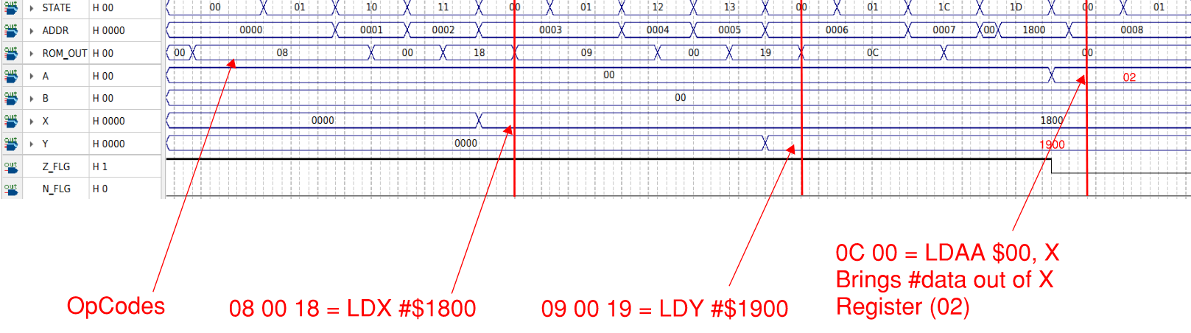
Figure 3: Prefilled EPROM Test Run, one full loop. (PT. 1)
Additional to above notes: We see that as soon as A != 0, Z_FLG 0. We can also see that the negative flag never fires as we do not have any negative numbers.
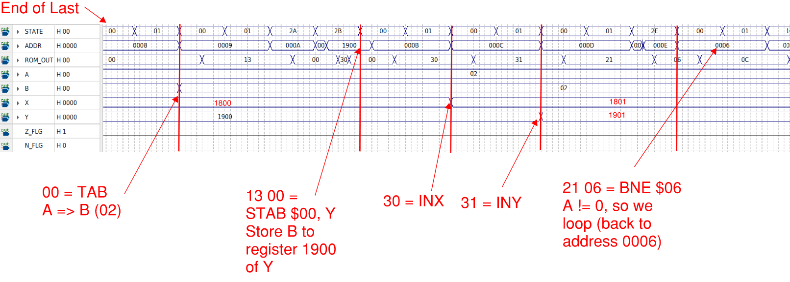
Figure 4: Prefilled EPROM Test Run, one full loop. (PT. 2)

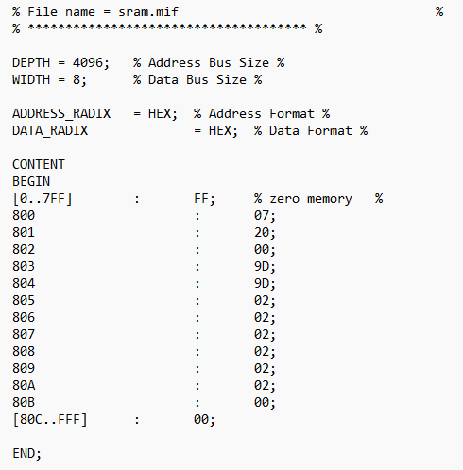
Figure 5: Edited SRAM for Part 1.

Table 2: Example Run of Edited EPROM and SRAM
Address(es) [$] | Opcodes [$] | Instruction | A [$] | B [$] | X [$] | Y [$] | Z | N | PC [$] | Comments
0000-0002 | 08 00 18 | LDX #$1800 | 00 | 00 | 1800 | 0000 | 1 | 0 | 0003 | Loads 1800 to X
0003-0005 | 09 00 19 | LDY #$1900 | 00 | 00 | 1800 | 1900 | 1 | 0 | 0006 | Loads 1900 to Y
0006-0007 | 0C 00 | LDAA $00, X | 07 | 00 | 1800 | 1900 | 0 | 0 | 0008 | Loads value in SRAM at $800 (07) to A
0008 | 00 | TAB | 07 | 07 | 1800 | 1900 | 0 | 0 | 0009 | Loads value in A to B
0009-000A | 13 00 | STAB $00, Y | 07 | 07 | 1800 | 1900 | 0 | 0 | 000B | Stores register B value to Y at register $1900
000B | 30 | INX | 07 | 07 | 1801 | 1900 | 0 | 0 | 000C | Increments X
000C | 31 | INY | 07 | 07 | 1801 | 1901 | 0 | 0 | 000D | Increments Y
000D-000E | 21 06 | BNE $06 | 07 | 07 | 1801 | 1901 | 0 | 0 | 0006 | Checks if Z = 1, loops if not.
0006-0007 | 0C 00 | LDAA $00, X | 20 | 07 | 1801 | 1901 | 0 | 0 | 0008 | Loads value in SRAM at $801 (20) to A
0008 | 00 | TAB | 20 | 20 | 1801 | 1901 | 0 | 0 | 0009 | Loads value in A to B
0009-000A | 13 00 | STAB $00, Y | 20 | 20 | 1801 | 1901 | 0 | 0 | 000B | Stores register B value to Y at register $1901
000B | 30 | INX | 20 | 20 | 1802 | 1901 | 0 | 0 | 000C | Increments X
000C | 31 | INY | 20 | 20 | 1802 | 1902 | 0 | 0 | 000D | Increments Y
000D-000E | 21 06 | BNE $06 | 20 | 20 | 1802 | 1902 | 0 | 0 | 0006 | Checks if Z = 1, loops if not.
0006-0007 | 0C 00 | LDAA $00, X | 00 | 20 | 1802 | 1902 | 1 | 0 | 0008 | Loads value in SRAM at $802 (00) to A
0008 | 00 | TAB | 00 | 00 | 1802 | 1902 | 1 | 0 | 0009 | Loads value in A to B
0009-000A | 13 00 | STAB $00, Y | 00 | 00 | 1802 | 1902 | 1 | 0 | 000B | Stores register B value to Y at register $1902
000B | 30 | INX | 00 | 00 | 1802 | 1902 | 1 | 0 | 000C | Increments X
000C | 31 | INY | 00 | 00 | 1803 | 1903 | 1 | 0 | 000D | Increments Y
000D-000E | 21 06 | BNE $06 | 00 | 00 | 1803 | 1902 | 1 | 0 | 000F | Checks if Z = 1, branching to 000F (00 for rest)

Like before, we see that Z only becomes true for when A = 0, and N stays false as we do not have any negative numbers in A. The only thing that changes are the values which are loaded for each register. I have kept 0 in register 803 to keep similarity between the two runs.

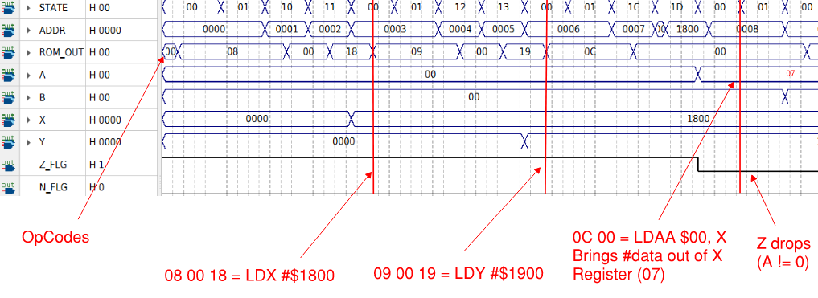
Figure 6: Edited EPROM Test Run, one full loop. (PT. 1)
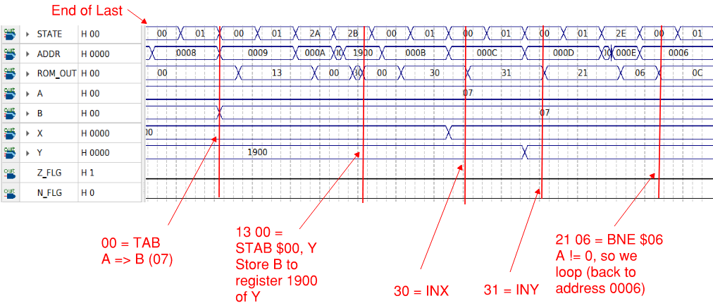
Figure 7: Edited EPROM Test Run, one full loop. (PT. 2)
Here we can see our program still follows the same pattern, but we input different numbers; the SRAM controls the data in/out and the EPROM controls the operation. We can still see that we load the same addresses in X and Y, we load data into A, copy it to B, store the data from B to register 1900 of Y (or the current value of Y for future cycles), increment X & Y, then loop if A != 0.

PART TWO
Table 3: A - B -> Y | Subtraction Loop Program
Address(es) [$] | Opcodes [$] | Instruction | Comments
0000-0002 | 08 4B 1E | LDX #data | Using SRAM to load 1E4B, data to X (table val 1)
0003-0005 | 0B 4B 1E | LDY data | Using SRAM to load 1E4B, data register to Y
0006-0007 | 0C 02 | LDAA 02, X | Loads A with data from register X + 2 (Tab Size)
0008-000A | 06 00 10 | STAA LoopTrack | Stores Tab size to LoopTrack, so we know when to stop.
000B-000C | 02 01 | LDAA #01 | Loads A with the value of 1.
000D-000E | 0E 04 | LDAB 04, X | Loads B with the data at X+4, our first subtraction term.
000F | 1B | COMB | Takes the compliment of B.
0010 | 15 | SUM AB | Adds 1 to the compliment of B (two's comp.), store in B.
0011-0012 | 0C 03 | LDAA 03, X | Loads A with the data at X+3, our first addition term.
0013 | 15 | SUM AB | Adds A & B (A + (-B)), outputs to B
0014-0015 | 13 00 | STAB 00, Y | Stores A to Y
0016 | 31 | INY | Increments Y by 1 (one output term for two inputs)
0017 | 30 | INX | Increments X by 1.
0018 | 30 | INX | Increments X by 1.
0019-001B | 04 00 10 | LDAA LoopTrack | Loads A with our term for counting remaining loops.
001C-001D | 03 FF | LDAB #FF | Loads negative 1 two's comp to B.
001E | 14 | SUM BA | Sums A + B, outputs to A. (LoopTrack - 1)
001F-0021 | 06 00 10 | STAA LoopTrack | Stores new LoopTrack to A
0022-0023 | 21 0B | BNE Loop | If A != 0, we continue our loop.
0024-0025 | 20 24 | BEQ Done | If A = 0, we break/branch.

Table 4: Hand-assembled Subtraction Program
Address(es) [$] | Opcodes [$] | Instruction | A [$] | B [$] | X [$] | Y [$] | Z | N | PC [$] | Comments
0000-0002 | 08 4B 1E | LDX #data | 00 | 00 | 1E4B | 0000 | 1 | 0 | 0003 | 1E4B data to X
0003-0005 | 0B 4B 1E | LDY data | 00 | 00 | 1E4B | 1A57 | 1 | 0 | 0006 | 1E4B register to Y
0006-0007 | 0C 02 | LDAA 02, X | 03 | 00 | 1E4B | 1A57 | 0 | 0 | 0008 | Loads A with tab size
0008-000A | 06 00 10 | STAA LoopTrack | 03 | 00 | 1E4B | 1A57 | 0 | 0 | 0009 | Stores tab size to LoopTrack
000B-000C | 02 01 | LDAA #01 | 01 | 00 | 1E4B | 1A57 | 0 | 0 | 000B | Loads A with the value of 1.
000D-000E | 0E 04 | LDAB 04, X | 01 | 0F | 1E4B | 1A57 | 0 | 0 | 000C | Loads B with first subtraction term.
000F | 1B | COMB | 01 | F0 | 1E4B | 1A57 | 0 | 0 | 000D | Takes the compliment of B.
0010 | 15 | SUM AB | 01 | F1 | 1E4B | 1A57 | 0 | 0 | 0006 | Stores two's comp in B.
0011-0012 | 0C 03 | LDAA 03, X | FF | F1 | 1E4B | 1A57 | 0 | 0 | 0008 | Loads A with first addition term.
0013 | 15 | SUM AB | FF | F0 | 1E4B | 1A57 | 0 | 0 | 0009 | Outputs two's comp to B.
0014-0015 | 13 00 | STAB 00, Y | FF | F0 | 1E4B | 1A57 | 0 | 0 | 000B | Stores B to Y.
0016 | 31 | INY | FF | F0 | 1E4B | 1A58 | 0 | 0 | 000C | Increments Y by 1.
0017 | 30 | INX | FF | F0 | 1E4C | 1A58 | 0 | 0 | 000D | Increments X by 1.
0018 | 30 | INX | FF | F0 | 1E4D | 1A58 | 0 | 0 | 0006 | Increments X by 1.
0019-001B | 04 00 10 | LDAA LoopTrack | 03 | F0 | 1E4D | 1A58 | 1 | 0 | 0008 | Loads A with LoopTrack.
001C-001D | 03 FF | LDAB #FF | 03 | FF | 1E4D | 1A58 | 1 | 0 | 0009 | Loads -1's 2-comp to B.
001E | 14 | SUM BA | 02 | FF | 1E4D | 1A58 | 1 | 0 | 000B | Finds Looptrack - 1
001F-0021 | 06 00 10 | STAA LoopTrack | 02 | FF | 1E4D | 1A58 | 1 | 0 | 000C | Stores LoopTrack to A
0022-0023 | 21 0B | BNE Loop | 02 | FF | 1E4D | 1A58 | 1 | 0 | 000D | Loop (A != 0)
000B-000C | 02 01 | LDAA #01 | 01 | FF | 1E4D | 1A58 | 0 | 0 | 000B | Loads A with 1.
000D-000E | 0E 04 | LDAB 04, X | 01 | 03 | 1E4D | 1A58 | 0 | 0 | 000C | Loads B with second subtraction term.
000F | 1B | COMB | 01 | FC | 1E4D | 1A58 | 0 | 0 | 000D | Takes the compliment of B.
0010 | 15 | SUM AB | 01 | FD | 1E4D | 1A58 | 0 | 0 | 0006 | Stores two's comp in B.
0011-0012 | 0C 03 | LDAA 03, X | 0A | FD | 1E4D | 1A58 | 0 | 0 | 0008 | Loads A with second addition term.
0013 | 15 | SUM AB | 0A | 07 | 1E4D | 1A58 | 0 | 0 | 0009 | Stores two's comp in B.
0014-0015 | 13 00 | STAB 00, Y | 0A | 07 | 1E4D | 1A58 | 0 | 0 | 000B | Stores B to Y.
0016 | 31 | INY | 0A | 07 | 1E4D | 1A59 | 0 | 0 | 000C | Increments Y by 1.
0017 | 30 | INX | 0A | 07 | 1E4E | 1A59 | 0 | 0 | 000D | Increments X by 1.
0018 | 30 | INX | 0A | 07 | 1E4F | 1A59 | 0 | 0 | 0006 | Increments X by 1.
0019-001B | 04 00 10 | LDAA LoopTrack | 02 | 07 | 1E4F | 1A59 | 1 | 0 | 0008 | Loads A with LoopTrack.
001C-001D | 03 FF | LDAB #FF | 02 | FF | 1E4F | 1A59 | 1 | 0 | 0009 | Loads -1 2's comp to B.
001E | 14 | SUM BA | 01 | FF | 1E4F | 1A59 | 1 | 0 | 000B | Finds Looptrack - 1
001F-0021 | 06 00 10 | STAA LoopTrack | 01 | FF | 1E4F | 1A59 | 1 | 0 | 000C | Stores new LoopTrack
0022-0023 | 21 0B | BNE Loop | 01 | FF | 1E4F | 1A59 | 1 | 0 | 000D | Loop (A != 0)
000B-000C | 02 01 | LDAA #01 | 01 | FF | 1E4F | 1A59 | 0 | 0 | 000B | Loads A = 1
000D-000E | 0E 04 | LDAB 04, X | 01 | 04 | 1E4F | 1A59 | 0 | 0 | 000C | Loads B with third subtraction term.
000F | 1B | COMB | 01 | FB | 1E4F | 1A59 | 0 | 0 | 000D | Takes the compliment of B.
0010 | 15 | SUM AB | 01 | FC | 1E4F | 1A59 | 0 | 0 | 0006 | Stores two's comp in B.
0011-0012 | 0C 03 | LDAA 03, X | 05 | FC | 1E4F | 1A59 | 0 | 0 | 0008 | Loads A with third addition term.
0013 | 15 | SUM AB | 05 | 01 | 1E4F | 1A59 | 0 | 0 | 0009 | Stores two's comp in B.
0014-0015 | 13 00 | STAB 00, Y | 05 | 01 | 1E4F | 1A59 | 0 | 0 | 000B | Stores B to Y.
0016 | 31 | INY | 05 | 01 | 1E4F | 1A5A | 0 | 0 | 000C | Increments Y by 1.
0017 | 30 | INX | 05 | 01 | 1E50 | 1A59 | 0 | 0 | 000D | Increments X by 1.
0018 | 30 | INX | 05 | 01 | 1E51 | 1A59 | 0 | 0 | 0006 | Increments X by 1.
0019-001B | 04 00 10 | LDAA LoopTrack | 01 | 01 | 1E51 | 1A59 | 1 | 0 | 0008 | Loads A with LoopTrack.
001C-001D | 03 FF | LDAB #FF | 01 | FF | 1E51 | 1A59 | 1 | 0 | 0009 | Loads -1 2's comp to B.
001E | 14 | SUM BA | 00 | FF | 1E51 | 1A59 | 1 | 0 | 000B | Finds Looptrack - 1
001F-0021 | 06 00 10 | STAA LoopTrack | 00 | FF | 1E51 | 1A59 | 1 | 0 | 000C | Stores new LoopTrack
0022-0023 | 21 0B | BNE Loop | 00 | FF | 1E51 | 1A59 | 1 | 0 | 000D | A = 0, no loop.
0024-0025 | 20 24 | BEQ Done | 00 | FF | 1E51 | 1A59 | 1 | 0 | 000F | If A = 0, we break/branch.

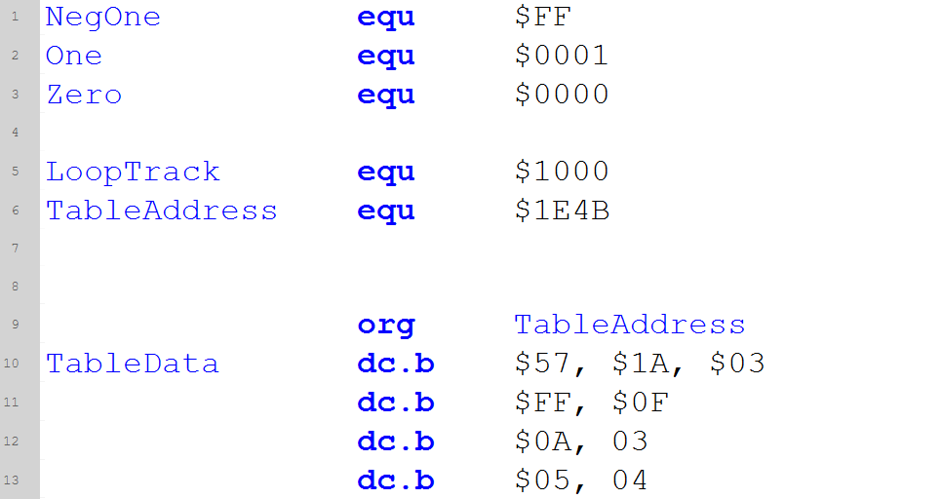
Figure 8: G-IDE Assembly Part 1
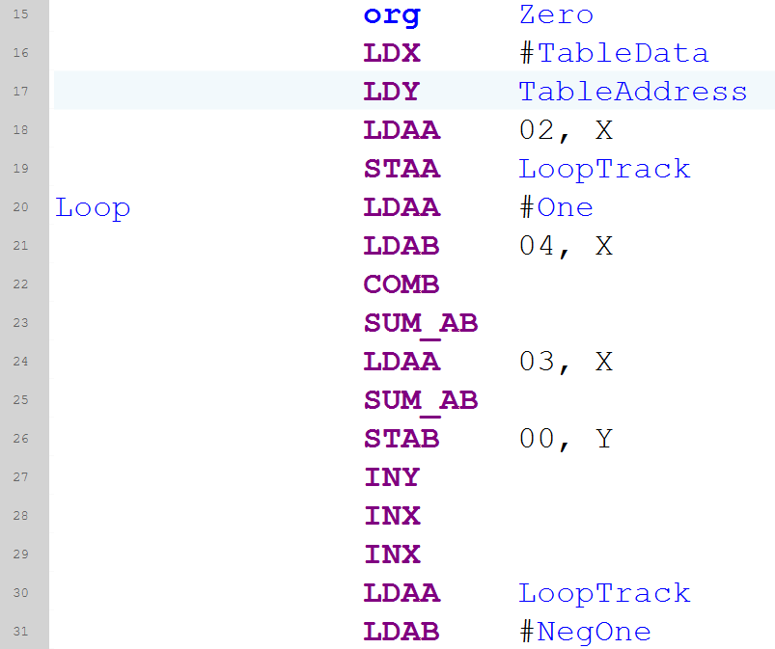
Figure 9: G-IDE Assembly Part 2
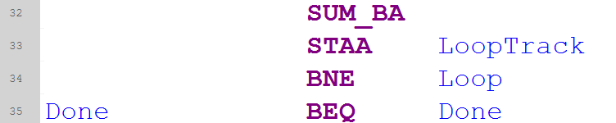
Figure 10: G-IDE Assembly Part 3

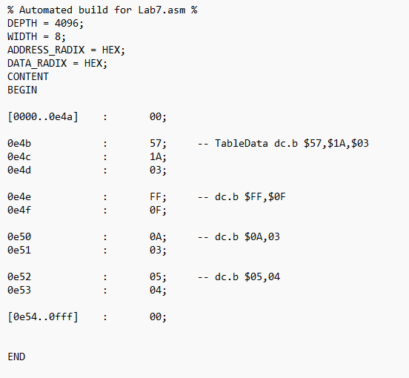
Figure 11: RAM .mif

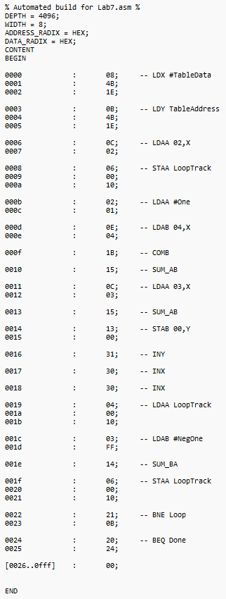
Figure 12: ROM .mif
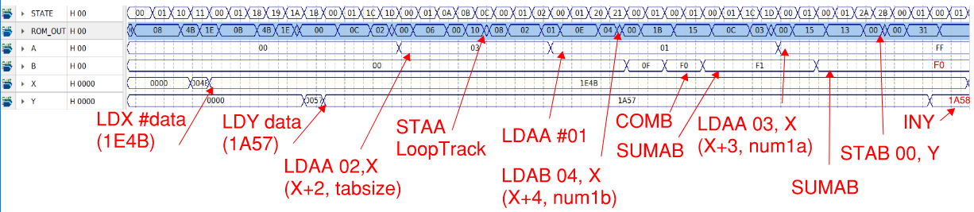
Figure 13: Quartus Waveform for EPROM and SRAM (Pt. 1)
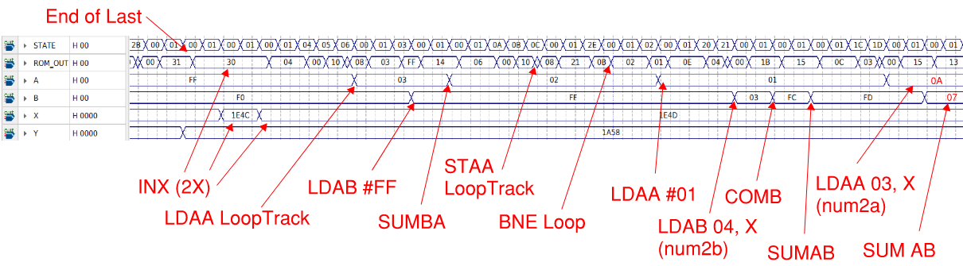
Figure 14: Quartus Waveform for EPROM and SRAM (Pt. 2)
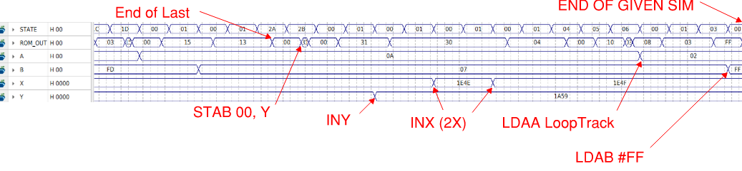
Figure 15: Quartus Waveform for EPROM and SRAM (Pt. 3)
Additional Annotations on next page.

Annotations
For our data, we can see we follow our pattern from the table:
- We load X with our data address (X -> 1E4B)
- We load the data in the address to Y (Y -> 1A57)
- We load X with the data offset by 2, which is our third value in the table: TabSize, this keeps track of how many times we will be looping, we will decrement after each successful loop.
- STAA LoopTrack stores the value in A to the variable LoopTrack
- LDAA #01 loads A with 1, so that we can make the twos complement of B
- LDAB 04, X takes num1b from the table and loads it to B.
- COMB takes the complement of B
- SUMAB adds 1 to the complement, completing the two’s complement of B.
- LDAA 03, X then loads A with num1a, so that we can do our subtraction.
- SUMAB does the addition of A + -B
- STAB 00, Y stores the output to the current Y register.
- INY increments Y
- INX increments X, we do this twice as we have numXa and numXb, so we need two input inc. per output inc.
- LDAA LoopTrack loads LoopTrack to A.
- LDAB #FF loads the twos complement of 1 so we can decrement LoopTrack
- SUMBA decrements LoopTrack and stores it to A
- STAA LoopTrack stores the decremented LoopTrack
- BNE Loop loops when LoopTrack != 0
- LDAA #01 loads 1 to A
- LDAB 04, X loads num2b to B
- COMB finds the complement of B
- SUMAB completes the two’s complement of B and stores it to B
- LDAA 03, X loads num2a and stores it to A
- SUM AB completes term two subtraction.
- STAB 00, Y stores the second output to the new Y (original Y + 1)
- INY increments Y
- INX x2 increments X twice
- LDAA LoopTrack loads looptrack to A
- LDAB #FF loads the two’s complement of 1 to B.
- Given simulation ends at 20 us.

