REQUIREMENTS NOT MET
N/A
PROBLEMS ENCOUNTER`ED
N/A
FUTURE WORK/APPLICATIONS
DO THIS SECTION
PRE-LAB EXERCISES
- Which configuration register allows the utilization of a subset of I/O port pins to be configured as inputs (without affecting other pins)? Which configuration register allowed the utilization of a subset of I/O port pins to be configured as an output (without affecting other pins)?
- What is the purpose of the SET/CLR/TGL variants of the DIR and OUT registers?
- Which I/O ports are utilized for the DIP switches and LEDs on the OOTB Switch & LED Backpack?
- Are the LEDs on the OOTB Switch & LED Backpack active-high, or active-low? Draw a schematic diagram for a single LED circuit with the same activation level used on the backpack, as well as one with the opposite activation level. Also, draw a schematic diagram for a single-pole, single-throw (SPST) switch circuit, using the same pull-up or pull-down resistor condition utilized on the backpack, as well as another switch circuit using the opposite configuration.
- Would it be possible to interface the OOTB µPAD with an external input device consisting of 22 inputs? If so, describe how many I/O ports would be necessary. If not, explain why.
PSEUDOCODE/FLOWCHARTS

PROGRAM CODE

APPENDIX

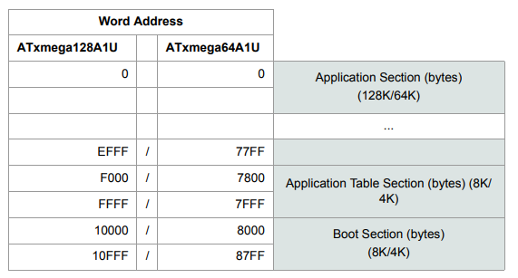
Figure 3: Program Memory Addressing

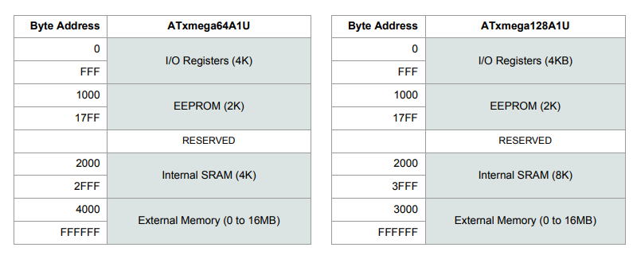
Figure 4: Data Memory Addressing

