The PT Spot

Evan Bell

UMKC
Revision History
(see repository)

Vision Statement
The PT Spot is designed to meet the needs of two groups: trainers seeking to market their services and individuals looking for a personal trainer. Users will be able to select a trainer reviewed by current and past clients. Trainers will be able to describe specific aspects of their services, which will also simplify the matching process. Our free web site and mobile application makes the PT Spot the most efficient and effective way for personal trainers and potential clients to find each other.

Requirements

Step #1: Identify Categories of Users
Trainers – Individuals who provide personal fitness training services.
Seekers – Individuals who are seeking a personal trainer to fit their fitness needs and goals

Step #2: Create Actor-Goal List
Actor | Goal
Trainer | Create a unique personal profile page that showcases their strengths as a personal trainer
 | Upload photos, describe services
 | Obtain multiple good standing reviews
Seeker | Search for a personal trainer
 | Search by name or location, sort results by category
 | Review a trainer
 | Search by name or location, sort results by category

Step #3: Identify User Stories
As a seeker I want to find a trainer that fits my needs and goals

Allow seeker to search for trainers in their area
Estimated Effort: 30 Story Points
Give seekers the option to either give us access to use their location, or search by zip code

Allow seeker to search for personal trainers that fits their budget
Estimated Effort: 5 Story Points

Give seekers the options to specify a price range to filter the results of personal trainers.

Allow seeker to search for trainers that fit their fitness goals
Estimated Effort: 7 Story Points
Give seekers the option to enter their fitness goal to filter results of personal trainers.

Allow seeker to find out what other people think about a particular trainer
Estimated Effort: 10 Story Points
Give seekers the option to see reviews of a particular trainer, as well as write their own reviews.

As a trainer I want an easy and affordable way to get my name out to potential clients

Allow trainer to edit profile
Estimated Effort: 8 Story Points
Give trainers the option to upload their own photos, and create a unique description about themselves

Allow trainer to market themselves to clients
Estimated Effort: 10 Story Points
Give trainers a unique URL that they can refer their clients and potential clients

Product Backlog
Story ID | Story | Story Points | Priority | Status
S1 | Allow seeker to search for trainer in their area | 15 | 5
S2 | Allow seeker to search for personal trainers that fits their budget | 5 | 4
S3 | Allow seeker to search for trainer that fits their fitness goals | 7 | 3
S4 | Allow seeker to find out what other people think about a particular trainer | 10 | 4
S5 | Allow trainer to market themselves to clients | 6 | 4
S6 | Allow trainer to edit profile | 5 | 2
S7 | Register trainers | 15 |  | Completed  9/25/2015
S8 | Register Seekers | 3 | 1
S9 | Set up workflow for continuous integration | 5 |  | Completed  10/11/2015
S10 | Log in/ Log out with OAuth 2.0 | 15 |  | Completed 11/22/2015
S11 | Allow Seekers to leave a review for a trainer | 5 | 3
S12 | Allow seekers to view a list of trainers | 10 | 1

Sprint #1
Story ID | Story / Task | Estimated  Hours | Actual  Hours
S7 | Design registration form | 1 | Not completed
 | Design trainer profile page | 4 | Not completed
 | Implement registration process | 7 | 10
 | Implement log in process | 2 | Not completed
 | Design UI | 1 | Not completed

Sprint #1 Review
Google App Engine Instance
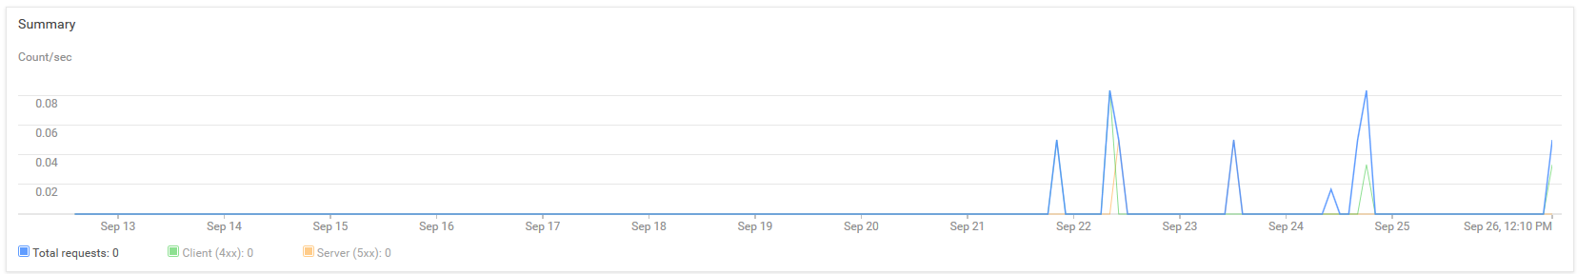
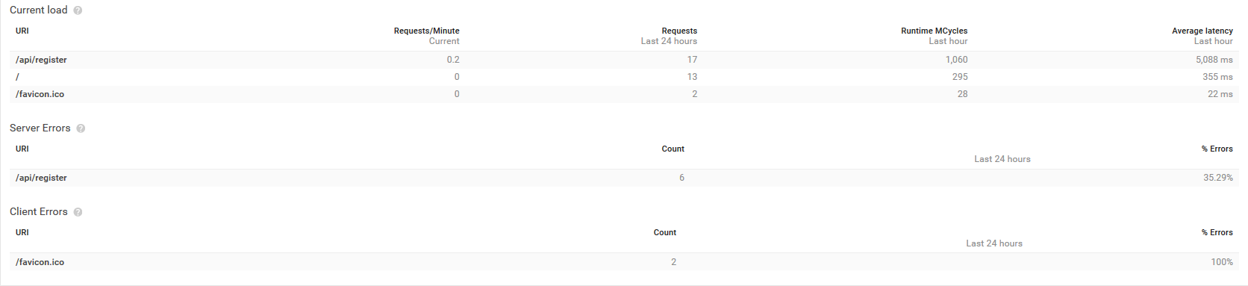
Google Compute Engine VM instance
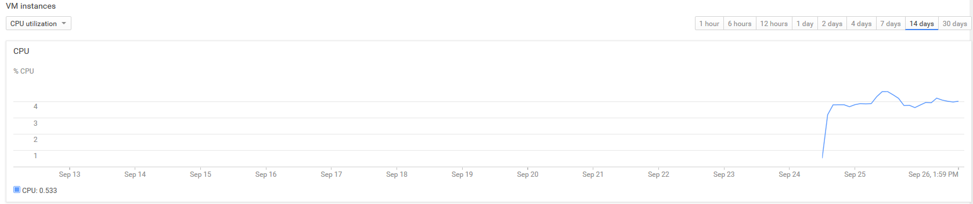
Registration Form (Bootstrap)
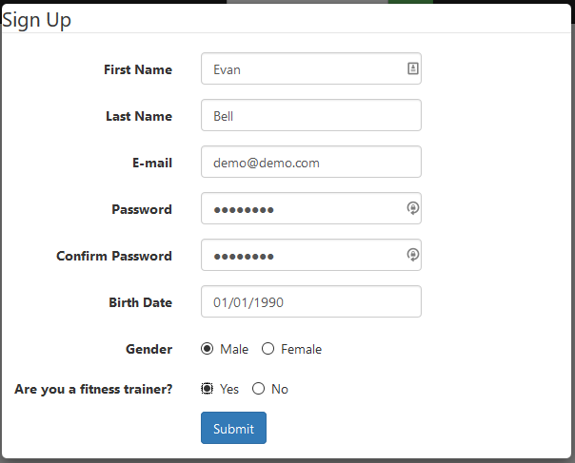
Post Variables
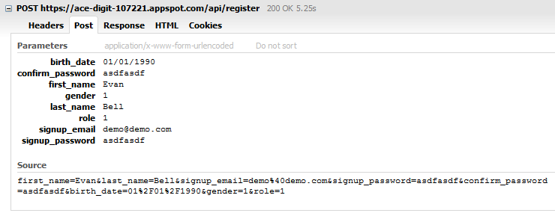

Iteration #1 Retrospective
I failed to consider the set up work I needed to do before I even started to implement the tasks needed to complete S7. Most of the time I spent these past two weeks (15 hours) was figuring out how to configure my project to deploy to Google App Engine (GAE). I found a tool called Code Ship that automatically builds and deploys my application to GAE. I got it to work, but it only allows me 100 free builds a month. It turns out that this is not enough. So, I will have to figure out how to configure an open source tool called Jenkins that will effectively do the same thing as Code Ship but for free.
Project Velocity: 15
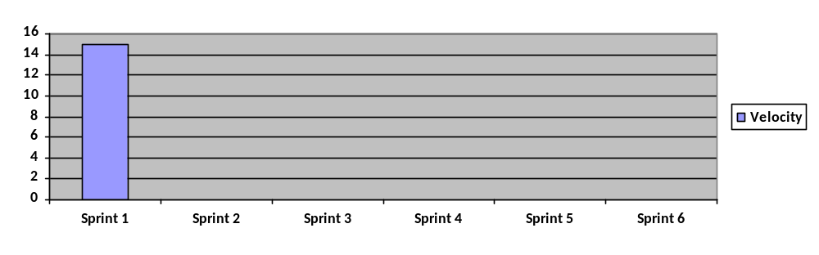

Sprint #2

Story ID | Story / Task | Estimated  Hours | Actual  Hours
S9 | Learn about Jenkins | 1 | 5
 | Go through Google’s instructions on how to set up Jenkins | 1 | 10
 | Test Jenkins by building and deploying my code to Google App Engine | 3 | 10
S7, S8 | Design registration form on Android Studio | 2 | 3
S8 | Connect Android app to API hosted on Google App Engine | 10 | Not Completed

Sprint #2 Review
Set up custom domain name

Set up 3 virtual servers hosted on Digital Ocean
- Ptspot-main is the main app server. This contains all the code that deploys to www.theptspot.com
- Jenkins is a tool used for continuous integration.
- Ptspot-database is the database server.
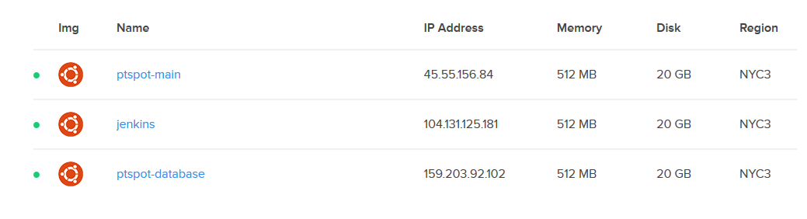
More on Jenkins…
This is the code that is cloned from my repository in Jenkins.
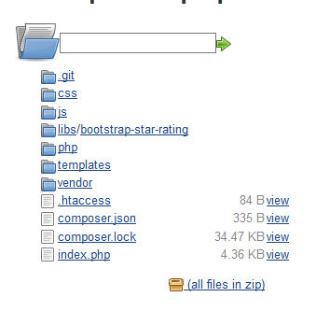
Every time I push to my BitBucket Repository, Jenkins will detect that a change has been made and update the code in the workspace
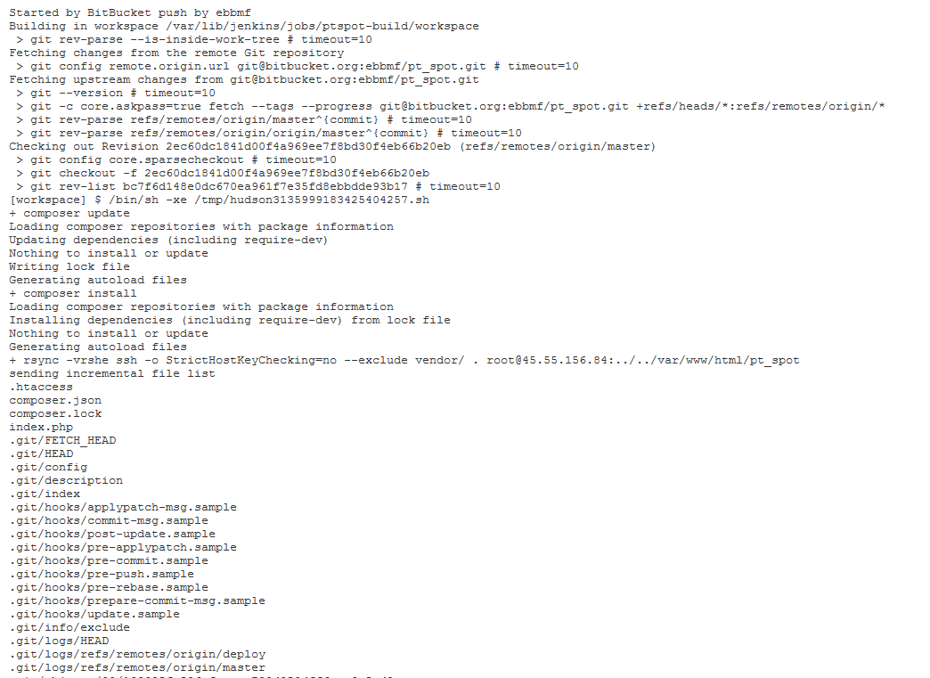
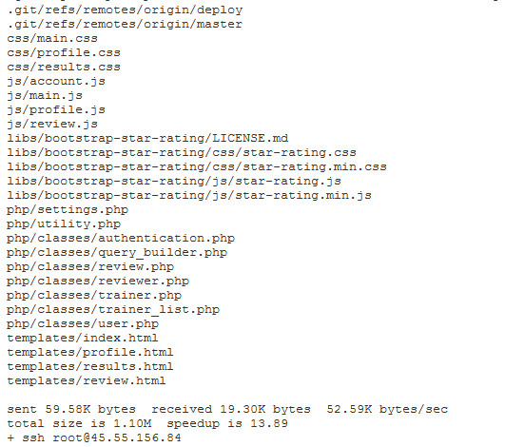
Notice the last command “ssh root@45.55.156.84”. Once the workspace is updated Jenkins ssh’s into the main app server. It updates the code in its workspace and installs dependencies.
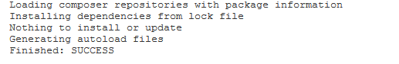

Android App Interface
Register
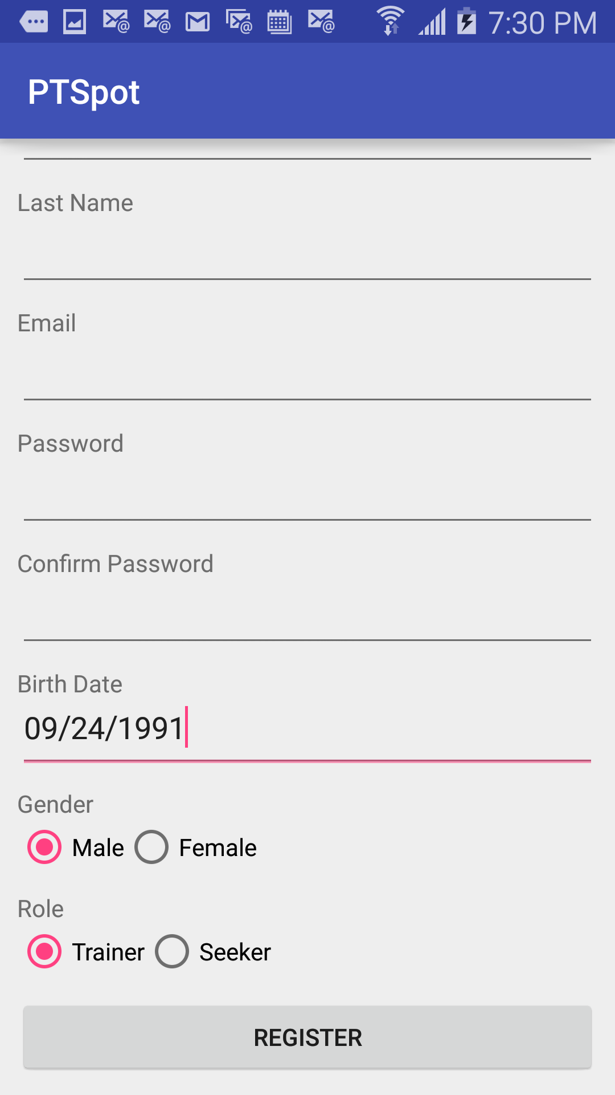

Login
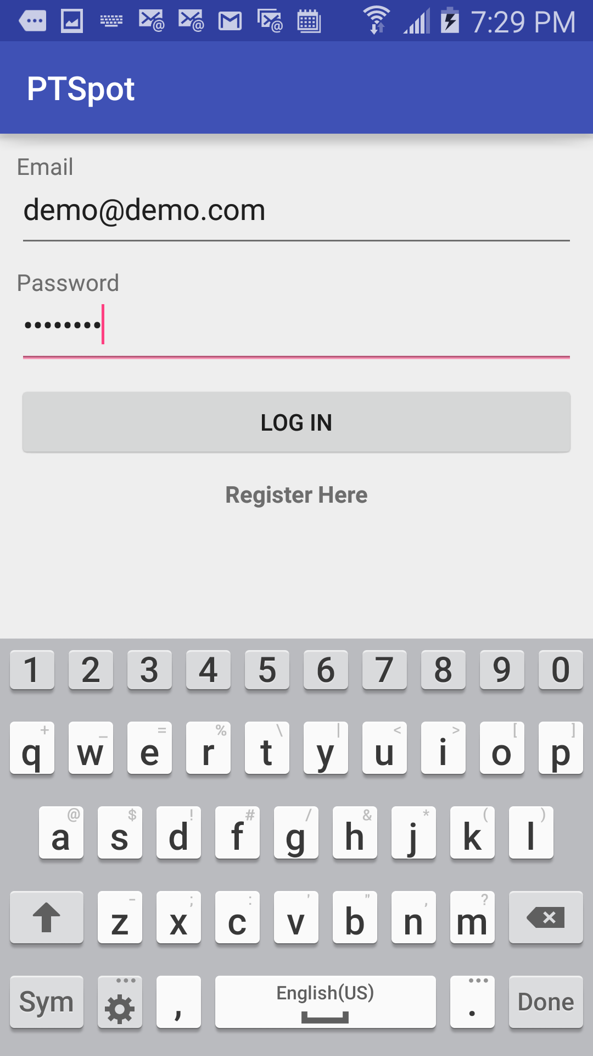

Profile
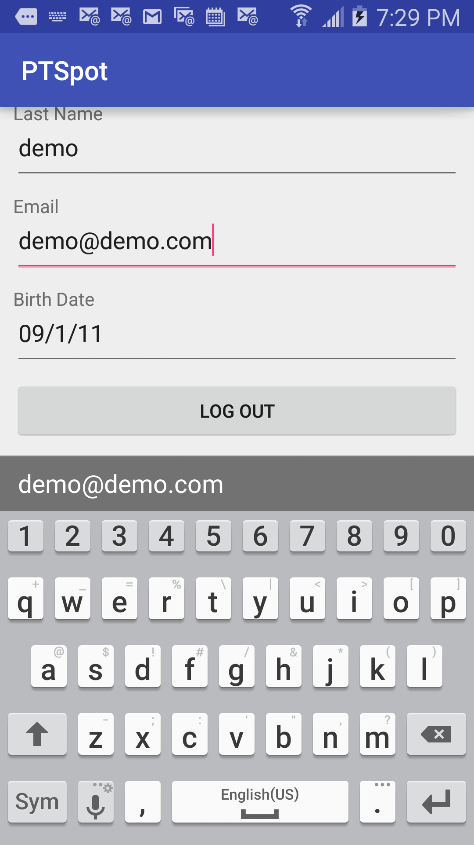

Iteration #2 Retrospective
Most of my time was spent trying to get Jenkins to work on Google App Engine. I finally gave up and switched to Digital Ocean. I found a helpful video on how to get Digital Ocean setup with Jenkins and PHP. Here is the link: https://www.youtube.com/watch?v=TiVIb0KRIZw
In the future, I will do more planning on who I should pick for hosting.
Project Velocity: 5
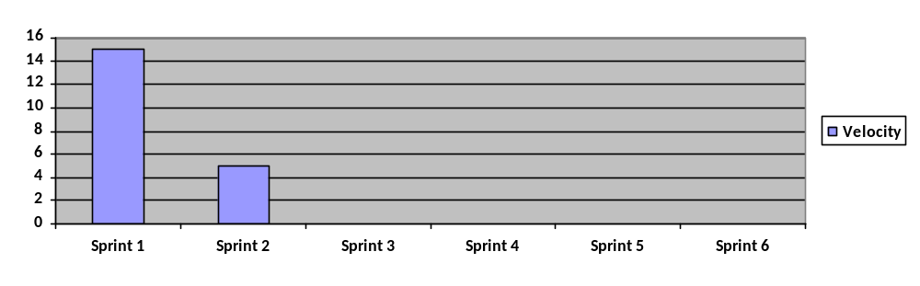

Sprint #3

Story ID | Story / Task | Estimated  Hours | Actual  Hours
S8 | Save seeker to database when registering | 1 | Not Completed
S10 | Session Management | 3 | 7
 | Update password hash | 1 | 1
S12 | Get JSON array of trainers from database using the API | 1 | 1
 | Populate html using JQuery | 2 | Not Completed
S6 | Update trainer info by sending requests to the API | 5 | Not Completed

Sprint #3 Review
Web login form
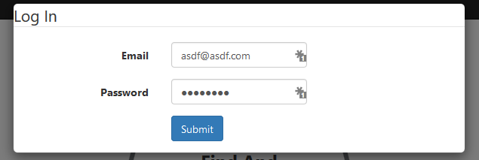
Web login post
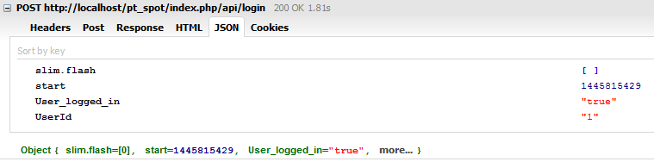
Android login form
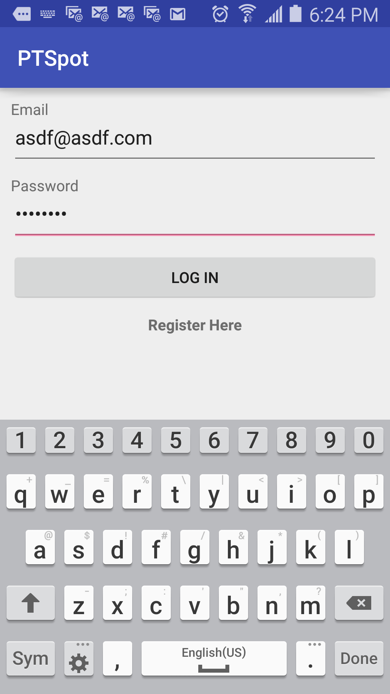
Android login post

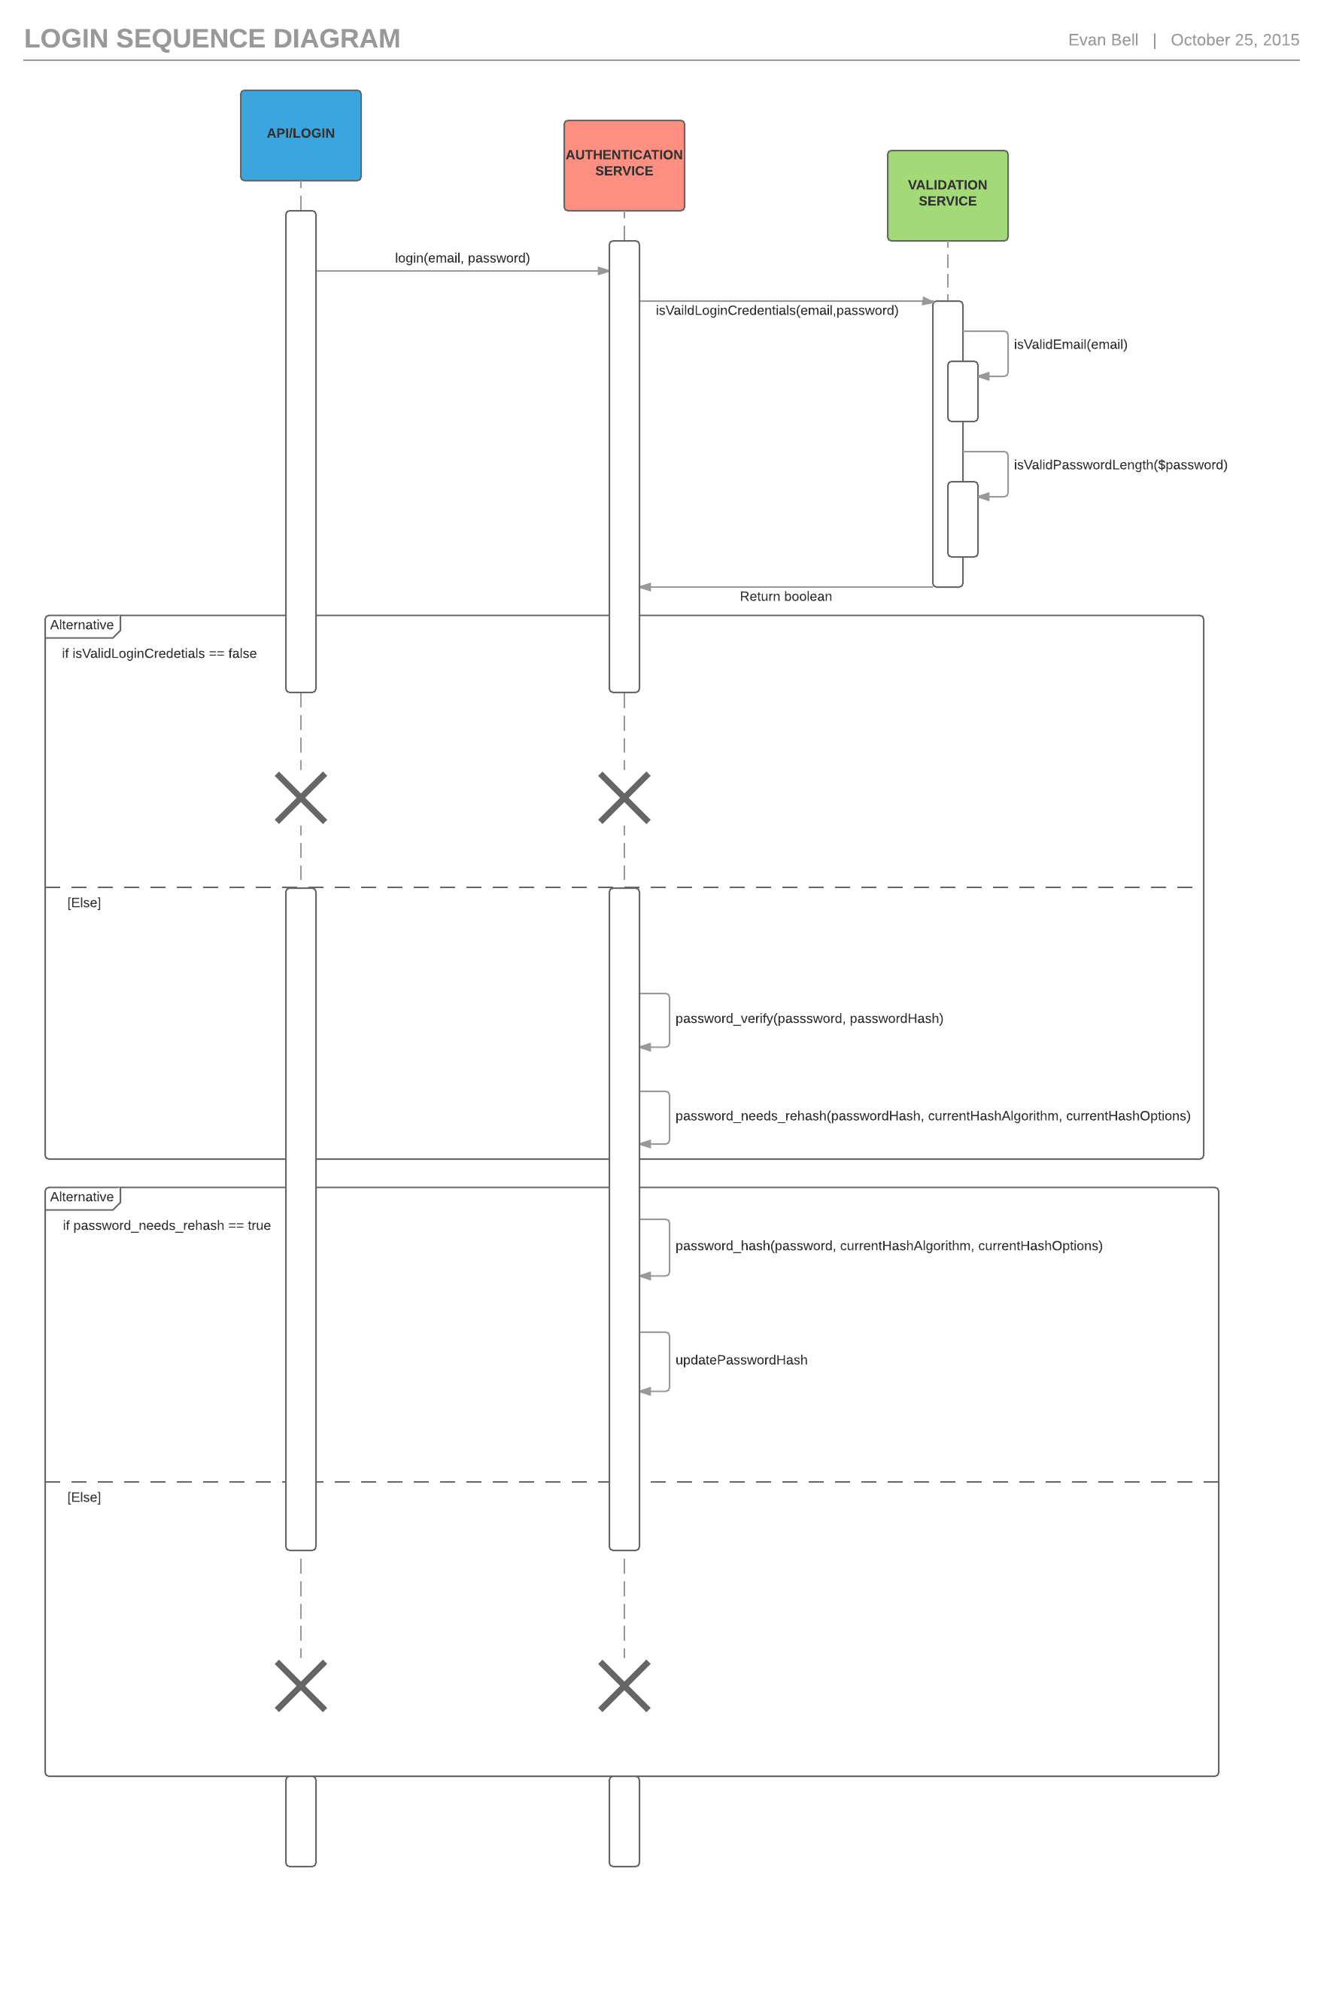

Iteration #3 Retrospective
I ended up spending most of my time on a task that wasn’t on the sprint plan because my professor went over how to send and receive JSON from Android and an external server. Since, this is a major part of my application; I decided to work on sending login credentials to the server for authentication, and receiving a response. I made a lot of progress on various things, but didn’t get any full stories completed.
Project Velocity: 0

Sprint #4

Story ID | Story / Task | Estimated  Hours | Actual  Hours
S8 | Register Seeker | 1 | Not completed
S10 | Choose grant type most appropriate for project | 1 | 1
 | Choose which PHP library to use | 1 | 1
 | Learn how to use the library | 2 | 5
 | Implement Resource Owner Password Credentials Grant Type | 2 | 5
 | Implement Refresh Token Grant Type | 2 | 3 Not completed
S12 | Populate list of trainers in Android and Html | 7 | Not completed

Sprint #4 Review
At the end of Sprint #3, I was in the process of keeping track of who was logged in with sessions. This sets the responsibility of keeping track of the state for every user in the database. This would work fine for a small number of users, but as the user base grows this will become very expensive to maintain. If I were to set up a multiple servers to handle sessions, I would have no way of knowing if a session in another server already exists, unless I were to store all sessions in a centralized database. There a convenient solution to this problem that replaces stateful sessions with stateless tokens. It’s called OAuth 2.0 and I decided to learn about it and implement it instead of sessions.

Insert a test client to the database
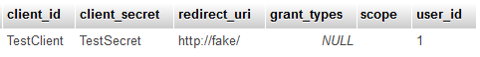

Web Login
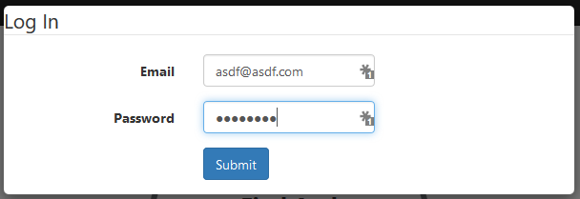

Request Header with encrypted TestClient and TestSecret
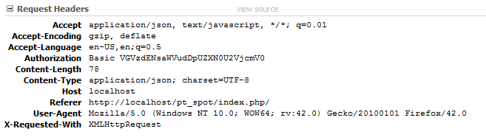
Post Data
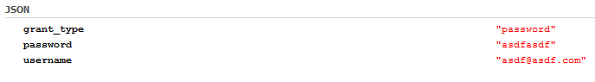
Response stored in cookie
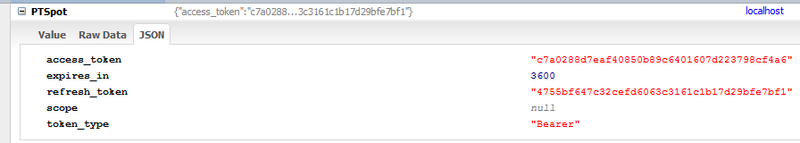
Access token added to database
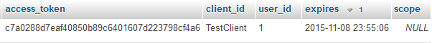

Refresh token added to database
Send refresh token to server. Server issues new access token
New access token added to the database
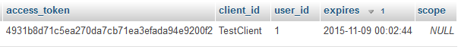
I have a problem at this point. The refresh token gets deleted from the database and I’m not sure why.

Exceptions
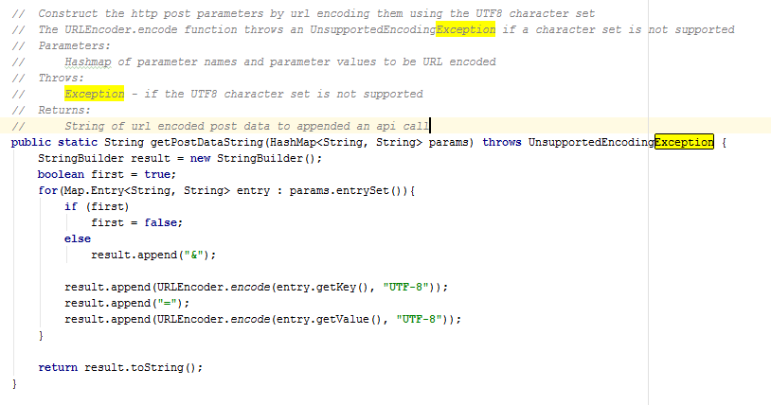

Iteration #4 Retrospective
I have been over ambitious on my goals this iteration. I underestimated how long learning about OAuth 2.0 would take and overestimated the amount of time I would have to work on this project. I still have a velocity of 0. Once I get over the higher learning curve of OAuth, my velocity will go up.
Project Velocity: 0
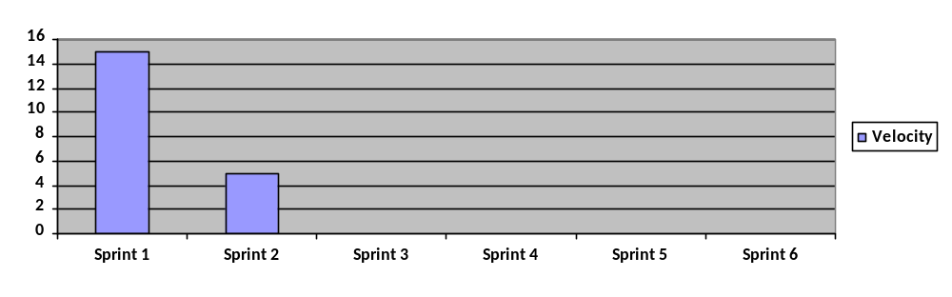
Project Velocity: 0

Sprint #5
Story ID | Story / Task | Estimated  Hours | Actual  Hours
S10 | Issue new access token when expired | 5 | 5
 | Check for access token on every request to the api | 5 | 5
12 | Display list of trainers on web app | 5 | 0

Sprint #5 Review
LoginService
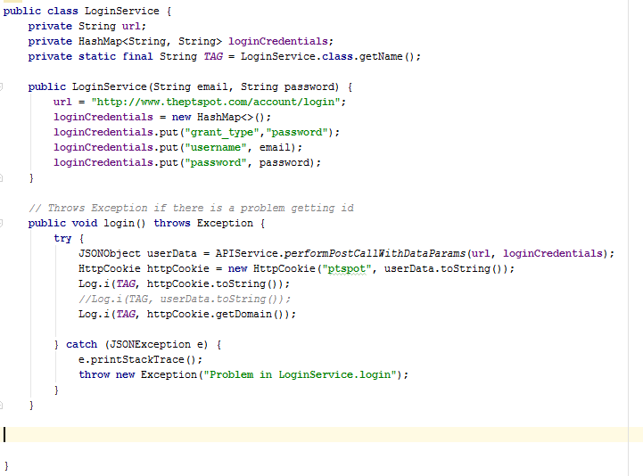
Notice that once I receive the token, I store it in a cookie.
Here are the contents of the token in the cookie
I wrote a unit test to test whether an Array List of Trainer objects is sorted by PTScore
TrainerList
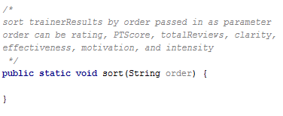
TrainerListTest

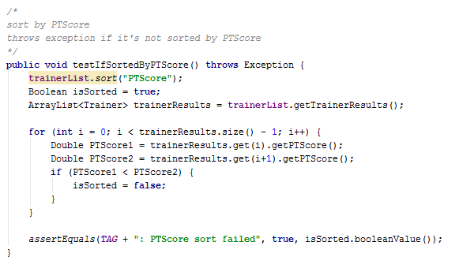
Run the test
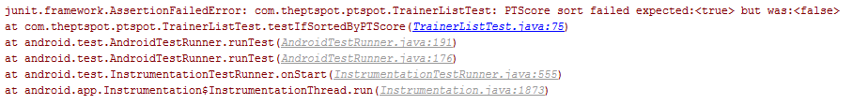
Write a comparator for the trainer class
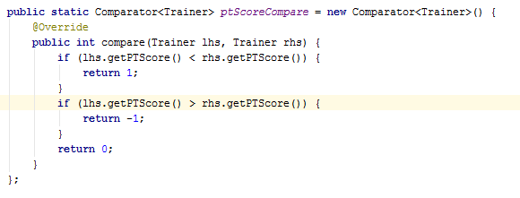
Write the sort function
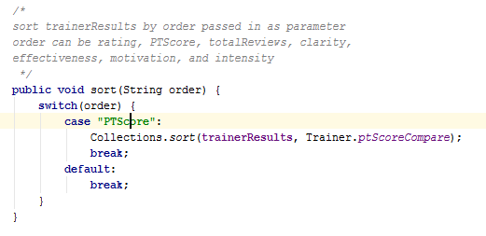
Run the test and succeeds.

Iteration #5 Retrospective
I am going to move on from trying to figure out refresh tokens for now. I have spent too much time on that.
Project Velocity: 15
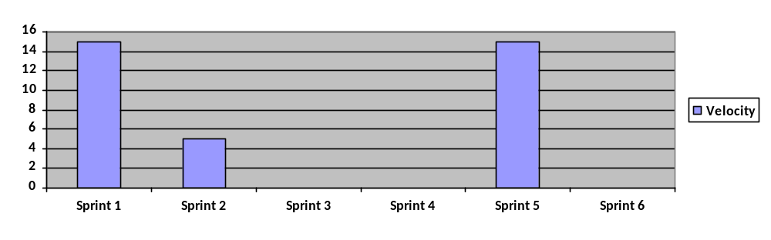

Sprint #6
Story ID | Story / Task | Estimated  Hours | Actual  Hours
S12 | Create Array Adapter of trainers | 3 | 5
 | Design UI | 3 | 2
 | Get trainer JSON from API | 2 | 1
 | Sort by rating | 2 | N/A

Sprint #6 Review
Refactoring: Extract Method
Initial
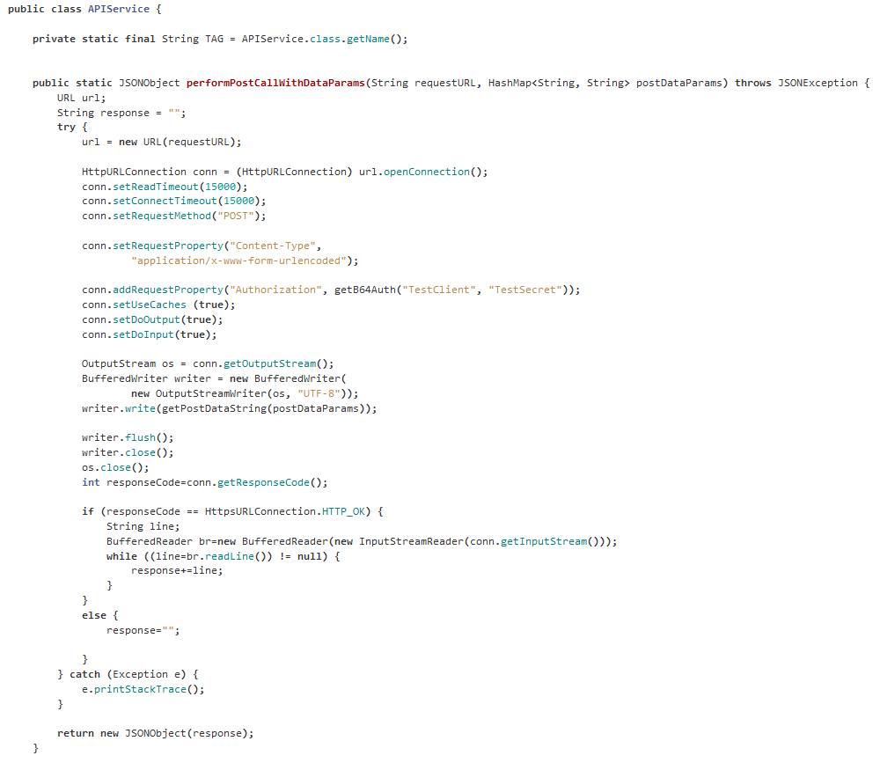

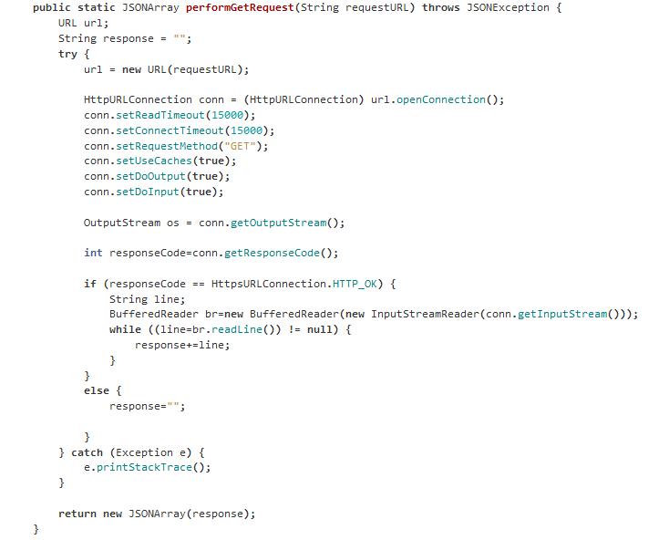
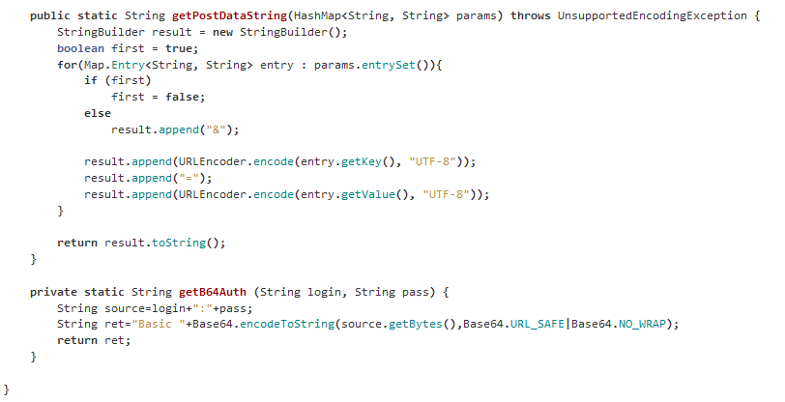
Notice all the repeated code in the performGetRequest and performPostCallWithDataParams methods. Also the name “performPostCallWithDataParams” is way too long. I was able to extract a few methods to construct a request.
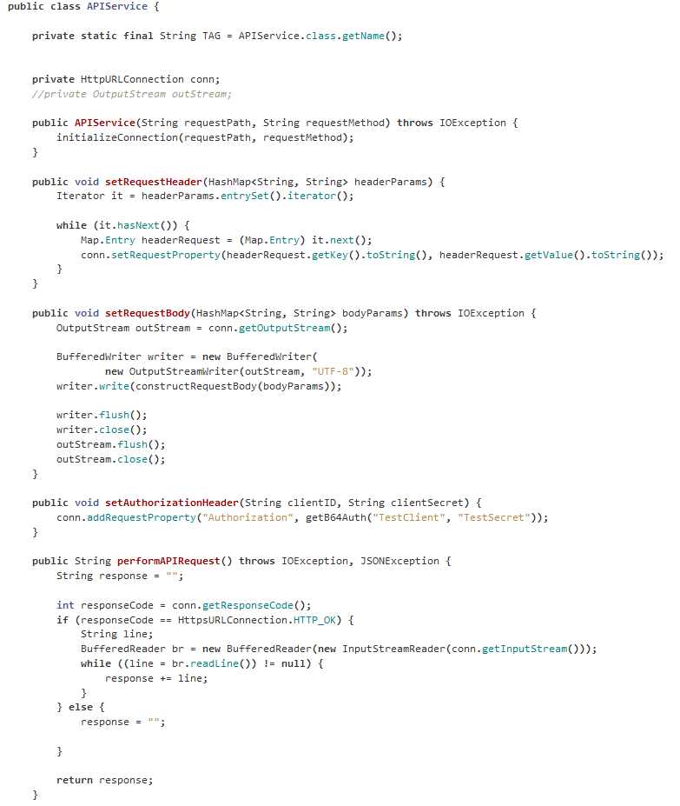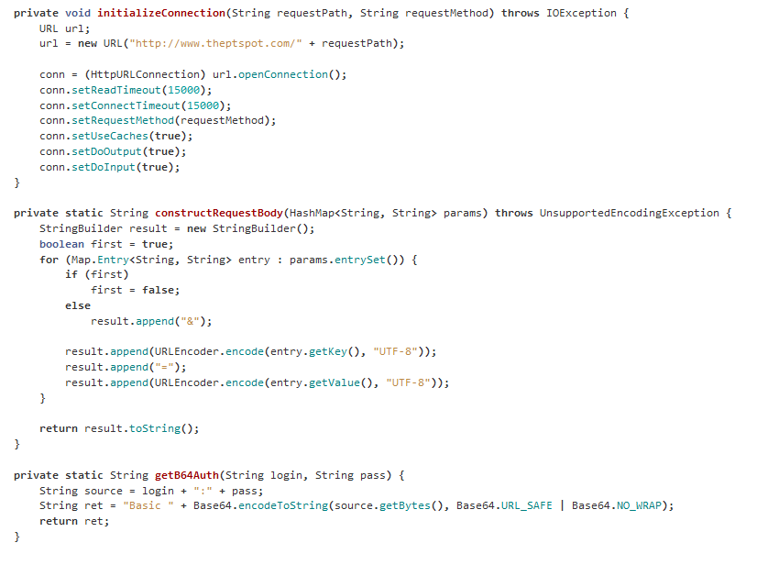
I noticed that this looks a lot like the builder pattern so I refactored to the builder pattern by simply returning this, on all public methods.
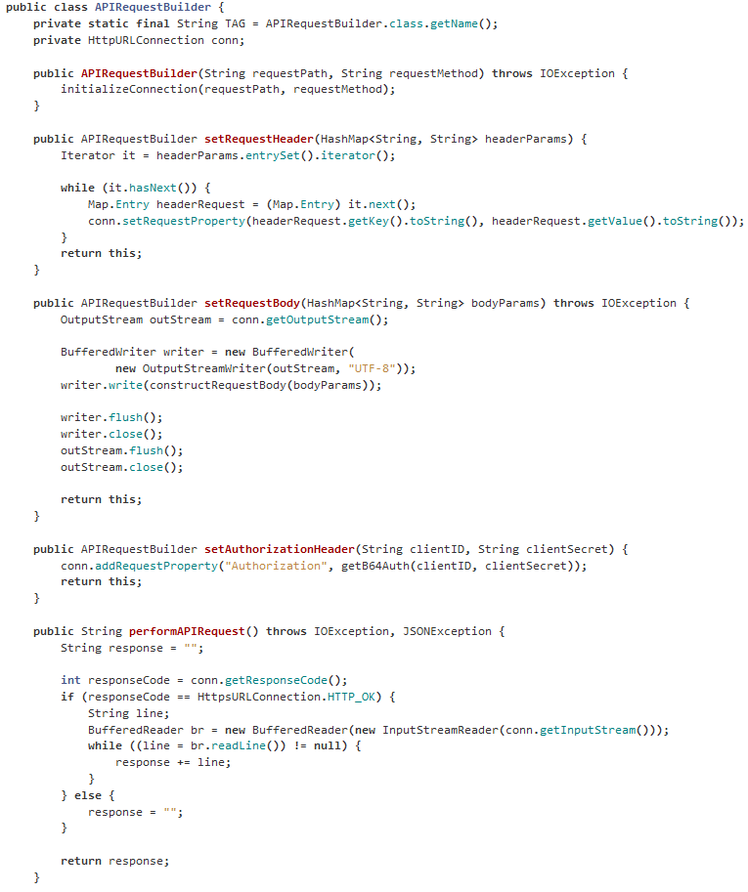
Here is a screen shot of the trainers when you click “Find A Trainer”
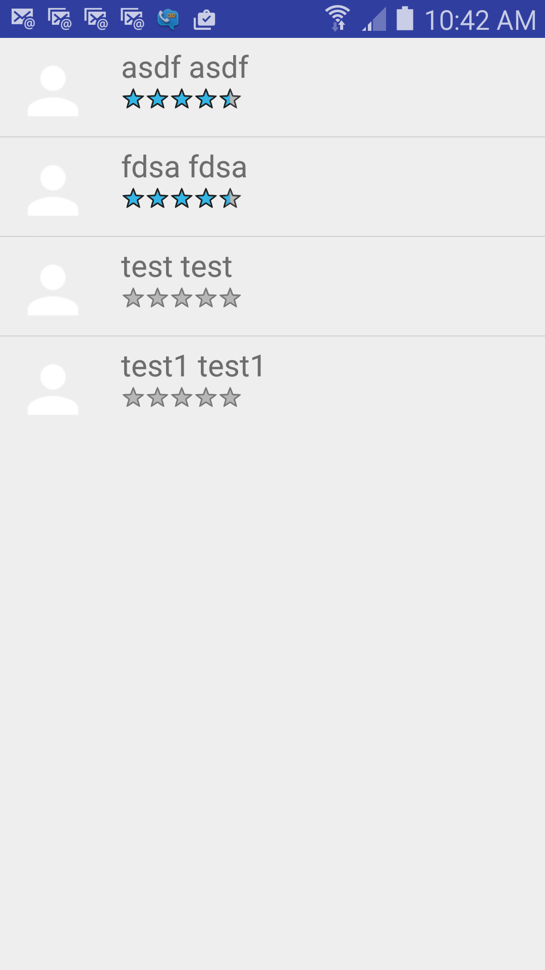

Iteration #6 Retrospective

Project Velocity: 15
