Assignment 3.3

Ece303-homework Commits

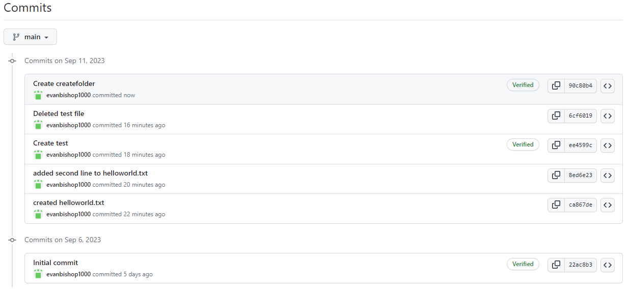

VS Code ece303-homework local repository

