Executive Summary

Initial Results of Analyses

Whole Set Analysis
Between 2014 and 2020, the dataset records 28,221 foreign gifts totaling $16.6 billion. The average gift size was approximately $588 thousand, while the median was substantially lower at $94 thousand, indicating a heavily right skewed distribution. Giving is also concentrated geographically and institutionally: Qatar alone makes up 16% of total giving and Carnegie Mellon University received the most in total gifts at around $1.5 billion.

UVA Analysis
University of Virginia received 98 foreign gifts totaling approximately $22.1 million. The mean gift was approximately $226 thousand, with a median gift of around $80 thousand, indicating a strong right skew: a relatively small number of very large gifts substantially increased the average. This pattern is also visible in the boxplot and log-scaled histogram, included below.
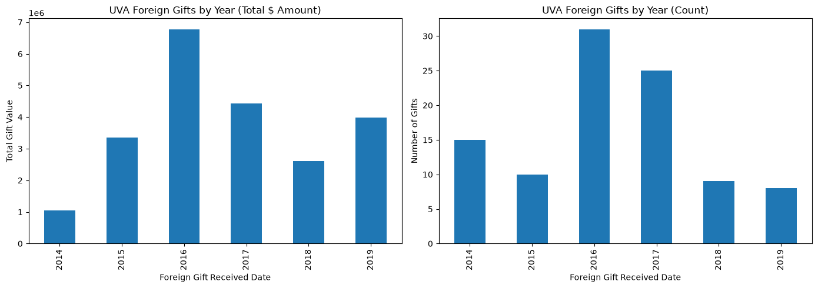

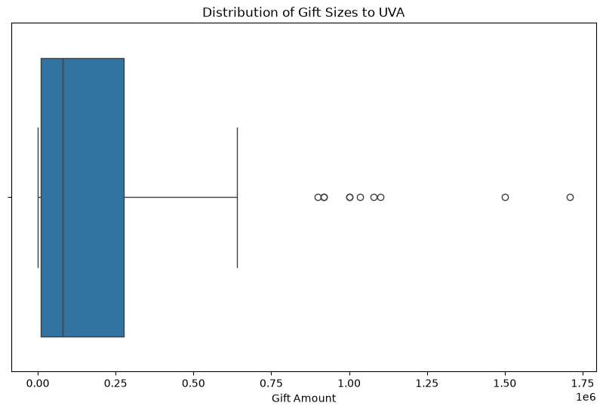
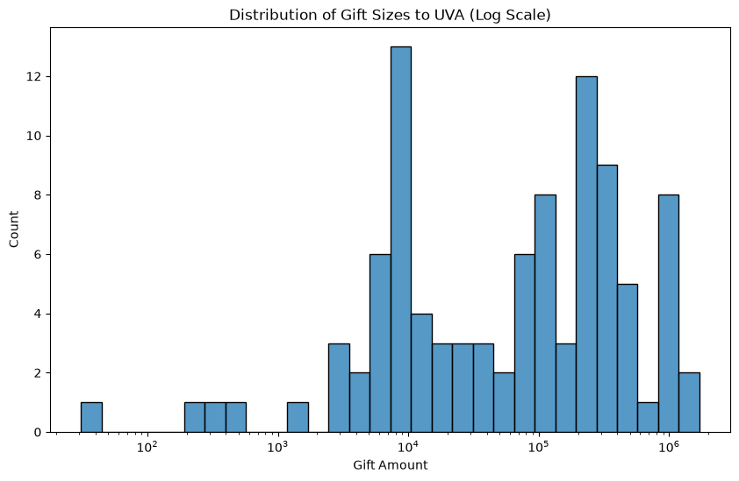
The largest total contributions came from Bangladesh, Sweden, and Tanzania, although countries with the most gift records were not necessarily those contributing the greatest total value. Gift activity varied across years, with the highest total amount and the greatest number of gifts happening in 2016.

