**DATA**

I use three datasets on auction sales in this paper: Impressionist art (1980-1991), Contemporary art (1982-1994), and recent assorted art sales (2006-2016). The Impressionist and Contemporary art datasets have been used extensively in the literature[1] and are already described in detail elsewhere[2]. Both of those datasets are available on the Brandeis website of Kathryn Graddy[3]. However, the latter is a new dataset constructed specifically for this paper.

The Impressionist art dataset (1980-1991) was constructed by Orley Ashenfelter and Andrew Richardson in 1992, and covers sales at Christie’s and Sotheby’s in both London and New York. There are well over 16,000 observations of art piece sales, which were compiled by manually scouring presale catalogs. Each observation contains the painting title, the artist name, the sale price and date, the auction house and location, the presale low and high estimates, and hedonic characteristics such as the piece dimensions and the presence of a signature. The dataset contains 58 major artists whose work is often featured at auction, and among the most frequent are Pablo Picasso (1881-1973), Raoul Dufy (1877-1953), and Pierre Renoir (1841-1919). Approximately half the auction sales are split between Christie’s and Sotheby’s, as well as between London and New York. Table 1 shows summary statistics for selected attributes. The highest sale in this dataset goes to Vincent Van Gogh’s *Portrait of Dr. Gachet* (1890), which netted approximately $82.5 million on May 15, 1990. Conversely, the lowest sale is a work by Paul Cesar Helleu that went for a mere $1,888 on March 25, 1986.

Table < > shows summary statistics for continuous (non-categorical) variables in the Impressionist art dataset. In general, we see very high variance: sales price, for example, reflects both paintings with record-high sales, as well as paintings that sold for minimal amounts or were bought in. Additionally, many of these quantities have distributions that are roughly log-normal (i.e., without the log transformation, skewed heavily right), showed in Figure <>. This is because the majority of paintings exhibit middle-market sale price, estimates, size, and so forth, while relatively few reach the highest ranges. The two painting dimensions have the most irregular distributions, particularly in the middle ranges. However, as seen in Figure <>, the large portion of paintings do not tend to be lopsided.

Next, the Contemporary art dataset represents every Contemporary art piece sold from 1982 to 1994 at Christie’s primary King Street location in London, for a total of approximately 4,500 observations. The dataset was compiled by Kathryn Graddy, who manually examined auction catalogs and sifted through internal data in the archives of Christie’s. Similar to the Impressionist dataset, each observation lists the artist, the auction sale price and date, the presale low and high estimates, the lot number, whether or not the item sold, and hedonic characteristics such as the artist and medium. Various currency exchange quantities are included, such as the UK CPI at the time, and monetary quantities are given in thousands of pounds. Nearly 600 artists are represented, with Lucio Fontana (1899-1968), Karel Appel (1921-2006), and Alexander Calder (1898-1976) being the most frequent. Table <> gives summary statistics for this dataset. As with the Impressionist dataset, and shown in Figure <>, quantitative dimensions such as sale price and size also show roughly a log-normal shape. As shown in Figure <>, Impressionist pieces tend to be far more expensive than Contemporary pieces, which can be attributed to the age and renown of the former. However, Contemporary pieces do tend to be physically larger (Figure <>).

A major contribution of this research is the construction of a large dataset of recent auctions sales of assorted paintings[4] (2006-2015). The motivation behind collecting and using a new dataset is twofold. First, the time gaps between auction sales in this dataset are on the much shorter scale of months, weeks, or even days, rather than years as in the previous datasets. This is far more conducive to studying anchoring. Second, this dataset consists of a very wide cornucopia of pieces, which is ideal for exploring substitutability across pieces. The Impressionist and Contemporary datasets tend to be more limited in their artistic scope, and so do not seem to be as conducive for studying substitution.

--------------

Table <>: Impressionist art, summary statistics for continuous features.

DIM_A LOW_EST HIGH_EST

Min. : 0.00 Min. : 102 Min. : 128

1st Qu.: 11.00 1st Qu.: 14000 1st Qu.: 18000

Median : 17.00 Median : 40000 Median : 50000

Mean : 18.31 Mean : 196023 Mean : 257967

3rd Qu.: 23.00 3rd Qu.: 132800 3rd Qu.: 168300

Max. :120.00 Max. :40000000 Max. :50000000

NA's :37

S_PRICE CNV_RATE DATE_PTG

Min. : 126 Min. :0.0000 Min. :1823

1st Qu.: 18700 1st Qu.:0.0000 1st Qu.:1902

Median : 53856 Median :1.2400 Median :1922

Mean : 285428 Mean :0.8639 Mean :1921

3rd Qu.: 176000 3rd Qu.:1.6800 3rd Qu.:1938

Max. :82500000 Max. :2.3610 Max. :1983

NA's :4696 NA's :3950

DATE_FLG DIM_B DIAM

Min. :0.0000 Min. : 0.00 Min. : 1.00

1st Qu.:0.0000 1st Qu.: 11.00 1st Qu.: 6.75

Median :0.0000 Median : 18.00 Median :11.50

Mean :0.3538 Mean : 18.69 Mean :15.10

3rd Qu.:1.0000 3rd Qu.: 24.00 3rd Qu.:24.50

Max. :1.0000 Max. :141.00 Max. :36.00

NA's :37 NA's :16243

PND_FLG

Min. :0.0000

1st Qu.:0.0000

Median :1.0000

Mean :0.5127

3rd Qu.:1.0000

Max. :2.0000

NA's :4

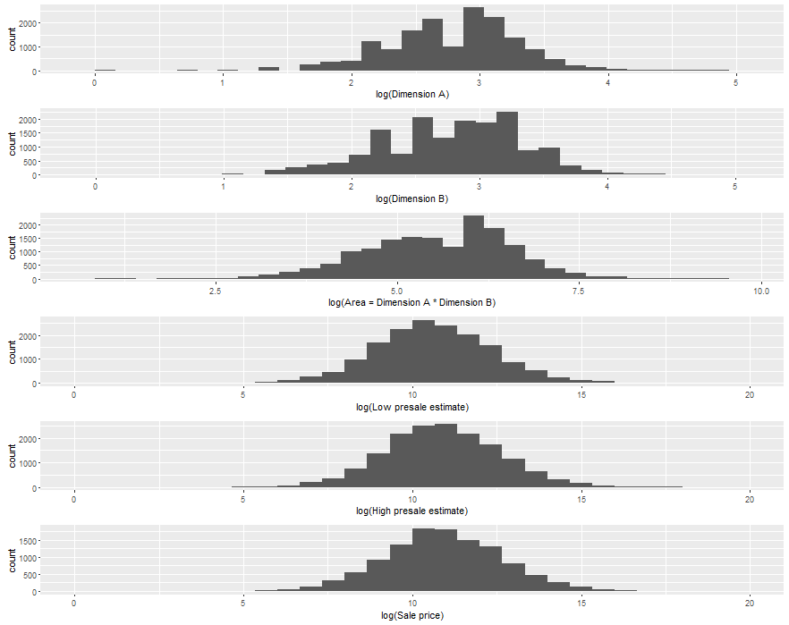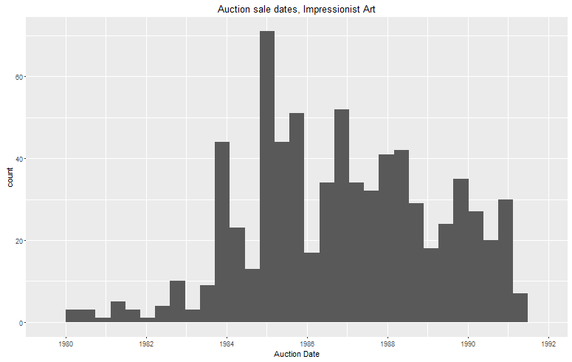

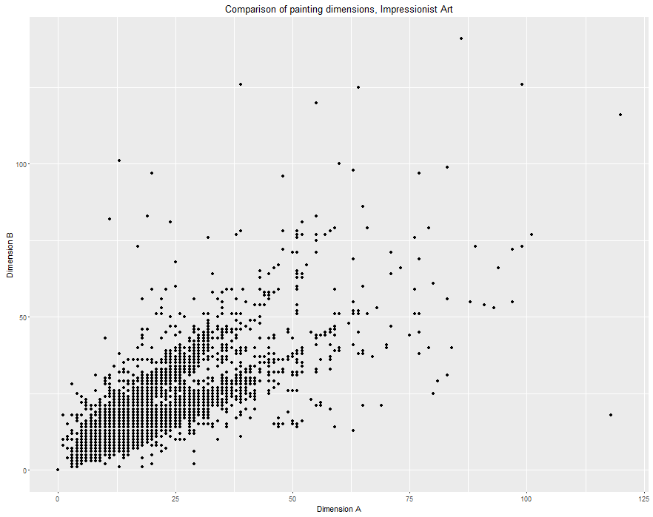

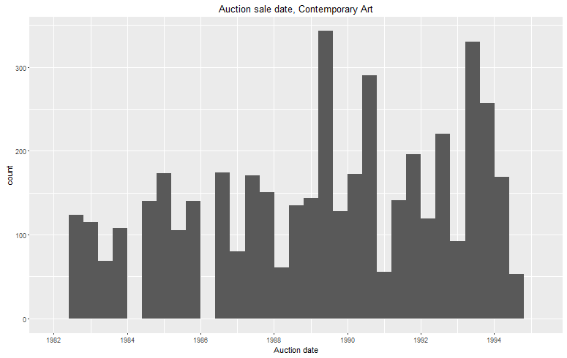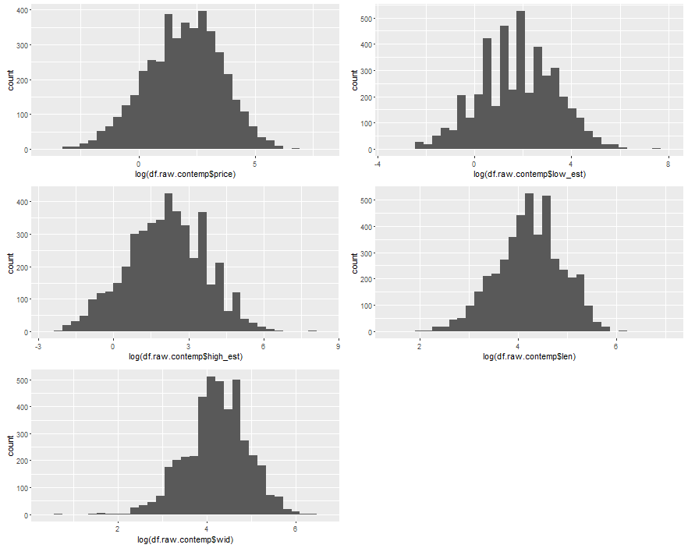

Table 2: Contemporary art, summary statistics.

Auction_date mdate ddate ydate

Min. :1982-06-29 Min. : 2.000 Min. : 1.00 Min. :1982

1st Qu.:1986-06-26 1st Qu.: 6.000 1st Qu.: 5.00 1st Qu.:1986

Median :1989-06-29 Median : 6.000 Median :22.00 Median :1989

Mean :1989-05-15 Mean : 7.831 Mean :17.07 Mean :1989

3rd Qu.:1992-07-02 3rd Qu.:12.000 3rd Qu.:26.00 3rd Qu.:1992

Max. :1994-06-30 Max. :12.000 Max. :30.00 Max. :1994

lot sold price low_est

Min. : 1.0 Min. :0.0000 Min. : 0.00 Min. : 0.05

1st Qu.: 87.0 1st Qu.:1.0000 1st Qu.: 1.90 1st Qu.: 2.00

Median : 423.0 Median :1.0000 Median : 7.00 Median : 6.00

Mean : 397.7 Mean :0.7745 Mean : 21.23 Mean : 19.53

3rd Qu.: 601.0 3rd Qu.:1.0000 3rd Qu.: 20.00 3rd Qu.: 20.00

Max. :1164.0 Max. :1.0000 Max. :1700.00 Max. :1800.00

NA's :2 NA's :45

high_est date_ptg len wid

Min. : 0.1 Min. :26.00 Min. : 5.40 Min. : 2.00

1st Qu.: 3.0 1st Qu.:60.00 1st Qu.: 44.50 1st Qu.: 46.00

Median : 8.0 Median :67.00 Median : 70.00 Median : 70.00

Mean : 26.1 Mean :68.24 Mean : 84.53 Mean : 84.71

3rd Qu.: 25.0 3rd Qu.:77.00 3rd Qu.:105.00 3rd Qu.:105.00

Max. :2600.0 Max. :91.00 Max. :957.00 Max. :602.00

NA's :45 NA's :449 NA's :73 NA's :293

artist medium CNV_RATE ukcpi

Length:4456 Length:4456 Min. :1.210 Min. :239.6

Class :character Class :character 1st Qu.:1.482 1st Qu.:286.4

Mode :character Mode :character Median :1.610 Median :339.3

Mean :1.609 Mean :342.9

3rd Qu.:1.722 3rd Qu.:407.1

Max. :1.954 Max. :423.0

ukinf uktb uscpi usinf

Min. : 1.270 Min. : 4.900 Min. :181.6 Min. :1.280

1st Qu.: 3.050 1st Qu.: 8.800 1st Qu.:204.1 1st Qu.:3.050

Median : 4.710 Median : 9.630 Median :231.7 Median :3.920

Mean : 5.061 Mean : 9.832 Mean :232.7 Mean :3.848

3rd Qu.: 6.520 3rd Qu.:11.990 3rd Qu.:261.9 3rd Qu.:4.600

Max. :10.430 Max. :14.540 Max. :276.8 Max. :6.220

ustb japcpi dj ftse

Min. : 2.970 Min. :149.3 Min. : 812.2 Min. : 736.2

1st Qu.: 3.990 1st Qu.:160.6 1st Qu.:1776.5 1st Qu.:1588.4

Median : 6.990 Median :168.2 Median :2458.3 Median :2182.0

Mean : 6.157 Mean :169.9 Mean :2438.5 Mean :2078.3

3rd Qu.: 7.760 3rd Qu.:182.3 3rd Qu.:3174.7 3rd Qu.:2546.6

Max. :10.320 Max. :185.4 Max. :3753.5 Max. :3223.9

VAT

Min. :0.0000

1st Qu.:0.0000

Median :0.0000

Mean :0.2949

3rd Qu.:1.0000

Max. :1.0000

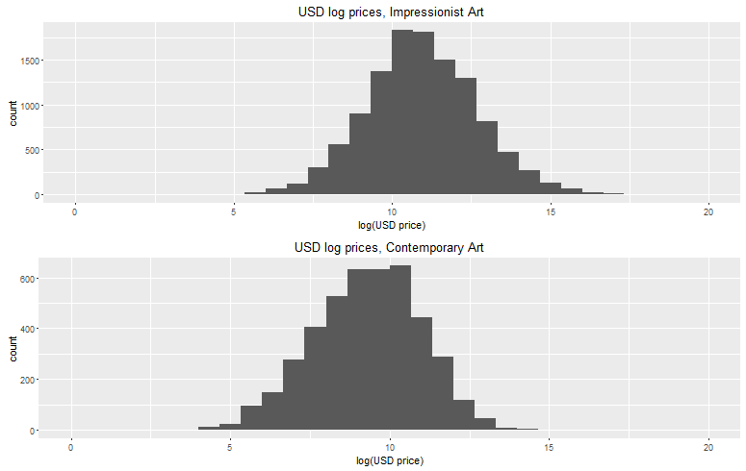

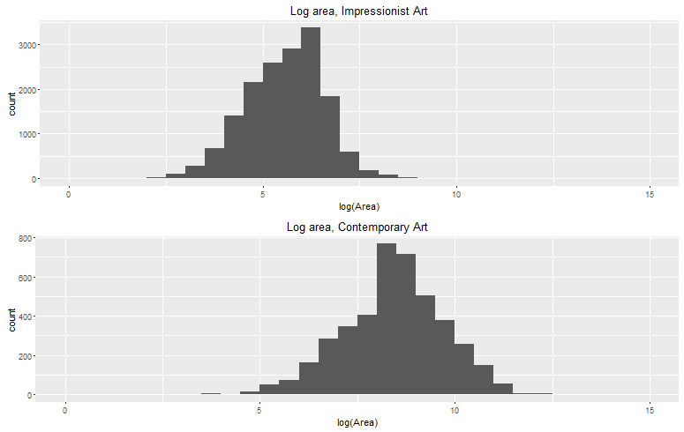

###

< reason for assorted art auctions – so time difference is small, can see how related art across a variety of different artists impacts each other. >

1. Richardson (2002); Abowd & Ashenfelter (1989); Beggs & Graddy (1997); Ashenfelter & Graddy (2003); Beggs & Graddy (2009)
2. http://www.jstor.org/stable/pdf/2556028.pdf?acceptTC=true
3. http://people.brandeis.edu/~kgraddy/data.html
4. The collected raw data also includes prints, drawings, and other mediums, but since we wish to compare against our other two datasets, we only use paintings here.