PRICE, ANCHORING, AND SUBSTITUTION

IN

THE MARKET FOR FINE ART AUCTIONS

Evan Chow

Princeton University

Department of Economics

April 5, 2016

Senior Thesis Draft #2

Due: April 13, 2016 before 4:00 PM

**TABLE OF CONTENTS**

1. ABSTRACT
2. ACKNOWLEDGEMENTS
3. INTRODUCTION
4. OVERVIEW OF ART AUCTIONS AND ANCHORING
5. LITERATURE REVIEW
6. METHODOLOGY
7. DATA
8. RESULTS
9. FUTURE DIRECTIONS
10. CONCLUSION

**ABSTRACT**

Given that Joan Miro and Salvador Dali were both Surrealist painters, can the past price of a Miro painting bias the current price of a Dali piece? We examine the existence and behavior of these “anchoring” cross-effects between prices of related art pieces sold at auction. My research generalizes the anchoring model of Beggs & Graddy (2009) in order to study related art pieces. We draw upon insights from conversations with art specialists and experts at Sotheby’s, and construct a new dataset of recent auction sales for assorted art (2006-2015). We find significant evidence of anchoring cross-effects. Our findings are of interest to art researchers, auction house specialists, and those who wish to understand where price signals travel in the art auction world.

**INTRODUCTION**

Imagine you are heading to Christie's to bid on a Monet oil painting, which experts believe will sell for $5 million based on its medium, artist, and so forth. You're unaware of that, and so when you learn that a very similar oil painting by Van Gogh (a peer of Monet) fetched $10 million just the week before, $8 or $9 million for the Monet seems like a bargain – even if that reflects more of the Van Gogh than the Monet.

This is the *anchoring effect* - a well-known cognitive bias in which the first number you hear (the “anchor”) can shape your perception of what is normal. This was demonstrated in a landmark experiment by Tversky & Kahneman[1], where participants were given only 5 seconds to calculate the product of numbers 1 through 8, shown either in increasing or decreasing order. It was found those who saw the lower numbers first gave a median estimate of 512, whereas those who saw higher numbers first gave a median estimate of 2250 – a huge difference due to first impressions.

This bias appears in the fine art auction market, which in 2014 enjoyed a sales volume of £5.1 billion (approximately $7.35 billion in today’s exchange rate)[2] [3]. To our knowledge, Beggs & Graddy (2009) are the first to formally study anchoring in the context of art auctions, and describe it as follows. First, the true value of a painting is determined by its hedonic characteristics: the artist, the medium, the presence of authenticity, and so forth. These intrinsic features do not change over time, which means buyers should pay based on their current demand for those hedonic features. This hedonic demand, of course, may change over time. If however, buyers learn the painting previously sold for a very high price, they may internalize that as a reference point (the “anchor”) and drive up price even more, even if that signal reflects irrelevant past circumstances (such as past bidding activity) rather than the painting’s intrinsic value. This impact of past price, an irrelevant signal in this context, on current price can thus be interpreted as an anchoring effect. It is important to note the exact behavioral mechanism by which auction participants internalize and act upon past price, however, is complex and cannot be inferred from just observing prices. Hence in our research and in much of our surveyed literature, the process is treated as a black box. The mere observation of past price biasing current price suffices for our definition of anchoring (discussed further in Section 5).

Using a regression model that isolates this phenomenon, Beggs & Graddy (2009) identify and analyze resales of Impressionist and Contemporary paintings, and do find significant evidence of anchoring effects. However, as they note it is very difficult to identify multiple sales of the same art piece, and they use only 1-2% of their original data. This method of studying anchoring only across resales cannot be applied to new works or works that have never been brought to auction. In practice, it turns out that auction specialists not only appraise an art piece based on its previous sales, but also on sales of related art pieces[4]. Hence, the anchoring research of Beggs & Graddy (2009) seems to be somewhat limited in its scope of price biases in the art auction market. # work on this section: make more important. Maybe move your example of Monet bias Van gogh here? Also hong et al.

In this paper, we thus study whether anchoring effects can occur across similar paintings (substitutes) – for example, whether the past price of a Monet can bias the current price of a similar piece by Van Gogh.

This is of tremendous interest to ____. For this thesis, we have conducted interviews with art experts at Sotheby’s a

To do this, we begin by replicating the original findings of Beggs & Graddy (2009). This gives us a

Paragraph 2: The notion of “similarity” across art pieces is not trivial # interviews

Isolated in beggs & graddys

If however, buyers not only consider those hedonic factors but the past price of a painting,

Beggs & Graddy (2009) interpret this impact as the anchoring effect,

The primary work on anchoring in art auctions is conducted by Beggs & Graddy (2009), who study this bias across multiple sales of Impressionist and Contemporary art pieces[5]. Their main idea

The main idea is that past sale price of a painting can irrelevantly bias its current sale, since the value of a painting should remain constant across sales.

and the authors do indeed find evidence of these anchoring effects, particularly for Impressionist art. In other words, if a Monet sells for an unexpectedly high price at time $t$ due to bidding excitement or other unobserved inputs, then at time $t+1$ buyers will internalize that past price as a starting point, thus artificially driving up price for that same Monet. However, as they note, it is very difficult to identify multiple sales of the same art piece, which is required for their regression model. Beggs & Graddy use only 1-2% of their original data on all painting sales.

The goal of this research is to examine whether anchoring can occur between related paintings, that is, whether the past sale price of one can bias the current sale of another.

This research generalizes the model of Beggs & Graddy to capture anchoring effects across similar art pieces (substitutes), i.e. anchoring cross-effects. This is important not only because of the dearth of resale data, but because understanding how similarity across art pieces affects prices allows one to more accurately appraise artwork in light of precedent sales. As we describe later, this issue is of great commercial interest to auction houses, who must continually estimate the value of pieces that are new or have never been brought to auction before.

This research draws upon the original data of Beggs & Graddy (2009), a new dataset of recent assorted art sale constructed specifically to explore anchoring, and insights from our conversations with specialists in the field. We manage to replicate, to some extent, the original work of Beggs & Graddy which tests for anchoring in the context of resale. We propose two different measures of substitution to quantitatively assess similarity across art pieces. With these measures, we find preliminary evidence of anchoring cross-effects in both the data of Beggs & Graddy as well as in our collected data.

This thesis proceeds as follows. In Section I, we give a brief overview of the art auction system and process, followed by a deeper discussion on anchoring and its role in this market. Section II surveys the relevant literature on anchoring in the art market, and shows how our research fits in. Section III describes our methodology, which includes the original regressions of Beggs & Graddy, our expanded regression models, and our measures of substitution. Section IV is a description of the original data of Beggs & Graddy, and explains the motivation behind and nature of our new dataset. Section V gives our results. This includes our replication of the anchoring work of Beggs & Graddy and our overall findings pertaining to anchoring cross-effects. The section also includes three empirical experiments we conducted on known pairs of “similar” artists, recommended by one of the experts we talked with. Section VI discusses directions for future work. Finally, Section VII concludes with a summary of our findings.

**A BRIEF OVERVIEW OF ART AUCTIONS**

In perhaps one of the world’s oldest duopolies, approximately 42% of the global art auction market is controlled by two major houses, Christie’s (est. 1766) and Sotheby’s (est. 1744)[6]. The former, headquartered in London, is privately held by French multibillionaire Francois-Henri Pinault and so only reports sales figures twice a year[7]. Sotheby’s on the other hand is headquartered in New York City and publicly traded, and is thus required to report revenue and costs in detail[8]. While both houses deal in art, often sourced from museum or private collections, in recent years Christie’s has become the larger player in this domain. In the first six months of 2015, Christie’s realized $4.5 billion in art sales, while Sotheby’s only pulled $3.5 billion[9]. Over the years, both houses have enjoyed their share of record-breaking auctions: Picassso’s *Les Femmes d’Alger (“Version O”)* sold for $179 million at Christie’s in 2015, while Pollock’s *No. 5, 1948* went for $164 million at Sotheby’s in 2006. The whole spectrum of art can be found at Christie’s and Sotheby’s, ranging from European sculptures and Impressionist oil paintings to Chinese ceramics and modern prints. Auctions are usually themed around a certain artist, medium, time period, or represent a private collection. Often individual events are part of a series, such as Christie’s “First Open” series (launched in 2005) for post-war and contemporary art[10]. In recent decades, one also sees the rise of other innovations. For example, Sotheby’s and Christie’s offer live online bidding for clients who can neither attend nor send a surrogate[11]. Both houses also offer art-backed loans, allowing collectors to borrow money against their own artwork – a highly illiquid asset.

In addition to fine art, both houses run auctions for other luxury goods such as jewelry, automobiles, and furniture – and so many believe these houses play to different strengths. To sell photographs, go to Sotheby’s; to sell books and manuscripts, go to Christie’s[12]. Only Sotheby’s sells classic automobiles[13]. Specialization is not limited to products, either: one administrator at Bonham’s, a well-known but smaller auction house, told me they appeal to prospective sellers because their lower sales volume (specifically, smaller lots) ensures their work will be better noticed. Competition between these houses is fierce, and each tries to capture the best consignments and expand market share by luring prospective sellers with benefits such as higher guaranteed prices and waived house commission fees[14]. Putting one’s own money on the line means profit margins are thin for both Sotheby’s and Christie’s, and both have lost millions as a result[15]. Despite this ongoing cut-throat battle, the two houses have cooperated – and even colluded – at times. For example, according to an auctioneer interview in Hong et al. (2015), Sotheby’s and Christie’s have an agreement to take turns leading New York City’s annual Auction Week, a major event which saw $1.5 billion in art sales in 2014[16]. The early 2000’s saw an infamous scandal where both houses fixed commission prices charged to sellers, and once convicted, were required to pay back $256 million to customers (and for Sotheby’s, shareholders)[17].

The auction process proceeds as follows. First, a client (prospective seller) will begin by requesting an auction estimate from the auction house for their item of interest, either by submitting photographs or scheduling an in-person appointment with a specialist. After assessing whether the item is appropriate for auction, the house will negotiate with the seller (e.g. for the reserve price) and draw up a seller’s contract. The item then goes to the house to be officially photographed, catalogued, and stored before the auction event[18]. Of course, many clients visit more than one auction house to compare deals.

Three quantities are determined by the seller and the house before any auction: a low and a high presale estimate for the art piece, and a reserve price. The low and high estimates represent the range of possible values the piece might go for, and are usually decided upon by a committee of in-house art experts. As shown empirically by Ashenfelter (1989), these estimates do generally seem to accurately predict the item’s sale price[19]. Some significant cross-house differences may exist: Bauwens and Ginsburgh (2000) show that in certain art categories, Sotheby’s tends to undervalue expensive pieces and overvalue inexpensive ones, while Christie’s does the opposite[20]. In negotiations, the seller and the house also determine a secret reserve price known only to those two parties. The reserve price is a closely guarded secret in the art auction world, but according to estimates by Ashenfelter, Graddy and Stevens (2004), the reserve price may be set around 70-80% of the low estimate. It is not known why the reserve is concealed, but Vincent (1995) suggests that under certain circumstances, announcing the reserve may discourage potential bidders from participating and could lower overall bids[21].

Before an auction, the house will typically put out a presale catalog for the art pieces, which is usually available both online and in print. In addition to the presale estimates, the description of each piece can include information such as the artist, the materials and a condition report, various signs of authenticity such as a signature, and where the work was previously displayed (provenance). Houses also host pre-auction viewings where both potential bidders and the public can examine the art pieces in person. Bidders must register before an auction, and for particularly opulent auctions, must show proof of their assets.

Auctions are almost always conducted in an ascending first price format. The auctioneer starts low (somewhere below the secret reserve price[22]) and calls increasing prices[23] until the bidding stops, at which the item is declared to be “knocked down” or “hammered down.” The final price is the “hammer price,” on top of which the house adds a commission or “buyer’s premium,” usually 10% to 17.5% of the hammer price, before the winning bidder receives the item[24]. At Sotheby’s and Christie’s, the seller receives payment approximately 35 days after the auction, minus a “seller’s premium” fee which is often around 10% of the hammer price[25] [26]. If an item does not meet its reserve price, it goes unsold and is said to have been “bought in.” The auction house, however, rarely purchases the item: instead, it may be resold later or taken off the market. Historically, auction houses have concealed whether items go unsold. However, since the 1980’s auction houses in NYC have been legally required to report this, and according to Ashenfelter & Graddy (2003) houses in other locations are following this trend[27].

**HOW ANCHORING AFFECTS ART AUCTIONS**

The auction market is particularly prone to unobserved psychological and behavioral biases, because on both sides of the market, participants must rely on subjective judgement, past experience, and personal preferences to evaluate artwork. The ever-changing heterogeneity of art pieces, buyers, and sellers makes it intractable for both auction houses and economists to perfectly estimate demand for art. The auction format, designed to set prices by discovering private valuations, is a natural way to tackle this issue. Yet auctions are perhaps shaped the most by behavioral phenomena: the thrill of winning, for example, can spark bidding wars that drive up sale prices far beyond an artwork’s estimated value[28].

Anchoring is one of the most-studied biases in the behavioral sciences: it is at once trivial to demonstrate and difficult to explain away. This effect occurs when first (quantitative) impressions distort future outcomes – even when the initial information is irrelevant[29] [30] or obviously mistaken[31]. As a relevant example of anchoring, a record high sale price for an Edgar Degas ballerina sculpture in March may induce buyers in April to pay more for other Degas ballerinas, even if the purely artistic value (“hedonic value” or “fundamental value”) of Degas ballerinas is unchanging or comparable year-to-year. It is essential to understand that anchoring differs from rational learning, in which past prices do correspond to changes in hedonic quality and thus are legitimately informative for predicting future prices[32]. Beggs & Graddy (2009) argue that demand for art changes over time, but underlying hedonic quality remains constant, thus allowing anchoring to be identified.

If the quality changes, then we can still identify anchoring, given we control for those differences[33]. This allows us to generalize the work of Beggs & Graddy (2009) beyond resales of the same good to sales of similar (substitute) goods. We define anchoring as follows: *when past observed quantities bias future quantities beyond hedonic factors, which either remain constant or whose changes are controlled for*. Even after controlling for such factors, the mechanism by which past quantities impact future ones is still a black box: this impact may be attributed to buyers, sellers, auctioneers, or some combination of all three[34]. For instance, the knowledge of a past price may affect buyers not only directly, but indirectly through the presale estimates set by auction house researchers. Hence, the mere observation of this effect suffices for our definition of anchoring. We outline just a few ways in which anchoring can impact auctions for art.

Bidders may anchor on numbers provided prior to auction: this can include presale estimates and past sale prices for a work of art, as well as estimates and prices for related pieces. The former is expected to anchor bidder perceptions, because the purpose of presale estimates is to provide a baseline idea of how much an art piece is worth. However, past sales prices may reflect not only the hedonic value of an art piece, but also unobserved characteristics such as bidding activity, the wealth of individual customers, and even the weather[35]. It is worth noting that anchoring is extremely difficult to avoid and can bias even experts in the field, though more expertise does guard against anchoring[36]. Additionally, anchoring effects tend to weaken when the value of goods is well-known.

Sellers, when setting reserve prices, may anchor on past sales prices. Past economic psychology research[37] finds that anchoring is more powerful for sellers than for buyers, though anchoring is weaker with more experience selling the goods of concern[38]. While sellers can set anchors through reserve prices, auctioneers can anchor bidder perceptions of value through what numbers they call out, particularly at the start of an auction. This can be a powerful tool for the auctioneer, but one veteran warns against setting anchors too high (to drive up future bids) or too low (to attract starting bids)[39]. Go too high, and your numbers lose credibility; go too low, and bidders will suspect something is wrong with the good.

Through interviews with art experts at Sotheby’s, we learned that auction houses are aware of anchoring effects. For example, when internal departments need to determine presale estimates for a work of art, a single specialist will research past sales of comparable pieces (same artist, medium, etc.) to get an idea of how much revenue to expect. Next, the specialist tells others in the department about the current work of art – but without revealing any prices from related past sales (which, if done, would introduce anchoring). Every person volunteers an estimate for the current work, and only then does the specialist reveal what related works went for in the past. From there presale estimates are formed, presumably as a combination of past sales information (the anchors) and more up-to-date expert knowledge of the art piece in question.

The question of what makes two art pieces similar (i.e. substitute goods) is therefore of enormous interest to auction houses. Before one can appraise a piece of art, one must identify past sale precedents, which requires understanding what makes art pieces similar. Only then is it possible to properly analyze anchoring and other biases that can drastically alter prices and sales. My research examines what it means quantitatively for two art pieces to be substitute goods, and what anchoring effects look like after controlling for substitution factors. To study this, I draw upon existing research, new and old data, and interviews with people in the field conducted specifically for this research.

**REVIEW OF THE LITERATURE**

**ANCHORING**

Anchoring is a well-studied bias with over 40 years of research in psychological and behavioral fields[40]. The seminal work on anchoring was first conducted by Tversky & Kahneman (1974), who conducted the experiment described in the introduction[41]. The anchoring effect is extremely complex, and many studies have attempted to understand its nature and implications. For instance, some studies show that people formulate estimates more quickly when provided with numbers to anchor on[42], while others show that anchoring decreases, but does not altogether vanish, with increased cognitive ability[43]. Other work demonstrates that anchoring is extremely difficult to avoid, even if the anchors are obviously incorrect.[44] A myriad of studies exist on anchoring: for a comprehensive survey of the anchoring literature, see Furnham & Boo (2011)[45].

Within economics generally, various work has been conducted with historical market data by examining prices for unchanging goods with shifting demand to assess potential anchors[46] [47]. Much of the anchoring research in economics uses experiments, surveys, or multiple-choice tests to understand questions about how individuals form estimates and judgments in the presence of an anchor[48] [49] [50]. The bias has been studied in many socioeconomic contexts such as accounting[51], real estate[52], the courtroom[53], public goods[54], and international finance[55]. Of course, anchoring has been researched in the context of auctions as well[56] [57]. For example, one bizarre experiment was conducted by Prelec and Ariely (2006), who first asked students to write down the last two digits of their Social Security number, then bid for various items such as chocolate, computer equipment, or a textbook[58]. The students who had higher digits submitted significantly higher bids, even when explicitly reminded that Social Security numbers are random quantities that carry no inherent meaning. In the case of a ’98 Cotes du Rhone wine, the high-digit students submitted bids that were, on average, over three times what the low-digit students had submitted. Wolk and Spann (2008) study bidding in online auctions in the presence of an anchor[59]. They find that bidders tend to respond strongly to internalized anchors such as knowledge of past prices for a good, while they respond to external anchors (such as advertiser-suggested bids) just moderately, and only when those numbers are not implausibly high.

**ANCHORING AND ART AUCTIONS**

The art auction market is no exception to anchoring, and the literature shows that first numerical impressions do seem to significantly impact prices, auctioneer estimates, and sale volume. Here, we provide an overview of research that studies anchoring in the art market, which is still a highly nascent topic.

To our knowledge, a discussion paper by Beggs & Graddy (2005) is the first to examine anchoring effects (i.e. “reference dependence”) as well as loss aversion[60] in the art auction market. To identify anchoring – specifically, the marginal impact of past price on current price (which is our definition) – they first use two datasets of repeat auction sales of Impressionist and Contemporary paintings, including not only hammer price but also hedonic characteristics such as artist and medium. The Impressionist dataset was originally collected by Orley Ashenfelter and Andrew Richardson at Princeton University in 1992, while the Contemporary dataset was constructed by Kathryn Graddy from the archives of Christie’s; we use both datasets in our research[61] [62]. The regression model of Beggs & Graddy (2005) isolates anchoring effects on the price for a second sale by controlling for hedonic characteristics as well as unobserved inputs into price such as bidder behavior. Beggs & Graddy in this paper, believe anchoring effects on the sale price can primarily be attributed to the buyers. The authors find strongly significant evidence for anchoring in both Impressionist and Contemporary genres, though no significant asymmetry between gains and losses appears for anchoring (and loss aversion is not evident either)[63].

The anchoring analysis in that discussion paper is formalized further in Beggs & Graddy (2009), which using the same resale approach and data, dives deeper into anchoring effects on price, presale estimates, and the probability of a sale[64]. For price, they find that anchoring effects are stronger for Impressionist art pieces than for Contemporary ones, particularly for items that are resold quickly after a first sale. They also find an association between presale low estimates and anchoring, although anchoring does not seem to significantly affect the probability of sale (which is estimated with a probit model). The anchoring models developed by Beggs & Graddy (2009) has been used in later anchoring research such as Leung et. al (2013)[65], and forms the basis of our own approach. We attempt to replicate selected results from Beggs & Graddy (2009) in a later section.

Graddy et al. (2014) further extends the work in Beggs & Graddy (2009) and Beggs & Graddy (2005) by studying anchoring (as well as loss aversion[66]) with more data[67]. The anchoring part of their model is mostly unchanged from Beggs & Graddy (2009). They again find significant evidence of anchoring, and validate the original paper’s finding that anchoring effects are stronger for items that are resold more quickly. However, they express more uncertainty on who to attribute anchoring effects to, whether to buyers, sellers, or auctioneers.

Bruno and Nocera (2008) study how anchoring affects presale estimates using a unique dataset of nearly 1,000 Italian paintings that have been sold at least twice (1985-2006)[68]. They regress the range of presale estimates on a multi-leveled dummy variable for anchoring to account for multiple past prices (anchors). Subsequently, the authors find significant evidence of anchoring. First, the existence of past prices makes the presale estimate range narrower, presumably because the auctioneer grows more confident[69]. Second, Bruno and Nocera find that the existence of a past price corresponds to the presale estimate range being more closely centered on the true hammer price. Hence, both the bias and variance of the presale estimate range seem to decrease in the presence of anchors. These findings are consistent with what we learned through interviews, namely, that specialists at auction houses do research past sales before formulating estimates (as described earlier).

Even the order in which art pieces are auctioned can beget anchoring effects, as shown in (Hong et al. 2015)[70]. For the semiannual Auction Week, a two-week auction series held every spring and fall across New York City[71], Sotheby’s and Christie’s have an arrangement to alternate who holds their auction first – a natural experiment. Using 26 years of Auction Week data and an adapted version of the resale model in Beggs & Graddy (2009), Hong et al. find that opening sale mean revenues significantly anchor later sales during the rest of an Auction Week. Specifically, they discover that if more expensive paintings are sold first, then Sotheby’s and Christie’s will pull in higher total revenue (+21% higher), and more works will sell overall (+11% more sales). They state that their anchoring coefficients are quantitatively comparable to those from Beggs & Graddy (2009).

Other behavioral research on art auctions exists, though much of it is more tangential to anchoring. In the art trade, there is the belief that if an art piece is bought in at auction, it becomes “burned” and will sell for less in the future. To test this quantitatively, Beggs & Graddy (2008)[72] use a sample of repeat sales from the Impressionist and Contemporary datasets in Beggs & Graddy (2005). The authors find that on average, burned paintings do seem to sell for significantly less (-30%), particularly if they are resold at the same auction house within 2 years (-37%). Whether this is directly due to buyer perceptions of failure, however, is ambiguous. Sentiment, emotion, and mood are also topics of research. For instance, Canals-Cerda (2012) analyze art auctions and seller reputations on eBay, and discover that negative feedback very significantly lowers sale price and the probability of sale[73]. Penasse et al. (2014) collect survey data on sentiment toward selected artists in the art community, and find that strong confidence can predict art returns in the short run[74]. Furthermore, De Silva et al. (2012) examine if weather, a proxy for mood, significantly impacts art auctions at Sotheby’s and Christie’s during the period 1990-2007[75]. They find a weakly significant effect, suggesting that external emotional shocks do affect art auction activity.

In the aforementioned literature, the exact mechanism by which past quantities anchor future ones is treated as a black box; only the impact is noted. This is consistent with our definition of anchoring earlier, as the details of transmission need not involve purely psychological factors. Rather, in this context it is enough to say anchoring occurs when past quantities bias future ones even though hedonic factors should be the only determinants.

**ON THIS RESEARCH**

It is clear that anchoring is pervasive in the art auction market, especially since empirically and anecdotally, psychological and behavioral factors seem to be significant inputs into auction activity. However, most of the research to date has studied anchoring by examining the resale of art pieces. This is problematic because as Beggs & Graddy (2009) acknowledge, it is extremely uncommon to encounter multiple sales of the same artwork. This is further limited by large time gaps between sales, which tend to weaken possible anchoring effects[76]. Additionally, it is difficult to show resale observations refer to the same art piece, since an artist may create multiple pieces with the same medium, dimensions, and so forth. For instance, Beggs & Graddy (2009) manually cross-checked their resale data against presale catalogs.

Most importantly, a shared (flawed) assumption across much of our aforementioned anchoring literature is that hedonic quality does not change much across auction sales. Thus, in one of our conversations with a specialist at Sotheby’s, we were surprised to hear how much artwork can deteriorate over time. Prints may tear accidentally, fade under glass, or if tacked to the wall for decoration will have holes in the corners. The canvas of a painting can weaken over time, and must be “relined” with a new canvas attached to the back for extra support. On the flip side, restoration (often by an unwitting owner) can also harm the value of an art piece. A specialist at Bonham’s told us that this is regularly corrected for: protective glaze is scraped off art pieces, retouched paintings is examined under ultraviolet light, and so forth. We suspect these factors explain why Beggs & Graddy (2009) find stronger anchoring effects for Impressionist artworks than for Contemporary ones. Paintings in the former category come from classic Impressionists artists such as Renoir and Monet, are an order of magnitude more valuable in both presale estimates and prices[77], and are thus probably far better maintained. This preserves their hedonic quality and better allows past sales to anchor future ones.

If an art piece can change over time, how can we test for anchoring? The key is to control for quality differences between an anchor and the current good. In previous literature, the anchor was nearly always a previous sale of the same good. However, if we control adequately for quality changes between the anchor and the current art piece, then we may use related artwork (substitutes) as the anchor instead of past sales. This is the intuition behind our generalization of the original anchoring model in Beggs & Graddy (2009). Developing a systematic measure of substitution to control for quality differences across artwork is not trivial. Yet, as discussed in an earlier section, this is of tremendous value to those in the field. The role of our research is primarily to understand anchoring effects across sales of related art pieces, which has not been studied in the literature before. However, we hope that our analysis may also shed light on the aforementioned similarity problem.

**METHODOLOGY**

**ANCHORING**

A two-stage regression model for detecting anchoring is specified in Beggs & Graddy (2009) who themselves cite Genesove & Mayer (2001). The same model is used to detect anchoring effects in later papers such as Hong et al. (2015), and in general, may be estimated for goods that exhibit unchanging hedonic quality over time – a key assumption of their work. Intuitively, their model identifies anchoring by looking at two sales of an item, say a painting, at different points in time. By controlling for hedonic characteristics (artist, medium, etc.) and unobserved inputs into the past price (bidding behavior), the difference between past price and hedonic quality can be isolated, and identified as the anchoring effect on current price.

Hedonic regressions are commonly used to estimate demand for highly heterogeneous items such as art, wine, and real estate as a function of their constituent attributes[78] [79]. For example, the value of a painting may depend on its dimensions and authenticity, while a bottle of wine may be appraised based on its age and where it was grown. In the first stage of the model, Beggs & Graddy (2009) regress the sale prices $P_{t}∈R^{\left[n,1\right]}$ of $n$ resold paintings[80] on their $k$ hedonic and temporal variables $X∈R^{\left[n, \left(k+1\right)\right]}$, while also controlling for temporal effects $δ_{t}∈R^{\left[n,1\right]}$. This yields a hedonic price prediction $π_{t}∈R^{\left[n,1\right]}$ for each observation of a painting sale. For my replication work, I use the same variables that Beggs & Graddy use on the Impressionist and Contemporary datasets, respectively. For Impressionist art this includes painting date, length, width, medium of the artwork, indicators of authenticity (signed, monogrammed, stamped), and artist. For Contemporary art this includes painting date, length, width, medium, and artist. The temporal effects are modelled by half-year time dummies.

$$π_{t}=XB+δ_{t}$$

In the same vein as Beggs & Graddy, I use the natural log of prices and hedonic price predictions, which allows us to interpret the regression results as relative effects. For unsold items, we proxy value with 80% of the low estimate as they do. It is important to note that multiple hedonic price predictions at different times $π_{t}, t∈\{1, 2, 3…\}$ may differ for the same painting, since these are estimated based on the price index $P_{t}, t∈\left\{1, 2, 3…\right\}$. The price index reflects demand for art, which varies over time. The $k$ hedonic variables, however, are assumed to remain constant across sales.

In the second stage of the model, Beggs & Graddy specify the following regression in order to separate out anchoring from other effects. They do this for each unique painting.

$$ω=a_{0}+a_{1}π_{t}+a_{2}\left(P_{t-1}-π_{t}\right)+a_{3}\left(P_{t-1}-π_{t-1}\right)$$

Above, $P_{t-1}$ is the previous hammer price of a painting at time $t-1$ and $P_{t}$ is the currents sale at time $t$. Beggs and Graddy fit several regressions where the response $ω$ represents either the hammer price, an indicator for whether the item sells (which involves a probit transformation), or the presale estimate. The anchoring effect is captured in the term $(P_{t-1}-π_{t})$, which specifies how information from the past price (the anchor) $P_{t-1}$ differs the later hedonic price prediction $π_{t}$ and thus the dependent variable $ω$. The last term $P_{t-1}-π_{t-1}$ controls for unobservable non-hedonic effects on price. For example, if the past price was not only a function of the painting’s hedonic characteristics, but was also a function of bidding activity at the time, this will be controlled for in the $P_{t-1}-π_{t-1}$ term. Otherwise, $P_{t-1}-π_{t}$ not only reflects the impact by past price on the later hedonic prediction, but also past bidding activity and other non-hedonic factors inputted into $P_{t-1}$. In the case of the dependent variable $P_{t}$ (for a regression for hammer price), we see that those non-hedonic inputs, usually captured by $P_{t}-π_{t}$, would instead be contained in the residuals. One should also note that because hedonic prices may vary over time, $P_{t-1}-π_{t}$ is distinct from $P_{t-1}-π_{t-1}$. Additionally, the intercept $a_{0}$ represents the value of $ω$ in the absence of other predictors. For example, if $ω$ represents hammer (sale) price, then a high intercept could suggest a high average price for paintings across the given market.

**ANCHORING AND SUBSTITUTION**

As we discussed earlier and as Beggs & Graddy (2009) note, it is extremely difficult to track down multiple sales of the same item, to the extent that even auction house specialists formulate estimates from researching sales of related goods (substitutes) instead. The same art piece can become a drastically different hedonic object within its lifetime. And, many years or decades may elapse between sales of the same art piece – far too long to reliably measure anchoring biases.

It is reasonable to believe that buyers (and specialists), when bidding on an artwork, make judgments based not only on that artwork’s past sales, but also what similar pieces went for as well. This allows for a much more versatile approach to identifying anchoring effects, or if between different goods, cross-effects – given that we control adequately for hedonic differences. Here, we build on the two-stage regression model presented earlier.

Suppose, as before, we have our same design matrix $X∈R^{\left[n,k+1\right]}$ and our hammer prices $P_{t}∈R^{\left[n,1\right]}$. We run the first hedonic regression as before, except that we are not concerned specifically with resale and simply treat auction date as another explanatory variable.

$$π=XB+δ_{t}$$

We next depart from the original model. Denote the sale observation of our current good as $x_{c}$ and the observation of a single substitute as $x_{s}$, such that the hedonic predictions estimated above are $π_{c},π_{s}$, and $P_{c},P_{s}$ are the respective hammer prices[81]. Then our second regression is:

$$ω_{c}=b_{1}π_{c}+b_{2}\left(P_{s}-π_{c}\right)+b_{3}\left(P_{s}-π_{s}\right)+b_{4}Q$$

Here, the subscripts for the past and current sales $t-1$ and $t$ are replaced by subscripts for the substitute $s$ and current good $c$. The previous regression model assumed that there was no unobserved quality changes in the painting across sales, such that $X_{t}=X_{t-1}=X$ (though hedonic prices $π_{t}$ could still change). However, in this generalized framework, we assume that characteristics do differ across goods, that is $X_{c}≠X_{s}$. Thus, we need to control for those hedonic differences by including a measure of substitution $Q$ in our regression model, which may be constructed from either $π$ or $X$. This allows us identify anchoring effects in $(P_{s}-π_{c})$, as before.

What if a painting has multiple substitutes – the multivariate case? Let a given good $x_{c}$ have a vector of substitutes $X_{s}=\{x_{s1},x_{s2},…x_{sd}\}$. We can write:

$$w_{c}=b_{1}π_{c}+b_{i2}\left(P_{RS}-π_{c}\right)+b_{i3}\left(P_{RS}-π_{RS}\right)+b_{3}Q$$

$$P_{RS}=\frac{1}{d}\sum_{i=1}^{d}{P_{si}} π_{RS}=\frac{1}{d}\sum_{i=1}^{d}{π_{si}}$$

Here, $P_{RS}$ and $π_{RS}$ are price and hedonic prediction for a representative substitute. Two goods $c_{1}$ and $c_{2}$ may have different numbers of substitutes $d_{1},d_{2}$, which is why for our regression model it is necessary to aggregate them via a function such as the mean or maximum (I use the former). Hence, this multivariate regression tests whether there exists anchoring effects for the sale of the current good with respective to the “average” substitutive – a conglomerate of all substitutes together. The marginal effect of $Q$ on $w_{c}$, then, represents how strongly the dependent variable (such as price) is affected by our quality of substitution. As before, the measure of substitution $Q$ may be calculated from the multivariate $π$ or $X$.

**MEASURING SUBSTITUTION (SIMILARITY) ACROSS ART PIECES**

One of our interviewees stated that no two art pieces are the same. Even prints, an artistic medium where a batch of 100 or 150 copies (editions) of the same piece are produced, can vary dramatically in quality and price. In this research, we experiment with two simple measures of substitution $Q_{1}, Q_{2}$ between art pieces. The first is derived from the hedonic predictions, and represents unobserved quality differences. The second is formulated from our interviews with art experts and specialists. These do not and cannot perfectly capture differences between artworks, but do provide a starting point for quantitatively measuring art similarity.

**MEASURE #1: SECOND MOMENT OF HEDONIC PRICE DIFFERENCES**

For a current good $x_{c}$ and other art pieces $X_{s}=\left\{x_{s1},x_{s2},…x_{sd}\right\}$, which are aggregated into an “average substitute,” one way we can measure substitution is by examining differences between the hedonic price predictions. These correspond to unobserved quality differences. We use the following measure, which is essentially a second moment estimator about the current good’s hedonic prediction[82]:

As described before, we work in logs for relative effects, and the negative sign allows a higher $Q_{1}$ (smaller hedonic differences) to correspond to higher substitutability. The squared term is used instead of absolute value so that the estimator also captures the variability of hedonic differences. This is important because substitutability may differ drastically across goods. As the above measure describes how accurate our average substitute is, we note higher variability in the differences also corresponds to lower substitutability, since it is preferable to have uniformly substitutable goods rather than a motley mix of good and bad ones.

**MEASURE #2: DOMAIN KNOWLEDGE**

For our second measure of substitution, we draw upon domain knowledge from our expert interviews. We found some of the most commonly mentioned and important determinants of artwork similarity (substitutability) are artist, medium, signs of authenticity, size of the artwork, and how recently the artwork was auctioned. The opinions of our interviewees on more complex factors, such subject matter and artistic style, seemed to be mixed: some said these were key to measuring similarity between pieces, while others looked more to the factors above[83]. One thing we were surprised to learn about size in particular was that its importance in determining similarity varies at different price points. For the lower and middle price ranges, people usually purchase art as a decoration, and tend to purchase pieces of similar sizes to display next to each other. As price increases, people tend to value artwork more as an investment, and so the importance of size in determining similarity decreases.

To capture these anecdotal observations about art similarity, we present a second measure of substitution between a current piece $x_{c}$ and a substitute piece $x_{s}$, here formulated as two sale observations at different points in time. This measure of substitution depends on size $S_{i}$, hedonic price $π_{i}$, and auction date $t_{i}$. Artist, authenticity, medium are categorical variables and thus used primarily to filter for substitutes, as we describe later.

$$Q_{2}=-\log{\frac{1}{n}\sum_{i=1}^{n}{\left[\frac{{\left(S_{c}-S_{s}\right)}^{2}}{1+\left(π_{c}+π_{s}\right)}+Δdays\left(t_{c},t_{s}\right)\right]}}$$

Greater differences in size between the two goods correspond to decreased similarity and thus substitutability[84]. However, this effect decreases as the hedonic values of the pieces rise. Consistent with the anchoring literature discussed earlier, the farther the anchor (the substitute here) is in the past, the weaker the anchoring effect is. Note that we use hedonic prices to indicate increasing value. This is because $P_{c},P_{s}$ can reflect not only $π_{s}$ but also non-hedonic determinants of price, and furthermore, $P_{c}$ is the dependent variable to be determined in our main anchoring regression. No possible past anchoring effects are considered with the hedonic prices here: we assume buyers are myopic, as captured in the time difference effect, and assess similarity primarily based on hedonic factors.

The measures $Q_{1}$ and $Q_{2}$ are similar, given that both draw upon hedonic features, and often yield similar results (as we find later). However, they are distinct because $Q_{2}$ includes temporal effects (which do not enter into the hedonic regressions), and accounts for the relative differences in size between works, which are not explicitly captured in the individual $π$ terms.

**OTHER PRACTICAL CONSIDERATIONS**

It is intractable to calculate substitution measures between a current good and all other goods, many of which may be irrelevant. Thus, to find substitutes for the sale of a current art piece, we search through our data for past sales of other pieces with the same artist, medium, and signs of authenticity. I also omit observations where no substitutes were found. This allows us to run our regressions for anchoring cross-effects with the two substitution measures described above.

I begin by replicating Beggs & Graddy’s original anchoring regression for their two Impressionist and Contemporary datasets, then apply it to my new dataset of assorted art sales. Then, I run my anchoring cross-effects regression on all three datasets. I find significant evidence of anchoring effects and cross-effects. As an experiment, I also run my cross-effects regressions on three pairs of related artists, who were suggested by one of the experts we talked with.

**DATA**

I use three datasets on auction sales in this paper: Impressionist art (1980-1991), Contemporary art (1982-1994), and recent assorted art sales (2006-2016). The Impressionist and Contemporary art datasets have been used extensively in the literature[85] and are already described in detail elsewhere[86]. Both of those datasets are available on the Brandeis website of Kathryn Graddy[87]. However, the last is a new dataset constructed specifically for this paper.

**IMPRESSIONIST ART (1980-1991)**

The Impressionist art dataset (1980-1991) was constructed by Orley Ashenfelter and Andrew Richardson in 1992, and covers sales at Christie’s and Sotheby’s in both London and New York. There are well over 16,000 observations of art piece sales, which were compiled by manually scouring presale catalogs. Each observation contains the painting title, the artist name, the sale price and date, the auction house and location, the presale low and high estimates, and hedonic characteristics such as the piece dimensions and the presence of a signature. The dataset contains 58 major artists whose work is often featured at auction, and among the most frequent are Pablo Picasso (1881-1973), Raoul Dufy (1877-1953), and Pierre Renoir (1841-1919). Approximately half the auction sales are split between Christie’s and Sotheby’s, as well as between London and New York. Table 1 shows summary statistics for selected attributes. The highest sale in this dataset goes to Vincent Van Gogh’s *Portrait of Dr. Gachet* (1890), which netted approximately $82.5 million on May 15, 1990. Conversely, the lowest sale is a work by Paul Cesar Helleu that went for a mere $1,888 on March 25, 1986.

Many of these quantities have distributions that are roughly log-normal (i.e., without the log transformation, skewed heavily right), showed in Figure 1. In general, we see very high variation: sales price, for example, reflects both paintings with record-high sales, as well as paintings that sold for minimal amounts or were bought in. This is because the majority of paintings exhibit middle-market sale price, estimates, size, and so forth, while relatively few reach the highest ranges. The two painting dimensions have the most irregular distributions, particularly in the middle ranges. However, as seen in Figure 2, the large portion of paintings do not tend to be lopsided with respect to their physical dimensions. Finally, we see that auction sales in this dataset have tended to grow over time (Figure 3), though there are clearly some huge years with record numbers of sales.

**CONTEMPORARY ART (1982-1994)**

The Contemporary art dataset represents every Contemporary art piece sold from 1982 to 1994 at Christie’s primary King Street location in London, for a total of approximately 4,500 observations. The dataset was compiled by Kathryn Graddy, who manually examined auction catalogs and sifted through internal data in the archives of Christie’s. Similar to the Impressionist dataset, each observation lists the artist, the auction sale price and date, the presale low and high estimates, the lot number, whether or not the item sold, and hedonic characteristics such as the artist and medium. Various currency exchange quantities are included, such as the UK CPI at the time, and monetary quantities are given in thousands of pounds. Nearly 600 artists are represented, with Lucio Fontana (1899-1968), Karel Appel (1921-2006), and Alexander Calder (1898-1976) being the most frequent.

Table 2 gives summary statistics for this dataset. As with the Impressionist dataset, and shown in Figure 4, quantitative dimensions such as sale price and size also show roughly a log-normal shape, though auctions sales seem to be more uniform over time (Figure 5). As shown in Figure 6, Impressionist pieces tend to be far more expensive than Contemporary pieces, which can be attributed to age. However, Contemporary pieces do tend to be physically larger (Figure 7) and have far more unbalanced dimensions, though as with Impressionist pieces large width and length do generally seem to scale together (Figure 8).

**RECENT ASSORTED ART (2006-2015)**

A major contribution of this research is the construction of a large dataset of recent auctions sales of assorted paintings[88] (2006-2015), which was constructed by writing a computer program to scan recent listings on the Blouin Art Sales Index, a database that hosts a large collection of art auction data[89]. The motivation behind collecting and using a new dataset is twofold. First, the time gaps between auction sales in this dataset are on the much shorter scale of months, weeks, or even days, rather than years as in the previous datasets. This is far more conducive to studying anchoring. Second, this dataset consists of a very wide variety of artistic pieces, which is ideal for exploring substitutability across pieces. The Impressionist and Contemporary datasets tend to be more limited in their artistic scope, and so do not seem to be as conducive for studying substitution.

The raw dataset consists of approximately 500,000 observations, covering both 19th and 20th century art with some works from earlier time periods (earliest: approx. 1000 CE, for works by Song Dynasty artist Yi Yuanji). Nearly 90,000 artists are included, with the best represented being Pablo Picasso (1,868 works), Andy Warhol (1,712 works), and Joan Miro (880 works). However, the most expensive sale is an untitled crayon work by Cy Twombly (1928-2001), which went for $70.5 million at Sotheby’s in NYC in November 2015. The artists whose works sell for the most, on average, include Kazimir Malevich of the Suprematist movement (1879-1935), the Abstract Expressionist Mark Rothko (1903-1970), Vincent Van Gogh (1853-1890), and also Song Dynasty artists such as Emperor Huizong (1082-1135) and Yi Yuanji. As before, sale prices and other quantitative characteristics seem to follow a roughly log-normal distribution (Figure <>). Most of the paintings in this dataset sell for low 5 or 6 figure sums, while only a minority sell for higher figures reflected in the gradually diminishing right tail. It is clear that artists who sell more works through auction will enjoy higher revenue on average (regression slope: 0.52. p-val: <2E-16), as they become better-known in auction circles through higher representation (Figures 9-12).

Each observation in this new dataset includes the artwork title, the artist, artwork category as described by the auction house, a textual description of the materials, the lot number, sale date, auction house, and the USD sale price. Because information on the materials were given in the form of unstructured text data, which might be attributed to freeform data entry by Blouin, simple keyword extraction was used to extract hedonic characteristics such as height and width; more sophisticated textual extraction methods should be employed in future work. Some summary statistics for the full raw dataset are provided in Table 3.

**RESULTS**

**HEDONIC REGRESSION**

We begin by fitting a hedonic regression model to our three datasets in order to construct a measure of artistic value for each piece. For Impressionist art (as in Beggs & Graddy (2009)), though, predictions are fit separately for observations in London and in New York due to currency differences, then recombined for the anchoring regressions. Tables 4-7 below show the results of the hedonic predictions.

Overall, hedonic characteristics such as the painting dimensions, the presence of a signature, medium, and artist and time effects (both omitted for brevity; both highly significant) have a significant impact on the sale price of the painting. It is surprising that a painting’s date of creation is generally not significant, which can be explained by the importance of artist variables. For Impressionist Art and Contemporary Art, much of the variation in price is explained by our regression model, indicated by generally high $R^{2}$ values. For our new dataset, however, the $R^{2}$ value is extremely low although variables are significant. This is to be expected: our dataset covers a very large variety of paintings, and so we should see very high variance across prices in our regression model (though far lower bias, as indicated by our highly significant hedonic variables). The F-statistic is extremely significant in all cases, which shows that our regression variables are relevant as a whole. In general, the most impactful variables are those for the art medium and the dimensions. This may be attributed to large pieces and pieces from specialized mediums selling for more, as indicated by large, significant coefficients for certain mediums and not for others. Despite a high $R^{2}$ value for Impressionist art, the intercept is highly significant. This suggests that non-hedonic factors likely play a large role in determining value for Impressionist pieces, which is understandable given the relatively more pronounced age and renown of those works. Additionally, the presence of a signature specifically, rather than other signs of authenticity such as a monogram, generally seems to be more important to determining hedonic value. We do observe that signature is more significant for Impressionist art auctioned in NYC, while medium is probably a more significant factor for that auctioned in London. As a further note, regressing on only artist and time dummies corresponds to a reduction in $R^{2}$ in the Impressionist and Contemporary datasets, as noted in Beggs & Graddy (regressions not included). Generally, it is clear that hedonic factors such as size and medium do play a large role in determine value for the works we examine.

**REPLICATION: BEGGS & GRADDY (2009)**

Here, we attempt to replicate some of the work of Beggs & Graddy (2009), who analyze the same Impressionist and Contemporary datasets to test whether the first sale of a painting produces an anchoring effect on its later sales. In this research we only consider sale price, but they also run regressions for presale estimate and the probability of sale. As mentioned earlier, they identified resale observations by cross-checking against presale catalogs, so it is not possible for us to entirely replicate their work. We make the assumption that duplicate hedonic observations refer to multiple sales of the same item, and run our regressions for the full datasets each.

Tables 8 and 9 show our results, alongside the original tables of Beggs & Graddy. We were able to reproduce the discovery of highly significant anchoring effects in Impressionist art, and the more weakly significant effects in Contemporary art. However, our coefficients are not nearly as large, although significant. For Impressionist art, a 10% increase in the difference between past price and current hedonic prediction (anchoring) only corresponds to a 1.7% increase in the current sale price (original: 6.2-8.5%), while for Contemporary art this is only a 1.3% predicted increase (original: 5%). On the other hand, our regressions show that the residuals from past price (unobserved inputs into past price, such as the thrill of bidding) are much strong than anchoring in the case of Impressionist art (5% increase for Impressionist), which differs from the results of Beggs & Graddy. One explanation could be that the reputation of Impressionist pieces grows over time as these pieces trade ownership across collectors and museums, so that reputation effects tend to drive up buyer demand beyond hedonic value or even past price anchors. This suggests that bidders may not conduct serious hedonic analysis when considering related goods, or do not know how to properly appraise those substitutes. We do find a weaker impact of the past residuals on current price in the case of Contemporary art, a result which is shared by Beggs & Graddy. They attribute this to the heavy time-dependent variation in prices in this Contemporary art dataset (not shown here), which suggests past prices would not serve as meaningful anchors. We also replicated their discovery of relatively small time coefficients, particularly for Contemporary art. This indicates that the specific number of months between sales seems to not be a major influence in determining the current price of a work. Finally, our anchoring regressions also share the very high $R^{2}$ and adjusted $R^{2}$ values of Beggs & Graddy, indicating that much of the variation in hammer prices is explained by this model.

In addition to Impressionist and Contemporary art, we also ran their original anchoring regression on our new dataset of recent assorted painting sales (Table 10). Because our dataset does not seem to have identifiable multiple sales of the same item, we used an item’s average substitute (constructed as described in our methodology) instead of a past sale. This corresponds to running our regression for anchoring cross-effects without the measure of substitution, i.e. the control term $Q$. Despite this naïve approach that does not control for substitution, we can still discover some insight.

The $R^{2}$ value is much lower due to the very high variation in our data, but the F-statistic is extremely high indicating that our regression variables do seem to be relevant. We discovered strong and highly significant anchoring effects in this context (5.9% increase), although as in Contemporary art the residual from past price seemed to be relatively unimportant and less significant. This suggests that, although we have not properly controlled for substitution, anchoring is at work in this dataset. As in both the original results of Beggs & Graddy and our replication of their work, we found that time effects seemed to be relatively weak, though they are highly significant. Hence, our next regressions, designed to control for substitution, should yield more precise and accurate insight into anchoring effects.

**ANCHORING CROSS-EFFECTS**

In this section, we describe our regression results that control for substitution. We employ our measures $Q_{1},Q_{2}$ which describe how similar a current good is to its “average substitute,” a representative good constructed from all other identified substitutes. As discussed earlier, the measure $Q_{1}$ represents the (log) second moment of hedonic prices of substitutes about that of the current good. This allows $Q_{1}$ to capture both the spread of hedonic differences as well as the magnitude of those differences. Conversely, the variable $Q_{2}$ measures similarity across art pieces according to insight from our interviews, and represents the importance of size, price, and time effects.

**Q1: SECOND MOMENT OF HEDONIC PRICE DIFFERENCES**

$$ω_{c}=b_{1}π_{c}+b_{2}\left(P_{s}-π_{c}\right)+b_{3}\left(P_{s}-π_{s}\right)+b_{4}\left[Q_{1}=-\log{\frac{1}{n}\sum_{i=1}^{d}{{\left(π_{c}-π_{si}\right)}^{2}}}\right]$$

Tables 11 through 13 show the results of running the above regression for our Impressionist, Contemporary, and assorted art datasets. There are several results particularly worth noting here.

First, after controlling for substitution, anchoring effects lose significance for Contemporary art, and only retain significance for Impressionist and recent assorted art. It is possible that anchoring is no longer significant because Contemporary art tends to be especially diverse. As a result, a piece to be auctioned may lack obvious precedents for its value, which means that current price will be determined by the piece’s own characteristics as well as unobserved inputs into price such as general demand for Contemporary art. These seem to be confirmed by the highly significant, non-negative substitute residual, as well as the insignificant measure of substitution. For Impressionist art, we would expect past prices of substitutes, and unobserved inputs into those substitutes, to significantly affect the price for a current piece since as Beggs & Graddy (2009) show, Impressionist art prices have steadily risen over the decades. Here, while no doubt hedonic characteristics such as authenticity and artist do help determine value, the auction history of an Impressionist piece and its relatives are also informative. However, the anchoring coefficient for Impressionist art is small, suggesting that other factors into value (e.g. publicity for a well-known Impressionist work) are more influential. Finally, our assorted art dataset exhibits strong and highly significant anchoring effects. This could be due to the vastly larger and more diverse range of artworks, which could yield a higher chance of finding appropriate substitutes and other pieces that have closer hedonic price predictions.

Furthermore, while time effects (months since last sale) seem to be relatively strong (and significant) for Contemporary and assorted art sales, they are weaker for Impressionist art. From our interviews, we learned that buyers of art tend to be relatively myopic, in that they do not tend to internalize the full range of historical prices (only recent prices, i.e. anchoring). This is confirmed here by small coefficients. For example, in the assorted art dataset, a 100 month (8.3 year) time interval between sales only corresponds to an 8% decrease in the current price. For Contemporary art, the same gap corresponds to a 5% decrease, while for Impressionist art the association is almost nonexistent. This finding is corroborated for Impressionist art by the price indices in Beggs & Graddy (2009), who find small time coefficients for both Impressionist and Contemporary art. It seems that myopic buyers do not internalize earlier, lower prices which allows prices to climb up over time.

It is clear that our $Q_{1}$ measure of substitution is a stronger and more relevant predictor of price for Impressionist and assorted art than for Contemporary art. As we discussed earlier, it is more difficult to identify substitutes for Contemporary goods, which tend to be far more heterogeneous in their hedonic characteristics. For instance, based on our interviews, we learned that over time the boundaries between art mediums have become finer as mediums are combined in “mixed media” formats. These unusual Contemporary artworks do seem to fetch competitive sums at auction[90] [91]. Conversely, Impressionist works tend to have better-defined mediums such as oil and watercolor, which makes it easier to accurately assess substitution. Though significant, the coefficients are overall still relatively small, which indicates that price may not be hugely impacted by our measure $Q_{1}$. In the case of assorted art, a 100% increase in substitution quality only corresponds to a 2% increase in sale price, through the channel of anchoring.

The $R^{2}$ values are generally in line with our results for the original anchoring regression: there is generally much less variation in the Impressionist and Contemporary datasets than in our assorted art one. High F-statistics confirm the relevance of our variables, as before.

**Q2: DOMAIN KNOWLEDGE**

$$ω_{c}=b_{1}π_{c}+b_{2}\left(P_{s}-π_{c}\right)+b_{3}\left(P_{s}-π_{s}\right)+b_{4}\left[Q_{2}=-\log{\frac{1}{n}\sum_{i=1}^{n}{\left(\frac{{\left(S_{c}-S_{s}\right)}^{2}}{1+\left(π_{c}+π_{s}\right)}+Δdays\left(t_{c},t_{s}\right)\right)}}\right]$$

Tables 14 through 16 show the results of using $Q_{2}$ as a control for substitution. We see many similar results since both artwork size and hedonic price prediction enter into both measures of substitution, but some differences are apparent.

First, the measure of substitution becomes significant for Contemporary art. Size, which was already significant in our hedonic regression results, plays a much larger role in $Q_{2}$ and may be key behind this result. Unlike Impressionist art, which seems to be purchased more as an alternate investment or showpiece rather than for its hedonic characteristics, Contemporary art which is often newer seems to be evaluated more based on hedonic characteristics. This is demonstrated in our hedonic regression results: the much higher intercept for Impressionist art suggests that non-hedonic factors such as buyer wealth and general demand for Impressionist pieces are at play. Thus for Contemporary art, based on our results, focusing on major hedonic characteristics such as size may be a more appropriate measure of similarity for Contemporary art. For Impressionist art, $Q_{2}$ is less significant and may be less relevant than our previous measure $Q_{1}$. We suspect this is because time effects seem to be more impactful for Contemporary art than for Impressionist art (though the coefficients are still relatively small). Prices for Impressionist pieces, in general, seem to be somewhat resistant to long intervals between sales.

For our assorted art dataset, $Q_{2}$ is a hugely more impactful measure of substitution than $Q_{1}$: a 10% improvement in substitution quality corresponds to a 3.0% increase in sales price. Hence, we see that the quality of substitution is highly relevant to sale price, in that the former shapes the latter through anchoring (which remains roughly as impactful across $Q_{1}$ and $Q_{2}$). Focusing on size, hedonic price, and time duration seems to be far more effective as a control, since for this assorted art dataset, it is possible that the hedonic price predictions in $Q_{1}$ may capture too much noise to be helpful for measuring substitution. Nevertheless, regardless of which measure we use, we are still accounting for a lot of variation in the data, as evidenced by moderate-low $R^{2}$ values. This is as expected: the measure $Q_{2}$ invokes a smaller subset of hedonic variables than $Q_{1}$ does.

We see generally similar anchoring results regardless of whether we use $Q_{1}$ or $Q_{2}$, which is expected since the two measures invoke some of the same variables. We do see a decrease in the anchoring coefficients across the board when we use $Q_{2}$, which indicates that $Q_{2}$ might be a more stringent measure of substitution. Overall, even when controlling for quality of substitution we see significant anchoring cross-effects in the Impressionist and assorted art datasets. Anchoring cross-effects are vastly stronger in our assorted art dataset, which we attribute to our diversity of works. We can thus conclude that the price of a given art piece is indeed biased by the past sale prices of related goods (anchoring effect), although the exact mechanism by which this occurs remains a black box.

**THREE EXPERIMENTS**

One domain expert in the art history department here (Princeton University) helped us to identify pairs of “similar” artists in our assorted art dataset. In the next section, we run our $Q_{1}$ and $Q_{2}$ regressions on three pairs of artists for comparison. Specifically, we test whether one artist serves as an anchor for the other, and vice-versa. This allow us directly test our anchoring regressions on known substitutes, and evaluate our results more thoroughly. Only Contemporary artist pairs were provided for us.

**SUBSTITUTION EXPERIMENT #1:**

**JOAN MIRO (1893-1983) AND SALVADOR DALI (1904-1989)**

Miro and Dali were two of the most iconic Spanish Surrealists, and created pieces that are at once abstract, imaginative, and occasionally absurd. The work of Miro draws heavily on well-defined geometric shapes and lines, filled with bright colors and political overtones[92]. Dali’s work, which ranges from bizarre scenes to nightmarish landscapes, is dreamlike yet shows an appreciation for the realistic nature of classical and Renaissance art[93]. Works by both Surrealists have sold at auction for 6- and 7-figure sums, and the two Surrealists are occasionally paired together at museum and gallery exhibitions[94]. We were told that works by these two artists tend to also attract the same kinds of clients.

Tables 18 and 19 show the anchoring regression results for Miro and Dali (in our assorted art dataset) with our respective controls $Q_{1}$ and $Q_{2}$. First, it is notable that anchoring is entirely insignificant with $Q_{1}$, but gains a highly significant p-value and becomes much stronger when $Q_{2}$ is used. However, $Q_{1}$ is highly significant and impactful, but $Q_{2}$ is not. This negative association between the anchoring effect and the measure of substitution in this dataset suggests that $Q_{2}$ is not an appropriate control, which would indicate that the anchoring effects in the $Q_{2}$ case may be illusory. Either way, there is a large amount of variation that our model cannot explain, as evidenced by our low $R^{2}$ values. It is also surprising that the hedonic price predictions are relatively weak and insignificant, and that unobserved inputs into the substitute’s price (the substitute’s residual) are impactful and highly significant. Even further, the intercept term is very large and significant. Together, all these observations suggest that there are other influential inputs at work (in the error term) beyond our identified variables. Thus, a substitution control better tailored to Dali and Miro might be required in this scenario, as anchoring effects between Dali and Miro pieces are inconclusive here. However, this experiment does highlight the importance of controlling for substitution to prevent anchoring effects from being falsely detected.

As confirmed by our earlier regressions, time effects are significant and influential for both Dali and Miro who (as Surrealists) may be classified as Contemporary artists. Despite the variation in our data, a high F-statistic ensures the relevance of our model. Nevertheless, due to our mixed results, we cannot say that our $Q_{1}$ and $Q_{2}$ regressions detect significant anchoring between Dali and Miro.

**SUBSTITUTION EXPERIMENT #2:**

**PABLO PICASSO (1881-1973) AND MARC CHAGALL (1887-1985)**

Picasso and Chagall, former friends turned opponents[95] and two of the best-known Contemporary artists, spanned multiple artistic traditions. The works of Picasso range from Cubist nude portraits to Neoclassical and Surrealist paintings, and frequently depict real life in abstract forms. Chagall drew upon a variety of movements including Surrealism, Cubism, and Expressionism for his works, many of which focus on scenes from Eastern Europe[96] [97]. The two painters are featured together at exhibitions[98] [99], apparently more often than Dali and Miro are, and the works of Picasso and Chagall frequently fetch 7- and even 8-figure sums at auction.

Overall, $Q_{1}$ and $Q_{2}$ give very similar results for this comparison (Tables 20 and 21). Anchoring seems to be much stronger and detectable in this comparison between Picasso and Chagall. It is also associated with the presence of significant control terms this time, which suggests that even after controlling for substitution, anchoring is still very much at play. Also, the coefficients are large: if the price of the substitute is 10% higher than the hedonic value of the current good, we should expect to see a 15% increase in the current good’s price due to anchoring (if we use $Q_{1}$; 25% increase if we use $Q_{2}$). In the $Q_{2}$ case, the intercept is also much stronger and highly significant, compared to that of $Q_{1}$. We are also explaining a huge amount of variation in the data: the $R^{2}$ values are extremely low. This indicates that for Picasso and Chagall, other influences are probably at work, and that our two measures of substitution, although significant and generally a step in the right direction, could be improved. Time effects are fairly small, and do not seem to affect price much if at all.

While anchoring effects were less conclusive for Miro and Dali, for Picasso and Chagall we see highly significant evidence of strong anchoring cross-effects. Thus, we should expect prices for one artist’s works to noticeably impact those for the other’s pieces.

**SUBSTITUTION EXPERIMENT #3:**

**EDVARD MUNCH (1863) AND HENRI DE TOULOUSE-LAUTREC (1864-1901)**

Munch and Toulouse-Lautrec were contemporaries in Europe who, as we learned in our interviews, met with comparable levels of economic and critical success during their lifetimes. However, their artistic styles differ somewhat. Munch, a Norwegian artist associated with Expressionism and Symbolism, is known for the intensely psychological and brooding themes he imbued into his paintings and prints[100]. On the other hand, Toulouse-Lautrec is known for his Post-Impressionist, drawing-like depictions of people, often those from lower-class, urban environments[101]. It seems that Munch and Toulouse-Lautrec are featured together less frequently: a quick Google search only turns up a 1965 exhibition at the Metropolitan Museum of Art[102]. Nevertheless, both artists pull in hefty sums: Toulouse-Lautrec’s work “Au Lit: Le Baiser” fetched $16.3 million at Sotheby’s in early 2015[103], and Munch’s Internet-famous “The Scream” sold for nearly $120 million at Sotheby’s in 2012[104].

Tables 22 and 23 show the respective $Q_{1}$ and $Q_{2}$ anchoring regression results for Munch and Toulouse-Lautrec in our assorted art dataset. No significant or strong anchoring effects appear this time, regardless of whether we use $Q_{1}$ or $Q_{2}$. Even if the two artists did enjoy comparable success during their concurrent lifetimes, their artistic styles may be too different to permit anchoring cross-effects. It is also possible that the comparison between Munch and Toulouse-Lautrec is less conducive to anchoring in light of even more renowned artists during the same time period, such as Vincent Van Gogh (1853-1890) and Paul Gauguin (1848-1903). Works by Toulouse-Lautrec, in particular, seems to be auctioned off alongside those Impressionist artists[105]. Our measure of substitution is insignificant in both the $Q_{1}, Q_{2}$ cases, which seems to further suggest that Munch and Toulouse-Lautrec are not particularly close hedonic substitutes. That said, $Q_{2}$ has a somewhat larger coefficient, which could be due to its inclusion of near-significant time effects (p-value: 5.38). The $R^{2}$ value indicates that we do seem to explain more variation in the data than we did for other artist pairs, but relatively low F-statistics suggest that our model is not as relevant for the Munch/Toulouse-Lautrec pair. In fact, the only significant variable is the hedonic price prediction. Hence, we do not find any evidence of anchoring between Munch and Toulouse-Lautrec – which is understandable, given their relatively divergent artistic styles.

**FUTURE DIRECTIONS**

Measures of substitution (similarity) across art pieces is an enormous difficult problem from both an economic and an artistic point of view. Even in our interviews, we received sometimes divergent opinions on the relative importance of certain hedonic characteristics. Hence, there are a myriad of directions for future work.

First, the exact mechanism by which past price can bias current price is still a black box. The mere observation of this sufficed for our definition of anchoring, but it would be worthwhile to dig deeper into this regard in order to understand how financial capital flows between auction sales. To better understand how past price biases current price, it may be useful to conduct further interviews with buyers, auctioneers, and sellers to qualitatively understand where their price signals come from. Some theoretic work could also be formulated to account for such price signals.

Second, one could further develop measures of similarity between art pieces. While in this research we have optimized for breadth and generality, one should examine the art market more closely to understand how similarity is defined for different styles, artists, and price points. It is well-known that many artists pass through multiple artistic phases during their careers, and their styles can often change dramatically. Hence, future research may wish to take a complementary approach to our general survey by focusing on several artists in depth, and studying how anchoring cross-effects between them change based on different points in their careers.

Third, one could examine other applications of anchoring. While we have only focused on the impact of anchoring on sales (hammer) price, Beggs & Graddy (2009) also discuss how it can impact auctioneer presale estimates for a piece, as well as the probability of even selling the work. As in their paper, our regression model can easily be adapted for these by changing the dependent variable or applying a probit transformation. One could also test for asymmetric anchoring cross-effects between similar pieces, i.e. if gains in the price of a substitute affects a good’s sale price differently than losses do. Beggs & Graddy (2005) examined this for resale and found no significant evidence of asymmetry.

**CONCLUSION**

Can the past price of a Miro painting bias the current price of a Dali piece? In this research, we set out to examine the existence of anchoring cross-effects, building upon the original anchoring work of Beggs & Graddy (2009). To accomplish this, we developed a more general model to control for similarity between art pieces, effectively allowing us to consider related goods instead of past sales of an item. We proposed two measures of similarity, drawing upon insights from our interviews, and also constructed a new dataset of recent auction sales for assorted art.

We found <to be finished, summarize your results etc. >

**FIGURES**

Figure 1: Distribution of selected quantities in the Impressionist art dataset.

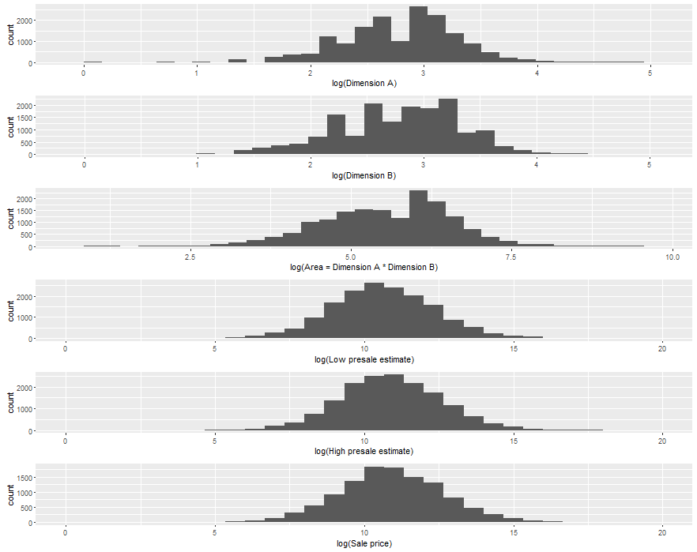

Figure 2: Comparison of painting dimensions, Impressionist art.

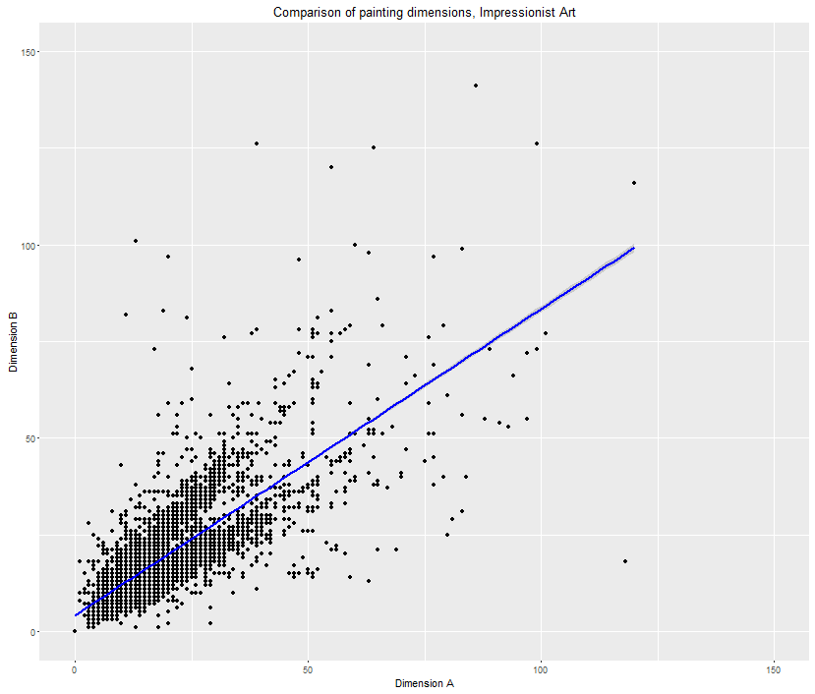

Figure 3: Impressionist art, auction sales over time.

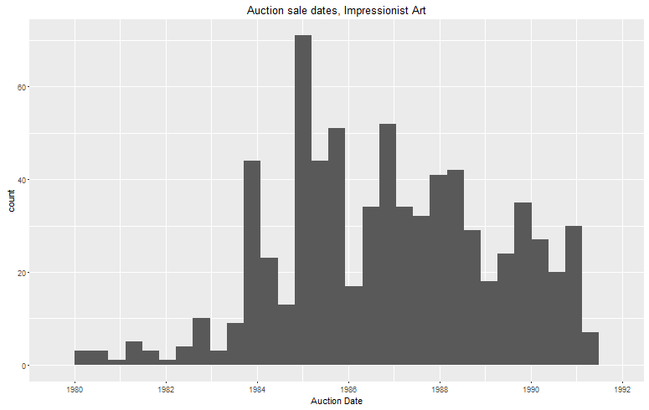

Figure 4: Distribution of selected quantities in the Contemporary art dataset.

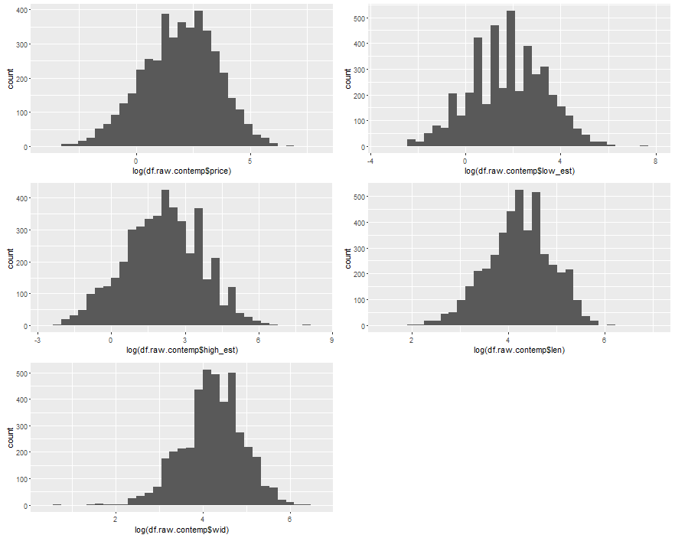

Figure 5: Auction sales over time, Contemporary art.

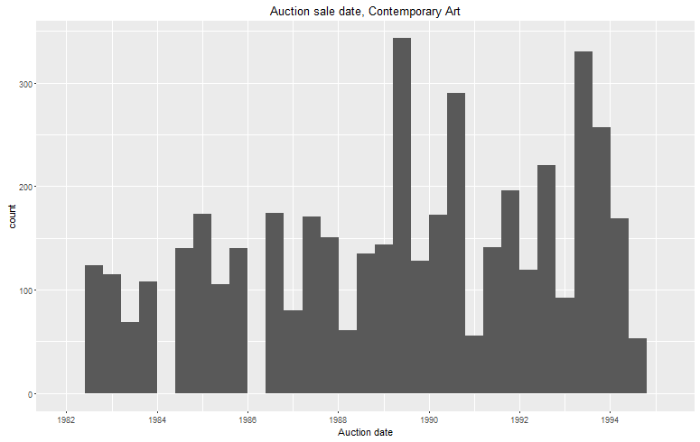

Figure 6: Comparison of log prices, Impressionist and Contemporary art.

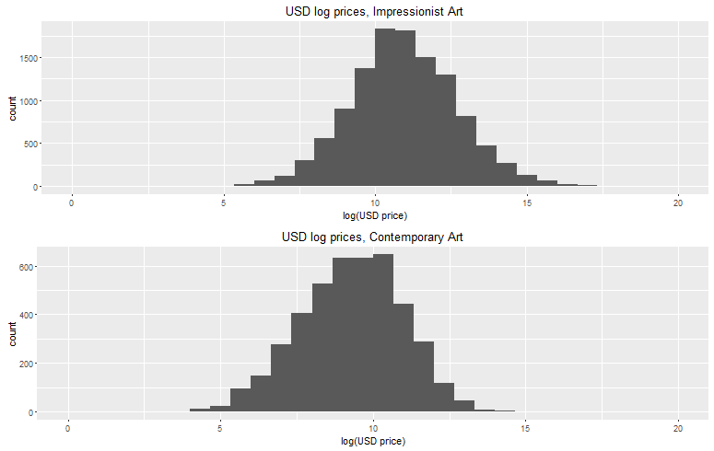

Figure 7: Comparison of log area, Impressionist and Contemporary art.

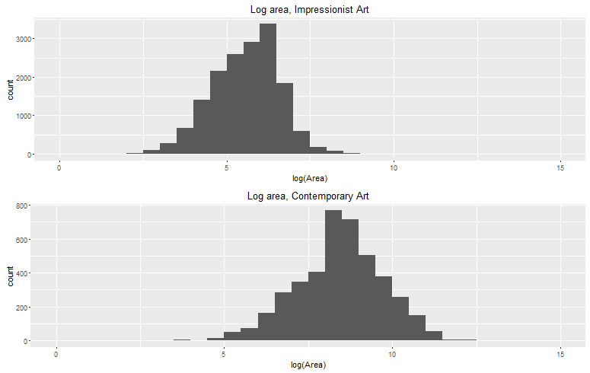

Figure 8: Comparison of painting dimensions, Contemporary art.

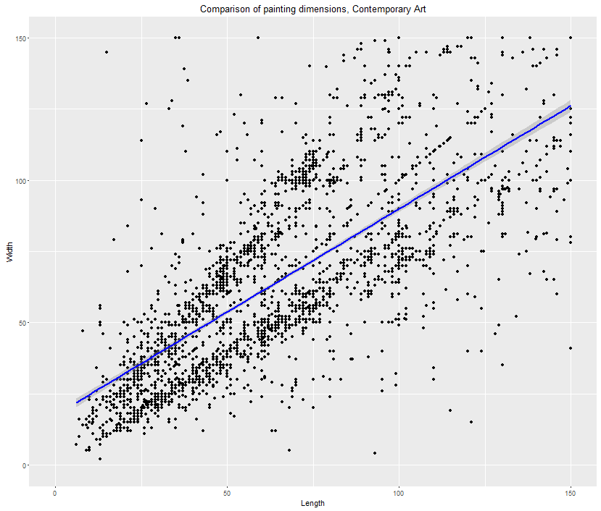

Figures 9-12: Plots for recent assorted art dataset.

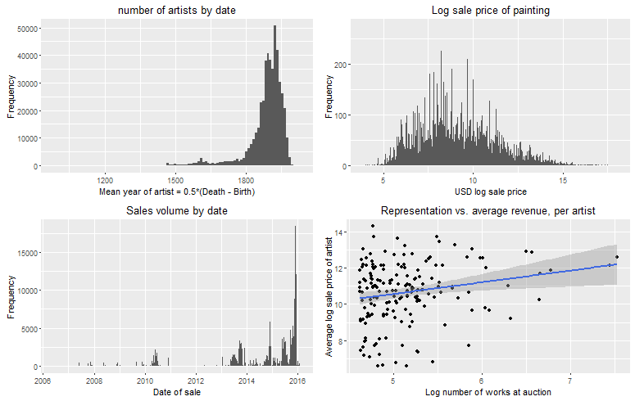

**TABLES**

**SUMMARY STATISTICS**

Table 1: Impressionist art, summary statistics for continuous features.

DIM_A LOW_EST HIGH_EST

Min. : 0.00 Min. : 102 Min. : 128

1st Qu.: 11.00 1st Qu.: 14000 1st Qu.: 18000

Median : 17.00 Median : 40000 Median : 50000

Mean : 18.31 Mean : 196023 Mean : 257967

3rd Qu.: 23.00 3rd Qu.: 132800 3rd Qu.: 168300

Max. :120.00 Max. :40000000 Max. :50000000

NA's :37

S_PRICE CNV_RATE DATE_PTG

Min. : 126 Min. :0.0000 Min. :1823

1st Qu.: 18700 1st Qu.:0.0000 1st Qu.:1902

Median : 53856 Median :1.2400 Median :1922

Mean : 285428 Mean :0.8639 Mean :1921

3rd Qu.: 176000 3rd Qu.:1.6800 3rd Qu.:1938

Max. :82500000 Max. :2.3610 Max. :1983

NA's :4696 NA's :3950

DATE_FLG DIM_B DIAM

Min. :0.0000 Min. : 0.00 Min. : 1.00

1st Qu.:0.0000 1st Qu.: 11.00 1st Qu.: 6.75

Median :0.0000 Median : 18.00 Median :11.50

Mean :0.3538 Mean : 18.69 Mean :15.10

3rd Qu.:1.0000 3rd Qu.: 24.00 3rd Qu.:24.50

Max. :1.0000 Max. :141.00 Max. :36.00

NA's :37 NA's :16243

PND_FLG

Min. :0.0000

1st Qu.:0.0000

Median :1.0000

Mean :0.5127

3rd Qu.:1.0000

Max. :2.0000

NA's :4

Table 2: Contemporary art, summary statistics.

Auction_date mdate ddate ydate

Min. :1982-06-29 Min. : 2.000 Min. : 1.00 Min. :1982

1st Qu.:1986-06-26 1st Qu.: 6.000 1st Qu.: 5.00 1st Qu.:1986

Median :1989-06-29 Median : 6.000 Median :22.00 Median :1989

Mean :1989-05-15 Mean : 7.831 Mean :17.07 Mean :1989

3rd Qu.:1992-07-02 3rd Qu.:12.000 3rd Qu.:26.00 3rd Qu.:1992

Max. :1994-06-30 Max. :12.000 Max. :30.00 Max. :1994

lot sold price low_est

Min. : 1.0 Min. :0.0000 Min. : 0.00 Min. : 0.05

1st Qu.: 87.0 1st Qu.:1.0000 1st Qu.: 1.90 1st Qu.: 2.00

Median : 423.0 Median :1.0000 Median : 7.00 Median : 6.00

Mean : 397.7 Mean :0.7745 Mean : 21.23 Mean : 19.53

3rd Qu.: 601.0 3rd Qu.:1.0000 3rd Qu.: 20.00 3rd Qu.: 20.00

Max. :1164.0 Max. :1.0000 Max. :1700.00 Max. :1800.00

NA's :2 NA's :45

high_est date_ptg len wid

Min. : 0.1 Min. :26.00 Min. : 5.40 Min. : 2.00

1st Qu.: 3.0 1st Qu.:60.00 1st Qu.: 44.50 1st Qu.: 46.00

Median : 8.0 Median :67.00 Median : 70.00 Median : 70.00

Mean : 26.1 Mean :68.24 Mean : 84.53 Mean : 84.71

3rd Qu.: 25.0 3rd Qu.:77.00 3rd Qu.:105.00 3rd Qu.:105.00

Max. :2600.0 Max. :91.00 Max. :957.00 Max. :602.00

NA's :45 NA's :449 NA's :73 NA's :293

artist medium CNV_RATE ukcpi

Length:4456 Length:4456 Min. :1.210 Min. :239.6

Class :character Class :character 1st Qu.:1.482 1st Qu.:286.4

Mode :character Mode :character Median :1.610 Median :339.3

Mean :1.609 Mean :342.9

3rd Qu.:1.722 3rd Qu.:407.1

Max. :1.954 Max. :423.0

ukinf uktb uscpi usinf

Min. : 1.270 Min. : 4.900 Min. :181.6 Min. :1.280

1st Qu.: 3.050 1st Qu.: 8.800 1st Qu.:204.1 1st Qu.:3.050

Median : 4.710 Median : 9.630 Median :231.7 Median :3.920

Mean : 5.061 Mean : 9.832 Mean :232.7 Mean :3.848

3rd Qu.: 6.520 3rd Qu.:11.990 3rd Qu.:261.9 3rd Qu.:4.600

Max. :10.430 Max. :14.540 Max. :276.8 Max. :6.220

ustb japcpi dj ftse

Min. : 2.970 Min. :149.3 Min. : 812.2 Min. : 736.2

1st Qu.: 3.990 1st Qu.:160.6 1st Qu.:1776.5 1st Qu.:1588.4

Median : 6.990 Median :168.2 Median :2458.3 Median :2182.0

Mean : 6.157 Mean :169.9 Mean :2438.5 Mean :2078.3

3rd Qu.: 7.760 3rd Qu.:182.3 3rd Qu.:3174.7 3rd Qu.:2546.6

Max. :10.320 Max. :185.4 Max. :3753.5 Max. :3223.9

Table 3: Assorted art, summary statistics.

height width area.inches artist.startdate

Min. : 0 Min. : 0 Min. :0.000e+00 Min. :1000

1st Qu.: 12 1st Qu.: 12 1st Qu.:1.520e+02 1st Qu.:1869

Median : 19 Median : 20 Median :3.920e+02 Median :1904

Mean : 64 Mean : 78 Mean :2.270e+08 Mean :1886

3rd Qu.: 29 3rd Qu.: 29 3rd Qu.:8.160e+02 3rd Qu.:1932

Max. :7700281 Max. :10197670 Max. :7.852e+13 Max. :2015

NA's :4000 NA's :31325 NA's :86729 NA's :19411

artist.enddate lot.number sale.date usd.sale.price

Min. :1016 Min. : 0 Min. :2006-06-09 Min. : 1

1st Qu.:1930 1st Qu.: 81 1st Qu.:2013-10-15 1st Qu.: 905

Median :1956 Median : 205 Median :2015-06-02 Median : 3009

Mean :1941 Mean : 1195 Mean :2014-08-27 Mean : 50275

3rd Qu.:1983 3rd Qu.: 599 3rd Qu.:2015-11-11 3rd Qu.: 12188

Max. :2015 Max. :221186 Max. :2016-02-04 Max. :70530000

NA's :19411 NA's :275 NA's :275 NA's :209591

**HEDONIC REGRESSION**

Table 4: Hedonic predictions, Impressionist Art (London). Half-year time dummies omitted for brevity.

Estimate Std. Error t value Pr(>|t|)

(Intercept) 10.667134 6.703545 1.591 0.112783

DATE_PTG -0.002122 0.003513 -0.604 0.546317

DIM_A 0.026975 0.007665 3.519 0.000512 ***

DIM_B 0.016575 0.006388 2.595 0.010018 *

SIGNED1 0.266633 0.350862 0.760 0.447990

SIGNED2 -0.064880 0.434096 -0.149 0.881308

SIGNED3 -0.429974 0.413009 -1.041 0.298822

ART_MED6 1.779714 0.677907 2.625 0.009178 **

ART_MED9 0.348789 0.684150 0.510 0.610622

ART_MED12 2.270866 0.674249 3.368 0.000874 ***

ART_MED15 1.473253 0.698082 2.110 0.035791 *

ART_MED18 2.952254 0.642515 4.595 6.80e-06 ***

ART_MED24 1.457382 0.771532 1.889 0.060030 .

ART_MED27 1.093956 0.661039 1.655 0.099170 .

ART_MED30 0.490681 0.658584 0.745 0.456923

ART_MED33 1.278982 0.846104 1.512 0.131866

ART_MED39 1.767484 0.660349 2.677 0.007918 **

R^2: 0.8664

Adjusted R^2: 0.8251

F-statistic: 21.01 on 79 and 256 DF, p-value: < 2.2e-16

Table 5: Hedonic predictions, Impressionist Art (NYC). Half-year time dummies omitted for brevity.

Estimate Std. Error t value Pr(>|t|)

(Intercept) 20.536155 5.799675 3.541 0.000458 ***

DATE_PTG -0.006033 0.002998 -2.013 0.044995 *

DIM_A 0.040589 0.007452 5.447 1.03e-07 ***

DIM_B 0.012602 0.007114 1.771 0.077433 .

SIGNED1 1.059125 0.156739 6.757 6.69e-11 ***

SIGNED2 0.301338 0.245387 1.228 0.220348

SIGNED3 0.203128 0.217131 0.936 0.350234

ART_MED6 -0.364772 0.687000 -0.531 0.595814

ART_MED9 -0.060186 0.642117 -0.094 0.925382

ART_MED12 1.014323 0.618434 1.640 0.101960

ART_MED15 -0.131242 0.665053 -0.197 0.843687

ART_MED18 1.248101 0.615153 2.029 0.043296 *

ART_MED21 0.773179 0.877041 0.882 0.378669

ART_MED24 0.361094 0.661262 0.546 0.585401

ART_MED27 -0.342484 0.656519 -0.522 0.602264

ART_MED30 -0.075431 0.646362 -0.117 0.907170

ART_MED38 -0.404069 0.807695 -0.500 0.617227

ART_MED39 0.645365 0.630585 1.023 0.306876

R^2: 0.8377

Adjusted R^2: 0.8

F-statistic: 22.24 on 74 and 319 DF, p-value: < 2.2e-16

Table 6: Hedonic predictions, Contemporary Art. Half-year time dummies omitted for brevity.

Estimate Std. Error t value Pr(>|t|)

(Intercept) -1.54229 1.91849 -0.804 0.422029

log(date_ptg) -0.67160 0.42660 -1.574 0.116371

log(len) 0.59158 0.11574 5.111 5.42e-07 ***

log(wid) 0.61585 0.11764 5.235 2.94e-07 ***

mediuma 0.37892 0.36754 1.031 0.303314

mediumbr -1.00407 0.47045 -2.134 0.033555 *

mediumchk -0.51240 0.50577 -1.013 0.311749

mediumcol -2.01051 0.54342 -3.700 0.000253 ***

mediumcr -0.85626 0.37571 -2.279 0.023304 *

mediumf -1.19646 0.49004 -2.442 0.015148 *

mediumg -0.92343 0.40669 -2.271 0.023817 *

mediumik -0.66618 0.38336 -1.738 0.083193 .

mediumo 0.33903 0.31500 1.076 0.282582

mediumpas -0.76427 0.55061 -1.388 0.166063

mediumpg 3.84267 0.64429 5.964 6.33e-09 ***

mediumph -2.97383 0.71974 -4.132 4.57e-05 ***

mediumpl 1.43608 0.66003 2.176 0.030281 *

mediumpn 0.73305 0.79588 0.921 0.357696

mediums -0.30325 0.49084 -0.618 0.537122

mediumsk 2.78109 0.57888 4.804 2.36e-06 ***

mediumt -0.77276 0.39024 -1.980 0.048510 *

mediumtp 0.25322 0.55431 0.457 0.648099

mediumw -0.41915 0.36663 -1.143 0.253758

R^2 0.9232

Adjusted R^2 0.8892

F-statistic: 27.17 on 146 and 330 DF, p-value: < 2.2e-16

Table 7: Hedonic predictions, assorted art. Half-year time dummies omitted for brevity. Artist and medium were omitted due to computational constraints.

Estimate Std. Error t value Pr(>|t|)

(Intercept) 6.224144 0.018000 345.782 <2e-16 ***

log(height) 0.614017 0.008031 76.454 <2e-16 ***

log(width) 0.230060 0.008092 28.431 <2e-16 ***

signed -0.634735 0.008009 -79.255 <2e-16 ***

monogrammed -0.203214 0.022359 -9.089 <2e-16 ***

stamped 0.086423 0.016030 5.391 7e-08 ***

R^2 0.1006

Adjusted R^2 0.1006

F-statistic: 5907 on 5 and 264109 DF, p-value: < 2.2e-16

**ANCHORING EFFECTS (REPLICATION)**

Table 8: Replicated anchoring effects, Impressionist Art

Estimate Std. Error t value Pr(>|t|)

(Intercept) -0.338390 0.192857 -1.755 0.0802 .

curr_hed_pred 1.018156 0.019093 53.327 < 2e-16 ***

anchoring 0.174402 0.072377 2.410 0.0165 *

past_control 0.503147 0.077019 6.533 2.29e-10 ***

months_since_last_sale 0.007903 0.001873 4.219 3.13e-05 ***

R^2 0.9231

Adjusted R^2 0.9222

F-statistic: 1047 on 4 and 349 DF, p-value: < 2.2e-16

Table 9: Replicated anchoring effects, Contemporary Art

Estimate Std. Error t value Pr(>|t|)

(Intercept) -0.1152982 0.0499920 -2.306 0.0223 *

curr_hed_pred 1.0344742 0.0203640 50.799 <2e-16 ***

anchoring 0.1312881 0.0740504 1.773 0.0780 .

past_control 0.1914626 0.0952936 2.009 0.0460 *

months_since_last_sale -0.0009164 0.0026884 -0.341 0.7336

R^2 0.9407

Adjusted R^2 0.9394

F-statistic: 698 on 4 and 176 DF, p-value: < 2.2e-16

Table 10: Anchoring effects, assorted art (original regression from Beggs & Graddy (2009))

Estimate Std. Error t value Pr(>|t|)

(Intercept) -1.598781 0.096913 -16.497 <2e-16 ***

log_hed_pred 1.147787 0.011706 98.054 <2e-16 ***

anchoring 0.590709 0.011442 51.626 <2e-16 ***

sub_price_hed_pred -0.020331 0.012078 -1.683 0.0923 .

avg_mon_subdiff -0.042259 0.004782 -8.837 <2e-16 ***

R^2 0.4144

Adjusted R^2 0.4144

F-statistic: 3.046e+04 on 4 and 172189 DF, p-value: < 2.2e-16

**ANCHORING CROSS-EFFECTS (Q1)**

Table 11: Anchoring cross-effects ($Q_{1}$) for Impressionist art.

Call:

lm(formula = log_sale_price ~ log_hed_pred + anchoring + sub_price_hed_pred +

substitute_measure + avg_months_since_sub_sale, data = df.anchor.sub.impress)

Residuals:

Min 1Q Median 3Q Max

-5.2368 -0.4767 0.0007 0.4753 3.2939

Coefficients:

Estimate Std. Error t value Pr(>|t|)

(Intercept) -0.1049942 0.0673771 -1.558 0.1192

log_hed_pred 1.0203528 0.0120905 84.393 <2e-16 ***

anchoring 0.0342261 0.0141471 2.419 0.0156 *

sub_price_hed_pred 0.2836732 0.0211621 13.405 <2e-16 ***

substitute_measure 0.0084785 0.0041261 2.055 0.0399 *

avg_months_since_sub_sale -0.0006209 0.0006000 -1.035 0.3008

---

Signif. codes: 0 ‘***’ 0.001 ‘**’ 0.01 ‘*’ 0.05 ‘.’ 0.1 ‘ ’ 1

Residual standard error: 0.773 on 11608 degrees of freedom

Multiple R-squared: 0.7752, Adjusted R-squared: 0.7751

F-statistic: 8004 on 5 and 11608 DF, p-value: < 2.2e-16

Table 12: Anchoring cross-effects ($Q_{1}$) for Contemporary art.

Call:

lm(formula = log_sale_price ~ log_hed_pred + anchoring + sub_price_hed_pred +

substitute_measure + avg_months_since_sub_sale, data = df.reg.sub)

Residuals:

Min 1Q Median 3Q Max

-2.96495 -0.33364 0.02062 0.35064 1.66091

Coefficients:

Estimate Std. Error t value Pr(>|t|)

(Intercept) 0.059521 0.090352 0.659 0.510202

log_hed_pred 1.034162 0.024752 41.781 < 2e-16 ***

anchoring -0.030017 0.028887 -1.039 0.299009

sub_price_hed_pred 0.298056 0.043888 6.791 1.95e-11 ***

substitute_measure -0.013093 0.008939 -1.465 0.143340

avg_months_since_sub_sale -0.050238 0.014234 -3.529 0.000436 ***

---

Signif. codes: 0 ‘***’ 0.001 ‘**’ 0.01 ‘*’ 0.05 ‘.’ 0.1 ‘ ’ 1

Residual standard error: 0.5653 on 952 degrees of freedom

Multiple R-squared: 0.8313, Adjusted R-squared: 0.8304

F-statistic: 938 on 5 and 952 DF, p-value: < 2.2e-16

Table 13: Anchoring cross-effects ($Q_{1}$) for assorted art.

Call:

lm(formula = log_sale_price ~ ., data = df.anchoring[complete.cases(df.anchoring),

])

Residuals:

Min 1Q Median 3Q Max

-7.3357 -1.1534 -0.0891 1.0304 7.7630

Coefficients:

Estimate Std. Error t value Pr(>|t|)

(Intercept) -1.994594 0.220561 -9.043 < 2e-16 ***

log_hed_pred 1.240644 0.025869 47.959 < 2e-16 ***

anchoring 0.661090 0.025028 26.414 < 2e-16 ***

sub_price_hed_pred -0.102460 0.026481 -3.869 0.00011 ***

substitute_measure 0.026968 0.005026 5.366 8.16e-08 ***

avg_mon_subdiff -0.088799 0.015873 -5.594 2.25e-08 ***

---

Signif. codes: 0 ‘***’ 0.001 ‘**’ 0.01 ‘*’ 0.05 ‘.’ 0.1 ‘ ’ 1

Residual standard error: 1.616 on 17693 degrees of freedom

Multiple R-squared: 0.4613, Adjusted R-squared: 0.4611

F-statistic: 3030 on 5 and 17693 DF, p-value: < 2.2e-16

**ANCHORING CROSS-EFFECTS (Q2)**

Table 14: Anchoring cross-effects ($Q_{2}$) for Impressionist art.

Call:

lm(formula = log_sale_price ~ log_hed_pred + anchoring + sub_price_hed_pred +

substitute_measure + avg_months_since_sub_sale, data = df.anchor.sub.impress)

Residuals:

Min 1Q Median 3Q Max

-5.2351 -0.4763 0.0000 0.4755 3.2843

Coefficients:

Estimate Std. Error t value Pr(>|t|)

(Intercept) 0.0085722 0.0741016 0.116 0.9079

log_hed_pred 0.9988786 0.0061643 162.044 <2e-16 ***

anchoring 0.0262716 0.0133724 1.965 0.0495 *

sub_price_hed_pred 0.2861356 0.0210827 13.572 <2e-16 ***

substitute_measure 0.0150060 0.0080184 1.871 0.0613 .

avg_months_since_sub_sale -0.0001465 0.0007528 -0.195 0.8457

---

Signif. codes: 0 ‘***’ 0.001 ‘**’ 0.01 ‘*’ 0.05 ‘.’ 0.1 ‘ ’ 1

Residual standard error: 0.773 on 11608 degrees of freedom

Multiple R-squared: 0.7752, Adjusted R-squared: 0.7751

F-statistic: 8004 on 5 and 11608 DF, p-value: < 2.2e-16

Table 15: Anchoring cross-effects ($Q_{2}$) for Contemporary art.

Call:

lm(formula = log_sale_price ~ log_hed_pred + anchoring + sub_price_hed_pred +

substitute_measure + avg_months_since_sub_sale, data = df.reg.sub)

Residuals:

Min 1Q Median 3Q Max

-2.95880 -0.33439 0.02226 0.34534 1.67089

Coefficients:

Estimate Std. Error t value Pr(>|t|)

(Intercept) -0.091648 0.114989 -0.797 0.425642

log_hed_pred 1.055614 0.018161 58.124 < 2e-16 ***

anchoring -0.021001 0.027097 -0.775 0.438519

sub_price_hed_pred 0.291614 0.043657 6.680 4.07e-11 ***

substitute_measure -0.011917 0.005894 -2.022 0.043486 *

avg_months_since_sub_sale -0.050393 0.014217 -3.545 0.000412 ***

---

Signif. codes: 0 ‘***’ 0.001 ‘**’ 0.01 ‘*’ 0.05 ‘.’ 0.1 ‘ ’ 1

Residual standard error: 0.5647 on 952 degrees of freedom

Multiple R-squared: 0.8316, Adjusted R-squared: 0.8307

F-statistic: 940.3 on 5 and 952 DF, p-value: < 2.2e-16

Table 16: Anchoring cross-effects ($Q_{2}$) for assorted art.

Call:

lm(formula = log_sale_price ~ ., data = df.anchoring[complete.cases(df.anchoring),

])

Residuals:

Min 1Q Median 3Q Max

-7.1890 -1.0271 0.0846 1.0769 7.9026

Coefficients:

Estimate Std. Error t value Pr(>|t|)

(Intercept) -2.03647 0.17645 -11.541 < 2e-16 ***

log_hed_pred 1.27157 0.01920 66.215 < 2e-16 ***

anchoring 0.51926 0.02197 23.632 < 2e-16 ***

sub_price_hed_pred 0.08111 0.02262 3.586 0.000337 ***

substitute_measure 0.29640 0.01520 19.504 < 2e-16 ***

avg_mon_subdiff 0.07226 0.01019 7.093 1.34e-12 ***

---

Signif. codes: 0 ‘***’ 0.001 ‘**’ 0.01 ‘*’ 0.05 ‘.’ 0.1 ‘ ’ 1

Residual standard error: 1.658 on 29784 degrees of freedom

Multiple R-squared: 0.3979, Adjusted R-squared: 0.3978

F-statistic: 3936 on 5 and 29784 DF, p-value: < 2.2e-16

Table 17: Summary of anchoring results.

|  |  |  |
| --- | --- | --- |
|  | Anchoring under $Q_{1}$ | Anchoring under $Q_{2}$ |
| Impressionist Art | 0.034 * | 0.026 * |
| Contemporary Art | -0.03 | -0.02 |
| Assorted Art | 0.66 *** | 0.52 *** |

**THREE EXPERIMENTS**

Table 18: Miro vs. Dali ($Q_{1}$)

Call:

lm(formula = log_sale_price ~ ., data = df.anchoring[complete.cases(df.anchoring),

])

Residuals:

Min 1Q Median 3Q Max

-3.2922 -1.0052 -0.1560 0.8208 8.4440

Coefficients:

Estimate Std. Error t value Pr(>|t|)

(Intercept) 7.15043 2.16084 3.309 0.000959 ***

log_hed_pred 0.51936 0.27060 1.919 0.055144 .

anchoring -0.37001 0.25243 -1.466 0.142918

sub_price_hed_pred 0.48840 0.25445 1.919 0.055125 .

substitute_measure 0.18523 0.02024 9.149 < 2e-16 ***

avg_mon_subdiff -0.08254 0.04425 -1.865 0.062339 .

---

Signif. codes: 0 ‘***’ 0.001 ‘**’ 0.01 ‘*’ 0.05 ‘.’ 0.1 ‘ ’ 1

Residual standard error: 1.483 on 1458 degrees of freedom

Multiple R-squared: 0.1255, Adjusted R-squared: 0.1225

F-statistic: 41.84 on 5 and 1458 DF, p-value: < 2.2e-16

Table 19: Miro vs. Dali ($Q_{2}$)

Call:

lm(formula = log_sale_price ~ ., data = df.anchoring[complete.cases(df.anchoring),

])

Residuals:

Min 1Q Median 3Q Max

-3.0733 -1.0296 -0.1694 0.7886 8.2793

Coefficients:

Estimate Std. Error t value Pr(>|t|)

(Intercept) 8.67695 2.23295 3.886 0.000107 ***

log_hed_pred -0.06076 0.27531 -0.221 0.825343

anchoring -0.97311 0.25364 -3.836 0.000130 ***

sub_price_hed_pred 1.03215 0.25775 4.005 6.53e-05 ***

substitute_measure 0.01170 0.03687 0.317 0.751092

avg_mon_subdiff -0.10641 0.04740 -2.245 0.024933 *

---

Signif. codes: 0 ‘***’ 0.001 ‘**’ 0.01 ‘*’ 0.05 ‘.’ 0.1 ‘ ’ 1

Residual standard error: 1.525 on 1458 degrees of freedom

Multiple R-squared: 0.07533, Adjusted R-squared: 0.07216

F-statistic: 23.76 on 5 and 1458 DF, p-value: < 2.2e-16

Table 20: Picasso vs. Chagall ($Q_{1}$)

Call:

lm(formula = log_sale_price ~ ., data = df.anchoring[complete.cases(df.anchoring),

])

Residuals:

Min 1Q Median 3Q Max

-4.6215 -1.0532 -0.1586 0.8661 7.3545

Coefficients:

Estimate Std. Error t value Pr(>|t|)

(Intercept) -2.88027 3.35265 -0.859 0.390372

log_hed_pred 2.02669 0.34011 5.959 2.92e-09 ***

anchoring 1.54597 0.32518 4.754 2.11e-06 ***

sub_price_hed_pred -1.12558 0.32794 -3.432 0.000609 ***

substitute_measure 0.36201 0.02246 16.116 < 2e-16 ***

avg_mon_subdiff -0.05674 0.03661 -1.550 0.121289

---

Signif. codes: 0 ‘***’ 0.001 ‘**’ 0.01 ‘*’ 0.05 ‘.’ 0.1 ‘ ’ 1

Residual standard error: 1.686 on 2359 degrees of freedom

Multiple R-squared: 0.179, Adjusted R-squared: 0.1773

F-statistic: 102.9 on 5 and 2359 DF, p-value: < 2.2e-16

Table 21: Picasso vs. Chagall ($Q_{2}$)

Call:

lm(formula = log_sale_price ~ ., data = df.anchoring[complete.cases(df.anchoring),

])

Residuals:

Min 1Q Median 3Q Max

-4.7629 -1.0573 -0.2084 0.8451 8.3682

Coefficients:

Estimate Std. Error t value Pr(>|t|)

(Intercept) -21.89473 3.22978 -6.779 1.52e-11 ***

log_hed_pred 3.47944 0.34053 10.218 < 2e-16 ***

anchoring 2.53673 0.33207 7.639 3.16e-14 ***

sub_price_hed_pred -2.24188 0.33296 -6.733 2.08e-11 ***

substitute_measure 0.55122 0.08374 6.582 5.69e-11 ***

avg_mon_subdiff 0.20532 0.05785 3.549 0.000394 ***

---

Signif. codes: 0 ‘***’ 0.001 ‘**’ 0.01 ‘*’ 0.05 ‘.’ 0.1 ‘ ’ 1

Residual standard error: 1.76 on 2359 degrees of freedom

Multiple R-squared: 0.1051, Adjusted R-squared: 0.1032

F-statistic: 55.39 on 5 and 2359 DF, p-value: < 2.2e-16

Table 22: Munch vs. Toulouse-Lautrec ($Q_{1}$)

Call:

lm(formula = log_sale_price ~ ., data = df.anchoring[complete.cases(df.anchoring),

])

Residuals:

Min 1Q Median 3Q Max

-5.2478 -0.9364 -0.0661 1.0238 7.1826

Coefficients:

Estimate Std. Error t value Pr(>|t|)

(Intercept) 2.21191 2.30155 0.961 0.337

log_hed_pred 0.85602 0.20483 4.179 3.83e-05 ***

anchoring -0.21898 0.19898 -1.101 0.272

sub_price_hed_pred 0.14003 0.21334 0.656 0.512

substitute_measure 0.04258 0.04577 0.930 0.353

avg_mon_subdiff 0.05321 0.07060 0.754 0.452

---

Signif. codes: 0 ‘***’ 0.001 ‘**’ 0.01 ‘*’ 0.05 ‘.’ 0.1 ‘ ’ 1

Residual standard error: 1.567 on 305 degrees of freedom

Multiple R-squared: 0.2927, Adjusted R-squared: 0.2811

F-statistic: 25.24 on 5 and 305 DF, p-value: < 2.2e-16

Table 23: Munch vs. Toulouse-Lautrec ($Q_{2}$)

Call:

lm(formula = log_sale_price ~ ., data = df.anchoring[complete.cases(df.anchoring),

])

Residuals:

Min 1Q Median 3Q Max

-5.2282 -0.9288 -0.0752 0.9997 7.0301

Coefficients:

Estimate Std. Error t value Pr(>|t|)

(Intercept) 2.7240 2.1874 1.245 0.2140

log_hed_pred 0.8145 0.2060 3.953 9.59e-05 ***

anchoring -0.2728 0.2016 -1.353 0.1770

sub_price_hed_pred 0.1956 0.2151 0.909 0.3639

substitute_measure 0.3686 0.2114 1.744 0.0822 .

avg_mon_subdiff 0.2615 0.1351 1.936 0.0538 .

---

Signif. codes: 0 ‘***’ 0.001 ‘**’ 0.01 ‘*’ 0.05 ‘.’ 0.1 ‘ ’ 1

Residual standard error: 1.562 on 305 degrees of freedom

Multiple R-squared: 0.2977, Adjusted R-squared: 0.2862

F-statistic: 25.86 on 5 and 305 DF, p-value: < 2.2e-16

1. Tversky, Amos, and Daniel Kahneman. "Judgment under uncertainty: Heuristics and biases." *science* 185.4157 (1974): 1124-1131.
2. http://www.christies.com/about/press-center/releases/pressrelease.aspx?pressreleaseid=7712
3. <http://www.xe.com/currencyconverter/convert/?From=GBP&To=USD> accessed 2/20/2015
4. Interview with Raphaelle Benabou
5. Beggs, Alan, and Kathryn Graddy. "Anchoring effects: Evidence from art auctions." *The American Economic Review* 99.3 (2009): 1027-1039.
6. http://www.bloomberg.com/news/articles/2015-06-21/auction-wars-christie-s-sotheby-s-and-the-art-of-competition
7. http://www.bloombergview.com/articles/2014-12-03/how-sothebys-and-christies-went-wrong
8. http://www.wikinvest.com/stock/Sotheby's_Holdings_(BID)
9. http://www.nytimes.com/2015/08/17/arts/international/sothebys-and-christies-jostle-for-sales.html
10. http://www.christies.com/auctions/first-open-september-2014/#specialist-picks-section
11. http://www.sothebys.com/en/news-video/auction-essays/sothebys-digital-features/2015/01/online-bidding-regis.html
12. http://www.forbes.com/2001/11/14/1114connguide.html
13. http://www.nytimes.com/2015/08/17/arts/international/sothebys-and-christies-jostle-for-sales.html
14. http://www.bloomberg.com/news/articles/2015-06-21/auction-wars-christie-s-sotheby-s-and-the-art-of-competition
15. http://www.nytimes.com/2015/01/08/arts/design/sothebys-and-christies-return-to-guaranteeing-art-prices.html
16. http://www.artspace.com/magazine/news_events/the_heat_index/how_to_understand_new_york_record_auction_week-52310
17. http://www.wsj.com/articles/SB969829620926708015
18. http://www.sothebys.com/en/news-video/videos/2014/10/how-to-sell-at-auction.html
19. Ashenfelter, Orley. "How auctions work for wine and art." *The Journal of Economic Perspectives* 3.3 (1989): 23-36.
20. http://www.jstor.org/stable/pdf/40724283.pdf?_=1459015351227
21. Vincent, Daniel R. "Bidding off the wall: Why reserve prices may be kept secret." *Journal of Economic Theory* 65.2 (1995): 575-584.
22. Ashenfelter, Orley. "How auctions work for wine and art." *The Journal of Economic Perspectives* 3.3 (1989): 23-36.
23. Typically, the auctioneer will call out prices that are approximately 10% higher than the current bid. http://www.sothebys.com/en/Glossary.html
24. http://www.ppge.ufrgs.br/giacomo/arquivos/econ-cultura/ashenfelter-graddy-2003.pdf
25. http://www.christies.com/features/guides/selling-guide/selling-at-christies/after-the-sale/
26. http://www.ppge.ufrgs.br/giacomo/arquivos/econ-cultura/ashenfelter-graddy-2003.pdf
27. http://www.ppge.ufrgs.br/giacomo/arquivos/econ-cultura/ashenfelter-graddy-2003.pdf
28. http://video.cnbc.com/gallery/?video=3000504214
29. Tversky, A.; Kahneman, D. (1974). "Judgment under Uncertainty: Heuristics and Biases" (PDF). Science 185 (4157): 1124–1131. doi:10.1126/science.185.4157.1124. PMID 17835457.
30. Sugden, Robert, Jiwei Zheng, and Daniel John Zizzo. "Not all anchors are created equal." *Journal of Economic Psychology* 39 (2013): 21-31.
31. Edward Teach, "Avoiding Decision Traps", CFO (1 June 2004). Retrieved 29 May 2007.
32. Graddy, Kathryn, et al. "Anchoring or loss aversion? Empirical evidence from art auctions." (2014).
33. Observation from MB 00 about how even the same work can change over time?
34. Graddy, Kathryn, et al. "Anchoring or loss aversion? Empirical evidence from art auctions." (2014).
35. De Silva, Dakshina G., Rachel AJ Pownall, and Leonard Wolk. "Does the sun ‘shine’on art prices?." *Journal of Economic Behavior & Organization*82.1 (2012): 167-178.
36. Northcraft, Gregory B., and Margaret A. Neale. "Experts, amateurs, and real estate: An anchoring-and-adjustment perspective on property pricing decisions." *Organizational behavior and human decision processes* 39.1 (1987): 84-97.
37. Sugden, Robert, Jiwei Zheng, and Daniel John Zizzo. "Not all anchors are created equal." *Journal of Economic Psychology* 39 (2013): 21-31.
38. Alevy, Jonathan E., John A. List, and Wiktor L. Adamowicz. "How can behavioral economics inform nonmarket valuation? An example from the preference reversal literature." *Land Economics* 87.3 (2011): 365-381.
39. https://mikebrandlyauctioneer.wordpress.com/2015/04/13/value-anchoring-in-the-auction-business/
40. Furnham, Adrian, and Hua Chu Boo. "A literature review of the anchoring effect." *The Journal of Socio-Economics* 40.1 (2011): 35-42.
41. Tversky, Amos, and Daniel Kahneman. "Judgment under uncertainty: Heuristics and biases." *science* 185.4157 (1974): 1124-1131.
42. http://soco.uni-koeln.de/files/jpsp73.pdf
43. Bergman, Oscar, et al. "Anchoring and cognitive ability." *Economics Letters*107.1 (2010): 66-68.
44. Strack, Fritz; Mussweiler, Thomas (1997). "Explaining the enigmatic anchoring effect: Mechanisms of selective accessibility.". Journal of Personality and Social Psychology 73 (3): 437–446. doi:10.1037/0022-3514.73.3.437.
45. Furnham, Adrian, and Hua Chu Boo. "A literature review of the anchoring effect." *The Journal of Socio-Economics* 40.1 (2011): 35-42.
46. Rajendran & Tellis (1994); Greenleaf (1995); Geltner (2011); Dougal et al. (2012).
47. Furnham, Adrian, and Hua Chu Boo. "A literature review of the anchoring effect." *The Journal of Socio-Economics* 40.1 (2011): 35-42.
48. Frykblom, Peter, and Jason F. Shogren. "An experimental testing of anchoring effects in discrete choice questions." *Environmental and resource economics* 16.3 (2000): 329-341.
49. Winter, Joachim. "Bracketing effects in categorized survey questions and the measurement of economic quantities." (2002).
50. Flachaire, Emmanuel, and Guillaume Hollard. "Starting point bias and respondent uncertainty in dichotomous choice contingent valuation surveys."*Resource and energy economics* 29.3 (2007): 183-194.
51. Kinney Jr, William R., and Wilfred C. Uecker. "Mitigating the consequences of anchoring in auditor judgments." *Accounting Review* (1982): 55-69.
52. Bucchianeri, Grace W., and Julia A. Minson. "A homeowner's dilemma: Anchoring in residential real estate transactions." *Journal of Economic Behavior & Organization* 89 (2013): 76-92.
53. Mussweiler, Thomas. "Sentencing Under Uncertainty: Anchoring Effects in the Courtroom1." *Journal of applied social psychology* 31.7 (2001): 1535-1551.
54. Green, Donald, et al. "Referendum contingent valuation, anchoring, and willingness to pay for public goods." *Resource and Energy Economics* 20.2 (1998): 85-116.
55. Nianhang, Xu, and Wu Shinong. "A Study on Anchoring Effect for Non-tradable Share Reform of Listed Companies in China [J]." *Economic Research Journal* 1 (2007): 009.
56. Lucking‐Reiley, David, et al. "Pennies from ebay: The determinants of price in online auctions*." *The Journal of Industrial Economics* 55.2 (2007): 223-233.
57. Ku, Gillian, Adam D. Galinsky, and J. Keith Murnighan. "Starting low but ending high: A reversal of the anchoring effect in auctions." *Journal of Personality and social Psychology* 90.6 (2006): 975.
58. Ariely, Dan, George Loewenstein, and Drazen Prelec. "Tom Sawyer and the construction of value." *Journal of Economic Behavior & Organization* 60.1 (2006): 1-10.
59. Wolk, Agnieszka, and Martin Spann. "The effects of reference prices on bidding behavior in interactive pricing mechanisms." *Journal of Interactive Marketing* 22.4 (2008): 2-18.
60. Beggs, Alan, and Kathryn Graddy. "Testing for reference dependence: An application to the art market." (2005).
61. Richardson, Andrew. 1992. “An Econometric Analysis of the Auction Market for Impressionist and Modern Pictures, 1980-1991.” Senior thesis, Department of Economics, Princeton University.
62. Beggs, Alan, and Kathryn Graddy. "Testing for reference dependence: An application to the art market." (2005).
63. Loss aversion is another behavioral bias that says losses are felt more strongly than equivalent gains.
64. Beggs, Alan, and Kathryn Graddy. "Anchoring effects: Evidence from art auctions." *The American Economic Review* 99.3 (2009): 1027-1039.
65. Leung, Tin Cheuk, and Kwok Ping Tsang. "Anchoring and loss aversion in the housing market: implications on price dynamics." *China Economic Review* 24 (2013): 42-54.
66. See also Mei, J., et al. "Loss Aversion? What Loss Aversion? Some Suprising Evidence from the Art Market." *Working Paper*. 2010.
67. Graddy, Kathryn, et al. "Anchoring or loss aversion? Empirical evidence from art auctions." (2014).
68. Bruno, Brunella, and Giacomo Nocera. "Investing in art: The informational content of Italian painting pre-sale estimates." *Available at SSRN 1179183*(2008).
69. Specifically, both the relative and absolute range between low and high estimates.
70. Hong, Harrison, et al. "Ordering, revenue and anchoring in art auctions." *The RAND Journal of Economics* 46.1 (2015): 186-216.
71. http://www.artspace.com/magazine/news_events/the_heat_index/how_to_understand_new_york_record_auction_week-52310
72. Beggs, Alan, and Kathryn Graddy. "Failure to meet the reserve price: The impact on returns to art." *Journal of Cultural Economics* 32.4 (2008): 301-320.
73. Canals-Cerdá, José J. "The value of a good reputation online: an application to art auctions." *Journal of Cultural Economics* 36.1 (2012): 67-85.
74. Pénasse, Julien, Luc Renneboog, and Christophe Spaenjers. "Sentiment and art prices." *Economics Letters* 122.3 (2014): 432-434.
75. De Silva, Dakshina G., Rachel AJ Pownall, and Leonard Wolk. "Does the sun ‘shine’on art prices?." *Journal of Economic Behavior & Organization*82.1 (2012): 167-178.
76. See Graddy et al. (2014); Hong et al. (2015).
77. See Table 1 and 2 – sample means – in Beggs & Graddy (2009).
78. Edmonds, Radcliffe G. "A theoretical basis for hedonic regression: A research primer." *Real Estate Economics* 12.1 (1984): 72-85.
79. Costanigro, Marco, Jill J. McCluskey, and Ron C. Mittelhammer. "Segmenting the wine market based on price: hedonic regression when different prices mean different products." *Journal of agricultural Economics*58.3 (2007): 454-466.
80. The data here consists of all sale observations that correspond to the set of paintings that have been resold multiple times. Beggs & Graddy have painstakingly verified each observation against presale catalogs. Because those are not available, in my replication analysis I make the assumption that duplicate observations in their Impressionist and Contemporary data refer to multiple sales of the same item.
81. As with resale, we add the temporal constraint that the sale of a substitute must occur before the sale of the current good – in this context, one can only anchor on the past.
82. We do not subtract the other term ${\left(E\left[X=|π_{c}-π_{s}|\right]\right)}^{2}$ typically used in calculating variance $V\left[X\right]=E\left[X^{2}\right]-E{\left[X\right]}^{2}$, since that (squared) first moment term reflects absolute hedonic differences $X=|π_{c}-π_{s}|$ between pieces which we still wish to account for. Hence, our measure captures both variance and mean.
83. For further discussion: http://www.jstor.org/stable/pdf/20715780.pdf?acceptTC=true
84. We add one in the denominator of the first term to protect against results exploding toward infinity. Empirically, however, this is negligible compared to the magnitude of our hedonic prices.
85. Richardson (2002); Abowd & Ashenfelter (1989); Beggs & Graddy (1997); Ashenfelter & Graddy (2003); Beggs & Graddy (2009)
86. http://www.jstor.org/stable/pdf/2556028.pdf?acceptTC=true
87. http://people.brandeis.edu/~kgraddy/data.html
88. The collected raw data also includes prints, drawings, and other mediums, but since we wish to compare against our other two datasets, we only use paintings here.
89. http://artsalesindex.artinfo.com
90. http://www.christies.com/lotfinder/paintings/invader-alias-hk-59-5875653-details.aspx
91. For instance, Matt Lamb’s “Figures” fetched $24K at Christie’s, London on June 22, 2010. http://www.christies.com/lotfinder/paintings/matt-lamb-figures-5332422-details.aspx
92. http://joanmiro.com/style-of-joan-miro/
93. http://www.theartstory.org/artist-dali-salvador.htm
94. http://www.galeriemichael.com/current-exhibitions/miro-dali-poetic-visions-two-catalan-surrealists/
95. http://www.pablopicasso.org/picasso-and-chagall.jsp
96. http://www.theartstory.org/artist-chagall-marc.htm
97. http://www.infoplease.com/encyclopedia/people/chagall-marc.html
98. http://www.operagallery.com/catalogues/picasso_chagall_dubai/cata.pdf
99. http://pueblopulp.com/picasso-matisse-chagall
100. http://www.theartstory.org/artist-munch-edvard.htm
101. http://www.toulouse-lautrec-foundation.org/biography.html
102. <http://libmma.contentdm.oclc.org/cdm/ref/collection/p16028coll12/id/1460>
103. http://www.theguardian.com/artanddesign/2015/feb/04/sothebys-auction-highest-sales-total-ever
104. http://www.nytimes.com/2012/05/03/arts/design/the-scream-sells-for-nearly-120-million-at-sothebys-auction.html?_r=0
105. http://www.bloomberg.com/news/articles/2015-02-05/here-s-why-sotheby-s-and-christie-s-just-sold-444-8-million-in-impressionist-art