**FIGURES**

Figure 1: Distribution of selected quantities in the Impressionist art dataset.

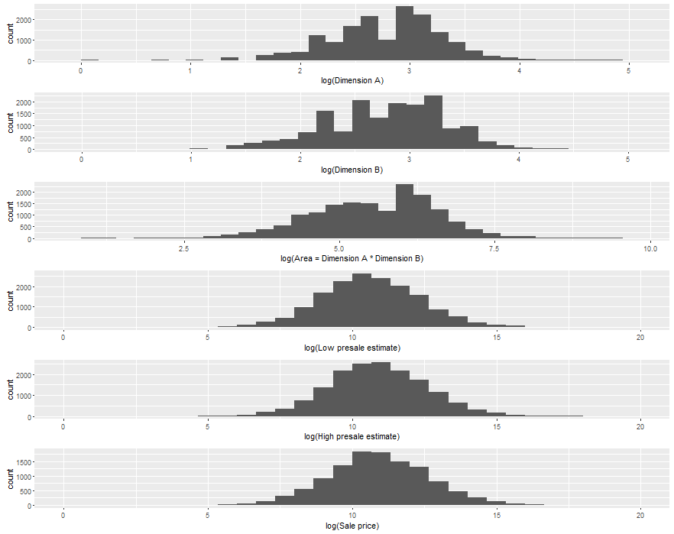

Figure 2: Comparison of painting dimensions, Impressionist art.

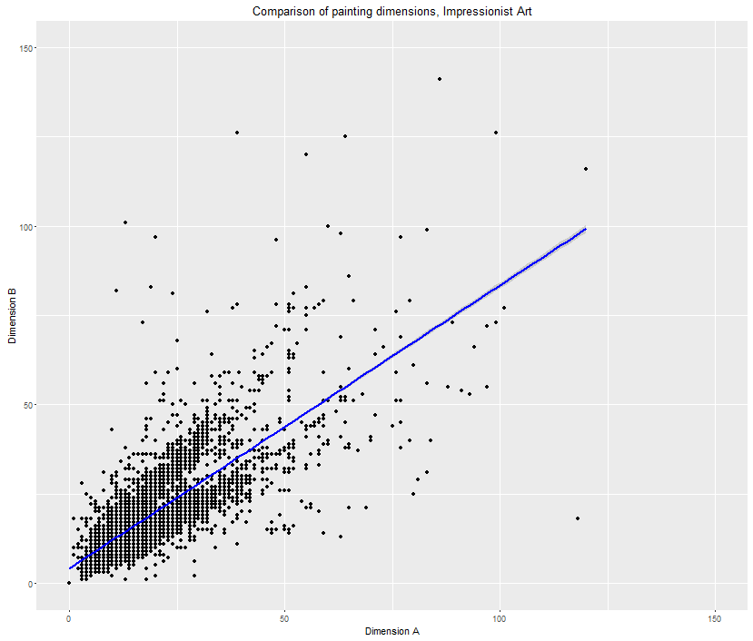

Figure 3: Impressionist art, auction sales over time.

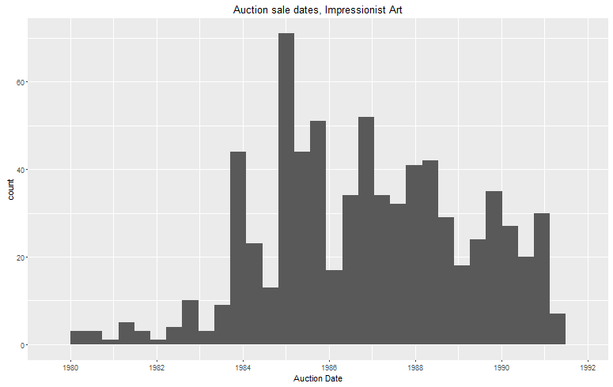

Figure 4: Distribution of selected quantities in the Contemporary art dataset.

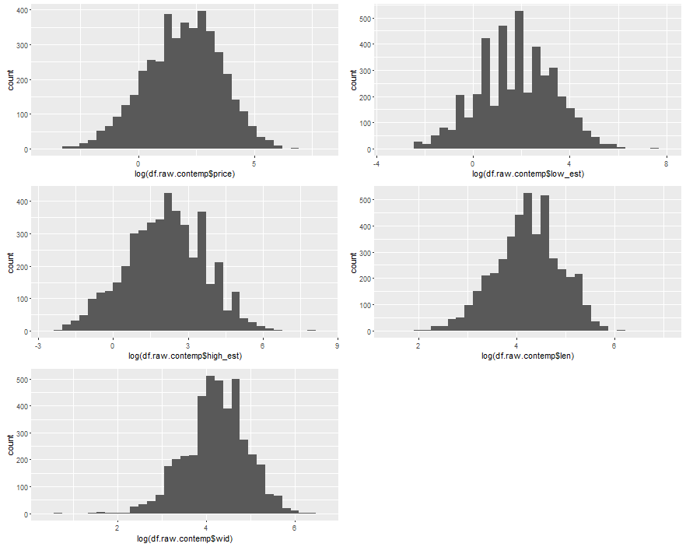

Figure 5: Auction sales over time, Contemporary art.

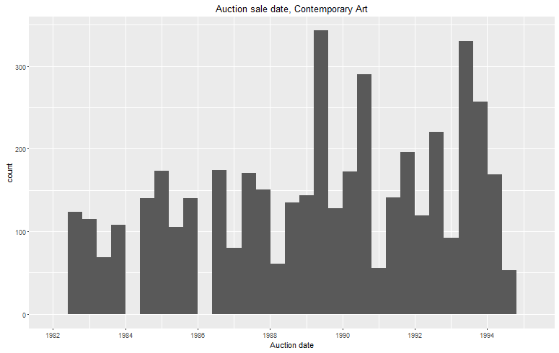

Figure 6: Comparison of log prices, Impressionist and Contemporary art.

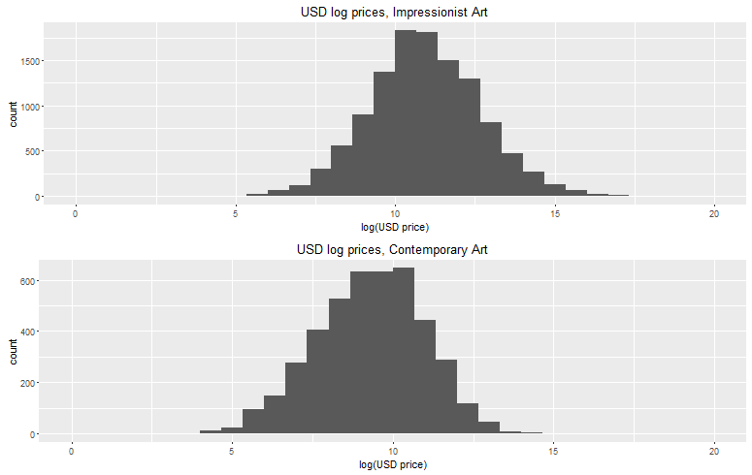

Figure 7: Comparison of log area, Impressionist and Contemporary art.

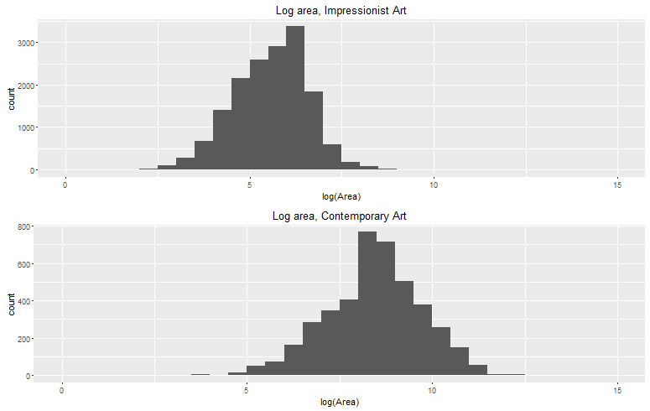

Figure 8: Comparison of painting dimensions, Contemporary art.

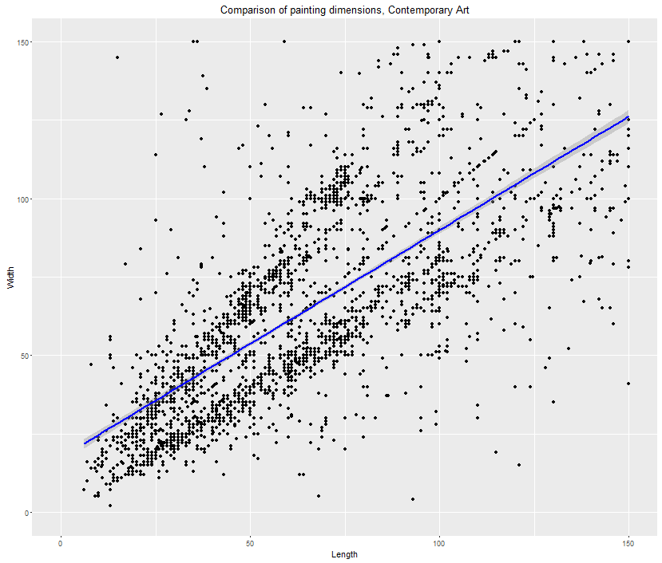

Figures 9-12: Plots for recent assorted art dataset.

