PRICE, ANCHORING, & SUBSTITUTION

IN

THE MARKET FOR FINE ART AUCTIONS

Evan C. Chow

Submitted to Princeton University

Department of Economics

In Partial Fulfillment of the Requirements for the A. B. Degree

April 11, 2016

**ABSTRACT**

Pablo Picasso and Marc Chagall are two Contemporary painters often featured together at auction. Can the past price of a Picasso painting drive up the current price of a Chagall piece? We examine the existence and behavior of “anchoring” cross-effects between prices of related art pieces sold at auction. Our research generalizes the anchoring model of Beggs & Graddy (2009), which only examines anchoring across resales of the same item. We draw upon insights from conversations with art specialists and experts at Sotheby’s, and construct a new dataset of recent auction sales for assorted art (2006-2015). We introduce two ways to quantify artistic similarity, which has not been done before in the art economics literature. We find significant evidence of anchoring cross-effects for both old and new data, and show the robustness of our model through three experiments. Our findings are of interest to art researchers, auction house specialists, and those who wish to understand where price signals travel in the art auction world.

**TABLE OF CONTENTS**

1. INTRODUCTION 1
2. OVERVIEW OF ART AUCTIONS & ANCHORING 7
   1. The Art Auction System 7
   2. How Anchoring Affects Art Auctions 10
3. REVIEW OF THE LITERATURE 14
   1. Anchoring 14
   2. Anchoring & Art Auctions 15
   3. Contribution of This Research 19
4. DATA
   1. Impressionist Art (1980-1991) 21
   2. Contemporary Art (1982-1994) 22
   3. Assorted Art (2006-2015) 23
5. METHODOLOGY 26
   1. Detecting Anchoring Across Sales of the Same Good 26
   2. Identifying Substitutes 29
   3. Detecting Anchoring Across Substitutes 31
   4. Measuring Substitution Across Art Pieces 33  
      1. Measure #1: Second Moment of Hedonic Price Differences 33
      2. Measure #2: Domain Knowledge of Similarity 34
6. RESULTS 37
   1. Hedonic Regressions 37
   2. Replicating Beggs & Graddy (2009) 38
   3. Anchoring Cross-Effects for Impressionist, Contemporary, 42  
      & Assorted Art   
      1. Q1: Second Moment of Hedonic Price Differences 43
      2. Q2: Domain Knowledge of Similarity 46
   4. Three Experiments 48  
      1. Substitution Experiment #1: 48  
         Pablo Picasso (1881-1973) & Marc Chagall (1887-1985)
      2. Substitution Experiment #2: 49  
         Joan Miro (1893-1983) & Salvador Dali (1904-1989)
      3. Substitution Experiment #3: 51  
         Edvard Munch (1863-1944) &   
         Henri de Toulouse-Lautrec (1864-1901)
7. CONCLUSION & FUTURE DIRECTIONS 53
8. BIBLIOGRAPHY 56
9. FIGURES AND TABLES 60
   1. Figures 60
   2. Tables 69

**1. INTRODUCTION**

Imagine you are heading to Christie's to bid on a Monet painting, which experts believe is worth $1 million based on its size and medium. However, you’re unaware of those experts’ estimates and you have no idea how much the Monet is worth, so you look up recent sales of other Impressionist paintings. You find out a Van Gogh sold for $20 million last week. With that number in mind, you start to believe the Monet is also worth $20 million, and that’s how much you bid – even if that amount reflects more the price of the Van Gogh than the Monet itself.

This is known as the *anchoring effect* - a well-studied cognitive bias in which the first value you hear (the “anchor”) can shape your perception of what sorts of values are normal. This was first demonstrated in a landmark experiment by Tversky & Kahneman (1974). In that study, participants were given five seconds to mentally calculate the product of the numbers 1 through 8, visually written out for them on a blackboard. It was found that if the numbers were displayed as “1x2x3x4x5x6x7x8”, participants would read the lower numbers first and give a median estimate of 512 for the product. On the other hand, if the numbers were displayed as “8x7x6x5x4x3x2x1”, then participants would first see the higher numbers and give a much higher median estimate of 2250. Thus, it seems that first impressions do affect judgement, at least in quantitative scenarios.

This bias also appears in the market for fine art auctions, which in 2014 saw a sales volume of approximately $7.35 billion (Christie’s Figures 2014). To the best of our knowledge, Beggs & Graddy (2009) are the first to formally study anchoring in the context of art auctions. In their model, the hedonic value of an artwork, say a painting, is assumed to be determined by its hedonic characteristics such as the artist, medium, and degree of authenticity. These features do not change over time, which means that if buyers were perfectly rational, they would pay only according to their (time-dependent) demand for these features. [1] If however, buyers learn that the painting previously sold for a very high price, they may internalize that previous high price as a reference point – the “anchor” – and be willing to pay much more as a result. Past price could legitimately inform current price since it reflects hedonic value, as well as other relevant, non-hedonic influences such as bidder wealth and artwork reputation. However, if we control for those, then past price becomes an irrelevant signal for determining current price, and any remaining impact can be interpreted as an anchoring effect. Thus, anchoring is said to occur when past price biases current price, controlling for hedonic value and non-hedonic price determinants.

Of course, the ways in which auction participants internalize and act upon past price cannot be inferred from just observing prices. Hence in our research and in much of the literature, including Beggs & Graddy (2009), this is treated as a black box. The mere observation of this effect, i.e. past price biasing current price, suffices for our definition of anchoring (discussed further in Section 2).

Using a regression model that carefully separates out anchoring, Beggs & Graddy (2009) identify and analyze resales of Impressionist and Contemporary paintings, finding significant evidence of anchoring effects. However, as mentioned in their paper, it is very difficult to identify multiple sales of the same art piece. This method of testing for anchoring effects cannot be applied to new works or works that have never been brought to auction. Moreover, in practice, it turns out that auction specialists appraise an art piece based primarily on past sales of related pieces.[2] The anchoring research of Beggs & Graddy (2009) is limited in its analysis and applicability.

In this paper, we study whether the sales of similar paintings (substitutes) display anchoring cross-effects: for example, whether the past price of a Monet can bias the current price of a Van Gogh. Our data consists of two datasets of Impressionist and Contemporary art, used not only in Beggs & Graddy (2009) but also in many other econometric papers on art auctions, as well as a new dataset of assorted art sales between 2006 and 2015 specifically collected for this project. We begin by successfully replicating the general anchoring findings from Beggs & Graddy (2009). Our success is surprising and noteworthy because, as discussed later in Section 6, we do not know exactly which observations in their data were originally used. Next, we introduce our expanded version of their model, testing for anchoring cross-effects by controlling for similarity across pieces. We introduce two quantitative measures of similarity between art pieces. Running our model on these three datasets, we discover significant evidence of anchoring cross-effects for Impressionist and assorted art. To ensure robustness, we also run our model on a subset of our assorted art dataset for three specific artist pairs who we already know to be similar or dissimilar. This selection, explained in Section 6, includes Pablo Picasso & Marc Chagall, Joan Miro & Salvador Dali, and Edvard Munch & Henri de Toulouse-Lautrec. In those three comparisons, we find the extent of artistic similarity (or dissimilarity) really is accurately reflected in whether our model detects anchoring.

This research makes several major contributions to the existing literature on art auctions. First, to the best of our knowledge, no econometric work has attempted to quantify hedonic similarity between art pieces. Thus, this study is useful not only for appraising art, but also for other tasks where art pieces must be compared, such as constructing price indices across heterogeneous artworks. We hope our two measures of similarity may provide a starting point for such analysis. Second, much of the econometric work on art auctions has relied on the same two Impressionist and Contemporary art datasets that only include sales until 1991 and 1994, respectively. Our new dataset of approximately 500,000 assorted art sales (2006-2015), constructed by writing a Python program to scrape an online art database for 10 straight days, is a larger and more up-to-date collection of auction data (Blouin Art Sales Index). Lastly, our discovery of anchoring cross-effects is notable because it adds to the growing body of research on how price signals implicitly propagate around the art auction market. Our work allows researchers to account for hidden biases such as anchoring when comparing sales of different art pieces, and demonstrates how Beggs & Graddy’s original anchoring model may be successfully customized. For auction houses and professionals, our work provides a practical regression model for estimating an artwork’s price in light of related sales. Beggs & Graddy’s original model has been extensively applied in other domains such as corporate finance, real estate, and horse racing (Dougal et al. 2015; Leung & Tsang 2013; McAlvanah & Moul 2013). Our approach to anchoring is more general than Beggs & Graddy’s, and may find application in other fields as well.

As part of our research, we conducted interviews with several specialists and experts in the field. To learn about the art market and how auction specialists appraise pieces, we talked with Mark Best, a former financial analyst who is now a specialist in American, Modern, and Contemporary prints at Sotheby’s NYC. For insight into artistic similarity, we talked with Hadley Newton, who formerly worked at Sotheby’s with Impressionist art. The three artist pairs we examine in Section 6 were suggested by Hadley. We also talked extensively with Raphaelle Benabou, who is an administrator of art collections, estates, and valuations at Bonham’s in London. Raphaelle provided us with many of our anecdotes and fact-checked our description of the auction system. We draw upon these interviews for both our discussion and our quantitative analysis.

Determining artistic similarity is not trivial: we were told that no two art pieces are the same.[3] Even in the case of prints, where 100-200 copies (editions) of the same art piece are manufactured and numbered in order of production, an edition with a lower number (i.e. produced earlier) may sell for more than an edition with a higher number. Furthermore, drivers of similarity can vary at different price points, and whether art is purchased as a decoration or as an investment. In this paper, we provide a starting point for quantitatively measuring similarity between pieces, but acknowledge that better measures could be constructed.

This thesis proceeds as follows. In Section 2, we give a brief overview of the art auction system and process, followed by a discussion of anchoring and its role in this market. Section 3 surveys the literature relevant to anchoring in the art market and explains the importance of our research. Section 4 describes the original data of Beggs & Graddy (2009) as well as our new dataset, and explains the motivation behind constructing the latter. Section 5 describes our methodology, which includes the original regressions of Beggs & Graddy, our expanded regression models, and our measures of substitution. Section 6 gives our results. This includes our replication of the anchoring work of Beggs & Graddy, followed by our findings on anchoring cross-effects. We then present the results of our experiments on the three artist pairs suggested to us by Hadley Newton. Finally, Section 7 concludes with a summary of our research and directions for future work.

**2. OVERVIEW OF ART AUCTIONS & ANCHORING**

**The Art Auction System**

In perhaps one of the world’s oldest duopolies, approximately 42% of the global art auction market is controlled by two major houses: Christie’s and Sotheby’s, established in 1766 and 1744 respectively (Baker & Kazakina 2015). The former, headquartered in London, is privately held by French multibillionaire Francois-Henri Pinault and only reports sales figures twice a year. Sotheby’s, headquartered in New York City, is publicly traded and reports detailed revenues and costs. While both houses deal in art, often sourced from museum or private collections, in recent years Christie’s has become the larger player. In the first six months of 2015, Christie’s realized $4.5 billion in art sales, while Sotheby’s only pulled $3.5 billion (Reyburn 2015). That said, both houses have enjoyed their share of record-breaking auctions: Picassso’s *Les Femmes d’Alger (“Version O”)* sold for $179 million at Christie’s in 2015, while Pollock’s *No. 5, 1948* went for $164 million at Sotheby’s in 2006. The whole spectrum of art can be found at Christie’s and Sotheby’s, ranging from Impressionist oil paintings to Chinese ceramics. Auctions are usually themed around a certain artist, medium, time period, or represent a private collection. Often individual events are part of a series, such as Christie’s “First Open” series for post-war and contemporary art (launched in 2005). Other smaller but well-known auction houses include Bonham’s and Phillip’s, both headquartered in the United Kingdom.

In addition to art, both houses run auctions for other goods such as jewelry, automobiles, and furniture. Many believe these houses play to different strengths. To sell photographs, go to Sotheby’s; to sell books and manuscripts, go to Christie’s (Rohleder 2001). For classic automobiles, go to Sotheby’s or Bonham’s (Reyburn 2015). Specialization is not limited to product selection, either. According to Raphaelle Benabou, Bonham’s (as a smaller house) appeals to many sellers because lower sales volume ensures pieces will be better noticed at auction. Competition between auction houses is fierce, and each tries to capture the best consignments by luring sellers with benefits such as higher guaranteed prices and waived house commission fees (Baker & Kazakina 2015). Yet, the two houses have cooperated and even colluded at times. In the early 2000’s, both houses were convicted of fixing commission fees charged to sellers, and were required to pay back $256 million each (O’Connell 2000).

The actual auction process is as follows. First, a client (prospective seller) will request an estimate from the auction house for their item of interest, either by submitting photographs or scheduling an in-person appointment with a specialist. If the item is deemed appropriate for auction, the house and the seller will enter negotiations and draw up a seller’s contract. The item then travels to the house to be officially photographed, catalogued, and stored before the auction event (“How to Sell” n.d.). Clients may visit more than one auction house to compare arrangements.

Three quantities are decided by the seller and the house before any auction: a low and a high presale estimate for the art piece, and a reserve price. The low and high estimates represent the range of possible values the piece might go for, and are usually suggested by a committee of in-house art experts. As shown empirically by Ashenfelter (1989), these estimates do generally seem to accurately predict sale price. Some cross-house differences may exist: Bauwens & Ginsburgh (2000) show that in certain art categories, Sotheby’s tends to undervalue expensive pieces and overvalue inexpensive ones (while Christie’s does the opposite). In negotiations, the seller and the house also determine a reserve price known only to those two parties. The reserve price, which designates the minimum price the seller will accept for an item, is a closely guarded secret in the art auction world. However, according to estimates by Ashenfelter et al. (2002), the reserve price may be set around 70-80% of the low estimate. It is unclear why the reserve is concealed, but Vincent (1995) suggests that under certain circumstances, announcing the reserve may discourage potential bidders from participating and could lower overall bids.

Before the auction event, the house will typically publish a presale catalog for the art pieces, available both in print and online. For each piece to be sold, the catalog includes photographs and the presale estimates, as well as information on the artist, the materials and a condition report, signs of authenticity such as a signature, and who previously owned the work (provenance). Houses also host pre-auction viewings where both potential bidders and the public can examine items in person. Bidders must register before an auction, and for particularly opulent events, must show proof of their assets.

Auctions are almost always conducted in an ascending first price format. Unless starting bids have been pre-placed, the auctioneer starts low (somewhere below the secret reserve price) and calls increasing prices until the bidding stops, upon which the item is declared to be “knocked down” or “hammered down” (Ashenfelter 1989).[4] The final sale price is the “hammer price.” On top of this, the house adds “buyer’s premium” commission fee, usually 20% to 25% of the hammer price, before the winning bidder receives the item (Ashenfelter & Graddy 2003).[5] At Sotheby’s and Christie’s, the seller receives payment approximately 35 days after the auction, minus a “seller’s premium” which is usually around 10% of the hammer price (“Selling at Christie’s” n.d.; Ashenfelter & Graddy 2003). If an item does not meet its reserve price, it goes unsold and is said to have been “bought in.” The auction house, however, rarely purchases the item: instead, it may be resold later at a lower estimate or taken off the market. Historically, auction houses did not publish records of whether items went unsold. However, since the 1980s, auction houses in NYC have been legally required to report this information. And, according to Ashenfelter & Graddy (2003), houses in other locations are following this trend as well.

**How Anchoring Affects Art Auctions**

The art auction market is especially vulnerable to unobserved psychological and behavioral biases, because on both sides of the market, participants must rely on subjective judgement, past experience, and personal preferences to evaluate artwork. The ever-changing heterogeneity of art pieces, buyers, and sellers makes it intractable for both auction houses and economists to perfectly estimate demand for art. Thus, the auction format, designed to set prices by discovering private valuations, seems fitting for this context. Yet, auction outcomes can be shaped drastically by behavioral phenomena. Competition can become fierce between bidders who wish to win the same item (“bidding wars”), driving up hammer prices far beyond an artwork’s estimated value (Gleadell 2016). Auctions are very emotional experiences, as we learned firsthand when we attended an auction for Chinese ceramics at Christie’s NYC. When one sculpture got caught in a bidding war and ended up selling for nearly $500,000, the room erupted in applause.

Anchoring is one of the most-studied biases in the behavioral sciences: it is at once trivial to demonstrate and difficult to explain away. The effect occurs when first quantitative impressions distort future outcomes, even when the initial information is irrelevant (Tversky & Kahneman 1974; Sugden et al. 2013). As described in our introduction, we can identify anchoring through the impact of past sale price on current price, controlling for hedonic quality and non-hedonic influences on current price. The assumption of constant hedonic quality across sales is foundational for Beggs & Graddy (2009), and this quality must clearly be controlled for since it informs price at every time step. Yet, non-hedonic influences may also shape current price. For instance, if buyers believe an artwork will sell for more in the future, then they may pay more at time $t-1$. These high expectations may carry forward to later buyers, driving up the current price further at time $t$. Thus, controlling for both hedonic and non-hedonic determinants of current price is necessary if we wish to study how past price anchors current price.

As mentioned earlier, the exact behavioral mechanism by which this occurs is a black box: the overall effect may be attributed to buyers, sellers, auctioneers, or some combination of all three (Graddy et al. 2014). Below, we briefly describe what this could look like for those different groups.

Bidders may anchor on numbers provided prior to auction: this can include presale estimates and past prices for an artwork, as well as estimates and prices for related pieces. Estimates are expected to anchor bidder perceptions, because by definition, they give a general idea of how much a piece is worth. As discussed, past prices can reflect not only hedonic value but unobserved past factors such as bidding activity, the wealth of individual buyers, and even exogenous factors such as the weather (De Silva et al. 2012). It is worth noting that anchoring is difficult to avoid, though more expertise in the given area helps to guard against this bias (Northcraft & Neale 1987).

Sellers may anchor on past sales prices when setting the reserve. Some research finds that anchoring is more powerful for sellers than for buyers, but weakens with increased seller experience (Sugden et al. 2013; Alevy et al. 2011). Auctioneers can actively anchor bidder perceptions of value through the numbers they call out, particularly at the start of an auction. While this can be a powerful tool for the auctioneer, Brandly (2015) warns against setting anchors too high (to drive up future bids) or too low (to attract starting bids). Go too high, and your numbers lose credibility; go too low, and people will suspect something is wrong with the item.

We learned that auction houses are aware of anchoring effects, not only between resales of the same item, but between sales of related pieces.[6] When internal departments formulate presale estimates for a work of art, a single specialist will research past sales of comparable pieces (similar size, artist, medium, etc.) to get a ballpark idea of the current work’s value. Next, the specialist describes the current work to others in the department, but without revealing any numbers from those past sales (which would introduce anchoring). Every person volunteers an estimate for the current work, and only then does the specialist reveal what related works went for in the past. From there presale estimates are formed, presumably as a combination of information from past sales of related pieces (the anchors) and more up-to-date knowledge of the art piece in question. These anchoring cross-effects between related goods are the primary focus of our study, and discussed further in the next section.

The question of what makes two art pieces similar (i.e., substitutes) is therefore of enormous interest to those in the field. Before one can appraise a piece of art, one must identify past sale precedents, which requires understanding what makes art pieces similar. Only then is it possible to properly analyze anchoring and other biases that can distort prices and sales.

**3. REVIEW OF THE LITERATURE**

**Anchoring**

Anchoring is a cognitive bias that has been studied in psychology and behavioral sciences for over 40 years. A comprehensive survey of the anchoring literature is given by Furnham & Boo (2011). The seminal work on anchoring was first authored by Tversky & Kahneman (1974), who conducted experiments such as the one described in the introduction to this paper. In another experiment that demonstrated anchoring, those authors showed participants a random number between 0 and 100. Then, the participants were asked to estimate the percentage of African countries in the United Nations. Tversky & Kahneman found that those who initially received a low number underestimated the correct percentage, while those who received a high number overestimated the correct percentage. This showed that a numerical first impression could serve as a starting point (an “anchor”) for later quantitative judgment, even if that first impression was arbitrary or irrelevant.

The anchoring effect is extremely complex, and many studies have attempted to understand its nature and implications. For instance, some research shows people formulate estimates more quickly when provided with numbers to anchor on (Strack & Mussweiler). Some studies show that anchoring decreases, but does not altogether vanish, with increased cognitive ability (Bergman et al. 2010).

Within economics, much of the anchoring work focuses on historical market data. Some studies test for anchoring by examining changing prices and demand for unchanging goods (Rajendran & Tellis 1994; Greenleaf 1995; Bokhari & Geltner 2011; Dougal et al. 2012). Much of the anchoring research in economics uses experiments, surveys, or multiple-choice tests to find out how individuals form estimates and judgments in the presence of an anchor (Frykblom & Shogren 2000; Winter 2002; Flachaire & Hollard 2007). Anchoring has been studied in many socioeconomic contexts such as accounting, real estate, the courtroom, public goods, and international finance (Kinney & Uecker 1982; Bucchianeri & Minson 2013; Mussweiler 2001; Green et al. 1998; Nianhang & Shinong 2007).

In addition, anchoring has been researched in the context of auctions (Lucking-Reiley et al. 2007; Ku et al. 2006). For example, one bizarre experiment was conducted by Ariely & Prelec (2006). Students were first asked to write down the last two digits of their Social Security number, then bid for various items such as chocolate, computer equipment, or a textbook. The students who had higher digits submitted significantly higher bids, even when explicitly reminded that Social Security numbers are random quantities that carry no inherent meaning. Wolk and Spann (2008) studied bidding for online auctions in the presence of an anchor. They found that bidders respond most strongly to internalized anchors such as one’s knowledge of past prices for a good. However, bidders respond to external anchors (such as advertiser-suggested bids) to a much lesser extent, and only when those numbers are not implausibly high.

**Anchoring & Art Auctions**

Anchoring is also present in the art market: the literature shows that first numerical impressions do impact prices, auctioneer estimates, and sale volume. Here, we provide an overview of research that studies anchoring in the art market, which is still a highly nascent topic.

To our knowledge, a discussion paper by Beggs & Graddy (2005) is the first to examine anchoring effects (i.e. “reference dependence”) in the art auction market. That paper is described as a working paper in Beggs & Graddy (2009). To identify anchoring, they examine resales within two datasets of Impressionist and Contemporary paintings, which contain not only hammer price but also hedonic characteristics such as artist and medium. Both the Impressionist and Contemporary art datasets are used in our research, and are described in detail in Section 4. The regression model of Beggs & Graddy (2005) detects anchoring by first controlling for hedonic value and non-hedonic biases on price, then testing for the impact of past price on current price. This model is formalized in Beggs & Graddy (2009), except that the 2005 model tests separately for positive (gains) and negative impacts (losses) of anchoring on current price. The authors find strongly significant evidence for anchoring in both Impressionist and Contemporary categories. They find no significant evidence that positive impacts of anchoring are different from negative ones.

Beggs & Graddy (2009), using the same resale approach and data, dive deeper into the impact of anchoring effects on price, presale estimates, and the probability of a sale. Their model, which we apply and expand, does not test asymmetrically for gains and losses. For price, they find that anchoring effects are stronger for Impressionist art pieces than for Contemporary ones, particularly for items that are resold quickly after a first sale. They also find significant anchoring effects for the presale low estimates, noting that low estimates tend to gravitate toward past price as the anchor. Beggs & Graddy do not find anchoring significantly affects the probability of sale. The anchoring models developed by Beggs & Graddy (2009) have been used in later anchoring research such as Leung et. al (2013), and form the basis of our own approach. We replicate the general results from Beggs & Graddy (2009) in Section 6. Beggs & Graddy believe anchoring effects on the sale price may primarily be attributed to the buyers, since buyers primarily determine price, but beyond that treat anchoring as a black box. Graddy et al. (2014) use more data and mostly corroborate the anchoring results of Beggs & Graddy (2009). However, they express more uncertainty about whether anchoring effects should be attributed to buyers, sellers, or auctioneers.

Bruno & Nocera (2008) study how anchoring affects presale estimates using a unique dataset of nearly 1,000 Italian paintings that have been sold at least twice (1985-2006). They regress the range of presale estimates on a multi-level dummy variable for anchoring to account for multiple past prices (anchors). The authors find significant evidence of anchoring. First, the existence of past prices makes the presale estimate range narrower, presumably because auction houses become more confident in their estimates of the item’s value.[7] Second, Bruno & Nocera find that if a past price exists for an item, the presale estimate range will be more closely centered on actual sale price. Hence, both the bias and variance of the presale estimate range, an estimator of what an item actually sells for, seem to decrease in the presence of anchors. These findings are consistent with what we heard through interviews, namely, that specialists at auction houses research past sales before formulating estimates.[8]

Even the order in which art pieces are auctioned can beget anchoring effects, as shown in Hong et al. (2015). For the semiannual Auction Week, a two-week auction series held every spring and fall across New York City, Sotheby’s and Christie’s have a handshake arrangement to alternate who holds their auction first. [9] Using 26 years of Auction Week data and an adapted version of the resale model in Beggs & Graddy (2009), Hong et al. find that average opening sale revenues significantly anchor later sales during the rest of an Auction Week. Specifically, they discover that if more expensive paintings are sold first, then Sotheby’s and Christie’s will pull in higher total revenue (+21% higher), and more works will sell overall (+11% more sales). They state that their anchoring coefficients are quantitatively comparable to those from Beggs & Graddy (2009). This is the only work we found that does not examine anchoring across resales of the same art piece. However, since they only analyze aggregated mean revenues of auction houses and do not consider individual art pieces, their approach cannot be applied in our context.

Other behavioral research on art auctions exists, though much of it is more tangential to anchoring. In the art trade, there is the belief that if an art piece goes unsold at auction, it becomes “burned” and will sell for less in the future. To test this quantitatively, Beggs & Graddy (2008) use an even smaller sample of repeat sales from the Impressionist and Contemporary datasets in Beggs & Graddy (2005). The authors find that on average, burned paintings do seem to sell for significantly less (-30%), particularly if they are resold at the same auction house within 2 years (-37%). Whether this is directly due to buyer perceptions of failure, however, is ambiguous. Sentiment, emotion, and mood are also growing areas of research. For instance, Canals-Cerdá (2012) analyze art auctions and seller reputations on eBay, and discover that negative feedback significantly lowers sale price and the probability of sale. Penasse et al. (2014) collect survey data on sentiment toward selected artists in the art community, and find that strong confidence on the part of auction houses and art collectors can predict art returns in the short run. Furthermore, De Silva et al. (2012) examine if weather, a proxy for mood, significantly impacted art auctions at Sotheby’s and Christie’s during the period 1990–2007. They find a weakly significant effect, suggesting that external emotional shocks do affect art auction activity.

In the aforementioned literature, the exact process by which past quantities anchor future ones is treated as a black box: only the impact is noted. This is what we described earlier, and the view of anchoring we adopt in this research.

**Contribution of This Research**

It is clear that anchoring is pervasive in the art auction market, especially since psychological and behavioral factors seem to be significant drivers of auction activity. However, the research to date (except Hong et al. 2015; see above) has studied anchoring only in the context of resale. This is problematic because as Beggs & Graddy (2009) acknowledge, it is extremely uncommon to encounter multiple sales of the same artwork. This is further limited by large time gaps between sales, which weaken anchoring effects (Graddy et al. 2014; Hong et al. 2015). Additionally, it is difficult to show resale observations refer to the same art piece, since an artist may create multiple pieces with the same medium, dimensions, and so forth. Beggs & Graddy (2009) painstakingly cross-checked their resale data against printed presale catalogs; we cannot replicate this.

More importantly, a shared but flawed assumption across much of the aforementioned literature on anchoring is that hedonic quality does not change across auction sales. In talking with Mark Best at Sotheby’s, we were surprised to hear how much artwork can deteriorate over time. Prints may tear accidentally, fade under glass, or become punctured, if tacked to the wall for decoration. The canvas of a painting can weaken over time, and must be “relined” with a new canvas attached to the back for extra support. Restoration (often by an unwitting owner) can also harm the value of an art piece: protective glaze must be scraped off, retouched paintings must be scrutinized under ultraviolet light, and so forth. We suspect these factors explain why Beggs & Graddy (2009) find stronger anchoring effects for Impressionist artworks than for Contemporary ones. Paintings in the former category mostly belong to renowned Impressionists artists such as Renoir and Monet, and are orders of magnitude more valuable in both presale estimates and prices (Beggs & Graddy 2009; see Tables 1 and 2). Thus, Impressionist works are probably far better maintained, which better preserves their hedonic quality. This allows past sales to better anchor future sales.

If the hedonic quality of a painting changes across sales, then we can still identify anchoring, given we control for those intertemporal differences. Yet, if we have to control for hedonic differences anyway, why not look at different art pieces altogether? This observation motivates us to generalize the anchoring work of Beggs & Graddy (2009) beyond resales of the same good to sales of related (substitute) goods. In all previous literature we are aware of, the anchor is always a previous sale of the same good. However, if we control adequately for quality changes between the anchor and the current art piece, then we may use sales of a related piece as the anchor instead of a past sale. We introduce this formally in Section 5.

**4. DATA**

We use three datasets on auction sales in this paper: Impressionist art (1980-1991), Contemporary art (1982-1994), and assorted art sales (2006-2016). The Impressionist and Contemporary art datasets have been used extensively in the literature and described in detail elsewhere (Richardson 1992; Beggs & Graddy 1997; Ashenfelter & Graddy 2003; Beggs & Graddy 2009). Both of those datasets are available on the Brandeis University academic website of Kathryn Graddy.[10] However, the last is a new dataset constructed specifically for this research.

**Impressionist Art (1980-1991)**

The Impressionist art dataset (1980-1991) was constructed at Princeton University for the undergraduate senior thesis of Andrew Richardson under the guidance of Orley Ashenfelter, and covers sales at Christie’s and Sotheby’s in both London and New York (Richardson 1992). There are well over 16,000 observations of art piece sales, which were compiled by manually scouring presale catalogs. Each observation contains the painting title, the artist name, the sale price and date, the auction house and location, the presale low and high estimates, and hedonic characteristics such as the piece dimensions and the presence of a signature. In-depth attribute details are unavailable in this dataset: for example, dimensions are called “DIM_A” and “DIM_B”. The dataset contains 58 major artists whose work is often featured at auction, and among the most frequent are Pablo Picasso (1,155 sales), Pierre Renoir (829 sales), and Raoul Dufy (763 sales). Approximately half the auction sales in this dataset are split between Christie’s and Sotheby’s, as well as between London and New York. Table 1 shows summary statistics for selected attributes. 29% of observations in this dataset are bought in, i.e. represent a no-sale. The highest sale in this dataset goes to Vincent Van Gogh’s *Portrait of Dr. Gachet* (1890), which netted approximately $82.5 million on May 15, 1990. Conversely, the lowest sale is a work by Paul Cesar Helleu that went for a mere $1,888 on March 25, 1986.

Many of these quantities have distributions that are roughly log-normal (i.e., without the log transformation, skewed heavily right), showed in Figure 1. In general, we see very high variation: sales price, for example, reflects both works with record-high sales as well as works that sold for minimal amounts or were bought in. This is because the majority of paintings exhibit middle-market sale price, estimates, size, and so forth, while relatively few reach the highest ranges. The two painting dimensions have the most irregular distributions, particularly in the middle ranges. However, as seen in Figure 2, the large portion of paintings do not tend to be lopsided in their physical dimensions. Finally, we see that auction sales in this dataset have generally risen over time (Figure 3), though there are some years with record numbers of sales.

**Contemporary Art (1982-1994)**

The Contemporary art dataset represents every Contemporary art piece sold from 1982 to 1994 at Christie’s primary King Street location in London, for a total of approximately 4,500 observations (Beggs & Graddy 2005). The dataset was compiled by Kathryn Graddy, who manually examined auction catalogs and sifted through internal data in the archives of Christie’s. Similar to the Impressionist dataset, each observation lists the artist, the auction sale price and date, the presale low and high estimates, the lot number, whether or not the item sold, and hedonic characteristics such as the artist and medium. Various currency exchange quantities are included, such as the UK CPI at the time, and monetary quantities are given in thousands of pounds. The data comes with a STATA .do file, which gives more detailed information on the attributes. Roughly 22.5% of observations in this dataset are bought in (unsold). Nearly 600 artists are represented, with Lucio Fontana (157 sales), Karel Appel (151 sales), and Alexander Calder (141 sales) being the most frequent.

Table 2 gives summary statistics for this dataset. As with the Impressionist dataset, and shown in Figure 4, quantitative dimensions such as sale price and size also show roughly a log-normal shape, though auctions sales seem to be more uniform over time (Figure 5). As shown in Figure 6, Impressionist pieces are generally orders of magnitude more expensive than Contemporary pieces. However, Contemporary pieces do tend to be physically larger (Figure 7) and have far more unbalanced dimensions, though as with Impressionist pieces width and length do seem to scale together (Figure 8).

**Assorted Art (2006-2015)**

A major contribution of this research is the construction of a large dataset of 500,000 recent auctions sales of assorted artworks (2006-2015). To do this, we wrote a Python program to scrape recent listings on the Blouin Art Sales Index, a frequently updated online database of art auction sales (Blouin Art Sales Index). The Blouin Art Sales Index was suggested to us by Bobray Bordelon, a economics & finance librarian at Princeton University. We ran our program for 10 nonstop days in December 2015. The motivation behind collecting and using a new dataset is threefold. First, the time gaps between auction sales in this dataset are much shorter, compared to our other datasets. The average time gap between sales in the Impressionist and Contemporary art datasets are 5.57 and 0.98 days, respectively, while the average gap here is only 0.0072 days – indicating most sales occur on the same day. Shorter gaps are more conducive to studying anchoring. Second, this dataset consists of a very wide range of artists and artistic styles, while the Impressionist and Contemporary datasets are more limited in their artistic scope. More variety allows us to identify more substitutes, and better test our measures of substitution. Finally, sales in this dataset are more recent and could better reflect the current auction climate.

The full, raw dataset consists of approximately 500,000 observations (paintings and non-paintings), covering primarily 19th and 20th century art. It also includes some works from earlier time periods, going back to 1000 CE for works by Song Dynasty artist Yi Yuanji. Nearly 90,000 artists are included, with the best represented being Pablo Picasso (3,440 sales), Andy Warhol (2,573 sales), and Salvador Dali (1,508 sales). However, we did not identify any resales. We only examine paintings, of which there are approximately 250,000 observations. The most expensive sale is an untitled crayon work by Cy Twombly (1928-2001), which went for $70.5 million at Sotheby’s in NYC in November 2015. The artists whose works sell for the most, on average, include Kazimir Malevich (1879-1935), Mark Rothko (1903-1970), Vincent Van Gogh (1853-1890), and also Song Dynasty artists such as Emperor Huizong (1082-1135) and Yi Yuanji. As before, sale prices and other quantitative characteristics seem to follow a roughly log-normal distribution (Figures 9-12). Most of the paintings in this dataset sell for low 5 or 6 figure sums, while only a minority sell for higher figures reflected in the gradually diminishing right tail. It is clear that artists who sell more works through auction will enjoy higher revenue on average, as they become better-known in auction circles through higher representation (Figure 12).

Each observation in this new dataset includes the artwork title, the artist, artwork category as described by the auction house, a textual description of the materials, the lot number, sale date, auction house, and the USD sale price. Information on the materials were given in the form of unstructured text data, which might be attributed to freeform data entry on the part of Blouin. Hence, simple keyword extraction was used to extract hedonic characteristics such as height and width; more sophisticated textual extraction methods should be employed in future work. Some summary statistics for the full raw dataset are provided in Table 3.

**5. METHODOLOGY**

**Detecting Anchoring Across Sales of the Same Good**

A two-stage regression model for detecting anchoring is specified in Beggs & Graddy (2009). The same model is used to detect anchoring effects in later papers such as Hong et al. (2015), and in general, may be applied to goods that exhibit unchanging hedonic quality over time. That hedonic quality for artwork would not change is thus a key assumption of Beggs & Graddy’s work. Intuitively, their model identifies anchoring by looking at two sales of an item, say a painting, at different points in time. After controlling for hedonic value and non-hedonic price biases at all time points, current price may be regressed on past price. That impact of past price is identified as the anchoring effect.

Hedonic regressions are commonly used to estimate demand for highly heterogeneous items such as art, wine, and real estate as a function of their constituent attributes (Edmonds 1984; Costanigro et al. 2007). For example, the value of a painting may depend on its dimensions and authenticity, while a bottle of wine may be appraised based on its age and where it was grown. In the first stage of the model, Beggs & Graddy (2009) regress the sale prices $P∈R^{\left[n,1\right]}$ of $n$ resold paintings on their $k$ hedonic and temporal variables $X∈R^{\left[n, \left(k+1\right)\right]}$, while also including temporal effects $δ_{t}∈R^{\left[n,1\right]}$. This yields a hedonic price prediction $π_{t}∈R^{\left[n,1\right]}$ for each observation of a painting sale. The resulting equation, which both Beggs & Graddy and we use, is given below. We denote the current period as $t$ and the previous period as $t-1$.

$$π_{t}=XB+δ_{t}$$

For our replication work on the Impressionist and Contemporary datasets, we use the same hedonic variables that Beggs & Graddy used. For Impressionist art this includes painting date, length, width, medium of the artwork, indicators of authenticity (signed, monogrammed, stamped), and artist.[11] For Contemporary art this includes painting date, length, width, medium, and artist. The temporal effects are modelled by half-year time dummies.

In the same manner as Beggs & Graddy, we use the natural log of prices and hedonic price predictions, which allows us to interpret the regression results as relative effects (percent changes). For unsold items, we proxy value with 80% of the low estimate as they do. It is important to note that hedonic price predictions for a single painting $π_{t} : t∈\{1, 2, 3…\}$ may vary with respect to time, since these are estimated based on prices for the painting at different times. These prices reflect demand for art, which may change over time. The $k$ hedonic variables, however, are assumed to remain constant across sales.

In the second stage of the model, Beggs & Graddy specify the following regression – for each unique painting – in order to separate out anchoring from other effects. Their equation (which we also use) is given below.

$$ω=a_{0}+a_{1}π_{t}+a_{2}\left(P_{t-1}-π_{t}\right)+a_{3}\left(P_{t-1}-π_{t-1}\right)$$

Below follows a description of regression variables.

* $ω$ is the response variable. Beggs and Graddy fit several regressions where the response $ω$ represents either the hammer price, the presale estimator, or an indicator for whether the item sells, which involves a probit transformation. In our replication work, we only examine $ω$ as hammer price.
* $π_{t}$ is the current hedonic valuation of bidders, i.e. the hedonic price prediction in the current period $t$. To detect anchoring effects, hedonic valuations $π_{t}$ must be controlled for. Otherwise, one would not be able to separate hedonic and non-hedonic influences in the current period.
* $(P_{t-1}-π_{t})$ identifies the anchoring effect. This specifies how past hammer price $P_{t-1}$, the anchor, differs from $π_{t}$, the current (predicted) hedonic valuation of bidders. Thus, this term measures the extent to which past price irrelevantly impacts current price. To make this possible, we have controlled for the current hedonic valuation $π_{t}$ (see above) as well as non-hedonic components of past price that could possibly affect current price (see $(P_{t-1}-π_{t-1})$ below).
* $\left(P_{t-1}-π_{t-1}\right)$ is the past residual, i.e. non-hedonic inputs into past price. This controls for any other components of past price that could, conceivably, affect current price. For example, past price might be a function of general bidder excitement for the work’s art genre. This would not only drive up past price, but could also drive up current price. [12] Hence, we control for such non-hedonic price biases in this term.

In the case of the dependent variable $P_{t}$ (i.e., when $ω$ is hammer price), we see that those non-hedonic inputs, usually captured by $(P_{t}-π_{t})$, would instead be contained in the residuals. One should also note that because hedonic prices may vary over time, $(P_{t-1}-π_{t})$ is distinct from $(P_{t-1}-π_{t-1})$. Additionally, the intercept $a_{0}$ represents the value of $ω$ in the absence of other predictors. For example, if $ω$ represents hammer (sale) price, then a high intercept could suggest a high average price for paintings across the given market.

**Identifying Substitutes**

As we discussed earlier and as Beggs & Graddy (2009) note, it is extremely difficult to track down multiple sales of the same item. The same art piece can become a drastically different hedonic object within its lifetime due to deterioration and restoration. Also, many years or decades may elapse between sales of the same art piece – far too long to reliably measure anchoring biases.

It is reasonable to believe that buyers, when bidding on an artwork, make judgments based not only on that piece’s past sales, but also what similar pieces went for. This allows for a more versatile approach to identifying anchoring effects (or if between different goods, cross-effects) as long as we control adequately for hedonic differences. Before measuring similarity, however, we must identify related pieces for the current good, since many pieces may be entirely irrelevant. Thus, to identify substitutes for the sale of an art piece, we search through our data for past sales of other pieces with the same artist, medium, and signs of authenticity. We also omit observations where no substitutes were found. This gives us a list of related sales to consider for the current good. Only then may we proceed to measure similarity and test for anchoring cross-effects, as described below.

**Detecting Anchoring Across Substitutes**

Here, we build on the two-stage regression model presented earlier. Suppose, as before, we have our same design matrix $X∈R^{\left[n,k+1\right]}$ and our hammer prices $P_{t}∈R^{\left[n,1\right]}$. We run the first hedonic regression as before, except that we are not concerned specifically with resale.

$$π=XB+δ_{t}$$

We next depart from the original model. Denote the sale observation of our current good as $x_{c}$ and the sale observation of a single substitute as $x_{s}$, such that the hedonic predictions estimated above are $π_{c},π_{s}$, and $P_{c},P_{s}$ are the respective hammer prices. Then our second regression is:

$$ω_{c}=b_{0}+b_{1}π_{c}+b_{2}\left(P_{s}-π_{c}\right)+b_{3}\left(P_{s}-π_{s}\right)+b_{4}Q$$

Here, the subscripts for the past and current sales $t-1$ and $t$ are replaced by subscripts for the substitute $s$ and current good $c$. In other words, instead of considering a current sale and past sale of the same painting (which corresponds to hedonic matrices $X_{t}$ and $X_{t-1}$), we consider the current sale of the painting and the past sale of a substitute (thus replacing $X_{t}$ and $X_{t-1}$ with $X_{c}$ and $X_{s}$). The previous regression model assumed that there was no unobserved quality changes in the painting across sales, such that $X_{t}=X_{t-1}=X$. Hedonic prices $π_{t}$ could still change due to time-dependent demand. However, in this generalized framework, we assume that characteristics do differ across goods, such that $X_{c}≠X_{s}$. Thus, we control for those hedonic differences by including a measure of substitution $Q$ in our regression model, which may be constructed from either $π$ or $X$. This allows us identify anchoring effects in $(P_{s}-π_{c})$, as before.

What if a painting has multiple substitutes – the multivariate case? Let a given good $x_{c}$ have a vector of substitutes $X_{s}=\{x_{s1},x_{s2},…x_{sd}\}$. We can write:

$$w_{c}=b_{1}π_{c}+b_{i2}\left(P_{RS}-π_{c}\right)+b_{i3}\left(P_{RS}-π_{RS}\right)+b_{3}Q$$

$$P_{RS}=\frac{1}{d}\sum_{i=1}^{d}{P_{si}} π_{RS}=\frac{1}{d}\sum_{i=1}^{d}{π_{si}}$$

Two goods $c_{1}$ and $c_{2}$ may have different numbers of substitutes $d_{1},d_{2}$, which is why for our regression model it is necessary to aggregate them into a “representative substitute” via a summarizing function such as the mean or maximum (we use the former). This produces a representative price $P_{RS}$ and hedonic prediction $π_{RS}$. Hence, this multivariate regression tests whether there exists anchoring effects for the sale of the current good with respect to the “average” substitute: a conglomerate of all substitutes together. The marginal effect of $Q$ on $w_{c}$, then, represents how strongly the dependent variable (such as price) is affected by our quality of substitution. The measure of substitution $Q$ may be calculated from the multivariate $π$ or $X$. Finally, if we omit $Q$ and use the current good’s previous sale instead of its average substitute, this reduces to the original resale model of Beggs & Graddy.

**Measuring Substitution Across Art Pieces**

In this paper, we experiment with two simple measures of substitution $Q_{1}$ and $Q_{2}$ between art pieces. The first is derived from the hedonic predictions, and represents unobserved quality differences. The second is formulated from our interviews with art experts and specialists. These measure do not and cannot perfectly capture differences between artworks, but they do provide a starting point for quantitatively measuring art similarity.

**Measure #1: Second Moment of Hedonic Price Differences**

Consider the current good $x_{c}$ and $d$ substitute art pieces $X_{s}=\left\{x_{s1},x_{s2},…x_{sd}\right\}$, which are aggregated into an “average substitute.” One way we can measure substitution is by examining how much, on average, the hedonic price predictions of the substitutes differ from that of the current good. This corresponds to hedonic value differences $(π_{c}-π_{si})$ that are not captured in our hedonic regression model. It is not, however, sufficient to just capture the average magnitude of these hedonic differences. If some substitutes have hedonic values below that of the current good, and some have hedonic values above, then our “average substitute” may have the same hedonic value as the current good, indicating perfect substitution! It is preferable to have uniformly substitutable goods rather than a polarized mix of good substitutes and bad substitutes. Thus, we use the following measure of similarity, which is essentially a second moment estimator about the current good’s hedonic prediction[13]:

This measure captures both the hedonic differences $\left(π_{c}-π_{si}\right)$ as well as the variability of such differences (indicated in the squared term). As described before, we work in logs for relative effects, and the negative sign allows a higher $Q_{1}$ (smaller hedonic differences and lower variation in those differences) to correspond to higher substitutability.

**Measure #2: Domain Knowledge of Similarity**

For our second measure of substitution, we draw upon domain knowledge from our expert interviews. We found the most commonly mentioned and important determinants of artwork similarity (substitutability) were artist, medium, signs of authenticity, size of the artwork, and how recently the artwork was auctioned. The opinions of our interviewees on more complex factors, such subject matter and artistic style, seemed to be mixed: some said these were key to measuring similarity between pieces, while others did not believe they were as relevant.[14] One thing we were surprised to learn about size in particular was that its importance in determining similarity varies at different price points. For the lower and middle price ranges, people usually purchase art as a decoration, and usually purchase pieces of similar sizes that can be displayed side-by-side. As price increases, people tend to value artwork more as an investment, and so the importance of size in determining similarity decreases.

To capture these anecdotal observations about art similarity, we present a second measure of substitution between a current piece $x_{c}$ and its substitutes $X_{s}=\left\{x_{s1},x_{s2},…x_{sd}\right\}$. This measure of substitution depends on size $S_{i}$, hedonic price $π_{i}$, and auction date $t_{i}$.

$$Q_{2}=-\log{\frac{1}{d}\sum_{i=1}^{d}{\left[\frac{{\left(S_{c}-S_{si}\right)}^{2}}{1+\left(π_{c}+π_{si}\right)}+Δdays\left(t_{c},t_{si}\right)\right]}}$$

Greater differences in size between the current good and its substitutes correspond to decreased similarity and thus decreased substitutability.[15] However, this effect decreases as the hedonic values of the current good or its substitutes rise. The second inner term captures the anchoring literature discussed earlier: the farther the anchor (the sale of a substitute) is in the past, the weaker the anchoring effect is. Note that we use hedonic prices to indicate increasing value. This is because $P_{si}$ and $P_{c}$ may reflect not only $π_{si}$ and $π_{c}$ but also non-hedonic determinants of price, and furthermore, $P_{c}$ is the dependent variable to be determined in our main anchoring regression. No possible past anchoring effects are considered with the hedonic prices here: we assume buyers are myopic, as captured in the time difference effect, and assess similarity primarily based on hedonic factors.

The hedonic price predictions enter into both $Q_{1}$ and $Q_{2}$, but the two measures are considerably different. Hedonic differences are the primary focus of $Q_{1}$, while for $Q_{2}$ they only serve the implicit purpose of scaling size. The measure $Q_{2}$ also includes temporal differences, which do not explicitly enter into the hedonic regressions. Hence, we may consider $Q_{1}$ a very broad measure of hedonic similarity, while $Q_{2}$ is a narrower measure formulated from domain knowledge. It is surprising that these two divergent measures yield similar evidence of anchoring effects, and given that we apply these broadly, detect anchoring effects at all. We show this in the next section.

**6. RESULTS**

We begin by fitting a hedonic regression model to all three datasets. Next, we replicate the original anchoring findings of Beggs & Graddy (2009) for their two Impressionist and Contemporary datasets. Then, we apply their same model to our new dataset of assorted art sales. Finally, we run our anchoring cross-effects regression on all three datasets. As a final experiment to ensure the robustness of our model, we also run our cross-effects regressions on three selected pairs of artists.

**Hedonic Regressions**

We begin by fitting a hedonic regression model to our three datasets in order to construct a measure of artistic value for each piece. For Impressionist Art, as Beggs & Graddy (2009) did, we fit separate hedonic regressions for Impressionist art depending on whether it was auctioned in NYC or London, due to currency differences. We then recombine the regression results and renormalize for those currency differences (omitted for brevity). Tables 4 through 7 below show the results of the hedonic predictions.

Overall, hedonic characteristics such as the painting dimensions, the presence of a signature, medium, and artist and time effects (both omitted for brevity; both significant) have a significant impact on the sale price of the painting. It is surprising that a painting’s date of creation is generally not significant, which may be explained by the importance of artist variables. For Impressionist Art and Contemporary Art, much of the variation in price is explained by our regression model, indicated by generally high $R^{2}$ values. For our new dataset, however, the $R^{2}$ value is extremely low although variables are significant. This is to be expected: our dataset covers a very large variety of paintings, and so we should see very high variance across prices in our regression model (though we see lower bias, as indicated by our highly significant hedonic variables). The F-statistic is extremely significant in all cases, which shows that our regression variables are relevant as a whole. In general, the most impactful variables are those for the art medium and the dimensions. This may be attributed to large pieces and pieces from specialized mediums selling for more, as indicated by large, significant coefficients for certain mediums and not for others. While there is a high $R^{2}$ value for Impressionist art, we also see a large intercept (London: 10.667; NYC: 20.536). This suggests that non-hedonic factors likely play a large role in determining value for Impressionist pieces, which is understandable given the relatively more pronounced age and renown of those works. Additionally, the presence of a signature specifically, rather than other signs of authenticity such as a monogram, generally seems to be more important to determining hedonic value. We do note that signature is more significant for Impressionist art auctioned in NYC, while medium is more significant factor for that auctioned in London. As a further note, regressing on only artist and time dummies corresponds to a reduction in $R^{2}$ in the Impressionist and Contemporary datasets, as noted in Beggs & Graddy (regressions not included). Generally, it is clear that hedonic factors such as size and medium do play a large role in determining value for the works we examine.

**Replicating Beggs & Graddy (2009)**

Here, we attempt to replicate some of the work of Beggs & Graddy (2009), who analyze the same Impressionist and Contemporary datasets to test whether the first sale of a painting exerts an anchoring effect on its later sales. In this research we only consider sale price, but Beggs & Graddy did also run regressions for presale estimate and the probability of sale. As mentioned earlier, they identified resale observations in the Impressionist and Contemporary datasets by cross-checking them against presale catalogs, which we do not have. Hence, we make the assumption that duplicate hedonic observations refer to multiple sales of the same item, which is clearly too lenient since even different art pieces may have the same characteristics. However, as discussed below, we are still able to reproduce their general findings even without knowing which exact observations were originally used.

Tables 8 and 9 show our results, alongside the original tables (Tables 8b and 9b) of Beggs & Graddy. We were able to reproduce the discovery of highly significant anchoring effects in Impressionist art, and the more weakly significant effects in Contemporary art. However, our anchoring coefficients are not nearly as large as theirs. For Impressionist art, a 10% increase in the difference between past price and current hedonic prediction (anchoring) only corresponds to a 1.7% increase in the current sale price (Beggs & Graddy: 6.25%), while for Contemporary art the same 10% increase only corresponds to a 1.3% predicted increase in current sale price (Beggs & Graddy: 1.8%). On the other hand, our regressions show that the residuals from past price (unobserved inputs into past price, such as the thrill of bidding) are much strong than anchoring in the case of Impressionist art (5% increase for Impressionist), which differs from the results of Beggs & Graddy. One explanation could be that the reputation of Impressionist pieces grows over time as these pieces trade ownership across collectors and museums, so that reputation effects tend to drive up buyer demand beyond hedonic value or even past price anchors. This would be captured in the past residuals, and we also discuss these reputation effects further later in this paper.

We do find a weaker impact of the past residuals on current price in the case of Contemporary art, a result which is shared by Beggs & Graddy. They attribute this to the heavy time-dependent variation in prices in this Contemporary art dataset (not shown here), which suggests past prices would not serve as meaningful anchors. We also replicated their discovery of relatively small time coefficients, particularly for Contemporary art (coef: -0.001). This indicates that the specific number of months between sales seems to not be a major influence in determining the current price of a work (at least in the context of resale). Finally, our anchoring regressions also show very high $R^{2}$ and adjusted $R^{2}$ values (Impressionist: 0.92; Contemporary: 0.94), also achieved by Beggs & Graddy, indicating that much of the variation in hammer prices is explained by this model.

In addition to Impressionist and Contemporary art, we also ran Beggs & Graddy’s original anchoring regression on our new dataset of recent assorted painting sales (Table 10). Because our dataset does not seem to have identifiable multiple sales of the same item, we used the average substitute of an item (constructed as described in our methodology) instead of a past sale as a point of comparison for the anchoring effect. This reduces to running our regression for anchoring cross-effects without the measure of substitution, i.e. the control term $Q$. Despite this simplistic approach that does not control for substitution, we can still discover some insight.

We discovered strong and highly significant anchoring effects in this context (coef: 0.591), and, as in our findings for Contemporary art, the residual from past price seemed to be relatively unimportant. This preliminary evidence suggests, since we have not controlled for substitution yet, we should further investigate for anchoring. The $R^{2}$ value is much lower due to the very high variation in our data, but the F-statistic is extremely high indicating that our regression variables do seem to be relevant. As in both the original results of Beggs & Graddy and our replication of their work, we found that time effects seemed to be relatively weak, though they are highly significant. Hence, our next $Q_{1}$ and $Q_{2}$ regressions, designed to control for substitution, should yield more precise and accurate insight into anchoring effects.

**Anchoring Cross-effects for Impressionist, Contemporary, & Assorted Art**

In this next section, we describe our regression results that control for substitution. We employ our measures $Q_{1},Q_{2}$ which describe how similar a current good is to its “average substitute,” a representative good constructed from all other identified substitutes. As discussed earlier, the measure $Q_{1}$ represents the (log) second moment of hedonic prices of substitutes about that of the current good. This allows $Q_{1}$ to capture both the spread of hedonic differences as well as the magnitude of those differences. Conversely, the variable $Q_{2}$ measures similarity across art pieces according to insight from our interviews, and represents the importance of size, price, and time effects.

**Q1: Second Moment of Hedonic Price Differences**

$$ω_{c}=b_{0}+b_{1}π_{c}+b_{2}\left(P_{s}-π_{c}\right)+b_{3}\left(P_{s}-π_{s}\right)+b_{4}Q_{1}$$

$$Q_{1}=-\log{\frac{1}{d}\sum_{i=1}^{d}{{\left(π_{c}-π_{si}\right)}^{2}}}$$

Tables 11 through 13 show the results of running the $Q_{1}$ regression (shown again above) for our Impressionist, Contemporary, and assorted art datasets. There are several results particularly worth noting here.

First, after controlling for substitution, anchoring effects lose significance for Contemporary art, and only retain significance for Impressionist and recent assorted art. It is possible that anchoring is no longer significant for Contemporary art because it tends to be especially diverse artistically. For instance, based on our interviews, we learned that over time the boundaries between art mediums have become finer as mediums are combined in “mixed media” formats. These unusual Contemporary artworks do seem to fetch competitive sums at auction.[16] As a result, a Contemporary artwork to be auctioned may lack obvious precedents for the determination of its value. Thus, current price will be determined by the piece’s own characteristics as well as unobserved inputs into price such as general demand for Contemporary art. This seems to be confirmed by the highly significant hedonic price prediction (coef: 1.034), as well as the highly significant, non-negative substitute residual (coef: 0.298). The lack of anchoring effects for Contemporary art goes hand-in-hand with the insignificance of the substitution measure, which indicates that price does not seem to be determined by substitution phenomena.

On the other hand, anchoring effects and substitution are significant for Impressionist art. In general, Impressionist works tend to have better-defined mediums such as oil and watercolor, which likely makes it easier to identify similar sale precedents. Hence, anchoring is significant (though not particularly strong): a 10% gap between the substitute’s sale price and the current piece’s hedonic value (i.e., anchoring) corresponds to 0.3% change in the current price. More impactful is the substitute sale residual, which exhibits a highly significant and stronger coefficient. We believe this may be due to reputation effects. Impressionist pieces, which tend to be much older, scarcer, and well-known, seem to be purchased more as an investment rather than a decoration (Bittar n.d.; Beggs & Graddy 2009, see price indices). Hence, we would expect their non-hedonic value to rise as their provenance and auction history becomes more and more illustrious over time. As a result, the sale prices of these pieces begin to reflect their historical reputation more than their hedonic value. Historical reputation may be tied to general attributes such as the artist and provenance, which may of course be shared by multiple works. Thus, we should expect buyers of a piece to draw upon price signals from sales of similarly reputable works, which are captured in the significant substitute residual here.

Finally, our assorted art dataset exhibits strong and highly significant anchoring effects. We believe this is partially due to the far smaller time gaps between sales, which as discussed in our literature review, seem to be more conducive to anchoring. However, in addition to containing both Impressionist and Contemporary works, the assorted art dataset is much larger and diverse. This means that for a given art piece, it may be possible to find closer substitutes, which is suggested here by the highly significant coefficient for the substitution measure. Another explanation for our discovery is that anchoring, in this dataset, reflects more the Impressionist works than the Contemporary ones. This would be confirmed by the highly significant substitute residual, which, as we discussed just now, may capture reputation effects.

Time effects (months since last sale) have small coefficients across the board, and are insignificant for Impressionist art. From our interviews, we learned that buyers of art tend to be myopic, in that they do not act upon prices very far back in the past. This seems to be confirmed by the price indices and small time coefficients in Beggs & Graddy (2009), which suggest that prices can climb up dramatically over long stretches of time. Here, for assorted art, a 100 month (8.3 year) time interval between sales only corresponds to an 8% decrease in the current price. For Contemporary art, the same gap corresponds to a 5% decrease, while for Impressionist art the association seems to be nonexistent. Nevertheless, the somewhat larger coefficients of Contemporary and assorted art suggest that smaller time intervals between sales can counteract buyer nearsightedness.

The $R^{2}$ values are generally in line with our results for the original anchoring regression: there is much less variation in the Impressionist and Contemporary datasets than in our assorted art one. High F-statistics confirm the relevance of our variables, as before.

**Q2: Domain Knowledge of Similarity**

$$ω_{c}=b_{1}π_{c}+b_{2}\left(P_{s}-π_{c}\right)+b_{3}\left(P_{s}-π_{s}\right)+b_{4}Q_{2}$$

$$Q_{2}=-\log{\frac{1}{d}\sum_{i=1}^{d}{\left(\frac{{\left(S_{c}-S_{si}\right)}^{2}}{1+\left(π_{c}+π_{si}\right)}+Δdays\left(t_{c},t_{si}\right)\right)}}$$

Tables 14 through 16 show the results of using domain knowledge of artistic similarity, captured in $Q_{2}$, as a control for substitution. Even though the design and focus of $Q_{2}$ is considerably different from those of $Q_{1}$, we reach similar results, which further confirms our overall discovery of anchoring effects.

First, anchoring is significant for Impressionist and assorted art and insignificant for Contemporary art. This is just what we found in the $Q_{1}$ case, which is surprising since $Q_{2}$ only focuses on a couple of key variables (size, time) that reflect our interviews Nevertheless, anchoring coefficients are weaker across the board, which suggests that $Q_{1}$ might be a more stringent control.

Although $Q_{2}$ becomes a significant predictor of price across all three datasets, the impact of $Q_{2}$ on price is mixed, compared to the $Q_{1}$ case. For Impressionist art, $Q_{2}$ has a larger coefficient (in absolute value) than $Q_{1}$ did – but loses significance. As in the $Q_{1}$ case, non-hedonic influences of value may very much be at work. Reputation effects, which we discussed earlier, are captured in the highly significant and impactful substitute residual. This may also be captured in the time aspect of $Q_{2}$, which would explain that coefficient’s large magnitude. For Contemporary art, $Q_{2}$ now produces a smaller coefficient than $Q_{1}$ did, but gains significance. This indicates that domain knowledge, captured in the now significant $Q_{2}$, does seem to be legitimately helpful in predicting price. This is consistent with our discussion of Contemporary art pieces in the $Q_{1}$ case, and the comparatively lower (though still high) $R^{2}$ for Impressionist art in our hedonic regression model (Tables 5 and 6). Compared to Impressionist pieces, Contemporary art pieces seem to have a more limited provenance and history, and so derive their value more from hedonic factors. Hence, although the significance of $Q_{2}$ still reflects that, it is possible that our measure $Q_{2}$ misses many hedonic drivers of value. Time effects are stronger for Contemporary art than for Impressionist art, and some of the predictive ability of $Q_{2}$ seems to be sapped by the significant time coefficient also included in the regression (coef: -0.050). This is because that coefficient, like $Q_{2}$, also measures time gaps between sales. Prices for Impressionist pieces seem to be relatively independent of long intervals between auctions, as indicated by the lower and nonsignificant time coefficient (p-value: 0.846).

While both $Q_{1}$ and $Q_{2}$ are significant for assorted art, $Q_{2}$ is a hugely more impactful measure of substitution: a 10% improvement in substitution quality corresponds to a 3.0% increase in sales price. Focusing on size and time duration seems to be far more effective as a control, since for this assorted art dataset, it is possible that $Q_{1}$ (as a more general hedonic measure of similarity) may capture too much noise to be helpful for measuring substitution. Nevertheless, regardless of which measure we use, we are still accounting for a lot of variation in the data, as evidenced by moderate-low $R^{2}$ values.

**Three Experiments**

Hadley Newton (formerly of Sotheby’s) helped us to sift through our assorted art dataset for pairs of artists to compare. This includes Pablo Picasso & Marc Chagall, Joan Miro & Salvador Dali, and Edvard Munch & Henri de Toulouse-Lautrec. Picasso & Chagall seem to have produced the most artistically similar work, and should be expected to exhibit strong anchoring cross-effects. As two Surrealists, Miro & Dali are also somewhat similar and we may see anchoring. However, the last pair Munch and Toulouse-Lautrec had fairly divergent artistic styles. Thus, they should not be expected to display anchoring effects. This allows us to ensure the robustness of our model, specifically, that it does not falsely detect anchoring in light of non-artistic similarity.

In this section, we run our $Q_{1}$ and $Q_{2}$ regressions on those three pairs of artists for comparison. Specifically, we test whether one artist serves as an anchor for the other, and vice-versa: an artist may not be their own anchor. This allow us directly test our anchoring regressions on known substitutes, and evaluate our results more thoroughly.

**Substitution Experiment #1:**

**Pablo Picasso (1881-1973) & Marc Chagall (1887-1985)**

Picasso and Chagall, former friends turned opponents and two of the best-known Contemporary artists, spanned multiple artistic traditions (“Pablo Picasso Paintings” n.d.). The works of Picasso range from Cubist nude portraits to Neoclassical and Surrealist paintings, and frequently depict real life in abstract forms. Chagall drew upon a variety of movements including Surrealism, Cubism, and Expressionism for his works, many of which focus on scenes from Eastern Europe. Overall, the styles of Picasso and Chagall seem to be relatively similar, and some research even suggests that price indices for those two artists tend to move together (Finkelstein 2002). The two painters are frequently featured together at exhibitions (Opera Gallery 2009; Brandstatter 2015), more often than our other two artist pairs are, and the works of Picasso and Chagall often fetch 7- and even 8-figure sums.

Overall, for this comparison we see similar results whether we use $Q_{1}$ or $Q_{2}$ (Tables 18 and 19). Anchoring is strong and significant in this comparison between Picasso and Chagall. It is also associated with the presence of significant control terms this time, which suggests that even after controlling for substitution, anchoring is still very much at work. Also, the coefficients are large: if the price of the substitute is 10% higher than the hedonic value of the current good, we should expect to see a 15% increase in the current good’s price due to anchoring (that is, if we use $Q_{1}$; 25% increase if we use $Q_{2}$). In the $Q_{2}$ case, the intercept is also much stronger and highly significant, compared to that of $Q_{1}$. There is a lot of variation in the data, as evidenced by the extremely low $R^{2}$ values. This indicates that for Picasso and Chagall, prices for their art are probably very affected by other influences, and that our two measures of substitution, although significant and generally a step in the right direction, could be improved. Time effects are fairly small, and do not seem to affect price much if at all.

For Picasso and Chagall, we see here highly significant evidence of strong anchoring cross-effects, which makes sense given their artistic similarity. Thus, we should expect prices for one artist’s works to noticeably impact those for the other’s pieces.

**Substitution Experiment #2:**

**Joan Miro (1893-1983) & Salvador Dali (1904-1989)**

Miro and Dali were two of the most iconic Spanish Surrealists, and created pieces that are at once abstract, imaginative, and occasionally absurd. The work of Miro draws heavily on well-defined geometric shapes and lines, filled with bright colors and political overtones (Danto n.d.). Dali’s work, which ranges from bizarre scenes to nightmarish landscapes, is dreamlike yet shows an appreciation for the realistic nature of classical and Renaissance art (“Salvador Dali Biography” n.d.). Overall, their artistic styles only seem to be moderately similar, given Miro’s focus on geometry and Dali’s emphasis on realism. That said, works by both Surrealists have sold at auction for 6- and 7-figure sums, and the two Surrealists are sometimes paired together at museum and gallery exhibitions (Galerie Michael n.d.). We were told works by these artists tend to attract the same kinds of clients.[17]

Tables 20 and 21 show the anchoring regression results for Miro and Dali (in our assorted art dataset) with our respective controls $Q_{1}$ and $Q_{2}$. Here, anchoring effects are inconclusive: anchoring is entirely insignificant with $Q_{1}$, but becomes highly significant and much stronger when $Q_{2}$ is used. However, the substitution measure in the $Q_{1}$ case is highly significant and impactful while that of the $Q_{2}$ case is not. This relationship between the anchoring effect and the measure of substitution in this dataset suggests that $Q_{2}$ is not an appropriate control, which would indicate that the anchoring effects in the $Q_{2}$ case may be illusory. Either way, there is a large amount of variation that our model cannot explain, as evidenced by our low $R^{2}$ values. It is also surprising that the hedonic price predictions are relatively weak and insignificant, and that unobserved inputs into the substitute’s price (the substitute’s residual) are impactful and highly significant. Even further, the intercept term is very large and significant. Together, all these observations suggest that there are other influential inputs at work (in the error term) beyond our identified variables. Thus, a substitution control better tailored to Dali and Miro might be revealing in this scenario, as anchoring effects between Dali and Miro pieces are not detected here with our two diverse measures.

As confirmed by our earlier regressions, time effects are significant and influential for both Dali and Miro who (as Surrealists) may be classified as Contemporary artists. Despite the variation in our data, high F-statistics in both the $Q_{1}$ and $Q_{2}$ cases ensures the relevance of our model. However, we cannot say there are conclusive anchoring effects between Dali and Miro – which makes sense given their somewhat divergent styles, even within the larger Surrealist movement.

**Substitution Experiment #3:**

**Edvard Munch (1863-1944) & Henri de Toulouse-Lautrec (1864-1901)**

We were suggested to pair together Munch and Toulouse-Lautrec because, as contemporaries in Europe, they met with similar levels of economic and critical success during their lifetimes. However, their artistic styles seem to somewhat differ. Munch, a Norwegian artist associated with Expressionism and Symbolism, is known for the intensely psychological and brooding themes he imbued into his paintings and prints (“Edvard Munch Biography” n.d.). On the other hand, Toulouse-Lautrec is known for his Post-Impressionist, drawing-like depictions of people, often those from lower-class, urban environments (“Henri de Toulouse-Lautrec Biography” n.d.). It seems that Munch and Toulouse-Lautrec are featured together less frequently: a quick Google search only turns up a 1965 exhibition at the Metropolitan Museum of Art (“Metropolitan Museum” 1965). Nevertheless, both artists pull in hefty sums: Toulouse-Lautrec’s work “Au Lit: Le Baiser” fetched $16.3 million at Sotheby’s in early 2015, and Munch’s Internet-famous “The Scream” sold for nearly $120 million at Sotheby’s in 2012 (Ellis-Petersen 2015; Vogel 2012).

Tables 22 and 23 show the respective $Q_{1}$ and $Q_{2}$ anchoring regression results for Munch and Toulouse-Lautrec in our assorted art dataset. As expected, no significant or strong anchoring effects appear this time, regardless of whether we use $Q_{1}$ or $Q_{2}$. Even if the two artists did enjoy comparable success during their concurrent lifetimes, which would be reflected in similar prices, their artistic styles seem to be too different to permit anchoring cross-effects. Our measure of substitution is insignificant in both the $Q_{1}, Q_{2}$ cases, which seems to further suggest that Munch and Toulouse-Lautrec are not particularly close hedonic substitutes. That said, $Q_{2}$ has a somewhat larger coefficient, which could be due to its inclusion of near-significant time effects (p-value: 5.38). The $R^{2}$ value indicates that we do seem to explain more variation in the data than we did for other artist pairs, but relatively low F-statistics confirms that anchoring is not at play between the Munch/Toulouse-Lautrec pair. In fact, the only significant variable is the hedonic price prediction. Hence, we do not find any evidence of anchoring between Munch and Toulouse-Lautrec – which is understandable, given their relatively divergent artistic styles. This is encouraging, because it means our model is relatively robust and does not detect anchoring too leniently.

**7. CONCLUSION AND FUTURE DIRECTIONS**

If a Picasso painting fetches a high sum at auction, will a similar painting by Dali also sell for more? In this research, we set out to examine the existence of these anchoring cross-effects, building upon the original anchoring work of Beggs & Graddy (2009). To accomplish this, we developed a more general model to control for similarity between art pieces, allowing us to consider related goods instead of past sales of an item. With the Python programming language, we also constructed a new dataset consisting of 500,000 auction sales of assorted art (including 250,000 paintings) spanning the years 2006-2015. This is itself a major contribution to the art economics literature, much of which has relied on the same Impressionist and Contemporary auction data compiled in the 1990’s.

We were able to replicate the general findings of Beggs & Graddy (2009) on their original dataset, despite not knowing exactly which observations they used. This included the discovery of significant anchoring effects across the resales of Impressionist and Contemporary art pieces, as well as various other replication results (similarly high $R^{2}$ values, small time coefficients, etc.). This ensured we were applying their model correctly before modifying it for our purposes.

Our model, which generalizes the original model of Beggs & Graddy (2009), allows one to test for anchoring cross-effects across sales of similar art pieces. As discussed in Section 3, this is of significant interest to auction houses, who are aware of anchoring cross-effects in their everyday work of appraising and selling art pieces. For our model, we introduced two quantitative measures of similarity (substitution) between art pieces, drawing upon insights from our interviews with experts and specialists in the art world. Quantitative measures of artistic similarity, to our knowledge, have not previously appeared in the art econometric literature. Running our model, we were able to find significant evidence of anchoring cross-effects in our Impressionist and assorted art datasets. To ensure our model’s robustness, we also ran three experiments on three pairs of artists with differing degrees of similarity. We identified strong and significant anchoring between Picasso and Chagall, inconclusive effects between Miro and Dali, and no significant anchoring between Munch and Toulouse-Lautrec. This showed that our anchoring model successfully accounts for artistic similarity when it is obviously strong (Picasso and Chagall), and at the other extreme, is robust against false detection of anchoring when there is clear artistic dissimilarity (Munch and Toulouse-Lautrec).

Overall, our discovery of anchoring cross-effects was surprising given that the similarity measures we constructed were considerably different and broadly applied. Measuring similarity across art pieces is an enormously difficult challenge, even for art experts. In our interviews, we sometimes received very divergent opinions on the relative importance of various hedonic characteristics. Yet assessing artistic similarity is vital to properly appraising works, and as we were told in our interviews, something that those in the field must continually address. Our work thus provides an important econometric precedent for understanding artistic similarity. We list some possible directions for future research.

First, the exact mechanism by which past price can bias current price is still a black box. The mere observation of this sufficed for our definition of anchoring, but it would be worthwhile to dig deeper into this regard in order to understand how price signals flows across auction sales. To better understand how past price anchors current price, it may be useful to conduct further interviews with buyers, auctioneers, and sellers to understand how they formulate estimates for art.

Second, one could further develop measures of similarity between art pieces. While in this research we have optimized for breadth and generality, one should examine the art market more closely to understand how similarity is defined for different styles, artists, and price points. It is well-known that many artists pass through multiple artistic phases during their careers, and their styles can often change dramatically. Hence, future research may wish to take a complementary approach to our general survey by focusing on several artists in depth, and studying how anchoring cross-effects between them change based on different points in their careers.

Finally, one could examine other applications of anchoring. While we have only focused on the impact of anchoring on sale (hammer) price, Beggs & Graddy (2009) also discuss how it can impact auctioneer presale estimates for a piece, as well as the probability of even selling the work. As in their paper, our regression model can easily be adapted for these by changing the dependent variable or applying a probit transformation. One could also test for asymmetric anchoring cross-effects between similar pieces, i.e. if gains in the price of a substitute affects a good’s sale price differently than losses do. However, when Beggs & Graddy examined this for resales of the same work, they found no significant evidence of asymmetric effects.

**8. BIBLIOGRAPHY**

Alevy, J. E., List, J. A., & Adamowicz, W. L. (2011). How can behavioral economics inform nonmarket valuation? An example from the preference reversal literature. *Land Economics*, *87*(3), 365-381.

Ariely, D., Loewenstein, G., & Prelec, D. (2006). Tom Sawyer and the construction of value. *Journal of Economic Behavior & Organization*, *60*(1), 1-10.

Ashenfelter, O. (1989). How auctions work for wine and art. *The Journal of Economic Perspectives*, *3*(3), 23-36.

Ashenfelter, O. (1989). How auctions work for wine and art. *The Journal of Economic Perspectives*, *3*(3), 23-36.

Ashenfelter, O., & Graddy, K. (2003). Auctions and the price of art. *Journal of Economic Literature*, *41*(3), 763-787.

Ashenfelter, O., Graddy, K., & Stevens, M. (2002). A study of sale rates and prices in Impressionist and Contemporary art auctions. *Princeton University and University of Oxford*.

Baker, S., & Kazakina, K. (21, June 2015). Auction Wars: Christie's, Sotheby's, and The Art of Competition. *Bloomberg.* Retrieved April 11, 2016, from http://www.bloomberg.com/news/articles/2015-06-21/auction-wars-christie-s-sotheby-s-and-the-art-of-competition

Bauwens, L., & Ginsburgh, V. (2000). Art experts and auctions: Are pre-sale estimates unbiased and fully informative?. *Recherches Economiques de Louvain/Louvain Economic Review*, 131-144.

Beggs, A., & Graddy, K. (1997). Declining values and the afternoon effect: Evidence from art auctions. *The Rand Journal of Economics*, 544-565.

Beggs, A., & Graddy, K. (2005). Testing for reference dependence: An application to the art market.

Beggs, A., & Graddy, K. (2008). Failure to meet the reserve price: The impact on returns to art. *Journal of Cultural Economics*, *32*(4), 301-320.

Beggs, A., & Graddy, K. (2009). Anchoring effects: Evidence from art auctions. *The American Economic Review*, *99*(3), 1027-1039.

Beggs, A., & Graddy, K. (2009). Anchoring effects: Evidence from art auctions. *The American Economic Review*, *99*(3), 1027-1039.

Bergman, O., Ellingsen, T., Johannesson, M., & Svensson, C. (2010). Anchoring and cognitive ability. *Economics Letters*, *107*(1), 66-68.

Bershidsky, L. (2014, December 3). How Sotheby's and Christie's Went Wrong. *Bloomberg View*. Retrieved April 11, 2016, from http://www.bloombergview.com/articles/2014-12-03/how-sothebys-and-christies-went-wrong

Bittar, P. (n.d.). Why invest in a Bittar? Retrieved April 11, 2016, from http://pierrebittar.com/why-invest.html

Blouin Art Sales Index. (n.d.). Retrieved April 11, 2016, from http://artsalesindex.artinfo.com/

Bokhari, S., & Geltner, D. (2011). Loss aversion and anchoring in commercial real estate pricing: Empirical evidence and price index implications. *Real Estate Economics*, *39*(4), 635-670.

Brandly, M. (2015, April 13). Value anchoring in the auction business. Retrieved April 11, 2016, from https://mikebrandlyauctioneer.wordpress.com/2015/04/13/value-anchoring-in-the-auction-business/

Brandstatter, T. (2015). Picasso, Matisse, Chagall. Retrieved April 11, 2016, from http://pueblopulp.com/picasso-matisse-chagall

Bruno, B., & Nocera, G. (2008). Investing in art: The informational content of Italian painting pre-sale estimates. *Available at SSRN 1179183*.

Bucchianeri, G. W., & Minson, J. A. (2013). A homeowner's dilemma: Anchoring in residential real estate transactions. *Journal of Economic Behavior & Organization*, *89*, 76-92.

Canals-Cerdá, J. J. (2012). The value of a good reputation online: an application to art auctions. *Journal of Cultural Economics*, *36*(1), 67-85.

Christie's Lotfinder. (n.d.). Retrieved from http://www.christies.com/lotfinder/

Costanigro, M., McCluskey, J. J., & Mittelhammer, R. C. (2007). Segmenting the wine market based on price: hedonic regression when different prices mean different products. *Journal of agricultural Economics*, *58*(3), 454-466.

Cupchik, G. C., Winston, A. S., & Herz, R. S. (1992). Judgments of similarity and difference between paintings. *Visual Arts Research*, 37-50.

Danto, A. (n.d.). Style of Joan Miro. Retrieved April 11, 2016, from http://joanmiro.com/style-of-joan-miro/

De Silva, D. G., Pownall, R. A., & Wolk, L. (2012). Does the sun ‘shine’on art prices?. *Journal of Economic Behavior & Organization*, *82*(1), 167-178.

De Silva, D. G., Pownall, R. A., & Wolk, L. (2012). Does the sun ‘shine’on art prices?. *Journal of Economic Behavior & Organization*, *82*(1), 167-178.

Dougal, C., Engelberg, J., Garcia, D., & Parsons, C. A. (2012). Journalists and the stock market. *Review of Financial Studies*, *25*(3), 639-679.

Dougal, C., Engelberg, J., Parsons, C. A., & Van Wesep, E. D. (2015). Anchoring on credit spreads. *The Journal of Finance*, *70*(3), 1039-1080.

Edmonds, R. G. (1984). A theoretical basis for hedonic regression: A research primer. *Real Estate Economics*, *12*(1), 72-85.

Edvard Munch Biography, Art, and Analysis of Works. (n.d.). Retrieved April 11, 2016, from http://www.theartstory.org/artist-munch-edvard.htm

Ellis-Petersen, H. (2015, February 3). Sotheby's auction breaks sales record. *The* *Guardian*. Retrieved April 11, 2016, from http://www.theguardian.com/artanddesign/2015/feb/04/sothebys-auction-highest-sales-total-ever

Finkelstein, A. (2002). Investing in the arts: Financial and aesthetic returns to prints. *University Avenue Undergraduate Journal of Economics*, *6*(1), 4.

Flachaire, E., & Hollard, G. (2007). Starting point bias and respondent uncertainty in dichotomous choice contingent valuation surveys. *Resource and energy economics*, *29*(3), 183-194.

Frykblom, P., & Shogren, J. F. (2000). An experimental testing of anchoring effects in discrete choice questions. *Environmental and resource economics*, *16*(3), 329-341.

Furnham, A., & Boo, H. C. (2011). A literature review of the anchoring effect.*The Journal of Socio-Economics*, *40*(1), 35-42.

Galerie Michael. (n.d.). Miro & Dali Poetic Visions Two Catalan Surrealists. Retrieved April 11, 2016, from http://www.galeriemichael.com/current-exhibitions/miro-dali-poetic-visions-two-catalan-surrealists/

Gleadell, C. (2016, February 03). Sotheby's Shows Solid Results at $135 Million Impressionist and Modern Art Evening Sale. Retrieved April 11, 2016, from https://news.artnet.com/art-world/sothebys-135-million-impressionist-and-modern-evening-sale-419528

Goldstein, A. (2014, May 17). How to Understand New York's Gazillion-Dollar Auction Week. Retrieved April 11, 2016, from http://www.artspace.com/magazine/news_events/the_heat_index/how_to_understand_new_york_record_auction_week-52310

Graddy, K., Loewenstein, L. P., Mei, J., Moses, M., & Pownall, R. A. (2014). Anchoring or loss aversion? Empirical evidence from art auctions.

Green, D., Jacowitz, K. E., Kahneman, D., & McFadden, D. (1998). Referendum contingent valuation, anchoring, and willingness to pay for public goods. *Resource and Energy Economics*, *20*(2), 85-116.

Greenleaf, E. A. (1995). The impact of reference price effects on the profitability of price promotions. *Marketing science*, *14*(1), 82-104.

Henri De Toulouse-Lautrec Biography. (n.d.). Retrieved April 11, 2016, from http://www.toulouse-lautrec-foundation.org/biography.html

Hong, H., Kremer, I., Kubik, J. D., Mei, J., & Moses, M. (2015). Ordering, revenue and anchoring in art auctions. *The RAND Journal of Economics*,*46*(1), 186-216.

How to Sell at a Sotheby’s Auction. (n.d.). Retrieved April 11, 2016, from http://www.sothebys.com/en/news-video/videos/2014/10/how-to-sell-at-auction.html

Kathryn Graddy. *Contemporary Art Data* [STATA file]. Retrieved from http://people.brandeis.edu/~kgraddy/data.html

Kathryn Graddy. *Impressionist Art Data* [STATA file]. Retrieved from http://people.brandeis.edu/~kgraddy/data.html

Kinney Jr, W. R., & Uecker, W. C. (1982). Mitigating the consequences of anchoring in auditor judgments. *Accounting Review*, 55-69.

Ku, G., Galinsky, A. D., & Murnighan, J. K. (2006). Starting low but ending high: A reversal of the anchoring effect in auctions. *Journal of Personality and social Psychology*, *90*(6), 975.

Leung, T. C., & Tsang, K. P. (2013). Anchoring and loss aversion in the housing market: implications on price dynamics. *China Economic Review*,*24*, 42-54.

Leung, T. C., & Tsang, K. P. (2013). Anchoring and loss aversion in the housing market: implications on price dynamics. *China Economic Review*,*24*, 42-54.

Lucking‐Reiley, D., Bryan, D., Prasad, N., & Reeves, D. (2007). Pennies from ebay: The determinants of price in online auctions*. *The Journal of Industrial Economics*, *55*(2), 223-233.

Marc Chagall Biography, Art, and Analysis of Works. (n.d.). Retrieved April 11, 2016, from http://www.theartstory.org/artist-chagall-marc.htm

McAlvanah, P., & Moul, C. C. (2013). The house doesn’t always win: Evidence of anchoring among Australian bookies. *Journal of Economic Behavior & Organization*, *90*, 87-99.

Metropolitan Museum opens exhibition of Edvard Munch and Toulouse-Lautrec prints. (1965). Retrieved April 11, 2016, from http://libmma.contentdm.oclc.org/cdm/ref/collection/p16028coll12/id/1460

Mussweiler, T. (2001). Sentencing Under Uncertainty: Anchoring Effects in the Courtroom1. *Journal of applied social psychology*, *31*(7), 1535-1551.

Nianhang, X., & Shinong, W. (2007). A Study on Anchoring Effect for Non-tradable Share Reform of Listed Companies in China [J]. *Economic Research Journal*, *1*, 009.

Northcraft, G. B., & Neale, M. A. (1987). Experts, amateurs, and real estate: An anchoring-and-adjustment perspective on property pricing decisions.*Organizational behavior and human decision processes*, *39*(1), 84-97.

O'Connell, V. (2000, September 25). Christie's, Sotheby's Agree to Pay $512 Million Collusion Settlement. *The Wall Street Journal*. Retrieved April 11, 2016, from http://www.wsj.com/articles/SB969829620926708015

Opera Gallery. (2009). Picasso & Chagall: The Reconciliation. Retrieved April 11, 2016, from http://www.operagallery.com/catalogues/picasso_chagall_dubai/cata.pdf

Pablo Picasso Paintings, Quotes, and Biography. (n.d.). Picasso and Marc Chagall. Retrieved April 11, 2016, from http://www.pablopicasso.org/picasso-and-chagall.jsp

Pénasse, J., Renneboog, L., & Spaenjers, C. (2014). Sentiment and art prices. *Economics Letters*, *122*(3), 432-434.

Rajendran, K. N., & Tellis, G. J. (1994). Contextual and temporal components of reference price. *Journal of Marketing*, *58*, 22-34.

Release: Christie's Figures 2014. (2015, January 20). Retrieved from http://www.christies.com/about/press-center/releases/pressrelease.aspx?pressreleaseid=7712

Reyburn, S. (2015, August 17). Sotheby's and Christie's Jostle for Sales. *The New York Times*. Retrieved April 11, 2016, from http://www.nytimes.com/2015/08/17/arts/international/sothebys-and-christies-jostle-for-sales.html

Richardson, A. (1992). An Econometric Analysis of the Auction Market for Impressionist and Modern Pictures, 1980-1991. *Senior thesis, Princeton University*.

Rohleder, A. (2001, November 14). Which Auction House Is Right For You? *Forbes*. Retrieved April 11, 2016, from http://www.forbes.com/2001/11/14/1114connguide.html

Salvador Dali Biography, Art, and Analysis of Works. (n.d.). Retrieved April 11, 2016, from http://www.theartstory.org/artist-dali-salvador.htm

Selling at Christie's. (n.d.). Retrieved April 11, 2016, from http://www.christies.com/features/guides/selling-guide/selling-at-christies/after-the-sale/

Sotheby's - Glossary. (n.d.). Retrieved April 11, 2016, from http://www.sothebys.com/en/Glossary.html

Strack, F., & Mussweiler, T. (1997). Explaining the enigmatic anchoring effect: Mechanisms of selective accessibility. *Journal of personality and social psychology*, *73*(3), 437.

Sugden, R., Zheng, J., & Zizzo, D. J. (2013). Not all anchors are created equal. *Journal of Economic Psychology*, *39*, 21-31.

Tversky, A., & Kahneman, D. (1974). Judgment under uncertainty: Heuristics and biases. *science*, *185*(4157), 1124-1131.

Vincent, D. R. (1995). Bidding off the wall: Why reserve prices may be kept secret. *Journal of Economic Theory*, *65*(2), 575-584.

Vogel, C. (2012, May 2). ‘The Scream’ Is Auctioned for a Record $119.9 Million. *The New York Times*. Retrieved April 11, 2016, from http://www.nytimes.com/2012/05/03/arts/design/the-scream-sells-for-nearly-120-million-at-sothebys-auction.html?_r=0

Winter, J. (2002). Bracketing effects in categorized survey questions and the measurement of economic quantities.

Wolk, A., & Spann, M. (2008). The effects of reference prices on bidding behavior in interactive pricing mechanisms. *Journal of Interactive Marketing*,*22*(4), 2-18.

**9. FIGURES AND TABLES**

**FIGURES**

Figure 1: Distribution of selected quantities in the Impressionist art dataset. Y-axis is number of observations. The dimensions in this dataset were not specified beyond “DIM_A” and “DIM_B.”

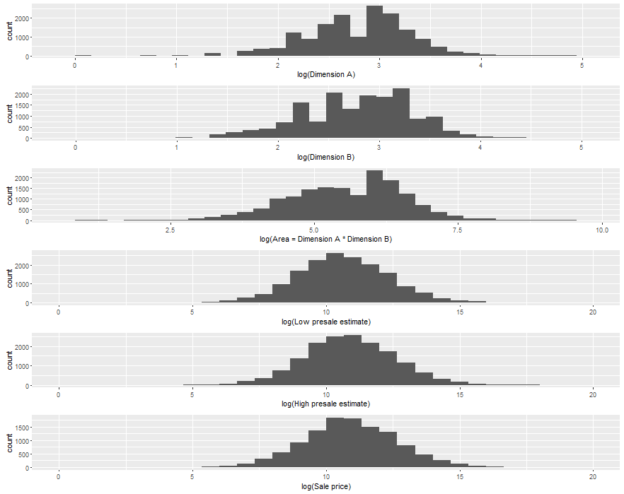

Figure 2: Comparison of painting dimensions, Impressionist art. OLS regression line included.

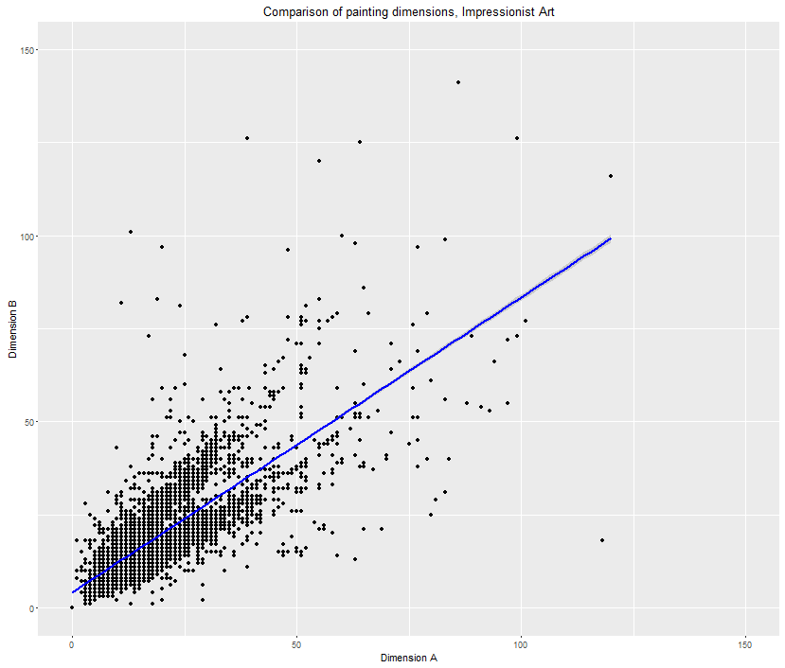

Figure 3: Impressionist art, auction sales over time.

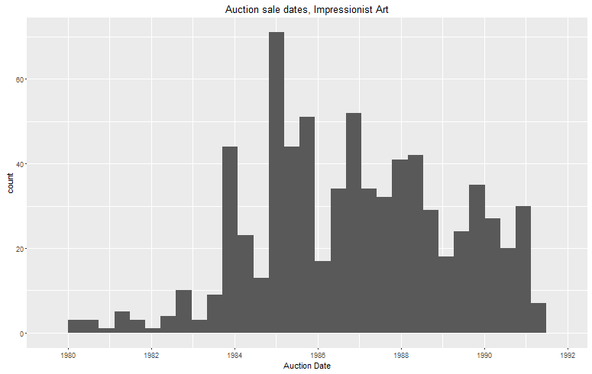

Figure 4: Distribution of selected quantities in the Contemporary art dataset.

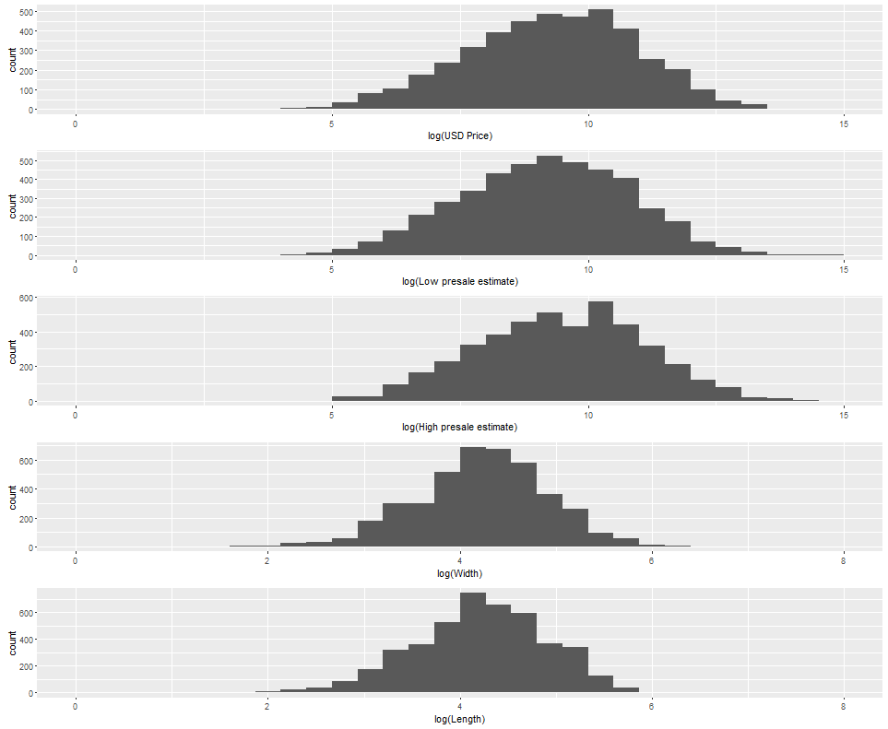

Figure 5: Auction sales over time, Contemporary art.

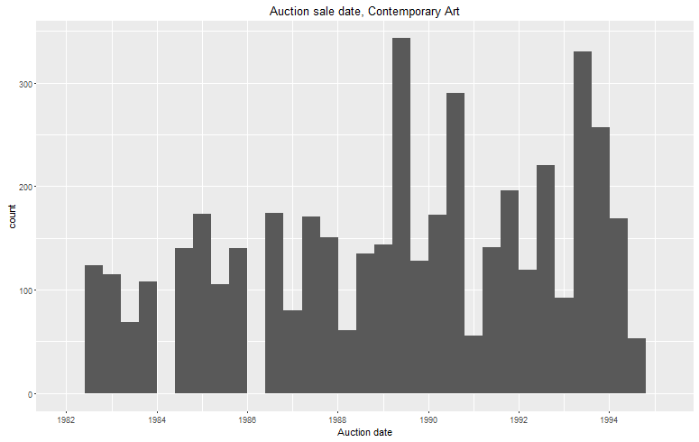

Figure 6: Comparison of log prices, Impressionist and Contemporary art.

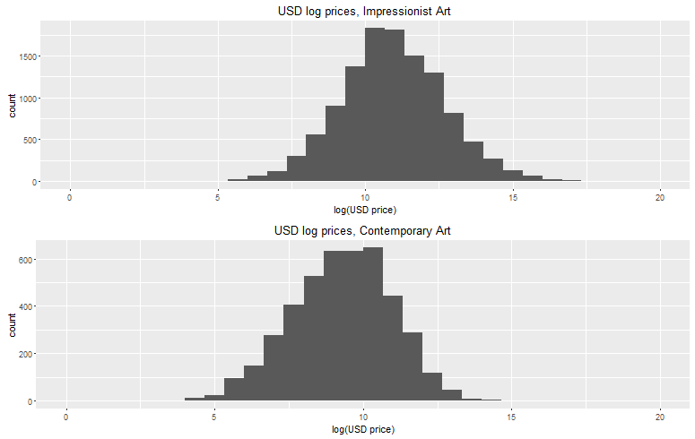

Figure 7: Comparison of log area, Impressionist and Contemporary art.

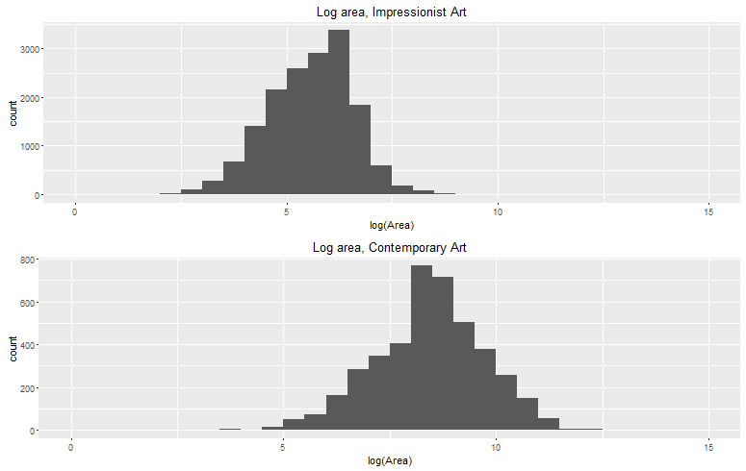

Figure 8: Comparison of painting dimensions, Contemporary art. OLS regression line included.

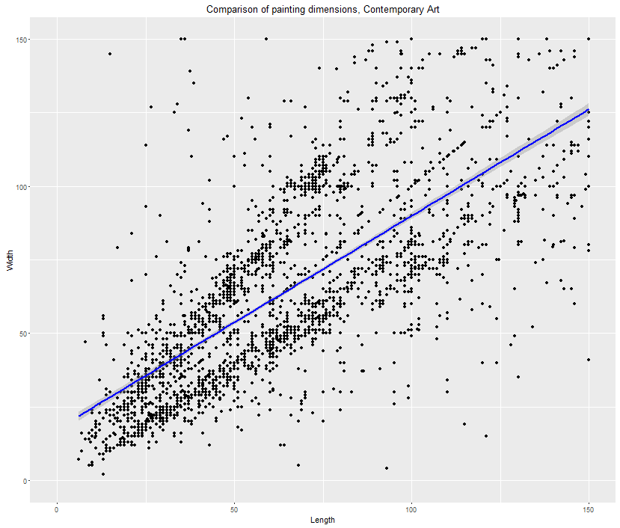

Figure 9: Assorted art (paintings only), number of artists by date.

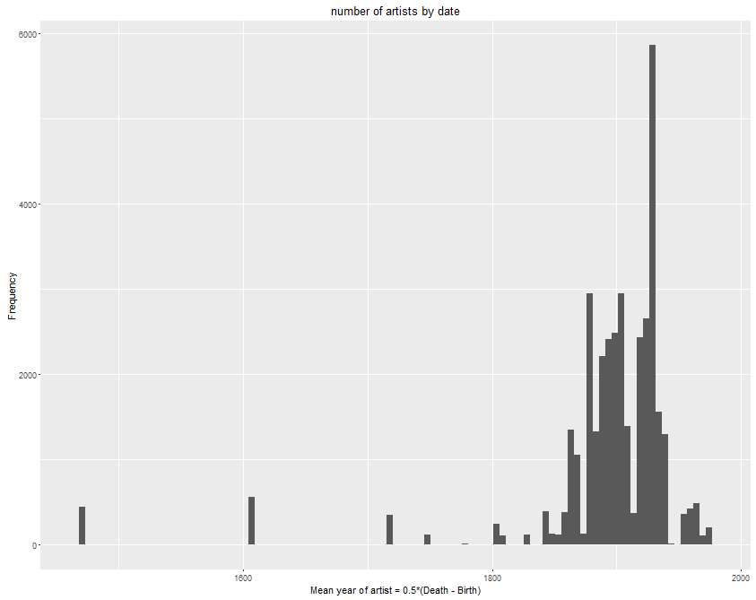

Figure 10: Assorted art (paintings only), log sale price.

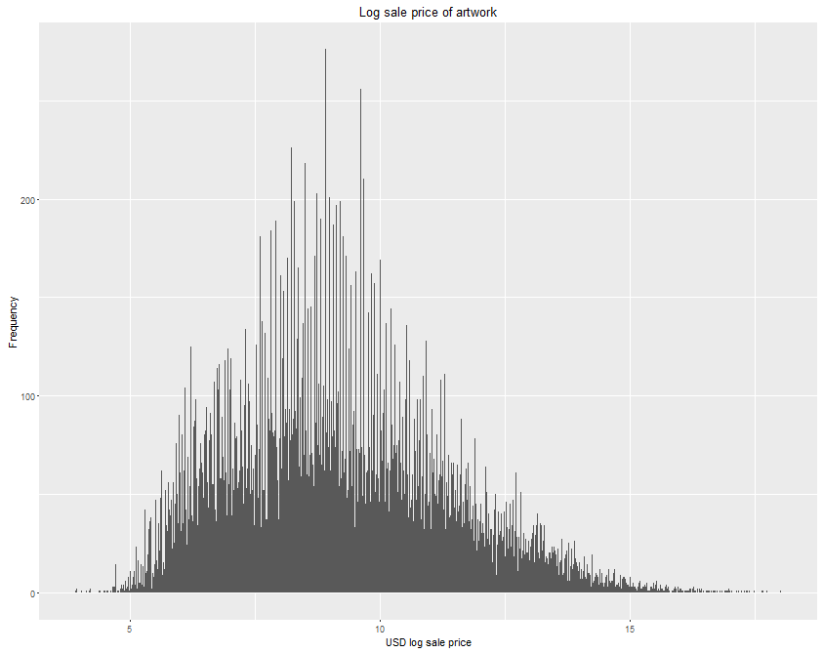

Figure 11: Assorted art (paintings only), sales volume over time.

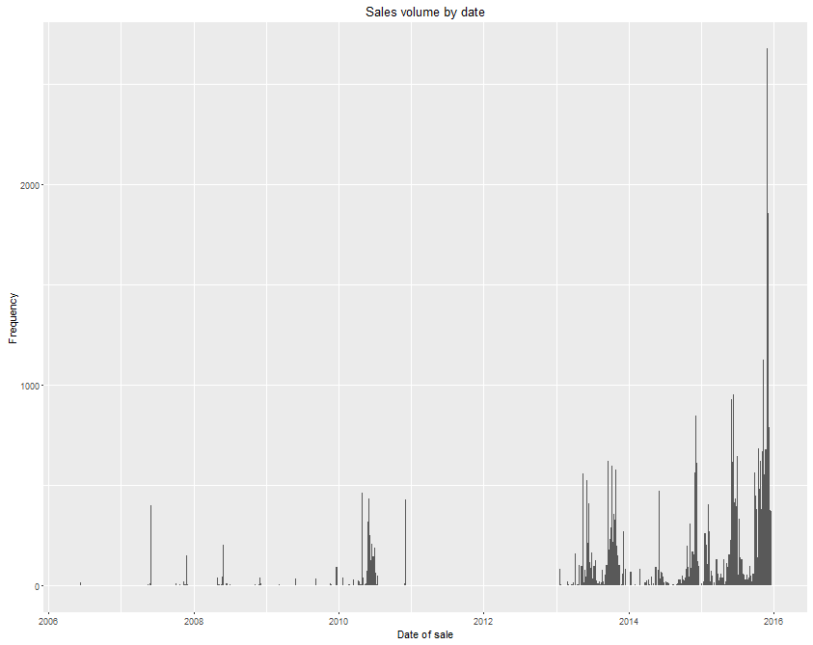

Figure 12: Assorted art (paintings only), average artist revenue based on number of artist works featured at auction.

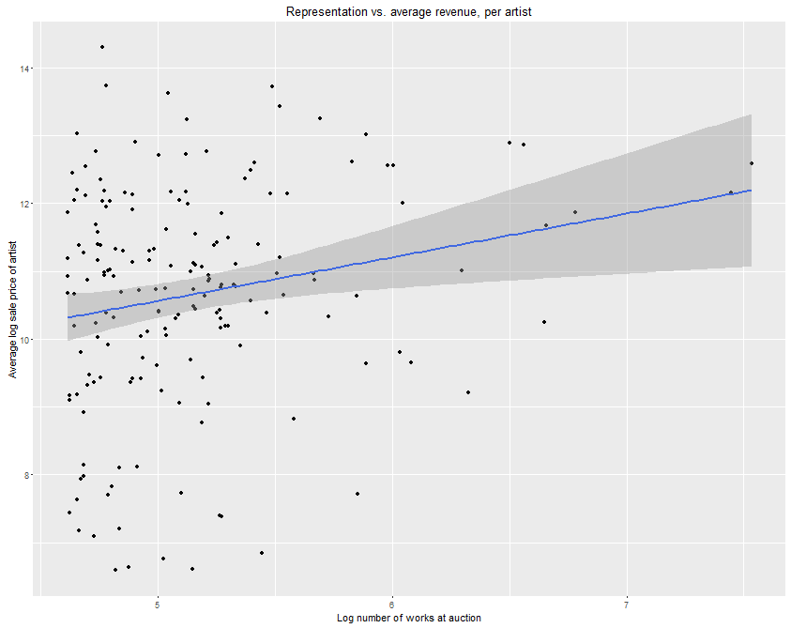

**TABLES**

Table 1: Impressionist art (16,253 observations), summary statistics for selected continuous features. Units unknown for the dimensions. The # of NA values (missing values) for Sale Price indicate observations where the work of interest did not sell. 91% of works have signs of authenticity (indicated in a multi-level variable SIGN for different signs of authenticity. It equals 0 if no signs are present).

|  |  |  |  |  |  |  |  |
| --- | --- | --- | --- | --- | --- | --- | --- |
| Variable | Min | 1st Qu. | Median | Mean | 3rd Qu. | Max | # NA vals |
| Date of Auction | 3/26/1980 | 2/21/1985 | 11/20/1986 | 12/01/1986 | 10/19/1988 | 5/9/1991 | 0 |
| Dimension A | 0 | 11 | 17 | 18.31 | 23.00 | 120.00 | 37 |
| Dimension B | 0 | 11 | 18 | 18.69 | 24 | 141 | 37 |
| Low Estimate (USD) | 102 | 14,000 | 40,000 | 196,023 | 132,800 | 40,000,000 | 0 |
| High Estimate (USD) | 128 | 18,000 | 50,000 | 257,967 | 168,300 | 50,000,000 | 0 |
| Sale Price (USD) | 126 | 18,700 | 53,856 | 285,428 | 176,000 | 82,500,000 | 4,696 |
| Date of Painting’s Creation | 1823 | 1902 | 1922 | 1921 | 1938 | 1983 | 3,950 |
| Diameter of Painting | 1 | 6.75 | 11.50 | 15.10 | 24.50 | 36.00 | 16,243 |

Table 2: Contemporary art (4,456 observations), summary statistics for selected continuous variables. There already exists a dummy variable SOLD which indicates whether or not a painting has sold (see Data section on Contemporary art). Here, Sale Price (USD) reflects either the final sale price of the work (if it has sold) or the final highest bid (if it is bought in). Additionally, the STATA .do information file that accompanied this dataset did not provide the exact units for length and width. This dataset did not included indicators of authenticity such as a signature.

|  |  |  |  |  |  |  |  |
| --- | --- | --- | --- | --- | --- | --- | --- |
| Variable | Min | 1st Qu. | Median | Mean | 3rd Qu. | Max | # NA vals |
| Date of Auction | 6/29/1982 | 6/26/1986 | 6/29/1989 | 5/15/1989 | 7/2/1992 | 6/30/1994 | 0 |
| Low Estimate (USD) | 81 | 3,078 | 10,248 | 32,619 | 30,681 | 3,491,100 | 45 |
| High Estimate (USD) | 145 | 4,316 | 13,342 | 43,613 | 40,545 | 5,042,700 | 45 |
| Sale Price (USD) | 0 | 3,024 | 11,055 | 35,179 | 34,030 | 3,297,150 | 2 |
| Length | 5.40 | 44.50 | 70 | 84.53 | 105 | 957 | 73 |
| Width | 2 | 46 | 70 | 84.71 | 105 | 602 | 293 |

Table 3: Assorted art (264,115 observations, only paintings), summary statistics for selected continuous variables. Approximately 72% of the works are signed. Other hedonic characteristics not included in this table are artist and materials. We do not consider presale estimates, since they are not the focus of our research.

|  |  |  |  |  |  |  |  |
| --- | --- | --- | --- | --- | --- | --- | --- |
| Variable | Min | 1st Qu. | Median | Mean | 3rd Qu. | Max | # NA vals |
| Date of Auction | 6/9/2006 | 9/28/2013 | 2/14/2015 | 7/4/2014 | 10/16/2015 | 12/22/2015 | 0 |
| Sale Price (USD) | 1 | 989 | 3,007 | 50,497 | 12,435 | 70,530,000 | 0 |
| Height (Inches) | 0.04 | 11.89 | 19.49 | 23.51 | 29.53 | 358.27 | 0 |
| Width (Inches) | 0.15 | 12.20 | 19.57 | 23.58 | 28.74 | 355.71 | 0 |

**HEDONIC REGRESSIONS**

P-values that are significant at the 5% level (or lower) are **bolded**. All p-values are two-tailed.

Table 4: Hedonic predictions, Impressionist Art (London). Half-year time dummies omitted for brevity. Multiple signs of authenticity accounted for; medium is also a categorical variable. The regression software we used (R programming language) dropped certain columns for estimation.

|  |  |  |  |  |
| --- | --- | --- | --- | --- |
| Variable | Estimate | Std. Error | t-value | p-value |
| Constant | 10.667 | 6.704 | 1.591 | 0.113 |
| Date of Painting | -0.002 | 0.004 | -0.604 | 0.546 |
| Dimension A | 0.027 | 0.008 | 3.519 | **0.001** |
| Dimension B | 0.017 | 0.006 | 2.595 | **0.010** |
| Authenticity #1 | 0.267 | 0.251 | 0.760 | 0.448 |
| Authenticity #2 | -0.065 | 0.434 | -0.149 | 0.881 |
| Authenticity #3 | -0.430 | 0.413 | -1.04 | 0.298 |
| Medium 6 | 1.780 | 0.680 | 2.625 | **0.009** |
| Medium 9 | 0.349 | 0.684 | 0.510 | 0.610 |
| Medium 12 | 2.270 | 0.674 | 3.368 | **0.001** |
| Medium 15 | 1.470 | 0.698 | 2.110 | **0.036** |
| Medium 18 | 2.950 | 0.643 | 4.595 | **0.000** |
| Medium 24 | 1.460 | 0.770 | 1.889 | **0.060** |
| $$R^{2}$$ | 0.866 |  |  |  |
| Adjusted $R^{2}$ | 0.825 |  |  |  |
| F-Statistic | 21.01 on 79 and 256 DF (p-value: < 2.2E-16) | | | |

Table 5: Hedonic predictions, Impressionist Art (NYC). Half-year time dummies omitted for brevity.

|  |  |  |  |  |
| --- | --- | --- | --- | --- |
| Variable | Estimate | Std. Error | t-value | p-value |
| Constant | 20.536 | 5.800 | 3.541 | **0.000** |
| Date of Painting | -0.006 | 0.003 | -2.013 | **0.045** |
| Dimension A | 0.041 | 0.007 | 5.447 | **0.000** |
| Dimension B | 0.013 | 0.007 | 1.771 | 0.077 |
| Authenticity #1 | 1.059 | 0.157 | 6.757 | **0.000** |
| Authenticity #2 | 0.301 | 0.245 | 1.228 | 0.220 |
| Authenticity #3 | 0.203 | 0.217 | 0.936 | 0.350 |
| Medium 6 | -0.365 | 0.687 | -0.531 | 0.596 |
| Medium 9 | -0.060 | 0.642 | -0.094 | 0.925 |
| Medium 12 | 1.014 | 0.618 | 1.640 | 0.102 |
| Medium 15 | -0.131 | 0.665 | -0.197 | 0.844 |
| Medium 18 | 1.248 | 0.615 | 2.029 | **0.043** |
| Medium 21 | 0.773 | 0.877 | 0.882 | 0.379 |
| Medium 24 | 0.361 | 0.661 | 0.546 | 0.585 |
| Medium 27 | -0.342 | 0.657 | -0.522 | 0.602 |
| Medium 30 | -0.075 | 0.646 | -0.117 | 0.907 |
| Medium 38 | -0.404 | 0.808 | -0.500 | 0.617 |
| Medium 39 | 0.645 | 0.631 | 1.023 | 0.307 |
| $$R^{2}$$ | 0.837 |  |  |  |
| Adjusted $R^{2}$ | 0.800 |  |  |  |
| F-Statistic | 22.24 on 74 and 319 DF (p-value: < 2.2E-16) | | | |

Table 6: Hedonic predictions, Contemporary Art. Half-year time dummies omitted for brevity.

|  |  |  |  |  |
| --- | --- | --- | --- | --- |
| Variable | Estimate | Std. Error | t-value | p-value |
| Constant | -1.542 | 1.918 | -0.804 | 0.422 |
| log(Date of Painting) | -0.672 | 0.427 | -1.574 | 0.116 |
| log(Length) | 0.592 | 0.116 | 5.111 | **0.000** |
| log(Width) | 0.616 | 0.118 | 5.235 | **0.000** |
| Medium a | 0.379 | 0.368 | 1.031 | 0.303 |
| Medium br | -1.004 | 0.470 | -2.134 | **0.034** |
| Medium chk | -0.512 | 0.506 | -1.013 | 0.312 |
| Medium col | -2.011 | 0.543 | -3.700 | **0.000** |
| Medium cr | -0.856 | 0.376 | -2.279 | **0.023** |
| Medium f | -1.196 | 0.490 | -2.442 | **0.015** |
| Medium g | -0.923 | 0.407 | -2.271 | **0.024** |
| Medium ik | -0.666 | 0.383 | -1.738 | 0.083 |
| Medium o | 0.339 | 0.315 | 1.076 | 0.283 |
| Medium pas | -0.764 | 0.551 | -1.388 | 0.166 |
| Medium pg | 3.843 | 0.644 | 5.964 | **0.000** |
| Medium ph | -2.974 | 0.720 | -4.132 | **0.000** |
| Medium pl | 1.436 | 0.660 | 2.176 | **0.030** |
| Medium pn | 0.733 | 0.796 | 0.921 | 0.358 |
| Medium s | -0.303 | 0.491 | -0.618 | 0.537 |
| Medium sk | 2.781 | 0.579 | 4.804 | **0.000** |
| Medium t | -0.773 | 0.390 | -1.980 | **0.049** |
| Medium tp | 0.253 | 0.554 | 0.457 | 0.648 |
| $$R^{2}$$ | 0.923 |  |  |  |
| Adjusted $R^{2}$ | 0.889 |  |  |  |
| F-Statistic | 27.17 on 146 and 330 DF (p-value: < 2.2E-16) | | | |

Table 7: Hedonic predictions, assorted art. Half-yr. dummies, artist, med. omitted for brevity.

|  |  |  |  |  |
| --- | --- | --- | --- | --- |
| Variable | Estimate | Std. Error | t-value | p-value |
| Constant | 6.224 | 0.018 | 345.782 | **<2e-16** |
| log(Height) | 0.614 | 0.008 | 76.454 | **<2e-16** |
| log(Width) | 0.230 | 0.008 | 28.431 | **<2e-16** |
| Signed | -0.635 | 0.008 | -79.255 | **<2e-16** |
| Monogrammed | -0.203 | 0.022 | -9.089 | **<2e-16** |
| Stamped | 0.086 | 0.016 | 5.391 | **0.000** |
| $$R^{2}$$ | 0.101 |  |  |  |
| Adjusted $R^{2}$ | 0.101 |  |  |  |
| F-Statistic | 5907 on 5 and 264109 DF (p-value: < 2.2E-16) | | | |

**ANCHORING EFFECTS (REPLICATION)**

Throughout this paper, we are only interested in regressions where price is the dependent variable. This is reflected in all following tables for anchoring effects.

Table 8: Replicated anchoring effects, Impressionist Art. In the original anchoring regression, the current hedonic prediction (at time $t$) represents $π_{t}$, the anchoring effect represents $(P_{t-1}-π_{t})$, and the past residual represents $(P_{t-1}-π_{t-1})$.

|  |  |  |  |  |
| --- | --- | --- | --- | --- |
|  | Estimate | Std.Error | t-value | p-value |
| Constant | -0.338 | 0.193 | -1.755 | 0.080 |
| Current hedonic prediction | 1.018 | 0.019 | 53.327 | **<2e-16** |
| Anchoring effect | 0.174 | 0.072 | 2.410 | **0.017** |
| Past residual | 0.503 | 0.077 | 6.533 | **0.000** |
| Months since last sale | 0.008 | 0.002 | 4.219 | **0.000** |
| $$R^{2}$$ | 0.923 |  |  |  |
| Adjusted $R^{2}$ | 0.922 |  |  |  |
| F-Statistic | 1047 on 4 and 349 DF  (p-value: < 2.2E-16) | | | |

Table 8b: Original anchoring results for Impressionist Art, Beggs & Graddy (2009). This corresponds to the full sample with price as the dependent variable. Findings of anchoring were significant (not shown).

|  |  |  |
| --- | --- | --- |
|  | Estimate | Std. Error |
| Constant | 0.246 | 0.436 |
| Current hedonic prediction | 0.982 | 0.036 |
| Anchoring effect | 0.625 | 0.131 |
| Past residual | 0.323 | 0.141 |
| Months since last sale | 0.011 | 0.0003 |
| $$R^{2}$$ | 0.90 |  |

Table 9: Replicated anchoring effects, Contemporary Art

|  |  |  |  |  |
| --- | --- | --- | --- | --- |
|  | Estimate | Std.Error | t-value | p-value |
| Constant | -0.115 | 0.050 | -2.316 | **0.022** |
| Current hedonic prediction | 1.034 | 0.020 | 50.799 | **0.000** |
| Anchoring effect | 0.131 | 0.074 | 1.773 | 0.078 |
| Past residual | 0.191 | 0.095 | 2.009 | **0.046** |
| Months since last sale | -0.001 | 0.003 | -0.341 | 0.734 |
| $$R^{2}$$ | 0.941 |  |  |  |
| Adjusted $R^{2}$ | 0.940 |  |  |  |
| F-Statistic | 698 on 4 and 176 DF  (p-value: < 2.2E-16) | | | |

Table 9b: Original anchoring results for Contemporary art, Beggs & Graddy (2009).

|  |  |  |
| --- | --- | --- |
|  | Estimate | Std. Error |
| Constant | -0.292 | 0.408 |
| Current hedonic prediction | 1.015 | 0.047 |
| Anchoring effect | 0.183 | 0.091 |
| Past residual | 0.379 | 0.146 |
| Months since last sale | 0.0002 | 0.0004 |
| $$R^{2}$$ | 0.91 |  |

Table 10: Anchoring effects, assorted art.

|  |  |  |  |  |
| --- | --- | --- | --- | --- |
|  | Estimate | Std.Error | t-value | p-value |
| Constant | -1.599 | 0.010 | -16.467 | **0.000** |
| Current hedonic prediction | 1.148 | 0.012 | 98.054 | **0.000** |
| Anchoring effect | 0.591 | 0.011 | 51.626 | **0.0000** |
| Past residual | -0.020 | 0.012 | -1.683 | 0.092 |
| Months since last sale | -0.042 | 0.005 | -8.837 | **0.000** |
| $$R^{2}$$ | 0.414 |  |  |  |
| Adjusted $R^{2}$ | 0.414 |  |  |  |
| F-Statistic | 3.04E4 on 4 and 172189 DF  (p-value: < 2.2E-16) | | | |

**ANCHORING CROSS-EFFECTS (Q1)**

Table 11: Anchoring cross-effects ($Q_{1}$) for Impressionist art. In our anchoring cross-effects regression, the current hedonic prediction is represents $π_{c}$, the anchoring cross-effect represents $(P_{s}-π_{c})$, the substitute residual represents $(P_{s}-π_{s})$, and the substitute measure represents $Q$ which is $Q_{1}$ here. Again, the substitute here represents the “average substitute” for the current good.

|  |  |  |  |  |
| --- | --- | --- | --- | --- |
|  | Estimate | Std.Error | t-value | p-value |
| Constant | -0.105 | 0.067 | -1.558 | 0.119 |
| Current hedonic prediction | 1.020 | 0.012 | 84.393 | **0.000** |
| Anchoring cross-effect | 0.034 | 0.014 | 2.419 | **0.016** |
| Substitute residual | -0.284 | 0.021 | 13.405 | **0.000** |
| Substitute measure | 0.008 | 0.004 | 2.055 | **0.040** |
| Months since substitute sale | -0.001 | 0.001 | -1.035 | 0.301 |
| $$R^{2}$$ | 0.775 |  |  |  |
| Adjusted $R^{2}$ | 0.775 |  |  |  |
| F-Statistic | 8004 on 5 and 11608 DF  (p-value: < 2.2E-16) | | | |

Table 12: Anchoring cross-effects ($Q_{1}$) for Contemporary art.

|  |  |  |  |  |
| --- | --- | --- | --- | --- |
|  | Estimate | Std.Error | t-value | p-value |
| Constant | 0.60 | 0.090 | 0.659 | 0.510 |
| Current hedonic prediction | 1.034 | 0.025 | 41.781 | **0.000** |
| Anchoring cross-effect | -0.030 | 0.029 | -1.039 | 0.299 |
| Substitute residual | 0.298 | 0.044 | 6.791 | **0.000** |
| Substitute measure | -0.013 | 0.009 | -1.465 | 0.143 |
| Months since substitute sale | -0.050 | 0.014 | -3.529 | **0.000** |
| $$R^{2}$$ | 0.831 |  |  |  |
| Adjusted $R^{2}$ | 0.830 |  |  |  |
| F-Statistic | 938 on 5 and 952 DF  (p-value: < 2.2E-16) | | | |

Table 13: Anchoring cross-effects ($Q_{1}$) for assorted art.

|  |  |  |  |  |
| --- | --- | --- | --- | --- |
|  | Estimate | Std.Error | t-value | p-value |
| Constant | -1.995 | 0.221 | -9.043 | **0.000** |
| Current hedonic prediction | 1.241 | 0.026 | 47.959 | **0.000** |
| Anchoring cross-effect | 0.661 | 0.025 | 26.414 | **0.000** |
| Substitute residual | -0.102 | 0.026 | -3.869 | **0.000** |
| Substitute measure | 0.027 | 0.005 | 5.366 | **0.000** |
| Months since substitute sale | -0.089 | 0.016 | -5.594 | **0.000** |
| $$R^{2}$$ | 0.461 |  |  |  |
| Adjusted $R^{2}$ | 0.461 |  |  |  |
| F-Statistic | 3030 on 5 and 17693 DF  (p-value: < 2.2E-16) | | | |

**ANCHORING CROSS-EFFECTS (Q2)**

Table 14: Anchoring cross-effects ($Q_{2}$) for Impressionist art.

|  |  |  |  |  |
| --- | --- | --- | --- | --- |
|  | Estimate | Std.Error | t-value | p-value |
| Constant | 0.009 | 0.074 | 0.116 | 0.9079 |
| Current hedonic prediction | 0.999 | 0.006 | 162.044 | **0.000** |
| Anchoring cross-effect | 0.026 | 0.013 | 1.965 | **0.050** |
| Substitute residual | 0.286 | 0.021 | 13.572 | **0.000** |
| Substitute measure | 0.015 | 0.008 | 1.871 | 0.061 |
| Months since substitute sale | -0.0001 | 0.001 | -0.195 | 0.8457 |
| $$R^{2}$$ | 0.775 |  |  |  |
| Adjusted $R^{2}$ | 0.775 |  |  |  |
| F-Statistic | 8004 on 5 and 11608 DF  (p-value: < 2.2E-16) | | | |

Table 15: Anchoring cross-effects ($Q_{2}$) for Contemporary art.

|  |  |  |  |  |
| --- | --- | --- | --- | --- |
|  | Estimate | Std.Error | t-value | p-value |
| Constant | -0.092 | 0.115 | -0.797 | 0.426 |
| Current hedonic prediction | 1.056 | 0.019 | 58.124 | **0.000** |
| Anchoring cross-effect | -0.021 | 0.027 | -0.775 | 0.439 |
| Substitute residual | 0.292 | 0.044 | 6.680 | **0.000** |
| Substitute measure | -0.012 | 0.006 | -2.022 | **0.0435** |
| Months since substitute sale | -0.050 | 0.014 | -3.545 | **0.000** |
| $$R^{2}$$ | 0.8316 |  |  |  |
| Adjusted $R^{2}$ | 0.8307 |  |  |  |
| F-Statistic | 940.3 on 5 and 952 DF  (p-value: < 2.2E-16) | | | |

Table 16: Anchoring cross-effects ($Q_{2}$) for assorted art.

|  |  |  |  |  |
| --- | --- | --- | --- | --- |
|  | Estimate | Std.Error | t-value | p-value |
| Constant | -2.036 | 0.176 | -11.541 | **0.000** |
| Current hedonic prediction | 1.272 | 0.019 | 66.215 | **0.000** |
| Anchoring cross-effect | 0.519 | 0.022 | 23.632 | **0.000** |
| Substitute residual | 0.081 | 0.023 | 3.586 | **0.000** |
| Substitute measure | 0.296 | 0.015 | 19.504 | **0.000** |
| Months since last sale | 0.072 | 0.010 | 7.093 | **0.000** |
| $$R^{2}$$ | 0.398 |  |  |  |
| Adjusted $R^{2}$ | 0.398 |  |  |  |
| F-Statistic | 3936 on 5 and 29784 DF  (p-value: < 2.2E-16) | | | |

Table 17: Summary of results, anchoring (cross-effects). Shows the anchoring coefficients and p-values for our regressions with $Q_{1}$ and $Q_{2}$, respectively.

|  |  |  |
| --- | --- | --- |
| Variable | Anchoring coef (& p-val), $Q_{1}$ | Anchoring coef (& p-val), $Q_{2}$ |
| Impressionist art | **0.034 (0.016)** | **0.026 (0.0495)** |
| Contemporary art | -0.03 (0.299) | -0.02 (0.438) |
| Assorted art | **0.66 (0.000)** | **0.52 (0.000)** |

**THREE EXPERIMENTS**

Table 18: Picasso vs. Chagall ($Q_{1}$)

|  |  |  |  |  |  |
| --- | --- | --- | --- | --- | --- |
|  | | Estimate | Std.Error | t-value | p-value |
| Constant | | -2.880 | 3.353 | -0.859 | 0.391 |
| Current hedonic prediction | | 2.027 | 0.340 | 5.959 | **0.000** |
| Anchoring cross-effect | | 1.546 | 0.325 | 4.754 | **0.000** |
| Substitute residual | | -1.126 | 0.328 | -3.432 | **0.001** |
| Substitute measure | | 0.362 | 0.022 | 16.116 | **0.000** |
| Months since last sale | | -0.057 | 0.0366 | -1.550 | 0.121 |
| $$R^{2}$$ | | 0.179 |  |  |  |
| Adjusted $R^{2}$ | | 0.177 |  |  |  |
| F-Statistic | 102.9 on 5 and 2359 DF  (p-value: < 2.2E-16) | | | | |

Table 19: Picasso vs. Chagall ($Q_{2}$)

|  |  |  |  |  |  |  |  |
| --- | --- | --- | --- | --- | --- | --- | --- |
|  | Estimate | Std.Error | | t-value | | p-value | |
| Constant | -21.895 | | 3.230 | | -6.779 | | **0.000** |
| Current hedonic prediction | 3.479 | | 0.341 | | 10.218 | | **0.000** |
| Anchoring cross-effect | 2.537 | | 0.332 | | 7.639 | | **0.000** |
| Substitute residual | -2.242 | | 0.333 | | -6.733 | | **0.000** |
| Substitute measure | 0.551 | | 0.0837 | | 6.582 | | **0.000** |
| Months since last sale | 0.205 | | 0.0579 | | 3.549 | | **0.000** |
| $$R^{2}$$ | 0.105 | |  | |  | |  |
| Adjusted $R^{2}$ | 0.103 | |  | |  | |  |
| F-Statistic | 55.39 on 5 and 2359 DF  (p-value: < 2.2E-16) | | | | | | |

Table 20: Miro vs. Dali ($Q_{1}$)

|  |  |  |  |  |  |
| --- | --- | --- | --- | --- | --- |
|  | | Estimate | Std.Error | t-value | p-value |
| Constant | | 7.150 | 2.161 | 3.309 | **0.001** |
| Current hedonic prediction | | 0.519 | 0.271 | 1.919 | 0.055 |
| Anchoring cross-effect | | -0.370 | 0.252 | -1.466 | 0.143 |
| Substitute residual | | 0.488 | 0.254 | 1.919 | 0.055 |
| Substitute measure | | 0.18523 | 0.020 | 9.149 | **0.000** |
| Months since last sale | | -0.0825 | 0.044 | -1.865 | 0.0623 |
| $$R^{2}$$ | | 0.126 |  |  |  |
| Adjusted $R^{2}$ | | 0.123 |  |  |  |
| F-Statistic | 41.84 on 5 and 1458 DF  (p-value: < 2.2E-16) | | | | |

Table 21: Miro vs. Dali ($Q_{2}$)

|  |  |  |  |  |  |
| --- | --- | --- | --- | --- | --- |
|  | | Estimate | Std.Error | t-value | p-value |
| Constant | | 8.677 | 2.233 | 3.886 | **0.000** |
| Current hedonic prediction | | -0.061 | 0.275 | -0.221 | 0.825 |
| Anchoring cross-effect | | -0.973 | 0.254 | -3.836 | **0.000** |
| Substitute residual | | 1.032 | 0.258 | 4.005 | **0.000** |
| Substitute measure | | 0.012 | 0.037 | 0.317 | 0.751 |
| Months since last sale | | -0.106 | 0.047 | -2.245 | **0.025** |
| $$R^{2}$$ | | 0.075 |  |  |  |
| Adjusted $R^{2}$ | | 0.072 |  |  |  |
| F-Statistic | 23.76 on 5 and 1458 DF  (p-value: < 2.2E-16) | | | | |

Table 22: Munch vs. Toulouse-Lautrec ($Q_{1}$)

|  |  |  |  |  |  |
| --- | --- | --- | --- | --- | --- |
|  | | Estimate | Std.Error | t-value | p-value |
| Constant | | 2.212 | 2.302 | 0.961 | 0.337 |
| Current hedonic prediction | | 0.856 | 0.205 | 4.179 | **0.000** |
| Anchoring cross-effect | | -0.219 | 0.199 | -1.101 | 0.272 |
| Substitute residual | | 0.140 | 0.213 | 0.656 | 0.512 |
| Substitute measure | | 0.043 | 0.46 | 0.930 | 0.353 |
| Months since last sale | | 0.053 | 0.071 | 0.754 | 0.452 |
| $$R^{2}$$ | | 0.2927 |  |  |  |
| Adjusted $R^{2}$ | | 0.2811 |  |  |  |
| F-Statistic | 25.24 on 5 and 305 DF  (p-value: < 2.2E-16) | | | | |

Table 23: Munch vs. Toulouse-Lautrec ($Q_{2}$)

|  |  |  |  |  |  |
| --- | --- | --- | --- | --- | --- |
|  | | Estimate | Std.Error | t-value | p-value |
| Constant | | 2.724 | 2.187 | 1.245 | 0.214 |
| Current hedonic prediction | | 0.815 | 0.206 | 3.953 | **0.000** |
| Anchoring cross-effect | | -0.273 | 0.202 | -1.353 | 0.177 |
| Substitute residual | | 0.196 | 0.215 | 0.909 | 0.364 |
| Substitute measure | | 0.369 | 0.211 | 1.744 | 0.082 |
| Months since last sale | | 0.262 | 0.135 | 1.936 | 0.054 |
| $$R^{2}$$ | | 0.298 |  |  |  |
| Adjusted $R^{2}$ | | 0.286 |  |  |  |
| F-Statistic | 25.86 on 5 and 305 DF  (p-value: < 2.2E-16) | | | | |

HONOR CODE PLEDGE

This paper represents my own work in accordance with University regulations.

Evan Chow

1. Age is not considered a hedonic feature, because for us it represents time-dependent demand for art rather than intrinsic characteristics of the work.
2. Interview, Raphaelle Benabou.
3. Interview, Mark Best.
4. The auctioneer will call out prices around 10% higher than the current bid (“Sotheby’s – Glossary” n.d.).
5. Interview, Raphaelle Benabou.
6. Interview, Raphaelle Benabou.
7. Specifically, the range between low and high estimates.
8. Interview, Raphaelle Benabou.
9. For more about Auction Week, see Goldstein (2014).
10. http://people.brandeis.edu/~kgraddy/data.html
11. Besides the artist’s hand-drawn signature, monograms and stamps may also be used to mark an artwork as authentic. A monogram is a stylized symbol of the artist (sometimes an artistic rendering of their initials) that may be put onto a work. Artists may also have a custom stamp for their work, which may include their printed name.
12. Another example would be a work’s reputation, which could drive up both past and current price. This component of quality, however, cannot be modeled as another hedonic attribute like size, medium, etc., since reputation is not an intrinsic property of an art piece.
13. We do not subtract the other term ${E\left[X=\left(π_{c}-π_{s}\right)\right]}^{2}$ typically used in calculating variance $V\left[X\right]=E\left[X^{2}\right]-E{\left[X\right]}^{2}$, since that (squared) mean term reflects the absolute hedonic differences $X=(π_{c}-π_{s})$. Our measure represents $E[X^{2}]$, the summation of $V[X]$ and $E{\left[X\right]}^{2}$, and this is how we account for both spread and magnitude.
14. See Cupchik et al. (1992) for further discussion.
15. We add one in the denominator of the first term to protect against results exploding toward infinity. Empirically, however, this is negligible compared to the magnitude of our hedonic prices.
16. For instance, Matt Lamb’s “Figures” fetched $24K at Christie’s, London on June 22, 2010. (Christie’s Lotfinder)
17. Interview, Hadley Newton.