**FIGURES**

Figure 1: Distribution of selected quantities in the Impressionist art dataset.

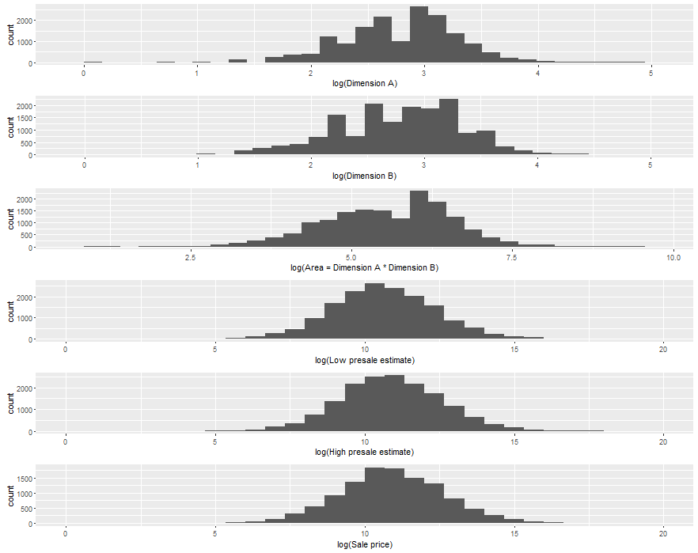

Figure 2: Comparison of painting dimensions, Impressionist art.

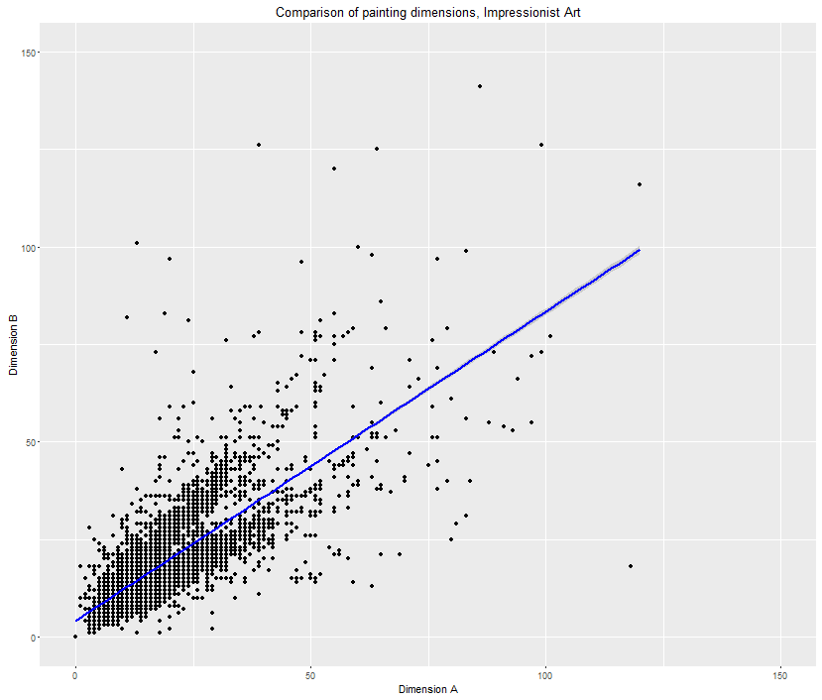

Figure 3: Impressionist art, auction sales over time.

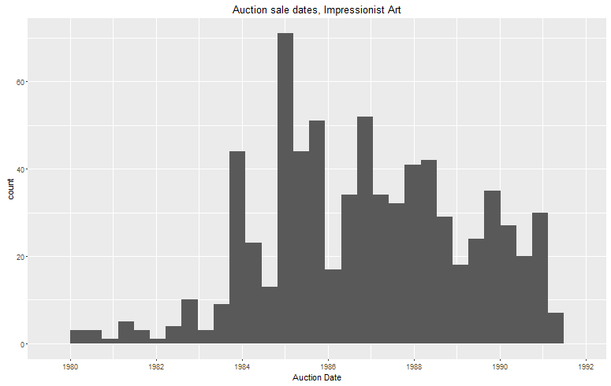

Figure 4: Distribution of selected quantities in the Contemporary art dataset.

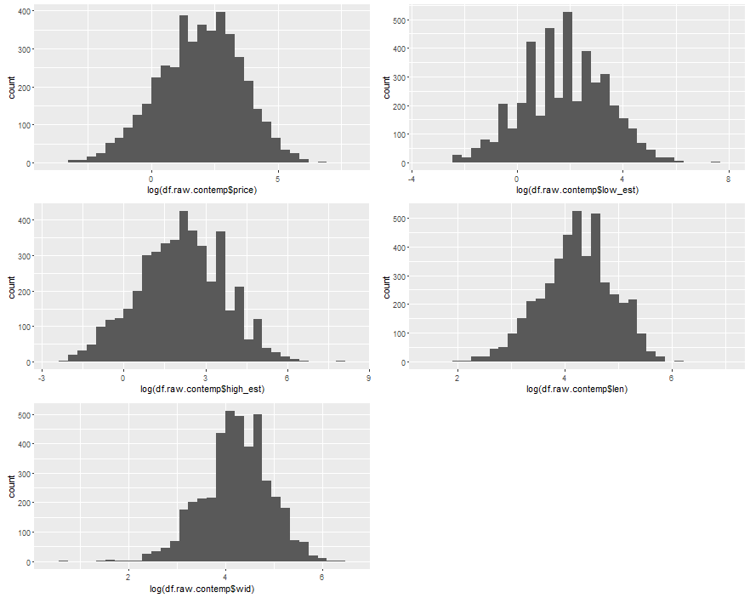

Figure 5: Auction sales over time, Contemporary art.

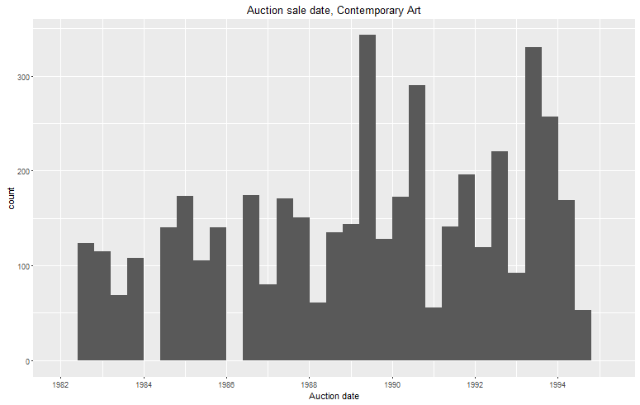

Figure 6: Comparison of log prices, Impressionist and Contemporary art.

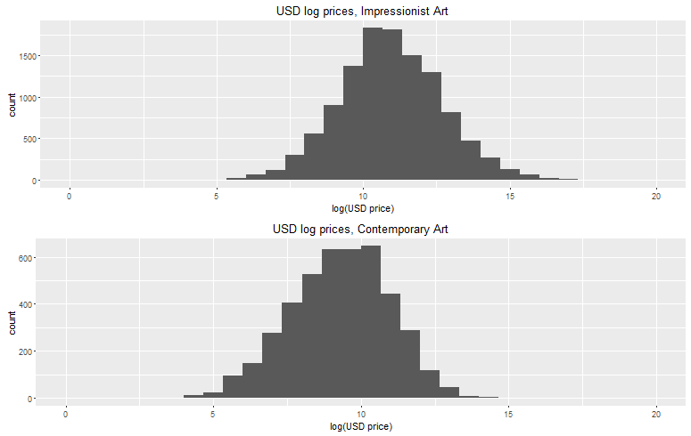

Figure 7: Comparison of log area, Impressionist and Contemporary art.

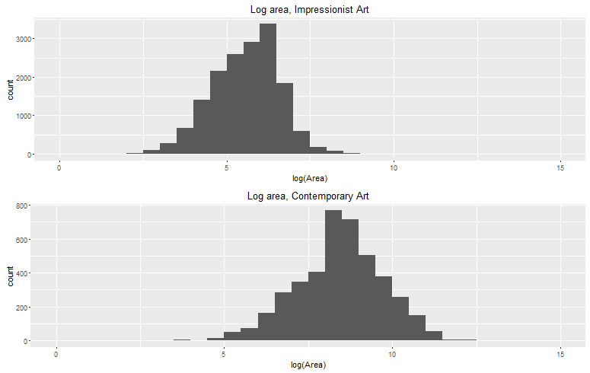

Figure 8: Comparison of painting dimensions, Contemporary art.

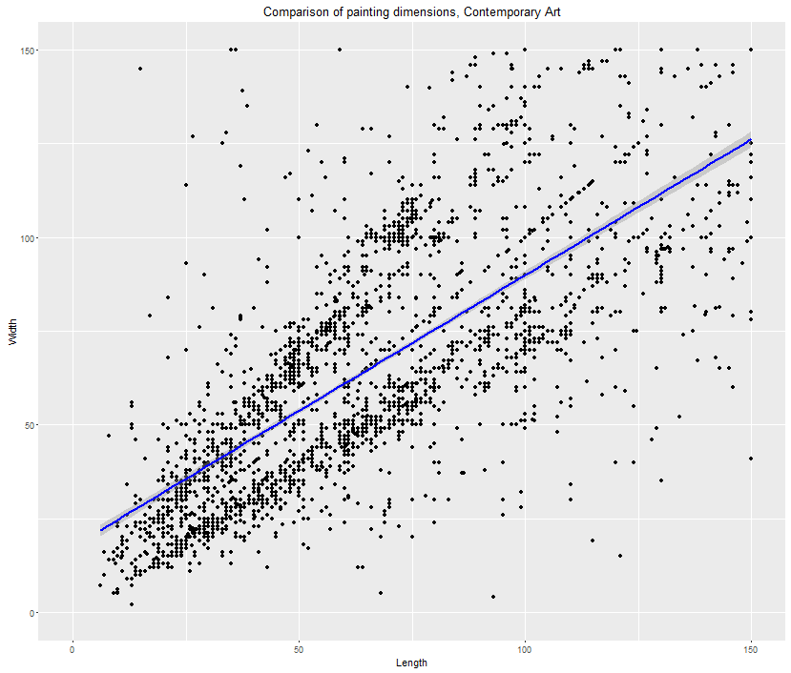

Figures 9-12: Plots for recent assorted art dataset.

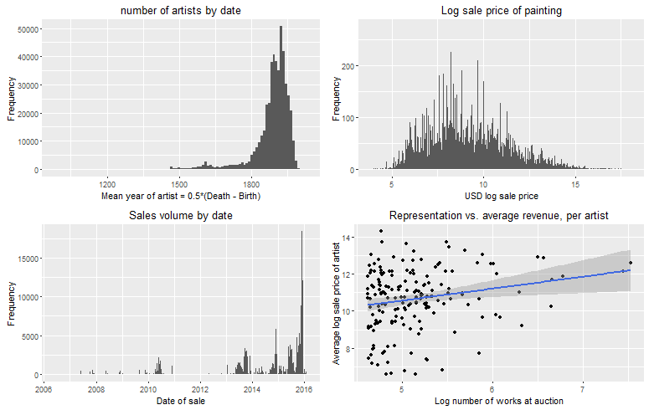

**TABLES**

**SUMMARY STATISTICS**

Table 1: Impressionist art, summary statistics for continuous features.

DIM_A LOW_EST HIGH_EST

Min. : 0.00 Min. : 102 Min. : 128

1st Qu.: 11.00 1st Qu.: 14000 1st Qu.: 18000

Median : 17.00 Median : 40000 Median : 50000

Mean : 18.31 Mean : 196023 Mean : 257967

3rd Qu.: 23.00 3rd Qu.: 132800 3rd Qu.: 168300

Max. :120.00 Max. :40000000 Max. :50000000

NA's :37

S_PRICE CNV_RATE DATE_PTG

Min. : 126 Min. :0.0000 Min. :1823

1st Qu.: 18700 1st Qu.:0.0000 1st Qu.:1902

Median : 53856 Median :1.2400 Median :1922

Mean : 285428 Mean :0.8639 Mean :1921

3rd Qu.: 176000 3rd Qu.:1.6800 3rd Qu.:1938

Max. :82500000 Max. :2.3610 Max. :1983

NA's :4696 NA's :3950

DATE_FLG DIM_B DIAM

Min. :0.0000 Min. : 0.00 Min. : 1.00

1st Qu.:0.0000 1st Qu.: 11.00 1st Qu.: 6.75

Median :0.0000 Median : 18.00 Median :11.50

Mean :0.3538 Mean : 18.69 Mean :15.10

3rd Qu.:1.0000 3rd Qu.: 24.00 3rd Qu.:24.50

Max. :1.0000 Max. :141.00 Max. :36.00

NA's :37 NA's :16243

PND_FLG

Min. :0.0000

1st Qu.:0.0000

Median :1.0000

Mean :0.5127

3rd Qu.:1.0000

Max. :2.0000

NA's :4

Table 2: Contemporary art, summary statistics.

Auction_date mdate ddate ydate

Min. :1982-06-29 Min. : 2.000 Min. : 1.00 Min. :1982

1st Qu.:1986-06-26 1st Qu.: 6.000 1st Qu.: 5.00 1st Qu.:1986

Median :1989-06-29 Median : 6.000 Median :22.00 Median :1989

Mean :1989-05-15 Mean : 7.831 Mean :17.07 Mean :1989

3rd Qu.:1992-07-02 3rd Qu.:12.000 3rd Qu.:26.00 3rd Qu.:1992

Max. :1994-06-30 Max. :12.000 Max. :30.00 Max. :1994

lot sold price low_est

Min. : 1.0 Min. :0.0000 Min. : 0.00 Min. : 0.05

1st Qu.: 87.0 1st Qu.:1.0000 1st Qu.: 1.90 1st Qu.: 2.00

Median : 423.0 Median :1.0000 Median : 7.00 Median : 6.00

Mean : 397.7 Mean :0.7745 Mean : 21.23 Mean : 19.53

3rd Qu.: 601.0 3rd Qu.:1.0000 3rd Qu.: 20.00 3rd Qu.: 20.00

Max. :1164.0 Max. :1.0000 Max. :1700.00 Max. :1800.00

NA's :2 NA's :45

high_est date_ptg len wid

Min. : 0.1 Min. :26.00 Min. : 5.40 Min. : 2.00

1st Qu.: 3.0 1st Qu.:60.00 1st Qu.: 44.50 1st Qu.: 46.00

Median : 8.0 Median :67.00 Median : 70.00 Median : 70.00

Mean : 26.1 Mean :68.24 Mean : 84.53 Mean : 84.71

3rd Qu.: 25.0 3rd Qu.:77.00 3rd Qu.:105.00 3rd Qu.:105.00

Max. :2600.0 Max. :91.00 Max. :957.00 Max. :602.00

NA's :45 NA's :449 NA's :73 NA's :293

artist medium CNV_RATE ukcpi

Length:4456 Length:4456 Min. :1.210 Min. :239.6

Class :character Class :character 1st Qu.:1.482 1st Qu.:286.4

Mode :character Mode :character Median :1.610 Median :339.3

Mean :1.609 Mean :342.9

3rd Qu.:1.722 3rd Qu.:407.1

Max. :1.954 Max. :423.0

ukinf uktb uscpi usinf

Min. : 1.270 Min. : 4.900 Min. :181.6 Min. :1.280

1st Qu.: 3.050 1st Qu.: 8.800 1st Qu.:204.1 1st Qu.:3.050

Median : 4.710 Median : 9.630 Median :231.7 Median :3.920

Mean : 5.061 Mean : 9.832 Mean :232.7 Mean :3.848

3rd Qu.: 6.520 3rd Qu.:11.990 3rd Qu.:261.9 3rd Qu.:4.600

Max. :10.430 Max. :14.540 Max. :276.8 Max. :6.220

ustb japcpi dj ftse

Min. : 2.970 Min. :149.3 Min. : 812.2 Min. : 736.2

1st Qu.: 3.990 1st Qu.:160.6 1st Qu.:1776.5 1st Qu.:1588.4

Median : 6.990 Median :168.2 Median :2458.3 Median :2182.0

Mean : 6.157 Mean :169.9 Mean :2438.5 Mean :2078.3

3rd Qu.: 7.760 3rd Qu.:182.3 3rd Qu.:3174.7 3rd Qu.:2546.6

Max. :10.320 Max. :185.4 Max. :3753.5 Max. :3223.9

Table 3: Assorted art, summary statistics.

height width area.inches artist.startdate

Min. : 0 Min. : 0 Min. :0.000e+00 Min. :1000

1st Qu.: 12 1st Qu.: 12 1st Qu.:1.520e+02 1st Qu.:1869

Median : 19 Median : 20 Median :3.920e+02 Median :1904

Mean : 64 Mean : 78 Mean :2.270e+08 Mean :1886

3rd Qu.: 29 3rd Qu.: 29 3rd Qu.:8.160e+02 3rd Qu.:1932

Max. :7700281 Max. :10197670 Max. :7.852e+13 Max. :2015

NA's :4000 NA's :31325 NA's :86729 NA's :19411

artist.enddate lot.number sale.date usd.sale.price

Min. :1016 Min. : 0 Min. :2006-06-09 Min. : 1

1st Qu.:1930 1st Qu.: 81 1st Qu.:2013-10-15 1st Qu.: 905

Median :1956 Median : 205 Median :2015-06-02 Median : 3009

Mean :1941 Mean : 1195 Mean :2014-08-27 Mean : 50275

3rd Qu.:1983 3rd Qu.: 599 3rd Qu.:2015-11-11 3rd Qu.: 12188

Max. :2015 Max. :221186 Max. :2016-02-04 Max. :70530000

NA's :19411 NA's :275 NA's :275 NA's :209591

**HEDONIC REGRESSION**

Table 4: Hedonic predictions, Impressionist Art (London). Half-year time dummies omitted for brevity.

Estimate Std. Error t value Pr(>|t|)

(Intercept) 10.667134 6.703545 1.591 0.112783

DATE_PTG -0.002122 0.003513 -0.604 0.546317

DIM_A 0.026975 0.007665 3.519 0.000512 ***

DIM_B 0.016575 0.006388 2.595 0.010018 *

SIGNED1 0.266633 0.350862 0.760 0.447990

SIGNED2 -0.064880 0.434096 -0.149 0.881308

SIGNED3 -0.429974 0.413009 -1.041 0.298822

ART_MED6 1.779714 0.677907 2.625 0.009178 **

ART_MED9 0.348789 0.684150 0.510 0.610622

ART_MED12 2.270866 0.674249 3.368 0.000874 ***

ART_MED15 1.473253 0.698082 2.110 0.035791 *

ART_MED18 2.952254 0.642515 4.595 6.80e-06 ***

ART_MED24 1.457382 0.771532 1.889 0.060030 .

ART_MED27 1.093956 0.661039 1.655 0.099170 .

ART_MED30 0.490681 0.658584 0.745 0.456923

ART_MED33 1.278982 0.846104 1.512 0.131866

ART_MED39 1.767484 0.660349 2.677 0.007918 **

R^2: 0.8664

Adjusted R^2: 0.8251

F-statistic: 21.01 on 79 and 256 DF, p-value: < 2.2e-16

Table 5: Hedonic predictions, Impressionist Art (NYC). Half-year time dummies omitted for brevity.

Estimate Std. Error t value Pr(>|t|)

(Intercept) 20.536155 5.799675 3.541 0.000458 ***

DATE_PTG -0.006033 0.002998 -2.013 0.044995 *

DIM_A 0.040589 0.007452 5.447 1.03e-07 ***

DIM_B 0.012602 0.007114 1.771 0.077433 .

SIGNED1 1.059125 0.156739 6.757 6.69e-11 ***

SIGNED2 0.301338 0.245387 1.228 0.220348

SIGNED3 0.203128 0.217131 0.936 0.350234

ART_MED6 -0.364772 0.687000 -0.531 0.595814

ART_MED9 -0.060186 0.642117 -0.094 0.925382

ART_MED12 1.014323 0.618434 1.640 0.101960

ART_MED15 -0.131242 0.665053 -0.197 0.843687

ART_MED18 1.248101 0.615153 2.029 0.043296 *

ART_MED21 0.773179 0.877041 0.882 0.378669

ART_MED24 0.361094 0.661262 0.546 0.585401

ART_MED27 -0.342484 0.656519 -0.522 0.602264

ART_MED30 -0.075431 0.646362 -0.117 0.907170

ART_MED38 -0.404069 0.807695 -0.500 0.617227

ART_MED39 0.645365 0.630585 1.023 0.306876

R^2: 0.8377

Adjusted R^2: 0.8

F-statistic: 22.24 on 74 and 319 DF, p-value: < 2.2e-16

Table 6: Hedonic predictions, Contemporary Art. Half-year time dummies omitted for brevity.

Estimate Std. Error t value Pr(>|t|)

(Intercept) -1.54229 1.91849 -0.804 0.422029

log(date_ptg) -0.67160 0.42660 -1.574 0.116371

log(len) 0.59158 0.11574 5.111 5.42e-07 ***

log(wid) 0.61585 0.11764 5.235 2.94e-07 ***

mediuma 0.37892 0.36754 1.031 0.303314

mediumbr -1.00407 0.47045 -2.134 0.033555 *

mediumchk -0.51240 0.50577 -1.013 0.311749

mediumcol -2.01051 0.54342 -3.700 0.000253 ***

mediumcr -0.85626 0.37571 -2.279 0.023304 *

mediumf -1.19646 0.49004 -2.442 0.015148 *

mediumg -0.92343 0.40669 -2.271 0.023817 *

mediumik -0.66618 0.38336 -1.738 0.083193 .

mediumo 0.33903 0.31500 1.076 0.282582

mediumpas -0.76427 0.55061 -1.388 0.166063

mediumpg 3.84267 0.64429 5.964 6.33e-09 ***

mediumph -2.97383 0.71974 -4.132 4.57e-05 ***

mediumpl 1.43608 0.66003 2.176 0.030281 *

mediumpn 0.73305 0.79588 0.921 0.357696

mediums -0.30325 0.49084 -0.618 0.537122

mediumsk 2.78109 0.57888 4.804 2.36e-06 ***

mediumt -0.77276 0.39024 -1.980 0.048510 *

mediumtp 0.25322 0.55431 0.457 0.648099

mediumw -0.41915 0.36663 -1.143 0.253758

R^2 0.9232

Adjusted R^2 0.8892

F-statistic: 27.17 on 146 and 330 DF, p-value: < 2.2e-16

Table 7: Hedonic predictions, assorted art. Half-year time dummies omitted for brevity. Artist and medium were omitted due to computational constraints.

Estimate Std. Error t value Pr(>|t|)

(Intercept) 6.224144 0.018000 345.782 <2e-16 ***

log(height) 0.614017 0.008031 76.454 <2e-16 ***

log(width) 0.230060 0.008092 28.431 <2e-16 ***

signed -0.634735 0.008009 -79.255 <2e-16 ***

monogrammed -0.203214 0.022359 -9.089 <2e-16 ***

stamped 0.086423 0.016030 5.391 7e-08 ***

R^2 0.1006

Adjusted R^2 0.1006

F-statistic: 5907 on 5 and 264109 DF, p-value: < 2.2e-16

**ANCHORING EFFECTS (REPLICATION)**

Table 8: Replicated anchoring effects, Impressionist Art

Estimate Std. Error t value Pr(>|t|)

(Intercept) -0.338390 0.192857 -1.755 0.0802 .

curr_hed_pred 1.018156 0.019093 53.327 < 2e-16 ***

anchoring 0.174402 0.072377 2.410 0.0165 *

past_control 0.503147 0.077019 6.533 2.29e-10 ***

months_since_last_sale 0.007903 0.001873 4.219 3.13e-05 ***

R^2 0.9231

Adjusted R^2 0.9222

F-statistic: 1047 on 4 and 349 DF, p-value: < 2.2e-16

Table 9: Replicated anchoring effects, Contemporary Art

Estimate Std. Error t value Pr(>|t|)

(Intercept) -0.1152982 0.0499920 -2.306 0.0223 *

curr_hed_pred 1.0344742 0.0203640 50.799 <2e-16 ***

anchoring 0.1312881 0.0740504 1.773 0.0780 .

past_control 0.1914626 0.0952936 2.009 0.0460 *

months_since_last_sale -0.0009164 0.0026884 -0.341 0.7336

R^2 0.9407

Adjusted R^2 0.9394

F-statistic: 698 on 4 and 176 DF, p-value: < 2.2e-16

Table 10: Anchoring effects, assorted art (original regression from Beggs & Graddy (2009))

Estimate Std. Error t value Pr(>|t|)

(Intercept) -1.598781 0.096913 -16.497 <2e-16 ***

log_hed_pred 1.147787 0.011706 98.054 <2e-16 ***

anchoring 0.590709 0.011442 51.626 <2e-16 ***

sub_price_hed_pred -0.020331 0.012078 -1.683 0.0923 .

avg_mon_subdiff -0.042259 0.004782 -8.837 <2e-16 ***

R^2 0.4144

Adjusted R^2 0.4144

F-statistic: 3.046e+04 on 4 and 172189 DF, p-value: < 2.2e-16

**ANCHORING CROSS-EFFECTS (Q1)**

Table 11: Anchoring cross-effects ($Q_{1}$) for Impressionist art.

Call:

lm(formula = log_sale_price ~ log_hed_pred + anchoring + sub_price_hed_pred +

substitute_measure + avg_months_since_sub_sale, data = df.anchor.sub.impress)

Residuals:

Min 1Q Median 3Q Max

-5.2368 -0.4767 0.0007 0.4753 3.2939

Coefficients:

Estimate Std. Error t value Pr(>|t|)

(Intercept) -0.1049942 0.0673771 -1.558 0.1192

log_hed_pred 1.0203528 0.0120905 84.393 <2e-16 ***

anchoring 0.0342261 0.0141471 2.419 0.0156 *

sub_price_hed_pred 0.2836732 0.0211621 13.405 <2e-16 ***

substitute_measure 0.0084785 0.0041261 2.055 0.0399 *

avg_months_since_sub_sale -0.0006209 0.0006000 -1.035 0.3008

---

Signif. codes: 0 ‘***’ 0.001 ‘**’ 0.01 ‘*’ 0.05 ‘.’ 0.1 ‘ ’ 1

Residual standard error: 0.773 on 11608 degrees of freedom

Multiple R-squared: 0.7752, Adjusted R-squared: 0.7751

F-statistic: 8004 on 5 and 11608 DF, p-value: < 2.2e-16

Table 12: Anchoring cross-effects ($Q_{1}$) for Contemporary art.

Call:

lm(formula = log_sale_price ~ log_hed_pred + anchoring + sub_price_hed_pred +

substitute_measure + avg_months_since_sub_sale, data = df.reg.sub)

Residuals:

Min 1Q Median 3Q Max

-2.96495 -0.33364 0.02062 0.35064 1.66091

Coefficients:

Estimate Std. Error t value Pr(>|t|)

(Intercept) 0.059521 0.090352 0.659 0.510202

log_hed_pred 1.034162 0.024752 41.781 < 2e-16 ***

anchoring -0.030017 0.028887 -1.039 0.299009

sub_price_hed_pred 0.298056 0.043888 6.791 1.95e-11 ***

substitute_measure -0.013093 0.008939 -1.465 0.143340

avg_months_since_sub_sale -0.050238 0.014234 -3.529 0.000436 ***

---

Signif. codes: 0 ‘***’ 0.001 ‘**’ 0.01 ‘*’ 0.05 ‘.’ 0.1 ‘ ’ 1

Residual standard error: 0.5653 on 952 degrees of freedom

Multiple R-squared: 0.8313, Adjusted R-squared: 0.8304

F-statistic: 938 on 5 and 952 DF, p-value: < 2.2e-16

Table 13: Anchoring cross-effects ($Q_{1}$) for assorted art.

Call:

lm(formula = log_sale_price ~ ., data = df.anchoring[complete.cases(df.anchoring),

])

Residuals:

Min 1Q Median 3Q Max

-7.3357 -1.1534 -0.0891 1.0304 7.7630

Coefficients:

Estimate Std. Error t value Pr(>|t|)

(Intercept) -1.994594 0.220561 -9.043 < 2e-16 ***

log_hed_pred 1.240644 0.025869 47.959 < 2e-16 ***

anchoring 0.661090 0.025028 26.414 < 2e-16 ***

sub_price_hed_pred -0.102460 0.026481 -3.869 0.00011 ***

substitute_measure 0.026968 0.005026 5.366 8.16e-08 ***

avg_mon_subdiff -0.088799 0.015873 -5.594 2.25e-08 ***

---

Signif. codes: 0 ‘***’ 0.001 ‘**’ 0.01 ‘*’ 0.05 ‘.’ 0.1 ‘ ’ 1

Residual standard error: 1.616 on 17693 degrees of freedom

Multiple R-squared: 0.4613, Adjusted R-squared: 0.4611

F-statistic: 3030 on 5 and 17693 DF, p-value: < 2.2e-16

**ANCHORING CROSS-EFFECTS (Q2)**

Table 14: Anchoring cross-effects ($Q_{2}$) for Impressionist art.

Call:

lm(formula = log_sale_price ~ log_hed_pred + anchoring + sub_price_hed_pred +

substitute_measure + avg_months_since_sub_sale, data = df.anchor.sub.impress)

Residuals:

Min 1Q Median 3Q Max

-5.2351 -0.4763 0.0000 0.4755 3.2843

Coefficients:

Estimate Std. Error t value Pr(>|t|)

(Intercept) 0.0085722 0.0741016 0.116 0.9079

log_hed_pred 0.9988786 0.0061643 162.044 <2e-16 ***

anchoring 0.0262716 0.0133724 1.965 0.0495 *

sub_price_hed_pred 0.2861356 0.0210827 13.572 <2e-16 ***

substitute_measure 0.0150060 0.0080184 1.871 0.0613 .

avg_months_since_sub_sale -0.0001465 0.0007528 -0.195 0.8457

---

Signif. codes: 0 ‘***’ 0.001 ‘**’ 0.01 ‘*’ 0.05 ‘.’ 0.1 ‘ ’ 1

Residual standard error: 0.773 on 11608 degrees of freedom

Multiple R-squared: 0.7752, Adjusted R-squared: 0.7751

F-statistic: 8004 on 5 and 11608 DF, p-value: < 2.2e-16

Table 15: Anchoring cross-effects ($Q_{2}$) for Contemporary art.

Call:

lm(formula = log_sale_price ~ log_hed_pred + anchoring + sub_price_hed_pred +

substitute_measure + avg_months_since_sub_sale, data = df.reg.sub)

Residuals:

Min 1Q Median 3Q Max

-2.95880 -0.33439 0.02226 0.34534 1.67089

Coefficients:

Estimate Std. Error t value Pr(>|t|)

(Intercept) -0.091648 0.114989 -0.797 0.425642

log_hed_pred 1.055614 0.018161 58.124 < 2e-16 ***

anchoring -0.021001 0.027097 -0.775 0.438519

sub_price_hed_pred 0.291614 0.043657 6.680 4.07e-11 ***

substitute_measure -0.011917 0.005894 -2.022 0.043486 *

avg_months_since_sub_sale -0.050393 0.014217 -3.545 0.000412 ***

---

Signif. codes: 0 ‘***’ 0.001 ‘**’ 0.01 ‘*’ 0.05 ‘.’ 0.1 ‘ ’ 1

Residual standard error: 0.5647 on 952 degrees of freedom

Multiple R-squared: 0.8316, Adjusted R-squared: 0.8307

F-statistic: 940.3 on 5 and 952 DF, p-value: < 2.2e-16

Table 16: Anchoring cross-effects ($Q_{2}$) for assorted art.

Call:

lm(formula = log_sale_price ~ ., data = df.anchoring[complete.cases(df.anchoring),

])

Residuals:

Min 1Q Median 3Q Max

-7.1890 -1.0271 0.0846 1.0769 7.9026

Coefficients:

Estimate Std. Error t value Pr(>|t|)

(Intercept) -2.03647 0.17645 -11.541 < 2e-16 ***

log_hed_pred 1.27157 0.01920 66.215 < 2e-16 ***

anchoring 0.51926 0.02197 23.632 < 2e-16 ***

sub_price_hed_pred 0.08111 0.02262 3.586 0.000337 ***

substitute_measure 0.29640 0.01520 19.504 < 2e-16 ***

avg_mon_subdiff 0.07226 0.01019 7.093 1.34e-12 ***

---

Signif. codes: 0 ‘***’ 0.001 ‘**’ 0.01 ‘*’ 0.05 ‘.’ 0.1 ‘ ’ 1

Residual standard error: 1.658 on 29784 degrees of freedom

Multiple R-squared: 0.3979, Adjusted R-squared: 0.3978

F-statistic: 3936 on 5 and 29784 DF, p-value: < 2.2e-16

Table 17: Summary of anchoring results.

|  |  |  |
| --- | --- | --- |
|  | Anchoring under $Q_{1}$ | Anchoring under $Q_{2}$ |
| Impressionist Art | 0.034 * | 0.026 * |
| Contemporary Art | -0.03 | -0.02 |
| Assorted Art | 0.66 *** | 0.52 *** |

**THREE EXPERIMENTS**

Table 18: Miro vs. Dali ($Q_{1}$)

Call:

lm(formula = log_sale_price ~ ., data = df.anchoring[complete.cases(df.anchoring),

])

Residuals:

Min 1Q Median 3Q Max

-3.2922 -1.0052 -0.1560 0.8208 8.4440

Coefficients:

Estimate Std. Error t value Pr(>|t|)

(Intercept) 7.15043 2.16084 3.309 0.000959 ***

log_hed_pred 0.51936 0.27060 1.919 0.055144 .

anchoring -0.37001 0.25243 -1.466 0.142918

sub_price_hed_pred 0.48840 0.25445 1.919 0.055125 .

substitute_measure 0.18523 0.02024 9.149 < 2e-16 ***

avg_mon_subdiff -0.08254 0.04425 -1.865 0.062339 .

---

Signif. codes: 0 ‘***’ 0.001 ‘**’ 0.01 ‘*’ 0.05 ‘.’ 0.1 ‘ ’ 1

Residual standard error: 1.483 on 1458 degrees of freedom

Multiple R-squared: 0.1255, Adjusted R-squared: 0.1225

F-statistic: 41.84 on 5 and 1458 DF, p-value: < 2.2e-16

Table 19: Miro vs. Dali ($Q_{2}$)

Call:

lm(formula = log_sale_price ~ ., data = df.anchoring[complete.cases(df.anchoring),

])

Residuals:

Min 1Q Median 3Q Max

-3.0733 -1.0296 -0.1694 0.7886 8.2793

Coefficients:

Estimate Std. Error t value Pr(>|t|)

(Intercept) 8.67695 2.23295 3.886 0.000107 ***

log_hed_pred -0.06076 0.27531 -0.221 0.825343

anchoring -0.97311 0.25364 -3.836 0.000130 ***

sub_price_hed_pred 1.03215 0.25775 4.005 6.53e-05 ***

substitute_measure 0.01170 0.03687 0.317 0.751092

avg_mon_subdiff -0.10641 0.04740 -2.245 0.024933 *

---

Signif. codes: 0 ‘***’ 0.001 ‘**’ 0.01 ‘*’ 0.05 ‘.’ 0.1 ‘ ’ 1

Residual standard error: 1.525 on 1458 degrees of freedom

Multiple R-squared: 0.07533, Adjusted R-squared: 0.07216

F-statistic: 23.76 on 5 and 1458 DF, p-value: < 2.2e-16

Table 20: Picasso vs. Chagall ($Q_{1}$)

Call:

lm(formula = log_sale_price ~ ., data = df.anchoring[complete.cases(df.anchoring),

])

Residuals:

Min 1Q Median 3Q Max

-4.6215 -1.0532 -0.1586 0.8661 7.3545

Coefficients:

Estimate Std. Error t value Pr(>|t|)

(Intercept) -2.88027 3.35265 -0.859 0.390372

log_hed_pred 2.02669 0.34011 5.959 2.92e-09 ***

anchoring 1.54597 0.32518 4.754 2.11e-06 ***

sub_price_hed_pred -1.12558 0.32794 -3.432 0.000609 ***

substitute_measure 0.36201 0.02246 16.116 < 2e-16 ***

avg_mon_subdiff -0.05674 0.03661 -1.550 0.121289

---

Signif. codes: 0 ‘***’ 0.001 ‘**’ 0.01 ‘*’ 0.05 ‘.’ 0.1 ‘ ’ 1

Residual standard error: 1.686 on 2359 degrees of freedom

Multiple R-squared: 0.179, Adjusted R-squared: 0.1773

F-statistic: 102.9 on 5 and 2359 DF, p-value: < 2.2e-16

Table 21: Picasso vs. Chagall ($Q_{2}$)

Call:

lm(formula = log_sale_price ~ ., data = df.anchoring[complete.cases(df.anchoring),

])

Residuals:

Min 1Q Median 3Q Max

-4.7629 -1.0573 -0.2084 0.8451 8.3682

Coefficients:

Estimate Std. Error t value Pr(>|t|)

(Intercept) -21.89473 3.22978 -6.779 1.52e-11 ***

log_hed_pred 3.47944 0.34053 10.218 < 2e-16 ***

anchoring 2.53673 0.33207 7.639 3.16e-14 ***

sub_price_hed_pred -2.24188 0.33296 -6.733 2.08e-11 ***

substitute_measure 0.55122 0.08374 6.582 5.69e-11 ***

avg_mon_subdiff 0.20532 0.05785 3.549 0.000394 ***

---

Signif. codes: 0 ‘***’ 0.001 ‘**’ 0.01 ‘*’ 0.05 ‘.’ 0.1 ‘ ’ 1

Residual standard error: 1.76 on 2359 degrees of freedom

Multiple R-squared: 0.1051, Adjusted R-squared: 0.1032

F-statistic: 55.39 on 5 and 2359 DF, p-value: < 2.2e-16

Table 22: Munch vs. Toulouse-Lautrec ($Q_{1}$)

Call:

lm(formula = log_sale_price ~ ., data = df.anchoring[complete.cases(df.anchoring),

])

Residuals:

Min 1Q Median 3Q Max

-5.2478 -0.9364 -0.0661 1.0238 7.1826

Coefficients:

Estimate Std. Error t value Pr(>|t|)

(Intercept) 2.21191 2.30155 0.961 0.337

log_hed_pred 0.85602 0.20483 4.179 3.83e-05 ***

anchoring -0.21898 0.19898 -1.101 0.272

sub_price_hed_pred 0.14003 0.21334 0.656 0.512

substitute_measure 0.04258 0.04577 0.930 0.353

avg_mon_subdiff 0.05321 0.07060 0.754 0.452

---

Signif. codes: 0 ‘***’ 0.001 ‘**’ 0.01 ‘*’ 0.05 ‘.’ 0.1 ‘ ’ 1

Residual standard error: 1.567 on 305 degrees of freedom

Multiple R-squared: 0.2927, Adjusted R-squared: 0.2811

F-statistic: 25.24 on 5 and 305 DF, p-value: < 2.2e-16

Table 23: Munch vs. Toulouse-Lautrec ($Q_{2}$)

Call:

lm(formula = log_sale_price ~ ., data = df.anchoring[complete.cases(df.anchoring),

])

Residuals:

Min 1Q Median 3Q Max

-5.2282 -0.9288 -0.0752 0.9997 7.0301

Coefficients:

Estimate Std. Error t value Pr(>|t|)

(Intercept) 2.7240 2.1874 1.245 0.2140

log_hed_pred 0.8145 0.2060 3.953 9.59e-05 ***

anchoring -0.2728 0.2016 -1.353 0.1770

sub_price_hed_pred 0.1956 0.2151 0.909 0.3639

substitute_measure 0.3686 0.2114 1.744 0.0822 .

avg_mon_subdiff 0.2615 0.1351 1.936 0.0538 .

---

Signif. codes: 0 ‘***’ 0.001 ‘**’ 0.01 ‘*’ 0.05 ‘.’ 0.1 ‘ ’ 1

Residual standard error: 1.562 on 305 degrees of freedom

Multiple R-squared: 0.2977, Adjusted R-squared: 0.2862

F-statistic: 25.86 on 5 and 305 DF, p-value: < 2.2e-16