Team Name/Number: Team 9

Team Member Names: Chou, Evan; Masutomi, Jordan; Refaee, Cameron

Date of submission: December 6th, 2018

You Snooze You Lose

**Design Summary**

Problem Statement: People have a difficult time waking up because normal alarm clocks are not strong and powerful enough to force people out of bed, with causes people to specifically avoid alarm clocks and sleep through them.

Our idea and purpose is to build an alarm clock that will can get anybody out of bed, even the hardest to wake up. An alarm sounded through speaker will be triggered from an Arduino program which will result in an activation of a solenoid valve. The solenoid valve is designed to splash the person sleeping, so he will wake up regardless of how tired he or she is; this will be the last resort if an audible or optical alarm is not effective. The hardware needed to build the prototype are a photoresistor for a sunrise alarm, jumper wires, a small and large breadboard, Arduino and 9V battery, a solenoid valve, 36 LEDs for an optical alarm, a piezo speaker for an audible alarm, a push button to stop the alarm (used to reset the whole process), 6 transistors, ¼” square tubing, and sheet metal. Our plan is to build the 3 alarms in the sequence of audible alarm, optical alarm, and water spray alarm. In other words, the audible alarm will turn on first, followed by the optical alarm, and finally ending with the water spray alarm. The alarms will be turned on and off with an Arduino program. If/else statements will be used to control the alarms and stopping the clock if the user presses the push button. Specifically, the alarm will start at sunrise when the photoresistor detects light. It is our goal that this alarm will force anyone to wake up, especially individuals who repeatedly sleep through their alarms in the morning.

**3 Design Options**

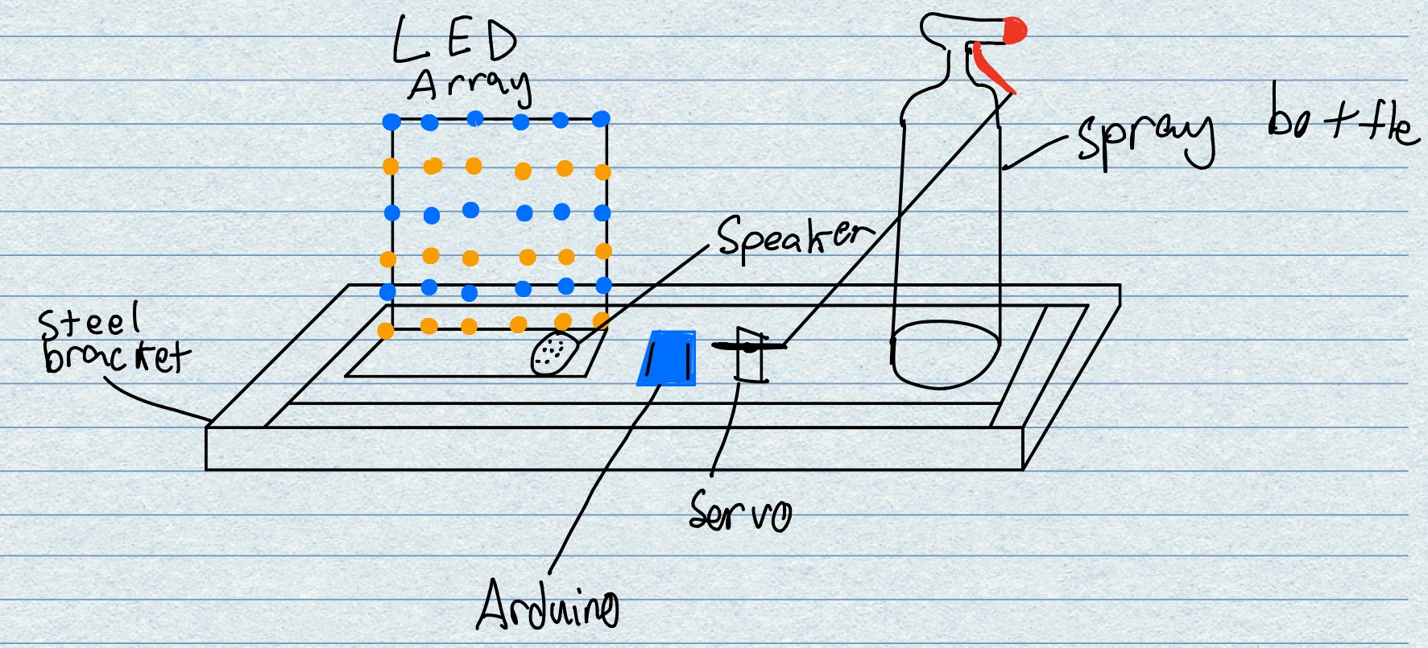**Design 1**

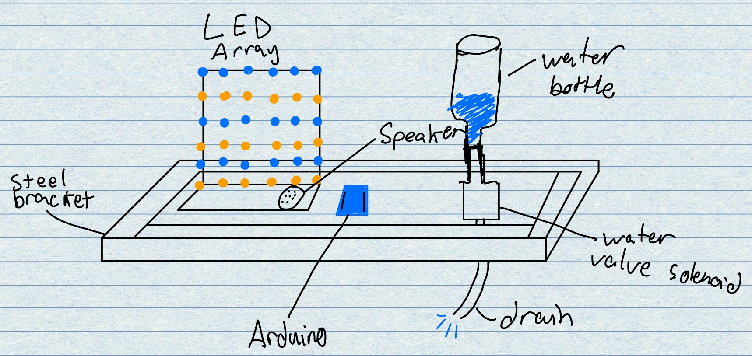

**Design 2**

The initial design had a light, sound, and water/movement component. These functions were performed by a surprisingly loud piezo speaker, a custom made 6X6 LED matrix, and a servo motor that would actuate a spray bottle. The program would initially run in an order to give the sleeping person multiple chances to wake up; first the audible alarm, then flashing lights, and then a few sprays of water. At the start of the program, light would be detected by the photosensor triggering the sound component first, followed shortly after by a blinking light array, and finally followed up by being sprayed in the face by water. There was also a snooze button to stop the alarm when the user finally woke up. For our movement component we had a servo motor that pulled the trigger of a spray bottle to wake up the sleeping customer.

Our second design looked to improve on the first one by scrapping the spray bottle idea in favor of a much simpler gravity fed water delivery system. This was accomplished by a full water bottle that was placed on top of an electronically actuated solenoid valve. This solenoid replaced the servo as our moving component of the project. After the solenoid, a ¼” fuel line was attached and is designed to be placed close to the user’s head. The solenoid is rated for 12V at 100mA, but a 9V battery is still powerful enough to actuate the solenoid through a transistor circuit thanks to its ~500mAh capacity. We kept the logic of the program the same for this design.

Our third and final design looked to improve the overall usability of the alarm clock. We felt that our hardware design is solid, but the logic of the program didn’t seem to be adequate for such a device. We figured that the type of user that would see the need for such a device would be willing to wake up on time no matter what; with this in mind, we removed the snooze button. This change lead us to create an entirely new program from the ground up. First, all alarms will go off at the same time. This means that the user will hear an alarm, get flashed by the LED matrix, and soaked with water at sunrise. There is a short delay between the start of the sound and flashing lights to the water alarm as to not completely startle the user; the water soaking the bed and the user should be uncomfortable enough to make the user wake up and start the day. Once the alarm has finished (about 20 seconds), the program stops all alarms and arms itself for the next day. This is accomplished by using one if statement, an else if statement, and a boolean variable. The boolean variable is initially set to true and is a condition for the if statement; true means that the photoresistor has detected darkness. If the photoresistor has previously detected darkness (night) and if it currently detects light, the alarm will initiate and the boolean variable is set to false. The program uses the else if statement to check for a nighttime condition where it will set the boolean value to true. This logic allows the alarm to be completely autonomous and will reset itself for each morning.

**Final Design**

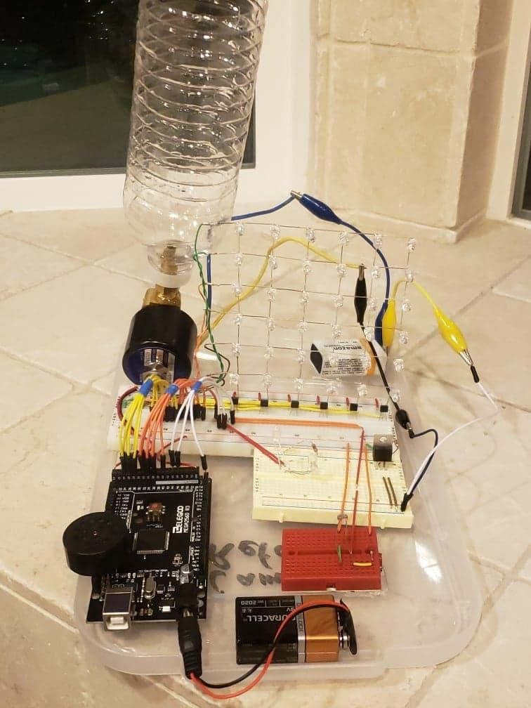

Above is the final design completed. The LED matrix consists of 36 red and blue (alternating) LEDs that have been soldered together. The solenoid is under the water bottle and drains under the platform. The piezo speaker is top mounted directly to the Arduino for simpler cable management. The photoresistor and its circuit are on the red breadboard.

**Materials/Parts used**

|  |  |  |  |  |
| --- | --- | --- | --- | --- |
| Item | Description | Quantity | Loaned (Yes/No) | Cost |
| Mega Microcontroller | Arduino Uno | 1 | Yes | $0.00 |
| Computer Cable | USB | 1 | Yes | $0.00 |
| Battery Snap | Arduino barrel to 9V connector | 1 | Yes | $0.00 |
| Buzzer | Small piezo | 2 | Yes | $0.00 |
| Sensor | Photoresistor | 1 | Yes | $0.00 |
| Breadboard | small | 1 | Yes | $0.00 |
| Wires | jumpers | 20 | Yes | $0.00 |
| Battery | 9V battery | 1 | Yes | $0.00 |
| Pushbutton | N/A | 3 | Yes | $0.00 |
| Transistor | Using for motor | 1 | Yes | $0.00 |
| Transistor | N/A | 6 | No | $2.52 |
| Resistor | 10 kΩ | 3 | Yes | $0.00 |
| Resistor | 220 Ω | 1 | Yes | $0.00 |
| Wires | Female to Male | 8 | Yes | $0.00 |
| Breadboard | Large | 1 | Yes | $0.00 |
| LED Lights | N/A | 38 | No | $2.55 |
| Water Bottle | Filled with water | 1 | No | Free |
| Plastic Bin Lid | For mounting surface | 1 | No | $2.00 |
| Water Solenoid Valve | with fittings and sealant: as our mechanical device for the water system | 1 | No | $11.00 |
| Jumper wiring kit | Flat wires | 1 | no | $6.50 |
| Breadboard | Red, really small | 1 | no | $3.00 |
| Resistor | 1KΩ | 6 | no | $1.25 |
| Piezo Speaker | Smaller but louder than the ones provided | 1 | no | $0.95 |

**Total: $29.77**

**Electronic Schematic (Robot Circuitry)**

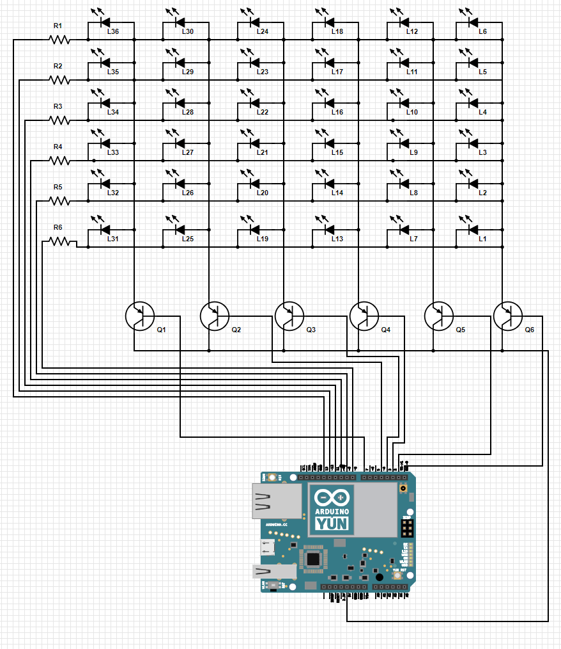

The diagram above represents the circuit for the LED matrix. Both anode and cathode ends are attached to an individual Arduino pin (not GND or 5V) for a total of 12 inputs/outputs. The transistors are supplied with 5V from the Arduino. R1-R6 = 1KΩ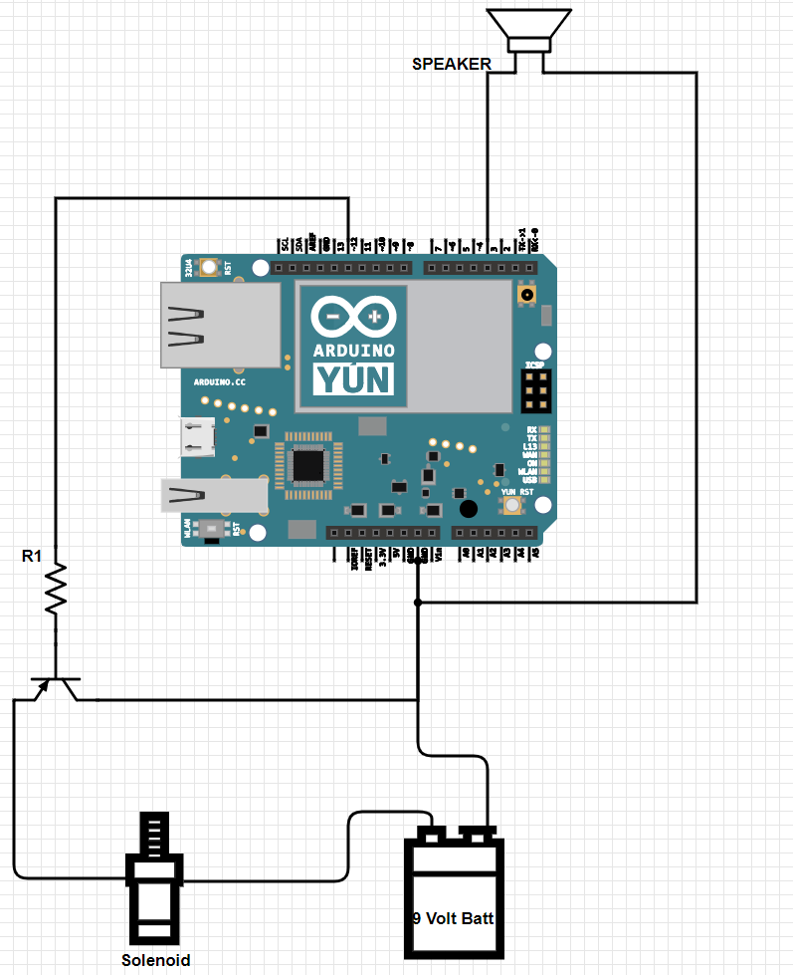

The diagram above represents the circuits for the solenoid and the piezo speaker. The LED matrix, solenoid, and speaker are all controlled by the same Arduino Mega. R1 = 1KΩ

**Pins Used**

Because we are using more than 14 pins, we were required to use an Arduino Mega with 54 digital pins. As the circuit was constructed, the use for each pin was recorded in the spreadsheet below.

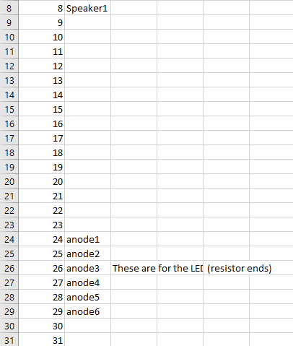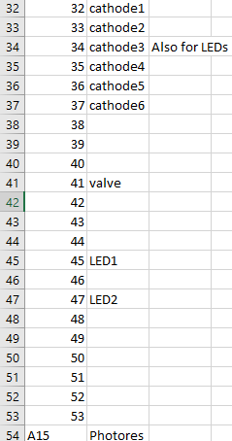

**Prototype Main Breadboard**

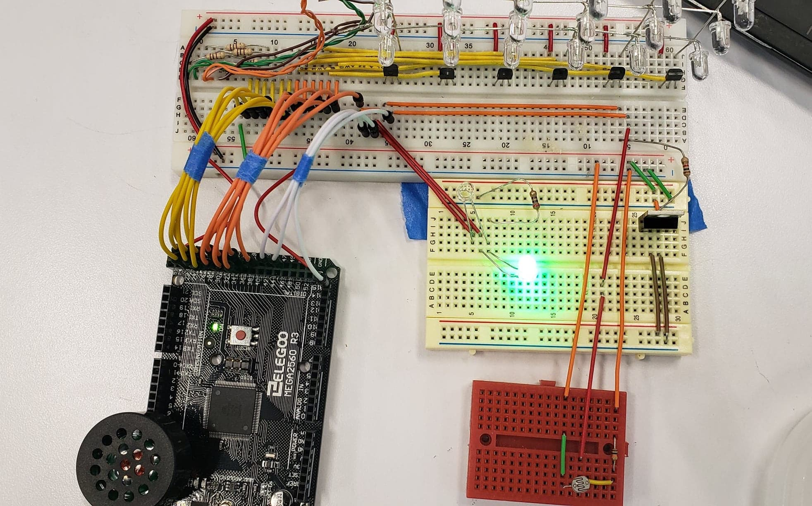

Here is the main breadboard we have constructed. It has the LED array and speaker on it along with the circuits for both. The LED array circuit is slightly complicated with transistors; these along with the negative end of the array will allow us to select which LEDs receive power at an individual level. We also used a solenoid to cause the contents of a water bottle to be poured onto the sleeping individual.

**Commented Arduino Code**

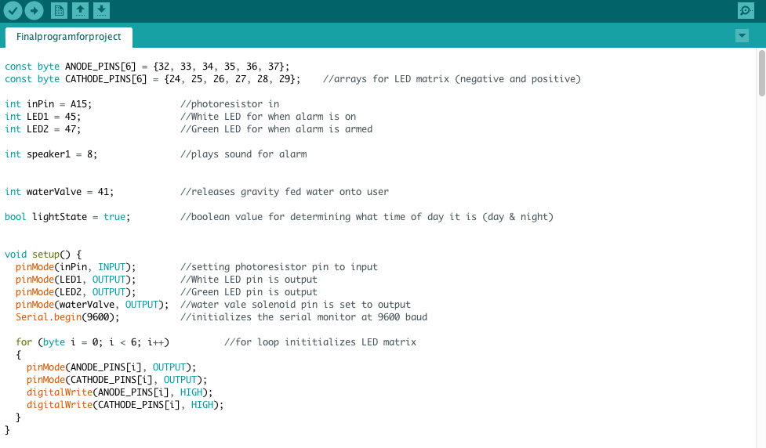

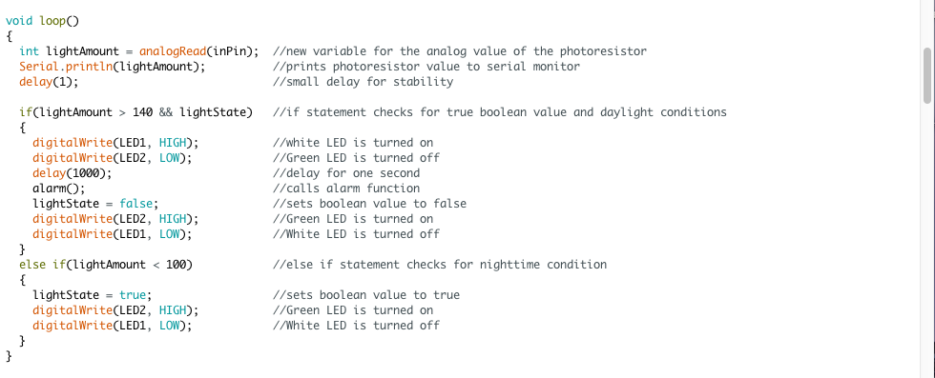

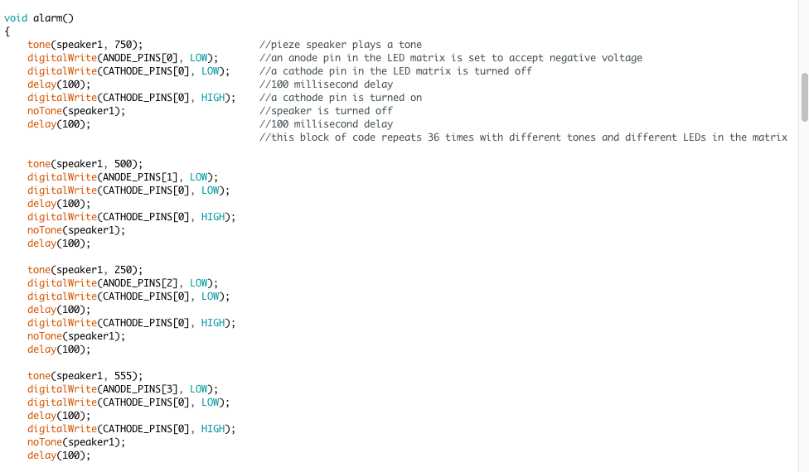







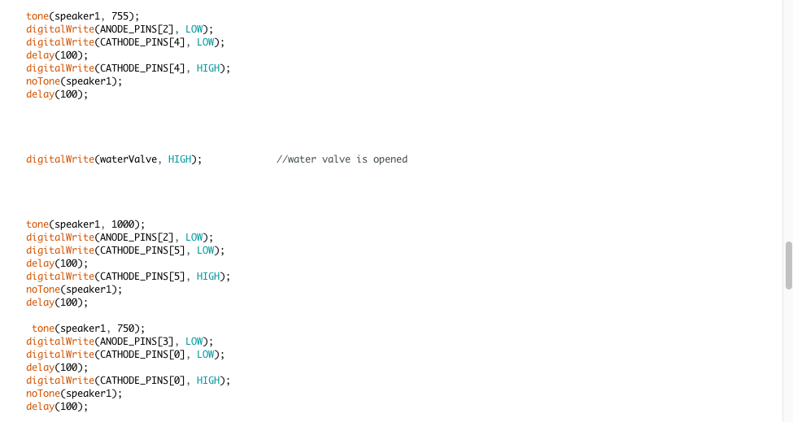









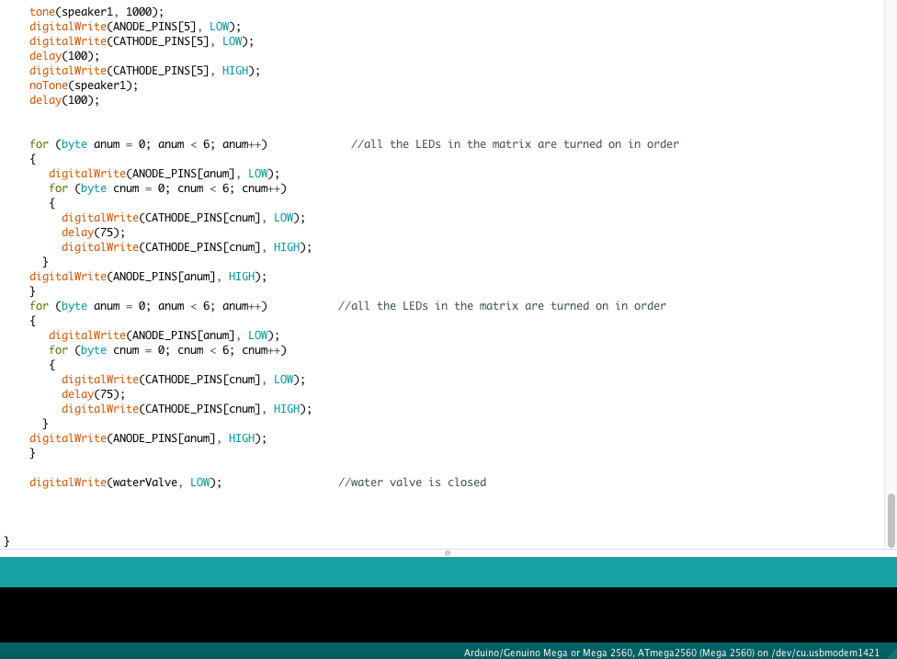

**Arduino Code access link:** <https://drive.google.com/file/d/18YRDmgF32xzwJgmLR66pfHG9fgU7MSAK/view?usp=sharing>

**Team Member Log**

|  |  |  |
| --- | --- | --- |
| **Team Member** | **Time spent on project (include individual and team time)** | |
|  | In-class (any lab periods attended) | Out-of-class (non-lab periods) |
| Evan Chou | 6 | 22 |
| Jordan Masutomi | 6 | 6 |
| Cameron Refaee | 6 | 30+ |