CS265 Final Project
Higher Diploma in Science (Software Development)
Course Code: HDSSDF
Student Name: Evan Campion
Student ID: 20253027

Overview of game
The game is rock, paper, scissors and it is a command line game. Multiple rounds of the game can be played depending on the users interest and the user also has an opportunity to view all the results when the game is exited. The results are presented in order of play. It is based on the traditional game of rock, paper, scissors. The program is self explanatory and guides you through as you play. The idea is that the user has three choices: rock, paper or scissors and then plays a game against the computer. When the game is ran, a prompt is displayed which gives the user the three choices and asks them to decide by entering their decision. The program makes a choice and this is displayed on the screen. Then depending on the choice of the user and the computer, the user either wins, loses or ties. The user is prompted once again whether they would like to play again. If yes, the program runs again. If not, then the results are displayed.

How to play
- Start by entering your choice of either rock, paper or scissors
- The program will now make a choice
- The result will be displayed on screen
- Play again by entering “y” at the next prompt or exit by entering “n”
- If game is exited then the results will be displayed

Code Structure
The way I structered my code is as follows. I split the code into 4 classes; Data (a class to declare the choices in an array to be used globally), Result (a class that creates a result object to save results), Queue (which stores the result objects each time the game is played) and Game (the main class that has the call to start the userInterface i.e. the game). In the Game class, there are 6 methods; main, userInterface, systemChoice, resultHandler, verifyInput, delay and showResults.
The Data class was created to hold the array of choices that is used multiple times thoughout the game for input validation and for the system to make a random choice. The reason that this is in a separate class is because it is reused between methods so this was to declare it globally in a sense.
The Result class is to create a result object on the back of every game. This is used to store the information that will be presented to the user on program termination. In here, the users choice is recorded aswel as the computers choice and the result.
The Queue class, which is an implementation of the abstract data type. This is used to store the result objects in a central location. Methods here also allow the results to be displayed in order.
The Game class contains the main method which calls the userInterface method, providing the user with an interface. The userInterface method calls the helper functions. The helper functions allow code to be encapsulated outside userInterface and keep it clean.
Data structures and algorithms used
I will discuss the Data, Result and Queue classes first as they are all complementary to the Game class.
The Data[1] class is simple, this is used to store the class attribute “choices” which is an array of strings that hold the choices for the game. This was used to reduce errors and encapsulate repeated code because “choices” is used a few times in methods in the Game.
The Result[2] class is for creating a result object. The class has 3 attributes, “user”, “opponent” and “result” and 2 methods, “Result” (the general constructor) and “displayResult”. The object created from this class is one that holds these values for a particular game that was played. “displayResult” will return the string with these attributes concatenated. This method was included as the results will be displayed to the user so the user interface needed a string in good format to print.
The Queue[3] class creates a queue object which is used to store the result objects in a queue for safekeeping. This is implemented through methods declared in the class which act on the class’s attributes. The principal method in this class is the general constructor which uses the attributes to create a Queue object. The insert and remove methods allow the result objects to be added and removed from the queue. Complementary to these two methods are isFull and isEmpty which determine whether any further objects can be added or taken away.
systemChoice[4] uses java.util.Random. A random object “r” is created first and the array of strings is fetched from the Data class which are the systems three choices (rock, paper and scissors). Using the object “r”, a random number is selected in the range 0 to the length of the array choices and assigned to the int variable “n”. The variable “n” is used as an index for the “choice” array and the choice at that index is returned.
resultHandler[5] is a method to deal with the comparison between “userChoice” and “systemChoice” and to determine the result of the game. The obvious parameters for this method is both the “userChoice” and the “systemChoice”. At the top of the method, an empty string “outcome” is declared – this will be the returned String determined by the parameters. “userChoice” is used as the basis for determining the outcome. Depending on this state, it will be compared to the other choices and the outcome is identified. The outcome is returned and “userInterface” can deal with displaying this to the user as the result.
verifyInput[6] is the method used to ensure the program doesn’t receive any inputs it doesn’t like. Again, using the Data class, the array of choices is fetched. A boolean flag is used here and initially set to false, assuming that the input data is wrong. It is the methods job to prove otherwise. To do this the method loops through the array of choices and compares each value to the users input. If any of these match, then the boolean flag is set to true. When the loops exits, there are two outcomes, one that no value in the array matched the user input – in this case the flag is still false and this is returned – the other being that one of the values was a match and the flag is now true – in this case true is returned.
delay[7] is a method used to give the game more of a human feel. Without this delay, the program runs very fast and does not give the game any suspense or realness. The user waits for the result to be calculated but not too long so that the user can’t figure it out for themselves. This is implemented through the use of java.util.concurrent. Within this class, the enum TimeUnit takes care of the sleeping of the program. This can modified on call using the parameter “t” set in the delay method.
showResults[8] is the last method in the class. This method takes care of displaying the previous results to the screen for the user to see. Various iformation is printed to the screen to give the illusion of a table and then the results are printed in order through the use of the Result class and the Queue class.

Learning Outcomes
There were many learning outcomes through the development of this game. In general, I learned how to implement some data structures and algorithms in a real world context such as the development of a game. The game provided me with the opportunity to explore some data structures in more detail and how to use various operations to realise a desired outcome.
It showed me the importance of planning the structure of the code and encapsulating code for clarity and resuse. I was able to isolate code for specific functions and work on it without worrying about code that already fuctioned as expected. Code could be written and integrated with existing code such as the function for validating input being integrated into the user interface. Further to this, classes could be used to further isolate specific code that could be used across the board. I was able to create the abstract data type queue, a class to hold result data and another to hold available choices for the game.
Another valuable lesson I learned was declaring a variable as global across the program. I initially realised that I would need this when it was clear that user choices would be needed in various methods. After doing some research, I discovered that a variable can be declared as an attribute to a class. This attribute can be accessed by creating an object from the class wherever it is needed and using for notation accessing the attribute or in my case the array of strings for the choices. This is a very useful technique for me and I can see that there is infinite use cases. It is advantageous as it reduces code by have to declare the variable multiple times in the program, but also because it can reduce error. It will reduce errors due to the fact that you only need to write the variable once, then through object creation, make a copy of it.
Perhaps the biggest lesson learned was the use of the results objects and a queue to store and display the results of the game. I found this interesting as it allowed me to present the results to the user in a neat way. When I was deciding on whether to use a stack or a queue the obvious abstact data type for me was the queue. This was because I wanted to display the results in the order they were recorded or in other words when the user played the game. As the queue was first in first out (FIFO), it provided me with this feature. When I learned queues during the module, I never realised the functionality that could come out of it.

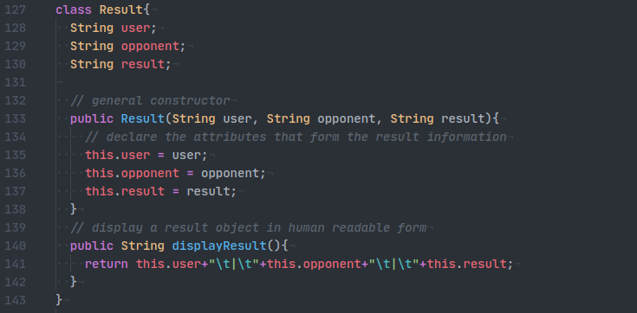
Appendices
1.
2.

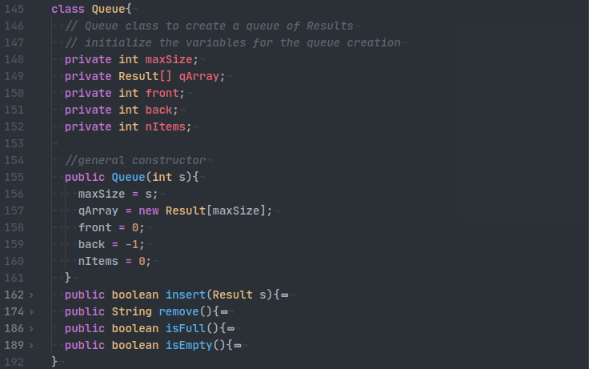
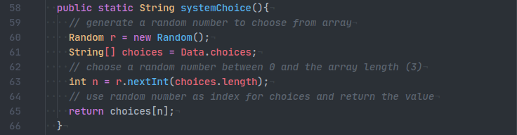
3.
4.

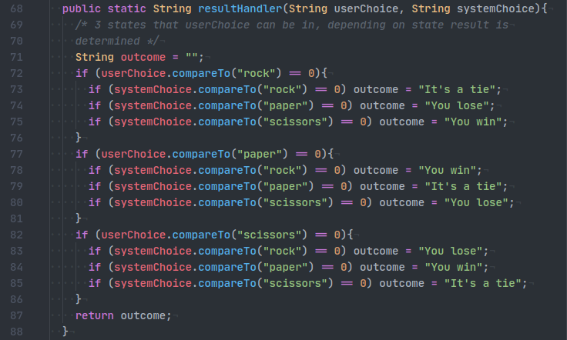
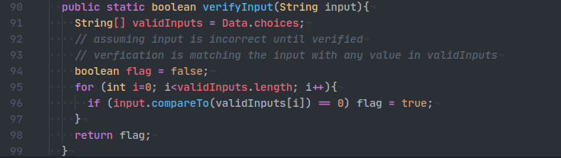
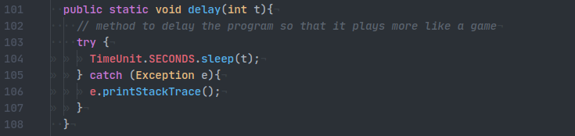
5.
6.
7.

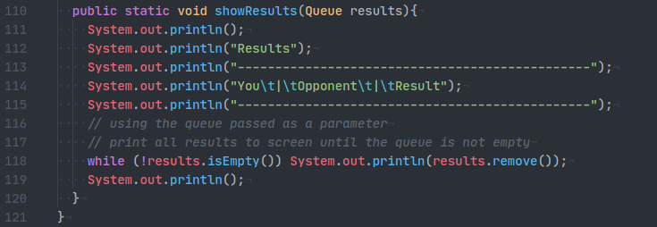
8.

