Pre-Work: Coding a Java Web Application

# Pre-Work

The application you’ll be developing in this workshop requires JDK 6 or 7 (not a JRE), the Eclipse IDE for Java EE Developers (Kepler SR1, linked below), the AWS Toolkit for Eclipse, and a local installation of Tomcat 7. Please be sure you have all of these components installed (instructions below) before the day of the workshop

* [Java SE Development Kit 7](http://www.oracle.com/technetwork/java/javase/downloads/jdk7-downloads-1880260.html) [or OpenJDK 7](http://openjdk.java.net/projects/jdk7/) (JDK, not just JRE)
* [Eclipse IDE for Java EE Developers](http://www.eclipse.org/downloads/packages/eclipse-ide-java-ee-developers/keplersr1)
* [Tomcat 7](http://tomcat.apache.org/download-70.cgi)
* [The AWS Toolkit for Eclipse](http://aws.amazon.com/eclipse/)

## Eclipse IDE for Java EE Developers

This application has been developed and tested on the Kepler SR1 release of Eclipse on OS X 10.8.5, Windows 7, and Ubuntu 12.04LTS.

## Configure Eclipse to Use a JDK

Confirm that Eclipse is using a JDK and not just a JRE:

1. Open Eclipse
2. Click the Window menu and choose Preferences
3. Expand Java, choose Installed JREs, and ensure that a JDK is selected as opposed to *just* a JRE:  
   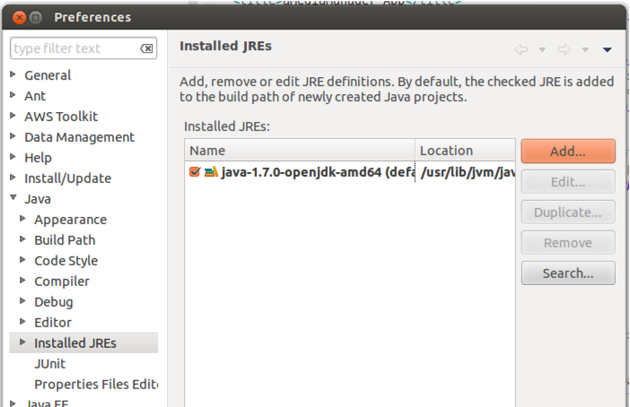
4. If a JDK is not selected, you may download and install JDK 7 from Oracle or OpenJDK 7
5. Choose Compiler and set the Compiler compliance level to 1.6:  
   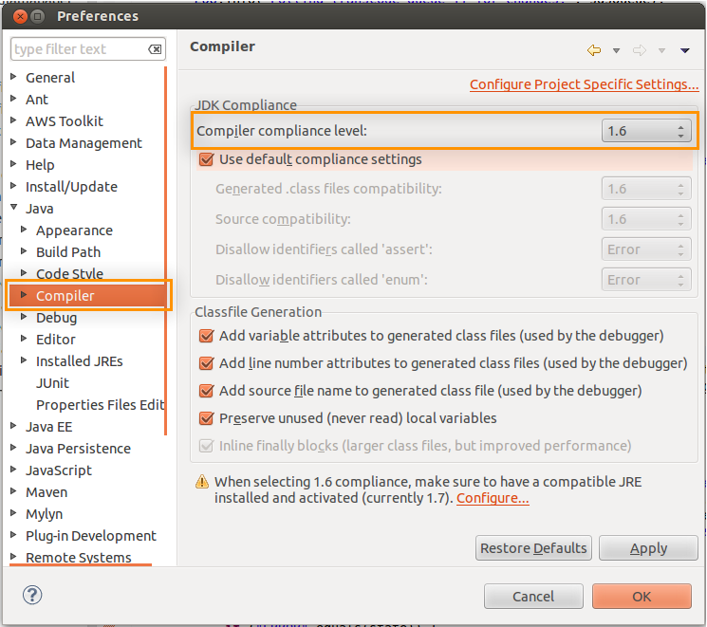

## Create a Local Tomcat 7 Server

Follow these steps if you do not already have Tomcat 7 installed and configured in Eclipse. The local Tomcat 7 server will be used for rapid dev/test on your workstation between deploys to your Elastic Beanstalk environment.

1. Open Eclipse
2. Right-click in the *Servers* pane, choose *New > Server* and complete the wizard to create a new one  
   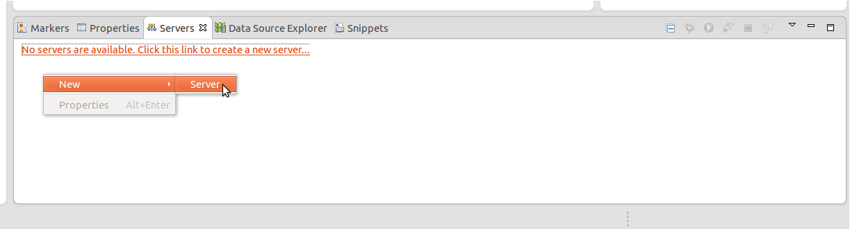
3. Type ‘Tomcat v7’ in the filter box, choose the item and click Next:  
   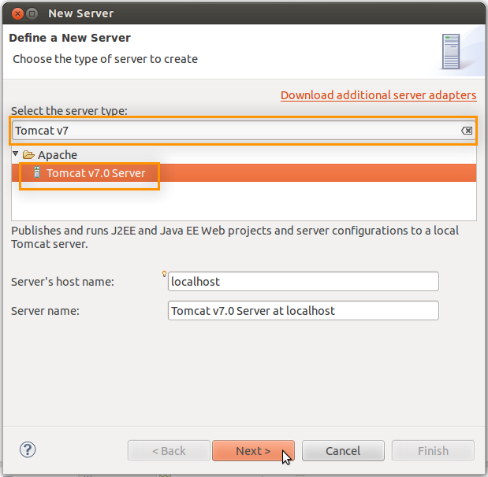
4. Click Browse and locate the directory where you installed Tomcat 7. The ‘Workbench default JRE’ value for JRE presumes you correctly selected a JDK in the previous section

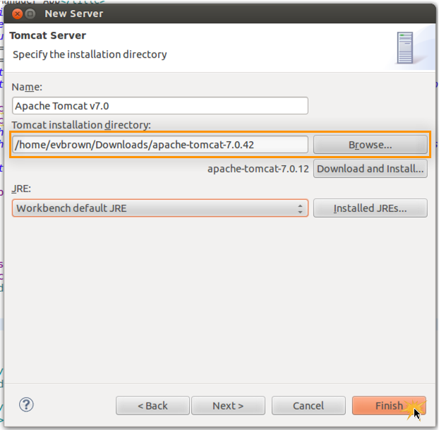

1. Click Finish

## The AWS Toolkit for Eclipse

The AWS Toolkit for Eclipse allows you to integrate your IDE with Elastic Beanstalk, making it easy to deploy your application a remote environment on AWS. Follow the instructions at <http://aws.amazon.com/eclipse/> to install the toolkit.