Demo Report: Projected Income

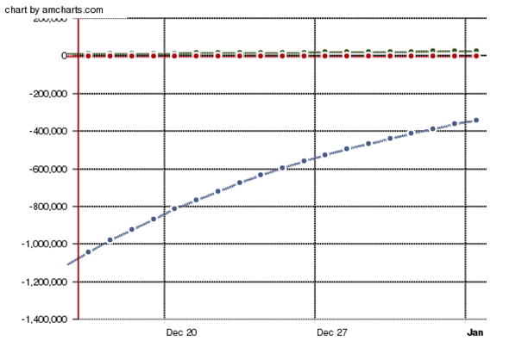
 | Investment A | Investment B | Investment C
Wed Dec 15 2010 | 10000.00 | -5000.00 | -1111111.00
Thu Dec 16 2010 | 10500.00 | -4550.00 | -1044444.34
Fri Dec 17 2010 | 11025.00 | -4140.50 | -981777.68
Sat Dec 18 2010 | 11576.25 | -3767.86 | -922871.02
Sun Dec 19 2010 | 12155.06 | -3428.75 | -867498.76
Mon Dec 20 2010 | 12762.82 | -3120.16 | -815448.83
Tue Dec 21 2010 | 13400.96 | -2839.35 | -766521.90
Wed Dec 22 2010 | 14071.00 | -2583.81 | -720530.59
Thu Dec 23 2010 | 14774.55 | -2351.26 | -677298.75
Fri Dec 24 2010 | 15513.28 | -2139.65 | -636660.83
Sat Dec 25 2010 | 16288.95 | -1947.08 | -598461.18
Sun Dec 26 2010 | 17103.39 | -1771.84 | -562553.51
Mon Dec 27 2010 | 17958.56 | -1612.38 | -528800.30
Tue Dec 28 2010 | 18856.49 | -1467.26 | -497072.28
Wed Dec 29 2010 | 19799.32 | -1335.21 | -467247.94
Thu Dec 30 2010 | 20789.28 | -1215.04 | -439213.07
Fri Dec 31 2010 | 21828.75 | -1105.69 | -412860.28
Sat Jan 01 2011 | 22920.18 | -1006.18 | -388088.66
Sun Jan 02 2011 | 24066.19 | -915.62 | -364803.35
Mon Jan 03 2011 | 25269.50 | -833.21 | -342915.14

