Demo Report: Projected Income

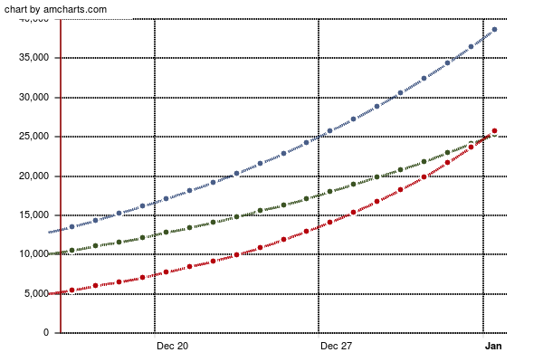

|  |  |  |  |
| --- | --- | --- | --- |
|  | Investment A | Investment B | Investment C |
| Date 1 | A | B | C |
| Date 2 | D | E | F |
| Date 3 | G | H | I |