Demo Report: Projected Income

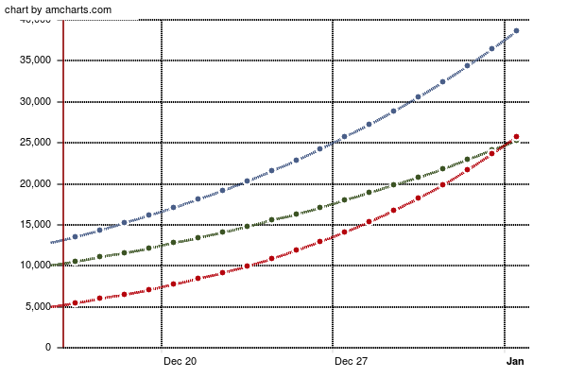

|  |  |  |  |
| --- | --- | --- | --- |
|  | Investment A | Investment B | Investment C |