Methods — Self-Balancing Robot
Nov 8, 2026 · @Evan Moore

2. Methods
This is a simulation study. We model a two-wheeled self-balancing robot as a planar wheeled inverted pendulum [1], control it with a cascaded PID, and tune the four PID gains by black-box optimization over a physics simulation. Every physical constant comes from a reference build of purchasable parts (Section 2.1); the robot itself was not built. The tuned controller is compared with a PID and LQR controllers designed from the linear model, on randomized robots it never saw during tuning.

2.1 Components
Parts were chosen for a robot of about 0.8 kg with 70 mm wheels and a 2S battery. Their datasheets [2]–[5] supply the model's constants; the body's mass properties come from a layout of these parts on a three-deck tower with the battery on top.
Table I. Reference build.
Function | Part | Key spec | Why this part
Wheel motors (×2) | Pololu 25D HP 6 V, 20.4:1, 48 CPR encoder [2] | k_t = 5.3 mN m/A; R ≈ 1.25 Ω with driver and wiring | The encoder sits on the motor shaft, so it measures wheel speed relative to the body, which is what the dynamics use
Motor drivers (×2) | Pololu DRV8874 [3] | 2.1 A continuous; current-sense output | Current sensing lets firmware close a torque loop, as the actuator model assumes
Wheels (×2) | Pololu 70×8 mm with 4 mm hub [4] | r = 35 mm; 34 g per pair | Matches the target scale and fits the motor shaft
Battery | 2S LiPo, 1300 mAh | 6.8 V (cutoff, under load) to 8.4 V (full) | Sets the supply range used in robust scoring
IMU | TDK ICM-42688-P [5] | Gyro noise 6×10⁻⁴ rad/s per sample at 200 Hz | Lower noise than the common MPU-6050; the model uses 10–30× more noise to cover chassis vibration
Derived quantities: total stall torque 0.337 N m (2 A current limit, 78% gearbox efficiency), corner speed 1.65 m/s, and reflected rotor inertia J = 4.2×10⁻⁴ kg m². Seen through the gearbox, the rotors add J/r² = 0.34 kg to the effective translating mass, 19× the contribution of the wheels' own spin, so the model must include them.
Latency budget. From sensing to the motor current responding, this build takes about 1.3–4.6 ms. The stages are the IMU's low-pass filter group delay (1–3 ms [5]), the sensor read over I²C or SPI (0.05–0.5 ms), the controller computation on a 32-bit microcontroller (under 0.5 ms), the PWM update (about 0.05 ms) and the current rise, L/R (0.2–0.5 ms).

2.2 Dynamic model
The robot is one rigid body on a lumped wheel pair (Fig. 1a; parameters in Table II). The generalized coordinates are axle position x and pitch θ from vertical, both positive forward. The motors apply torque τ to the wheels and, by Newton's third law, −τ to the body. Viscous friction β acts across the same joint, so the net joint torque is τ_net = τ − βω, where ω = ẋ/r − θ̇ is the wheel speed relative to the body. In robust scoring a smoothed Coulomb term is subtracted the same way.
Table II. Model parameters (both wheels and both motors lumped).
Symbol | Meaning | Value
M | Body mass, motors included | 0.80 kg
l | Body COM height above the axle | 0.10 m
I_b | Body pitch inertia about its COM | 6.5×10⁻³ kg m²
m_w | Wheel mass | 0.034 kg
r | Wheel radius | 0.035 m
I_w | Wheel inertia about the axle | 2.2×10⁻⁵ kg m²
J | Motor rotor inertia reflected to the axle | 4.2×10⁻⁴ kg m²
N, η | Gear ratio; gearbox efficiency | 20.4; 0.78
k_t, R | Torque constant; resistance with driver and wiring | 5.3 mN m/A; 1.25 Ω
V_s, i_max | Supply voltage; current limit per motor | 7.6 V; 2.0 A
τ_max | Torque command limit, both motors | 0.34 N m
β | Viscous joint friction | 0 nominal; 0–0.0015 N m s/rad in robust scoring
Assumptions. Planar motion; rolling without slip (x = rφ, with φ the wheel angle); wheels stay on the ground; rotor gyroscopic cross terms, smaller by the factor N, are dropped. Section 2.4 checks no-slip and ground contact against simulated runs.
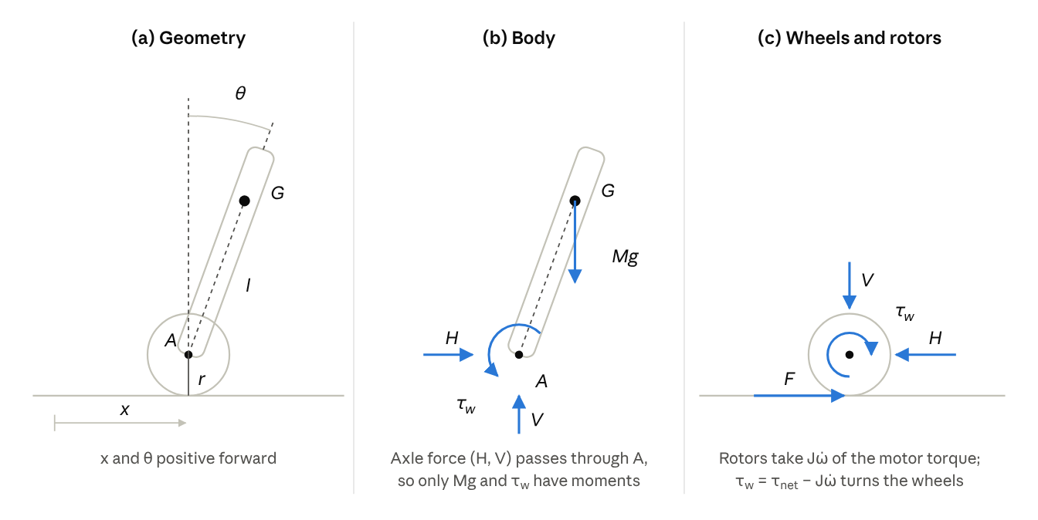
Fig. 1. (a) Geometry and coordinates. (b) Body and (c) wheel–rotor free-body diagrams; the joint torque τ_w and axle force (H, V) act equally and oppositely on each. Vertical forces on the wheels (weight, normal force) are omitted because they do not enter (1)–(3).
Newton–Euler equations (Fig. 1b–c). Let F be the horizontal ground force on the wheels. The body's COM is at (x + l sinθ, r + l cosθ).
Whole robot, horizontal momentum:
F = (M + m_w)\,\ddot x + Ml\,(\ddot\theta\cos\theta - \dot\theta^2\sin\theta) \tag{1}
Rotors and wheels, about the axle. The rotors absorb Jω̇ of the motor torque. The rest, τ_w = τ_net − Jω̇, turns the wheels against the ground:
I_w\,\frac{\ddot x}{r} = \tau_{net} - J\Bigl(\frac{\ddot x}{r} - \ddot\theta\Bigr) - F r \tag{2}
Body, moments about the axle A. The axle force passes through A, leaving gravity and the reaction −τ_w:
I_b\ddot\theta + Ml\,(l\ddot\theta + \ddot x\cos\theta) = Mgl\sin\theta - \tau_{net} + J\Bigl(\frac{\ddot x}{r} - \ddot\theta\Bigr) \tag{3}
Eliminating F between (1) and (2), and collecting terms in (3), gives the equations of motion:
\begin{pmatrix} a & b(\theta) \\ b(\theta) & d \end{pmatrix}\begin{pmatrix} \ddot x \\ \ddot\theta \end{pmatrix} = \begin{pmatrix} \tau_{net}/r + Ml\,\dot\theta^2\sin\theta \\ -\tau_{net} + Mgl\sin\theta \end{pmatrix} \tag{4}

a = M + m_w + \frac{I_w + J}{r^2},\qquad b(\theta) = Ml\cos\theta - \frac{J}{r},\qquad d = Ml^2 + I_b + J
The mass matrix is the kinetic-energy matrix, so it is positive definite at every angle and (4) always solves for the accelerations.
Equivalence to the simulator's Lagrangian form. The simulator derives (4) from Lagrange's equations [6] with L = T − V and generalized forces Q_x = τ_net/r, Q_θ = −τ_net (Appendix A). The two forms match term for term: the Lagrange x-equation is the whole-robot momentum balance, and the θ-equation is the body's moment balance. Numerically, F computed both ways agrees to 8×10⁻¹⁵ N over 30 closed-loop runs, and the total energy changes by exactly the work of the motor and friction, to 1.1×10⁻⁸ J.
Linearization. About upright, with β = 0 and state s = (x, ẋ, θ, θ̇):
\dot s = A s + B\tau,\quad A = \begin{pmatrix} 0&1&0&0\\ 0&0&-4.07&0\\ 0&0&0&1\\ 0&0&71.19&0 \end{pmatrix},\quad B = \begin{pmatrix} 0\\ 37.63\\ 0\\ -238.85 \end{pmatrix} \tag{5}
Three properties of (5) bound what any controller can do:
- Unstable pole at 8.44 rad/s. An uncorrected tilt doubles every 82 ms.
- Right-half-plane zero at 6.74 rad/s in the velocity response. To accelerate forward, the robot must first roll backward, which caps the velocity-loop bandwidth near 3.4 rad/s [7, Ch. 5].
- Minimum pitch gain. Proportional pitch control is stabilizing only if k_p > aMgl/c = 0.298 N m/rad, where c = a + b(0)/r. This sets the tuner's lower search bound.
Actuator. Each motor is a brushed DC motor driven in current (torque) mode. Inductance is neglected (L/R ≈ 0.3 ms, against the 5 ms control period), and k_e = k_t by power balance. The delivered torque equals the command until it reaches the torque limit, the 2 A current limit, or the supply voltage less back-EMF. The scenario's 1.3 m/s cruise is below the nominal motor's 1.65 m/s corner speed but above the weakest randomized motors' 1.16 m/s, so on those robots back-EMF limits the torque available to recover from a push. This current-mode assumption requires firmware to close a current loop on the driver's current-sense output; the Discussion examines what happens without one.
Sensors. The controller reads pitch, pitch rate and wheel velocity with additive Gaussian noise (σ = 0.005 rad, 0.02 rad/s and 0.02 m/s per sample). Pitch carries a constant offset δ_θ = 0.01 rad from mounting error, and the gyro a constant bias δ_g = 0.01 rad/s. These readings stand for the output of an onboard pitch estimator such as a complementary filter; the estimator itself is not simulated.

2.3 Controllers
Cascaded PID (tuned). An outer loop turns velocity error into a lean set-point; an inner loop turns pitch error into torque (Fig. 2). Both run at 200 Hz (T = 5 ms):
\theta_{sp} = \operatorname{clip}\bigl(k_v(v_{goal} - \hat{\dot x}),\ \pm 25^\circ\bigr),\qquad \tau = \operatorname{clip}\Bigl(k_p \varepsilon + k_i\!\int\! \varepsilon\,dt + k_d\hat{\dot\theta},\ \pm\tau_{max}\Bigr),\qquad \varepsilon = \hat\theta - \theta_{sp} \tag{6}
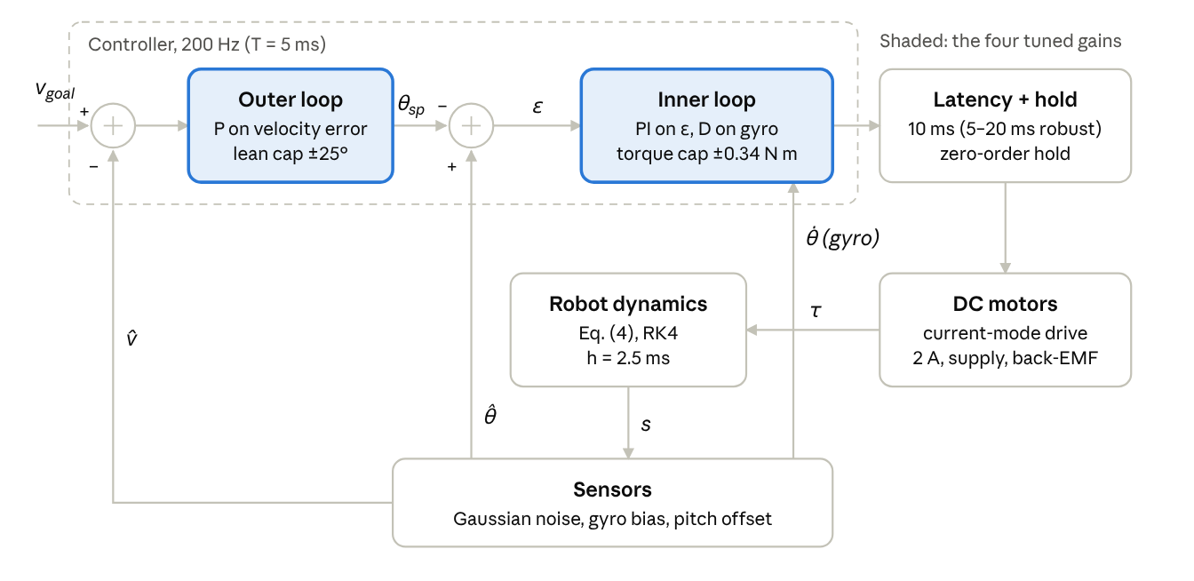
Fig. 2. Cascaded PID loop as simulated. The outer loop turns velocity error into a lean set-point θ_sp; the inner loop turns pitch error ε into torque, with its derivative acting on the gyro reading. Commands pass through the latency and a zero-order hold before the motor model limits them.
- The derivative term damps the measured pitch rate (the gyro reading), not dε/dt. When the lean set-point θ_sp jumps, dε/dt would spike and so would the torque ("derivative kick"); the gyro sees only the body's actual rotation [8].
- Both integrators use conditional-integration (clamping) anti-windup [8].
- The outer loop is proportional only. The pitch integrator rejects the gyro bias completely; the pitch offset leaves a steady velocity error of δ_θ/k_v.
Cascade stability bound. Closing both loops on (5) gives a quartic characteristic polynomial. Its s³ coefficient yields a necessary condition for stability:
k_v < \frac{c}{e}\cdot\frac{k_d}{k_p},\qquad e = \frac{d}{r} + b(0) \tag{7}
The outer gain the cascade can afford scales with the inner loop's k_d/k_p. Bound (7) explains the direction the tuner moved the gains: raising k_d/k_p lifts the ceiling on k_v.
Model-based PID (baseline). The same cascade, designed from the linear model with no simulation, by the standard sequential method for cascade loops: the inner loop first, then the outer loop around it [8]. The inner loop's three gains place the three roots of its characteristic polynomial, Δ₀s³ + c k_d s² + (c k_p − aMgl) s + c k_i: a critically damped pair at twice the unstable pole (2p = 16.9 rad/s) and an integral pole at a tenth of that, by pole placement [9]. The outer gain sets the velocity-loop bandwidth G k_v to a third of the RHP zero (z/3 = 2.2 rad/s) [7]. This gives k_p = 1.73 N m/rad, k_i = 2.01 N m/(rad s), k_d = 0.148 N m s/rad and k_v = 0.314 rad/(m/s), linearly stable for latencies up to 23.75 ms. More aggressive common choices fail: with an outer bandwidth of z/2 the cascade is unstable even without delay, and an underdamped inner pair (ζ = 0.707) is unstable with the 10 ms delay.
LQR (baseline). A discrete-time LQR [9] on the linearized model, with the 10 ms latency built into the state, uses the cost function's own weights (Section 2.4). It is optimal for the noise-free, unsaturated linear robot and needs no simulation. We also report LQRs whose weights, or whose gains directly, are tuned like the PID.

2.4 Simulation, tuning and validation
Simulation. Equation (4) is integrated with fourth-order Runge–Kutta (RK4) [10] at h = 2.5 ms. The controller runs every 5 ms with a zero-order hold, and each command reaches the motor after 10 ms of latency. The hardware's estimated latency budget is 1.3–4.6 ms (Section 2.1), so 10 ms is conservative. A run ends as a fall if |θ| > 60°.
Scenario. Each element of the 20 s training scenario targets one behavior and is sized from a limit of the robot (Table III, Fig. 3). Every tilt and push can be survived by a full-torque response on every robot the randomization can draw, so a fall reflects the controller, not the robot. Goal changes blend with continuous acceleration and jerk, so the goal is physically trackable.
Table III. Test scenario.
Time (s) | Element | Value | What it tests, and how it is sized
0 | Start tilt | 0.05, −0.15 or 0.30 rad | Recovery in both directions. 0.30 rad equals the cost's pitch limit and is 77% of the largest tilt every randomized robot survives
0–2 | Stand still | 0 m/s | Rejection of gyro bias and pitch offset
2–3.6 | Accelerate | 0 → 1.3 m/s, 1.78 m/s² peak | Aggressive tracking: needs a 0.25 rad lean, 56% of what the lean cap allows. A 1.3 s blend made the tuned gains fall on weak robots
3.6–9.5 | Cruise | 1.3 m/s | The top speed at which every randomized motor still has the torque that lean-cap acceleration needs. Above the weakest motors' 1.16 m/s corner, so back-EMF binds
5.5, 7.5 | Pushes | ±2.9 N at the COM for 50 ms (0.145 N s) | Disturbance rejection at top speed. 97% of the largest forward push the worst randomized robot survives
9.5–12.5 | Brake and reverse | 1.3 → −0.5 m/s | Crossing zero speed, where Coulomb friction flips sign
12.5–14 | Cruise backward | −0.5 m/s | The pitch offset acting the other way
14–16.5 | Stop | −0.5 → 0 m/s, 0.44 m/s² peak | Small-signal tracking
16.5–20 | Stand still | 0 m/s | Settling after the full sequence
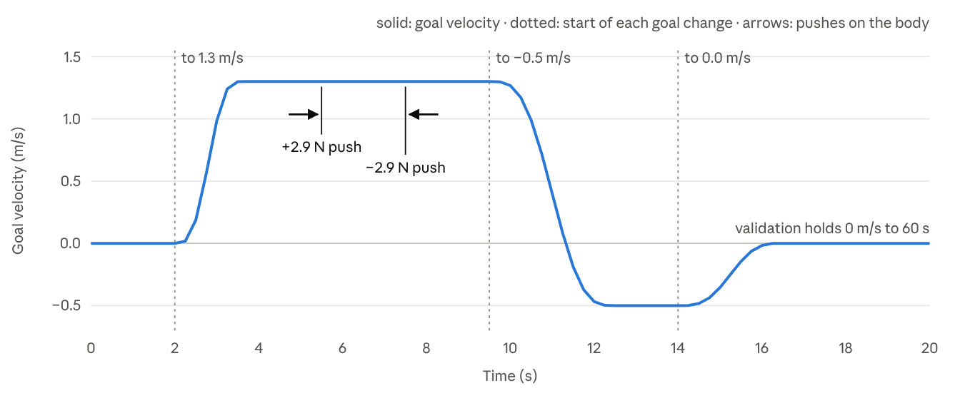
Fig. 3. Goal velocity over the 20 s training scenario, from the simulator's goal function, with the two pushes marked. Each goal change starts at a dotted line and blends with continuous acceleration and jerk. Validation holds the final standstill out to 60 s.
Cost. Each run is scored by
\mathcal{J} = \int_0^{t_{dur}}\Bigl[\theta^2 + w_u\tau^2 + w_v(\dot x - v_{goal})^2\Bigr]dt \;+\; \mathbb{1}_{fell}\,P\Bigl(1 + \frac{t_{left}}{t_{dur}}\Bigr) \tag{8}
The weights follow Bryson's rule [11] from acceptable limits of 0.3 rad pitch, 0.2 m/s velocity error and 0.1 N m torque: w_u = (0.3/0.1)² = 9 and w_v = (0.3/0.2)² = 2.25. The integrand of (8) is summed at every physics step as the run proceeds (Appendix B). The τ² term is proportional to copper loss in the windings. The fall penalty P = 1000 exceeds 883, an upper bound on the cost of any 20 s run that stays up, so a fall always scores worse than staying up.
Robust scoring. Each candidate is scored on 150 scenarios: 50 noise seeds × 3 start tilts. Each scenario also draws its own robot, a form of domain randomization [12]:
- body mass and COM height ±15%; body inertia ±25%; wheel inertia ±20%; rotor inertia ±50%;
- k_t ±10%; resistance ±15%; supply voltage ±10.5% (6.8–8.4 V); gear efficiency ±10%;
- viscous friction 0–0.0015 N m s/rad and Coulomb friction 0.02–0.08 N m, from the motors' free-run current;
- latency 5–20 ms.
A twin of each scenario, with the start tilt nudged by 10⁻⁴ rad, adds a chaos penalty, mean |𝒥 − 𝒥_twin|. It penalizes gains whose outcome hinges on the initial condition. The robust score is the mean cost plus this penalty, from 300 simulations per candidate.
Optimizers. CMA-ES [13] (30 generations of 120), differential evolution [14] (2,976 candidates) and random search (3,600 candidates) each search the four gains (k_p, k_i, k_d, k_v) up to 30, 5, 1 and 0.9 respectively (Fig. 4). k_p is searched on a log scale and floored at 1.1× the minimum pitch gain of the most demanding robot the randomization can draw. Below that gain no setting of the other three is stable (Section 2.2), so the search never wastes candidates there; the 10% margin covers the integral term, which raises the true minimum slightly. The log scale spreads candidates evenly over the 70-fold range of k_p (Appendix B). Candidates are simulated in vectorized batches in float32 (Appendix B); reported scores come from float64 re-runs. In the LQR comparison, the PID and both LQR searches each get about 4,800 candidates under the same scoring.
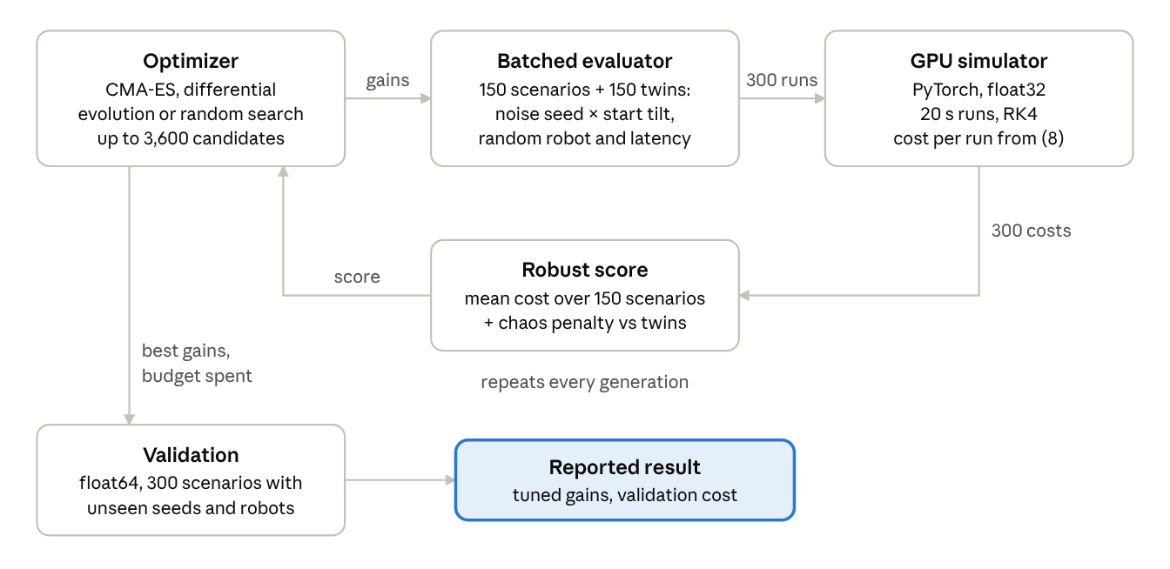
Fig. 4. Tuning loop. Each candidate gain set is scored on 150 randomized scenarios and their nudged twins (300 simulations). When the budget is spent, the best gains are re-scored on robots and noise seeds the search never saw.
Validation. Each method's best gains are re-scored in float64 on 100 unseen noise seeds with unseen robots (300 scenarios). Validation runs last 60 s: the final standstill is held 40 s longer, so slow instabilities that a 20 s run would hide have time to cause a fall.
Verification.
- The batched simulator reproduces the reference simulator bit for bit in float64 (Appendix B).
- RK4 shows its expected 16× error reduction per halving of h. RK4's global error is O(h⁴), so halving h should cut it by 2⁴ = 16 [10]; measured ratios were 15.6–16.0.
- An exact discrete-time model of the sampled, delayed loop predicts the simulator's latency-stability boundary to within 1 ms (Appendix C).
- No slip needs a ground friction coefficient of at least 0.54 for the tuned gains. The normal force never drops below 7.01 N (static value 8.18 N), so the wheels never lift.

Areas to expand
Cut for concision, listed roughly by how much a reviewer would miss them. Not part of the paper.
- Motor-driver assumption. The model assumes the driver delivers the commanded current. If it instead sets PWM duty from the torque command, every gain set falls. Now flagged in Section 2.2 (Actuator). The result (with PWM duty proportional to torque and capped at the torque limit, all 30 validation runs fall) belongs in Results/Discussion, and the firmware current loop in future work.
- Hardware validation (future work). Friction, rotor inertia, sensor noise and latency are estimates. A short plan of what to measure on a built robot, and how, would strengthen the Discussion.
- IMU and estimator. The controller gets true pitch plus white noise and a constant offset, standing in for a filter's output; no filter is simulated. A real estimate has lag and slow, correlated errors, and a raw accelerometer tilt reading would be off by up to 52° during these accelerations, so the filter must lean on the gyro.
- LQR fairness. The tuned-gain LQR has no integral action, so friction handicaps it. Either state this as a limitation or add a guarded integral gain.
- Delay-margin analysis. Now in Appendix C; a figure of spectral radius against latency for each controller would make it visual.
- Randomization limits. Parameters are drawn independently, so correlated extremes (for example I_b ∝ M) are under-sampled.
- Scenario coverage. The redesigned scenario (Table III) closes the push, top-speed, large-tilt and slow-instability gaps. Still untested: true step commands, which mostly test saturation, and slopes or rough ground, which the planar flat-ground model cannot represent.
- Reference check. Confirm [2]–[5] against the live product pages and set their access dates. Add pinpoints (chapter or page) for the textbook citations [6], [8]–[11], which cite specific results; only [7, Ch. 5] has one so far. None of [1] or [6]–[15] has been checked against the source itself in this draft; each must be read and confirmed to support its claim before submission.

Appendix A. Lagrangian derivation (as implemented)
With q = (x, θ) and ω = ẋ/r − θ̇, the five kinetic-energy parts (wheel translation and spin, body translation and rotation, rotor spin) and the potential energy reduce to
T = \tfrac12 a\dot x^2 + b(\theta)\,\dot x\dot\theta + \tfrac12 d\,\dot\theta^2,\qquad V = Mgl\cos\theta \tag{A1}
The joint torque's virtual work, δW = τ_net(δx/r − δθ), gives Q_x = τ_net/r and Q_θ = −τ_net. Applying d/dt(∂L/∂q̇ᵢ) − ∂L/∂qᵢ = Qᵢ with L = T − V yields exactly (4); the ẋθ̇ terms cancel in the θ-equation. The energy balance follows directly:
\frac{d(T+V)}{dt} = Q_x\dot x + Q_\theta\dot\theta = \tau\omega - \beta\omega^2 \tag{A2}
So energy is conserved with no torque or friction, and friction only dissipates.

Appendix B. Implementation
The simulator exists in two forms. A reference version steps one robot at a time in float64 and defines what is correct. A batched version steps many robots at once, with a NumPy backend on the CPU and a PyTorch [15] backend on the GPU.
- Agreement. In float64, the NumPy backend reproduces the reference trajectories bit for bit, and the GPU backend matches to about 10⁻⁹. In float32, GPU costs stay within 0.1% of float64.
- Why re-score in float64. Gains whose runs switch repeatedly in and out of saturation are chaotic: no precision reproduces them exactly, so a float32 search can over- or under-rate them. Each method's finalists are therefore re-scored in float64 with NumPy. The tuned gains lie in the well-behaved region, where all backends agree.
- Scale. Each search scores up to 3,600 candidates × 300 simulations, about 1.1 million 20 s runs per method. A full robust tuning run took about 5 min on a laptop GPU (NVIDIA RTX 5070 Ti) running on battery power.
- Step size. The 2.5 ms RK4 step is a deliberate choice: half the 5 ms control period and a quarter of the 10 ms latency, so sensing and actuation land on physics steps, and small enough that accuracy is not a limit. The full scenario at 2.5 ms differs from a 0.25 ms run by under 10⁻⁹ in pitch and velocity, and the fastest plant eigenvalue gives |λh| ≤ 0.052, far inside RK4's stability limit of about 2.8 [10]. The cost (8) is accumulated as a left Riemann sum over these steps, within about 0.01% of the 0.25 ms value.
- Search space. The optimizers propose points in a unit cube, and each coordinate maps to one gain. k_p maps logarithmically onto [0.424, 30] N m/rad, so equal steps in the cube are equal ratios of k_p: doubling the gain is the same distance anywhere in the range. That matters because the useful gains sit near the floor. Every tuned or designed k_p in this paper is between 1.6 and 4, and below 1 N m/rad stability changes fastest. With a linear map, k_p < 1 would get 2% of the candidates; on the log scale it gets 20%, and the 15–30 band, where no good gain lies, drops from half of the candidates to a sixth. k_i, k_d and k_v map linearly onto [0, 5], [0, 1] and [0, 0.9]: zero is a meaningful value for each (no integral, damping or velocity loop), and a log scale cannot reach it.

Appendix C. Exact stability of the sampled, delayed loop
The stable-latency ranges in this paper come from an exact discrete-time model of the linearized loop, not from a continuous-time approximation of the delay such as Padé. Take the plant state s = (v, θ, θ̇) from (5); position is dropped because nothing depends on it. Write the latency as L = qT + ℓ with 0 ≤ ℓ < T. Within each control period the motor sees the command from q + 1 ticks ago for the first ℓ seconds and the one from q ticks ago for the rest. Integrating (5) exactly over the period, with each command held constant [9], gives
s_{k+1} = \Phi s_k + \Gamma_1 u_{k-q} + \Gamma_2 u_{k-q-1},\quad \Phi = e^{AT},\quad \Gamma_1 = \int_0^{T-\ell}\! e^{A\sigma}d\sigma\, B,\quad \Gamma_2 = e^{A(T-\ell)}\!\int_0^{\ell}\! e^{A\sigma}d\sigma\, B \tag{C1}
The unsaturated controller (6) with a goal of zero is
u_k = (k_p + k_i T)\,\varepsilon_k + k_i I_{k-1} + k_d\dot\theta_k,\qquad \varepsilon_k = \theta_k + k_v v_k \tag{C2}
Stacking z_k = (s_k, I_{k−1}, u_{k−1}, …, u_{k−q−1}) gives a linear recursion z_{k+1} = 𝒜 z_k. The loop is stable exactly when every eigenvalue of 𝒜 lies inside the unit circle. Sweeping L on a 0.25 ms grid gives each controller's stable range; an LQR is handled the same way, with its gain in place of (C2).
The model is exact for the linear robot but leaves out saturation, the lean cap and noise. Against the nonlinear simulator (ideal actuator, 0.5 ms steps), the tuned PID's predicted boundary of 37.5 ms holds to within 1 ms: a disturbance decays at 36.5 ms and persists at 37.5 ms (up to 0.020 rad of pitch in the last second of the run), and reaches 0.092 rad at 38.5 ms.

References
[1] F. Grasser, A. D'Arrigo, S. Colombi, and A. C. Rufer, "JOE: A mobile, inverted pendulum," IEEE Trans. Ind. Electron., vol. 49, no. 1, pp. 107–114, Feb. 2002.
[2] Pololu Corp., "20.4:1 Metal Gearmotor 25Dx65L mm HP 6V with 48 CPR Encoder," item 4803. [Online]. Available: https://www.pololu.com/product/4803/specs
[3] Pololu Corp., "DRV8874 Single Brushed DC Motor Driver Carrier," item 4035. [Online]. Available: https://www.pololu.com/product/4035
[4] Pololu Corp., "Pololu Wheel 70×8mm," item 1425. [Online]. Available: https://www.pololu.com/product/1425/specs
[5] TDK InvenSense, "ICM-42688-P." [Online]. Available: https://invensense.tdk.com/products/icm-42688-p/
[6] D. T. Greenwood, Principles of Dynamics, 2nd ed. Englewood Cliffs, NJ, USA: Prentice-Hall, 1988.
[7] S. Skogestad and I. Postlethwaite, Multivariable Feedback Control: Analysis and Design, 2nd ed. Chichester, U.K.: Wiley, 2005.
[8] K. J. Åström and T. Hägglund, Advanced PID Control. Research Triangle Park, NC, USA: ISA, 2006.
[9] G. F. Franklin, J. D. Powell, and A. Emami-Naeini, Feedback Control of Dynamic Systems, 8th ed. Hoboken, NJ, USA: Pearson, 2019.
[10] E. Hairer, S. P. Nørsett, and G. Wanner, Solving Ordinary Differential Equations I: Nonstiff Problems, 2nd ed. Berlin, Germany: Springer, 1993.
[11] A. E. Bryson and Y.-C. Ho, Applied Optimal Control. Washington, DC, USA: Hemisphere, 1975.
[12] J. Tobin, R. Fong, A. Ray, J. Schneider, W. Zaremba, and P. Abbeel, "Domain randomization for transferring deep neural networks from simulation to the real world," in Proc. IEEE/RSJ Int. Conf. Intell. Robots Syst. (IROS), 2017, pp. 23–30.
[13] N. Hansen and A. Ostermeier, "Completely derandomized self-adaptation in evolution strategies," Evol. Comput., vol. 9, no. 2, pp. 159–195, 2001.
[14] R. Storn and K. Price, "Differential evolution—A simple and efficient heuristic for global optimization over continuous spaces," J. Global Optim., vol. 11, no. 4, pp. 341–359, 1997.
[15] A. Paszke et al., "PyTorch: An imperative style, high-performance deep learning library," in Adv. Neural Inf. Process. Syst. 32, 2019, pp. 8024–8035.

