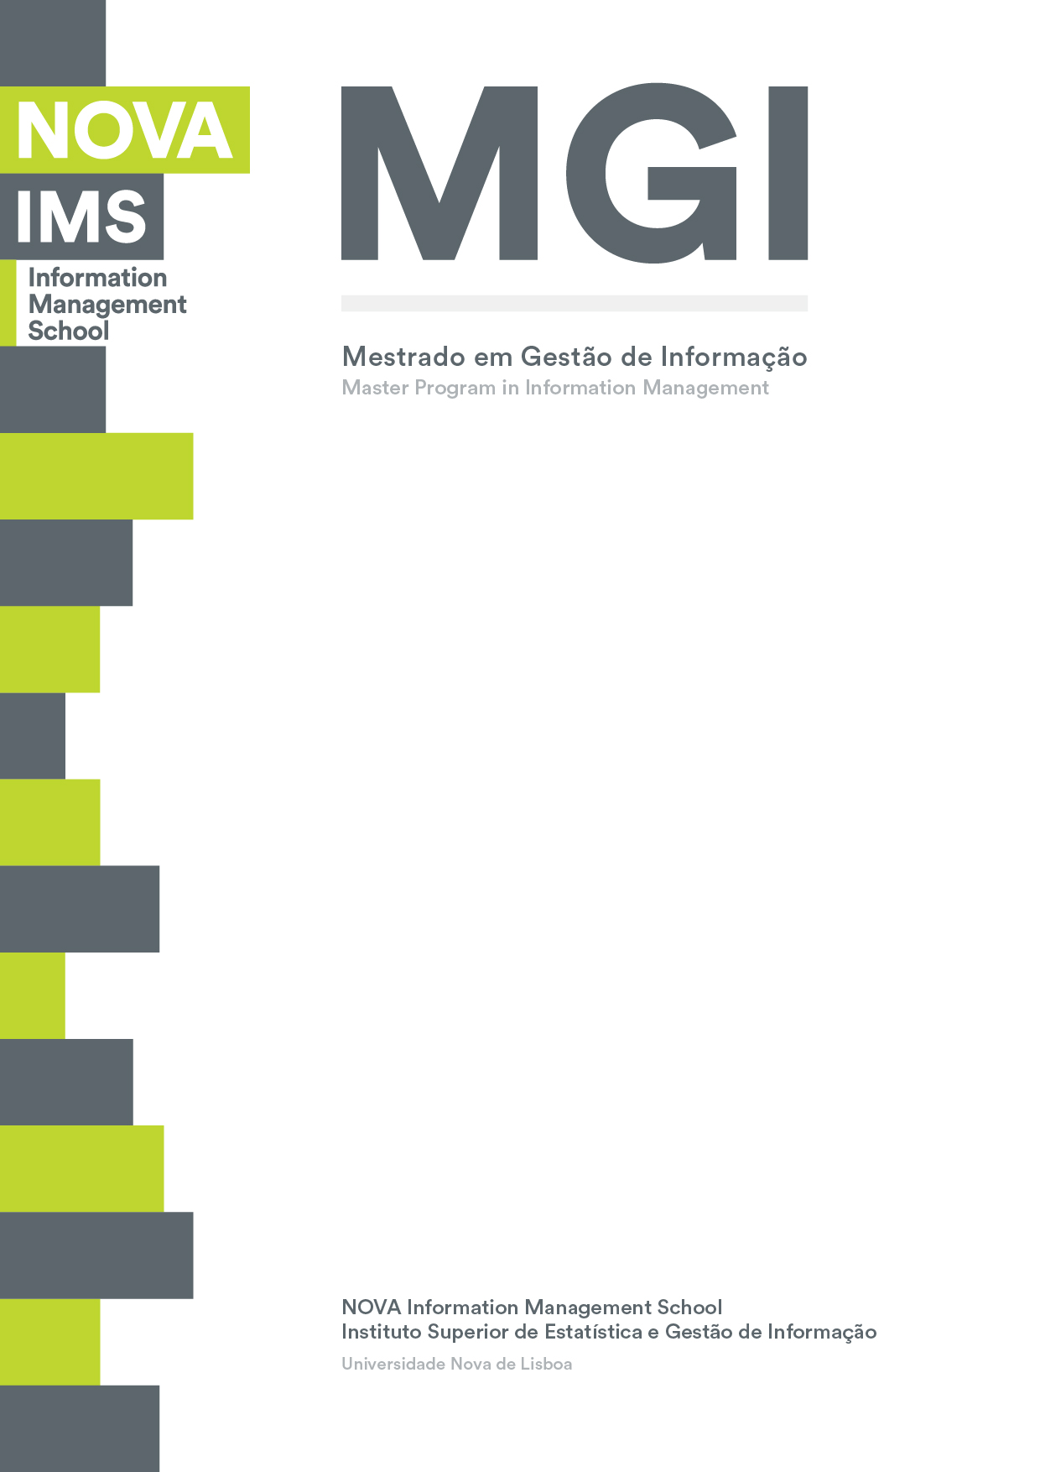

Genetic Algorithm for a Multiple Capacitated Arc Routing Problem

Case of Campolide Waste Management

Evandro da Silva Mendonça

Project Work presented as requirement for obtaining the Master’s degree in Information Management

MEGI

///

2018
Title:
Subtitle:
Evandro da Silva Mendonça
MGI



NOVA Information Management School
Instituto Superior de Estatística e Gestão de Informação
Universidade Nova de Lisboa

TITLE
by
Evandro da Silva Mendonça

Project Work presented as requirement for obtaining the Master’s degree in Information Management, with a specialization in Knowledge Management and Business Intelligence

Advisor: Professor Miguel de Castro Neto, PhD

October 2018
Dedication (optional)

Acknowledgements (optional)

Abstract
Abstract text Abstract text Abstract text Abstract text Abstract text Abstract text Abstract text Abstract text Abstract text Abstract text Abstract text Abstract text Abstract text Abstract text Abstract text Abstract text Abstract text Abstract text Abstract text Abstract text Abstract text Abstract text Abstract text Abstract text Abstract text Abstract text Abstract text Abstract text Abstract text Abstract text Abstract text Abstract text Abstract text Abstract text Abstract text Abstract text Abstract text Abstract text Abstract text Abstract text Abstract text Abstract text Abstract text Abstract text Abstract text Abstract text Abstract text Abstract text Abstract text Abstract text Abstract text Abstract text Abstract text Abstract text Abstract text Abstract text Abstract text Abstract text Abstract text Abstract text Abstract text Abstract text Abstract text.

Keywords
Keyword 1; Keyword 2; Keyword 3; Keyword 4

INDEX
1. Introduction 1
2. Literature review 2
2.1. Level 2 title 2
2.1.1. Level 3 title 3
3. Literature review 4
4. Methodology 5
5. Results and discussion 6
6. Conclusions 7
7. Limitations and recommendations for future works 8
8. Bibliography 9
9. Appendix (optional) 10
10. Annexes (optional) 11

List of Figures
Figure 1.1 - Illustrative Figure 2

LIST OF TABLES
Table 1.1 - Illustrative Table 2

List of Abbreviations and Acronyms
Acronym 1 Explanation of acronym 1 Explanation of acronym 1 Explanation of acronym 1 Explanation of acronym 1 Explanation of acronym 1 Explanation of acronym 1
Acronym 2 Explanation of acronym 2 Explanation of acronym 2 Explanation of acronym 2 Explanation of acronym 2 Explanation of acronym 2 Explanation of acronym 2

Introduction

Cities urbanization and waste management problem
Human activity has been pushing environmental changes. Global warming, air pollution and biodiversity decrease are some of the examples of these changes that can be observed (Bătăgan, 2011). Urban areas are the principal responsible that drive these changes at multiple scale. Being centers of production, consumption and waste disposal, the impacts on the environment can be repeatedly observed among the cities, especially those located in the developed world (Grimm et al., 2008).
The issues generated by the urbanization are even more worrying given that from 1950s to 2014 the urban population went from 30 per cent to more than half of the world’s population with 54 per cent. Furthermore, in the coming decades, the change on the size and distribution of the urban area will be more expressive, projected to have 66 per cent of the entire world’s population living in the cities by 2050 (United Nations, 2014). Megacities, the ones that by convention have more than 10 million inhabitants are emerging mostly in the developing world, and economic growth will follow the urban growth, demanding more services and resources (Grimm et al., 2008). Although the urbanization process brings opportunities for development, at the same time challenges arise, namely on social equity, environmental sustainability and government (United Nations, 2014).
Among many challenges that come with urbanization, waste management is particularly impactful in the short-term to the citizens and the environment. Uncollected waste, for example, can be harmful to the environment and consequently bring a variety of health issues to the population. Also, poorly waste management have economics impact to the city, because the costs can be higher than it would be to properly address the problem. Manage the waste collection of the households is a hard problem that are faced by cities’ government across the globe (Hoornweg & Bhada-Tata, 2012).

Smart cities role in waste management

Literature review

Level 2 title
Sample text with the inclusion of figures and tables Sample text with the inclusion of figures and tables Sample text with the inclusion of figures and tables Sample text with the inclusion of figures and tables Sample text with the inclusion of figures and tables.


Figure 2.1 – Illustrative figure
Sample text with the inclusion of figures and tables Sample text with the inclusion of figures and tables Sample text with the inclusion of figures and tables Sample text with the inclusion of figures and tables Sample text with the inclusion of figures and tables Sample text with the inclusion of figures and tables.

Title | Title
Text | Number
Text | Number
Text | Number
Table 2.1 – Illustrative table
Sample text with the inclusion of figures and tables Sample text with the inclusion of figures and tables Sample text with the inclusion of figures and tables Sample text with the inclusion of figures and tables Sample text with the inclusion of figures and tables Sample text with the inclusion of figures and tables.

Level 3 title
Example of unnumbered list:
- Item 1
- Item 2
- Item 3

Level 4 title
Example of numbered list:
- Item 1
- Item 2
- Item 3

Literature review
Literature review text Literature review text Literature review text Literature review text Literature review text Literature review text Literature review text Literature review text Literature review text Literature review text Literature review text Literature review text Literature review text Literature review text Literature review text Literature review text Literature review text Literature review text.

Methodology
Text about methodology Text about methodology Text about methodology Text about methodology Text about methodology Text about methodology Text about methodology Text about methodology Text about methodology Text about methodology Text about methodology Text about methodology Text about methodology Text about methodology Text about methodology Text about methodology Text about methodology Text about methodology Text about methodology Text about methodology.

Results and discussion
Text about results and discussion Text about results and discussion Text about results and discussion Text about results and discussion Text about results and discussion Text about results and discussion Text about results and discussion Text about results and discussion Text about results and discussion Text about results and discussion Text about results and discussion Text about results and discussion Text about results and discussion Text about results and discussion.

Conclusions
Conclusion text Conclusion text Conclusion text Conclusion text Conclusion text Conclusion text Conclusion text Conclusion text Conclusion text Conclusion text Conclusion text Conclusion text Conclusion text Conclusion text Conclusion text Conclusion text Conclusion text Conclusion text.

Limitations and recommendations for future works
Text of limitations and recommendations for future works Text of limitations and recommendations for future works Text of limitations and recommendations for future works Text of limitations and recommendations for future works Text of limitations and recommendations for future works Text of limitations and recommendations for future works Text of limitations and recommendations for future works Text of limitations and recommendations for future works Text of limitations and recommendations for future works Text of limitations and recommendations for future works.

Bibliography
Author, A. A., Author, B. B., & Author, C. C. (Year). Title of article. Title of Periodical, volume number (issue number), pages.
Bătăgan, L. (2011). Smart Cities and Sustainability Models. Revista de Informatică Economică, 15(3), 80–87. Retrieved from http://revistaie.ase.ro/content/59/07 - Batagan.pdf
Grimm, N. B., Faeth, S. H., Golubiewski, N. E., Redman, C. L., Wu, J., Bai, X., & Briggs, J. M. (2008). Global Change and the Ecology of Cities. Science, 319(5864), 756–760. https://doi.org/10.1126/science.1150195
Hoornweg, D., & Bhada-Tata, P. (2012). What a waste: a global review of solid waste management. World Bank, Washington DC.
United Nations. (2014). World Urbanization Prospects 2014. Demographic Research. https://doi.org/(ST/ESA/SER.A/366)

Appendix (optional)

Annexes (optional)

