**Final Year Project Proposal**

**Evan Fahy**

**G00287967**

**Title: Precision control circuit for a high current short circuit tester.**

**Sponsor: Western Automation R&D Ltd.**

**Overall Functionality:**

The project’s overall functionality is to perform a short circuit test, passing a high current through the contacts of a circuit breaker called a *Residual Current Device* (RCD). The outcome of this test is to verify what condition the contacts of a RCD unit will be in after a short circuit has occurred in the unit. The high current could “blow” open the contacts or weld\melt them, etc.

Our main aim of this project is to design a tester to allow a user to decide what precise point/angle (o) of a mains voltage AC sine wave signal will be passed through the contacts under the short circuit test. This precise point is known as the **Point-On-Wave (PoW) phase position.** A control system will be designed to monitor and synchronise with the mains frequency so that it knows exactly when to “fire” the output trigger signal. For this synchronisation, it is necessary to step down the mains voltage to a suitable value, so it can be passed to an *Analog-Digital Converter* (*ADC)* to be monitored by a microcontroller. Once the PoW is reached, the microcontroller will output a signal to a *Silicon-Controlled Rectifier/SCR* (Thyristor) which switches on the current to the *device under test* (DUT). This project will be implementing a user interface via a *Raspberry Pi* to adjust settings of the tester and to gather and store data.

For this project, the aim is to apply the current at the precise time. The person doing the test will make observations and visual inspections of the RCD after the test.

**Main Functionality:**

* Accurately detect the required Point-On-Wave (PoW) phase position.
* Implement an accurate zero-cross detection system.
* Capability to issue a trigger signal from a PIC microcontroller based on phase position on the mains input.
* Issuing the trigger signal via an external push-button, that indicates that the circuit should “fire” at the next PoW on the incoming mains circuitry to the switch gear (RCD).
* PoW position to be programmable and variable by means of an external interface.
* Communicate settings and measurements to a Serial Peripheral Interface (SPI) controller via a Raspberry Pi.
* Using the SPI to implement network/cloud capabilities to store data.

**Hardware:**

* Voltage stepdown circuit, PIC, ADC, Opto-isolator, SCR, Raspberry Pi.

**Software:**

* Embedded C/C, Python/Java

**Block Diagram:**

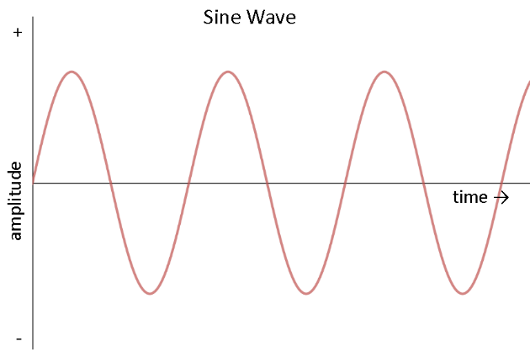

Current flowing to contacts of circuit breaker

Electronic Switch

* Turns on SCR but insures no leakage current accidentally turns on SCR

µC (PIC)

Fire Trigger Signal

ADC

* Monitors signal from mains

Settings for PoW

* Set by the Raspberry Pi

Push button

* Trigger to fire signal

AC Sine wave from mains

Buffer circuit

* Steps down mains voltage

SCR

* Allows current to flow until voltage becomes negative

Raspberry Pi

* User Interface