Virtual Counselor

Visual Guide for Students and Admin

Evan Firoozi, Marcello Yapura

December 2018

CS 03C

**Main page**

From This page, users can use to work as Administrator or Student and they can Exit from the application by clicking on Exit button.

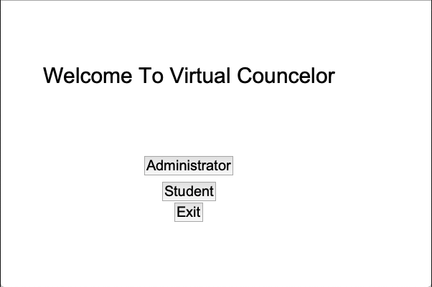

**Admin Portal**

Admin main page.

Question and Answer: add, edit, remove, or retrieve a question and answer

Get Survey Results: print survey results on the screen

Get Student Info: print all the students information on the screen

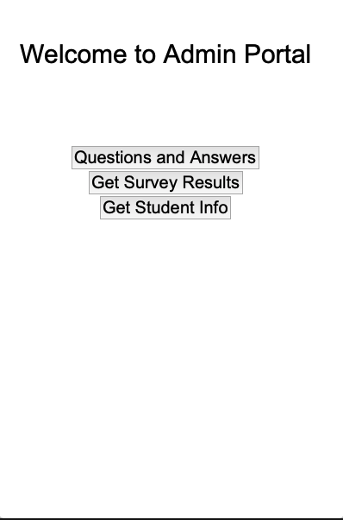

**Student Info page**

This page asks for student information. Each student at least should enter their ID. This page sends students to their main panel.

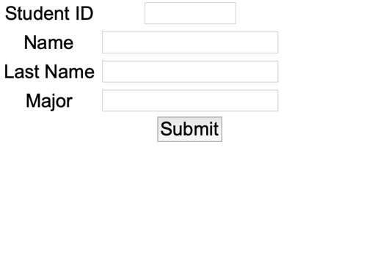

**Student Portal**

Student portal is the main panel for students, they can choose to find answer to a question, email a counselor, or find information on transfer

