Following on from my last post, I mentioned I would be moving on to SQL subqueries this week. It was another learning curve after the last batch of SQL, but pushing through it has deepened my understanding of the core concepts and what they are teaching me.
1. Thinking ahead with query structure
Working with subqueries forced me to think beyond the immediate question and consider the bigger picture. Rather than solving one step at a time, I had to plan the overall structure of a query in advance, which has helped me think more clearly about how a program fits together as a whole.
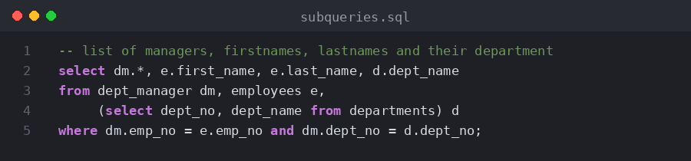
2. Spotting errors and debugging
Syntax errors have become trickier to spot as the queries get more complex, but I now have a much better sense of what a correct query should look like. This makes it easier to identify what has gone wrong — not just when the terminal flags an error, but in that “something doesn’t look right” moment before it does. It has also reminded me how important careful, precise typing is, since a small typo can be enough to crash a project.
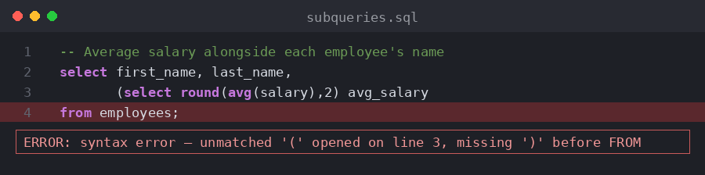
3. Version control with Git
Just in case you didn’t know, I also have a GitHub account. As a working process, I tried to work independently of the Coursera project itself and set up my own system to upload my progress to GitHub using Git. Git is a core tool used throughout software development, so I wanted to get some hands-on experience with it rather than just knowing it in theory. However, I am only doing the basics at the moment (init, commit and push commands), despite this I believe it’s a solid stepping stone to deepening my own understanding of how software is built, updated and maintained over time.
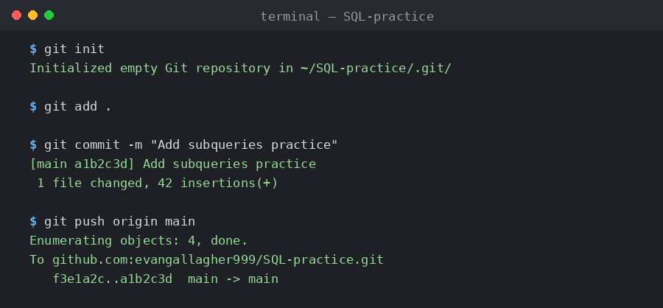
As always, here is a link to view my certificate:
https://www.coursera.org/account/accomplishments/verify/R4OKWCKIPDDP
And if you are curious about my GitHub account, it is below:
https://github.com/evangallagher999/SQL-practice
#PostgreSQL #Subqueries #Git #GitHub #ContinuousDevelopment

