|  |
| --- |
| QAS Address Verification Module for Magento |

Magento Commerce

|  |
| --- |
|  |

Contents

1 Introduction .......................................................................................................................................... 4

2 Overview ............................................................................................................................................... 4

3 Requirements ........................................................................................................................................ 4

4 QAS Touch-points .................................................................................................................................. 4

4.1 Address Book ...................................................................................................................................... 4

4.2 Checkout ............................................................................................................................................. 5

5 Installation ............................................................................................................................................. 7

5.1 Implementation Steps ........................................................................................................................ 7

5.2 Manual Installation ............................................................................................................................. 9

5.3 Setting up a QAS Username and Password ....................................................................................... 10

6 Test Addresses ...................................................................................................................................... 10

7 Configuration ........................................................................................................................................ 11

7.1 Settings .............................................................................................................................................. 11

7.1.1 WSDL url ......................................................................................................................................... 11

7.1.2 Use Local WSDL ………………………………………………………………………………………………………………………… 11

7.1.3 Username ....................................................................................................................................... 11

7.1.4 Password ........................................................................................................................................ 11

7.1.5 AU Layout ....................................................................................................................................... 11

7.1.6 AU Dataset ..................................................................................................................................... 11

7.1.7 NZ Layout ....................................................................................................................................... 11

7.1.8 NZ Dataset ...................................................................................................................................... 11

8 Technical Information ......................................................................................................................... 12

8.1 Integration ....................................................................................................................................... 12

8.1.1 Components ................................................................................................................................. 12

8.1.1.1 Block .......................................................................................................................................... 12

8.1.1.2 Controllers ................................................................................................................................. 12

8.1.1.3 Models ....................................................................................................................................... 12

8.1.1.4 Frontend .................................................................................................................................... 12

8.1.1.5 Database Tables ........................................................................................................................ 12

8.1.1.5 CSS ............................................................................................................................................. 12

9 Unsupported Features & Known Issues .............................................................................................. 12

**1 Introduction**

This document is intended as a technical resource for the installation, setup and use of the QAS Address Verification Module for Magento. QAS is a leading provider of address data quality software and services. The QAS software suites of products are designed for Real-time address verification.

**2 Overview**

Magento is an open source ecommerce CMS that uses a LAMP(Linux, Apache, MySQL, PHP) architecture.

As an open source platform the modifications one could make to their website are limitless. With this in mind the integration was developed to incorporate as close to core Magento API functionality as possible.

This integration expects that customizations made by administrators to Magento will be to the front-end (end-user display), therefore it does not depend on the layout of these forms. This can result in a few display peculiarities described within.

**3 Requirements**

Magento Enterprise Edition v1.11+ or Magento Community Edition v1.7+

QAS on Demand (with v3 WSDL) with proper credentials

php_soap and php_openssl extensions and access to the QAS OnDemand service via an internet connection

Magento QAS Address Verification Module from Magento Connect

Magento Administrative Privileges.

**4 QAS Touch-points**

**4.1 Address Book**

The *Address Book* is located in the *My Account* section on a Magento website, the billing and shipping addresses within the *Address Book* can be seen and edited from the *Account Dashboard* within a user’s *My Account*. QAS standard Address Verification Best Practices are used at these touch points and as the customer enters an address in address field, QAS checks entered text in address field and give appropriate addresses in pick list now the customer would requires to select one address, In this way QAS performs Real-time address verification.

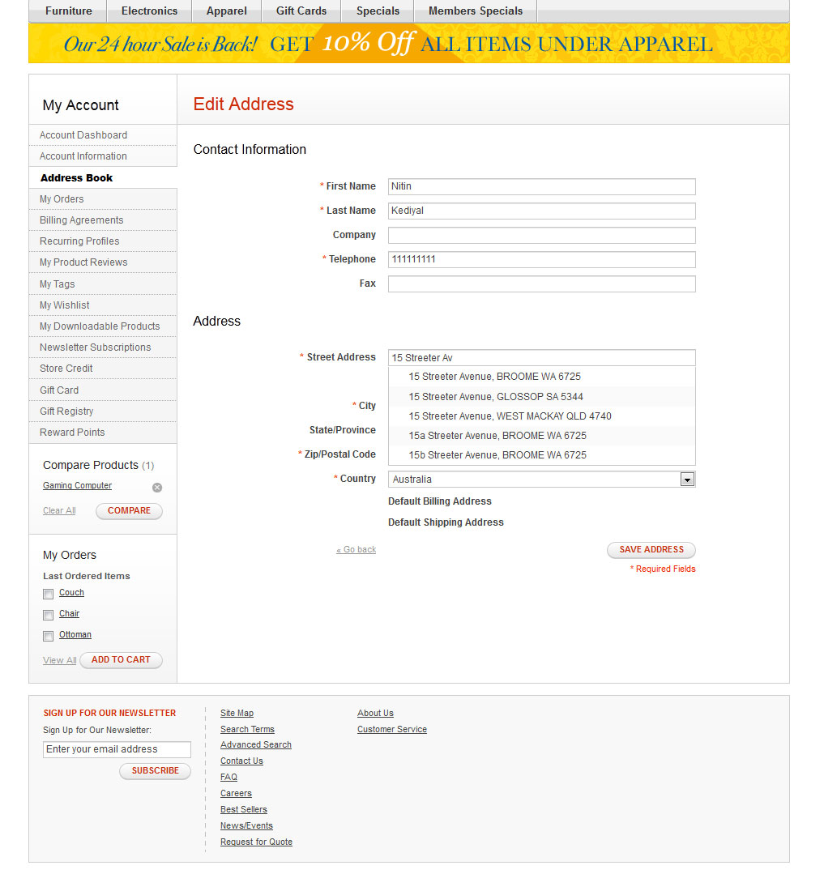

**4.2 Checkout**

The *Onepage Checkout* is used when an end-user performs a checkout. QAS standard Address Verification Best Practices are used at these touch points and as the end-user enters an address in address field of Billing information or Shipping information, QAS checks entered address in address field and give appropriate addresses in pick list now the customer would requires to select one address, In this way QAS performs Real-time address verification.

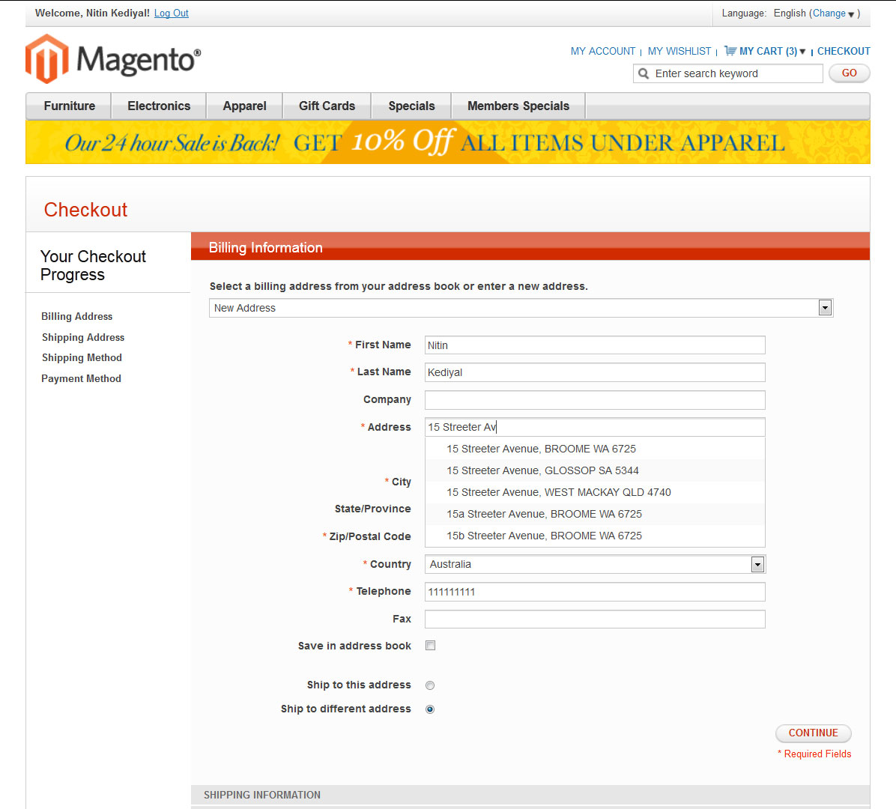

However any changes made to an existing address, or new addresses entered by a *Registered User* are not saved to the users *Address Book* and these changes are only saved as the shipping and billing addresses for this particular order.

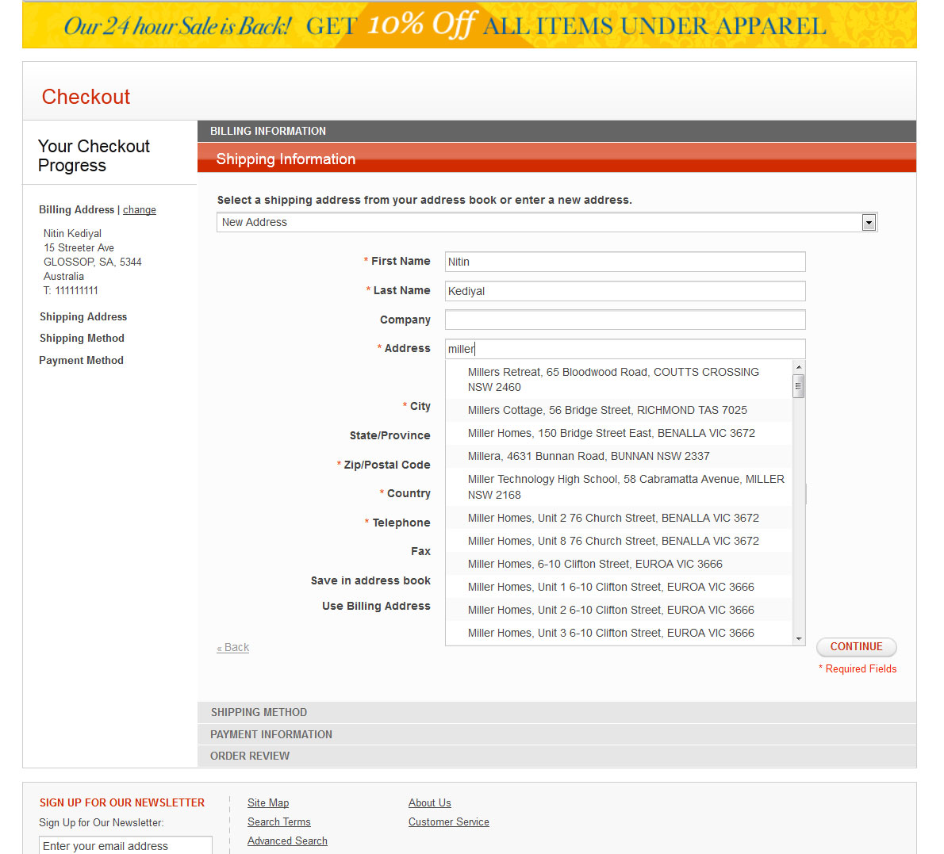

There is also a *Multi-shipping Checkout* that can be enabled in a Magento website; however this integration does not support this touch point.

**5 Installation**

**5.1 Implementation Steps**

Prior to Install be sure that php_soap and php_openssl extensions are both enabled and have access to the QAS OnDemand service via an internet connection.

1. Install the QAS Verification Module from Magento Connect.
2. After the installation is complete browse to your Magento homepage in order to complete the module install.
3. You should now have a “General” and “Frontend” section in your Admin Panel under System>Configurations>QAS Address Verification.
4. By default “WSDL URL” QAS Ondemand Web Service url is populated in the config.

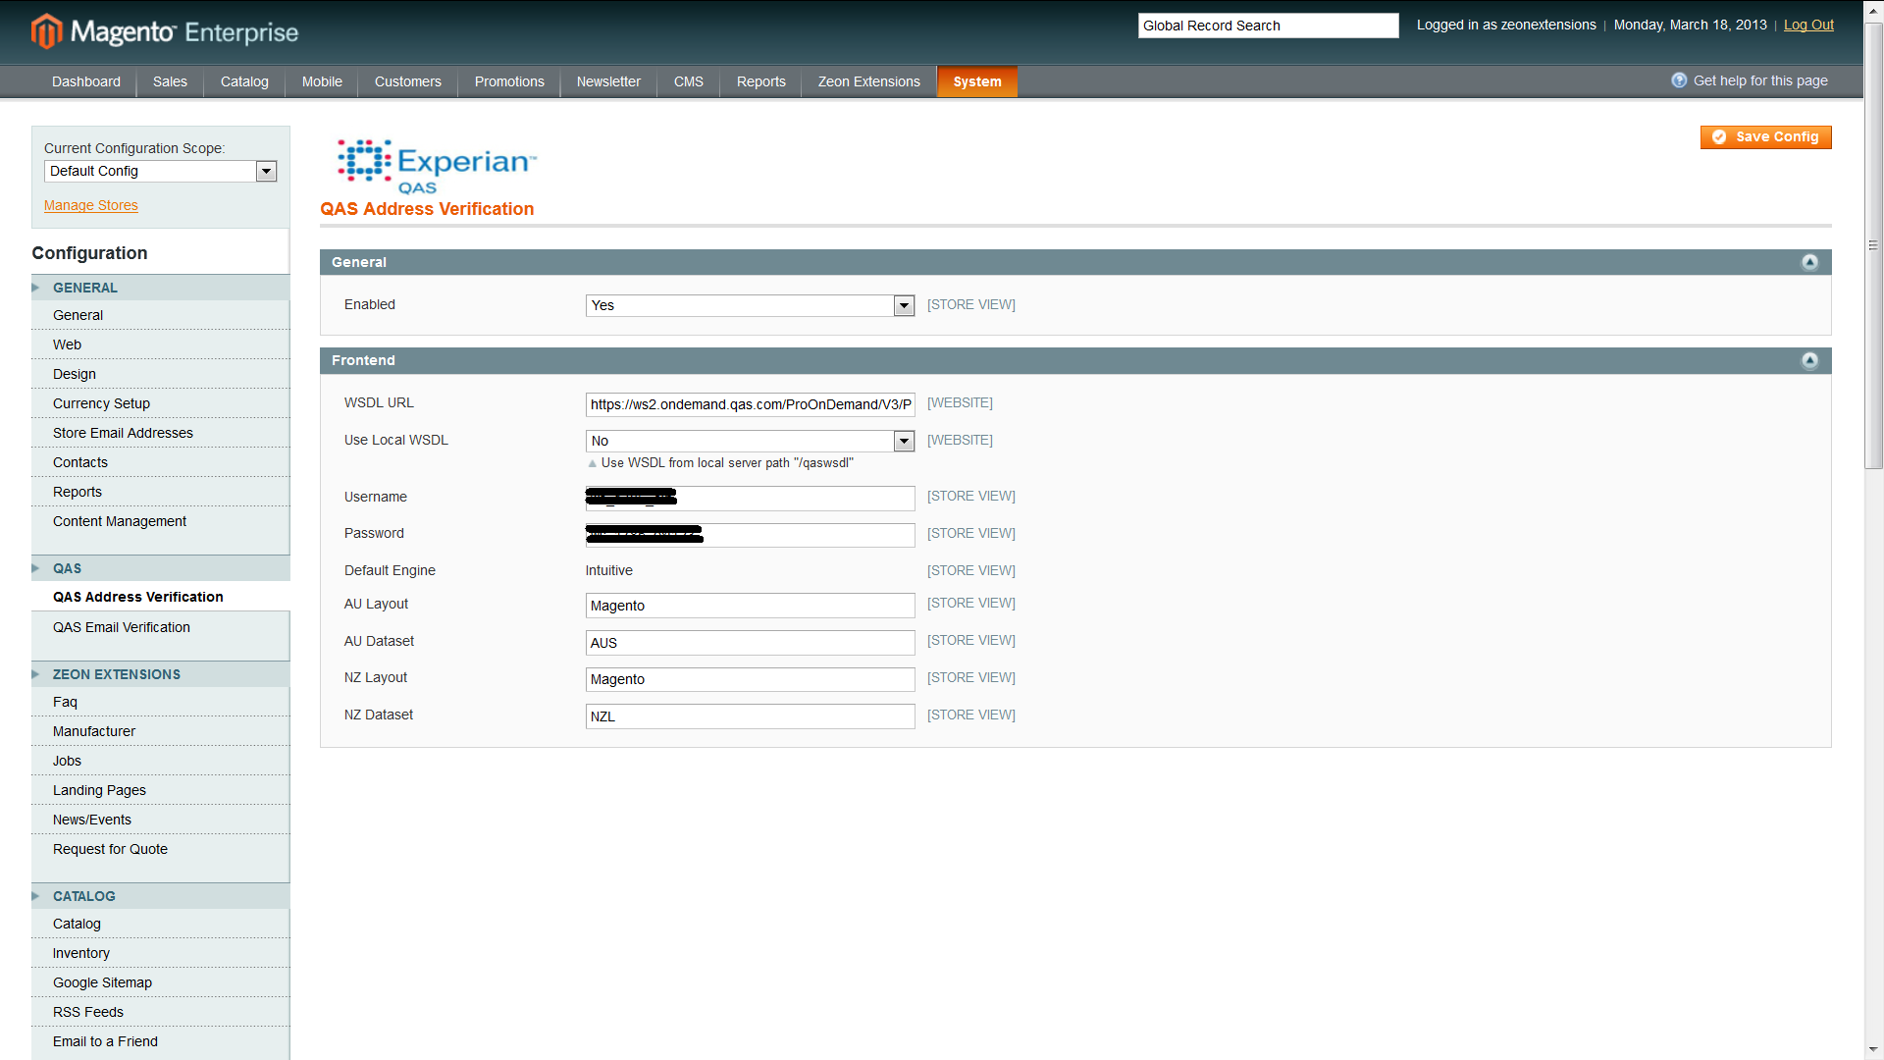

1. Enter your QAS OnDemand credentials in the Username and Password fields.
2. By default, “AU Dataset” of Australia addresses is AUS and “NZ Dataset” of New Zealand addresses is NZL. Make sure theses settings reflect the country data sets you purchased and the country code may vary according to the dataset.
3. By default an Australia and New Zealand OnDemand layout is populated in this config. The layout defines the format that the returned address should be in (e.g. case, and what lines the various components should appear on). These layouts both work with 2 street address lines. If you’ve altered your Magento instance to include more or less than 2 address lines, or if the address data does not populate back into the address fields, then you will need to change the layout.
4. QAS Address verification should now be enabled. You can test this with the addresses provided in section 6 of this document.
5. All fields, beginning with Title and moving through to the end of the Config, are customizable by the admin. They contain text that is presented during all the stages of user address interaction. Although we advise keeping these messages as is, or with little changes, the admin is free to change them as they wish.

**5.2 Manual Installation**

QAS recommends installing via Magento Connect rather than manually for a simpler implementation.

Prior to Install be sure that php_soap and php_openssl extensions are both enabled and have access to the QAS OnDemand service via an internet connection.

1. Obtain a copy of the QAS module.
2. Copy files into the appropriate folder structure within your Magento Website (ie app/code/local/QAS from the downloaded package should be placed in /app/code/local/ in your instance of Magento)
3. After all copying is complete browse to your Magento homepage in order to complete the module install
4. You should now have a “General” and “Frontend” section in your Admin Panel under System>Configurations>QAS Address Verification
5. By default “WSDL URL” QAS Ondemand Web Service url is populated in this config.



1. Enter your QAS OnDemand credentials in the Username and Password.
2. By default, “AU Dataset” of Australia addresses is AUS and “NZ Dataset” of New Zealand addresses is NZL. Make sure theses settings reflect the country data sets you purchased and the country code may vary according to the dataset.
3. By default an Australia and New Zealand OnDemand layout is populated in this config. The layout defines the format that the returned address should be in (e.g. case, and what lines the various components should appear on). These layouts both work with 2 street address lines. If you’ve altered your Magento instance to include more or less than 2 address lines, or if the address data does not populate back into the address fields, then you will need to change the layout. To request a new layout please email us.support@qas.com.
4. QAS Address verification should now be enabled. You can test this with the addresses provided in section 6 of this document.
5. All fields, beginning with Title and moving through to the end of the Config, are customizable by the admin. They contain text that is presented during all the stages of user address interaction. Although we advise keeping these messages as is, or with little changes, the admin is free to change them as they wish.

**5.3 Setting up a QAS Username and Password**

After purchasing QAS OnDemand for Magento you should receive an email requesting you to verify your email address. Follow the link and fill in the required information and afterwards you will receive another email with your QAS OnDemand account portal information. Log into the portal and follow the “QAS Pro OnDemand” link and then select the “Web Services” tab. Here you will be able to administer your username and password information that is necessary to enter into QAS Config Username and Password fields as noted in sections 5.1 & 5.2.

For more information about the QAS OnDemand service please reference the accompanying Activate On Demand Instructions or download the QAS Pro OnDemand documentation available from <http://support.qas.com/?sc=us>.

**6 Test Addresses**

The following is a list of New Zealand addresses for each possible verification level, use these to test that each user interaction page is working correctly.

Street addresses: 445 Mount Eden Road, Mount Eden, Auckland

Rural addresses: 21 Greens Road RD 2 Ruawai 0592

Partial addresses: Main Highway Otaki; 32 Wilson Street

PO Boxes: PO Box 39100

Community Boxes: CMB C5, Huntly

Counter Delivery: Counter Delivery, Carters Beach PostCentre, Westport

**7 Configuration**

### All configuration’s are handled in the Magento *Admin Panel* the *QAS Config* is located in System>Configuration> QAS Address Verification.

**7.1 Settings**

**7.1.1 WSDL url**

QAS Ondemand Web Service endpoint url.

**7.1.2 Use Local WSDL**

Set the ‘Use Local WSDL’ to ‘yes’ if the WSDL url doesn’t work.

**7.1.3 Username**

QAS OnDemand username. This will be supplied to you via email after purchase.

**7.1.4 Password**

QAS OnDemand password. This will be supplied to you via email after purchase.

**7.1.5 AU Layout**

This is the OnDemand layout to use for AU addresses – the layout should have the same number of address lines as the customer is using in Magento. The Default should be “Magento”

Please contact QAS support before altering this field.

**7.1.6 AU Dataset**

Make sure theses settings reflects country code of the country data sets you purchased and the country code may vary according to the dataset.

**7.1.7 NZ Layout**

This is the OnDemand layout to use for AU addresses – the layout should have the same number of address lines as the customer is using in Magento. The Default should be “Magento”

Please contact QAS support before altering this field.

**7.1.8 NZ Dataset**

Make sure theses settings reflects country code of the country data sets you purchased and the country code may vary according to the dataset.

**8 Technical Information**

**8.1 Integration**

**8.1.1 Components**

The QAS module has the following components.

***8.1.1.1 Block***

The QAS Block file calls a function to get address in to pick list or displays “An exact match wasn’t found” popup if no address match the search string.

***8.1.1.2 Controllers***

The QAS Module doesn’t override any core controller functionality.

***8.1.1.3 Models***

The Model contains two files one has Soap Client connectivity function and three functions for Intuitive Engine to search and pick address from dataset. Another file passes the parameters to these functions.

***8.1.1.4 Frontend***

This module has two template files located in app/design/frontend/base/default/template/qas, one initialize the Authenticating variable on page load and other calls the JavaScript functions.

***8.1.1.5 Database Tables***

The QAS Module doesn’t create any data base table on installation.

***8.1.1.6 CSS***

The QAS Module css files located in skin/frontend/base/default/css/addressverification.css. The display should conform to the look and feel of the webpage upon installation.

**9 Unsupported Features & Known Issues**

1. The Multi-Shipping checkout option in Magento is unsupported.
2. Address verification within the Customer Management section of Magento admin is unsupported.
3. For Country besides Australia and New Zealand is not applicable.