Entities
- qualification
- jobType
- positionLevel
- experience
- firstname
- lastname
- company
- userType
- Job
- Address
- Profile
- User
- country
- city
- Thread
- messageTrack
- message
- threadReply

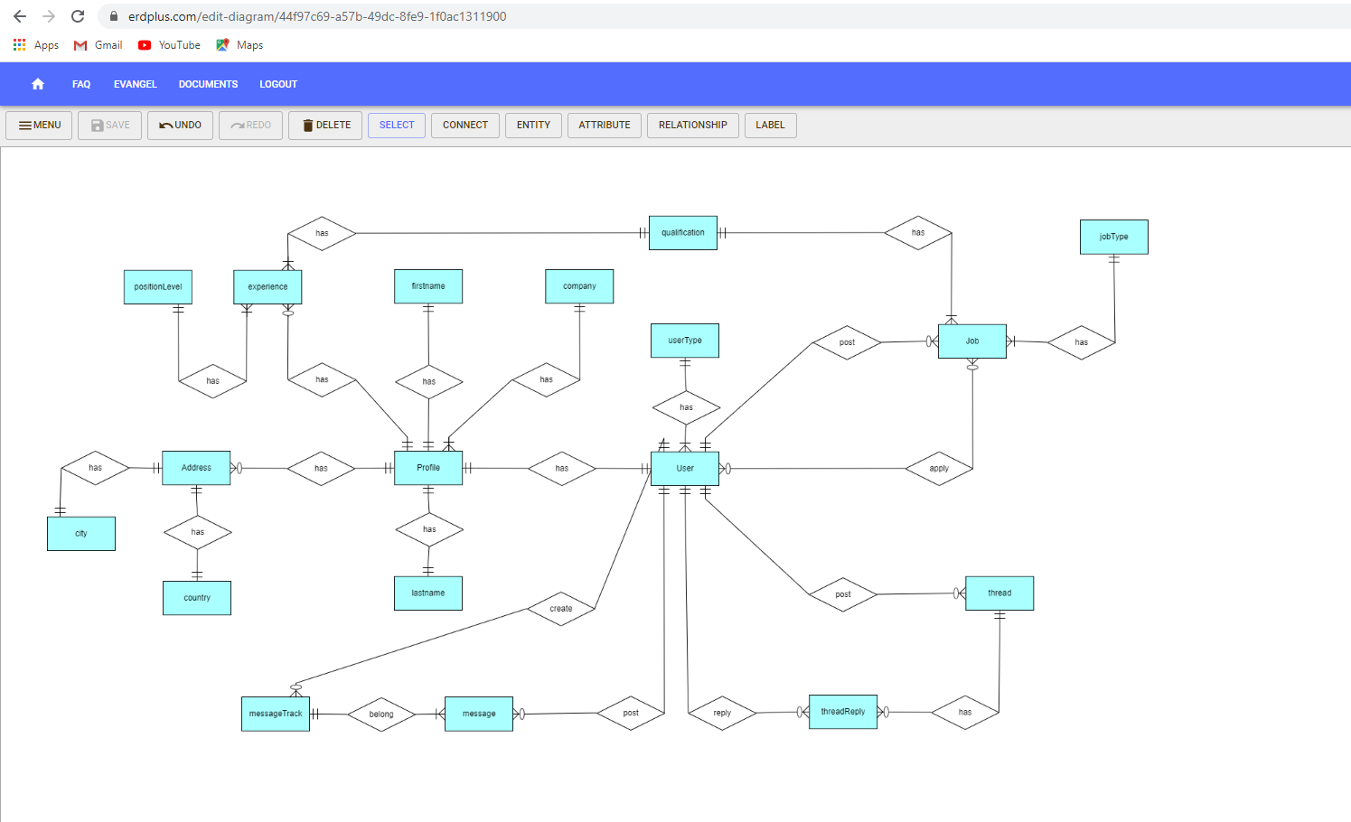
ERD

