Create a batch script to backup database using Navicat Premium

1. Right click on communityportal and select Dump SQL File -> Structure And Data…

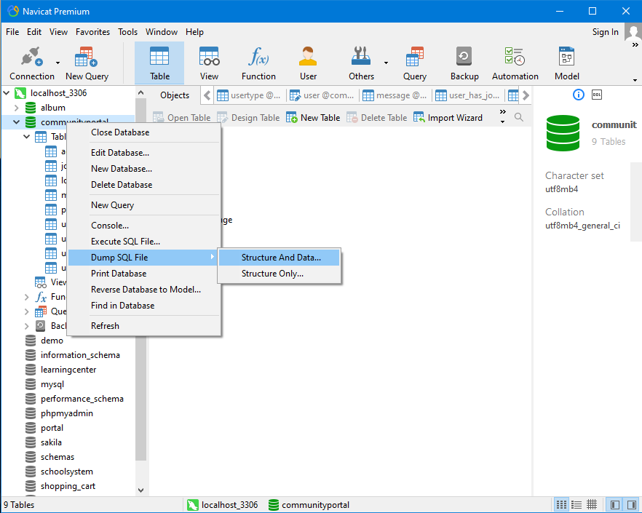

1. 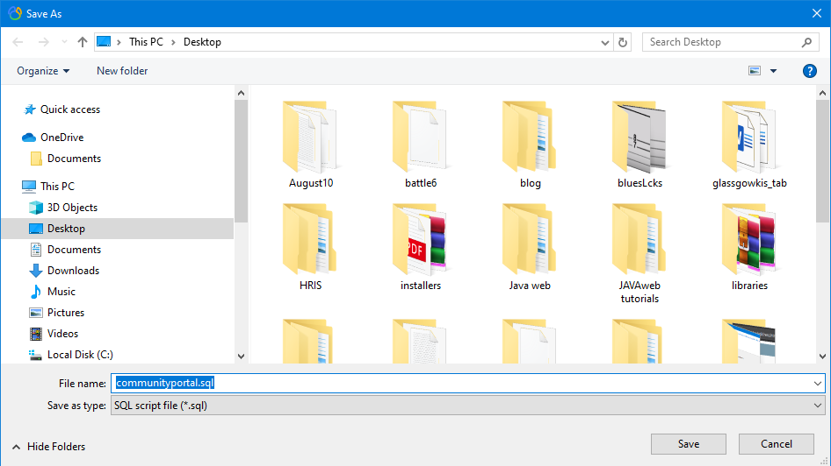Select destination and click Save
2. 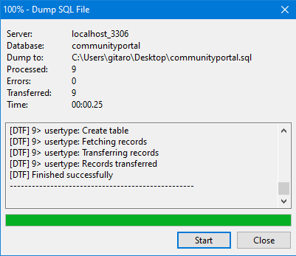Click Close