Report

1. 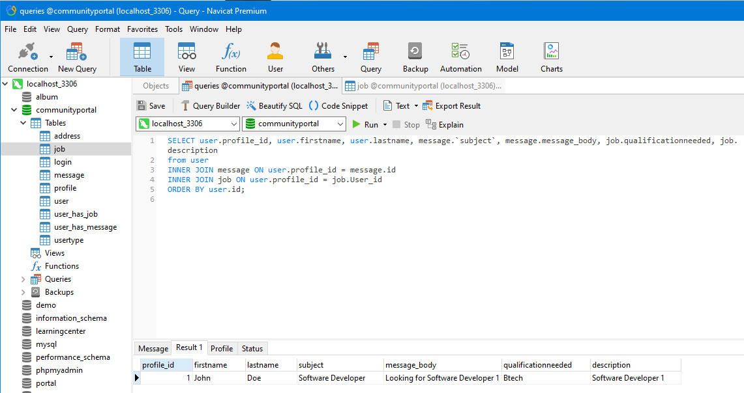Query and Result in community portal using Navicat Premium
2. Click Export Result -> Export Saved Query

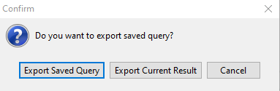

1. Select Html and click Next

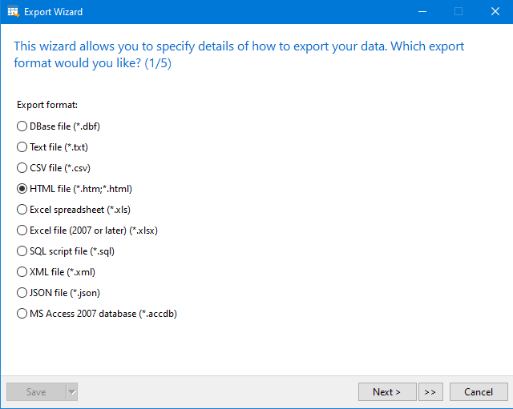

1. Click Next

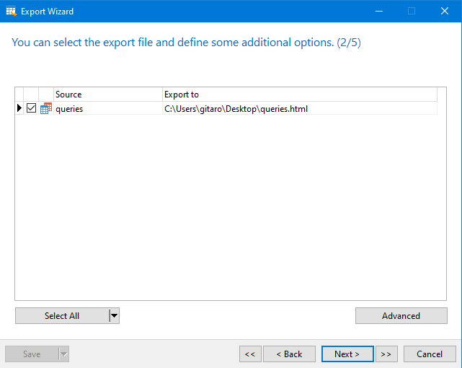

1. Click Next

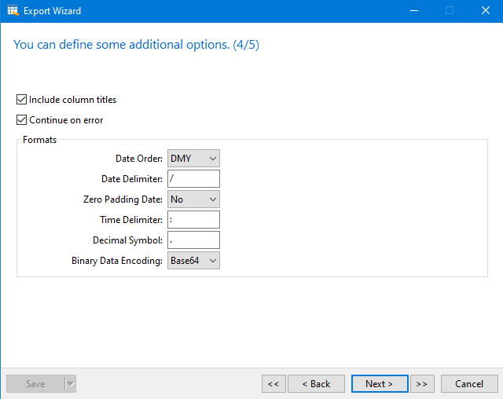

1. 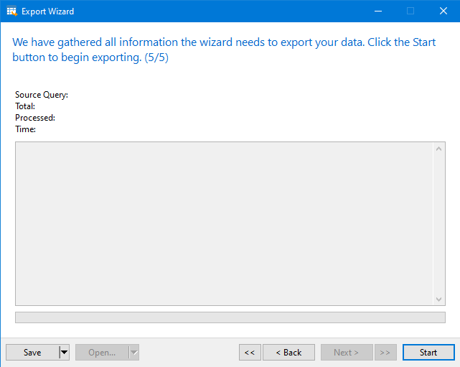Click Start
2. Click Close

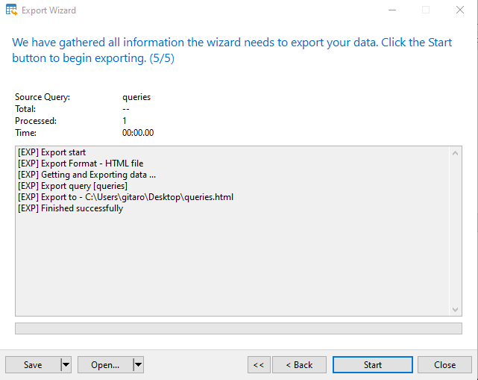

1. Generated result in HTML