Create a Restoration script in case of failure using Navicat Premium

1. 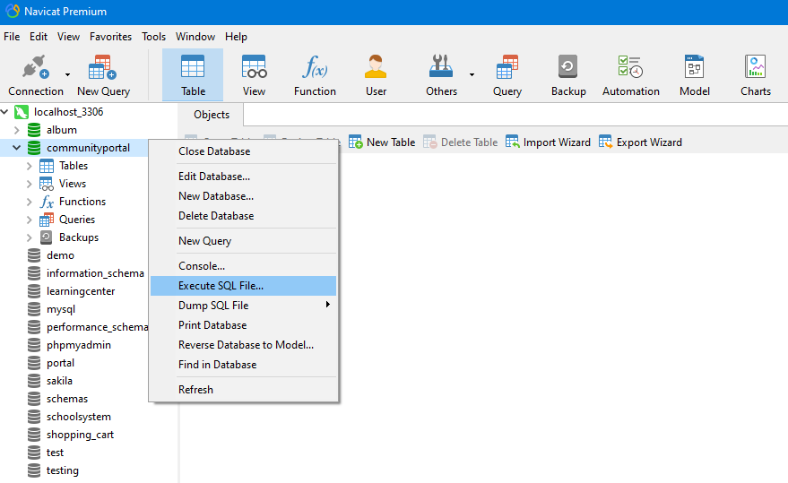Right click on communityportal and select Execute SQL File…
2. Search File

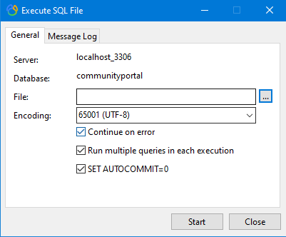

1. 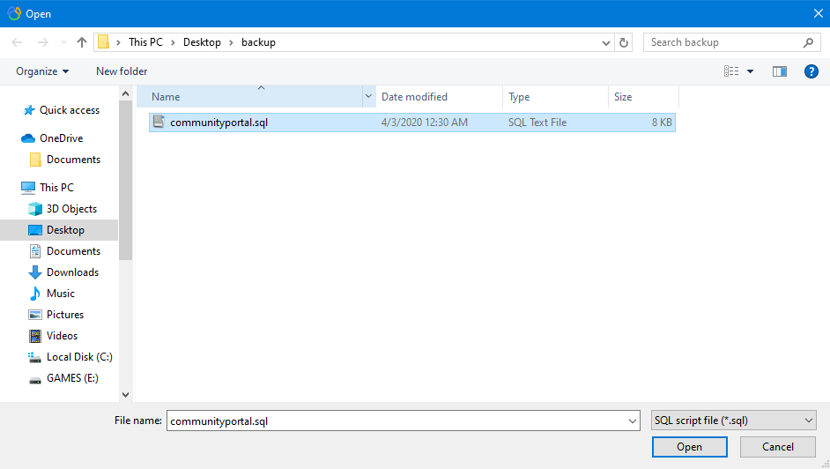Select communityportal.sql and Click Open
2. Click Start

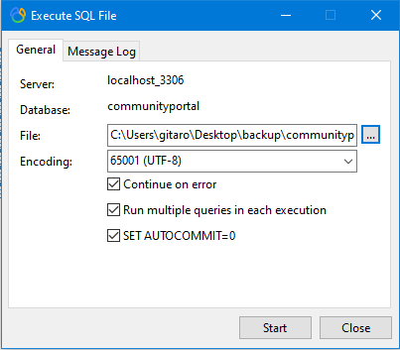

1. Click Close

