MODULE CODE AND TITLE: SWDBD401 BACKEND APPLICATION DEVELOPMENT

Learning Outcome 1: Develop RESTFUL APIs with Node JS
Learning Outcome 2: Secure Backend Application
Learning Outcome 3: Test the Backend Application
Learning Outcome 4: Manage Backend Application

Learning Outcome 1: Develop RESTFUL APIs with Node JS
Indicative contents
1.1 Setup Node. Js Environment
1.2 Connection of Node Js to the ES5 or ES6 server
1.3 Establishment of database connection
1.4 Develop RESTFUL APIs

Learning Outcome 1: Develop RESTFUL APIs with Node JS
Indicative content 1.1: Setup Node. Js Environment
1. Node.js
- An open-source environment that runs JavaScript code outside the browser, specifically on servers.
- Key feature: Uses an event-driven, non-blocking I/O model, meaning it can handle many tasks simultaneously without waiting for one to finish before starting another.
- Why it matters: Ideal for building scalable, real-time applications like chat apps, live updates, or streaming services because it efficiently manages multiple connections at once.
- Example: A simple Node.js server might look like this in code:
const http = require('http');
const server = http.createServer((req, res) => {
res.end('Hello, World!');
});
server.listen(3000);
This creates a server that responds to requests on port 3000.
2. NPM (Node Package Manager): NPM is the built-in tool for managing JavaScript packages in Node.js projects. It's like a massive app store for code libraries, you search, install, and update them easily.
- How It Works: You run commands like npm install express to add packages. It reads from a global registry (npmjs.com) with millions of free packages.
- Key Files: It creates or updates a package.json file (your project's "shopping list" of dependencies) and a package-lock.json (to lock versions for consistency).
- Why It's Important: Saves time by reusing code. For instance, instead of writing your own HTTP server from scratch, install Express.js via NPM.
- Commands to Know: npm init (start a project), npm update (update packages), npm uninstall (remove them).
3. Dependencies
- Dependencies are external packages or libraries your application relies on to perform specific tasks. Example, if your app requires database connections, you might depend on a package like mongoose for MongoDB.
- Management: Listed in package.json file; installed and updated via NPM.
- Example: A package for handling HTTP requests, database access, or authentication.
- Best Practices: Keep them updated to avoid security vulnerabilities (use npm audit). Example: In a web app, you might depend on express for routing and body-parser for handling form data. Mismanaged dependencies can lead to "dependency hell" (version conflicts), so tools like NPM help automate this.
4. Backend Application
- Is the server-side part of a web application.
- Responsibilities: Processes user requests, interacts with databases, performs computations, and sends data or web pages back to the client. Processes HTTP requests (e.g., login attempts), queries databases, authenticates users, and sends responses (data or errors).
- Contrast with Frontend: Frontend is what users see (HTML/CSS/JS in browsers); backend is invisible but essential.
- Example: In an e-commerce site like Amazon, the backend checks inventory, processes payments, and updates your cart when you add items. Node.js excels here due to its speed.
- Architecture Tip: Often uses MVC (Model-View-Controller) pattern: Models for data, Views for UI (though in Node.js, views might be API responses), Controllers for logic.

5. Routes
- Definition: URL patterns that determine how your server responds to different HTTP requests. Routes are like address mappings in a web app, they tell the server what to do when a specific URL is requested via HTTP methods (GET, POST, etc.).
- Function: Map URLs to specific functions or controllers, enabling the server to handle various actions like showing a page, submitting data, or deleting records.
- How They Work: In Node.js (often with Express.js), you define routes like /users to fetch user data. Each route links to a function that handles the request.
- HTTP Methods: GET (read data), POST (create), PUT (update), DELETE (remove).
- Example in Express.js:
app.get('/home', (req, res) => {
res.send('Welcome to the home page!');
});
This responds to GET requests at /home.
- Importance: Enables organized, modular code. Without routes, your server couldn't differentiate between /login and /profile.
6. Class (in JavaScript)
- What it is: A blueprint to create objects with shared properties and behaviours.
- Purpose: Supports Object-Oriented Programming (OOP), promoting code reuse and organization.
- Syntax:
class Car {
constructor(make, model) {
this.make = make;
this.model = model;
}
drive() {
console.log('Vroom!');
}
}
- Inheritance: Classes can extend others (e.g., class ElectricCar extends Car).
7. Object
- Object is a collection of key-value pairs representing data and behaviour.
- Example: A user object might have properties like name and email, and methods like login().
8. Method
- Method is a function attached to an object that performs actions related to that object.
- Example: user.login() is a method that performs login functionality.

9. Properties: are the data attributes of an object, like variables inside it. They describe the object's state.
- Types: Can be primitives (strings, numbers) or complex (arrays, other objects).
- Access: Dot notation (user.name) or brackets (user['name']).
- In Practice: In a Node.js app, a request object might have properties like req.body (user-submitted data).
10. Express.js
- Express.js is a lightweight framework for Node.js that simplifies web app development.
- Features: Middleware (functions that process requests, e.g., logging), routing, template engines.
- Installation: npm install express.
- Example: Sets up a server faster than plain Node.js.
- It is popular because of its Flexibility, and used in millions of apps

11. Postman: is a GUI tool for API testing. It's like a simulator—send requests, view responses without writing code.
- Uses: Test endpoints, automate collections of tests, generate docs.
- Features: Supports variables, environments (dev/prod), scripting.
- Example: Test a GET /users route by entering the URL, headers, and clicking "Send".

12. Nodemon: is a development tool that auto-restarts your Node.js server on file changes.
- Function: Monitors your Node.js files, automatically restarting the server whenever code changes are detected, speeding up development workflow.
- How: Install via npm install -g nodemon, run with nodemon app.js.
- Benefit: Speeds up iteration no manual restarts. Ideal for local dev.
13. API (Application Programming Interface): A set of rules and protocols that enable different software systems to communicate.
- Function: Defines how to request data or actions from another program, often over the internet.
Types of APIs
Type | Description | Examples | Access Level
Open APIs (Public) | Freely available to anyone; promotes innovation. | Twitter API, Google Maps API | Public
Internal APIs (Private) | Used within a company for internal tools; not public. | Company's HR system API | Internal
Partner APIs | Shared with trusted partners under agreements. | Payment gateway like Stripe for partners | Restricted

• Advantages:
- Automation: Handles repetitive tasks, e.g., auto-syncing data between apps.
- Innovation: Reuse existing services, like embedding YouTube videos via API.
- Security: Adds layers like API keys or OAuth to control access.
- Cost Efficiency: Use third-party services (e.g., AWS APIs) instead of building everything.
• Common Use Cases:
- Integrating Systems: Link CRM (e.g., Salesforce) with email (e.g., Mailchimp) to auto-send welcomes. Salesforce is a cloud-based Customer Relationship Management (CRM) platform and software used by businesses to better manage and connect to their customers. It acts as a central hub for a business to manage things like customer interactions, sales activities, and marketing campaigns.
- Enhancing Functionality: Add maps to a ride-sharing app via Google Maps API.
- Connecting IoT: Smart home devices (e.g., Nest thermostat) use APIs to talk to apps or cloud.
- Scalable Systems: Microservices architecture, where small services (e.g., user auth, payments) communicate via APIs.
- Reducing Costs: Automate reports instead of manual work.
- Security & Governance: Enable SSO (Single Sign-on) (e.g., login with Google) or enforce policies like expense approvals.
• API Working Process:
- API Client: The application sending the request (e.g., a web browser, a mobile app, or Postman a tool specifically designed for testing APIs without needing a frontend).
- API Request: This is a package sent to the server containing:
Endpoint: The unique URL for the resource (e.g., https://api.myapp.com/users).
Method: The action to perform:
  - GET - Retrieve data.
  - POST - Create new data.
  - PUT/PATCH - Update existing data.
  - DELETE - Remove data.
Parameters: Parameters are the variables that are passed to an API endpoint to provide specific instructions for the API to process. For example, the /articles endpoint of a blogging API might accept a “topic” parameter, which it would use to access and return articles on a specific topic.
Request Headers: Request headers are key-value pairs that provide extra details about the request, such as its content type or authentication credentials.
Request Body: The actual data that is required to create, update, or delete a resource.
- API Server: The API client sends the request to the API server, which is responsible for handling authentication, validating input data, and retrieving or manipulating data.
- API Response: Finally, the API server sends a response to the client. Includes:
  - Status Code: HTTP status codes are three-digit codes that indicate the outcome of an API request.
  - Some of the most common status codes include:
1. Informational (1xx)
- 100 Continue: The server has received the request headers, and the client should proceed to send the request body (if any).
- 101 Switching Protocols: The server is switching protocols as requested by the client (e.g., switching from HTTP to WebSocket).
- 102 Processing: The server has received and is processing the request, but no response is available.
2. Successful (2xx)
These indicate that the request was successfully received, understood, and accepted by the server.
- 200 OK: The request was successful, and the server returned the requested data.
- 201 Created: The request was successful, and the server created a new resource (often used in POST requests).
- 202 Accepted: The request has been accepted for processing, but it has not yet been completed.
- 204 No Content: The request was successful, but there is no content to return (e.g., a successful DELETE request).
- 205 Reset Content: The request was successful, but the client should reset the document view.
- 206 Partial Content: The server returns a part of the resource (usually for range requests).
3. Redirection (3xx)
These codes indicate that further action is needed to fulfill the request, usually a URL redirect.
- 301 Moved Permanently: The resource has been permanently moved to a new URL, and future requests should use the new URL.
- 302 Found (Temporary Redirect): The resource has been temporarily moved to a different URL.
- 303 See Other: The response to the request can be found at another URL, often used after a POST request.
- 304 Not Modified: The resource has not been modified since the last request, and the client can use the cached version.
- 307 Temporary Redirect: The resource is temporarily available at another URL, and the client should use the same HTTP method.
- 308 Permanent Redirect: The resource has been permanently moved to a new URL, and the client should use the new URL with the same HTTP method.
4.Client Error (4xx)
These codes indicate that the client seems to have made an error in the request.
- 400 Bad Request: The request could not be understood or was malformed.
- 401 Unauthorized: The request requires authentication, but the client has not provided valid credentials.
- 402 Payment Required: Reserved for future use (though it’s rarely used).
- 403 Forbidden: The server understood the request, but it refuses to authorize it.
- 404 Not Found: The requested resource could not be found on the server.
- 405 Method Not Allowed: The HTTP method used is not allowed for the resource.
- 406 Not Acceptable: The server cannot produce a response that matches the client's requested content type.
- 407 Proxy Authentication Required: The client must authenticate with a proxy before proceeding.
- 408 Request Timeout: The server timed out waiting for the client to send the request.
- 409 Conflict: The request could not be completed due to a conflict with the current state of the resource (e.g., attempting to create a resource that already exists).
- 410 Gone: The resource is no longer available and will not be available again.
- 411 Length Required: The server requires the Content-Length header to be set.
- 412 Precondition Failed: One or more conditions in the request header fields were not met.
- 413 Payload Too Large: The request entity is too large to process.
- 414 URI Too Long: The request URI is too long for the server to process.
- 415 Unsupported Media Type: The server does not support the media type of the request.
- 416 Range Not Satisfiable: The range specified by the client cannot be fulfilled.
- 417 Expectation Failed: The server cannot meet the expectations set by the Expect header.
- 418 I'm a teapot: An April Fools' joke from the HTTP/1.1 specification. It's a humorous error.
- 422 Un-processable Entity: The server understands the request but cannot process it (often used for validation errors).
- 429 Too Many Requests: The client has sent too many requests in each amount of time (rate limiting).
5. Server Error (5xx)
These codes indicate that the server failed to fulfil a valid request due to an error on its part.
- 500 Internal Server Error: A generic error when the server encounters an unexpected condition.
- 501 Not Implemented: The server does not support the functionality required to fulfil the request.
- 502 Bad Gateway: The server, while acting as a gateway or proxy, received an invalid response from the upstream server.
- 503 Service Unavailable: The server is currently unable to handle the request, usually due to being overloaded or down for maintenance.
- 504 Gateway Timeout: The server, acting as a gateway, did not receive a timely response from the upstream server.
- 505 HTTP Version Not Supported: The server does not support the HTTP protocol version used in the request.
- 507 Insufficient Storage: The server is unable to store the representation needed to complete the request.
- 508 Loop Detected: The server detected an infinite loop while processing a request.
- 510 Not Extended: The server requires further extensions to fulfil the request.
- 511 Network Authentication Required: The client needs to authenticate to gain network access.
These status codes are essential for understanding how a server processes requests and helps developers troubleshoot and optimize their applications.
- Response headers: HTTP response headers are very similar to request headers; except they are used to provide additional information about the server's response.
- Response body: The response body includes the actual data or content the client asked for or an error message if something went wrong.

15. Database Management Systems (DBMS)
- DBMS: is software for storing, managing, and retrieving data.
- Types:
  - SQL-based (Relational): Use structured schemas (tables). Examples: MySQL, PostgreSQL.
  - NoSQL-based (Non-relational): Flexible schemas, suitable for unstructured data. Examples: MongoDB, Redis.
Key Differences:
- SQL databases: Rigid schemas, ACID compliance for reliable transactions.
ACID is an acronym representing a set of four key properties that guarantee the reliability and consistency of database transactions. These properties are:
Atomicity:
This property ensures that a transaction is treated as a single, indivisible unit of work.
Consistency:
This property guarantees that a transaction brings the database from one valid state to another.
Isolation:
This property ensures that concurrent transactions do not interfere with each other.
Durability:
This property guarantees that once a transaction has been committed, its changes are permanent and will survive any subsequent system failures, such as power outages or crashes.
- NoSQL databases: Flexible, scalable, suitable for large, distributed systems.
  - Flexible: They can handle various data types and structures without rigid schemas, allowing for easy adaptation to different data needs.
  - Scalable: They can efficiently grow to accommodate increasing amounts of data and traffic, often by adding more servers or resources.
  - Suitable for large, distributed systems: They are well-designed to operate across multiple servers or locations, making them ideal for big, complex systems that require data to be stored and accessed across different regions or data centers.
SQL vs. NoSQL Comparison Table
Aspect | SQL-Based (Relational) | NoSQL-Based (Non-Relational)
Schema | Fixed (tables, columns predefined). | Flexible (no strict schema; add fields anytime).
ACID/BASE | ACID (reliable transactions: Atomicity, Consistency, etc.). | BASE (available, eventual consistency for distributed apps).
Structure | Tables with rows/columns; normalized to avoid duplicates. | Varied: Documents (JSON-like), key-value, graphs.
Query Language | SQL (e.g., SELECT * FROM users). | Varies (e.g., MongoDB's query objects).
Scalability | Vertical (bigger servers); good for complex queries. | Horizontal (add servers); handles big data/unstructured.
Data Types | Structured (e.g., numbers, strings). | Flexible (structured, semi-, unstructured like JSON).
Examples | MySQL, PostgreSQL, Oracle, SQL Server, Access. | MongoDB (documents), Redis (key-value), Cassandra (wide-column).
Use Cases | Banking (needs transactions), e-commerce inventories. | Social media (user posts), IoT (sensor data), big data apps.

Why Choose?: SQL for data integrity (e.g., financial apps); NoSQL for speed/flexibility (e.g., real-time analytics). In Node.js, connect via ORM (Object-Relational Mapping) tools for easier queries.

1.1.2: Installation of Node Js Modules and packages
1. Install node js
✓ Visit the Node.js official website (https://nodejs.org/en) or install it from external
driver such as flash disk.
✓ Download the installer for your operating system (Windows, macOS, Linux).
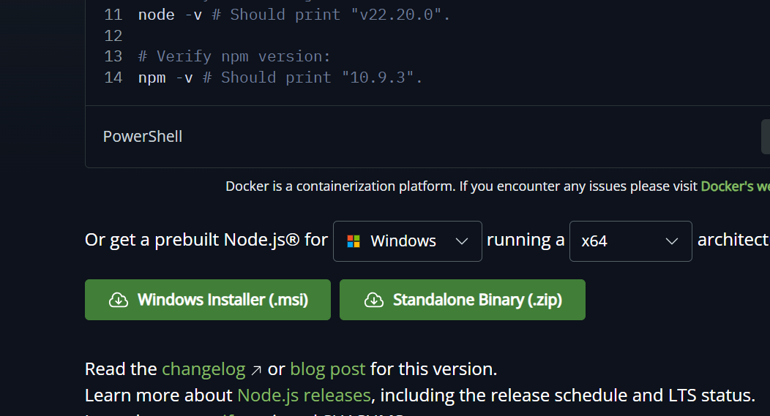
✓ Run the installer and follow the prompts to install Node.js.
2. Check if node and npm are installed
✓ Open a terminal or command prompt.
✓ To check Node.js installation, run in CMD or BASH:
node –v
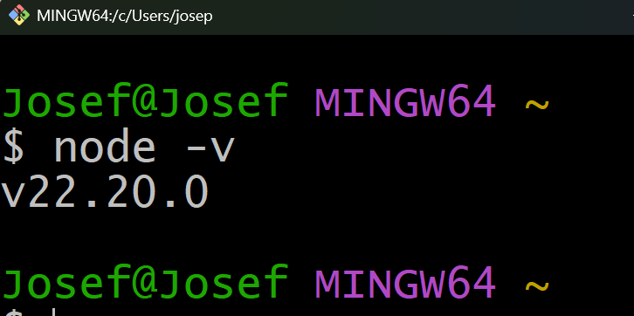
This command should output the version of Node.js installed.
✓ To check npm installation, run:
npm –v
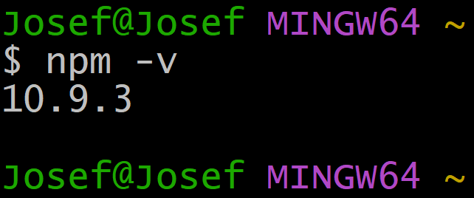
This command should output the version of npm installed.
3. Make a directory
✓ Open your terminal or command prompt.
✓ Navigate to the directory where you want to create your project, for example:
D: then press Enter will move you to local disk D of your computer
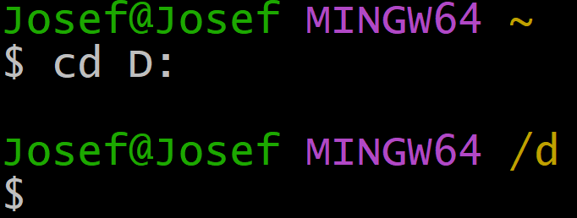
Or Use this in CMD

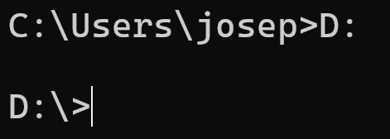
✓ Create a new directory (replace project-name with your desired project name):
mkdir project-name
Example: Let us create a project called StudentRegistartion
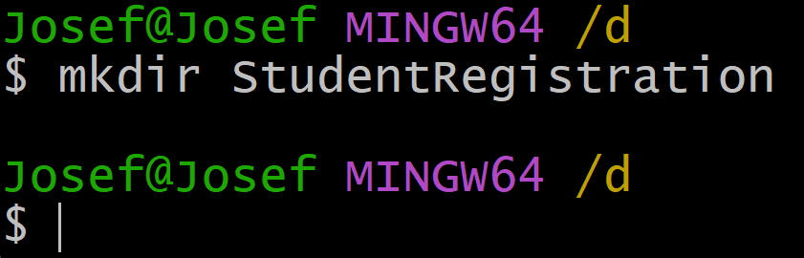
4. Navigate to created directory
After creating the directory, navigate into it:
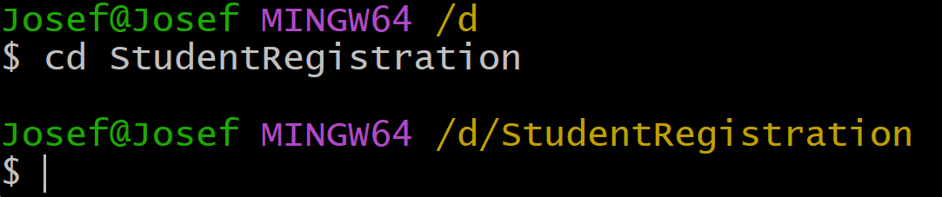
Or Use CMD and this is what you will get
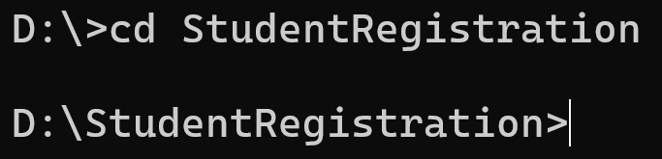
5. Initialise npm
Once inside your project directory, initialize npm (Node Package Manager) by using npm init or npm init –y which creates a package. json file:
npm init is interactive and allows customization, while npm init -y is noninteractive and uses default values to quickly create a package. json file.
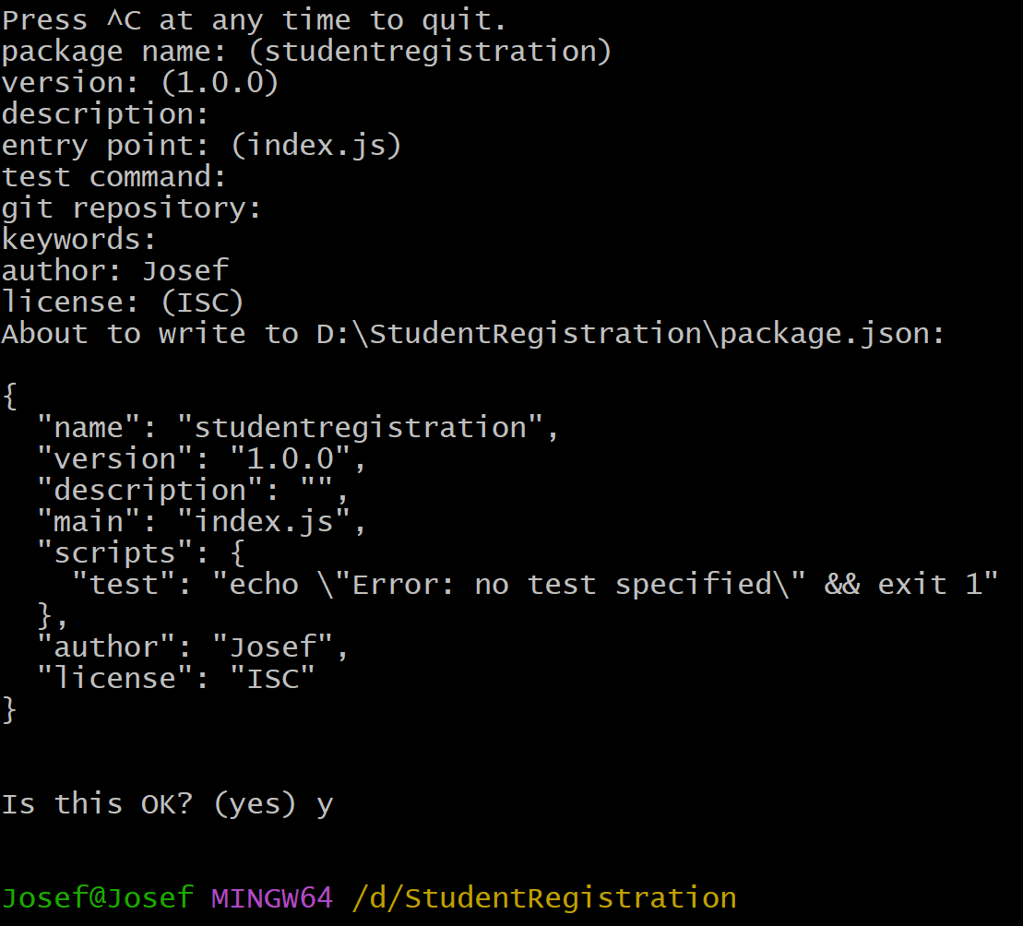
6. Install express and Nodemon
Install Express (a web framework for Node.js) and Nodemon (a utility that monitors for changes in your source code and restarts your server):
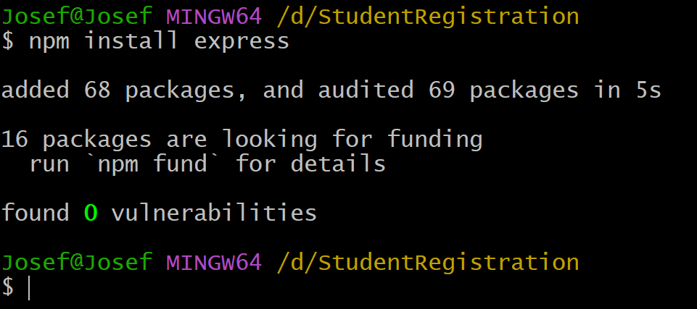
For installing nodemon replace the code by npm install nodemon
NB: You can install all necessary packages at the same time by writing them in single line of code
Ex: npm install express nodemon mysql2
For that case it will insatall express, nodemon and mysql2.
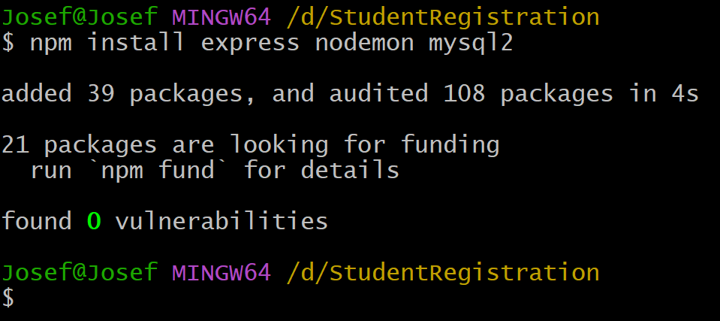
Once you install express js in your project folder it come up with a new folder called node_modules.
7. Open the created project in vs code.
Open Visual Studio Code (ensure it's installed on your system). Navigate to your project directory in VS Code.
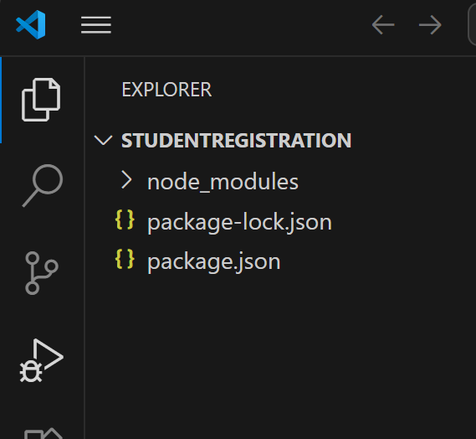

1.1.3: Installation and configuration of Postman
To install and configure postman you follow the following steps:
1. Download the Installer from official website or use it installer file on external device
Go to the official Postman website (https://www.postman.com/downloads/)
and download the installer suitable for your operating system (Windows, macOS, Linux).
2. Run the Installer
Once the download is complete, run the installer file. Follow the installation prompts to complete the installation process.
3. Launch Postman
After installation, launch Postman from your desktop or applications folder.
4. Configure the basic settings like user account (Email, Username and password) or sign up using google or sign in with SSO(Single Sign On).
✓ Upon launching Postman for the first time, you'll be prompted to sign in or sign up.
✓ If you have an existing Postman account, enter your email and password to sign in.
✓ If you don't have an account, you can sign up using your email address or sign in with Google or a Single Sign-On (SSO) provider.
✓ Follow the on-screen instructions to complete the sign-up or sign-in process.
✓ Once signed in, you can configure basic settings such as default environments, workspace preferences, and more from the Postman interface.
✓ Postman is now installed and configured. You can start using it to create, test, and manage APIs.

1.1.4: Configuration of MySQL Server
To configure MySQL Server on Windows, follow these steps:
- Download and install mysql from dev.mysql.com
- After the installation, the MySQL Installer will prompt you to configure the MySQL Server. Click "Next" to begin the configuration.
- Choose the appropriate configuration type. "Standalone MySQL Server" is suitable for most users.
- Set up the server configuration details:
- Config Type: Select "Development Machine", "Server Machine", or "Dedicated Machine" based on your use case
- Connectivity: Choose the port number (default is 3306) and enable TCP/IP networking.
- Authentication: Choose the authentication method (MySQL 8.0's strong password encryption is recommended).
- Windows Service: Configure MySQL Server to run as a Windows service. You can also choose to start the server at system start up.
5. Apply configuration: Click "Next" to review the configuration settings, and then click "Execute" to apply the configuration
6. Complete installation: Once the configuration is applied, the installer will show a summary of the completed tasks. Click "Finish" to complete the installation process.
7. Verify installation: Open a Command Prompt window and type mysql -u root -p to log in to the MySQL server using the root account. Enter the root password you set during configuration to access the MySQL shell and verify that the server is running correctly.
Points to Remember
- Node.js is an open-source JavaScript runtime environment that allows developers to execute JavaScript code on the server side. Once you install node js it comes up with it default package manager (NPM) that is used to install necessary packages and dependencies like express js and Nodemon.
- In development of backend application, you have to include concepts of object-oriented programming (OOP) like class, object, methods and properties. And as it deals with server side it must be connected to database such as SQL based or NoSQL based one.
- The backend application must respond to the HTTP methods via routes and once connecting to frontend there is the application of APIs and those ones are tested and documented by using postman.
- Once you want to develop a backend application you follow the following starting steps:
✓ Install node js
✓ Check if node and npm are installed
✓ Make directory as project name
✓ Navigate to created directory
✓ Initialise npm
✓ Install Express and Nodemon
✓ Open the created project in vs code.
● To install and configure Postman you follow the following steps:
✓ Download the Installer from the official website or use it installer file on an external device
✓ Run the Installer
✓ Launch Postman
✓ Configure the basic settings like user account (Email, Username, and
password) or sign-up using Google or sign in with SSO.
● To configure MySQL Server in Windows you follow those steps:
❖ Set up the server configuration details like:
✓ Config Type
✓ Connectivity
✓ Authentication
✓ Accounts and Roles
✓ Windows Service
❖ Apply Configuration
❖ Complete the Installation
❖ Verify Installation

1.2: Connection of Node Js to the ES5 or ES6 server
1.2.1.: Description of client libraries and ES5 or ES6
1. Popular Node.js Client Libraries by Category
The NPM ecosystem provides over a million packages. Here are the most essential libraries categorized by their primary use case:
Category | Library | Key Feature
HTTP Clients | Axios | Promise-based HTTP client for making requests to APIs, works in browser and Node.js.
 | node-fetch | A lightweight library that brings the window.fetch function to Node.js, useful for making HTTP requests
 | SuperAgent | A flexible and straightforward HTTP client for making REST API requests.
Databases | Mongoose | An object data modelling (ODM) library for MongoDB and Node.js, providing schema-based solutions.
 | Sequelize | An Object-Relational Database (ORM) for Node.js that supports multiple SQL dialects, including MySQL, PostgreSQL, and SQLite
 | pg / mysql2 | Pg: A PostgreSQL client for Node.js that allows you to interact with PostgreSQL database.  Mysql2: A MySQL client for Node.js that supports both callbacks and promises.
Authentication | Passport.js | A middleware for authentication in Node.js applications, supporting various strategies like OAuth, JWT, and local login.
 | jsonwebtoken | A library for generating and verifying JSON Web Tokens, commonly used in secure API authentication.
Utilities | Lodash | Modular functions for array, object, and string manipulation.
 | Moment.js | A library for parsing, validating, manipulating, and formatting dates.
 | Underscore.js | Another utility library that provides functional helpers for tasks like manipulating arrays, objects, and functions.
Template Engines | EJS (Embedded JavaScript) | A simple templating language that lets you generate HTML markup with plain JavaScript
 | Pug | A high-performance template engine heavily influenced by Haml and implemented with JavaScript.
Real-time | Socket.io | Enables bi-directional communication
 | (WebSockets) ws | High-speed, simple WebSocket client and server.
File Handling Libraries | Multer | A middleware for handling multipart/form-data, primarily used for uploading files
 | Fs-extra | An extension of the built-in fs module, providing additional methods for file manipulation like copying, moving, and removing directories
Testing | Jest | All-in-one framework with a focus on simplicity.
 | Mocha / Chai | Flexible test framework paired with an assertion library.
Security | Helmet | Secures Express apps by setting various HTTP headers.
 | bcryptjs | Specialized in hashing and salting user passwords.
Haml stands for HTML Abstraction Markup Language.
It is a templating system (or pre-processor) designed to make HTML cleaner, more readable, and faster to write. Instead of using traditional angle brackets (< >) and closing tags (</div>), Haml relies on indentation and CSS-like shorthand to define the structure of a web page.
In standard web browsing, the communication is unidirectional (one-way). The client (your browser) asks for a page, and the server sends it. The server cannot talk to the client unless it is spoken to first.
Bi-directional communication breaks this rule. It allows the client and the server to send data to each other simultaneously and independently over a single, persistent connection.

2. HTTP vs. HTTPS: The Security Layer
The choice between these two protocols determines how data is handled during transit.
- HTTP (Hypertext Transfer Protocol): Transmits data in plain text. It is vulnerable to "man-in-the-middle" attacks because anyone intercepting the traffic can read the contents (passwords, credit cards, etc.).
- HTTPS (HTTP Secure): Encrypts data using SSL/TLS (Secure Sockets Layer/Transport Layer Security). It ensures data integrity and privacy, making it the modern standard for all web traffic.
3. JavaScript Evolution: ES5 vs. ES6
ES6 (ECMAScript 2015) was a major update that modernized JavaScript syntax and added powerful new capabilities.
Feature | ES5 (Old Standard) | ES6+ (Modern Standard)
Variables | var (Function scope) | let and const (Block scope)
Functions | function name() {} | () => {} (Arrow functions)
Strings | Concatenation: 'Hi ' + name | Template Literals: `Hi ${name}`
Modules | CommonJS (require) | import and export statements
Objects | Constructor functions & prototypes | class syntax (Syntactic sugar)
Async Code | Callbacks (leads to "callback hell") | Promises and async/await
Destructuring | Manual assignment from arrays/objects | Unpacking values: const { name } = user;
Parameters | Manual checks for undefined | Default parameters in function signatures
Operators | apply() to spread arrays | Spread/Rest operator (...)
Note on Utilities: While Moment.js is listed above, it is now considered a legacy project. For new projects, developers often prefer lighter alternatives like date-fns or Day.js.

1.2.2: Creation of basic server with Express Js
Creating a basic server with Express.js involves a few straightforward steps. Express.js is a minimal and flexible Node.js web application framework that provides robust features for building web and mobile applications.
Steps to Create a Basic Server with Express.js
1. Install Node.js and NPM
Make sure you have Node.js installed on your machine. NPM (Node Package Manager) is included with Node.js. You can check if Node.js and NPM are installed by running:
node -v
npm -v
2. Initialize a New Node.js Project
Create a new directory for your project and initialize a new Node.js project.
mkdir my-express-app
cd my-express-app
npm init –y or npm init
This will create a package.json file with default settings.
The commands `npm init -y` and `npm init` are both used to create a `package.json` file for a Node.js project, but they differ in how they handle the initialization process.
npm init
• When you run `npm init`, it starts an interactive process that prompts you to answer several questions about your project. These questions include the package name, version, description, entry point, test command, repository, keywords, author, and license.
• You could customize the `package.json` file according to your preferences.
npm init -y
• The `-y` flag (or `--yes`) automatically answers "yes" to all the prompts, creating a `package.json` file with default values.
• This is useful when you want to quickly set up a project without going through the interactive prompts, especially if you are okay with the default settings.
NB:
• Use `npm init` when you want to customize the `package.json` file and provide specific details about your project.
• Use `npm init -y` when you want to quickly create a `package.json` file with default values without any prompts.
3. Install Express.js
Install Express.js using NPM. npm install express --save
4. Create the Server File
Create a new file called index.js or app.js in your project directory.
5. Write Basic Express.js Server Code
Open the index.js file and write the following code to create a basic server.
// Import Express
const express = require('express');
// Initialize Express
const app = express();
// Define a Port
const port = 3000;
// Create a Basic Route
app.get ('/', (req, res) => {
res. sends ('Hello, World!'); });
// Start the Server
app. listen (port, () => {
console.log (`Server is running on http://localhost:${port}`);
});
6. Run the Server
To start the server, run the following command in your terminal:
node index.js
The server will start, and you’ll see the message: Server is running on http://localhost:3000.
7. Test the Server
Open your browser and go to http://localhost:3000. You should see the message Hello, World!
Explanation of the Code
const express = require ('express');: Imports the Express module.
const app = express ();: Creates an instance of Express.
const port = 3000; Defines the port number the server will listen to.
app.get ('/', (req, res) => { ... });: Sets up a route to handle GET requests to the root URL (/). When someone visits this URL, the server responds with "Hello, World!".
app. listen(port, () => { ... });: Starts the server and listens on the defined port. The callback function runs once the server starts, logging a message to the console. Adding More Routes (Optional)
You can add more routes to handle different requests:
// About Route
app.get ('/about', (req, res) => {
res. sends ('This is the About page.');
});
// Contact Route
app.get ('/contact', (req, res) => {
res. sends ('This is the Contact page.');
});
Middleware and Static Files
You can also use middleware to serve static files or handle specific routes.
// Serve Static Files from the 'public' Directory
app.use(express. static('public'));
// Middleware Example
app.use ((req, res, next) => {
console.log ('A new request received at ' + Date.now());
next ();
});
1.2.3: Application of Client Libraries
1. HTTP and HTTPS Modules
Node.js has built-in `http` and `https` modules that allow you to make HTTP and HTTPS requests without needing to install any additional libraries.
Example using `http`:
const http = require('http');
http.get ('http://example.com', (resp) => {
let data = '';
// A chunk of data has been received.
resp. on('data', (chunk) => {
data += chunk; });
// The whole response has been received.
resp. on ('end', () => {
console.log(data); });
}).on("error", (err) => {
console.log("Error: " + err.message);
});
Example using `https`:
const https = require('https');
https.get('https://example.com', (resp) => {
let data = '';
resp.on('data', (chunk) => {
data += chunk;
});
resp.on('end', () => {
console.log(data);
});
}).on("error", (err) => {
console.log("Error: " + err.message);
});
2. Axios
Axios is a popular promise-based HTTP client for the browser and Node.js. It provides an easy-to-use API for making requests.
Example using Axios:
First, you need to install Axios if you haven't already: npm install axios
Then, you can use it in your `server.js`:
const axios = require('axios');
axios.get('https://example.com')
then (response => {
console.log(response.data);
})
catch (error => {
console. error ('Error:', error);
});
3. Request
The Request library was once a popular choice for making HTTP requests, but it has been deprecated. However, if you're working on a legacy project that still uses it, here's how you can implement it.
Example using Request:
First, install the Request library: npm install request
Then, you can use it in your `server.js`:
const request = require('request');
request ('https://example.com', (error, response, body) => {
if (! error && response. statusCode == 200) {
console.log(body); // Print the response body
} else {
console. error('Error:', error);
}
});
1.2.4: Establishment and Test of server connection
Establishing and testing a server connection in a Node.js application involves several steps.
Below, is general approach to set up a simple server and test the connection using the libraries we discussed in key readings 1.2.3.
Steps to Establish and Test a Server Connection
Step 1: Set Up Your Node.js Environment
1. Install Node.js: Ensure you have Node.js installed on your machine. You can download it from [nodejs.org](https://nodejs.org/).
2. Create a New Project
mkdir my-server-project
cd my-server-project
npm init -y
Step 2: Create a Simple Server
1. Create a `server.js` file
Create a new file named `server.js` in your project directory.
2. Set Up the Server
Use the built-in `http` module to create a simple server.
// server.js
const http = require('http');
const hostname = '127.0.0.1'; // Localhost
const port = 3000; // Port number
const server = http. createServer ((req, res) => {
res. statusCode = 200; // HTTP status code
res. setHeader ('Content-Type', 'text/plain');
res.end ('Hello, World! \n'); // Response message
});
server. listen (port, hostname, () => {
console.log (`Server running at http://${hostname}:${port}/`);
});
Step 3: Run the Server
1. Start the Server
In your terminal, run the following command: node server.js
You should see a message indicating that the server is running.
Step 4: Test the Server Connection
You can test the server connection using various methods:
1. Using a Web Browser
Open your web browser and navigate to `http://127.0.0.1:3000`. You should see the message "Hello, World!".
2. Using CURL
If you have CURL installed; you can test the connection from the command line:
curl http://127.0.0.1:3000
This should return "Hello, World!".
3. Using Postman
If you prefer a GUI tool, you can use Postman to send a GET request to `http://127.0.0.1:3000` and see the response.
4. Using Axios
You can also create another script to test the server using Axios. Create a file named `test.js`:
// test.js
const axios = require('axios');
axios.get('http://127.0.0.1:3000')
then (response => {console.log ('Response from server:', response.data);
})
catch (error => {
console. error ('Error:', error);
});
Run this script in your terminal:
node test.js
Step 5: Handle Errors and Debugging
If you encounter issues:
Check the terminal for any error messages.
Ensure the server is running and listening on the correct port.
Verify that you are using the correct URL when testing the connection.
Point to Remember
● Node.js has a vast ecosystem of client libraries available through NPM (Node Package Manager). These libraries cover a wide range of functionalities, from HTTP requests to database access, and even utility functions. The number of libraries is enormous, with over a million packages available on NPM, and new ones being added regularly.
● Creating a basic server with Express.js involves different steps.
Here are steps to Create a Basic Server with Express.js
❖ Install Node.js and NPM
❖ Initialize a New Node.js Project
❖ Install Express.js
❖ Create the Server File
❖ Write Basic Express.js Server Code
❖ Run the Server
❖ Test the Server
● There are different libraries in express js but as developer you have to apply them
depending on the project structure. Here are the basic ones
✓ Use the built-in `http` and `https` modules for basic requests.
✓ Use Axios for a more modern and flexible approach to making HTTP requests.
✓ The Request library is deprecated, but you may encounter it in older projects.
● While establishing and testing the server you must follow those steps.
1. Set up your Node.js environment and create a new project.
2. Create a simple server using the built-in `http` module.
3. Run the server and test the connection using a browser, CURL, Postman, or Axios.
4. Handle any errors and debug as necessary.
1.3: Establishment of Database Connection
1.3.1: Establishment of database connection
Below are the steps to establish a database connection in Node.js including:
✓ creating a database
✓ setting up a schema
✓ configuring the database connection
✓ and testing the connection.
We'll use MySQL as an example database, but the concepts can be adapted to other databases like PostgreSQL or MongoDB.
Step 1: Install Required Packages
First, you need to install the MySQL package for Node.js. You can use `mysql2` or `mysql` package. Here, we will use `mysql2`.
npm install mysql2
Step 2: Create Database
You can create a database using a MySQL client or through a script. Here’s how to do it in a script:
CREATE DATABASE my_database; //change the database name as you need. You can run this command in a MySQL client or include it in your Node.js script.
Step 3: Schema Setup
You can set up a schema (i.e., create tables) using SQL commands.
For example:
CREATE TABLE users (
id INT AUTO_INCREMENT PRIMARY KEY,
name VARCHAR (100) NOT NULL,
email VARCHAR (100) UNIQUE NOT NULL );
For that case we have created a database called users with three fields id, name and email.
Step 4: Configure Database Connection
Create a file named `db.js` to handle the database connection.
Here’s how you can configure it:
const mysql = require('mysql2');
// Create a connection to the database
const connection = mysql. createConnection ({
host: 'localhost',
user: 'your_username’, // replace with your MySQL username
password: 'your_password’, // replace with your MySQL password
database: 'my_database' // replace with your database name });
// Connect to the database
connection. connect((err) => {
if (err) {
console. error ('Error connecting to the database:', err. stack); return;
}
console.log ('Connected to the database as ID', connection.threadId);
});
module. exports = connection;
Step 5: Test Database Connection
You can test the database connection by creating a simple script. Create a file named `testConnection.js`:
const connection = require('./db');
// Test the connection
connection. query ('SELECT 1 + 1 AS solution', (err, results) => {
if (err) {
console. error ('Error executing query:', err);
return;
}
console.log ('The solution is:', results[0].solution);
});
// Close the connection
connection.end ();
Step 6: Run the Test Script
In your terminal, run the following command to execute the test script:
node testConnection.js
If everything is set up correctly, you should see output indicating that you are connected to the database, and the solution to the query (which should be `2`).
Points to Remember
● In Establishment of database connection, you must follow those steps:
1. Install MySQL package: Use `npm install mysql2`.
2. Create a database: Use SQL commands in a MySQL client.
3. Set up a schema: Create tables using SQL commands.
4. Configure database connection: Use `mysql2` to set up a connection in a Node.js
file.
5. Test the connection: Run a simple query to ensure the connection works.
1.4: Develop endpoints and HTTP Methods
Defining endpoints and HTTP methods using Express.js in Node.js. you follow different steps.
We'll create a simple RESTful API to manage a list of items.
Step 1: Set Up Your Express Server
First, ensure you have Express installed in your project.
Then, create a file named `server.js` and set up a basic Express server:
const express = require('express');
const app = express ();
const PORT = 3000;
// Middleware to parse JSON bodies
app.use(express. json());
// Sample in-memory data store
let items = [];
// Start the server
app. listen (PORT, () => {
console.log (`Server is running on http://localhost:${PORT}`);
});
Step 2: Define Endpoints
Now, let's define the endpoints for the various HTTP methods.
1. Create POST Endpoint
This endpoint will allow you to create a new item.
// Create POST endpoint
app.post ('/items', (req, res) => {
const newItem = {
id: items.length + 1,
name: req.body.name, };
items. push(newItem);
res. status(201).json(newItem); // Respond with the created item
});
2. Create All Items GET Endpoint
This endpoint retrieves all items.
// Create GET endpoint for all items
app.get ('/items', (req, res) => {
res. json(items); // Respond with the list of items
});
3. Create Specific ID GET Endpoint
This endpoint retrieves a specific item by its ID.
// Create GET endpoint for a specific item by ID
app.get ('/items/:id', (req, res) => {
const itemId = parseInt (req.params.id, 10);
const item = items. find (i => i.id === itemId);
if (! item) {
return res. status (404). json({ message: 'Item not found' });
}
res. json(item); // Respond with the found item
});
4. Create PUT Endpoint
This endpoint updates an existing item by its ID.
// Create PUT endpoint for updating an item
app.put ('/items/:id', (req, res) => {
const itemId = parseInt (req.params.id, 10);
const item = items.find(i => i.id === itemId);
if (!item) {
return res.status(404).json({ message: 'Item not found' });
}
// Update the item
item.name = req.body.name;
res.json(item); // Respond with the updated item
});
5. Create DELETE Endpoint
This endpoint deletes an item by its ID.
// Create DELETE endpoint for removing an item
app. delete ('/items/:id', (req, res) => {
const itemId = parseInt(req.params.id, 10);
const itemIndex = items.findIndex(i => i.id === itemId);
if (itemIndex === -1) {
return res.status(404).json({ message: 'Item not found' });
}
items.splice(itemIndex, 1); // Remove the item from the array
res.status(204).send(); // Respond with no content
});
Full Example
Here’s the complete code for `server.js` with all the endpoints defined:
const express = require('express');
const app = express();
const PORT = 3000;
app.use(express.json());
let items = [];
// Create POST endpoint
app.post('/items', (req, res) => {
const newItem = {
id: items.length + 1,
name: req.body.name,
};
items.push(newItem);
res.status(201).json(newItem);
});
// Create GET endpoint for all items
app.get('/items', (req, res) => {
res.json(items);
});
// Create GET endpoint for a specific item by ID
app.get('/items/:id', (req, res) => {
const itemId = parseInt(req.params.id, 10);
const item = items.find(i => i.id === itemId);
if (!item) {
return res.status(404).json({ message: 'Item not found' });
}
res.json(item);
});
// Create PUT endpoint for updating an item
app.put('/items/:id', (req, res) => {
const itemId = parseInt(req.params.id, 10);
const item = items.find(i => i.id === itemId);
if (!item) {
return res.status(404).json({ message: 'Item not found' });
}
item.name = req.body.name;
res.json(item);
});
// Create DELETE endpoint for removing an item
app.delete('/items/:id', (req, res) => {
const itemId = parseInt(req.params.id, 10);
const itemIndex = items.findIndex(i => i.id === itemId);
if (itemIndex === -1) {
return res.status(404).json({ message: 'Item not found' });
}
items.splice(itemIndex, 1);
res.status(204).send();
});
// Start the server
app.listen(PORT, () => {
console.log(`Server is running on http://localhost:${PORT}`);
});
Step 3: Testing the Endpoints
1.4.2: Testing the Endpoints using Postman
Testing your API endpoints using Postman is a straightforward process.
Here are the steps to follow to test the endpoints you created in your Express.js application:
Step 1: Check if Postman is installed
We have covered that topic in indicative content 1.
Step 2: Start Your Express Server
Before testing, ensure that your Express server is running. Open your terminal and navigate to your project directory, then run:
node server.js
You should see a message indicating that the server is running, e.g., `Server is running on http://localhost:3000`.
Step 3: Open Postman
Launch Postman after installation.
Step 4: Testing the Endpoints
1. Create a New Item (POST)
✓ Select POST from the dropdown menu next to the URL input field.
✓ Enter the URL: `http://localhost:3000/items`.
✓ Go to the Body tab and select raw. Then choose JSON from the dropdown menu.
✓ Enter the JSON data for the new item.
For example:
json {
"name": "Item 1" }
✓ Click the Send button. You should see a response with the created item, including
its ID.
2. Get All Items (GET)
✓ Select GET from the dropdown menu.
✓ Enter the URL: `http://localhost:3000/items`.
✓ Click the Send button. You should see a response with an array of all items.
3. Get a Specific Item (GET)
✓ Select GET from the dropdown menu.
✓ Enter the URL: `http://localhost:3000/items/1` (replace `1` with the ID of the item
you want to retrieve).
✓ Click the Send button. You should see a response with the specific item if it exists.
4. Update an Item (PUT)
✓ Select PUT from the dropdown menu.
✓ Enter the URL: `http://localhost:3000/items/1` (replace `1` with the ID of the item
you want to update).
✓ Go to the Body tab, select raw, and choose JSON.
✓ Enter the new data for the item.
For example:
json {
"name": "Updated Item 1" }
✓ Click the Send button. You should see a response with the updated item.
5. Delete an Item (DELETE)
✓ Select DELETE from the dropdown menu.
✓ Enter the URL: `http://localhost:3000/items/1` (replace `1` with the ID of the item
you want to delete).
✓ Click the Send button. You should receive a response with a status code of `204 No
Content`, indicating that the item was successfully deleted.
Step 5: Check Responses
For each request, check the response section in Postman to see the data returned by your API. You can also view the status codes to ensure that your requests are being handled correctly (e.g., `200 OK`, `201 Created`,`204 No content`, `404 Not Found`, etc.).
You can test these endpoints using tools like Postman
-POST `/items` to create a new item.
-GET `/items` to retrieve all items.
-GET `/items/:id` to retrieve a specific item by ID.
-PUT `/items/:id` to update an existing item.
-DELETE `/items/:id` to delete an item.

1.4.3: Implementation of API endpoints
Implementing API endpoints in Node.js using Express involves several steps, from setting up your environment to writing the code for your endpoints.
Below, is step-by-step guide along with sample code to help implement a simple RESTful API.
Step 1: Set Up Your Environment
1. Create a New Project Directory
2. Initialize a New Node.js Project
3. Install Express
Step 2: Create the Server File
Step 3: Write the Basic Server Code
Basic structure for your `server.js` file:
const express = require('express');
const app = express();
const PORT = 3000;
// Middleware to parse JSON bodies
app.use(express.json());
// Sample in-memory data store
let items = [];
// Start the server
app.listen(PORT, () => {
console.log(`Server is running on http://localhost:${PORT}`);
});
Step 4: Define API Endpoints
Now, let’s add the API endpoints to the `server.js` file.
1. Create a POST Endpoint
This endpoint will allow you to create a new item.
// Create POST endpoint
app.post('/items', (req, res) => {
const newItem = {
id: items.length + 1,
name: req.body.name,
};
items.push(newItem);
res.status(201).json(newItem); // Respond with the created item
});
2. Create a GET Endpoint for All Items
This endpoint retrieves all items.
// Create GET endpoint for all items
app.get('/items', (req, res) => {
res.json(items); // Respond with the list of items
});
3. Create a GET Endpoint for a Specific Item by ID
This endpoint retrieves a specific item by its ID.
// Create GET endpoint for a specific item by ID
app.get('/items/:id', (req, res) => {
const itemId = parseInt(req.params.id, 10);
const item = items.find(i => i.id === itemId);
if (!item) {
return res.status(404).json({ message: 'Item not found' });
}
res.json(item); // Respond with the found item
});
4. Create a PUT Endpoint for Updating an Item
This endpoint updates an existing item by its ID.
// Create PUT endpoint for updating an item
app.put('/items/:id', (req, res) => {
const itemId = parseInt(req.params.id, 10);
const item = items.find(i => i.id === itemId);
if (!item) {
return res.status(404).json({ message: 'Item not found' });
}
// Update the item
item.name = req.body.name;
res.json(item); // Respond with the updated item
});
5. Create a DELETE Endpoint for Removing an Item
This endpoint deletes an item by its ID.
// Create DELETE endpoint for removing an item
app.delete('/items/:id', (req, res) => {
const itemId = parseInt(req.params.id, 10);
const itemIndex = items.findIndex(i => i.id === itemId);

1.4.4: Description of middleware services
1. Middleware services
In Express.js are functions that execute during the request-response cycle. They can modify the request and response objects, end the request-response cycle, and call the next middleware function in the stack.
2. Use of Middleware Services
Middleware functions can be used for various purposes, such as:
-Logging requests: Keeping track of incoming requests.
-Parsing request bodies: Converting incoming request data into a usable format (e.g., JSON).
-Authentication: Verifying if a user is logged in or has the right permissions.
-Error handling: Catching errors and sending appropriate responses.
-Input validation: Ensuring that incoming data meets certain criteria before processing it.
3. Types of Middleware Services
1. Application-Level Middleware: Middleware that is bound to an instance of the app. You can use it to apply middleware to specific routes or globally.
const express = require('express'); const app = express();
app.use(express.json()); // Built-in middleware to parse JSON bodies
2. Router-Level Middleware: Middleware that is bound to an instance of `express.Router()`. It can be used to group routes and apply middleware to those routes.
const router = express.Router();
router.use(express.json()); // Apply middleware to all routes in this router
3. Error-Handling Middleware:
Middleware specifically designed to catch and handle errors. It has four parameters: `err`, `req`, `res`, `next`.
app.use((err, req, res, next) => {
console.error(err.stack);
res.status(500).send('Something broke!'); });
4. Built-in Middleware: Express comes with built-in middleware functions like
`express.json()` and `express.urlencoded()`.
5. Third-Party Middleware: Middleware created by the community, such as `morgan` for logging and `cors` for handling Cross-Origin Resource Sharing.
6. Logging middleware is essential for tracking requests and debugging issues in your application. It helps you monitor incoming requests, the status of responses, and any errors that occur.
7. Input Validation
Input validation middleware is crucial for ensuring that incoming data is in the expected format before it’s processed by your application. This helps prevent errors and potential security vulnerabilities.
NB: These middleware services can be used together to create robust and secure applications.
Example Workflow:
- Logging Middleware records the details of the incoming request.
- Input Validation Middleware checks the data in the request and ensures it meets the necessary requirements.
- If an error occurs (e.g., due to invalid input or server issues), Error
- Handling Middleware catches the error and sends an appropriate
1.4.5: Use middleware services
1. Error Handling Middleware
Error handling middleware is used to catch and manage errors that occur during the request-response cycle. It helps ensure that your application can gracefully handle unexpected situations without crashing.
Define an error-handling middleware function at the end of your middleware stack.
It should have four parameters: `err`, `req`, `res`, and `next`.
Example
const express = require('express');
const app = express();
const PORT = 3000;
// Sample route
app.get('/', (req, res) => {
throw new Error('Something went wrong!'); // Simulate an error
});
// Error handling middleware
app.use((err, req, res, next) => {
console.error(err.stack); // Log the error stack
res.status(500).json({ message: 'Internal Server Error' }); // Send a response with a 500 status
});
app.listen(PORT, () => {
console.log(`Server is running on http://localhost:${PORT}`);
});
2. Logging Middleware
Purpose: Logging middleware records information about each incoming request, such as the HTTP method, URL, status code, response time, and more. This helps in monitoring and debugging applications.
Implementation:
• Logging middleware can log data to the console or save it to a file or external logging service.
• Libraries like morgan are commonly used for logging HTTP requests in Node.js applications.
Example using morgan:
const morgan = require('morgan');
app.use(morgan('combined')); // Logs requests in Apache combined format
• Custom logging middleware can also be created to log specific information.
app.use((req, res, next) => {
console.log(`${req.method} ${req.url}`); next();
});
3. Input Validation Middleware
Purpose: Input validation middleware ensures that the data coming into the application (via request bodies, query parameters, or headers) meets the required format, type, and constraints. This is crucial for preventing security vulnerabilities like SQL injection and ensuring data integrity.
Implementation:
• Libraries like express-validator provide tools to validate and sanitize user inputs easily.
• Input validation can be done by defining rules and running them against the incoming data before passing it to the next middleware or route handler.
Example using express-validator:
const { body, validationResult } = require('express-validator');
app.post('/register', [
body('email').isEmail().withMessage('Enter a valid email'),
body('password').isLength({ min: 5 }).withMessage('Password must be at least 5 characters long')
], (req, res, next) => {
const errors = validationResult(req);
if (!errors.isEmpty()) {
return res.status(400).json({ errors: errors.array() });
}
next();
});
• Custom validation middleware can be written to handle specific validation logic.

1.4.6: Perform CRUD operations using MySQL Database
• To perform CRUD operation in node js you must follow the following steps
1. Setup Your Node.js Environment
Install Node.js: Make sure Node.js is installed on your machine
2. Initialize a Node.js Project
mkdir manualdevdb-project
cd manualdevdb-project
npm init -y
3. Install Required Packages
mysql2, express
npm install express mysql2
4. Create a MySQL Connection
Create a db.js file to establish a connection to your MySQL database. // db.js
const mysql = require('mysql2');
const connection = mysql.createConnection({
host: 'localhost',
user: 'your_mysql_username',
password: 'your_mysql_password',
database: 'manualdevdb'
});
connection.connect((err) => { if (err) {
console.error('Error connecting to the database:', err.stack);
return;
}
console.log('Connected to the MySQL database.'); });
module.exports = connection;
5. Set Up Express Server
Create an index.js file to set up an Express server and define CRUD routes.
// index.js
const express = require('express');
const connection = require('./db');
const app = express();
app.use(express.json()); // To parse JSON bodies
const PORT = process.env.PORT || 3000;
// 1. CREATE: Add a new developer
app.post('/developers', (req, res) => {
const { Names, sex, phone, district, school, trade, module, Degree, accountnumber } = req.body;
const sql = 'INSERT INTO developers (Names, sex, phone, district, school, trade, module, Degree, accountnumber) VALUES (?, ?, ?, ?, ?, ?, ?, ?, ?)';
connection.query(sql, [Names, sex, phone, district, school, trade, module, Degree, accountnumber], (err, results) => {
if (err) {
return res.status(500).send(err);
}
res.status(201).send('Developer added successfully!');
});
});
// 2. READ: Get all developers
app.get('/developers', (req, res) => {
const sql = 'SELECT * FROM developers';
connection.query(sql, (err, results) => { if (err) {
return res.status(500).send(err);
} res.status(200).json(results);
});
});
// 3. READ: Get a developer by ID
app.get('/developers/:id', (req, res) => {
const { id } = req.params;
const sql = 'SELECT * FROM developers WHERE id = ?';
connection.query(sql, [id], (err, results) => {
if (err) {
return res.status(500).send(err);
}
res.status(200).json(results[0]);
});
});
// 4. UPDATE: Update a developer by ID
app.put('/developers/:id', (req, res) => {
const { id } = req.params;
const { Names, sex, phone, district, school, trade, module, Degree, accountnumber } = req.body;
const sql = 'UPDATE developers SET Names = ?, sex = ?, phone = ?, district = ?, school = ?, trade = ?, module = ?, Degree = ?, accountnumber = ? WHERE id = ?';
connection.query(sql, [Names, sex, phone, district, school, trade, module, Degree, accountnumber, id], (err, results) => {
if (err) {
return res.status(500).send(err); }
res.status(200).send('Developer updated successfully!'); });
});
// 5. DELETE: Delete a developer by ID
app.delete('/developers/:id', (req, res) => {
const { id } = req.params;
const sql = 'DELETE FROM developers WHERE id = ?'; connection.query(sql, [id], (err, results) => {
if (err) {
return res.status(500).send(err);
}
res.status(200).send('Developer deleted successfully!');
});
});
// Start the server
app.listen(PORT, () => {
console.log(`Server is running on port ${PORT}`);
});
6. Run Your Application
Start your Node.js application: node index.js
7.Test the CRUD operations using tools like Postman. Sample CRUD Requests
Create (POST):
Endpoint: http://localhost:3000/developers
Body (JSON): {
"Names": "John Peace", "sex": "Male", "phone": "1234567890", "district": "Kigali", "school": "BTICTHUB", "trade": "Software Development", "module": "Module 1", "Degree": "Bachelor", "accountnumber": "123456789" }
Read All (GET):
Endpoint: http://localhost:3000/developers
Read by ID (GET):
Endpoint: http://localhost:3000/developers/1
Update (PUT):
Endpoint: http://localhost:3000/developers/1 Body (JSON):
{
"Names": "Jane Peace", "sex": "Female", "phone": "0987654321", "district": "Kigali", "school": "BTICTHUB", "trade": "Web Development", "module": "Module 2", "Degree": "Masters", "accountnumber": "987654321" }
Delete (DELETE):
Endpoint: http://localhost:3000/developers/1

1.4.7: Use HTTP Status code
To implement proper HTTP status codes in the CRUD operations using Node.js and MySQL, you should modify the response handling in each route.
Here's how you can implement it: Updated index.js with HTTP Status Codes Example containing sample codes
// index.js
const express = require('express');
const connection = require('./db');
const app = express();
app.use(express.json()); // To parse JSON bodies
const PORT = process.env.PORT || 3000;
// 1. CREATE: Add a new developer
app.post('/developers', (req, res) => {
const { Names, sex, phone, district, school, trade, module, Degree, accountnumber } = req.body;
const sql = 'INSERT INTO developers (Names, sex, phone, district, school, trade, module, Degree, accountnumber) VALUES (?, ?, ?, ?, ?, ?, ?, ?, ?)';
connection.query(sql, [Names, sex, phone, district, school, trade, module, Degree, accountnumber], (err, results) => {
if (err) {
return res.status(500).json({ error: 'Failed to add developer', details: err });
}
res.status(201).json({ message: 'Developer added successfully!', developerId: results.insertId });
}); });
// 2. READ: Get all developers
app.get('/developers', (req, res) => { const sql = 'SELECT * FROM developers'; connection.query(sql, (err, results) => { if (err) {
return res.status(500).json({ error: 'Failed to retrieve developers', details: err }); }
res.status(200).json(results);
}); });
// 3. READ: Get a developer by ID
app.get('/developers/:id', (req, res) => { const { id } = req.params;
const sql = 'SELECT * FROM developers WHERE id = ?';
connection.query(sql, [id], (err, results) => { if (err) {
return res.status(500).json({ error: 'Failed to retrieve developer', details: err }); }
if (results.length === 0) {
return res.status(404).json({ error: 'Developer not found' });
} res.status(200).json(results[0]); });
});
// 4. UPDATE: Update a developer by ID
app.put('/developers/:id', (req, res) => { const { id } = req.params;
const { Names, sex, phone, district, school, trade, module, Degree, accountnumber } = req.body;
const sql = 'UPDATE developers SET Names = ?, sex = ?, phone = ?, district = ?, school = ?, trade = ?, module = ?, Degree = ?, accountnumber = ? WHERE id = ?';
connection.query(sql, [Names, sex, phone, district, school, trade, module, Degree, accountnumber, id], (err, results) => {
if (err) {
return res.status(500).json({ error: 'Failed to update developer', details: err }); }
if (results.affectedRows === 0) {
return res.status(404).json({ error: 'Developer not found' }); }
res.status(200).json({ message: 'Developer updated successfully!' });
}); });
// 5. DELETE: Delete a developer by ID
app.delete('/developers/:id', (req, res) => { const { id } = req.params;
const sql = 'DELETE FROM developers WHERE id = ?'; connection.query(sql, [id], (err, results) => {
if (err) {
return res.status(500).json({ error: 'Failed to delete developer', details: err });
}
if (results.affectedRows === 0) {
return res.status(404).json({ error: 'Developer not found' }); }
res.status(200).json({ message: 'Developer deleted successfully!' }); });
});
// Start the server
app.listen(PORT, () => {
console.log(`Server is running on port ${PORT}`); });
✓ Explanation of HTTP Status Codes
- 201 Created: Used when a new resource (developer) is successfully created.
- 200 OK: Used for successful requests that return data or indicate successful updates/deletions.
- 404 Not Found: Used when a requested resource (developer by ID) does not exist in the database.
- 500 Internal Server Error: Used when there is a server-side error, such as a database query failing.
How the Responses Work
- Create Developer (POST /developers): Returns 201 Created if successful, along with the new developer's ID. If there's a server error, it returns 500 Internal Server Error.
- Read All Developers (GET /developers): Returns 200 OK with the list of developers if successful. If there's a server error, it returns 500 Internal Server Error.
- Read Developer by ID (GET /developers/:id): Returns 200 OK with the developer's details if found, 404 Not Found if the developer doesn't exist, and 500 Internal Server Error if there's a server error.
- Update Developer (PUT /developers/:id): Returns 200 OK if successful, 404 Not Found if the developer doesn't exist, and 500 Internal Server Error if there's a server error.
- Delete Developer (DELETE /developers/:id): Returns 200 OK if successful, 404 Not Found if the developer doesn't exist, and 500 Internal Server Error if there's a server error.
1.4.8: Debugging RESTFUL APIs
Debugging a RESTful API can be an essential part of development, ensuring that your API behaves as expected.
Steps to Debug a RESTful API
Step 1: Set Up Your Development Environment
1. Use a Reliable Code Editor: Choose an editor like Visual Studio Code, which
has excellent support for JavaScript and Node.js.
2. Install Debugging Tools: Make sure you have Node.js installed and consider
using tools like Postman or cURL for testing API endpoints.
Step 2: Implement Logging
1. Add Logging to Your API: Use `console.log()` statements or a logging library
like `winston` or `morgan` to log requests, responses, and errors.
const express = require('express');
const morgan = require('morgan');
const app = express();
app.use(morgan('dev')); // Logs HTTP requests
app.get('/api/example', (req, res) => {
console.log('Received request for /api/example');
res.json({ message: 'Hello, World!' }); });
2. Log Errors: Make sure to log errors with sufficient detail, including stack traces
if necessary.
app.use((err, req, res, next) => {
console.error(err.stack);
res.status(500).send('Something broke!'); });
Step 3: Use a Debugger
1. Node.js Debugger: You can use the built-in Node.js debugger. Start your server with the `inspect` flag:
node inspect server.js
Then, you can connect to it using Chrome DevTools or Visual Studio Code.
2. Set Breakpoints: In your code editor, set breakpoints in your API routes to inspect variable states and flow.
Step 4: Test API Endpoints
1. Use Postman or cURL: Send requests to your API endpoints and inspect the responses. Look for:
- Status codes (e.g., 200, 404, 500)
- Response body
- Headers
2. Check Request Payloads: Ensure that the data you send in requests (for POST or PUT) is correctly formatted.
Step 5: Validate Input Data
1. Input Validation: Ensure that your API validates incoming data. Use libraries like `Joi` or `express-validator` to validate request bodies.
const { body, validationResult } = require('express-validator');
app.post('/api/data', [
body('name').isString().notEmpty(),
], (req, res) => {
const errors = validationResult(req);
if (!errors.isEmpty()) {
return res.status(400).json({ errors: errors.array() }); }
// Handle valid data
});
Step 6: Monitor Network Traffic
1. Browser Developer Tools: If your API is called from a web application, use the Network tab in your browser's developer tools to inspect requests and responses.
2. Check for CORS Issues: If your API is accessed from a different origin, watch for Cross-Origin Resource Sharing (CORS) issues in the browser console.
Step 7: Review API Documentation
1. Check API Specifications: Ensure that your API endpoints, methods, and expected request/response formats match your documentation (e.g., OpenAPI/Swagger).
2. Update Documentation: Keep your API documentation up to date as you make changes.
Step 8: Use Automated Testing
1. Write Unit Tests: Use testing frameworks like Mocha, Chai, or Jest to write unit tests for your API endpoints.
2. Integration Tests: Test the interaction between different parts of your application to ensure they work together correctly.
const request = require('supertest');
const app = require('./server');
describe('GET /api/example', () => {
it('should return Hello, World!', (done) => {
request(app)
get('/api/example')
.expect('Content-Type', /json/)
expect(200, { message: 'Hello, World!' }, done); });
});
Step 9: Analyse Performance
1. Use Profiling Tools: Monitor the performance of your API using tools like New Relic, Datadog, or built-in Node.js profiling tools.
2. Identify Bottlenecks: Look for slow responses or excessive resource usage and optimize your code accordingly.
Point to remember
Defining endpoints and HTTP methods using Express.js in Node.js. you follow different steps.
Step 1: Set Up Your Express Server
Step 2: Define Endpoints
Step3: Testing the Endpoints
● Using Postman, you can easily test all the endpoints of your Express.js application by performing the following actions:
1. Open Postman
2. Select the HTTP method (GET, POST, PUT, DELETE).
3. Enter the appropriate URL.
4. Provide any necessary request body in JSON format.
5. Click Send and observe the response.
● Implementing API endpoints in Node.js using Express involves several steps, from setting up your environment to writing the code for your endpoints.
● Middleware services in Express.js are functions that execute during the request response cycle. They can modify the request and response objects, end the request-response cycle, and call the next middleware function in the stack.
● In node js we have different types of middleware services but that are used depending on the application to be developed, among them we can use the followings:
Logging Middleware records the details of the incoming request.
Input Validation Middleware checks the data in the request and ensures it meets the necessary requirements.
If an error occurs (e.g., due to invalid input or server issues), Error Handling Middleware catches the error and sends an appropriate response to the client.
● To perform CRUD operation in node js you have to follow the following steps
✓ Setup Your Node.js Environment
✓ Initialize a Node.js Project
✓ Install Required Packages:
✓ Create a MySQL Connection
✓ Set Up Express Server that contains all operations included in CRUD (Create, Read, Update and Delete as endpoints)
✓ Run Your Application
✓ Test the CRUD operations using tools like Postman.
● HTTP Status Codes can be classified as the followings:
✓ 201 Created: Used when a new resource (developer) is successfully created.
✓ 200 OK: Used for successful requests that return data or indicate successful updates/deletions.
✓ 404 Not Found: Used when a requested resource (developer by ID) does not exist in the database.
✓ 500 Internal Server Error: Used when there is a server-side error, such as a database query failing.
● Debugging a RESTful API can be an essential part of development, ensuring that
your API behaves as expected. Here’s a step-by-step guide to help you debug a
RESTful API effectively:
1. Set up your development environment and implement logging.
2. Use a debugger to set breakpoints and inspect your code.
3. Test API endpoints with tools like Postman.
4. Validate input data and monitor network traffic for issues.
5. Review and update your API documentation.
6. Write automated tests for your API endpoints.
7. Analyse performance to identify bottlenecks.

Learning Outcome 2: Secure Backend Application
2.1: Data Encryption in Securing RESTFUL APIs

