**What are Channels and Kernels (according to EVA)?**

**Channels :**

* Channel is the collection of one or a similar feature.
* The feature can be an edge, a number or a pattern in the image.

*For Example :* If we consider Alphabets in images there can be 52 different types of characters/patterns [Upper Case + Lower Case] which will form the features for grouping each channel.

**Kernels :**

* The kernel is a feature extractor, also known as filters.
* In image processing, a kernel is a small matrix. It is used for blurring, sharpening, embossing, edge detection, and more.
* Matrix Dot product is done between channels and their kernels, if the value comes out to be higher, the feature is believed to be present in data.
* An interesting mathematical concept is two numbers when multiplied with each other gives maximum value when they are closer to each other and minimum value when farthest from each other when their sum is same. To prove my point (9 x 9 = 81) and (9 + 9 = 18) **Closest** (10 x 8 = 80) and (10 + 8 = 18) (17 x 1 = 17) and (17 +1 = 18) **Farthest**

**Why should we (nearly) always use 3x3 kernels?**

* Less number of filters will be useful to capture the smallest details (such as edge, small change in gradient) into a feature.
* 3x3 is the smallest odd dimension kernel after 1x1
* Lesser filter means less number of computation (3x3 = 9)**.**

**How many times to we need to perform 3x3 convolutions operations to reach close to 1x1 from 199x199 (type each layer output like 199x199 > 197x197...)**

There are total of 100 layers. 3x3 convolution operation will be performed 99 times to reach 1x1 from 199x199 as explained below,

(199 x 199) > (197 x 197) > (195 x 195) > (193 x 193) > (191 x 191) > (189 x 189) > (187 x 187) > (185 x 185) > (183 x 183) > (181 x 181) > (179 x 179) > (177 x 177) > (175 x 175) > (173 x 173) > (171 x 171) > (169 x 169) > (167 x 167) > (165 x 165) > (163 x 163) > (161 x 161) > (159 x 159) > (157 x 157) > (155 x 155) > (153 x 153) > (151 x 151) > (149 x 149) > (147 x 147) > (145 x 145) > (143 x 143) > (141 x 141) > (139 x 139) > (137 x 137) > (135 x 135) > (133 x 133) > (131 x 131) > (129 x 129) > (127 x 127) > (125 x 125) > (123 x 123) > (121 x 121) > (119 x 119) > (117 x 117) > (115 x 115) > (113 x 113) > (111 x 111) > (109 x 109) > (107 x 107) > (105 x 105) > (103 x 103) > (101 x 101) > (99 x 99) > (97 x 97) > (95 x 95) > (93 x 93) > (91 x 91) > (89 x 89) > (87 x 87) > (85 x 85) > (83 x 83) > (81 x 81) > (79 x 79) > (77 x 77) > (75 x 75) > (73 x 73) > (71 x 71) > (69 x 69) > (67 x 67) > (65 x 65) > (63 x 63) > (61 x 61) > (59 x 59) > (57 x 57) > (55 x 55) > (53 x 53) > (51 x 51) > (49 x 49) > (47 x 47) > (45 x 45) > (43 x 43) > (41 x 41) > (39 x 39) > (37 x 37) > (35 x 35) > (33 x 33) > (31 x 31) > (29 x 29) > (27 x 27) > (25 x 25) > (23 x 23) > (21 x 21) > (19 x 19) > (17 x 17) > (15 x 15) > (13 x 13) > (11 x 11) > (9 x 9) > (7 x 7) > (5 x 5) > (3 x 3) > (1 x 1)

**How are kernels initialized?**

Machine learning works on principle **Make mistakes to correct them**,

* A model performs best if every node learns to identify a different feature, and that happens when each filter has a value which is different from the rest.
* In case all the values are initialized to the same value, the model is not diverse enough to learn different features hence fails to generalize the trends in the data
* First step is we have to initialize our kernel with random values, and calculate the error with the actual value
* Then we make small yet significant changes to minimize the error until we our model generalizes to our data.
* Random Initialization of kernels also makes our model diverse enough to learn different features

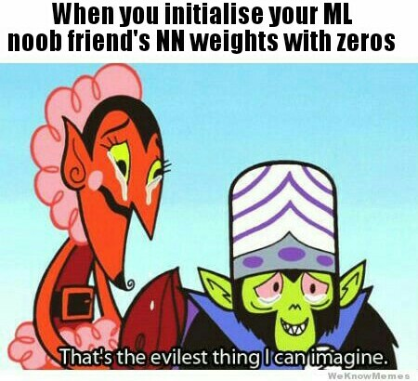

**What happens during the training of a DNN?**

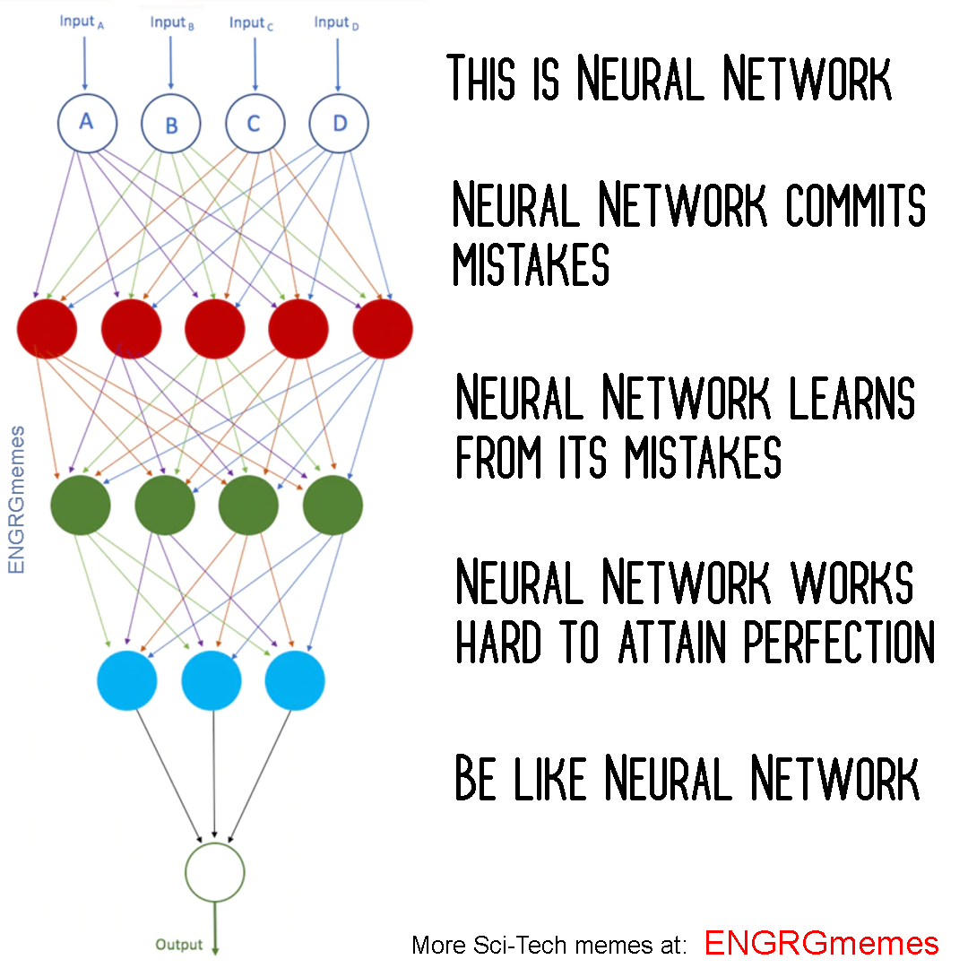

Let’s suppose we are training a DNN for image classification, our goal is to classify these images lets say Cats vs Dogs, we have labelled images as our dataset. Now we work on the above principal, **Make mistakes to correct them**

* First, we need to convert our images into the forms our models can understand i.e. array of numbers.
* So these images are then passed into our model, a neural network architecture is shown above. The nodes in hidden layers are also called channels. Each channel as explained the is expert on a specific task
* Initial layers (red ones) would identify edges, gradients, patters, the deep layers would detect parts of objects (eyelashes, nails, whiskers) (green ones) and objects (Face, legs, torso). Hence the channel looking out for that feature, and it finds it the node gets activated.
* Final layer sums up all the information (activation of previous nodes) collected by the earlier layers and gives a prediction.
* E.g.:
  + (2 eyes, nose, 4 legs, whiskers, pointy ears, mean AF --> Cat)
  + (2 eyes, pointy nose, 4 legs, ears, Loving AF --> Dog)
* When initialized with random values, the nodes are bound to make errors, . But then comes the part where we correct these mistakes.
* The error is then propagated backwards into the model to minimize them in small yet significant steps also known as backprop.