October 29, 2019

Stanford Science Fellows Program

Stanford University・Stanford, California 94305

Dear Selection Committee,

I am writing to apply for a Stanford Science Fellowship. Along with this letter, I have uploaded my curriculum vitae, a career goals statement, and a statement of research problems I will study as a fellow to AcademicJobsOnline.

As a graduate research fellow at the University of Colorado—Boulder, I have led several theoretical studies which have investigated fundamental processes in stellar convection. I have performed two- and three-dimensional simulations of convection in both highly simplified systems and in more complex, fully compressible, stratified atmospheres. I have demonstrated that the nature of turbulent convection in stratified, compressible systems, or rotating systems, is fundamentally similar to more well-studied, simplified setups. I have also developed a tool which can equilibrate convective simulations using ten times fewer cpu-hours than traditional methods. More recently, I have investigated simulations of discrete convective downflows and learned how density stratification affects their propagation. My doctoral studies have employed the *Dedalus* pseudospectral code and were performed in cutting edge, highly resolved (e.g., 2048x3842), and highly turbulent regimes through the use of massively parallel techniques on modern supercomputers like NASA’s *Pleiades*. As I wrap up my graduate studies with Prof. Benjamin Brown (Univ. Colorado), I am working on two collaborative research projects which build on my previous work. First, along with Prof. Daniel Lecoanet (Princeton / Northwestern) and Dr. Lydia Korre (Univ. Colorado), I am extending my studies of individual downflows to learn how deeply downflows travel into convectively stable regions like the one beneath the Sun’s convection zone. Second, I am collaborating with Prof. Geoff Vasil (Univ. Sydney) to show that thermal equilibration in rotating convection can cause convective flows at early simulation times to be in very different dynamical regimes from equilibrated flows.

Stanford University hosts numerous experts who I am excited to collaborate with as I extend my doctoral research to the problems I have proposed in my research statement. Stanford’s Physics department is a natural home for my research, and I will collaborate closely with Profs. Abel, Petrosian, and Wagoner. Beyond the Physics department, I look forward to creating cross-disciplinary connections in the departments of Earth System Science and Mathematics as well as at Stanford’s Center for Turbulence Research. Beyond research, I am eager to participate in the Stanford Science Fellows program’s community-building and professional development activities as I continue to work towards my ultimate career goal of becoming a professor.

Thank you for considering my application,

Evan H. Anders

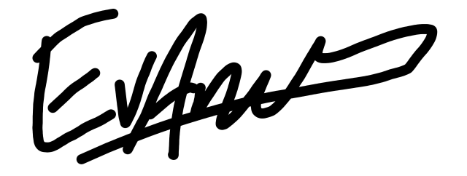

NASA Earth and Space Science Fellow

Department of Astrophysical and Planetary Sciences

University of Colorado, Boulder