Evan Handy’s Project Planning Document

CIT 230-02

# Project Purpose

This site will give provide its viewers with a collection of musical resources for their everyday use. In my life, I have come across a few great music websites that I use frequently. An example of a music website is a website that has a library of sheet music you can download for your personal use. This website is made specifically for sharing these with others. It will include around four or five pages; a main page and a page for each of the music websites. Each of these pages will have a description of what the website does, a link to it, and my personal comments.

# The Audience

The audience will most likely be people my age who I associate with, but it could also be whoever happens to stumble upon my site. I envision most people viewing this on a desktop or a laptop, while they are looking for new music websites to visit.

# Persona

# C:\Users\Evan\AppData\Local\Microsoft\Windows\INetCache\Content.Word\central-african-man.jpg

Name: Sam Johnson

Job: TA for CIT 160

Demographics:

* 21 years old
* Male
* Single
* Current CIT major at BYU-I
* Plays the piano and enjoys music

Goals and tasks: Sam’s a busy guy, but ever-so-often he finds the time to enjoy some good music, both for listening and for playing on the piano. He knows it can be tricky to find reliable websites for musical resources, so he appreciates getting some good recommendations.

Environment: Very confident on his computer. Prefers using his laptop, but will occasionally browse the web on his phone. Being a CIT major he notices obvious problems in websites he visits.

Quote: “Where can I find some good new music?”

# Web Pages

The main page has a HTML5 video that introduces the site. All other pages (musictheory.net, IMSLP, NinSheetMusic, Overclocked Remix, and Bandcamp) use JSON data for their content.

# Wireframe Sketches

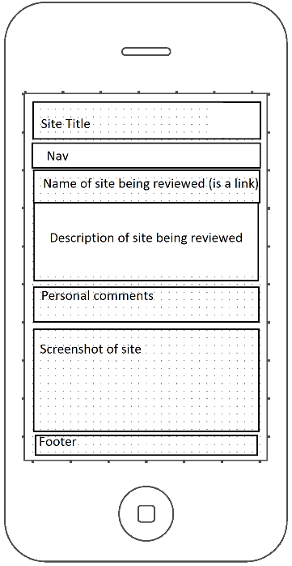

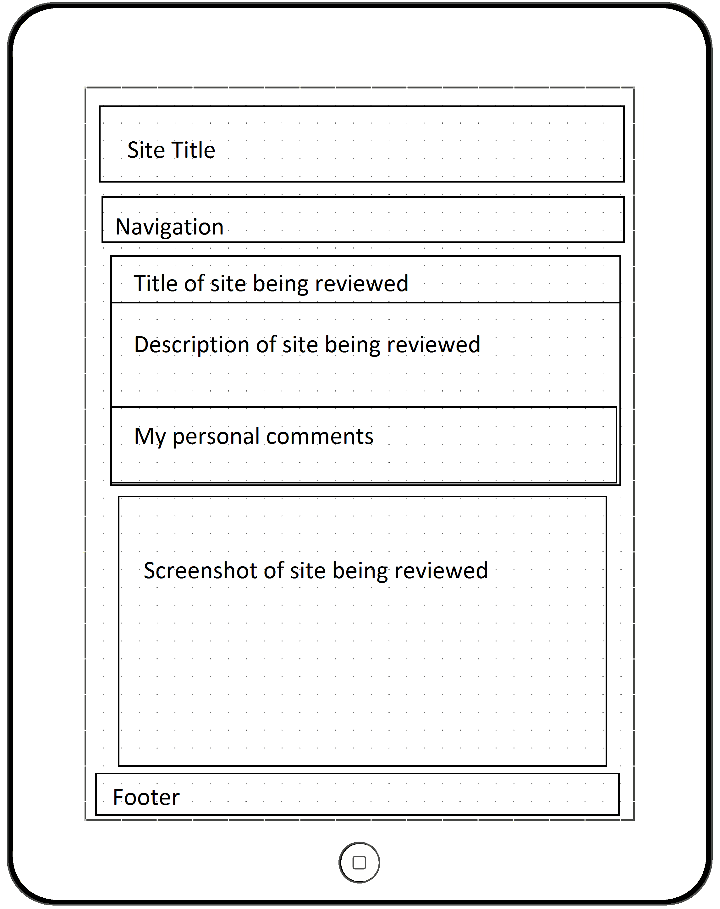

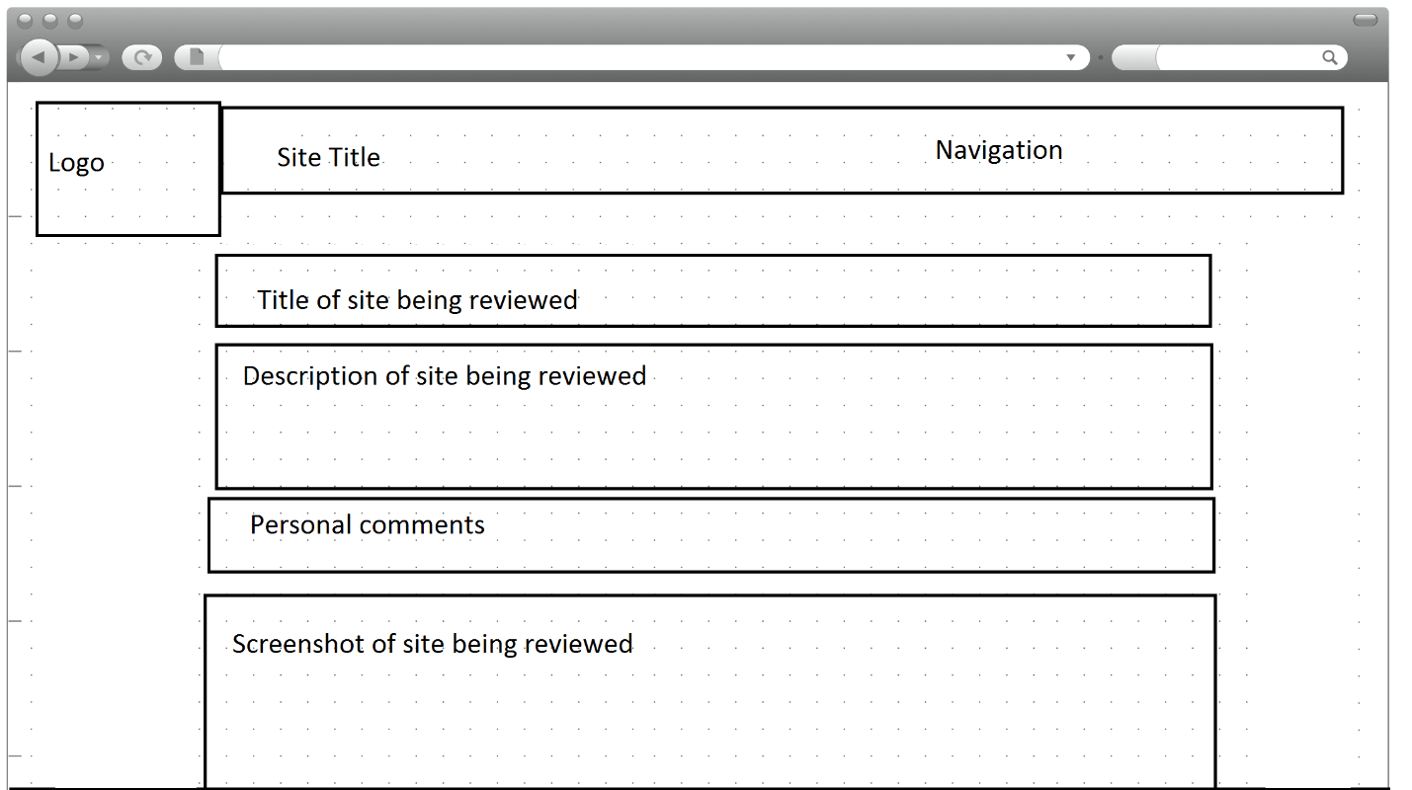

# Usability Concepts

Along with having the crucial, highlighted concepts, I intend on having adequate text-to-background contrast, linking the logo to the homepage, and keeping my styles and colors consistent.