STAT1361 Final Project: Technical Report

Evan Heffelfinger
University of Pittsburgh
STAT1361: Statistical Learning and Data Science
Dr. Lucas Mentch
April 21, 2026
Introduction
Airbnb is exploring methods to better predict which factors influence rental prices in the Minneapolis-St. Paul (MSP) area. Airbnb provides a training set (N=3028) and test set (N=700), which excludes nightly listing price. The predictors span five broad categories: property characteristics (bedrooms, bathrooms, accommodates, room type), host attributes (superhost status, identity verification, number of active listings), guest review scores (overall rating, listing accuracy, cleanliness, check-in experience, host communication, location, value), availability (minimum and maximum booking nights, availability in next 365 days), and location (neighborhood, distance to either downtown). The goal is to use the training data to predict nightly prices for the test data. This was done by performing four regression models (OLS, ridge, LASSO, elastic net) and two tree-based models (single tree, random forest), which were evaluated for predictive accuracy.
Exploratory Data Analysis
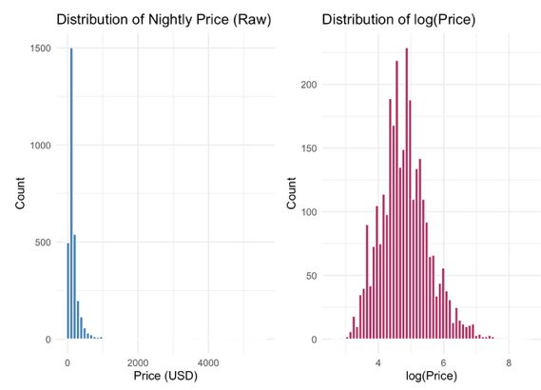
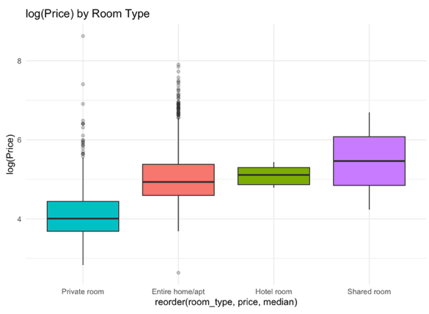
Exploratory data analysis revealed that nightly listing price is right-skewed; therefore, a logarithmic transformation was performed on the response to stabilize variance and reduce skewing across a large range of values. This is demonstrated in Figure 1. It is also worth noting that some predictors had interesting distributions. Regarding room type, 2,262 listings were the entire home, 755 were private rooms, nine were hotel rooms, and two were shared rooms. This is one of strongest predictors of listing price and is demonstrated in Figure 2.
Figure 2

Figure 1

Nightly listing price ranged from $14.00 to $5,556.00, with the mean being $170.30 and median $120.00. The 99th percentile is $965.87, reflecting large outliers that dramatically influence the distribution. Across neighborhoods, there appears to be some meaningful variation in nightly listing price, but it is worth noting that over half (N=1584, 52.3%) of observations for this predictor come from Hennepin; there are a total of 16 neighborhood levels. Regarding number of accommodates and nightly listing price, there appears to be a positive linear relationship. There also appears to be an increase in price farther from downtown areas, but this relationship becomes insignificant after ~20 miles.
Data Oddities
It was noted previously that there are extreme outliers in the response, which are not representative of the typical MSP market, as these observations likely represent ultra-luxury listings. These responses above the 99th percentile were removed in preprocessing to not impair predictive accuracy. Several predictors: minimum nights, number of reviews, host listing count, and distance to downtown showed dramatic right-skews, so these were logarithmically transformed. The property characteristic variables (bedrooms, bathrooms, accommodates) and guest review variables (overall rating, location, cleanliness) demonstrate high correlation values, which suggests that multicollinearity is present among these predictors. Amongst the room type predictor, hotel room (N=9, 0.30%) and shared room (N=2, 0.07%) made up extremely small proportions of the overall predictor, which may cause instability in some models. Though not necessarily an oddity, it is worth noting that there are zero missing values in the entire dataset.
Summary of Models and Methods
Ordinary Least Squares (OLS)
OLS regression was fit using all predictors as a linear baseline with no tuning parameter. This is essentially the baseline model and is not expected to perform the best. Predictors with variance inflation factors (VIF) >5 were flagged as potentially problematic, as these indicate high collinearity.
Ridge Regression
Ridge regression applies an L2 penalty to the regression coefficients, which shrinks problematic or insignificant coefficients towards 0, but never eliminates them. This is an appropriate way to address the multicollinearity that exists amongst some predictors in the dataset. This penalty strength is controlled by a parameter known as lambda, which was selected for this dataset via 5-fold cross-validation (CV). The ideal lambda for ridge regression is 0.04075.
Least Absolute Shrinkage and Selection Operator (LASSO)
LASSO works similarly to ridge regression, but instead applies an L1 penalty, which will eliminate weak predictors by reducing them to 0. These models are more parsimonious than those of ridge, due to the eliminated predictors. This lambda was also selected with a 5-fold CV, with an optimal lambda of 0.00878.
Elastic Net
Elastic net regression is a mix of LASSO and ridge regression. It is based on a tuning parameter known as alpha, which acts along with lambda. Alpha essentially blends the L2 and L1 penalties. Alpha tunes both parameters simultaneously. Both ridge and LASSO parameters were chosen via 5-fold CV and yielded an optimal lambda of 0.00810 and alpha of 1. The alpha value of 1 indicates that the model defaulted to pure LASSO variable selection for this dataset.
Single Regression Tree
A single regression tree (SRT) was fit to achieve the optimal prediction cutoffs to minimize the error at each split. The trees are pruned, which controls how aggressively splits are made. Pruning aggression is controlled by the complexity parameter (cp). The optimal cp was found by 5-fold CV and yielded 0.002159. The single tree has high variance and thus is not anticipated to perform well; rather acts as a baseline to the random forest method.
Random Forest
Random forest works similarly to SRT, but instead is a bootstrapped ensemble of 500 single trees. At each node in the tree, mtry (tuning parameter) randomly selected predictors are chosen as predictors that are candidates for a split. This decorrelates trees, as without randomness, the most important predictor will be chosen as the split every time. This also acts to reduce variance. Mtry was selected via 5-fold CV over values of 3, 4, 5, 6, and 8, choosing 4 as the optimal mtry. To compute an independent measure of test error, the out-of-bag (OoB) mean squared error (MSE) was calculated to account for the bootstrap sampling.
Predictive Accuracy of the Models
Of all six models analyzed, random forest performed the best, providing the lowest MSE. As MSE is on a logarithmic scale and is not easily interpretable, root mean squared error (RMSE) is also included, since it is simply the square root of MSE. Notably, the four linear methods yielded very similar MSE values, indicating comparable predictive accuracy.
Model | Tuning Parameter | Optimal Value | CV MSE | CV RMSE
OLS | N/A | N/A | 0.1964 | 0.4432
Ridge | lambda | 0.04057 | 0.1967 | 0.4435
LASSO | lambda | 0.00878 | 0.1958 | 0.4425
Elastic Net | alpha, lambda | 1, 0.00810 | 0.1949 | 0.4415
Single Tree | cp | 0.002159 | 0.1818 | 0.4264
Random Forest | mtry | 4 | 0.1434 | 0.3787
Figure 3

Variable Importance
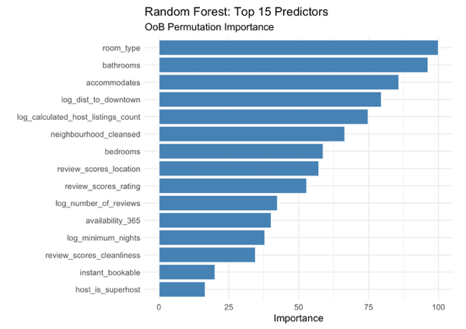
Random forest variable importance was assessed using OoB permutation (MSE=0.1407), where predictors are permuted on the training data that was left out in that specific tree. Higher magnitudes indicate higher variable importance, as shown in Figure 4. Most of the highly important predictors were listing characteristics, such as bathrooms, room type, and accommodates. This is consistent with EDA findings. Notably, review-based scores had lower importance, which is likely due to the limited variability of those predictors.
Figure 4

Conclusions
Random forest was chosen as the final prediction model based on its superior predictive accuracy. Predicted nightly listings ranged from $30.11 to $591.45, with a predicted mean of $141.98. The most important predictors of nightly listing prices are property characteristics, especially room type, bedrooms, and accommodates, as well as distance. This implies that across the MSP market, physical property characteristics and distance to either downtown area are the most important predictors of nightly listing price. Review scores played a small role in prediction of prices, though this may be due to limited data variability rather than reflective of a true trend.
Limitations and Future Directions
The primary limitation of this dataset is the skewed distribution of the prices. Though outcomes above the 99th percentile were removed, some higher-end listings exist in the training set, which may cause underprediction for genuine luxury properties. As mentioned above, review scores have limited variability, as they are on a 1-5 whole integer scale, with most clustering near 5. This lack of variability limits the predictive power that these predictors have. The dataset is missing some potentially important variables, such as seasonality trends or property amenities. Future analyses could include more predictors to ensure that potentially important variables are not being overlooked.

