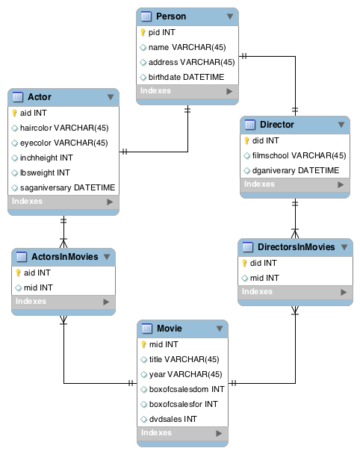

Functional Dependencies

Person

pid->name

pid->address

pid->birthdate

Actor

aid->haircolor

aid->eyecolor

aid->inchweight

aid->inchheight

aid->saganiversary

Director

did->filmschool

did->dganiversary

Movie

mid->title

mid->year

mid->boxofcsalesdom

mid->boxofcsalesfor

mid->dvdsales