Cupboardly
CMSC-4900-001 – Senior Project I

Design Document
December 9th, 2025

Team Members:
Eli Haky
Nikolaus Roebuck
Evan Thompson

Contents
Abstract 4
Description of Document 4
Purpose and Use 4
Ties to the Specification Document 5
Intended Audience 5
Project Block Diagram 5
Figure 1 6
Design Details 6
System Modules and Responsibilities 6
Module Cohesion 8
Module Coupling 8
Design Analysis 8
Data Flow 8
Figure 3: 9
Design Organization 10
Detailed Tabular Description of Classes 10
Functional Description 14
Decision: Programming Language / Reuse / Portability 29
Implementation Timeline 29
Design Testing 30
Appendix A: Schematic & Bill of Materials (BOM) 30
Appendix B: Team Details 31
Appendix C: Writing Center Report 32
Appendix D: Workflow Authentication 32
Appendix E: References 33

Instructor Comments

Abstract
Cupboardly is an Android app that will keep track of your kitchen inventory of ingredients and food stock. Additionally, it will track and organize recipes for use in the kitchen. Recipes and ingredients can be added manually on the app. Recipes can be scanned with a camera and uploaded to an AI API to then return a format for Cupboardly to store. When a recipe is used, the app will calculate the quantities of ingredients used by portion and update the ingredient data.
This document will be what specifies how Cupboardly will be designed and structured. We will describe how our classes and modules will be structured and designed to accomplish the goals we need to make Cupboardly functional. We will follow these guidelines to make sure that we can make Cupboardly easy to use and robust.

Description of Document

Purpose and Use
The purpose of this document will be a guideline for the architecture of our future program. It is made to give the developers a detailed way to keep the project on track without deviating from the original plan. We will specify the classes and objects that will be used within Cupboardly. We will also be defining any inputs for the program. Another purpose for this document will be to define the design details of the application. Some of the design details that this document will break down are the coupling and cohesion of each module, the classes and functions of each class, and the programming languages that are going to be used within the program.

Ties to the Specification Document
Our specification document roughly outlined what our program should be capable of. This document will go into much greater detail about how our program will work and function. The specification document was created to be a contract between the development team and the client to make sure the program stays on task and everything written in it will be fulfilled. The specification document will outline in more detail the specific classes, objects, and programming languages being used within the program.

Intended Audience
The intended audience of this document will be the development team. This document is not meant for the client because of the technical verbiage within the document. The development team will use this document during the coding process as a guide to complete the project in a timely manner.

Project Block Diagram
Cupboardly will be an application available for download through the Google Play Store. An Android device with access to the internet will be needed to download the application. Additionally, an internet connection will be needed to use the recipe scan feature of Cupboardly. This is because data must be passed to an external AI Agent using an API. In other words, the processing of the recipe data from the image is not completed locally on the device where Cupboardly is installed. All other features of Cupboardly will be able to function without an internet connection.
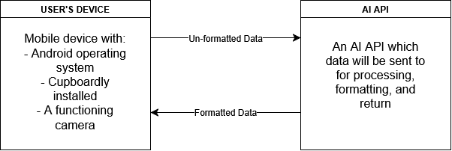
Figure 1: Project Block Diagram

Design Details

System Modules and Responsibilities
Overview:
Cupboardly is an Android app with the intention of improving the way individuals track their kitchen inventory and organize recipes. The app will require user input to view, modify, and add various ingredients and recipes to the local database. The app will split the UI into two modes, an ingredient and a recipe mode.
While in the ingredient mode, the user can input and modify the values relating to the record of ingredients. This includes adding and subtracting the quantity of ingredients, the removal or addition of an ingredient, and the ability to add the price of each ingredient at purchase.
While in recipe mode, the user can input and modify the content of a recipe record. This includes adding or removing a recipe, modifying the recipe instructions, modifying recipe ingredients and their quantities, ‘cooking’ a recipe which will modify the quantity of ingredients used, and adding a recipe via a photograph of a recipe. The recipe photograph scan will be sent to an AI to check the formatting and return it into a form that Cupboardly can store and display correctly and neatly.
Architectural Diagram
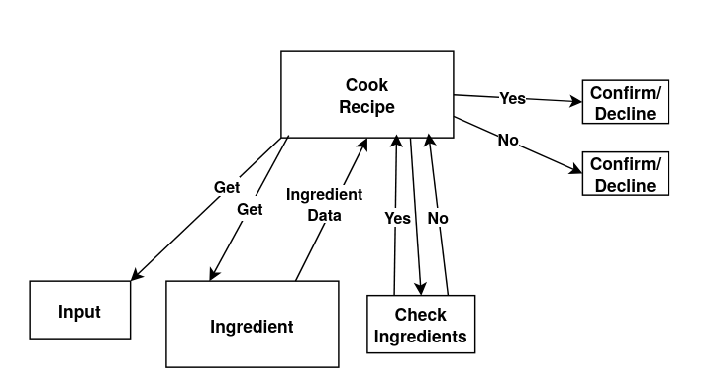Figure 2: Example Diagram of our ‘Cook Recipe’ Module

Module Cohesion
Cupboardly will use cohesion to maintain the classes for the data of ingredients and recipes saved. This includes the names, quantities, and values. This will be replicated for the recipe module, but with additional data for more information on the recipe and functionality regarding the camera module.

Module Coupling
The ingredients module and the recipe module are coupled in one way where the recipe module can read and subtract an amount of ingredients used for a particular recipe from the ingredient data. The ingredients module would never need to access the recipe module data. The camera module would need write access to the recipe module data as to add and modify the potentially new recipe addition.

Design Analysis

Data Flow
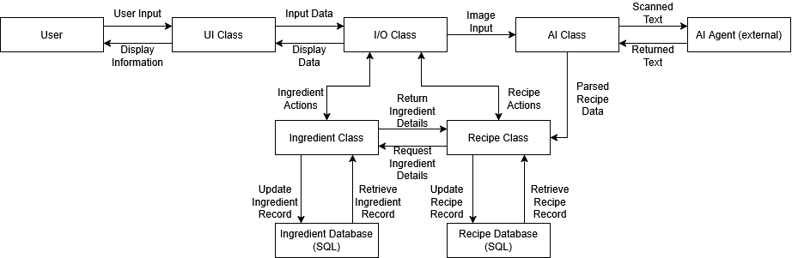
Figure 3: Dataflow Diagram

The Cupboardly data flow is composed of two main data storage locations - the Ingredient Database and the Recipe Database - and five processing components that manage data flow in and out of these data storage locations. A user interacts with the system through the UI Class, which in turn passes data and commands to the I/O Class. For ingredient related data and commands, the I/O Class communicates with the Ingredient Class, which is solely responsible for accessing the Ingredient Database. Only the Ingredient Class can read or write to the Ingredient Database.
In a similar way, when recipe related data or commands are passed from the UI Class to I/O Class, the I/O Class passes that information to the Recipe Class. Much like the Ingredient Class in reference to the Ingredient Database, only the Recipe Class is allowed to access the Recipe Database. The Recipe Class may request Ingredient Data from the Ingredient Class, such as ingredient quantity and cost. However, as mentioned, the Recipe Class cannot directly access the Ingredient Database, thus, any ingredient data requested by the Recipe Class must be forwarded through the Ingredient Class.
For the AI recipe scanning feature, the I/O Class sends an image to the AI Class, which scans and identifies text. This text data is then passed on to the AI Agent via API access. The Agent parses the text data and returns it to the AI Class in a format acceptable by the Recipe Class. The AI Class sends that formatted data to the Recipe Class. Finally, The Recipe Class makes the appropriate writes to the Recipe Database, indicating a new record has been created. This data flow ensures a clear separation of logic, storage, and intention of classes.

Design Organization

Detailed Tabular Description of Classes
Ingredient Class:
Description:
Manages all operations related to ingredient information, including quantity, price, and units. The Ingredient Class is permitted to read from and write to the Ingredient Database, and is the only class permitted to do so.
Data Members / Types / Constraints:
Data Member | Type | Constraints
ingredientName | string | Cannot be empty, must be unique
ingredientQuantity | float | Cannot be negative
unit | string | Must be valid unit (oz, lbs, qty, etc.)
price | float | Cannot be negative
pricePerUnit | float | Cannot be negative
dateEntered | integer | Timestamp, auto generated
dateLastUpdated | integer | Timestamp, auto updated on modification
amountUsedRecently | float | Cannot be negative

Member Functions Listing / Description:
Function | Description
addIngredient() | Creates a new ingredient entry and writes it to the Ingredient Database
updateIngredient() | Modifies ingredient fields and updates database
deleteIngredient() | Removes an ingredient record from the database
convertUnit() | Converts the ingredient quantity to a different unit as needed
calculatePricePerUnit() | Computes cost per unit based on price and quantity
getIngredientData() | Returns detailed ingredient information

Recipe Class:
Description:
Manages all operations related to recipe information, including ingredient list, quantity used, instructions, and cost calculations. The Recipe Class is permitted to read from and write to the Recipe Database, and is the only class permitted to do so.
Data Members / Types / Constraints:
Data Member | Type | Constraints
recipeName | string | Cannot be empty, must be unique
recipeInstructions | string
ingredientUsed | list | List of ingredient items
ingredientQuantityUsed | list of floats | No entry can be negative
costPerIngredient | list of floats | No entry can be negative
totalRecipeCost | float | Cannot be negative
dateCreated | integer | Timestamp for recipe creation
numTimesFollowed | integer | Cannot be negative, auto updated when recipe is followed

Member Functions Listing / Description:
Function | Description
addRecipe() | Creates a new recipe entry and writes it to the Recipe Database
updateRecipe() | Modifies recipe fields and updates database
deleteRecipe() | Removes a recipe record from the database
calculateTotalCost() | Calculates the total cost of the recipe
checkIngredientAvailability() | Determines if the user has enough quantities of ingredients to follow the recipe
scaleRecipe(factor) | Adjusts ingredient quantities and cost based on a scaling factor
followRecipe() | Subtracts required ingredient quantities from quantities in Ingredient Database using the Ingredient Class
getRecipeData() | Returns detailed recipe information

I/O Class:
Description:
The I/O Class acts as the intermediary between the UI Class and other classes such as the Recipe Class or Ingredient Class. It retrieves data from the UI Class and relays it to the appropriate class. It also relays returned data back to the UI class for displaying.
Member Functions Listing / Description:
Function | Description
processIngredientCommand() | Routes ingredient related requests to the Ingredient Class
processRecipeCommand() | Routes recipe related requests to the Recipe Class
processAICommand() | Forwards image data to the AI Class for scanning
validateInput() | Ensures valid data is input before forwarding it
returnOutputToUI() | Sends processed data back to the UI Class

UI Class:
Description:
The UI Class handles all visual elements and user interactions. It displays ingredient and recipe data, manages buttons and navigation, and collects and sends user input to the I/O Class.
Data Members / Types / Constraints:
Data Member | Type | Constraints
currentView | string | “Ingredients” or “Recipes”
selectedItem | string or null | Current ingredient or recipe selection
inputFields | dict | Must match required fields for add/edit operations

Member Functions Listing / Description:
Function | Description
displayIngredientList() | Shows all ingredients on screen
displayRecipeList() | Show all recipes on screen
displayDetails(item) | Displays expanded ingredient or recipe details
collectUserInput() | Gathers data and sends to I/O Class
showWarnings(message) | Displays warnings to the user
updateUI() | Refreshes the interface after any changes

AI Class:
Description:
The AI Class handles the text extraction from images of recipes and AI parsing of recipe data. It receives an image from the I/O Class, extracts the text from it, and sends it to an external AI Agent via API. Once the parsed data is returned from the AI Agent, the AI Class sends the data to the Recipe Class.
Data Members / Types / Constraints:
Data Member | Type | Constraints
scannedText | string | Raw text extracted from an image
returnedText | string | Must be formatted such that the Recipe Class can accept it
imageData | image object | Must be a valid image

Member Functions Listing / Description:
Function | Description
receiveImage(image) | Accepts image data from I/O Class
extractText() | Extracts text from the image
sendToAIAgent() | Sends extracted text to external AI service
receiveParsedText() | Stores structured recipe data returned by AI Agent
forwardToRecipeClass() | Sends structured recipe data to the Recipe Class

Functional Description

Input / Output / Return Parameters / Types

Ingredient Class:
addIngredient( )
Input: The input for the addIngredient( ) function will be the data for a new ingredient that will be added into the application
Output: The output for the ingredientName( ) function will be the data of the newly added ingredient.
Return Parameters: None
Types: String, float

updateIngredient( )
Input: The input for the updateIngredient( ) function will be any data that has changed within the ingredient such as name, amount, or price.
Output: The output for the ingredientQuantity( ) function will be the updated data of the specific ingredient.
Return Parameters: None
Types: string, float

deleteIngredient( )
Input: The input for the deleteIngredient( ) function will be a user input from a button to delete the current ingredient listing.
Output: The output for the deleteIngredient( ) function will be that the current selected ingredient will be deleted from the database.
Return Parameters: None
Types: None

convertUnit( )
Input: The input for the convertUnit( ) function will be the correct unit quantity that the ingredient should be.
Output: The output for the convertUnit( ) function will be the correct updated unit quantity of the ingredient.
Return Parameters: None
Types: Float

calculatePricePerUnit( )
Input: The input for the calculatePricePerUnit( ) function will be the calculated price of each individual ingredient.
Output: The output for the calculatedPricePerUnit( ) function will be the correct value of each individual ingredient based on price and quantity.
Return Parameters: None
Types: Float

getIngredientData( )
Input: The input for the getIngredientData( ) function will be detailed information of each ingredient.
Output: The output for the getIngredientData( ) function will be the correct detailed information of each specific ingredient.
Return Parameters: None
Types: String, Float

Recipe Class:
addRecipe( )
Input: The input for the addRecipe( ) function will be a list of instructions either manually inputted by the user or scanned by AI.
Output: The output for the addRecipe( ) function will be a new recipe entry that lists detailed instructions or a recipe that will be stored in the recipe database.
Return Parameters: None
Types: String, Float

updateRecipe( )
Input: The input for the updateRecipe( ) will be the updated information of a recipe that the user inputs.
Output: The output for the updateRecipe( ) function will be the correctly updated information of the specific recipe.
Return Parameters: None
Types: String, Float

deleteRecipe( )
Input: The input for the deleteRecipe( ) function will be a button call that is called by the user.
Output: The output for the deleteRecipe( ) function will be that the selected recipe will be deleted from the recipe database.
Return Parameters: None
Types: None

calculateTotalCost( )
Input: The input for the calculateTotalCost( ) function will be the price of each ingredient that will be used within a recipe.
Output: The output for the calculateTotalCost( ) function will be the total cost of a specific recipes ingredients.
Return Parameters: None
Types: Float

checkIngredientAvailability( )
Input: The input for the checkIngredientAvailability( ) function will be the amount of a specific ingredient that needs to be checked.
Output: The output for the checkIngredientAvailability( ) function will be the amount of the ingredient that is available to use.
Return Parameters: None
Types: Boolean, Float

scaleRecipe(factor)
Input: The input for the scaleRecipe(factor) function will be the scaling factor of the specific recipe.
Output: The output for the scaleRecipe(factor) function will be the scaled ingredient data of the speific recipe.
Return Parameters: None
Types: Float

followRecipe( )
Input: The input for the followRecipe( ) function will be the amount of ingredients required for a specific recipe.
Output: The output for the followRecipe( ) function will be the subtracted amount of ingredients quantities in the ingredient database in the ingredient class.
Return Parameters: None
Types: Float

getRecipeData( )
Input: The input for the getRecipeData( ) function will be a user input that gives the user a detailed description of the recipe information
Output: The output for the getRecipeData( ) function will be the detailed information of a specific recipe.
Return Parameters: None
Types: String, Float

I/O Class:
processIngredientCommand( )
Input: There will be no input for the processIngredientCommand( ) function because it does not handle any data.
Output: There will be no output for the processIngredientCommand( ) function because it does not handle any data.
Return Parameters: None
Types: None

processRecipeCommand( )
Input: There will be no input for the processRecipeCommand( ) function because it does not handle any data.
Output: There will be no output for the processRecipeCommand( ) function because it does not handle any data
Return Parameters: None
Types: None

processAICommand( )
Input: The input for the processAICommand( ) function will be the image data that the user has taken.
Output: The output for the processAICommand( ) function will be the outputted data taken from the image
Return Parameters: None
Types: String, Float

validateInput( )
Input: The input for the validateInput( ) function will be valid data taken from the AI processed image.
Output: The output for the validateInput( ) function will be the verified valid data from the AI processed image.
Return Parameters: None
Types: String, Float

returnOutputToUI( )
Input: The input for the returnOutputToUI( ) function will be the validated data from the AI image.
Output: The output for the returnOutputToUI( ) function will be the validated data that gets sent back to the UI class.
Return Parameters: None
Types: String, Float

UI Class:
displayIngredientList( )
Input: The input for the displayIngredientList( ) function will be all of the ingredients.
Output: The output for the displayIngredientList( ) will be all of the ingredients that are being displayed on the users screen.
Return Parameters: None
Types: String

displayRecipeList( )
Input: The input for the displayRecipeList( ) function will be all of the recipes.
Output: The output for the displayRecipeList( ) function will be all of the recipes that are being displayed on the users screen.
Return Parameters: None
Types: String, Float

displayDetails(item)
Input: The input ofr the displayDetails(item) function will be the detailed information of a specific ingredient.
Output: The output for the displayDetails(item) function will be the detailed information of the expanded ingredient that is being displayed on the users screen.
Return Parameters: None
Types: String, Float

collectUserInput( )
Input: There will be no input for the collectUserInput( ) function.
Output: There will be no output for the collectUserInput( ) function.
Return Parameters: None
Types: String

showWarnings(message)
Input: There will be no input for the showWarnings(message) function.
Output: The output for the showWarnings(message) function will be a message to the user.
Return Parameters: None
Types: String

updateUI( )
Input: There will be no input for the updateUI( ) function.
Output: There will be no output for the updateUI( ) function.
Return Parameters: None
Types: None

AI Class:
recieveImage( )
Input: The input for the recieveImage( ) function will be the image data of a recipe taken by the user.
Output: There will be no output for the recieveImage( ) function.
Return Parameters: None
Types: String, Float

extractText( )
Input: The input for the extractText( ) function will be the image of a recipe taken by the user.
Output: The output for the extractText( ) function will be the recipe data taken from the image.
Return Parameters: None
Types: String, Float

sendToAIAgent( )
Input: The input for the sendToAIAgent( ) function will be the image data.
Output: The output for the sendToAIAgent( ) function will be the image data.
Return Parameters: None
Types: String, Float

recieveParsedText( )
Input: The input for the recieveParsedText( ) function will be the structured recipe data from the AI Agent.
Output: There will be no output for the recieveParsedText( ) function.
Return Parameters:
Types:

forwardToRecipeClass( )
Input: The input for the forwardToRecpeClass( ) function will be the structured recipe data.
Output: The output for the forwardToRecipeClass( ) function will be the structured recipe data that gets sent to the Recipe class.
Return Parameters: None
Types: String, Float

Modules Used
We will be creating and using five class modules for this project. Additionally, we will be using an AI API access module to process and format recipe data for use in our application.

Files Accessed
The files that will need to be accessed while using the application will be stored locally within the application on the user's device.

Real-Time Requirements
The real-time requirements of our program will be a Wi-Fi or cellular connection. This will be needed to be able to use the AI functionality of the application to be able to scan recipe cards and input them into the application.

Narrative / PDL
Ingredient Menu:
- Add Ingredient
- Expand Ingredient
- Delete Ingredient
- View Recipes
Add Ingredient:
- Enter Ingredient data
Update Ingredient Database
Expand Ingredient:
View Detailed Ingredient Information
- Edit Ingredient
- Collapse Ingredient
Delete Ingredient:
- Update Ingredient Database
- Ingredient Menu
Edit Ingredient:
Update Ingredient Database
Collapse Ingredient:
- Ingredient Menu
View Recipes:
- Recipe Menu
Recipe Menu:
- Add Recipe
- Expand Recipe
- Delete Recipe
- View Ingredients
Add Recipe:
Add from image?
Yes? – AI Process
No? – Enter Recipe data
Update Recipe Database
AI Process:
Process image data
Update Recipe Database
Expand Recipe:
View Detailed Recipe Information
- Edit Recipe
- Cook Recipe
- Collapse Recipe
Edit Recipe:
Update Recipe Database
Cook Recipe:
Enough Ingredients?
Yes? – Update Ingredient Database
No? – Display Message
Collapse Recipe:
- Recipe Menu
Delete Recipe:
- Update Recipe Database
- Recipe Menu
View Ingredients:
- Ingredient Menu

Decision: Programming Language / Reuse / Portability
The programming languages that will be used throughout the course of this project will be Android Development Kit, Python, and SQL. These languages were chosen because of the usability and convenience of each language. The Android Development Kit was chosen because we are creating an application to be used on Android devices, and this is the best way to do that. We are using Python because of the ease of programming and the many libraries that Python offers for users to use and interact with. We are using SQL because it is one of the best languages to be used for storing bulk data.

Implementation Timeline
January | February | March | April | May | April+
Framework Design Planning | Software Design /Testing | Software Design /Testing | Design, verification, testing | Testing / Documentation | Post-Delivery Maintenance

Design Testing
Design testing will be done throughout the development process. Whenever a new component is added, it will be tested in isolation as well as in combination with the rest of the existing application. We will do this to ensure each component functions as intended. Additionally, it will ensure that each component works with every other component, and that implementing it does not break the function of our application. As testing is done, team members will consider edge cases and try to intentionally break the application to determine the limits of it and whether specific pieces need to be fixed. Given that the primary operation of Cupboardly is data input, storage, and output, we will frequently use test data to ensure the application is functioning properly. In addition to testing the flow of data, UI will also need to be tested frequently. To do this, frequent builds of Cupboardly will be installed on Android devices owned by the team members. This will allow for testing of the application in the environment where it will be deployed, rather than only testing in the IDE where it is being made. The development team is the testing team; the developers will be the ones doing the testing.

Appendix A: Schematic & Bill of Materials (BOM)
We will have no hardware costs. The Cupboardly application will be developed using existing hardware including PC’s and Android devices already owned by team members.
There is a $25 registration fee for Google which we will need to pay to post the app to the Google Play Store.^{[1]} This must be done to allow anyone with an Android device to easily download Cupboardly.

Appendix B: Team Details
This document was written in collaboration among all team members. Work was divided among them as described below:
Eli Haky was responsible for the sections:
- Description of the Document
- Purpose and Use
- Ties to the Specification Document
- Intended Audience
- Functional Description
  - Modules Used
  - Files Accessed
  - Real-Time Requirements
  - Narrative / PDL
- Decision: programming language / reuse / portability
Nikolaus Roebuck was responsible for the sections:
- Design Details
  - System Modules and Responsibilities
  - Module Cohesion
  - Module Coupling
Evan Thompson was responsible for the sections:
- Design Analysis
  - Data Flow
- Design Organization
  - Detailed Tabular Description of Classes
Any sections not assigned to a specific team member were written together in an in-person group setting.

Appendix C: Writing Center Report
See email sent on 12/9/2025

Appendix D: Workflow Authentication

I, Eli Haky, confirm that I have completed the work on this document as described above. Date: 12/08/2025

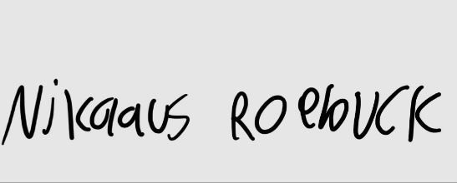
I, Nikolaus Roebuck, confirm that I have completed the work on this document as described above. Date: 12/08/2025


I, Evan Thompson, confirm that I have completed the work on this document as described above. Date: 12/08/2025

Appendix E: References
- How to use Play Console - Play Console Help. (n.d.). Support.google.com. https://support.google.com/googleplay/android-developer/answer/6112435?hl=en#zippy=

