Cupboardly
CMSC-4900-001 – Senior Project I

Specifications Document
November 14th, 2025

Team Members:
Eli Haky
Nikolaus Roebuck
Evan Thompson

Instructor Comments / Evaluation

Contents
Instructor Comments / Evaluation 2
Abstract: 5
Description of the Document: 5
Purpose and Use: 5
Intended Audience: 5
System Description: 6
Overview: 6
Environment and Constraints: 6
End User Profile: 6
User Interaction: 7
Hardware Constraints: 7
Software Constraints: 7
Time Constraints: 7
Cost Constraints: 8
Other Concerns: 8
Acceptance and Test Criteria: 8
Testers: 8
Criteria for User Acceptance: 9
Integration of Separate Parts and Installation: 9
System Modeling: 10
Functional: Use Cases and Scenarios: 10
Figure 1: 10
Class Diagrams: 13
Figure 2: 13
Class Descriptions: 13
Dynamic State Chart: 17
Figure 3: 17
Dataflow Diagram: 18
Figure 4: 18
Components Needed: 19
References: 19
Appendix: Glossary: 19
Appendix: Team Details: 21
Appendix: Writing Center Report: 22
Appendix: Workflow Authorization: 22

Abstract:
Cupboardly is a mobile application built for people who want to keep track of ingredients and recipes. Cupboardly will be used by both home cooks and professional chefs to know what ingredients they have and how much a recipe will use. This application will take what recipe you use and subtract the amount of ingredients automatically on the app, so you know how much you have left for the next recipe. The app will be programmed using Python and SQL programming languages and will use AI software to be able to scan recipe cards and input them into the app, so the user won't have to manually input them. This app is designed to keep kitchens and recipes organized and at your fingertips, so you don't have to search your whole kitchen for what you need.

Description of the Document:

Purpose and Use:
The purpose of this document is to provide a detailed description of the specific requirements for this project. This document will be used by developers to be able to accurately describe and plan the application; and by clients and users to be able to understand the specifics of the application.

Intended Audience:
The intended audience for our document will be clients and developers. This document was made so that the developers will have a clear understanding of the scope of the program. This document will also allow the clients and users to have an expectation and understanding of the finished application.

System Description:

Overview:
Cupboardly is a software application that can be used on a smart phone. It will be a home menu that can be switched from the ingredient tab to the recipe tab via buttons on the home screen. The app will allow the user to input recipes or ingredients and keep track of the amount of ingredients that are available to use. When picking a recipe that was inputted, the app will tell you if you have the correct amount of ingredients for the recipe and will automatically deduct that amount on the ingredients tab. The app will save all the data inputted locally so the user will be able to see what ingredients they have available at any time. The app will allow the user to add, subtract, or remove ingredients from the ingredient tab.

Environment and Constraints:

End User Profile:
The end users for Cupboardly would be those cooking at home and those interested in tracking pantry usage and inventory. The users would use the mobile app to input and browse their recipes through the recipes menu. They would also be able to modify and review their inventory of ingredients they have in their home. The users are expected to have basic knowledge of mobile app functionality. The app is designed to be used in a residential setting, but it could also be used in a professional kitchen.

User Interaction:
The users would interact with the app by navigating the menus to the desired recipe or ingredient. From their selected destination they may modify the entry by its amount or descriptions. They may also use the camera function to import a written or printed recipe from text and import it to their library. When a recipe is selected and told to “cook”, the ingredients used in the recipe will reflect the amount of ingredients removed from the pantry. The user may also be able to back up their catalog to load it onto another device.

Hardware Constraints:
The software will be developed for use with a mobile device that can download the app from the app store for the device’s vendor. Without a mobile device, access to the software cannot be provided. We will be developing this software for use with modern Android devices.

Software Constraints:
The software constraints we are limited to are the functionality provided by the Android SDK software and its functionality. The software will be developed with use on the Android Operating System. We will also use SQL for storing the catalog of recipes and ingredients, which will determine how the data is structured. The photo-to-recipe feature will utilize an AI API to read and structure the recipe into a format that can be easily implemented into our database.

Time Constraints:
The time constraints for completing this software are determined by the timeframe of a college semester. This would mean that we would have roughly fifteen weeks to complete the application’s construction. Our team will allot time within each week for progress made toward the completion of their section of the project.

Cost Constraints:
Cost constraints for this project would be determined by the cost of submitting an application to the Android Google Play store. The app will be free to download with no cost to the end user. A $25 registration fee is required to publish an application on the Google Play Store.^{[1]}

Other Concerns:
IOS development is not feasible due to hardware limitations of our group. IOS development requires one or more of us to own Apple hardware to use the iOS SDK to develop an application for the Apple App Store. Since none of the group members own, nor could feasibly own, an Apple computer we have to drop iOS support. Additionally, Apple charges an annual $99 fee minimum for publishing an app to the App Store.^{[2]}
Any other concerns pertaining to the Android version of the application will require the end users to have Wi-Fi access to download the application and to have functionality with the camera feature to upload recipes.

Acceptance and Test Criteria:

Testers:
The group members will be the main testers for our application. We will be testing it consistently throughout the creation of this project. We will do this to make sure the app is functioning as intended at each step and to be able to find and fix any issues that arise.

Criteria for User Acceptance:
Successful user acceptance for Cupboardly will be when the user can add or remove ingredients and recipes, and also change the amounts and contents of those using the mobile application. The following criteria will make Cupboardly a success per the development teams specifications.
- The user can add ingredients (including price) and recipes (manually or AI-scan) to the app.
- The user can search for an ingredient and view more detailed information about the ingredients.
- The user can edit ingredients or edit a recipe.
- The user can search a recipe in the system (e,g. Keywords in the recipe name) and the app will tell the user how much the recipe will cost based on purchase price of the ingredients.
- When a recipe is started, the app will deduct the amount of ingredients needed for the recipe from the ingredient tab.
- The app will inform the user if they do not have enough ingredients for a specific recipe.
- The user can delete ingredients and recipes.
- The system can export and import both ingredients and recipes.

Integration of Separate Parts and Installation:
Cupboardly will be a mobile application, so the only thing the users will need to install is the mobile application through the app store on their mobile devices. Since everything is going to be stored locally through the app, the users will not have to download anything separate from the application and they will be able to access their data on the app at any time.

System Modeling:

Functional: Use Cases and Scenarios:
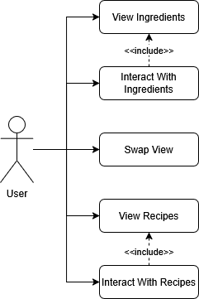
Figure 1: Use Case Diagram
The figure above shows a simplified Use Case diagram for the User interactions within the application. View Ingredients will display a list of all ingredients. Interact With Ingredients will allow the user to view specific details, modify, add, or delete ingredients. Swap View will swap between the View Ingredients and View Recipes screen. View Recipes will display a list of all recipes. Interact With Recipes will allow the user to view specific details, modify, add, or delete recipes.

Run Scenario:
- The User enters the application.
- If the User is in the View Ingredients screen, the User can select:
  - Swap View
  - Interact With Ingredients
- If Swap View is selected, the View Recipes screen is displayed.
- If Interact With Ingredients is selected, the User can select:
  - Search For Ingredient
  - Add Ingredient
  - Expand Ingredient
- If Search For Ingredient is selected, the user can search for a specific ingredient.
- If Add Ingredient is selected, the user can add a new ingredient to the list.
- Expand Ingredient will display additional information about a specific ingredient. Within Expand Ingredient, the user can select:
  - Modify Ingredient
  - Delete Ingredient
- If the User is in the View Recipes screen, the User can select:
  - Swap View
  - Interact With Recipes
- If Swap View is selected, the View Ingredients screen is displayed.
- If Interact With Recipes is selected, the user can select:
  - Search For Recipe
  - Add Recipe
  - Expand Recipe
- If Search For Recipe is selected, the user can search for a specific recipe.
- If Add Recipe is selected, the user can select:
  - Add Manually
  - Add From Camera
- If Add Manually is selected, the user can enter data for the new recipe manually.
- If Add From Camera is selected, the user can take a picture of a recipe, and the application will attempt to generate a new recipe from text extracted from the image.
- Expand Recipe will display additional information about a specific recipe. Within Expand Recipe, the user can select:
  - Modify Recipe
  - Delete Recipe
  - Follow Recipe

Class Diagrams:
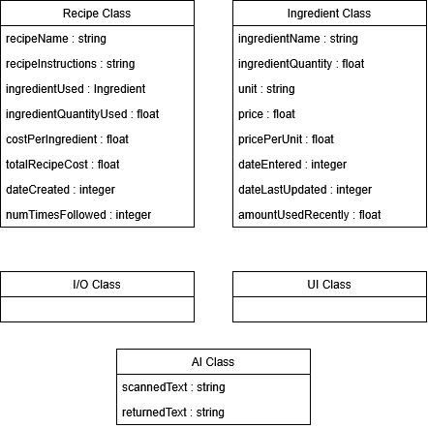
Figure 2: Class Diagrams

Class Descriptions:
Ingredient Class:
The ingredient class contains information relating to each ingredient. Data will be stored in SQL, but the recipe class will manage access to and modification of that data. The ingredient quantities will be stored in weight (oz) or whole items depending on the ingredient and what the user entered.
Variables used:
ingredientName : string
ingredientQuantity : float
unit : string
price : float
pricePerUnit : float
dateEntered : integer
dateLastUpdated : integer
amountUsedRecently : float
The ingredient class will also be able to convert an ingredient to a different unit if the user chooses to do so, or if the recipe class requires it.
Recipe Class:
The recipe class contains information relating to each recipe. Data will be stored in SQL, but the recipe class will manage access to and modification of that data.
Variables used:
recipeName : string
recipeInstructions : string
ingredientUsed, ingredientQuantityUsed, costPerIngredient : list of lists:
[[ingredientUsed, ingredientQuantityUsed, costPerIngredient], [ingredientUsed, ingredientQuantityUsed, costPerIngredient] ...]
totalRecipeCost : float
dateCreated : integer
numTimesFollowed : integer
The recipe class will also be able to scale a recipe by a given factor (ex. 0.5x, 2x) and adjust values (ingredientQuantityUsed, costPerIngredient, totalRecipeCost) accordingly.
I/O Class:
The I/O class will manage user input and interaction with the application. It will process data inputs and relay them to the appropriate location. It will also process user interactions with the UI of the application.
UI Class:
The UI class will be responsible for processing and displaying the graphical elements of the application. The UI class will interact closely with the I/O class, acting as the graphical side of user inputs. The look, function, and general user interaction with menus and submenus will be handled by the UI class. It will also be responsible for visually displaying all information related to ingredients and recipes. The UI class will contain and manage buttons for navigating and interacting with the application, including:
Choosing to navigate to the ingredient or recipe menu.
Choosing to view additional information about an ingredient or recipe.
Choosing to add a new ingredient or recipe.
Choosing to edit an ingredient or recipe.
Choosing to follow a recipe.
Choosing to convert units of an ingredient.
Choosing to search for, sort, or filter ingredients or recipes.
AI Class:
The AI class will process user photographs of recipes to identify information and send it to the Recipe Class. It will make use of a Python module to detect text from an image and store it in a variable called scannedText. The class will then send that value to the AI agent, which will then return it in a format usable by the recipe class in a variable called returnedText. A new recipe entry will then be made.

Dynamic State Chart:
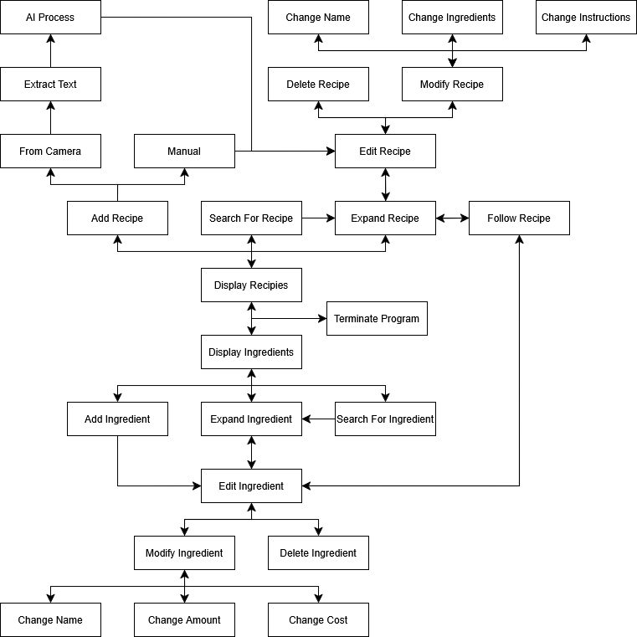
Figure 3: Dynamic State Chart
The system will include a multitude of states, though they can be divided into two primary sections: Display Recipes (and all its sub-states), and Display Ingredients (and all its sub-states). There is no main menu for this application. Rather, the application will default to the Display Ingredients page. The user can swap between Display Ingredients and Display Recipes as they wish.

Dataflow Diagram:
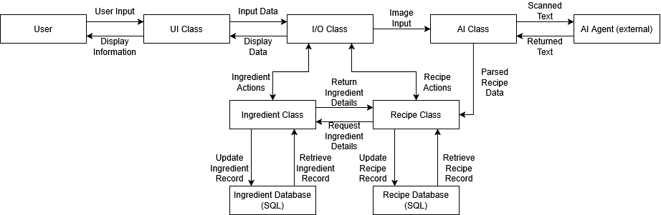
Figure 4: Dataflow Diagram
Data storage centers around two SQL databases, the Ingredient Database and Recipe Database. Access is restricted to the corresponding classes, wherein Ingredient Class and Recipe Class can exclusively access their respective database. Data transferred to and from these databases will pass through the I/O class before entering the UI Class, which displays information to the User. The Recipe Class can request details from the Ingredient Class, which acquires those details from the Ingredient Database. The AI Class and AI Agent are closely connected, with the AI Class receiving an image from the I/O Class. The AI Class then parses text from the image and sends the text to the AI Agent, which formats and returns the text, ready to be inputted into the Recipe Class.

Components Needed:
A mobile device running Android will be required to use the application. No other external hardware or software will be needed. For development, an IDE will be used to create an application that can be installed on Android devices.

References:
- How to use Play Console - Play Console Help. (n.d.). Support.google.com. https://support.google.com/googleplay/android-developer/answer/6112435?hl=en#zippy=
- Apple. (2025). Enrollment - Membership - Account - Help - Apple Developer. Apple.com. https://developer.apple.com/help/account/membership/program-enrollment/

Appendix: Glossary:
Python - A high-level, general-purpose programing language.
SQL - A programming language designed for storing and manipulating data.
AI - Artificial Intelligence: A computer learning, reasoning, or problem solving in ways traditionally outside of their scope.
Android – An operating system designed for touch screen mobile devices such as phones or tablets.
IOS – An operating system developed by Apple specifically designed for Apple mobile phones.
IDE - a software application that bundles a comprehensive set of programming tools into a single interface.
Application – A type of software designed to help users perform specific tasks.
UI – The point of Human-Computer interaction where a person controls a device and receives feedback
Data – Information stored on and used by a computer.
Developers - Someone who designs, creates, and maintains a computer application.
Clients - A person or company that receives a service.
End-User - A person who intends to use the software or application.
Android SDK - A software development kit to create and adjust applications on the android store.
IOS SDK - A software development kit to create and adjust applications on the apple store.
Variables - A named container that stores data.
String - A data type for characters.
Float - A data type for decimals.
Integer - A data type for numbers.
Class - A user defined data structure that has data and functions.
I/O - Input and output.
Parse - Analyzing a sequence of characters or data.

Appendix: Team Details:
This document was written in collaboration among all team members. Work was divided among them as described below:
Eli Haky was responsible for the sections:
- Abstract
- Purpose and Use
- Intended Audience
- System Description Overview
- Testers
- Criteria for User Acceptance
- Integration of Separate Parts and Installation
- Glossary
Nikolaus Roebuck was responsible for the sections:
- End User Profile
- User Interaction
- Hardware Constraints
- Software Constraints
- Time Constraints
- Cost Constraints
- Other Concerns
Evan Thompson was responsible for the sections:
- Functional: Use Cases and Scenarios
- Class Diagrams
- Class Descriptions
- Dynamic State Chart
- Dataflow Diagram
- Components Needed
Any sections not assigned to a specific team member were written together in an in-person group setting.

Appendix: Writing Center Report:
See email sent from the writing center on 11/13/2025

Appendix: Workflow Authorization:

I, Eli Haky, confirm that I have completed the work on this document as described above. Date: 11/12/2025


I, Nikolaus Roebuck, confirm that I have completed the work on this document as described above. Date: 11/12/2025


I, Evan Thompson, confirm that I have completed the work on this document as described above. Date: 11/12/2025

