The Impact of Autism Spectrum Disorder On A Restless Bandit Task

Evan Knep

2024-05-04

# **The Impact of Autism Spectrum Disorder On A Restless Bandit Task**

This research project aims to explore behavioral differences between individuals on the autism spectrum and the general population as they engage in an online restless bandit task. Prior research suggests that individuals with Autism Spectrum Disorder (ASD) may exhibit unique cognitive processing patterns that could influence their decision-making in such tasks. In particular, individuals on the spectrum possess rigid behaviors and stereotypies that may cause challenges in a task with high uncertainty. By comparing performance metrics such as average reward, reaction times, and choice biases between the two groups, this study seeks to identify distinct decision-making patterns that could shed light on the cognitive processes underlying ASD.

## **Hypothesis and Research Questions**

1. Individuals on the Autism Spectrum Will Exhibit Decreased Choice Distribution Compared to Control
2. Individuals on the Autism Spectrum Will Exhibit Faster Reaction Times Compared to Control
3. Individuals on the Autism Spectrum Will Exhibit Worse Performance Compared to Control
4. Classification Algorithms Will Be Able To Differentiate Between Participants on The Autism Spectrum and General Population Based on Behavioral metrics

# Method

### **Open Science Materials**

### **Participants**

Participants were collected in two rounds. Undergraduate students participating in psyREP opportunities took part in an online restless bandit task in the fall of 2023. Autism Spectrum Individuals were collected in collaboration with Simons Powering Autism Research (SPARK), and took part in an online restless bandit task in the Spring of 2024. Both rounds of data collection were administered via Pavlovia.org

### **Measures**

* num_correct: The number of trials in which each participant was rewarded
* p_reward: The percentage of total trials that each participant was rewarded on
* p_chance: The chance level of each participants individual “walk” (the random nature of the task means that each participant will experience a slightly different version of the task)
* reward_over_chance: p_reward - p_chance, or how much more often each participant was rewarded than if they sampled randomly. A measure of performance per participant
* avg_rt: average reaction time to make a decision once stimuli are presented
* median_rt: median reaction time to make a decision once stimuli are presented
* sd_rt: standard deviation of decision time
* max_choice_bias: The percentage of the trials in which each participant selected their most chosen option. An analog for behavioral stickiness and/or task engagement

### **Procedure**

Participants were asked to complete a restless bandit task, in which they must select one of 3 images each trial. Each image is associated with a probability of reward that change randomly and independently over time. The only way for participants to determine the reward probability of a given option is to sample the environment.

# **Analyses**

### **Descriptive Statistics and Static Visualizations**

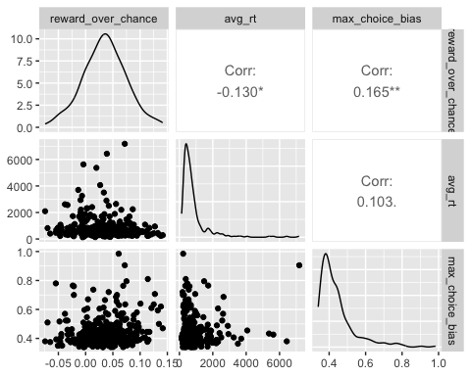

### **Interactive Visualization**

An interactive web app is available by [clicking this link](https://knepx001.shinyapps.io/psy8712-final/). The interactive component allows the reader to view the distribution of each feature by group, as well as the correlation between variables separated by group. Additional measures for reaction time for viewers to access.

### **Data Cleaning**

The data cleaning procedure for this project required taking individual trial by trial files for each participant. Files were combined into master files separated by group before being combined into one superfile with all participants. Results were filtered to include on trial relevant information, and then grouped by participant to calculate summary statistics for each participant rather than retaining trial by trial information. The resulting dataset containing one row for each participant was then used for data analysis and visualization.

### **Analysis**

**H1. Individuals on the Autism Spectrum Will Exhibit Decreased Choice Distribution Compared to Control**

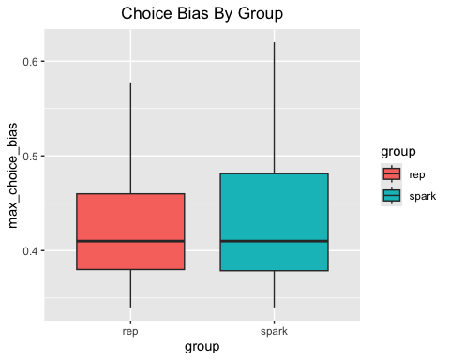

When comparing maximum choice bias between our spark (ASD) and rep (general population) participants, we find that there is not a significant difference between the two groups t(322) = -1.7091337, p = 0.0883988. This suggests that contrary to what we hypothesized, Autism associated stereotypies are not translating to the bandit task.

**H2. Individuals on the Autism Spectrum Will Exhibit Faster Reaction Times Compared to Control**

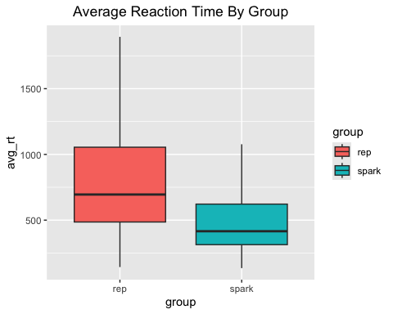

When comparing average reaction times between our spark and rep participants, we find that there is a significant difference between the two groups t(322) = 4.2453471, p = 2.858666^{-5}. This suggests that as we hypothesized, individuals on the Autism spectrum are in fact committing to a choice more quickly. This has interesting implications considering we did not see a group difference in choice bias, suggesting that they are not choosing more quickly as a result of sticking to a single choice.

**H3. Individuals on the Autism Spectrum Will Exhibit Worse Performance Compared to Control**

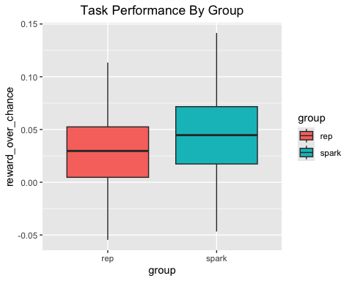

When comparing reward over chance, an analog for task performance, between our spark and rep participants, we find that there is a significant difference between the two groups t(322) = 4.2453471, p = 2.858666^{-5}. This suggests that are hypothesis is incorrect, and in fact individuals on the Autism spectrum are performing better than those in the general population.

**H4. Classification Algorithms Will Be Able To Differentiate Between Participants on The Autism Spectrum and General Population Based on Behavioral metrics**

| algo | training_accuracy | test_accuracy |
| --- | --- | --- |
| GLM | 0.69 | 0.67 |
| Naive Bayes | 0.71 | 0.70 |
| K Nearest Neighbor | 0.76 | 0.68 |

When examining classification performance across three different machine learning algorithms, we see that while imperfect, all three are able to predict participant group above chance. This suggests that when observing task behavior in the form of reward over chance, reaction time, and choice bias, there are distinct behavior profiles within those on the Autism spectrum and the general population, and that we may be able to predict bandit task behaviors based on diagnoses.

# **Reflection**

I’ve learned a great this semester and really enjoyed the course. I often didn’t have as much time as I would’ve liked to dedicate to experimenting with what we learned, but I anticipate doing so quite a bit in the coming months. I had very little experience in R, and plenty of bad practices from years of self-taught python. Learning in this sort of structured course environment, and this style of DataCamp lessons at home and troubleshooting/lecture in class, was really valuable. There are still plenty of concepts that I don’t fully understand beyond basic implementation, and I don’t doubt that there will be some best practice issues present in this final project, but overall I think the re-learning approach with better habits has been a great experience. If I had to pick one thing that I think I will be implementing the most, it would actually be piping. Such a clean way to sequentially process data, I’ve been looking for python alternatives but so far nothing quite compares. Thanks for a great semester!