Influence of coarse additions on the plasticity and toughness of soil mixtures, Part II: Effect of sand angularity and sand-size uniformity.

last compiled 2022-06-20, 1:54 PM

# Abstract

The Atterberg limits may offer a useful means to evaluate baseball infield soils because they quantitatively relate soil behavior to water content. Prior research has demonstrated that liquid and plastic limits (LL and PL) of sand-clay mixtures are affected by the quantity and type of admixed sand, but these studies have used <425 μm sand exclusively and little attention has been devoted to sand angularity and sand-size uniformity.

This research was conducted to clarify the effect of sand angularity and sand-size uniformity on the Atterberg limits of soil mixtures containing a range of sand contents and a significant mass percentage 2000-425 μm.

Experiment 1 compared the effect of mixing either on angular or a round sand (both 1000-500 μm) with a kaolinitic clay at sand contents between 0 and 80%. Little difference was observed in LL and PL, suggesting angularity plays a minimal role on mix performance.

Experiment 2 compared the effect of mixing one of two sands having similar D50 (420 and 490 μm) but varying uniformity (uniformity coefficients of 1.9 vs. 3.9) with an illitic clay at sand content 0-80%.

A small but significant increase in LL was observed for mixtures produced using the high-Cu sand. These mixtures also maintained their plasticity to higher sand content (~72.5%) than those produced with the low-Cu sand (~67.5%).

Calculations for the threshold fines content (TFC) agreed closely with the experiments, indicating a potential to estimate TFC from sand porosity alone.

# Introduction

The Atterberg limits are used by geotechnical engineers to classify fine-grained soils (ASTM International, 2017). These tests include the liquid limit (LL) and plastic limit (PL). The tests were developed for fine-grained soils (silts and clays), but research has shown the amount and properties of admixed sand also affects test results (Atterberg, 1911; Dumbleton and West, 1966; Sivapullaiah and Sridharan, 1985; Barnes, 2013); these studies were performed on soils meeting standard protocols which only allow particles <425 μm (ASTM D4318). Recent research has demonstrated that the LL and PL tests can be performed on soils containing a significant amount of particles 2000-425 μm (Mascitti and McNitt, Part I, this issue). It is unclear what effect sand shape and uniformity play on the Atterberg limits of soil mixtures containing these coarser sands.

Particle angularity and particle-size uniformity are known to affect the behavior of granular materials, but their effects are less clear for soils which contain significant amounts of fines (Mitchell and Soga, 1993; Hojae and McNitt, 2001; Holtz et al., 2010; Miller and Henderson, 2011; Zuo and Baudet, 2015).

## Atterberg limits of soils having varied sand angularity

Particle angularity is defined as the roughness of a particle surface (Brady and Weil, 2007). Mathematical definitions have been used to quantify angularity, although it is often estimated using representative charts developed from the metrics (Wadell, 1932; Krumbein, 1941; Suhr et al., 2020).

Research on the importance of sand angularity in soil mixtures has produced mixed results. Dumbleton and West (1966) evaluated mixtures of various types of coarse particles with either kaolinite or montmorillonite. Dumbleton and West (1966) demonstrated that mixtures including angular sand had higher LL and PL relative to mixtures produced with equivalent amounts of glass spheres. Dumbleton and West (1966) postulated that angular particles had more surface area compared to the spheres, requiring additional water to coat their surfaces before they could slide or flow past one another.

Findings by Sivapullaiah and Sridharan (1985) differ from those of Dumbleton and West (1966). Sivapullaiah and Sridharan (1985) mixed either angular or round particles of the same size fraction (150 μm – 75 μm) with bentonite clay at sand contents ranging from 20-95 %. Sivapullaiah and Sridharan (1985) reported no difference in the liquid or plastic limits due to angularity.

## Atterberg limits of soils having varied sand-size uniformity

Particle-size uniformity, or more simply “uniformity,” is defined as the similarity of diameters across particles within a soil. The coefficient of uniformity (Cu) is a commonly used mathematical definition (Adams and Gibbs, 1994; Holtz et al., 2010) and is the ratio between the particle diameters at which 60% and 10% of the sample is finer:

Little research is available on the effect of sand uniformity on the Atterberg limits of soil mixtures. This is probably because the upper boundary of allowed particle sizes in ASTM D4318 (425 μm) limits the total range of sand particle diameters. Dumbleton and West (1966) reported that mixes produced using non-uniform sand had similar Atterberg limits to mixes containing sand from a single mesh size. However, all the sand in their experiment was 425-75 μm, limiting the potential variability in uniformity. Lade et al. (1998) demonstrated that efficient particle packing is limited when particle diameters fall within a factor of 10. It is possible that a larger uniformity effect on LL and PL would be observed if sand >425 μm were included in the mixture.

At very low sand contents, angularity and uniformity are probably unimportant because the sand grains are suspended in a clay-water matrix and do play an insignificant role in transmitting loads through the soil skeleton. At higher sand contents, the coarse grains begin to contact one another and the nature of these contacts will affect the behavior of the bulk soil (Mitchell and Soga, 1993; Zuo and Baudet, 2015). As sand content continues to increase, the soil becomes nonplastic because plasticity is not observed in soils dominated by granular particles (Mitchell and Soga, 1993; Holtz et al., 2010). The behavior transition between sand-like and fines-like behavior occurs at a fines content termed the threshold fines content (TFC) (Zuo and Baudet, 2015; Sibley and Polito, 2020).

Less-uniform sands have less total void space, so one could expect these sands to require a lesser proportion of fines and water to fill their interstices compared with a more uniform sand. Therefore, sand uniformity could conceivably alter the LL, PL, and the highest sand content at which the soil will exhibit plasticity.

# Objectives

The present research was conducted to answer two questions:

1. How does sand particle angularity affect the LL and PL of sand-clay mixtures when total sand content and sand particle size are held constant?
2. How does sand-size uniformity affect the LL and PL of sand-clay mixtures when total sand content and sand D50 are held constant?

# Materials and methods

Two experiments were conducted to evaluate the effects of sand angularity and sand-size uniformity on the Atterberg limits of soil mixtures containing a range of sand contents.

In Experiment 1, soil mixtures were produced using seven rates of two sands having equivalent particle size but varied angularity and a single kaolinitic clay soil described in Mascitti and McNitt, Part I, this issue). In Experiment 2, soil mixtures were produced using 21 rates of one of two sands having equivalent D50 but varied Cu and an illitic clay for a total of 42 mixtures.

## Mixture component characterization

Particle size analyses (Gee and Or, 2002) were performed on each of the four sands and the two clay components used in the two experiments (Figure 2). For the fraction <53 μm, gravity sedimentation plus centrifugation were used along with the pipette method to compute the percent of the sample finer than 20, 5, 2, and 0.2 μm. Particles >53 μm were separated using a Ro-tap shaker (W.S. Tyler, Montor, OH) and a stack of mesh sieves.

The minimum and maximum void ratios of each sand component were characterized using modified versions of ASTM F-1815 and D4254 (ASTM 2011, 2016). The modification to the minimum void ratio test was that the sand was compacted in an air-dry state, rather than field-moist, to maximize the obtained density. In the maximum void ratio test, the sand was loosely poured into a container of known volume and leveled with a straight edge. Void ratio was determined using bulk density and particle density of the sand (ASTM 2016).

## Mixing procedure

All mixture components were air-dried and their water contents were determined gravimetrically. The clay components were pulverized and passed through 0.25 mm screen. Sands were mixed by hand with the relevant clay component until visually homogeneous. The mixture component percentages were adjusted for the trace amounts of particles 2000-53 μm in the clay components and the air-dry water content of each component. Final mixture percentages are expressed as oven-dry mass.

## Treatments

Experiment 1 evaluated mixtures containing equivalent amounts of one of two sands having varying angularity. Two sands were selected based on their classification as angular and well-rounded. The sands (Figure **1**) were visually classified using a microscope and the angularity chart from ASTM F1632. Each sand was then repeatedly sieved to remove particles <0.5 mm and >1 mm. The single-mesh sands were mixed with a kaolinitic clay to yield mixtures having 0, 20, 40, 60, 70, 75, and 80 % sand.

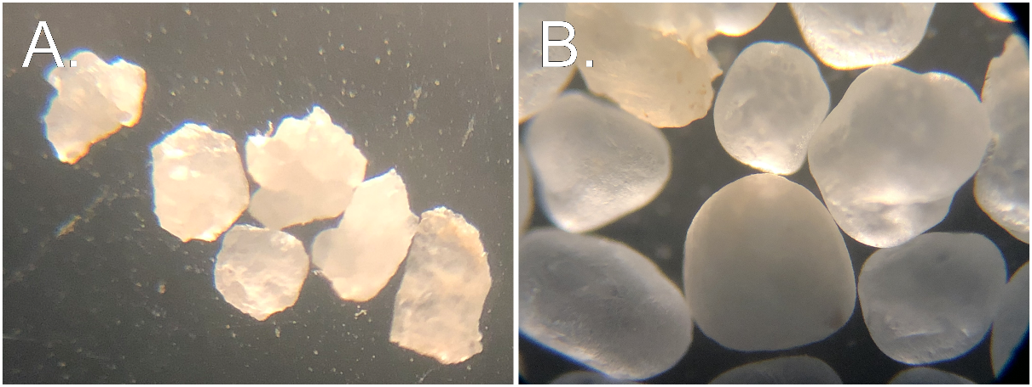

**Figure** **1**: Angular (A.) and well-rounded (B.) sands used for Experiment 1.

Experiment 2 evaluated the effect of sand-size uniformity for mixtures containing one of two sands having similar D50 but varying Cu and a majority of particles >425 μm. The two sands were produced from a single washed concrete sand having a wide particle size distribution. The original concrete sand was sieved to remove all particles >1 mm and <250 μm. The remaining fraction between 1000 and 500 μm was riffled into two aliquots. The first liquot remained untouched and is termed the “low-Cu sand”. The second aliquot, termed the “high-Cu sand”, had a portion of the previously removed particles (>1000 μm and <250 μm) returned. This procedure created a wider particle-size distribution while maintaining a similar D50. Figure **2** shows the particle size distributions of the low-Cu and high-Cu sands. These sands meet the criteria of having similar D50 values (420 μm and 490 μm) but different Cu values (1.9 vs. 3.9). While the Cu value of 3.9 is still relatively low compared to natural alluvial sands, in this experiment the maximum obtainable Cu was limited by the maximum particle diameter of 2000 μm and the intentionally limited mass of particles <425 μm.

Each of these sands were mixed with a single illitic clay soil to yield 42 mixtures having between 0 and 80% sand. Mixtures were produced at 5% sand content intervals between 0 and 50%, and a 2.5% interval between 50 and 80% sand. The increased spacing of data points between 50-80% sand was designed to provide better resolution near the threshold fines content.

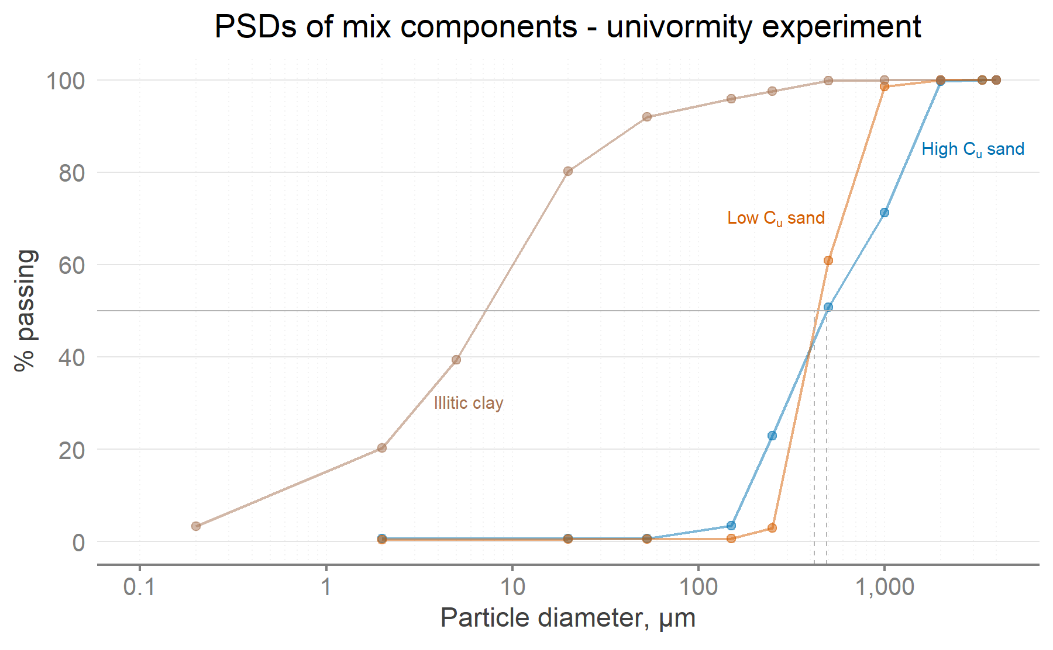

**Figure** **2**: Particle size distributions for the two sands and one clay used in Experiment 2. Dashed grey lines indicate for each sand.

## Atterberg limit test protocol

After mixing the sand with the relevant clay component, LL and PL tests were performed on a series of mixtures to evaluate the effect of sand angularity or uniformity.

The liquid and plastic limit tests were performed according to a modified version of ASTM D4318 (ASTM International, 2018). The modification eliminated the wet-sieving procedure so particles between 2000 and 425 μm remained in the sample (Mascitti and McNitt, Part I, this issue). At least four data points were collected during the LL test in order to plot the flow curve. In the PL test, 3 threads were rolled to the crumbling condition before being weighed to ± 0.001 g and oven-dried. In both experiments the average of the 3 results was used to represent the PL of each sample.

## Statistical analysis and computational environment

LL and PL were the dependent variables in both experiments. In Experiment 1, a two-way ANOVA model was fitted to test the interaction effect between particle shape and percent sand (Table **1**). Particle shape was considered a categorical predictor while a 2nd-order polynomial spline term was used to model percent sand as a continuous predictor. In Experiment 2, Cu was considered a categorical predictor while percent sand was treated as in Experiment 1. Main effects and interactions were tested using Type III Sums of Squares. Treatments were considered significantly different at α = 0.05.

All analyses were performed using the lm() function in the R Language for Statistical Computing (version 4.2.0) (R Core Team, 2022). GNU Make (GNU, 2020) was used to facilitate reproducible analyses by maintaining links between raw data, analysis code, and finished output. Raw data and analysis code are included in the supplemental materials.

# Results and discussion

## Experiment 1: Effect of sand angularity

Experiment 1 compared LL and PL of mixtures containing between 0 and 80% sand having equal particle size but varied angularity (Figure **3**). LL and PL were nearly identical for sand content <60%. At sand content ≥ 60%, LL and PL of mixtures containing the angular sand were slightly higher than mixtures containing the round sand, but the differences were not statistically significant.

The maximum difference between angular and round sand for any of the tests was 1.0 % water content. Under the conditions of this study, this finding suggests particle angularity has no effect on Atterberg limits when sand size and sand content are held constant.

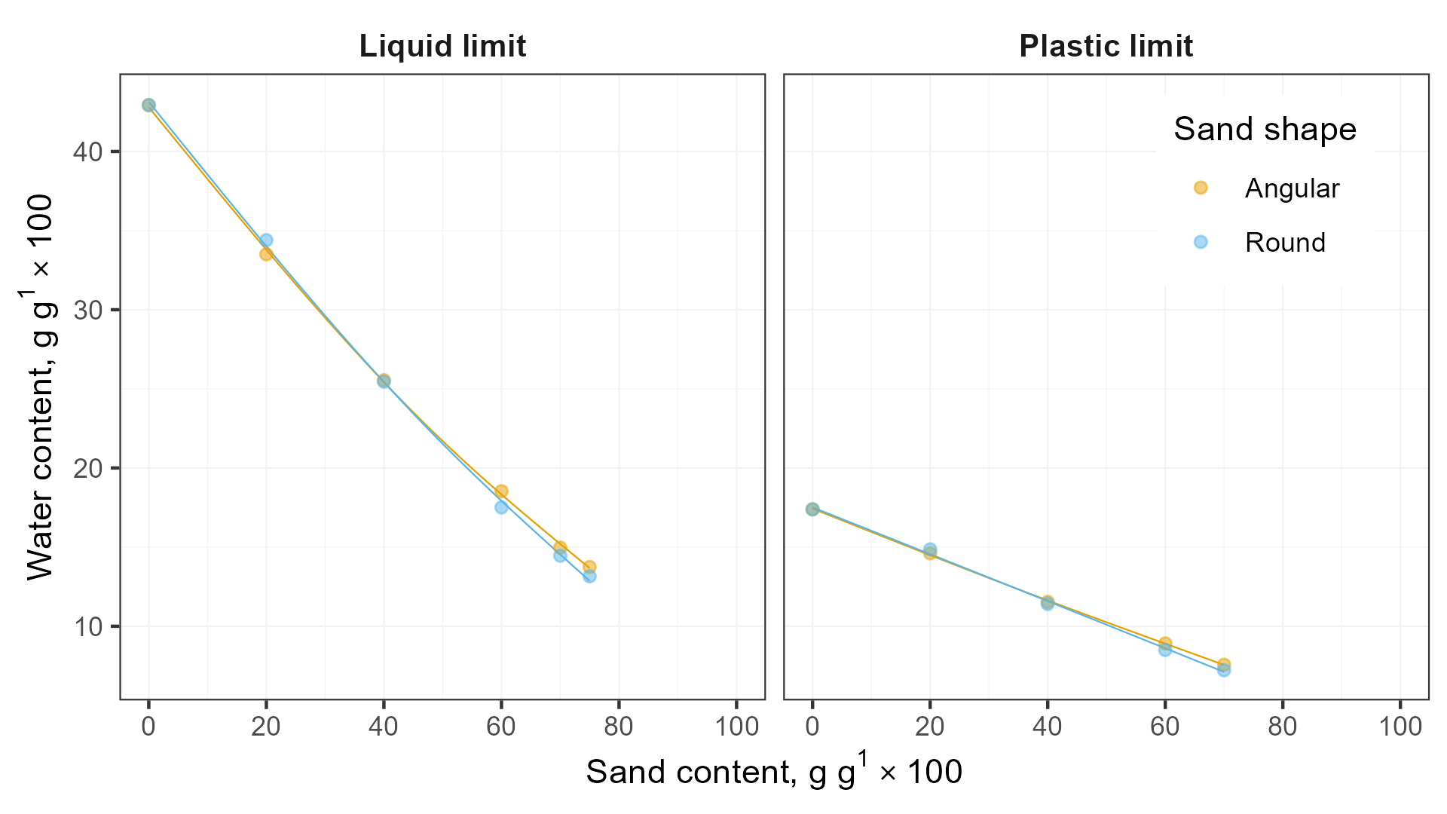

**Figure** **3**: Effect of particle shape on LL and PL in Experiment 1. The effect of particle shape on LL and PL in Experiment 1 was small and not statistically significant.

**Table** **1**: Analysis of variance table for LL and PL of the mixtures in Experiment 1.

| Test type | Term | Sum Sq. | Deg. of Fr. | F-Statistic | P-value |
| --- | --- | --- | --- | --- | --- |
|  | Intercept | 0.210 | 1 | 18,851 | <0.001 |
|  | % coarse addition | 0.0663 | 2 | 2,971 | <0.001 |
| LL | Shape | <0.0001 | 1 | 0.585 | 0.473 |
|  | % coarse addition x Shape | <0.0001 | 2 | 2.52 | 0.160 |
|  | Residuals | <0.0001 | 6 | - | - |
|  | Intercept | 0.0336 | 1 | 7,179 | <0.001 |
|  | % coarse addition | 0.0066 | 2 | 696.7 | <0.001 |
| PL | Shape | <0.0001 | 1 | 0.075 | 0.798 |
|  | % coarse addition x Shape | <0.0001 | 2 | 1.149 | 0.404 |
|  | Residuals | <0.0001 | 4 | - | - |

## 

## Experiment 2: Effect of sand-size uniformity

### Uniformity effect on LL and PL

The LL and PL of mixtures including either the low-Cu or high-Cu sand were inversely proportional to sand content up to ~65-70%, and this finding agrees with other research on mixtures containing sand with D50 > 0.425 mm (Mascitti and McNitt, Part I, this issue).

Mixtures produced with low-Cu sand had higher LL and PL than those produced using high-Cu sand (Figure **4**). This small effect was statistically significant for the LL but not for the PL (Table **2**). Although this effect is measurable, it is probably of little practical significance given/because…... In Experiment 2, the sand content was more influential than sand uniformity on the LL and PL. While only a single clay was tested, the effect of varying the clay’s plasticity would likely affect LL and PL to a greater degree than varying the Cu of the sand.

Dumbleton and West (1966) suggested that observed differences in LL and PL due to sand particle size were attributable to higher specific surface area (SSA). The nonlinear relationship between SSA and particle diameter means the low-Cu sand would consume more water and mixtures containing this sand would require a concomitant increase in bulk water content to allow the silt and clay particles to slide or flow during the PL and LL tests.

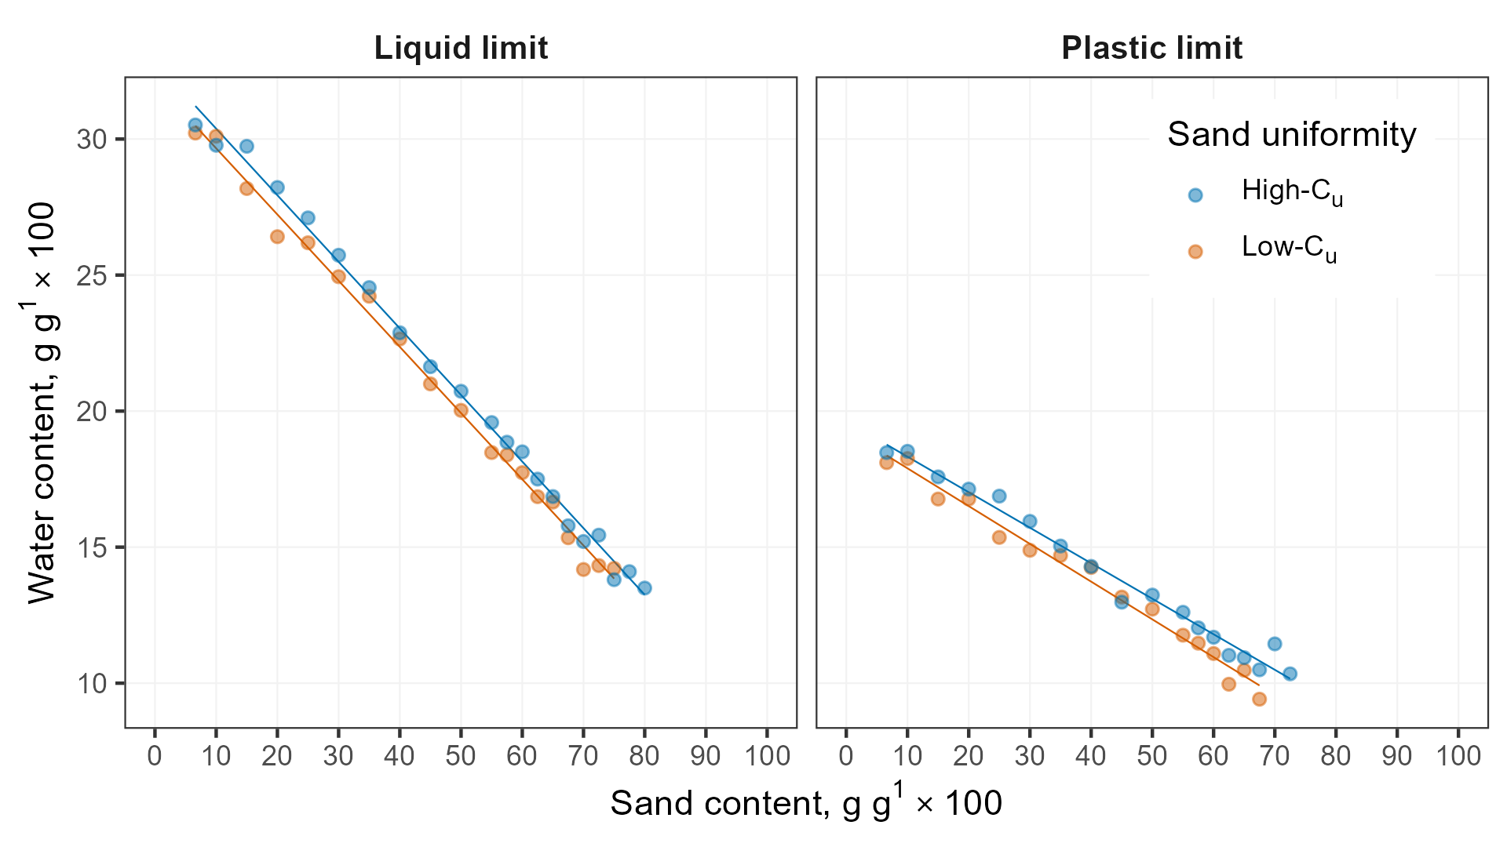

**Figure** **4**: The high-Cu sand had higher LL and PL than the low-Cu sand at nearly all sand contents.

**Table** **2**: Analysis of variance table for LL and PL of mixtures in Experiment 2. Significant effects at α=0.05 in bold.

| Test type | Term | Sum Sq. | Deg. of Fr. | F-Statistic | P-value |
| --- | --- | --- | --- | --- | --- |
|  | **Intercept** | **0.4116** | **1** | **24,715.22** | **0.0000** |
|  | **% sand** | **0.0659** | **1** | **3,954.04** | **0.0000** |
| **LL** | **Uniformity** | **0.0001** | **1** | **6.00** | **0.0193** |
|  | % sand x Uniformity | 0.0000 | 1 | 0.06 | 0.8065 |
|  | Residuals | 0.0006 | 36 |  |  |
|  | **Intercept** | **0.1315** | **1** | **8,914.39** | **0.0000** |
|  | **% sand** | **0.0137** | **1** | **928.96** | **0.0000** |
| PL | Uniformity | 0.0000 | 1 | 1.32 | 0.2595 |
|  | % sand x Uniformity | 0.0000 | 1 | 1.64 | 0.2101 |
|  | Residuals | 0.0004 | 30 |  |  |

### Uniformity effect on apparent threshold fines content

Another feature of Experiment 2 was that mixtures containing sands having varying Cu became nonplastic at different sand content. Low-Cu sand mixtures containing 70, 72.5, and 75% sand could not be rolled into threads, but high-Cu mixtures at these sand contents still had measurable plastic limits. These observations suggest that the threshold fines content is affected by sand uniformity and merits further study. Calculations for the TFC and real soil behavior observed in experiments rarely coincide (Zuo and Baudet, 2015). However, little attention has been paid to soil mixtures containing plastic fines as opposed to nonplastic silt. While this concept was neither replicated nor tested on multiple clays in the current study, further research may demonstrate that TFC can be accurately computed from the minimum void ratio of a sand without performing lengthy experiments.

# Conclusions

Standard Atterberg limit test protocols limit the particle size range to <425 um. Parts I and II of this research have each demonstrated that the tests can be accurately performed when the mixtures contain particles 2000-425 um, even when the mixtures contain up to ~70% added coarse particles. Both papers have also shown that when coarse sand is used, there is a strong linear relationship between sand content and LL or PL up to ≥60% sand, whereas Part I showed that the relationship is weaker for sands falling below the upper particle size limit.

Sand angularity had no effect on LL or PL in Experiment 1.

Sand-size uniformity affected LL but not PL in Experiment 2. High-Cu mixtures required more water to wet them to the LL than low-C­u mixtures. This trend could be due to the higher specific surface area of the high-Cu sand.

The high-Cu sand mixtures in Experiment 2 also became nonplastic at relatively lower sand content than low-Cu mixtures. This implies a predictive model might be developed from Cu and/or void ratio to compute the threshold fines content marking a change from plastic to nonplastic behavior.

Collectively, the results of Parts I and II demonstrate that Atterberg limits can be performed with significant amounts of particles coarser than the current limit specified in ASTM D4318. Sand angularity and sand-size uniformity have less influence on Atterberg limits of soil mixtures than sand particle size and total sand content.

# Acknowledgements

This work was supported by the USDA National Institute of Food and Federal Appropriations, the Foundation for Safer Athletic Fields for Everyone, the Pennsylvania Turfgrass Council, and the Keystone Athletic Field Managers Organization.

# Conflict of interest

The authors declare that there are no conflicts of interest.

# Author contributions

Evan Mascitti: [Conceptualization](http://credit.niso.org/contributor-roles/conceptualization/), [Data curation](http://credit.niso.org/contributor-roles/data-curation/), [Formal analysis](http://credit.niso.org/contributor-roles/formal-analysis/), [Investigation](http://credit.niso.org/contributor-roles/investigation/), [Methodology](http://credit.niso.org/contributor-roles/methodology/), [Project administration](http://credit.niso.org/contributor-roles/project-administration/), [Resources](http://credit.niso.org/contributor-roles/resources/), [Software](http://credit.niso.org/contributor-roles/software/), [Validation](http://credit.niso.org/contributor-roles/validation/), [Visualization](http://credit.niso.org/contributor-roles/visualization/), [Writing – original draft](http://credit.niso.org/contributor-roles/writing-original-draft/), [Writing – review & editing](http://credit.niso.org/contributor-roles/writing-review-editing/).

Andrew McNitt: [Funding acquisition](http://credit.niso.org/contributor-roles/funding-acquisition/), [Project administration](http://credit.niso.org/contributor-roles/project-administration/), [Resources](http://credit.niso.org/contributor-roles/resources/), [Supervision](http://credit.niso.org/contributor-roles/supervision/), [Writing – review & editing](http://credit.niso.org/contributor-roles/writing-review-editing/).

# References

Adams, W.A., and R.J. Gibbs. 1994. Natural Turf for Sport and Amenity. 1st ed. CABI International.

ASTM International. 2011. F1815-11 Standard Test Methods for Saturated Hydraulic Conductivity , Water Retention , Porosity , and Bulk Density of Athletic Field Rootzones. doi: [10.1520/F1815-11.2](https://doi.org/10.1520/F1815-11.2).

ASTM International. 2016. [4253-16: Test Methods for Maximum Index Density and Unit Weight of Soils Using a Vibratory Table](https://doi.org/10.1520/D4253-16). ASTM International.

ASTM International. 2017. [Test Methods for Particle-Size Distribution (Gradation) of Soils Using Sieve Analysis](https://doi.org/10.1520/D6913_D6913M-17). ASTM International.

ASTM International. 2018. D4318-17, Standard Test Methods for Liquid Limit, Plastic Limit, and Plasticity Index of Soils. doi: [10.1520/D4318-17E01.](https://doi.org/10.1520/D4318-17E01.)

Atterberg, A. 1911. Die Plastizität der Tone. Intern mitt. boden: 4–37.

Baker, B., Stephen W. (Sports Turf Research Institute). 2006. Rootzones, Sands and Top Dressing Materials for Sports Turf. Sports Turf Research Institute, West Yorkshire, England.

Barnes, G.E. 2013. The Plastic Limit and Workability of Soils. <https://www.escholar.manchester.ac.uk/api/datastream?publicationPid=uk-ac-man-scw:212752&datastreamId=FULL-TEXT.PDF>.

Brady, N.C., and R.C. Weil. 2007. The Nature and Properties of Soils. Prentice Hall, Upper Saddle River, NJ.

Dumbleton, M.J., and G. West. 1966. The influence of the coarse fraction on the plastic properties of clay soils- RRL Report No. 36. Road Research Laboratory, Crowthorne, Berkshire.

GNU. 2020. GNU Make. Free Software Foundation.

Hojae, Y., and A.S. McNitt. 2001. [Measurement of bulk mechanical properties of root-zone sand mixtures](https://doi.org/10.13031/2013.4119). 2001 Sacramento, CA July 29-August 1,2001. American Society of Agricultural and Biological Engineers

Holtz, R.D., W.D. Kovacs, and T.C. Sheahan. 2010. An Introduction to Geotechnical Engineering. Pearson, New York, NY.

Krumbein, W.C. 1941. Measurement and Geological Significance of Shape and Roundness of Sedimentary Particles. SEPM JSR Vol. 11. doi: [10.1306/D42690F3-2B26-11D7-8648000102C1865D](https://doi.org/10.1306/D42690F3-2B26-11D7-8648000102C1865D).

Lade, P.V., C.D. Liggio Jr., and J.A. Yamamuro. 1998. Effects of Particle Shapes and Sizes on the Minimum Void Ratios of Sand. Geotechnical Testing Journal 21(4): 336–347.

Miller, N.A., and J.J. Henderson. 2011. Correlating Particle Shape Parameters to Bulk Properties and Load Stress at Two Water Contents. Agron. J. 103(5): 1514–1523. doi: [10.2134/agronj2010.0235](https://doi.org/10.2134/agronj2010.0235).

Mitchell, J.K., and K. Soga. 1993. Fundamentals of Soil Behavior. 3rd ed. Wiley.

Sibley, E.L.D., and C.P. Polito. 2020. [Insights on Threshold Fines Content](https://geovirtual2020.ca/wp-content/files/406.pdf). Geovirtual 2020 Resilience and Innovation

Sivapullaiah, P.V., and A. Sridharan. 1985. Liquid Limit of Soil Mixtures. Geotechnical Testing Journal 8(3): 111–116. doi: [10.1520/gtj10521j](https://doi.org/10.1520/gtj10521j).

Suhr, B., W.A. Skipper, R. Lewis, and K. Six. 2020. Shape analysis of railway ballast stones: Curvature-based calculation of particle angularity. Sci Rep 10(1): 6045. doi: [10.1038/s41598-020-62827-w](https://doi.org/10.1038/s41598-020-62827-w).

Team, R.C. 2022. [R: A language and environment for statistical computing. R Foundation for Statistical Computing](https://www.R-project.org/). Vienna, Austria.

Wadell, H. 1932. Volume, Shape, and Roundness of Rock Particles. The Journal of Geology 40(5): 443–451. <https://www.jstor.org/stable/30058012>.

Zuo, L., and B.A. Baudet. 2015. Determination of the transitional fines content of sand-non plastic fines mixtures. Soils and Foundations 55(1): 213–219. doi: [10.1016/j.sandf.2014.12.017](https://doi.org/10.1016/j.sandf.2014.12.017).