Evan’s PhD thesis proposal

Evan C Mascitti

last updated 2020-10-23

Table of Contents

# 1 Introduction

The production of artificial soils has received much study. However, there are no published scientific experiments on this topic as it pertains to baseball and softball fields.

# 2 Purpose

The purpose of my thesis is to create a new way to think about the soils used on baseball and softball infields.

## 2.1 Objectives and deliverables

The deliverables from this project are:

1. a general framework for understanding the behavior of sand-clay mixes in a quantitative way
2. specific recommendations for the ratios which common clayey soils should be mixed with sand for optimal performance at any maintenance level
3. suggestions for how to beneficiate poorly-performing clay soils with other kinds of clays to maximize the locally available materials by “spiking” the local clay with a small percentage of imported solum

# 3 Review of literature

## 3.1 Soil mixtures for baseball and softball infields

Baseball was first played in the early 19th century, but the definitive origins of the game are likely lost to history (Walker et al., 1994). The earliest recorded attempt to alter the physical properties of an infield soil were by Harry Wright in 1875. Wright and his contemporaries incorporated various materials into their infield soils to enhance stability, firmness, or drainage of the playing surface. Amendments included organic debris (straw, ashes) and and inorganic materials (sand, lime, cinders) (Morris, 2007).

Infield soil mixes were produced off-site and imported beginning in the 1960s ?Zwasksa?.

Goodall et al. (2005) is the only published account of research on infield soil mixtures. The authors installed several soils which were commercially available within their region.

Brosnan et al. (2008) surveyed the surface conditions of the infield skin on extant playing fields at three maintenance levels. Particle size analyses were performed on soil sampled from each infield skin. The USDA soil texture of those samples is plotted in 3.1. These soils were sampled from the upper 13 mm and contained large granules of calcined clay infield conditioner; therefore, the texture measured with this method is coarser than the “true” texture of the base soil.

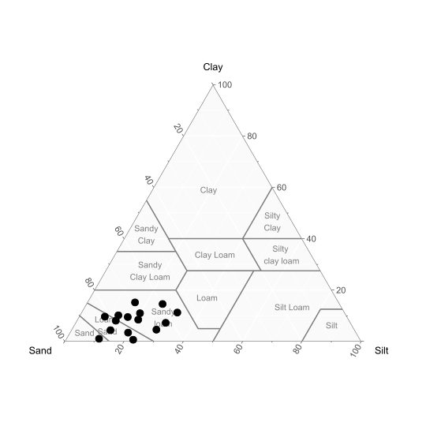

Figure 3.1: Infield soils suyveyed by Brosnan (2008a)

Additionally, Brosnan et al. published research on the infield skin’s role in athlete-to-surface interactions (2009) and ball-to-surface interactions (2011). Bulk density ($ρ_{bulk}$) was shown to influence surface properties, although the range of bulk densities tested (1.2 - 1.8 Mg m-3) was beneath values typically encountered on infield skins (author’s personal observation; data not shown).

However, the work of Brosnan et al. (2009; 2011) was performed on a single soil material and focused on construction and maintenance practices rather than mix design.

## 3.2 Laboratory methods for evaluating soil behavior and physical properties

Many soil tests have been developed with the goal of supplanting the Atterberg limits. However, due to the success and the abundance of data which has accumulated using these test methods, they are unlikely to be abandoned.

## 3.3 Definitions of soil behavior and physical properties

Toughness is really the most defining feature of clay soil.

### 3.3.1 Particle size analysis

### 3.3.2 Compaction tests

### 3.3.3 Compression and shear strength tests

### 3.3.4 Atterberg limits

### 3.3.5 Toughness tests

## 3.4 Behavior of sand-clay mixtures

The Atterberg limits and unconfined compression testing are the primary means which have been used to charazcterize soil mixtures. These mixtures may contain two components(sand and clay), or three components (sand and two separate types of clay soil)

# 4 Proposed experiments

## 4.1 Chapter 1: A novel method for measuring the performance of baseball and softball infield skin soils

## 4.2 Chapter 2: Toughness of clay soil near the plastic limit using unconfined compression tests

## 4.3 Chapter 3: A critical appraisal of particle size analysis as a proxy for soil behavior

## 4.4 Chapter 4: A rational theory of mix design for blended soils used on baseball and softball infields

# 5 References

Brosnan, J.T., A.S. McNitt, and T.J. Serensits. 2011. Effects of surface conditions on baseball playing surface pace. Journal of Testing and Evaluation 39(3). doi: [10.1520/JTE103215](https://doi.org/10.1520/JTE103215).

Brosnan, J.T., A.S. Mcnitt, and T.J. Serensits. 2009. Effects of varying surface characteristics on the hardness and traction of baseball field playing surfaces. International Turfgrass Society Research Journal 11(865): 1–13.

Brosnan, J.T., T. Plant, and S. Sciences. 2008. Surface Conditions of Highly Maintained Baseball Fields in the Northeastern United States : Part 1 , Non-Turfed Basepaths. Applied Turfgrass Science (April). doi: [10.1094/ATS-2008-0520-01-RS](https://doi.org/10.1094/ATS-2008-0520-01-RS).

Goodall, S.A., K. Guillard, W.M. Dest, and K.R. Demars. 2005. Ball response and traction of skinned infields amended with calcined clay at varying soil moisture contents. International Turfgrass Society Research Journal 10: 1085–1093.

Morris, P. 2007. Level Playing Fields: How the Groundskeeping Murphy Brothers Shaped Baseball. University of Nebraska Press, Lincoln, NE.

Walker, P.R., G.C. Ward, and K. Burns. 1994. Who Invented the Game? Alfred a Knopf.