ExamMaker User’s Manual Table of Contents

Introduction 3
What You’ll Need 3
System Overview 4
Getting Started 6
Using the ExamMaker Interface 21
Windows 21
Text boxes 21
Lists 22
Unusable buttons, text boxes, and other components. 22
ExamMaker Commands 23
Splash Window 23
Exam Maker Window 25
Enter or Edit Questions Window 36
Question Properties Window 39
Enter/Modify Answers Window 41
How to Use the Exported Files 44
Trouble Shooting 47
General Issues 47
Specific Issues 47
Troubleshooting Guide 49
Glossary 51
Index 53

Introduction

Welcome to ExamMaker! You are currently reading the User’s Manual, which will guide you through the various features of the ExamMaker software and will get you up and running with it in no time. This manual is for the end-user of the software— if you want to know how to use ExamMaker to produce exams, midterms, and tests, then you’re reading exactly the right thing.

What You’ll Need

To use ExamMaker, you should have experience with graphicl user interfaces (“GUIs”). If you’ve ever used MacOS or Microsoft Windows before, then you should be just fine. If not, you might need some help from someone with GUI experience as you go over this document.

System Overview

ExamMaker allows you to efficiently create, reproduce, and export exam content. This exported content consists of a text file that can be easily formatted using an external document processor (such as Microsoft Word) to produce written exams to students. An exam in ExamMaker can be thought of as a test, quiz, midterm, or similar type of examination that consists of a series of questions. ExamMaker provides a helpful system for reusing questions, allowing you to very quickly construct variants of an exam (or exams) by creating completely different mixtures of questions and answers.

Questions are the fundamental bits of information that you will be using in ExamMaker. Questions contain text that invite a response, for which the correct answer(s) or response(s) has (have) been pre-determined by you. Using ExamMaker, you can construct three types of questions:

True/False: These are questions for which there are only two possible answers—“true” or “false”. One of these is always correct and the other is always incorrect. The answer is meant to indicate whether the question text is correct or incorrect.

Multiple-Choice: You can create questions that will present four possible answers to the examinee. One of the answers will always be the correct response, and the other four will be incorrect (or less correct). A multiple choice question can have many more than four possible answers (correct or incorrect), but four (and only four) are presented to the user at a time. ExamMaker ensures that only one is correct, and that the three presented are incorrect.

Short Answer: You can create open ended questions, which do not have answers that are controlled by exam maker.

To allow you to reuse questions and answers, ExamMaker stores all the questions in “pools”. You can augment this question pool over the course of many exams, allowing you to create a vast repository of questions that can be used to make a new exam more quickly than the previous. It is easy to get to the point where you can create an new exam with very quickly without having to input a lot of new question content!

You will also be able to reload previously saved exams (“old exams”), view them, and export their contents. This allows you to quickly see what was in a previous exam, and adjust a currently developing exam accordingly.

As you can see, the ExamMaker philosophy is to reuse your previous work to make exam creation easier, faster, and more efficient for you. As you create more examination material, creating an original series of questions for a new exam will be easier because you will have more questions to choose from.

The ExamMaker software focus is content. While it makes creating exams easier, it does provide ways of formatting the resulting exam to make it presentable to the examinees. For this, you will need to pull out your trusting word-processor. ExamMaker “tags” it’s exported text, so that it is easy for you to search for questions, answers, and other content aspects in your word processor, and make formatting adjustments. There do exist exam creation software systems that do allow formatting of exams, such as ClassBuilder (developed by ClassBuilder.Com). However, these systems generally do not provide all the flexibility one would want in formatting, anyway. Additionally, since they don’t concentrate exclusively on exam creation, there software is not as easy to use as ExamMaker.

Getting Started

Getting started with ExamMaker is easy. Just follow these steps.

Start ExamMaker. On the windows desktop, there should be an icon with the words “ExamMaker” beneath it.

The Windows Desktop is what you first see after the computer finishes turning on. You can tell if you’re on the desktop because the desktop doesn’t have a blue bar with three buttons on the right at the top of the screen. If you see horizontal blue bars with three buttons, click the left-most of those three buttons to move the window out of the way. Eventually, you will get to the Windows desktop.

If you see the icon, double click on that icon to start ExamMaker. If you do not see it, go to the Windows start menu button (the button that says “Start” on the grey bar at the bottom of the screen), and click on it. Move the mouse cursor over the menu that pops up until you reach the entry marked “Programs”. Click this, and another menu should open to the right of that. You should see an entry in this new menu called “ExamMaker”.

If not, see if there is a small arrow at the bottom or top of the menu. If there is, click that— it might show some other menu items that might have been temporarily hidden. If you still don’t see it, then ExamMaker might not have been installed yet—see the ExamMaker installation instruction sheet (not in this manual) that came with the software.

If you see the ExamMaker entry, move the mouse up or down the menu until the mouse pointer if over words “ExamMaker”, and press that. One last menu should pop up to the right of that, also containing the words “ExamMaker”. Move the mouse over the menu to these words, and click on this to start ExamMaker.

Starting ExamMaker this second way might seem tedious at first, but it quickly becomes second nature, especially if you will be using other Windows software. If you want to use the first method, contact your system administrator about adding a “shortcut” for ExamMaker to the desktop.

You should see the ‘Splash’ window of ExamMaker appear on the screen:

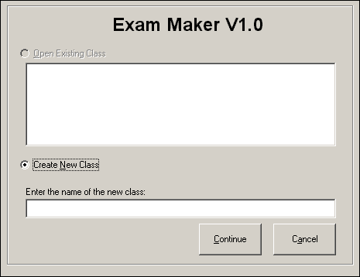

Create a new “class”. When the ‘Splash’ window appears, click the ‘Create New Class’ option. Type the name of a new class in the text box below where it says “Enter the name of the new class: “.

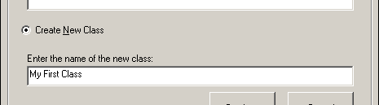

After you do this, you can press the 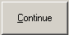 button to continue. The ‘Exam Maker’ window will appear.

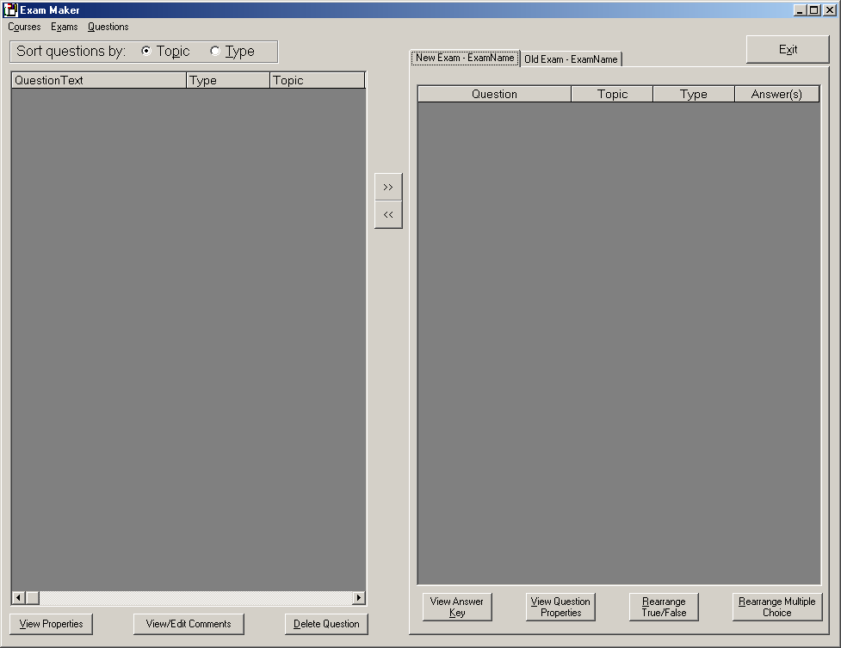

Add some questions. Before we create an exam, we will have to create some questions for our class question pool first. Click the ‘Question’ menu at the top of the screen, and then click the ‘Enter New Question’ item from the submenu.

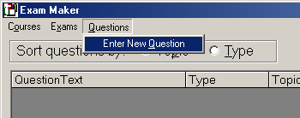

This will bring up the ‘Enter or Edit Questions’ window. Lets make an easy true/false question to start off with.

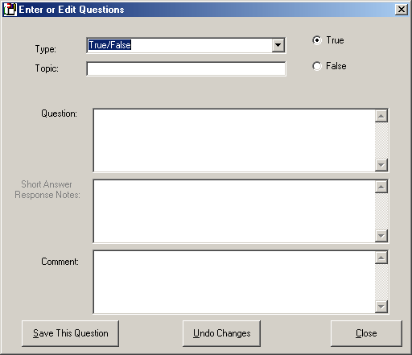

Make sure the text block to the right of the word Type says “True/False” (if it doesn’t, click on the little down arrow beside the text block, and select True/False from that dropdown menu).

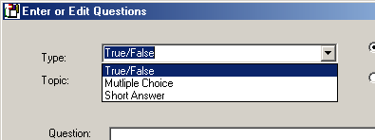

Next, we must give the question a topic. Topics allow us to easily sort questions later. We will give our first question the topic of “Hamster Juggling”. Type the words “Hamster Juggling” (If you can bring yourself to do it) into the text box to the right of the word Type in the window.

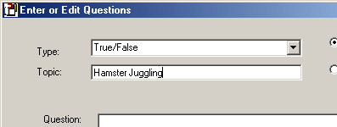

Next, we need to type the actual question true/false statement. Lets give the students something easy. Type “Hamster juggling is a good way to meet nice people” into the text box to the right of the words Question: .

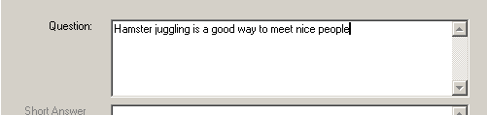

As we all know, this statement is not true, so we have to mark it as false. In the upper-right of the window, there are two options—one True, and one False. Select the False option, to mark this true/false question as being false.

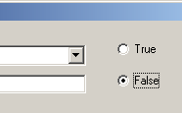

Lastly, we can give the question some comments, which will not be put in the exam output. These can be typed in the text box to the right of the words Comment: . You are sure to have some comments at this point, so you might as well type them in there.

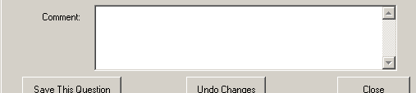

As a note, you can type multiple lines simply by pressing return or enter on the keyboard—the <return> or <enter> keys do not close the window, as in some GUI applications you might have used.

After your done, press the 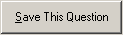 button to save the question to the question pool.

Next, lets add a short answer question to the question pool. Notice that the ‘Enter or Edit Questions’ window is still here—we can continue adding questions and saving them right here, until we want to go onto actually putting together an exam. For our short answer question, we’ll need to select the “Short Answer” item, this time, from the Type menu. Just go to the text block to the right of the words Type, click the down-arrow on the right side of the text block, and select “Short Answer” from the list. The words “Short Answer” will now appear in the text block.

Notice that the text block to the right of the word Topic still says “Hamster Juggling”. This allows us to avoid having to re-type the topic when the topic should be the same. In this case, we’re juggling, so we can leave the Topic text block alone!

Also, the True and False options in the upper-right of the window are not used for short answer or multiple choice questions. The option can be anything, if we are using the last two types of question.

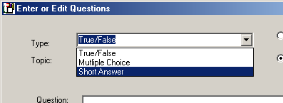

Okay, time to type our question text. We’ll give the students something more difficult this time. Type “Explain, in short detail, why it is disastrous to allow Tasmanian bull hamsters to drink anything within two hours of a juggling performance” into the text box to the right of the word Question: , just like we did with the true/false question.

With short answer questions, the examinee isn’t given a choice of answers— examinee must do all the work there. However, ExamMaker provides a place for you to make notes to yourself about what sort of response the question should elicit. For this question, you can simply type “See state laws concerning health and sanitation during public performances” into the text box to the right of the words Short Answer Response Notes: .

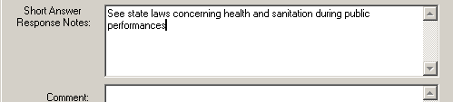

And lastly, type some comments in the text box to the right of the word Comment: . Press the button to save the question.

Lastly, we’ll tackle a multiple choice question. This is a bit more complicated than the true/false and short answer type questions, because it involves another window in addition to the ‘Enter or Edit Questions’ window. But we’ll be okay, just take each part slowly. Go to the ‘Type’ menu text block, press the down arrow to the right of it (as we did for the previous questions), and select “Multiple Choice”.

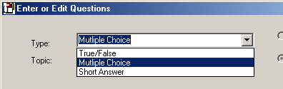

We’ll leave the topic as Hamster Juggling. Multiple-choice questions will give the user a choice of four answers (one of which is correct, and the rest of which are false) so we must word our question to reflect this setup. In the ‘Question’ text box, type “Which of the following is the correct way to comfort a dizzy hamster?”. Then, knock yourself out in the ‘Comment’ text box. Now, press the button as we did for the last questions. But this time, instead of clearing the window for another question, a small window pops up asking us if we want to “Add possible answers now?”.

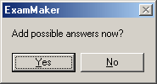

In this window, click the button. This will present us with another window, the ‘Enter/Modify Answer’ window!

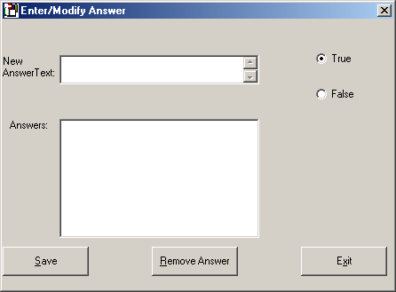

The ‘Enter/Modify Answer’ window will allow us to add answers to our multiple-choice question. We can add many more than four. But we need at least four, so that’s how many we’ll add for now (you can always add more answers later). To create a new answer, there are two things to do. First, we have to type the text of the answer. In the text box next to the words New Answer Text: , type “With 99-proof alcohol”.

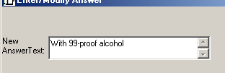

Secondly, we have to indicate if this response if true or false. Similar to the “True” and “False” options in the upper right of the Enter or Edit Questions window, we have a “True” and “False” option in the Enter/Modify Answer window. Select the “False” option, since everyone knows that you never comfort a dizzy hamster with alcohol.

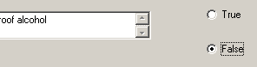

Lastly, click the 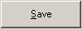 button to save the answer. Notice that our answer moves down into the Answers text block, where we can see all the answers that exist for this question. At the moment, our only answer is the answer we just created. Lets add three more. Type “By giving it a bath” in the ‘New Answer Text’ text box, and select “False”. Click the ‘Save’ button. Type “By putting it In a comfortably warm oven” in the ‘New Answer Text’ text box, and select “False”, and click the ‘Save’ button. And lastly, Type “By telling the hamster that it will all be worth it once you make your first mil, and the hamster pellets start rolling in”, select “False”, and click the ‘Save’ button. If you’ve noticed, all the answers we’ve entered have been false. But didn’t we need at least one true answer? Well, ExamMaker takes care of this, as we’ll see later!

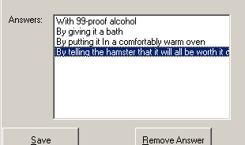

We’ve entered all the answers we’re going to for now, so click the 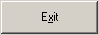 button in the Enter/Modify Answer window to close it. We’re now back at the ‘Exam Maker’ window.

Create a new exam. Notice that the three questions that we have created appear in the left pane of the Main window in a stack of horizontal slots. Try clicking in that pane, over a question. As you can see, the slot that the question is in expands so you can see the question more completely.

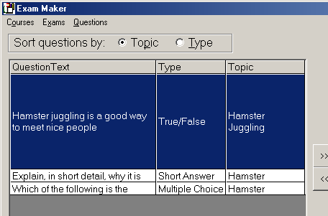

To add a question to the exam, simply select the question—it will be highlighted in blue, while the other questions will remain white—and press the  button in the center of the Main window. This ‘>>’ button tells Exam maker that you want to move the question from the ‘Question Pool’ pane, on the left, to a new exam, which is represented by the ‘New Exam’ pane on the right.

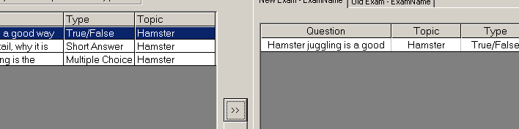

Select each question, and add it to the exam. Notice that as you add a question, it appears in the right pane. The right pane has some other information that the left pane doesn’t have, such as the answers to the question. Notice that the multiple-choice question has four answers associated with it, but that one of the answers isn’t one that we provided—it says “None of the above”.

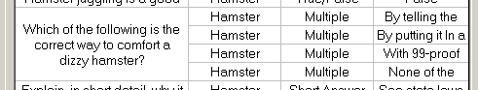

Remember that when we entered the answers for the multiple choice question, all of the answers we entered were false. Since a multiple choice question requires at least one true answer, ExamMaker substituted one of the false answers for a logically correct answer (which gives the examinee the choice of saying that all the answers are incorrect).

There’s even more ExamMaker can do with multiple choice questions. Below the right pane, click the 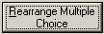 button a few times. Notice that the answers for the multiple choice question have changed! We could enter any number of answers (as long as we entered at least four), and ExamMaker will always select four answer and make sure that one of them is true, and the rest are false (or less true). This is one easy way to make a variation on an exam, at the click of a single button!

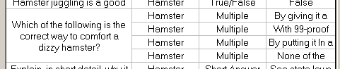

As you add more multiple choice questions with more multiple choice answers, the possibilities grow… But in any case, we’ve made an exam—it’s that easy!

Saving Exam. Okay, the old saying is “save early, save often”. So, we’re going to save our exam to disk, so we’re sure that nothing will happen to it. Go to the ‘Exams’ menu near the top of the window, and select the ‘Save Current Exam’ item.

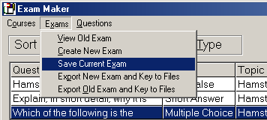

The ‘Enter Exam Properties’ window will appear, asking us to give the exam a name. In the ‘Enter Name’ text box, type “My First Exam”, and in the ‘Exam Type’ text box, just type exam. The exam type simply allows you to label what kind of exam it is—you can type anything here you want. Finally, you can enter comments about the exam as a whole in the ‘Exam Comment’ text box.

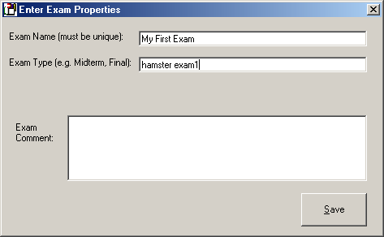

After type all this, press the button to save our exam! The Enter Exam Properties window will close, and we’ll be back to the ‘Exam Maker’ window.

When we save an exam, it becomes an “old exam”. This means it can’t be modified anymore. But we can still use it (we’d have to, or all the work we just did was for nothing!). Click the ‘Exam’ menu near the top of the window, again, and select the ‘View Old Exam’ item from the sub menu. The ‘Select an old exam to view’ window will open. Select “My First Exam” from the list, and press the ‘Open Exam’ button.

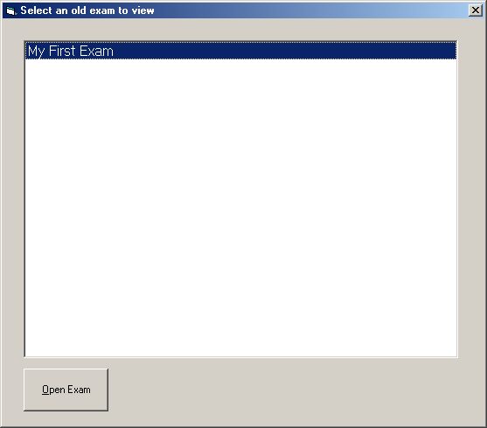

The ‘Select an old exam to view’ window will disappear. It will appear as if nothing has changed in the Main form, but if you go near the upper-right of the window, and click the pane tab that says “Old Exam – My First Exam”, we will see the text of our exam!

You might have noticed that the order in which the questions are placed in the exam is different from the order in which you created the questions. ExamMaker always insists on reordering the questions for you. All the true/false questions are listed first, then the multiple-choice, and lastly the short answer questions. This makes it easier to do some formatting externally, which will be covered later in the manual.

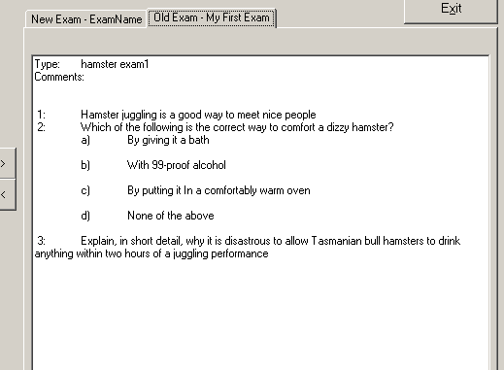

Okay, we have our exam back—lets export it to a text file so you can use it. Go to the ‘Exam’ menu, and select the ‘Export Old Exam and Key to Files’ item from the submenu.

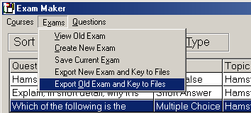

A small window will pop up to tell you that “Old exam files exported successfully”.

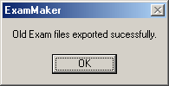

Just press the button to close it. That’s all there is to exporting your exam! You can grab the exported text files in the same directory that the ExamMaker software resides in. By default, this will be C:\ProgramFiles\ExamMaker. The file will be called “My First Exam.txt”, and the corresponding answer key will be called “MyFirst Examanswerkey.txt”. If you don’t know how to do this, then contact a system administrator for help. You can open these files up in your favorite text editor or word processor to view them, and use them to create your exam documents! Lets hope your students have studied their hamster juggling lore!

Some basic techniques for using these text files to create documents will be covered in a later section.

Using the ExamMaker Interface

This section will explain some of the general conventions the user interface for ExamMaker follows. This section will explain how to use the text boxes and menus, as well as other things. This information will make it easier for you to intuit how you should accomplish what you want in a given window.

Windows

Windows are rectangular portions of the screen that contain buttons, text boxes, and other interactive components. In general, when a window is opened over another window in ExamMaker, you must complete all operations in the new window and press the “Close” or “Exit” button before you will be allowed to work with the previous window again.

Pressing ‘Close’ or ‘Exit’ in a window does not register any changes made in the window. There will be a separate button (for example, ‘Save New Question’) that you must push to make the newest set of actions you’ve entered into the window stick. In other words, the ‘Close’ or ‘Exit’ button just closes the window, nothing else. Use the other available buttons to actually add the new question, or save the exam, etc…

Every window can be closed by clicking the [x] button in the upper right hand corner of the window. Recently entered information in the window, such as in the text boxes, will not be saved.

Text boxes

In general, text boxes can contain any characters that you can type at the keyboard. Sometimes, however, it’s not a good idea to type just anything. When naming an exam, for example, typing a bunch of spaces before the exam name will work, but not only will the exam name have spaces in front of it, but the export files (which are named after the exam) will have spaces infront of the title. This might be annoying to you, so it’s important to realize that what you type is what you get, and often multiple times as the text reoccurs in the use of the exam.

In ExamMaker, pressing the <return> or <enter> key on the keyboard does not close the window or apply any changes you make. There will be a button that specifically lets you tell the system that you’re finished typing and want to give the information to the system. Typically, this is usually some form of ‘Save*’ button.

Lists

In ExamMaker, you will often encounter lists of things—questions, exam names, answers, and more. By clicking the mouse on an item in the list, the item will be highlighted in blue (the other items will be white, or otherwise un-highlighted), and the result will be considered “selected”. Often, there are other buttons that will operate or use the selected item. For example, when adding questions to an exam, you select a question first by clicking on it, and then you press the ‘>>’ button to add the question you selected to the exam.

In general, you can only select one item at a time. On some occasion, you will be able to highlight more than one item (by using the <shift> key, and it will look like more than one item is highlighted (for example, when choosing questions to add to an exam), but even in this case, only one item will be acted upon. It is best to re-click on one item, and add then add the other items in turn.

Unusable buttons, text boxes, and other components.

Sometimes, some buttons, text boxes, lists, or other components can’t be used because of options you’ve chosen, or because you haven’t completed some action. For example, in the Enter or Edit Questions window, the Short Answer Response Notes: will not be available unless you choose the short answer question type from the Type: text block menu.

Sometimes an item must be selected, or a text box filled in, in order to use a button. While these buttons are still “pressable”, an error window will appear, indicating that some action has not been completed. Just close this error window by pressing the ‘Ok’ button, complete the action needed, and try the button again.

ExamMaker Commands

In this section, we will list all the commands that you can make to the ExamMaker system. The section is organized by window.

Splash Window

The ‘Splash’ window is the first thing you will see when you start ExamMaker. This window allows you to select which “class” you would like to work with. Each class contains it’s own question pool and set of exams.

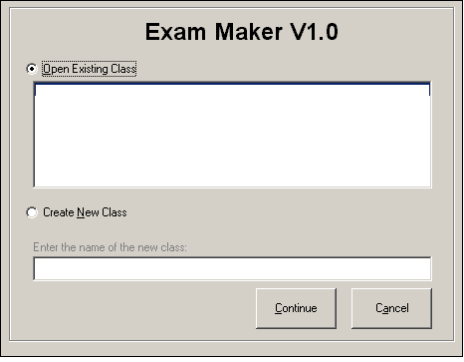

‘Open Existing Class’ option. Clicking this option indicates that you wish to open a class that you’ve already worked with. When this option is selected, you can then select the class that you wish to work with in the list below.

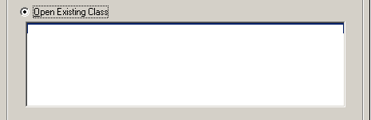

‘Create New Class’ option. Clicking this option indicates that you wish to create a whole new class, with an empty question pool. After selecting this option, you can type the name that you want to call this new class in the text box below.

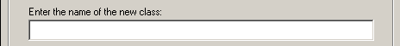

‘Continue’ button. Clicking the button indicates that you have decided which class to use, and that you want to move on to working with it. To use this button, you must have either selected an existing class under the ‘Open Existing Class’ option, or created a new class under the ‘Create New Class’ option. Pressing this button will close the Splash window, and take you to the ExamMaker window.

‘Cancel’ button. The 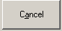 button indicates that you’ve changed your mind, and don’t want to work with ExamMaker right now. Pressing this will bring up a small window that asks you if you’re sure that you want to quit your ExamMaker session. 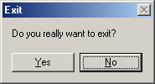

Clicking will exit the program, and clicking will return you to the Splash window.

Exam Maker Window

The ‘Exam Maker’ window is center point around which you create your exams. From here, you can choose to add questions to the class question pool, add questions to a new exam, view old exams, and export exams. It’s distinguishing characteristic is the pair of panes that take up the majority of the window area. The left pane represents the question pool, and the right pane represents the new exam. Questions are added to the new exam by moving them from the left pane to the right pane.

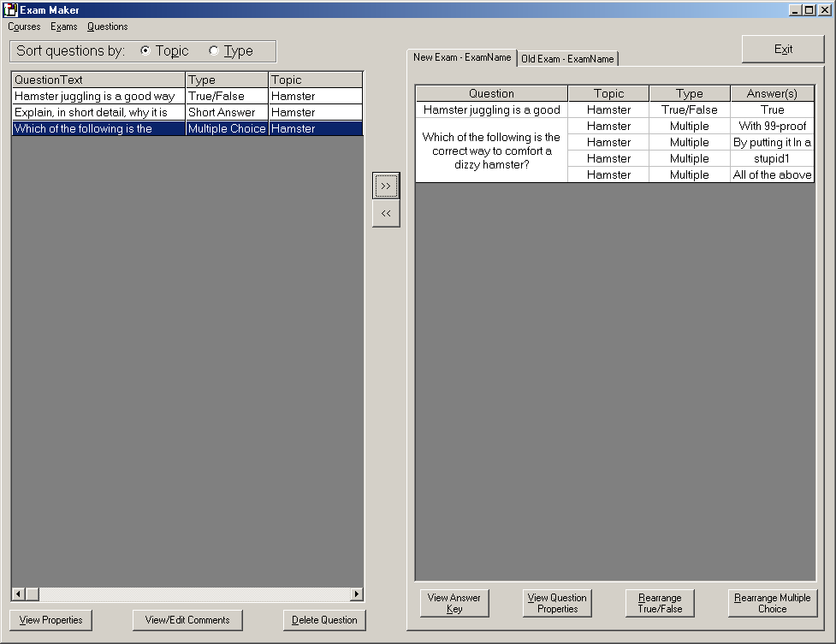

‘Courses’ menu. The ‘Courses’ menu allows you to change which class you are using. Each class has it’s own separate question pool.

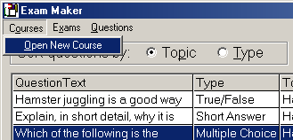

Selecting this option will return you to the Splash window. Be sure to save the exam you’re working on if you want to retrieve it later—changes will be lost if you do not.

‘Exams’ menu. The ‘Exams’ menu allows you to work with exams as whole entities. You can create, save, and view old exams with this menu. The ‘View Old Exam’ menu items opens the ‘Select an old exam to view’ window, and allows you to load an previously saved exam into the ‘Old Exam’ pane.

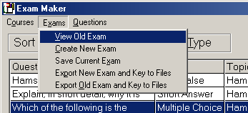

The ‘Create New Exam’ item allows you to indicate that a blank exam should be put in the exam pane. Before you can create a new Exam, however, you must save the one you’re currently working with, else you will get the an error message:

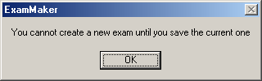

Just press the button. Save the exam, and select the ‘Create New Exam’ item again. ExamMaker will prompt you for a new exam name:

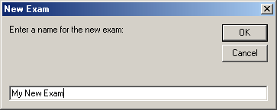

After you type a name for the new exam, press the button. If you change your mind, just click the button. If you clicked okay, then the exam pane will be blank, ready for some questions.

‘Save Current Exam’ item. This item saves the exam represented by the ‘New Exam’ pane on the right side of the window. When an exam is saved to disk, it becomes and “old exam”, and is unchangeable.

When you select this item, the ‘Enter Exam Properties’ window opens, which will allow you to do the actual saving of the exam to disk. In order to save the current exam, there must be at least one question in the exam. If not, the ‘Enter Exam Properties’ window will not allow you to save the exam.

‘Export New Exam and Key to Files’ item. The ‘Export New Exam and Key to Files’ item allows you to export the text files that contain the exam content, and the answer key for the current exam in the ‘New Exam’ pane. Like saving an exam, the exam in the right pane must have at least one question.

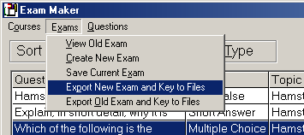

If you select this menu item, and the current exam is empty, then the system will display a message saying that it cannot export files from an empty exam:

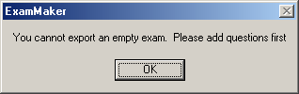

Just press the button to close this window, and adds some questions to the exam! If the exam had questions, then the exam text files will export correctly, and ExamMaker will display a message indicating that all is well:

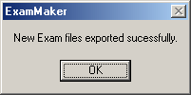

Just press the the button to close this window. The exported files will be placed in the same directory as the ExamMaker executable. By default, this is C:\Program Files\ExamMaker\. The exam content will be saved under the file name MyExam.txt (where ‘MyExam’ is the name of the exam), and the answer key will be placed in the file MyExamanswerkey.txt. The content of these files, and how to use them, will be covered in a later section.

‘Export Old Exam and Key to Files’ item. The ‘Export Old Exam and Key to Files’ menu item acts just like the the ‘Export New Exam and Key to Files’ menu item, except that it operates on a previously saved exam.

Before you can use this item, you must have loaded an old exam. Use the ‘View Old Exam’ menu item to load an old exam into the ‘Old Exam’ pane. As with the new exam, after the files are exported, ExamMaker will pop up a window that says ‘New Exam files exported sucessfully’, and you can just press to close it.

The ‘Question’ menu contains one option—the ‘Enter New Question’ item. You chose this menu item to create a new question to add to the classes answer pool.

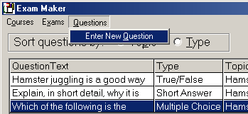

Clicking this menu item will bring up the ‘Enter or Edit Questions’ window, where you can create your questions.

‘Question Pool’ pane. The ‘Question Pool’ pane is where all the questions that are in the classes question pool are lists. Clicking on a question in this area will highlight it in blue, and expand the cell so that you can see the whole question clearly.

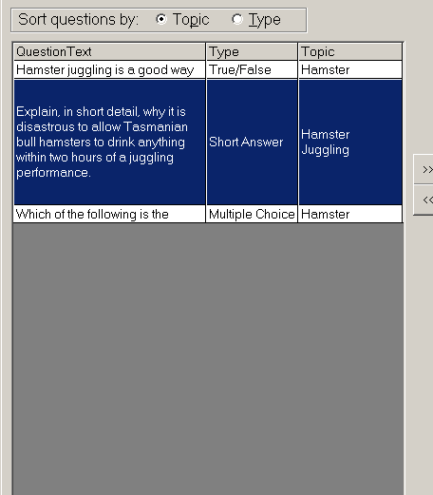

The first column of the ‘Question Pool’ pane displays the questions text. The second column displays the question type. Clicking on the ‘Topic’ option at the top will sort the questions by the topic (all true/false together, all multiple-choice together, and all short answer questions together). The third column displays the topic of the question. Clicking the ‘Type’ option at the top will sort all the questions according to there type (for example, all Hamster Juggling questions will be listed together). There are a set of buttons at the bottom of the ‘Question Pool’ pane, which can be used to further manipulate the questions in the question pool.

‘View Properties’ button. The 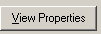 button brings up the ‘Question Properties’ window, which allows you to view and edit the selected question in detail. In addition, you will be able to add (additional) answers to multiple-choice questions, here.

‘View/Edit Comments’ button allows you to view and change (if you want) the comments for a question. While the same thing can be accomplished with the button, the button opens the ‘Question Comments’ window, which has less clutter than the ‘Question Properties’ window:

‘Delete Question’ button. The button allows you to remove a question from the question pool. Before deleting the question, ExamMaker pops up a window to make sure you really want to delete the question.

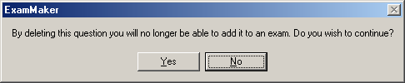

Just press the button to insist on deleting, or press the button to change your mind. Deleting the question is permanent—though no saved exams are affected, deleting the question will remove it and all it’s answers from the database, and you’ll have to recreate the question from scratch if you decide you want to use it later.

‘New Exam’ pane. The ‘New Exam’ pane is where all the questions that have been added to the currently developing exam are listed. Like the ‘Question Pool’ pane, this pane has Question, Topic, and Type columns. However, in addition, this pane lists the answers that will go with the question. In particular, this shows which subset of the answers for a multiple-choice question have been chosen by ExamMaker to put with the question in this exam.

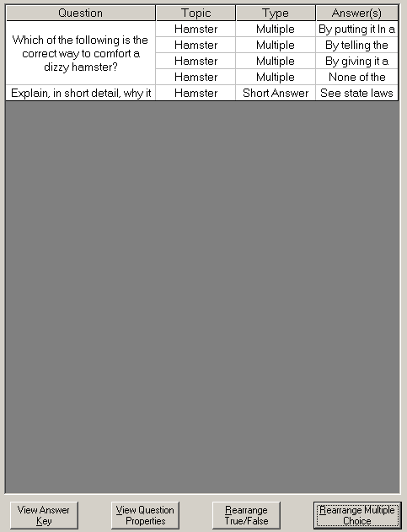

By clicking the ‘Rearrange Multiple Choice’ button, the choice of answers selected, along with their ordering, will change. You can press the button as many times as you want, until you get an ordering that pleases you.

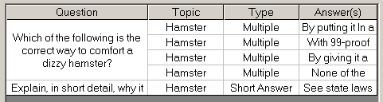

The ‘Rearrange True/False’ button changes the ordering (and just the ordering) of the true false questions in the exam. This is to prevent the case where a long sequence of questions are either all true or all false (which can throw even the best students off). Like the button, the 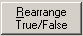 button can be pressed as many times as you like to get an arrangement that pleases you. You can use the ‘View Question Properties’ button does the same thing as the button in the ‘Question Pool’ pane, except this time the question chosen is based on what is selected in the ‘New Exam’ pane. The ‘View Answer Key’ button allows you to see the the list of correct answers for all the questions in the new exam. Pressing the 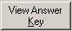 button will pull up the ‘Answer Key’ window, where you can view the results.

‘Old Exam’ pane. The old exam pane is used to display and work with previously saved exams. Once an exam is saved, it becomes an old exam, and can be viewed by using the ‘View Old Exam’ item from the ‘Exam’ menu. The ‘Old Exam’ pane is usually hidden behind the ‘New Exam’ pane. To switch between the two, just click the tab that says “Old Exam – “ at the top of the ‘New Exam’ pane.

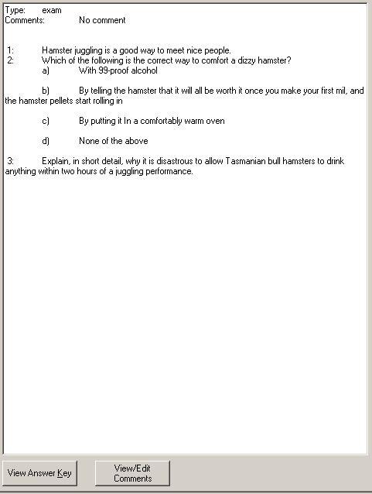

You can switch back to the ‘New Exam’ pane by likewise clicking the tab at the top of the pane that says “New Exam –“. As you can see, the contents of this pane are much different than the contents of the ‘New Exam’ or ‘Question Pool’ panes. Gone are the grid-like arrangement of questions, and in it’s place is a more natural text representation of the exam. It is designed to be easy and fast to read. The thing to remember about old exams is that you cannot edit them (the ‘View/Edit Comments’button allows you to view the old comment, but not actually save a new comment). The ‘View Answer Key’ button functions just like the button on the ‘New Exam’ pane. The ‘View/Edit Comments’ button allows you to view the exams general comments. Pressing will open a small window in which you can view the exam comments:

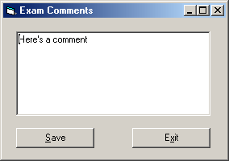

Pressing will close the window. The does absolutely nothing, since you cannot change an old exam.

‘>>’ button. The is used to send a question from the ‘Question Pool’ pane to the ‘New Exam’ pane. To use this button, you must first make sure that you have selected a question in the ‘Question Pool’ pane (it should be highlighted in blue). In addition, you cannot add the same question twice to an exam—if the question you are trying to add from the ‘Question Pool’ pane is already in the ‘New Exam’ pane, then you will receive an error message if you press :

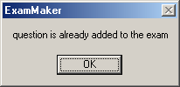

Just press the button to close this small window, and select a question to add which isn’t already in the exam (you can always just add more questions to the question pool, if you run out of questions to add!). One additional requirement applies only to multiple-choice questions. If the question to be added has been given less than four answers, ExamMaker will require you to supply enough additional answers to make the question viable for an exam (remember that a multiple-choice question on an exam must have four answers). If you try to add a multiple choice question with less than four answers to an exam, you will get a message window:

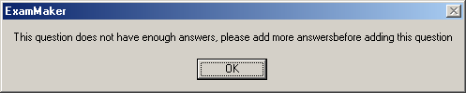

Just press the button to close this window, and go add some additional answers using the button under the ‘Question Pool’ pane. Of course, if a question has more than four answers, that is not only fine, but preferable, as some of the real power of ExamMaker is utilized by having many answers to the same question. In any case, if the question is valid, pressing the button will result in the question selected in the left pane being displayed in the right pane (along with any other questions that were previously in that pane). At this point, that question has been officially added to the new exam.

‘<<’ button. The  button does the opposite of the button—it removes a question from the ‘New Exam’ pane. Simply click on the question in the right pane that you which to remove, and press the button. You must select a question first! If you just press the button without selecting a question, then possibly any question might be removed from the exam. It might be difficult to determine which one, and so re-adding it might be tedious in that sense. But in all cases, any question removed can simply be added again by selecting that question in the left pane, and using the button.

‘Exit’ button. Pressing the ‘Exit’ button will close the ‘Exam Maker’ window, and the program will end and return you to the Windows desktop. Be sure to save before you press this, if you want to keep the changes you’ve made!

Enter or Edit Questions Window

The ‘Enter or Edit Questions’ window is where you will spend most of your question creating time. It allows you to enter the question text, set some question properties, and edit some answers that will belong to a question.

This window is designed to allow you to create a number of questions without having to close the window.

‘Type’ menu. Use the type menu to select the type of question you wish to create.

Press the down arrow next to the text block to select either “True/False” for a true false question, “Multiple Choice” for a multiple choice question, and “Short Answer” for a short answer question.

You can type a topic in the ‘Topic’ field. Over the course of adding multiple questions, the topic will continue to contain what was last typed into it, until changed again. This is helpful, because often you’ll type many questions that have the same topic, and this feature allows you to avoid having to retype the topic for each question.

You can type the Question text in the text box next to the word “Question: “, and a question comment in the text box next to the word “Comment: “. This text can contain multiple lines—just press return as you type in the text box. To move from one text box to another, just click inside the text box you want to edit with the mouse.

Depending on which question type you selected from the ‘Type’ menu, you will have to work with certain parts other parts of the ‘Enter or Edit Questions’ window.

For a true/false question, all you have to do is select either the “True” or “False” option beside the ‘Type’ menu to indicate whether the question statement you typed is true or false.

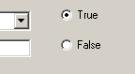

For short answer questions, you don’t have to do anything further, except perhaps type some notes as to what the answer should be in the text box to the right of the words “Short Answer Response Notes: “. The True/False option will be disabled, as it has no effect on short answer questions.

For multiple choice questions, both the True/False option and the short answer response notes text box will be disabled. You will get a chance to create some answers, soon!

‘Undo Changes’ button. The 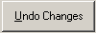 button simply clears all the text boxes in the ‘Enter or Edit Questions’ window.

‘Close’ button. The 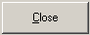 button simply closes the ‘Enter or Edit Questions’ window. Any information in the text boxes is lost, unless it was saved first.

‘Save This Question’ button. The button is what to press when the question is to your liking, and you want to save it. If you’ve forgotten to fill out anything, such as the question text, a small window will pop up to tell you that the question cannot be created as it is currently:

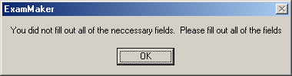

Just press the button to close this small window, and go back and complete all necessary fields.

Additionally, if the question is multiple choice, a tiny window will pop up to ask you if you want to enter some answers for the question at this point in time:

Press to go to the ‘Enter/Modify Answers’ window, else press to just get back to the ‘Enter or Edit Questions’ window.

Upon successfully saving the question, The ‘Enter or Edit Questions’ window then clears the text boxes (except for the ‘Topic’ field), so you can enter another question.

Question Properties Window

The ‘Question Properties’ window allows you to view, and possibly modify a question from the ‘Question Pool’ pane or ‘New Exam’ pane. A question can be modified if it has not been used in a previously saved exam.

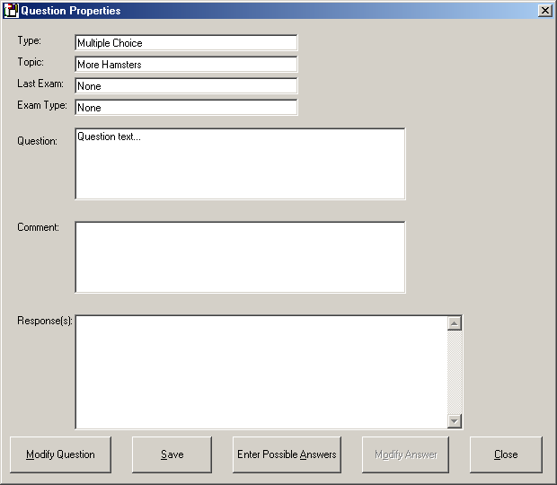

If you want to modify the question, press the ‘Modify Question’ button. Pressing the 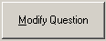 will put you into editing mode, and allow you to change the text in the “Question” and “Comment” text boxes.

If this is a multiple choice question, you can press the ‘Enter Possible Answers’ button. Pressing the 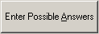 button will open the ‘Enter/Modify Answers’ window, where you can add more answers to the multiple choice question (keep in mind that at least four answer must have been added to a multiple choice question in total, before that question can be added to an exam, so don’t be shy with the answers!). If this is not a multiple choice question, this button is grayed-out.

If this is a short answer question, pressing the ‘Modify Answer’ button will allow you to edit the response notes. Pressing the 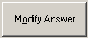 will allow to edit the “Response(s)” text box, where the short answer response notes are kept. This button is grayed-out, unless the question is a short answer. Note that you will not be able to save the changes unless you additionally press the button to explicitly say that you really want to modify this question.

The ‘Close’ button simply closes the window—no changes will be registered. Pressing 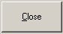 will return you to the ‘Exam Maker’ window.

The ‘Save’ button is grayed out until you elect to change the question by pressing . Pressing 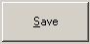 will save the modified question to the question pool in place of the old version. From here, you can make further modifications, or press the button to close this window, and get back to the ‘Exam Maker’ window.

Enter/Modify Answers Window

The ‘Enter/Modify Answers’ window’s sole purpose is to allow you to create answers for a multiple-choice question. In the spirit of ExamMaker, it allows you to enter as many answers as you like without having to close and reopen the window.

Using this window is easy. You just type the text that the answer is to contain in the text box next to the words “New Answer Text: “. Then, you select either “True” or “False” from the True/False options on the right, to indicate whether the answer is correct or incorrect.

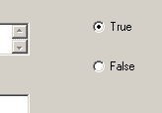

Then, simply press the ‘Save’ button to add the answer. When you press the button, the answer text moves from the ‘New Answer Text’ text box to the ‘Answers’ list at the bottom. This list displays all the answers that have been created for this question. If you decide you don’t like one of these answers, you can just select it with the mouse (it will be highlighted in blue), and press the ‘Remove Answer’ button. The 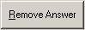 button will permanently remove the answer from the question.

As a caution, while you can always add more answers to a multiple-choice question, there are cases where you cannot remove answers. Specifically, when a question has been used in a saved exam, you will not be able to remove any answer, even if that answer has not been used in the exam. This is really a sort of bug. Just be careful—remember, ExamMaker chooses multiple-choice answers randomly. If you enter an answer that is bad, and then use the associated question in an exam, that bad answer will continue to pop up randomly. This bug is explained in a later section.

In any case, after you’ve finished entering answers, you can close the ‘Enter/Edit Answers’ window by pressing the button.

How to Use the Exported Files

The ExamMaker software focuses on content exclusively. Because of this, the software does not provide any direct means of formatting the exam output so that it looks presentable enough to give to examinees. In fact, the exported files that ExamMaker produces might look especially unreadable to most people. This is because the exported exam text file is not meant to be read as it is, but used in a word processor.

Let us look at the simple “hamster exam” we created in the “Getting Started” section of the manual.

The exported files should be in the C:\Program Files\ExamMaker directory. If they are not here, make sure you did export our hamster exam. If you cannot find this directory, get help from a system administrator.

The exported exam file should be called “My First Exam.txt”. Lets open this file up in Windows Wordpad application. You should see something like this:

<Exam>
<Exam Title>My First Exam<\Exam Title>
<TFQuestion>
<Question>1 Hamster juggling is a good way to meet nice people
<Answer>True<\Answer>
<Answer>False<\Answer>
<\Question>
<\TFQuestion>
<MCQuestion>
<Question>1 Which of the following is the correct way to comfort a dizzy hamster?
<Answer>a By giving it a bath<\Answer>
<Answer>b With 99-proof alcohol<\Answer>
<Answer>c By putting it In a comfortably warm oven<\Answer>
<Answer>d None of the above<\Answer>
<\Question>
<\MCQuestion>
<SAQuestion>
<Question>1 Explain, in short detail, why it is disastrous to allow Tasmanian bull hamsters to drink anything within two hours of a juggling performance

<\Question>
<\SAQuestion>
<\Exam>

The first thing that will probably jump out at you are all the “<>” type entries everywhere. These are “tags”. ExamMaker uses “tagged output” when it exports it’s exam files. (This is not true for the answer key file, which is already in human readable form).

Tags are designed to help you create your exam document from the raw ExamMaker export file using a word processor. Use the word processor to select all the text enclosed within the opening tag <tag> and the closing tag <\tag>. Closing tags look just like their corresponding opening tags, except that they have a “\” in front of tag name.

The exam output consists of an opening tag <Exam>, followed by a carriage return, a title, a sequence of questions of true/false questions, a sequence of multiple choice questions, and sequence of short answer questions, and a closing tag <\Exam>.

The title consists of an opening tag <Exam Title>, the text of the exam name, a closing tag <\Exam Title>, and a carriage return.

The sequence of true/false questions consist of an opening tag <TFQuestion>, a carriage return, a sequence of questions of type true/false, a closing tag <\TFQuestion>, and a carriage return.

The sequence of multiple choice questions consists of an opening tag <MCQuestion>, a carriage return, a sequence of multiple choice type questions, a closing tag <\MCQuestion>, and a carriage return.

The short answer seqence consists of an opening tag <SAQuestion>, a carriage return, a sequence of short answer type questions, a closing tag <\SAQuestion>, and a carriage return. Each question consists of an opening tag <Question>, an Arabic numeral to be used in enumerating the questions, a space, the question text, a second carriage return, a series of answers, and a closing tag <\Question>, and a final carriage return. Each answer section will depend on the type of question it is associated with.

For multiple choice questions, the answer section will consist of a sequence of four answers. Each answer will begin with an opening tag <Answer>, a single letter used in enumerating the answers (a, b, c, or d), a space, the answer text, a closing tag <\Answer>, and a carriage return.

For true/false questions, there will be two answers (one for true, one for false), each consisting of an opening tag <Answer>, the text “True” or “False respectively, a closing tag <\Answer>, and a carriage return.

Short answer questions do not have an answer section.

Trouble Shooting

There are some known issues with the ExamMaker software that, in it’s current state, you’ll have to watch out for. At the end of this section is a trouble shooting guide to help you solve some problem you might encounter when using this software.

General Issues

The first issue involves how you choose names. Names are supplied by you to identify classes and exams. Because of the way the software works, you should try to always choose a unique name for something. For example, if you have a class called “My Class”, try not to call the next class you create “My Class” also. Perhaps you could call it “My Class2”, or something along those lines. Often, this will simply result in odd behavior, while in other cases it can completely ruin the data you’ve entered. So, try to be careful with duplicate names.

The other major issue is that saving an exam has far reaching repercussions that are not very intuitive. In a lot of programs, when you “save” something, it generally means that you can continue editing and changing it, even if you close the program and then restart it at a later time. This is not true with ExamMaker exams. When you save an exam in ExamMaker, the exam become static, unchangeable, locked in stone, …you get the idea. In fact, the only way you can even see the exam again after you save it is by reopening it as an “old exam”.

More over (and this is very tricky) once an exam is saved, you cannot change the question in the question pool. There is one exception to this, and that involves adding multiple choice answers to a multiple choice question. However, with the current release of the software, all other editing will be greeted with an error message.

Some highlighting of selected items doesn’t work properly. However, if you click on the item, it is still selected, and everything should be okay from there.

Specific Issues

Creating a new class with a duplicate name. If you create a class with the same name as a previously created class in the list, any editing work you do with the new class will not be retrievable after you close the program. Upon selecting the class again upon restarting ExamMaker, the class opened for editing will be the original class that had the name that was duplicate by the new class.

Saving an exam with a duplicate name. If you save the current exam under the same name as another exam, this will actually corrupt the class file. You will not be able to open either original with the name that was duplicated or new exam. Be very careful with this, as no list of previous exam names is presented when you save the current exam. To be safe, try opening a previous exam, just to see what names have been used. Then, go back and save the current exam with a different name.

Adding an answer to a multiple choice question that has been used in a saved exam. If you add an answer to a multiple choice question that has been used in a saved exam, you will not be able to remove it, even if you have just added it in the window. This is a bug. Be careful when adding answer to questions that have been used in exams, because if you mistype something but don’t catch it until you after you’ve saved the answer, you won’t be able to remove it, even though the answer itself was not used in an exam and you have just added it to the question. This problem is compounded by the fact that ExamMaker always chooses multiple-choice questions randomly, and doesn’t off much explicit user control over which answers are used. You’ll just have to keep pressing the ‘Rearrange Multiple Choice’ button until the “bad” answer is not selected. Needless to say, this is a major hindrance to your ability to easily alter the arrangement of multiple-choice answers to you liking. This bug should be fixed in the next release.

Troubleshooting Guide
Trouble | The Fix
Tried to load old exam, but the exam name wasn’t in the list. | It is possible that you are in the wrong class. Just as question pools are associated with a class, so are all the exams that are created from that pool. If this is the case, just go back, select the right class, and your exam should be in the old exam list when you pull it up.  It is also possible that you didn’t save the exam. In this case, unfortunately, the exam is lost.
Tried to select a question in the ‘New Exam’ pane, but it won’t highlight properly no matter how much I click on it. | This is a bug. Even though it isn’t highlighted, though, when you click on the question, it is still selected. Everything should work fine from there.
I need to remove an answer from a multiple-choice question, but it won’t let me! | If the question has been used in an exam, then it cannot be removed. A work around this is to modify the question that the answer belongs to. After saving the modified question, you can then remove the answer. After removing the answer, delete the old question.
I exported the exam files and found them, but the file looks funny. | ExamMaker uses a “tagged text” format to allow you to easily format the exam in an external word processor. It is not meant to be read directly by people in the normal sense. If you would like to see a quick readable version, then save the exam, and open it as an “old exam”. The ‘Old Exam’ pane will give you a more readable output.

Glossary
Answer Key: A special form of exam output, where the software only displays/prints the text strings of answers that have been marked as being true.
Answer: A string of text meant to (ultimately) provide some choice of response from a student in regard to a particular associated question. An answer can be as simple as a “True” or “False” inserted by ExamMaker, or an elaborate explanation of some academic concept, spelled out by yourself. Answers are stored in pools that are associated with the answer’s question. Often, such as in multiple choice questions, several answers can be chosen to be associated with a question on a particular exam. Each answer has the property that it is either correct (true) or incorrect (false).
Class: Contains a question pool and a collection of related exams. Classes give you some additional power of organization, by allowing exams of one sort to be kept separate from exams of another. This reduces the number of possible questions you must work with when creating any one particular exam. Designed to correspond to a “real-world” scheduled class, but can be exploited in any way you see fit.
Comments: Comments are little notes to yourself. They can be added to many of the things you work with in ExamMaker, such as questions and exams.
Default Directory: Directory where ExamMaker puts the exported exam and answer key files. This is usually located at C:\Program Files\ExamMaker\
Exam Maker: The name of this software. Exam maker allows the fast, easy creation of exams from pools of questions and answers. The software outputs tagged text files that can be imported into document processors for visual formatting.
Exam: A sequence of questions.. These questions are created by pulling questions from the class question pool. Exams can easily be created, viewed, and printed by the user using the software. In many cases questions will have a short selection of possible answers that the examinee can choose from (such as with multiple-choice questions).
Question Pool: Each class has it’s own question pool, which contains all the questions associated with that class, along with all the possible answer responses (for multiple-choice questions) that ExamMaker can chose from when a question is added to an exam.
Question: A challenging enquiry or statement to the examinee. Questions are stored in question pools, wherefrom they can be added to exams. There are three types of questions: True/false, Multiple-choice, and Short answer.
Tag: A small bit of text that is enclosed in brackets “<>”. Tags are used in the exported exam content to allow you to easily create documents in an external word processor.
Text File: The ultimate output of the software will be a text file consisting of an exam or an answer key. The text file is in plain ASCII format, although the exam portion of the export contain “tags”.
Topic: The user can mark each question with a small description that can be used to group similarly themed questions. For example, questions concerning the use of “NOR Gates” can be marked with the last in quotes. Later, the user can more easily group questions related to “NOR Gates” that are marked as such.
Type: Questions come in three types: True/False, Multiple Choice, and Short answer. True/False questions have only two possible answers (True or False), where the user chooses which of these answers is correct for that particular question. Multiple Choice questions contain four of the answers from the questions list of answers. One of these four is always correct, and the remaining three are all incorrect (or less correct). Short Answer Questions basically have no answer, the idea being that the student should generate a response entirely of his or her own crafting. The user of the software can browse questions by type.

Index

‘
‘Courses’ menu, 28
‘Enter or Edit Questions’ window, 9, 12, 13, 32, 40, 41, 42, 43
‘Enter/Modify Answers’ window, 45
‘Exam Maker’ window, 8, 16, 19, 28, 40, 45
‘Exams’ menu, 18, 29
‘New Exam’ pane, 17, 30, 31, 34, 36, 37, 38, 39, 43, 53
‘Old Exam’ pane, 29, 32, 36, 54
‘Question Pool’ pane, 17, 32, 33, 34, 36, 38, 39, 43
‘Question Properties’ window, 34, 43
‘Question’ menu, 9, 32
‘Splash’ window, 8, 26, 53
A
answer, 4, 5, 13, 14, 15, 16, 17, 18, 24, 34, 35, 36, 39, 40, 42, 44, 45, 46, 47, 49, 50, 51, 52, 54, 55, 56
C
class, 8, 9, 26, 27, 28, 51, 52, 53, 55
E
exam, 4, 5, 9, 11, 12, 16, 17, 18, 19, 20, 21, 22, 23, 24, 28, 29, 30, 31, 32, 34, 36, 37, 38, 39, 43, 44, 47, 48, 49, 51, 52, 53, 54, 55
exported exam, 48
G
GUI, 3, 12
H
hamster, 14, 15, 16, 22, 48
L
Lists, 24
M
Multiple-Choice, 4
O
old exams, 5, 28, 29, 37, 54
Q
question, 4, 5, 9, 10, 12, 13, 14, 16, 17, 18, 20, 24, 28, 30, 31, 32, 33, 34, 36, 37, 39, 40, 41, 42, 49, 50, 52, 55, 56
question pool, 4, 9, 12, 26, 27, 28, 32, 33, 34, 39, 45, 51, 55
S
Short Answer, 4, 12, 13, 24, 41, 42, 56
T
tag, 49, 50
Text boxes, 23
True/False, 4, 10, 36, 41, 42, 46, 56
W
Windows, 23

