[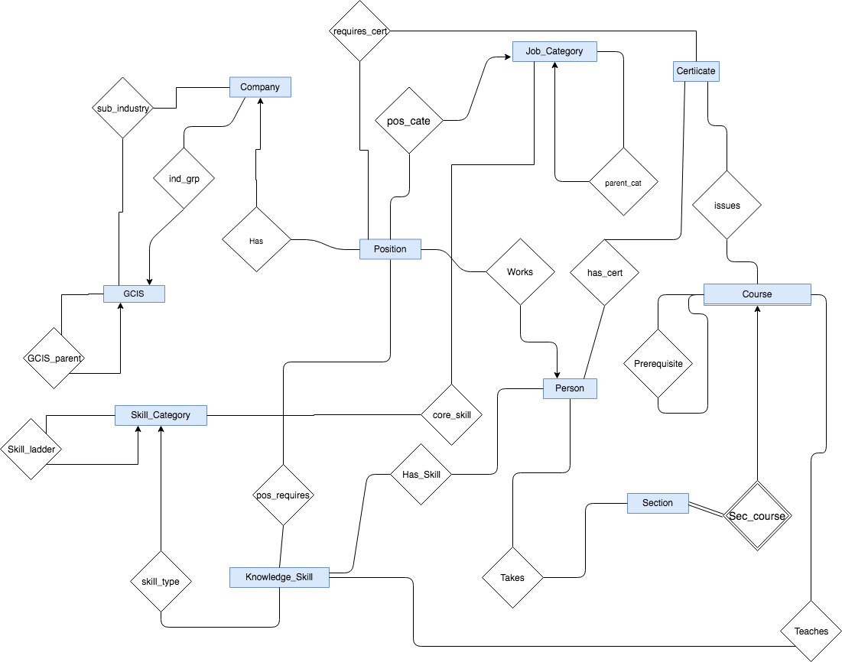](https://www.draw.io/#G1bqBJZC9Y41_VH0pCQFLrzxPUJVY0qRac)