All Women Shortlists Methodology

# Methodology

Previous research on gender differences in political speech patterns has focused on differences between male and female politicians (Yu 2014) or on variations in Hilary Clinton’s speech patterns (Jones 2016; Bligh et al. 2010).

To account for the possible effects of age, parliamentary experience and cohort, and in order to compare women selected through all women shortlists to women who were not (but theoretically had the possibility to contest all-women shortlists), speech analysis has been restricted only to Labour MPs elected during or after the 1997 General Election, and before the 2017 General Election. Words contained in parentheses were removed, as they are added by Hansard to provide additional information not actually spoken by the MP.[1] Speeches and MP data is from a previously assembled dataset (Odell 2018). Information on candidates selected through all women shortlists is from the House of Commons Library (Kelly 2016). Unsuccessful General Election candidates selected through all women shortlists who were subsequently elected in a byelection are classified as having been selected on an all women shortlist.

Word classification used the Linguistic Inquiry and Word Count 2015 (LIWC) dictionary (Pennebaker et al. 2015) and tokenising tools from the Quanteda R package (Benoit 2018). Word counts and words-per-sentence were calculated using stringi (Gagolewski 2018), a wrapper to the ICU regex library.

Following Yu (2014) drawing on (Newman et al. 2008) we used the following LIWC categories:

* All Pronouns (pronoun)
* First person singular pronouns (i)
* Verbs (verb)
* Auxiliary verbs (auxverb)
* Social processes (social)
* Positive emotions (posemo)
* Negative emotions (negemo)
* Tentative words (tentat)
* Words longer than six letters (Sixltr)
* First person plural pronouns (we)
* Articles (article)
* Prepositions (preps)
* Anger words (anger)
* Swear words (swear)
* Cognitive processes (cogproc)

We also included words-per-sentence (WPS), total word count (WC) and Flesch–Kincaid grade level (FK) (Kincaid et al. 1975), calculated using Quanteda (Benoit 2018) and stringi (Gagolewski 2018).

|  |  |  |  |  |  |  |  |  |  |
| --- | --- | --- | --- | --- | --- | --- | --- | --- | --- |
| General Election | Total MPs | Total Labour MPs | Total Female Labour MPs | Newly elected MPs | Intake Women | Percentage Intake Women | Intake Shortlist | Nominated Shortlist |  |
| 1997 | 659 | 418 | 101 | 177 | 64 | 36% | 35 | 38 |  |
| 2001 | 659 | 412 | 95 | 38 | 4 | 11% | 0 | 0 |  |
| 2005 | 646 | 355 | 98 | 40 | 26 | 65% | 23 | 30 |  |
| 2010 | 650 | 258 | 81 | 64 | 32 | 50% | 28 | 63 |  |
| 2015 | 650 | 232 | 99 | 49 | 31 | 63% | 31 | 77 |  |

Data in this table is from House of Commons library reports (Kelly 2016; Audickas, Hawkins, and Cracknell 2017). All women shortlists were not used by Labour during the 2001 General Election.

## Women vs Men

Effect Sizes for Male and Female Labour MPs

Women

Men

Effect Size

Mean

SD

Mean

SD

Cohen’s D

Magnitude

All Pronouns

10.07

4.60

10.15

4.99

0.02

negligible

First person singular pronouns

1.89

2.42

2.03

2.55

0.06

negligible

First person plural pronouns

0.97

1.42

0.99

1.51

0.01

negligible

Verbs

12.81

4.99

12.67

5.35

-0.03

negligible

Auxiliary verbs

7.90

3.45

7.93

3.69

0.01

negligible

Social processes

8.46

4.82

8.17

5.11

-0.06

negligible

Positive emotions

2.73

2.48

2.57

2.54

-0.06

negligible

Negative emotions

1.16

1.68

1.08

1.77

-0.05

negligible

Tentative words

1.48

1.74

1.57

1.90

0.05

negligible

More than six letters

19.82

6.96

19.08

7.33

-0.11

negligible

Articles

7.64

3.30

7.96

3.55

0.10

negligible

Prepositions

12.57

4.41

12.14

4.74

-0.10

negligible

Anger words

0.24

0.82

0.24

0.79

0.01

negligible

Swear words

0.00

0.06

0.00

0.09

0.01

negligible

Cognitive processes

8.68

4.82

8.82

5.14

0.03

negligible

Words per Sentence

43.23

19.41

40.79

19.74

-0.12

negligible

Total Word Count

402.34

689.78

369.53

645.77

-0.05

negligible

Flesh-Kincaid Grade Level

10.64

7.58

9.63

7.75

-0.13

negligible

There are no categories where gender differences meet the effect size threshold of $|0.2|$ suggested by Cohen (1988, 25–26) to indicate a small effect. 4 categories – words with more than six letters, prepositions, words-per-sentence and Flesh-Kincaid grade level – exceeded the $|0.1|$ threshold suggested by Newman et al (2008).

## Shortlists vs Non-Shortlists

Effect Sizes for Female Labour MPs by selection process

All Women Shortlists

Open Shorlists

Effect Size

Mean

SD

Mean

SD

Cohen’s D

Magnitude

All Pronouns

10.01

4.66

10.18

4.47

-0.04

negligible

First person singular pronouns

1.86

2.41

1.95

2.42

-0.04

negligible

First person plural pronouns

0.88

1.36

1.15

1.51

-0.19

negligible

Verbs

12.87

5.09

12.68

4.79

0.04

negligible

Auxiliary verbs

7.93

3.48

7.85

3.38

0.02

negligible

Social processes

8.46

4.93

8.44

4.58

0.00

negligible

Positive emotions

2.69

2.52

2.81

2.42

-0.05

negligible

Negative emotions

1.17

1.69

1.13

1.67

0.02

negligible

Tentative words

1.48

1.75

1.49

1.73

0.00

negligible

More than six letters

19.72

7.06

20.03

6.75

-0.05

negligible

Articles

7.69

3.38

7.55

3.14

0.04

negligible

Prepositions

12.55

4.54

12.63

4.15

-0.02

negligible

Anger words

0.23

0.78

0.24

0.90

-0.01

negligible

Swear words

0.00

0.06

0.00

0.05

0.01

negligible

Cognitive processes

8.59

4.89

8.85

4.67

-0.06

negligible

Words per Sentence

43.61

20.18

42.48

17.79

0.06

negligible

Total Word Count

401.30

702.85

404.36

663.60

0.00

negligible

Flesh-Kincaid Grade Level

10.80

7.88

10.33

6.96

0.07

negligible

There are no categories among female Labour MPs by selection process meeting the $|0.2|$ threshold. Only one category – first person plural pronouns, *d*=0.19 – exceeded $|0.1|$.

## Spacy

## POS Analysis

## Tokenising / Keyness

The most commonly used words by both men and women would be protocol boilerplate expressions, so we calculate the keyness of words to identify gender differences in the choices of topics raised by men and women, and by short-list and non-shortlist women.

### Men vs Women

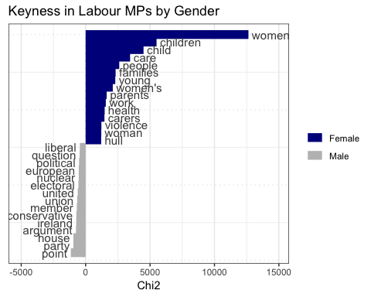

Keyness – a linguistic measure of the frequency of different words in two groups of texts – reveals clear gender differences in the most disproportionately common words used by female and male Labour MPs. Unsurprisingly, despite male MPs saying almost twice as many words (30601887 vs 15898845) as their female colleagues, female Labour MPs were more than two-and-a-half (2.61) times as likely to say “women”. They were also much more likely to refer to “women’s” and “woman”. Female Labour MPs also appear much more likely to discuss “children”, “people”, “care”, “families”, “home”, “parents”, “work” and social policy areas such as “services”, “disabled [people]” and “housing” than their male colleagues. Male MPs were more likely to refer to military topics (“Iraq”, “nuclear”), and to parliamentary process and protocol – “question”, “political”, “conservative”, “electoral”, “house”, “party”, “argument” “liberal” and “point” are far more common in speeches by male Labour MPs than by female ones. This could suggest that male MPs are more comfortable using the traditional language of House of Commons debate.

### Shortlists vs Non-Shortlists

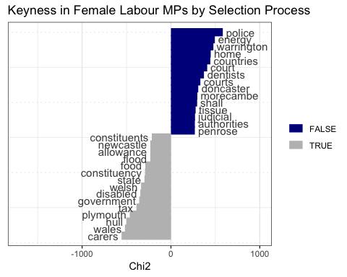

Keyness differences by selection process are not as obviously stereotypical. Nonetheless, the most common words amongst AWS MPs included “carers”, “disabled”, “bedroom” and “sen”[2]. [AWS MPs given policy briefs related to these areas? Seeking them out?]

## Topic Models

We assigned topic models using Latent Dirichlet Allocation (Blei, Ng, and Jordan 2003), implemented in the topicmodels R package (Grün and Hornik 2011). See Table 4 for the ten most common words in each topic model.

### Shortlists vs Non-Shortlists

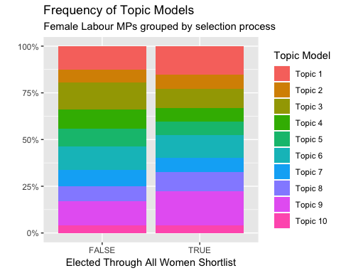

Topic Model Terms{#tbl:topicmodel} (continued below)

|  |  |  |  |  |
| --- | --- | --- | --- | --- |
| Topic 1 | Topic 2 | Topic 3 | Topic 4 | Topic 5 |
| report | children | legislation | housing | health |
| committee | young | clause | authorities | care |
| office | child | act | sector | services |
| question | education | amendment | scheme | nhs |
| mr | schools | law | homes | service |
| statement | school | case | services | hospital |
| review | parents | amendments | authority | patients |
| thank | families | might | council | mental |
| department | skills | system | planning | carers |
| issues | training | legal | financial | social |

|  |  |  |  |  |
| --- | --- | --- | --- | --- |
| Topic 6 | Topic 7 | Topic 8 | Topic 9 | Topic 10 |
| european | women | constituency | tax | energy |
| world | police | london | pay | industry |
| countries | home | transport | million | companies |
| uk | crime | areas | money | wales |
| international | officers | city | budget | uk |
| party | violence | area | cuts | scotland |
| parliament | justice | council | benefit | scottish |
| british | victims | constituents | credit | market |
| political | behaviour | services | cut | food |
| eu | men | north | jobs | amendment |

Topic Model Distribution

short_list

topic

topic_count

freq

FALSE

Topic 1

3489

0.1254675

FALSE

Topic 10

1174

0.0422181

FALSE

Topic 2

1964

0.0706272

FALSE

Topic 3

3949

0.1420095

FALSE

Topic 4

2878

0.1034954

FALSE

Topic 5

2633

0.0946850

FALSE

Topic 6

3527

0.1268340

FALSE

Topic 7

2376

0.0854430

FALSE

Topic 8

2264

0.0814154

FALSE

Topic 9

3554

0.1278049

TRUE

Topic 1

8148

0.1523475

TRUE

Topic 10

2204

0.0412094

TRUE

Topic 2

4182

0.0781931

TRUE

Topic 3

5376

0.1005179

TRUE

Topic 4

3896

0.0728456

TRUE

Topic 5

3917

0.0732382

TRUE

Topic 6

6471

0.1209917

TRUE

Topic 7

4002

0.0748275

TRUE

Topic 8

5612

0.1049305

TRUE

Topic 9

9675

0.1808986

Audickas, Lukas, Oliver Hawkins, and Richard Cracknell. 2017. “UK Election Statistics: 1918-2017.” Briefing Paper CBP7529. London: House of Commons Library. <http://researchbriefings.parliament.uk/ResearchBriefing/Summary/CBP-7529>.

Benoit, Kenneth. 2018. *Quanteda: Quantitative Analysis of Textual Data*. <https://doi.org/10.5281/zenodo.1004683>.

Blei, David M, Andrew Y Ng, and Michael I Jordan. 2003. “Latent Dirichlet Allocation.” *Journal of Machine Learning Research* 3 (Jan): 993–1022.

Bligh, Michelle, Jennifer Merolla, Jean Reith Schroedel, and Randall Gonzalez. 2010. “Finding Her Voice: Hillary Clinton’s Rhetoric in the 2008 Presidential Campaign.” *Women’s Studies* 39 (8): 823–50. <https://doi.org/10.1080/00497878.2010.513316>.

Cohen, Jacob. 1988. *Statistical Power Analysis for the Behavioral Sciences*. 2nd ed. Hillsdale, N.J: L. Erlbaum Associates.

Gagolewski, Marek. 2018. “R Package Stringi: Character String Processing Facilities.” <https://doi.org/10.5281/zenodo.1292492>.

Grün, Bettina, and Kurt Hornik. 2011. “Topicmodels: An R Package for Fitting Topic Models.” *Journal of Statistical Software* 40 (13): 1–30. <https://doi.org/10.18637/jss.v040.i13>.

Jones, Jennifer J. 2016. “Talk "Like a Man": The Linguistic Styles of Hillary Clinton, 1992-2013.” *Perspectives on Politics* 14 (03): 625–42. <https://doi.org/10.1017/S1537592716001092>.

Kelly, Richard. 2016. “All-Women Shortlists.” Briefing Paper 5057. London: House of Commons Library. <https://researchbriefings.parliament.uk/ResearchBriefing/Summary/SN05057>.

Kincaid, J. Peter, Robert P. Fishburne, Richard L. Rogers, and Brad S. Chissom. 1975. “Derivation of New Readability Formulas (Automated Readability Index, Fog Count and Flesch Reading Ease Formula) for Navy Enlisted Personnel:” Fort Belvoir, VA: Defense Technical Information Center. <https://doi.org/10.21236/ADA006655>.

Newman, Matthew L., Carla J. Groom, Lori D. Handelman, and James W. Pennebaker. 2008. “Gender Differences in Language Use: An Analysis of 14,000 Text Samples.” *Discourse Processes* 45 (3): 211–36. <https://doi.org/10.1080/01638530802073712>.

Odell, Evan. 2018. “Hansard Speeches and Sentiment V2.5.1 [Dataset],” July. <https://doi.org/10.5281/zenodo.1306964>.

Pennebaker, James W, Ryan L Boyd, Kayla Jordan, and Kate Blackburn. 2015. “The Development and Psychometric Properties of LIWC2015,” 26. <https://repositories.lib.utexas.edu/bitstream/handle/2152/31333/LIWC2015_LanguageManual.pdf>.

Yu, B. 2014. “Language and Gender in Congressional Speech.” *Literary and Linguistic Computing* 29 (1): 118–32. <https://doi.org/10.1093/llc/fqs073>.

1. e.g. a reference to “the member for Bethnal Green and Bow” in keeping with Parliamentary convention of identifying MPs by their seat rather than their name would be followed by “(Rushnara Ali)”.
2. Special Educational Needs