Channels:
- 4x phase current sense
- 4x phase voltage sense
- Battery+ voltage sense
- Chassis voltage sense (if doing floated chassis ground wrt battery)
- 4x more current and 4x more voltage sense channels with different gains (for different current and/or voltage ranges)
- Total: 18 channels

Need to define reqs:
- ADC type
- Rate
- Resolution
- Diff vs single ended
  - Can bias with amp circuit on phase current and voltage sense. Single ended will be noisier due to shared ground but will simplify by reducing the number of ADCs we need to toggle the SPI bus between. Im uncertain how easy it will be in firmware to manage multiple ADCs on a single SPI bus w/ chip select. Very likely worth dev’ing out with a prototype board
- Simultaneous sampling vs MUX
  - Ghosting possible concern for MUX’d ADCs. Less of a big deal if we have good low impedance amp outputs driving the ADC inputs
  - Flexible on this one I think. Possibly worth testing before fully committing to a MUX
Rate:
Using quadcopter motors as the high end of the signal speeds we want to characterize. Quadcopter motors peaking somewhere in the 10’s of kRPM
If we want to target racing drones or similar need to monitor motor currents/voltages on a ~40kRPM
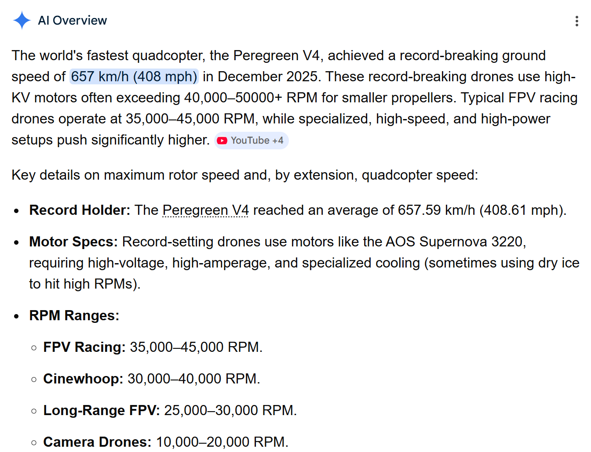

Want at least 3 samples per cycle of the electrical driving signal, maybe aim for 10 to be safe (fudge factor here)
For high KV motors we probably have a lower pole/slot count on the motor so these things kind of combat eachother in terms of sample rate reqs (higher KV->higher RPM->fewer slots to balance the electrical driving signal freq requirement)
Struggling to get good typical top end specs for slot count on high KV motor. Looks like 2000KV is generally on the high end for quadcopters.
- This one looks like a 12 slot at 2000KV
- Hard to tell but this one also probably 12 slots at 2200KV
  - These take 3s Lipos for a max of 4.2*3=12.6V -> 12.6V * 2200KV = 27720 RPM. 12 slots means 4 electrical cycles per revolution so we are looking at 110880 eRPM
- There are 4000KV motors like this, but this one seems to have 9 slots by eye
  - It also only takes a 2s Lipo which puts the eRPM at 4.2*2*4000*(9slots/3phases)=100800eRPM
- I don’t want to do a BLDC spec analysis here. Lets say we need to be able to characterize a 111000 eRPM signal as a worst case scenario
111000 RPM = 1850 Hz
Can adequately characterize this signal with a 18.5kHz ADC

Resolution:
12 bit is honestly probably fine. EMI induced noise will very likely be dominant over 122 ppm
Don’t break the bank or kill yourself to get a 14 or 16 bit ADC. If it’s a simple upgrade go for it. 12 bit is pretty widely available so I don’t think we need or want to step down to 10 or 8 bit
ADC resolution >= 12 bit

ADC type
Market in the rate/resolutions I am looking at is mostly dominated by delta sigmas and SARs
- Some background if you want it
  - https://dewesoft.com/blog/types-of-adc-converters
  - https://www.ti.com/europe/downloads/Choose%20the%20right%20data%20converter%20for%20your%20application.pdf
From experience with NI analog input cards, the delta sigma inherent anti-aliasing filter results in a noticeably lower noise floor
How much harder is it to implement a delta sigma ADC than a SAR? Need multiple clocks.
- Can we get some dev boards to test different ADCs? If not too difficult or expensive it may be worth trying each of these sampling multiple phase currents on a commercial ESC
  - I know the simultaneous sampled delta sigma will perform best. I suspect even a MUXs DSig will outperform a simultaneous sample SAR. What exactly would I be looking for in this test? Just the possibility that some options are, by the eye test, unusably bad?
    - Looks like >$100 for ADC eval boards too. Maybe good references for schematic though
- Should first look into how hard each is to implement
  - I think a lot of ADCs have built-in clocks. Many have integrated analog front end for scaling/filtering. Implementing a delta sigma in many cases may be as simple as thinking about power and SPI comm
Component selection – ADC
A NOTE FROM THE FUTURE: I misinterpreted the sample rate of the AD4115. The datasheet sayd 24845 SPS per channel. What they mean is 24845 shared among all channels (24845/# channels for the effective per channel sample rate). Looking for alternative ADCs but it looks like unless I want to spend $100’s per ADC im going to have to go with a SAR at my sample rate req
I like the AD4115 at a glance due to the channel count and rate. Some notes:
- “The AD4115 has no specific requirements for a power supply sequence. However, when all power supplies are stable, a device reset is required.” (Reset through SPI interface)
- 2 power supplies (very common for ADCs, separate power for analog and digital internal loads)
  - We can use the same power rail for both, maybe with some isolation. Alternatively we could give the digital side the 3V3 LDO output from the ESP32
  - An Altium video says I ought to share ground between them
    - Originally watched this: https://www.youtube.com/watch?v=9lVwNfXHwoE
    - It references this: https://resources.altium.com/p/how-properly-ground-adcs?utm_source=youtube&utm_medium=social&utm_campaign=yt-sponsor&utm_content=altium-academy
    - General idea here is that digital lines will have return paths near the transmission strips and you don’t want those pulsing return currents to couple into nearby analog signals. Can avoid this with good routing usually and don’t actually need separate AGND and DGND planes
    - Mention of low frequency analog signals having more distributed return paths. Interesting idea need to research this more maybe. Could result in poor performance on some single ended measurements as we have, say, battery voltage measurements which are pretty much DC values. Maybe an issue for cross-talk on current sensing at low RPM?
- This ADC is ~$25/ea… pretty costly worth considering some SAR alternatives
  - Checking octopart for some of the MAX series SARs it looks like we could maybe save 50% of the ADC cost. MAX11337 is a decent ~$12 option
  - Arrow has a solid deal on these for some reason at $5/ea
- OK so I want to test out this ADC. Want to explore a few things
  - Cross-talk between neighboring channels
    - Could be from ghosting (MUX’d ADC) or coupling on analog traces
      - May be able to play with ADC scan settings to differentiate between the two. Or could add jumpers that allow me to disconnect signals at the input to the ADC (so the coupling from signals on the traces remain the same but ADC doesn’t see the signal)
  - Input signal conditioning
    - Convert differential current sense to single ended ADC input
    - Convert larger differential DC voltages (batter+/-/chassis) to +/-10V single ended ADC inputs
  - SPI comm with multiple ADCs on the same bus. Can I juggle 2 ADCs with a single ESP32 SPI interface just by toggling chip select?
    - Toggling CS “resets” the digital interface, which may take some notable time.
  - There are probably a lot of unknown unknowns here. Getting data actually read in off one of these will be a nice win.
  - To do this I need a PCB with:
    - 5V power input interface (easy screw terminal or header pin. Can draw from exposed 5V pins supplying ESP32 dev board from USB C)
    - 2x AD4115
    - Different signal conditioning front ends on some channels
      - Current sense amplifier
        - Parallel samples of same shunt resistor
      - Difference amplifier (for voltage sense)
    - Exposed pins for SPI bus to ESP32
    - Exposed pins for 16x analog input channels
    - Really only the signal conditioning will require some component selection/design. The rest is just breakouts pretty much
Component selection – Current sense amplifier
INA241
- “Ultra-precise”. Input offset on the order of low 10’s of uV. Gain error around 100-150ppm
- PWM rejection may be helpful filtering out the phase switching noise
- Good gain options 10, 20, 50, 100, 200
- Comparatively large common-mode range -5 to 110 V
  - Common-mode range seems to typically be tight on the negative side. May make it difficult to float chassis at Vbatt/2 if our analog power rails also reference chassis
    - Could maybe bias analog and logic power closer to Vbatt-, or maybe even use Vbatt- as the ground ref. This means more conductor at Vbatt- which opens up more possibility of shorts but I think the PCB can be laid out intelligently. Also, I’m not necessarily holding myself to nail-through-board fault cases
  - Can we find anything that has low end common-mode range as low as -Vbatt (to allow amp to survive high-side chassis short)?
    - TI only has LMP86xx series which goes to -22
    - 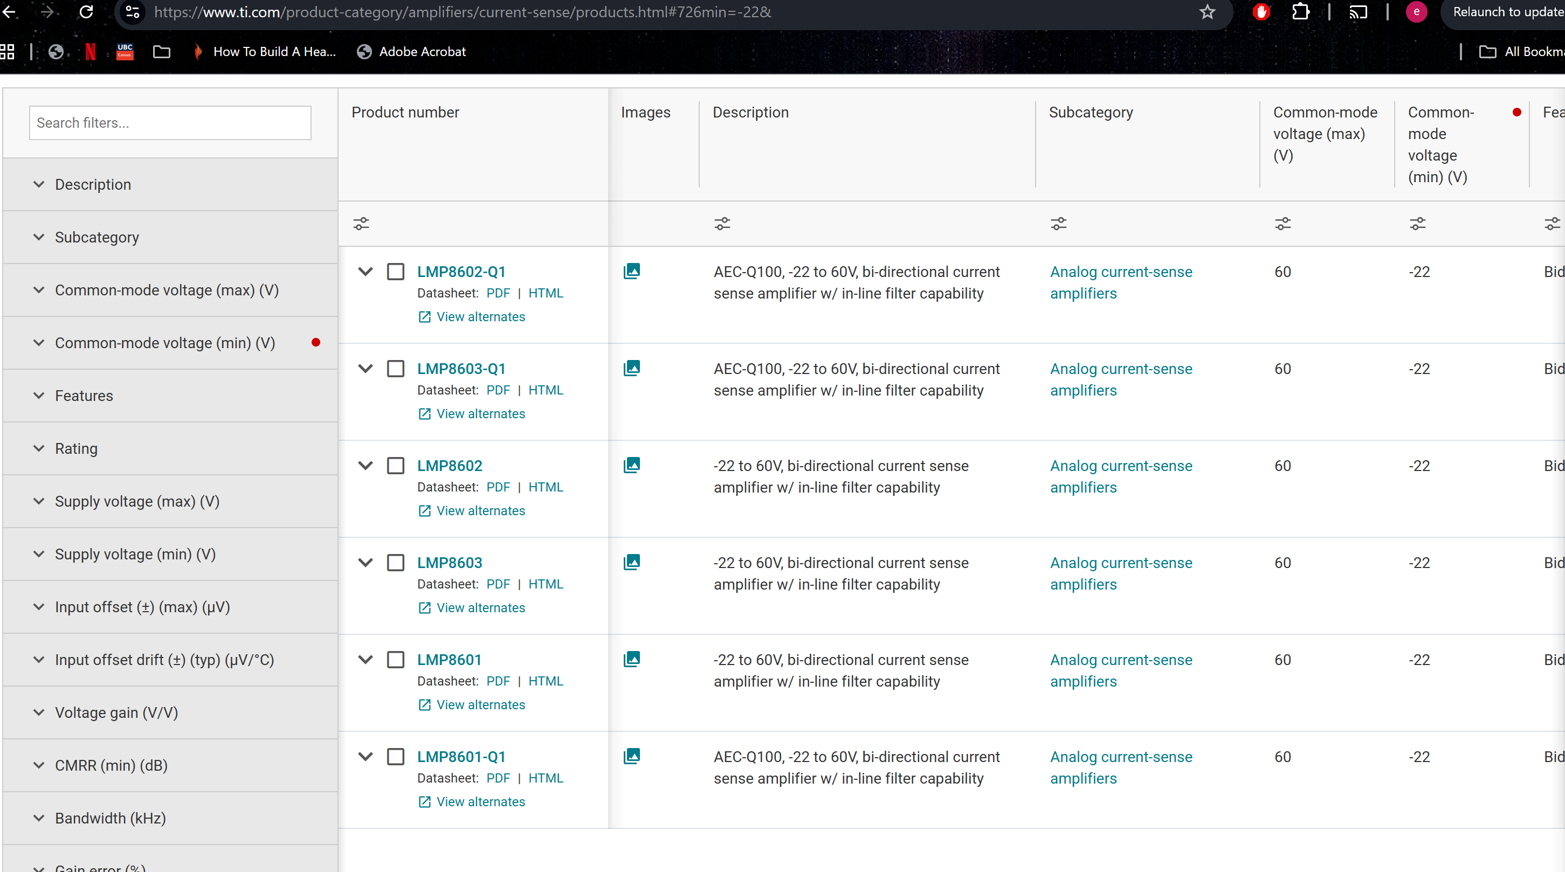
- Similar lower performance alts like INA299 are less than $1 cheaper.

