Table of Contents

Introduction 1

The Data 3

Imputation of Excused Absences on Tests 4

Analysis of the Network 5

Descriptive Statistics of Networks 5

Evolution of the Network 6

Decrease in Assortativity 6

Decrease in Number of Components 8

Charity 8

Stability of Collaboration: 9

Conclusion of Network Analysis: 10

Grade Regressions 11

Baseline Models without Student’s Identity 12

Unrestricted Models 14

Expectation Maximization 15

Help Received from Collaboration by Gender 15

Regressing Tests: 16

Simulating Grade Data to Test Null-Hypothesis 17

Conclusion of Predictive Modeling 17

Conclusion and Recommendations 17

Acknowledgements 19

Works Cited 20

Appendix 22

# Introduction

Collaboration is an important aspect of science, technology, engineering and mathematics (STEM) classes. In STEM classes, assignments typically have a small range of acceptable answers that every student must reach to obtain full credit. This contrasts with humanities and social science classes where every student’s essay will likely be distinct or plagiarism, if and when it occurs, will be much clearer. In addition, a problem on a STEM homework assignment may require a key insight which is easily communicated to other people. Furthermore, as in other disciplines, group work and brainstorming may lead more quickly to the correct answer than work in isolation. Finally, the importance of collaboration is magnified by the large portion of final grades that depend on homework.

Another characteristic of STEM classes is the large gender disparity. There is a wide body of research cataloging the differences in career choices and trajectories between men and women in STEM fields. Two overarching theories have been posited to explain these patterns: The deficit model and the difference model (Sonnert and Holton 1996). The deficit model emphasizes structural obstacles while the difference model focuses more on internal goals and behavior (Sonnert and Holton 1996). My research investigates the question of whether collaboration is one of these structural barriers preventing women from succeeding in STEM fields. In fact, prior research has found that classroom climate, including group working conditions, may reduce women’s confidence, especially in male-dominated fields (Hall 1982).

Computer Science has become an overwhelmingly male field. Since the middle of the 1980s, the percentage of women working in computer science related professions has steadily decreased. Women have earned only about 15% of the undergraduate degrees in computer science in recent years despite earning 37% in 1985 (Women in Computer Science 2017). While there is evidence that as much as 82% of the gap in STEM bachelor’s degrees is attributable to differences before college (Legewie and DiPrete 2014), the college experience is still worth studying. Many initiatives including “Girls Who Code” and “NASA Women” have attempted to combat the dearth of women in computer science by increasing women’s opportunity, participation, and interest.

This project explores and analyzes grades and collaboration from a computer science class at Yale to better understand the internal dynamics of the class. There are two major goals of this project. The first goal is to understand collaboration better by describing how it operates in this context and determining its relationship to grades and learning. The class studied is a particularly good example of the importance of collaboration. The class has a reputation for being difficult, has many students, and the homework makes up the majority (75%) of the final grade. In fact, many of the student reviews of the class mention the importance of collaboration. One student warned that “as long as you find a group to collaborate with, it’s a doable class” (Anonymous 2015). This heightened importance will make this class especially suitable for analysis.

The second goal is to explore the gender dynamics of the collaboration and grades to determine if and how different genders might be granted opportunities unequally. This essay aims to help understand and explain these trends by examining granular data from a computer science class. Focusing on the in-class dynamics that most organizations do not have access to, can expose barriers that women face inside the classroom that may be unrelated to external factors. A clearer understanding of the intersection of collaboration and gender can help make classes more data-driven and fair.

# The Data

The data analyzed consists of the grades (on both homework assignments and tests) and self-reported collaboration on homework by students in an upper-level computer science class at Yale University. There were seven problem sets assigned as homework for the course. There were also two in-class tests. While tests posed questions similar to the homework problems, the students had to complete them individually, despite being able to collaborate on homework. I scaled tests and problem sets to both be out of 30 points.

Information on collaboration was collected after each homework assignment via an online form. The professor instructed the students to identify whom they had received help from, including the option to state that you did not receive help from any other students. The professor strongly encouraged student to complete the forms by stating that failing to do so was a violation of academic honesty and by offering points for completion of the forms. Per class rules, students were only allowed to receive help from up to three other students.

The data began as adjacency lists and undertook the following transformations to become a network. Students were represented as nodes, and collaboration was represented as directed edges. When student A lists student B as a collaborator, there exists an edge B🡪A. While many of the edges are reciprocal (meaning A🡪B and B🡪A both exist), it is possible for only one of these to be in the graph. A network was made for each homework assignment since each assignment had different collaboration information.

Some students dropped the class after enrolling. Because the official drop deadline coincided with the due date of the fourth problem set, I will assume that any students who received no points after this date dropped the class. After the drop deadline, the class had 86 men, 23 women, and 1 non-binary student exemplifying the large gender divide typical of STEM classes. When comparing performance in different metrics across gender, I exclude the non-binary student because there is not much to be learned from a single data point.[1]

To protect the privacy of the students and to comply with regulations, students were assigned random identifiers. Because I was a student in the class, my grades and collaborations were removed from the dataset. This a source of error, as removing me changes the network. To further safeguard students’ identities, the grades on homework and tests were perturbed in a hidden manner by the professor before transferring the data to me for this project. The perturbed grades will be taken as is, but this perturbation is a further source of noise.

There are other potential limitations of the data set. For example, students may not have been completely honest in their voluntary reporting. While there are seven instances of students listing more than the allowed number of collaborators, this behavior may have been underreported because these disclosures could have been treated as a violation of academic policies. It is also difficult to determine whether students who did not list any collaborators actually did not collaborate with anyone. However, 72% of the students who list no collaborators also have no students list them as collaborators and the remaining 28% may have given help without receiving it. There was one example of a student listing everyone as a collaborator, which indicates students did not always take the online forms seriously; this student was removed from the dataset. Additionally, there are instances of students filling out the surveys multiple times. At the advice of the professor, I used the last response to the form in such an instance. Finally, there are many other attributes that are potentially interesting and important but that are not available. These include overall GPA, class year, residential college affiliation, major, and whether individuals were taking the class pass/fail. These could potentially be confounding variables. Despite these potential problems, the data is rich enough and robust enough to support analysis.

## Imputation of Excused Absences on Tests

There were excused absences that left three out of 220 test grades blank. There are two main strategies for dealing with missing data: Remove the observations that have missing data in any column, or impute the values. Because each student is important to the network structure, I did not remove these students from the data. I used the technique of computing conditioned means which leads to unbiased estimates of means but underestimates variance and overestimates covariance (Huisman 2014). Because of the relatively few instances of missing data, these effects are small. The best model for predicting each test was a linear model that was pruned using a combination of the Akaike information criterion (AIC) and removing predictors that were insignificant. AIC is asymptotically equivalent to leave one out cross validation (Stone 1977). Gender was ruled out as a predictor, and collaboration data was not considered as part of this imputation process. Finally, although I will proceed with the imputed data, it will be clear which grades were imputed – unlike read grades, the imputed grades are not integers.

# Analysis of the Network

## Descriptive Statistics of Networks

An examination of the network diagrams illustrates a few key trends that motivate further exploration. While network diagrams are not unique, the Fruchterman-Reingold algorithm places nodes by assigning physical forces to edges to create network diagrams that mimic the structure of the network. Nodes of the same genders are clustered because people tended to work with other students of the same gender. The overrepresentation of male students is also apparent from these diagrams. An additional property is the highly active core of the network, where most students reside. The shape of the largest connected component demonstrates the disperse information-sharing network that exists. This sharply contrasts with small, independent, fully-connected working groups. The largest connected component was at least 75 students in every problem and grew as the course went on, reaching 94 of the 110 students in the last problem set. Finally, as nodes are sized by grade on the assignment, the higher grades (larger nodes) tend to be concentrated in the highly-connected core while the worse grades are concentrated in the disconnected nodes on the periphery.

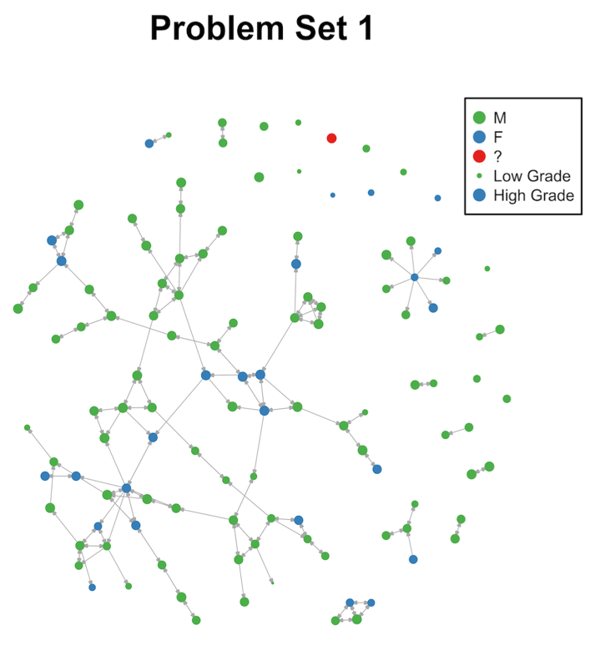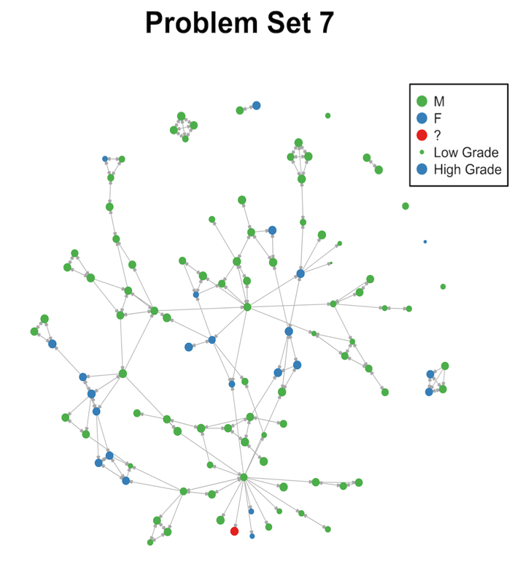

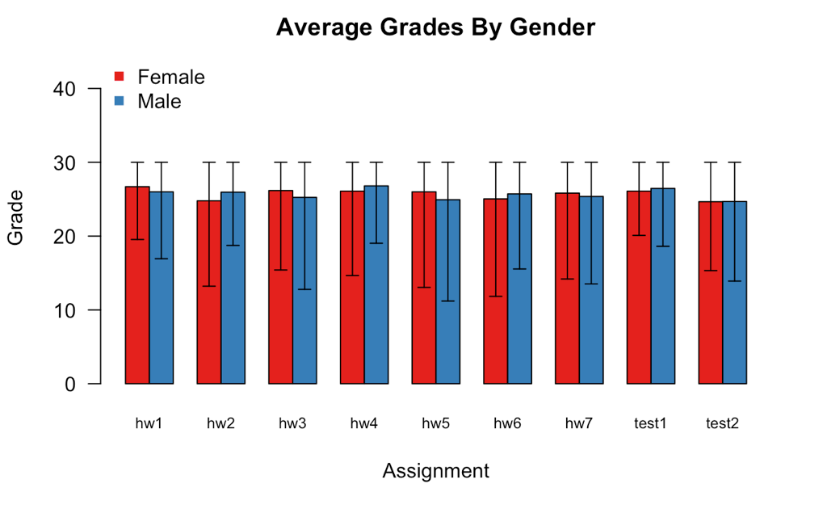The most basic properties in these directed graphs are in-degree, the number of students who helped you, and out-degree, the number of students whom you helped. The average in-degree and out-degree across all networks are both 1.8. Women had higher average in-degree (1.95 v. 1.75) and out-degree (1.92 to 1.77), but both these differences are insignificant. Over 99% of the in-degrees are less than 4 and 94% of the out-degrees are less than 5. The highest out-degree observed was 27. The degree distributions of the graphs do not follow a power law even though most real-world graphs’ degree distributions do follow a power law (Liljeros et al.). This difference is likely caused by the rule that you could only receive help from three other students.

Scores on homework and problem sets did not differ significantly by gender. The grades by gender are indistinguishable on every assignment. Grades in this class are high, and median grades were one or two points higher than mean grades because of long tails.

## Evolution of the Network

### Decrease in Assortativity

One of the features that evolved over time is increasing gender homophily, measured by assortativity coefficients. Homophily is the tendency for nodes that are similar in an external property (gender here), tend to connect to each other. The assortativity coefficient is positive when homophily is present in a graph and ranges from 1 to -1. Assortativity is calculated as where is the mixing matrix of the graph. The assortativity increased from .26 in the first problem set to .36 in the last problem set. This increase was caused both by fewer inter-gender edges and more intra-gender edges. To test whether this increase could have happened by chance, I took the core network, the set of edges that appeared in both the first and last problem, and randomly added the number of edges required to have the same edge count as in the last problem set. Randomly creating networks is a common technique in network studies to help determine significance (Bearman et al. 2004).

It is useful to distinguish between baseline homophily and inbreeding homophily. Baseline homophily is the homophily you would expect from random ties due to the prevalence of different groups while inbreeding homophily is the deviation above that random model (McPherson et al. 2001). Inbreeding homophily is homophily that is most interesting because it corresponds to the differential treatment of in-group and out-group members.

Out of the 10,000 simulated networks, in only 3 of them was the assortativity coefficient higher than the observed assortativity coefficient in the last problem set giving evidence to indicate inbreeding homophily. This finding gives credence to the idea that gender is a salient feature to the students and is not independent of which new connections are made and which connections are kept.

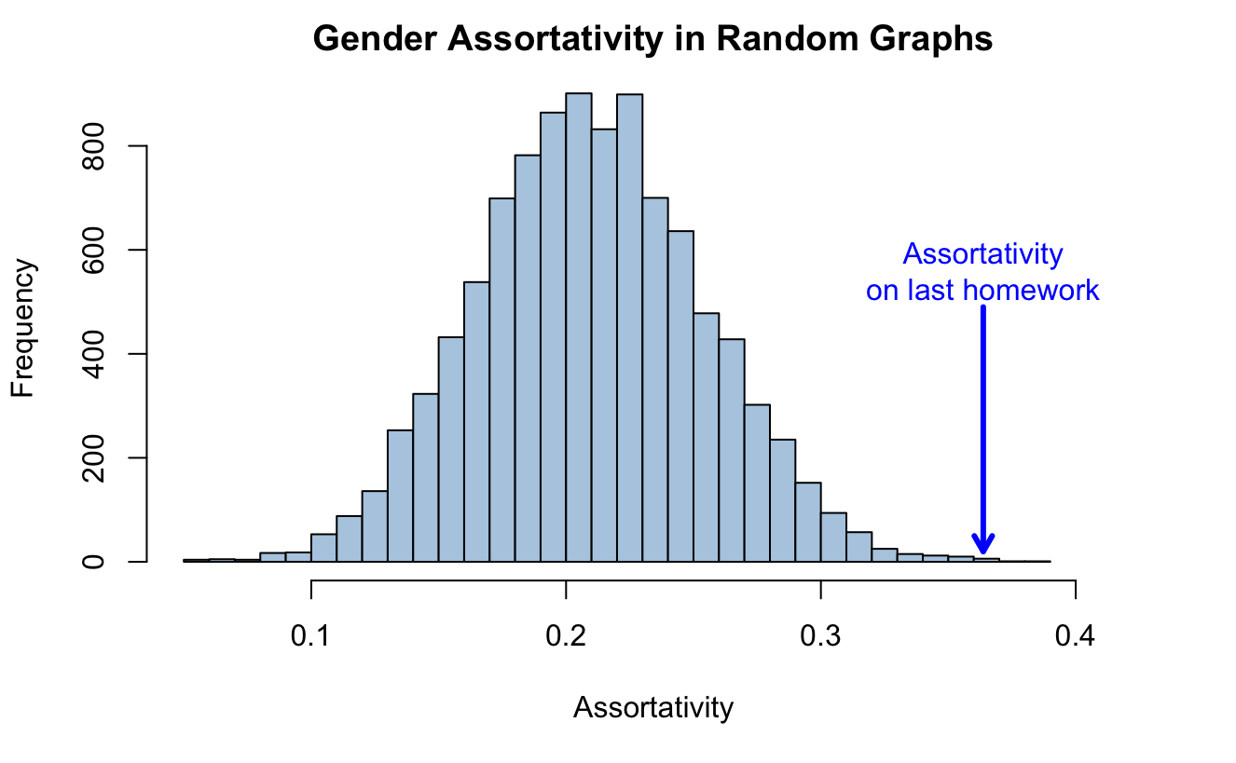

This finding may be related to the different ways that men and women interact with groups. Men have more negative perceptions of potential working partners, particularly women (Kuhn and Villeval 2013). These negative perceptions may have contributed to a greater lack of inter-gender ties than would have been expected by random chance. Additionally, because men tend to talk more during group work and are more likely to interrupt (Hall 1982), inter-gender working groups may be less effective and enjoyable, reinforcing the tendency to work with one’s own gender.

### Decrease in Number of Components

The decrease in number of components and the number of isolated students is aspect of the evolution of the networks. The number of connected components dropped from 34 to 9 while the number of unconnected students fell from 26 to 4. Meanwhile, the largest component grew from 75 to 94. While this seems like a big drop, this decrease in components and unconnected students is the expected result in random graphs. In fact, the increase in the largest connected component is smaller than would be expected. This suggests that edges were not formed independently of the network structure but that the decrease in components is largely due to the increased number of edges in the network and not some pattern specific to this class.

### Charity

Another difference in the way men and women interact with groups is that women seem to be motivated by inequity more than men and are more likely to partner with less able individuals (Kuhn and Villeval 2003). To test if a similar phenomenon was present in this collaboration data, I designated edges as charitable if student A helped student B but did receive help from student B and student A received at least as good a grade as student B. I grouped edges by the gender of the helper and the helpee and compared the proportions. After applying the Holm correction for multiple comparisons, inter-gender ties were significantly more likely to be charitable than intra-gender ties. While the conclusion that women were in general more likely to give charity than men was found in the prior study was not supported, there are interesting results. One reason that inter-gender ties were more likely to be charitable is that while people mostly worked with the same gender when groups were stuck they may have asked for help solving the problems from someone whom they didn’t typically work with. In fact, charitable ties appeared again in only 2.15 other problem sets on average while non-charitable ties appeared in 4.17 other problem sets on average. This difference is highly statistically significant. 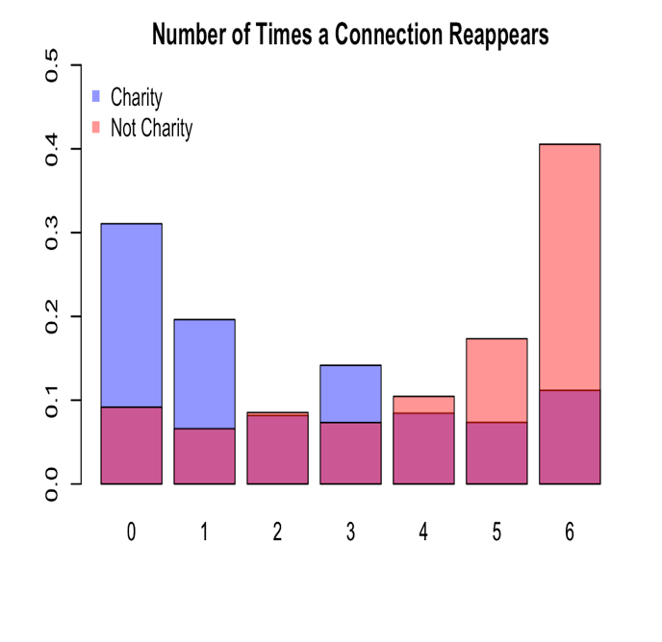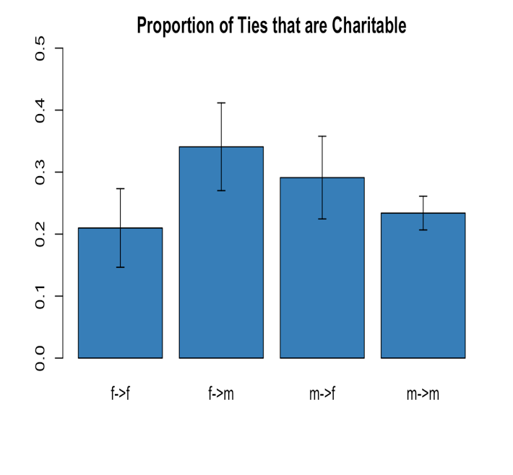

## Stability of Collaboration:

Despite the significant evolution of the networks, collaboration is largely consistent over time. 48% of edges are in part of edges that appear either in 6 or 7 of the 7 networks. Additionally, no two networks have less than 51% overlap in edges and the average overlap is 60% between networks. I categorized each edge that appeared any network by the number of times the edge appeared as well as structural and grade information associated with the endpoints. I then used a linear regression to determine which features led to more edge stability.

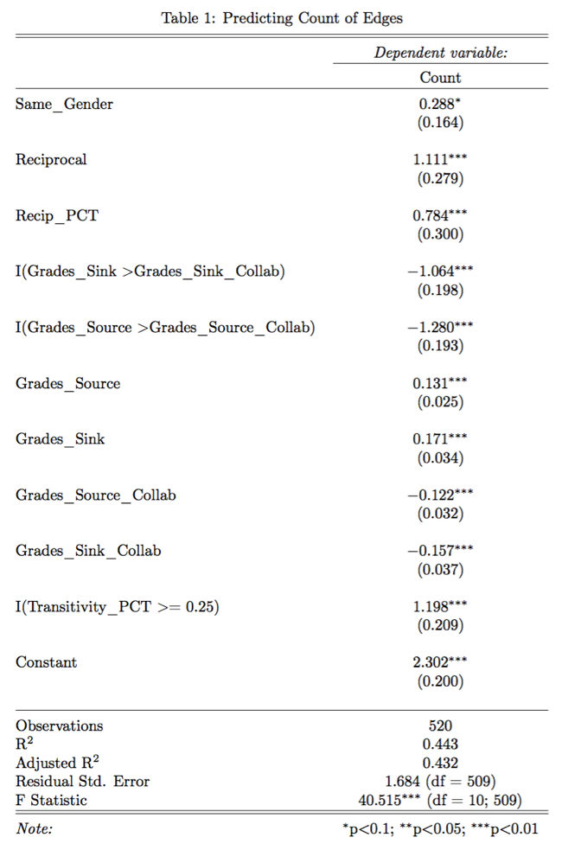Cross-gender edges were less likely to remain despite there being no difference based on the genders involved or direction, only that edges spanned different genders. When transitivity, measured by the Jaccard index of the set of individuals that each of the collaborators collaborated with during the semester, was greater than or equal to , collaborations were far more likely to be consistent suggesting that groups are more stable than one-off partnerships. The cutoff was chosen empirically. Additionally, reciprocity, both the fact that the reciprocal tie exists at all and the percentage of times the tie is reciprocal, were significant predictors of more collaborations perhaps illustrating an aversion to free-riding by the students giving the help without receiving any.

Another important factor was the success of the collaboration. When grades within the collaboration were less than students’ average grade in general, there was a strong aversion to continuing to collaborate. Furthermore, the extent of the difference was also important. Furthermore, in general, students who received better grades tended to have more stable collaboration. Whether this was because more stable collaboration led to better grades, because the students who received better grades preferred more stable collaboration, or the effect of another factor is impossible to determine.

## Conclusion of Network Analysis:

The networks of this class are highly clustered by gender and dominated by a single, large connected component. Over time, more students become active participants in the network. Although prior research has found that women are generally more attracted to collaborative working environments than men, there is no convincing evidence here to support that claim (Kuhn and Villeval 2003). There are no significant differences in the amount of collaboration or the grades received by gender. Collaboration in the network appears to be controlled by several norms. Collaboration relationships that are not reciprocal or part of a group are abandoned at much higher rates than those relationships that are reciprocal or in groups. Additionally, partnerships that are intra-gender and that receive high grades are more likely to stay together.

# Grade Regressions

However, this project strives not just to describe the norms and dynamics collaboration but also understand the connection with grades. Collaboration happens in many courses but the effects are unclear. When collaboration occurs in a course it can be difficult to determine what is true collaboration where students are working together to solve the problems and what is more like one student copying the answer from another. Additionally, there is the worry that students who collaborate are at a big advantage over those who don’t. One course reviewer complained and cautioned future students that “if you don't have friends in the class, that just means that your grades will be lower than everyone else who is able to collaborate - beware of that (Anonymous 2016)!” I will analyze and explore these two phenomena, both demonstrating the effects of collaboration and analyzing the potential abuses.

Measuring the influence of collaboration is a difficult exercise. It is hard to separate out the effects that come from individual students’ abilities and efforts when the only individual assignments are tests that may be influenced through increased or decreased learning when collaborating with others. Additionally, because collaboration is quite consistent throughout the semester, grades on other problem sets reflect both the students’ abilities and their level of collaboration on that other problem set. One difficulty is that for most problem sets there are a few students whose performance is very disparate from their performance on other problem sets. This is might be due to random events that were happening at the time in students’ lives.

Because grade means differed by assignment, I analyzed grades after subtracting out the means. Additionally, while there were some time dependent trends such as neighboring problem sets grades and collaboration being slightly more correlated, I found better results by removing information about which problem set or test grades came from. However, to avoid assuming independence when it was not there, cross-validation on problem sets occurred by holding out each problem set, training on the rest of the data, and then measuring performance on the held-out data. Grades within each problem set are not independent since grades between collaborators are correlated. All model selection and accuracy over baselines are reported using the held-out data while model coefficients and significance scores are reporting using the full data set to get the most accurate numbers possible.

To get a first approximation of the relationship between grades and collaboration, I created violin plots which are like boxplots but feature rotated kernel density plots to better illustrate the distribution of data across categories. There are several important observations from these graphs. Grouping by both in-degree and out-degree, there is a positive correlation between grades and collaboration but also diminishing marginal returns to more collaboration, especially after going from zero collaborators to one. Furthermore, the skew of the data is apparent. While most grades are around zero (the mean), there are long tails in the negative direction. While this analysis does not illustrate any causal information, it suggests that collaboration is strongly related to grades.

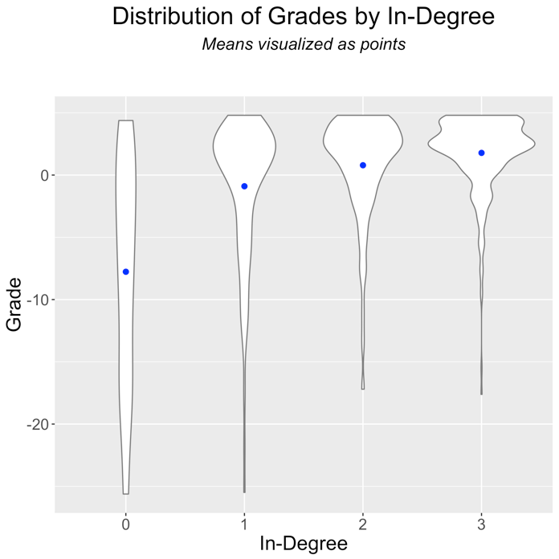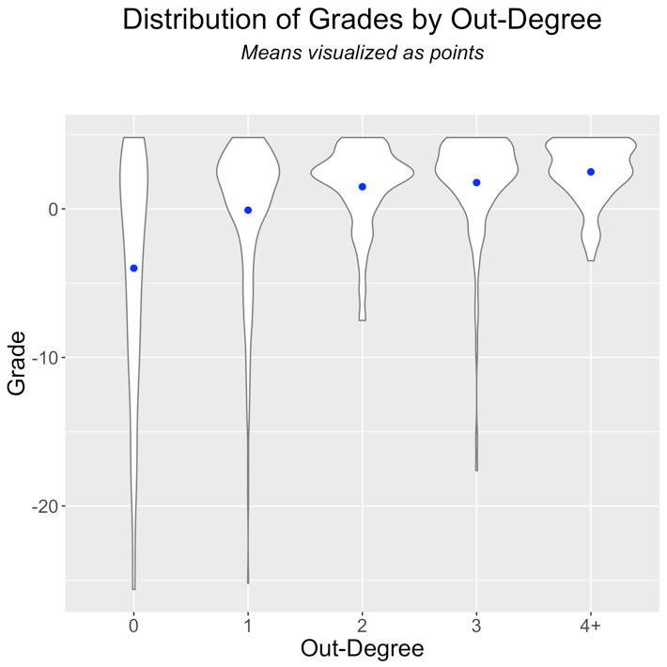

## Baseline Models without Student’s Identity

I then fit a variety of models with access to different information. Comparing the fits of these models will give some insight into which of these features are most important for predicting grades, and perhaps also success in the class.

First, I tried to predict grades using the information only obtainable from looking at the network structure. I then added information about the grades of collaborators but held out information about individuals’ grades on other assignments. The best models for both scenarios were random forests. For both models, the baseline is a naïve model that predicts the class mean for every person. Both models drastically outperformed the baseline but performed similarly to each other despite the increase in information available. This is likely because collaboration and good grades are correlated in a way that allows the simpler model without grade information to get an approximation of this information. Evidence of this is that membership in the largest component was included in the model for the simplest model but was removed for the model that allowed grade information to be considered. Membership in the largest component is related to higher grades but in a weaker way than collaborators’ grades.

Additionally, the measure of centrality that was most helpful for these predictions and was included in both models is constraint. Constraint measures access to disparate sources of information which might explain why it is so predictive here. Constraint is defined as

where is set of nodes connected to , and represents elements in the row-normalized adjacency matrix. Constraint is lower for students with less redundant ties and ranges from 0 to 1. Because constraint is undefined for isolated students, I set constraint to 1.5 for these students to allow the model to be fit with all the data. Since random forests were used for these models, the important thing is that there is a cut point that disambiguates this arbitrary value from the real values of constraint. Nevertheless, the value of 1.5 also fits well with the linear trend of constraint. Connections to different groups of students might give you exposure to more ideas and a better chance of getting the correct answer to a problem set. It also may be the case that better students have lower constraint because they are asked by many different people to collaborate. Lower constraint has been linked in work settings to the formulation of better ideas, higher salary, and promotions (Burt 2004). This corroborates the finding that constraint can be an important determiner of success, especially for complex tasks.

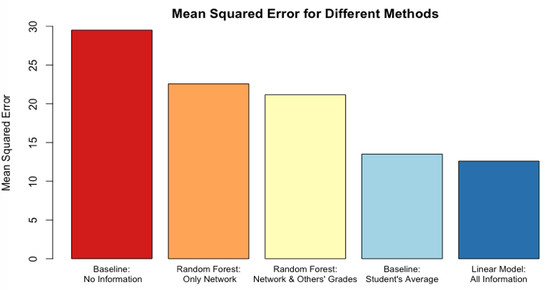

## Unrestricted Models

I then predicted grades based on all available information. Importantly, the model had access to individuals’ grades on other assignments and used student identities as a factor variable as well as all the network information. This method creates “ability scores” for each student. The baseline I compared this model against was an individual’s grades on other assignments, which turned out to be a great predictor of grades that was hard to improve over. The errors for both the baseline and the model in this section are about half as big as when student identities are hidden.

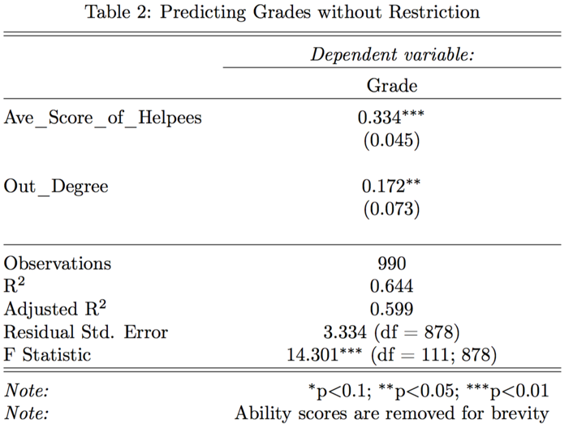 Nevertheless, there were significant improvements to be made by including information from the network but the improvements are much smaller because the baseline is already so good. Interestingly, both features selected here, Ave_Score_of_Helpees, which measures the score of those whom a student helped on an assignment, and out-degree, are about the help given out by a student, not the help received. I have two possible theories for why help given is so important. One is that by helping another student, a student learns the material better and this extra learning is reflected in higher grades. The second possibility that I find more compelling is that helping other students indicates a student who is confident that he/she has the right answer and that confidence is founded. However, these conclusions are dampened because this linear model, chosen for the best performance on the held-out data and AIC, is one of many similar models that can achieve roughly equivalent performance.

### Expectation Maximization

I also attempted to use expectation maximization to simultaneously fit coefficients for each individual’s own ability, , as well as coefficients and that measured the effect of the ability of edges coming in and out respectively according to the following formula.

However, this method did not produce any improvements from the baseline model of individuals’ average grades. Furthermore, the estimates of ability changed very little from this baseline of ability scores being set equal to students’ average grade. I suspect the failing of this method is the reliance more on the source of the collaboration than whether collaboration existed. In the other models that are more successful, the information that is most helpful is whether collaboration exists. Additionally, the reliance on ability scores neglects fine-grained information such as the score of students you helped on a specific problem set. This doesn’t allow for learning when a group of students may be performing worse than their average on a given problem set.

### Help Received from Collaboration by Gender

To compare the impact of collaboration on men and women, I compared the percentiles of grades to the percentiles of “ability scores.” Those with higher grades than ability scores were helped by collaboration while those with higher ability scores than grades may have benefitted from a different system. While women were more likely to receive help (61% vs. 49% for men), this difference is insignificant. This is parallel to the finding that women collaborate more than men in a statistically insignificant manner. The fact that women and men receive roughly similar amounts of help from collaboration is surprising given the large gender imbalance in the class and the notion of women being disadvantaged in STEM classes. One possible explanation for this phenomenon is that men are more confident in their abilities (Kuhn and Villeval 2003; Hall 1982) and believe that they don’t need to collaborate, even when collaboration could help them. Another possibility is that women are as active in the network because of selection effects. Since people expected collaboration to an important part of the class, only those with friends in the class chose to stay in the class. As the minority group in the class, this effect may have been stronger on the women leading to the women who stay in the class being more well-connected than one might expect without this selection bias given the underrepresentation of other women in the class.

## Regressing Tests:

To test the hypothesis that collaboration may lead students to copy other students’ work without learning the material, I predicted grades on tests using grades on homework grades and collaboration metrics on the homework assignments. To serve as a baseline for this section, I predict individual’s test grade by predicting their average grade on the problem sets. To prevent overfitting, I used 10-fold cross-validation that chooses which students to include completely randomly. Test scores for different people are independent of each other since they are individual assignments.

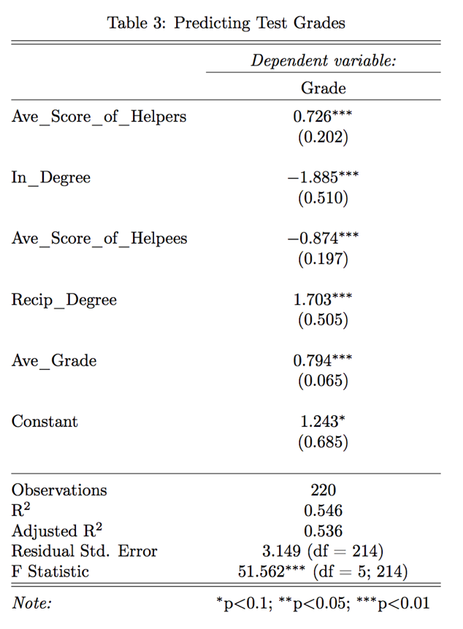A linear model outperformed the baseline by reducing mean squared error by 15% from 12 to 10.2. Average grades are a very good predictor of test scores mostly likely because of the nature of the class’s tests. The tests did not require students to solve new problems but instead required students to solve problems that appeared in class or on a homework assignment. The remaining coefficients suggest an interesting, intuitive story. After conditioning on grades, collaboration led to predictions of lower grades, particularly of those free-riding. While collaboration led to lower grades, the extent to which one’s in-degree was higher than their number of reciprocal ties the more extreme the expected penalty on one’s grade was. This effect was somewhat mitigated by having helpers have higher grades than those you are helping but this does not reverse the effect. This illustrates that the worry that students who collaborate do not learn as much is backed by the evidence. However, since students who collaborate do better on homework assignments, this method overrates the free-riding effects of collaboration. Still, the fact that collaboration, and particularly non-reciprocal collaboration, is associated with lower test scores is an important trend to recognize.

## Simulating Grade Data to Test Null-Hypothesis

To measure the robustness of these models, I created 1000 simulated data sets under the null hypothesis that grades are equal to people’s average grades plus a random error term.

This reduced the performance of the random forest predicting grades solely with network information by the least, but still significant, amount. This illustrates that the features included in that model (Constraint, Reciprocal Degree, In-Degree, Out-Degree, and membership in the biggest component) are features that mark higher grades but still are dependent on the exact dynamics of the network. The random forest that predicted grades based on the network information and the grades of collaborators declined much more in performance but still outperformed the baseline. Since this model relied heavily on the performance of collaborators and now performs worse, this illustrates grades of collaborators, and specifically, the deviations from their average grades, are more correlated than what would happen by chance alone.

In both linear models, the one predicting grades on homework and tests conditioned on all available information and the one predicting test scores based on average level of collaboration, not a single coefficient had a 95% confidence interval that excluded 0. These models were now equivalent to the baseline models. This finding gives more confidence to the results that the two linear models examined are detecting important features instead of simply following noise in the data and helps to reject the null hypothesis that the network structure is not connected to deviations in grades.

## Conclusion of Predictive Modeling

There are several main takeaways from these different models. While more collaboration is predictive of and correlated with higher grades, it is not possible to determine causal impacts. The data does not contain sufficient natural experiments. Nevertheless, the network structure is inextricably linked with grades. Diversity of collaborators appears to be advantageous because lower constraint consistently appears in a variety of models as a good predictor of better grades. Additionally, gender was never a useful or significant predictor of grades in any model. An important unobserved impact of collaboration may be the time saved in completing the assignment, something that may be equally as valuable to students as better grades. Finally, while there are instances of free-riding on the network and while these students can get higher grades on problem sets, the tests serve as a check against this behavior.

# Conclusion and Recommendations

Collaboration in this class is characterized by a diffuse network in which most activity is concentrated in the largest connected component. Gender is an important feature in the networks but neither side is significantly more active. The average grades received by men and women were indistinguishable. Despite women making up less than a quarter of the class, both the amount of collaboration and the estimates of help received from collaboration do not significantly differ by gender. There is no evidence of either gender being at a disadvantage. Intra-gender edges were more stable and became more prevalent as the course continued. While inter-gender edges were more likely to be charitable, these ties were short-lived. The other important norms enforced by students in the network were reciprocity and transitivity. Relationships that lacked these features were less likely to continue.

Collaborating with classmates is correlated with higher grades. One network feature that was consistently predicted higher grades is lower constraint, a measure of the redundancy of a student’s ties. This highlights the advantage to accessing multiple information sources. However, causal effects are elusive. There were no natural experiments and the consistency of collaboration made untangling the impact difficult. Although the best predictor of grades was the grades on other assignments, this could be improved with network information. There is some evidence of free-riding on problem sets. After conditioning on homework grades, test scores are lower for more active collaborators, especially for those who received more help than they gave.

Overall, the collaboration system seems to be working well, but there are ways for it to be improved. While most students collaborate, an effort to ensure that all students have access to collaborators could help students who don’t know other students in the class, especially because the first collaboration is so important. Encouraging more inter-gender collaboration could reduce the gender segregation in the network and lead to a more open and welcoming class. Although all genders succeeded equally in the class, the overwhelming majority of the students is male so attracting more non-male students to the class is another potential improvement. Finally, putting a larger emphasis on the individual tests could reduce the incentive to free-ride and reward the students who are learning the most.

# Acknowledgements

# Works Cited

Anonymous. (2015). Overview of Evaluations : CPSC 365 01 Design & Analysis of Algorithms.

Anonymous. (2016). Overview of Evaluations : CPSC 365 01 Design & Analysis of Algorithms.

Bearman, P. S., Moody, J., & Stovel, K. (2004). Chains of Affection: The Structure of Adolescent Romantic and Sexual Networks. *American Journal of Sociology*, *110*(1), 44–91. https://doi.org/10.1086/386272

Burt, R. S. (2004). Structural Holes and Good Ideas. *American Journal of Sociology*, *110*(2), 349–399. https://doi.org/10.1086/421787

Hall, R. M. |Sandler. (1982). The Classroom Climate: A Chilly One for Women?. Retrieved from https://eric.ed.gov/?id=ED215628

Hlavac, M. (2015). stargazer: Well-Formatted Regression and Summary Statistics Tables (Version R package version 5.2).

Huisman, M. (n.d.). Imputation of Missing Network Data. *ResearchGate*. Retrieved from https://www.researchgate.net/publication/264896130_Imputation_of_Missing_Network_Data

Kuhn, P. J., & Villeval, M.-C. (2013). *Are Women More Attracted to Cooperation Than Men?* (Working Paper No. 19277). National Bureau of Economic Research. Retrieved from http://www.nber.org/papers/w19277

Legewie, J., & DiPrete, T. A. (2014). Pathways to Science and Engineering Bachelor’s Degrees for Men and Women. *Sociological Science*, *1*, 41–48. https://doi.org/10.15195/v1.a4

Liljeros, F., Edling, C. R., Amaral, L. A. N., Stanley, H. E., & Åberg, Y. (2001). The web of human sexual contacts. *Nature*, *411*(6840), 907–908. https://doi.org/10.1038/35082140

McPherson, M., Smith-Lovin, L., & Cook, J. (2001). Birds of a Feather: Homophily in Social Networks. *Annual Review of Sociology*, *27*(1), 415–444. https://doi.org/10.1146/annurev.soc.27.1.415

Shirado, H. (2016). *analysis_advise_networks.R*.

Sonnert, G., & Holton, G. (1996). Career Patterns of Women and Men in the Sciences. *American Scientist*, *84*(1), 63–71.

Stone, M. (1977). An Asymptotic Equivalence of Choice of Model by Cross-Validation and Akaike’s Criterion. *Journal of the Royal Statistical Society. Series B (Methodological)*, *39*(1), 44–47.

Taylor, D. W., Berry, P. C., & Block, C. H. (1958). Does Group Participation When Using Brainstorming Facilitate or Inhibit Creative Thinking? *Administrative Science Quarterly*, *3*(1), 23–47. https://doi.org/10.2307/2390603

Women in Computer Science. (n.d.). Retrieved January 24, 2017, from http://www.computerscience.org/resources/women-in-computer-science/

# Appendix

The R code used in this project is attached. The attached code is edited to remove redundancy across files and to remove exploratory code. The full code is available on GitHub: <https://github.com/evanrgreen/Senior_Thesis>.

To run the R files on your local computer, you should first clone the repository. Then, you will need to change the path in the first chunk of each file to the indicate where you have put the folder entitled “Grade Data.” Additionally, if you do not have all the packages that are imported in the first chunk installed, you will need to install those before the code will run. You can also run Install_Packages.R in the R Files folder.

There are 4 R files that were integral to the project. They are all in the R Files folder.

Analyze_Grade_Networks.RMD

The file performs analysis about the network properties. This includes creating random graphs to test for the likelihood of different observed properties, calculating and visualizing the average grades and degree distribution by gender and analyzing the factors that lead to more stable edges.

Grade_Regressions.RMD

This file tests and validates various models that predicted the grades of students based on different assumptions and available information.

Imputing_Missing_Tests.RMD

This file tests different models for imputing the excused absences on tests and outputs a new file that has a complete, imputed set of grades.

Visualize_Network.RMD

This file uses a few different packages to create information visuals of the network itself.

1. The non-binary student was one of the top performers in the class but was not an active collaborator. The student received help from the same student five different times but never helped another student.