Arduino Codes for Connecting Different Sensors
Arduino Uno examples, wiring notes, and sensor illustrations

Arduino codes for connecting different sensors
Arduino is a small programmable board used to read information from sensors and control electronic devices. Below are beginner-friendly Arduino sketches for the sensors discussed.
The examples use an Arduino Uno and the Arduino IDE. Most examples display sensor readings in the Serial Monitor.

1. Basic setup
- Install the Arduino IDE on your computer.
- Connect the Arduino Uno to your computer using a USB cable.
- Connect the sensor's power pin (VCC or +) to 5V or 3.3V, as required by your specific sensor.
- Connect GND to Arduino GND.
- Connect the sensor's signal pin to the pin specified in the example.
- In Arduino IDE, select Tools → Board → Arduino Uno, then select the correct port.
- Upload the code and open Tools → Serial Monitor. Set the baud rate to match the code, usually 9600.
Important: Sensors have different pin layouts and voltage requirements. Check the markings and specifications on your actual module before connecting it. Never connect a 5V signal directly to a 3.3V-only input.

2. Temperature sensor (LM35)
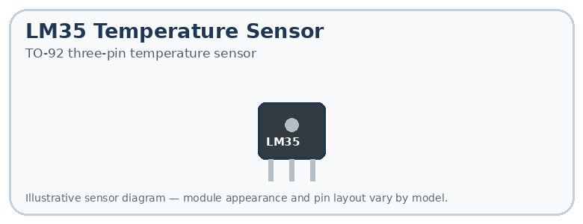

Connections
- VCC or supply pin → appropriate power supply for the LM35
- OUT → A0
- GND → GND

Arduino code
const int sensorPin = A0;
void setup() {
Serial.begin(9600);
}
void loop() {
int reading = analogRead(sensorPin);
float voltage = reading * (5.0 / 1023.0);
float temperature = voltage * 100.0;
Serial.print("Temperature: ");
Serial.print(temperature);
Serial.println(" C");
delay(1000);
}

Explanation
The Arduino reads the voltage from the LM35 and converts it into an estimated temperature in degrees Celsius. This formula assumes a 5V reference and the LM35's typical output of 10 mV per °C.

3. Light sensor (LDR)
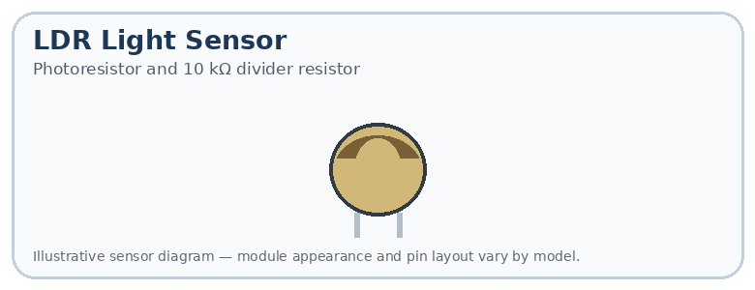

Connections
- One LDR leg → 5V
- Other LDR leg → A0
- A 10 kΩ resistor between A0 and GND

Arduino code
const int lightPin = A0;
void setup() {
Serial.begin(9600);
}
void loop() {
int lightValue = analogRead(lightPin);
Serial.print("Light reading: ");
Serial.println(lightValue);
if (lightValue < 300) {
Serial.println("Low light detected");
} else {
Serial.println("Bright light detected");
}
delay(500);
}

Explanation
The LDR's resistance changes with light. The Arduino reads the resulting voltage as a number from 0 to 1023 on a classic Uno. The threshold of 300 is only an example and may need adjusting.

4. Motion sensor (PIR HC-SR501)
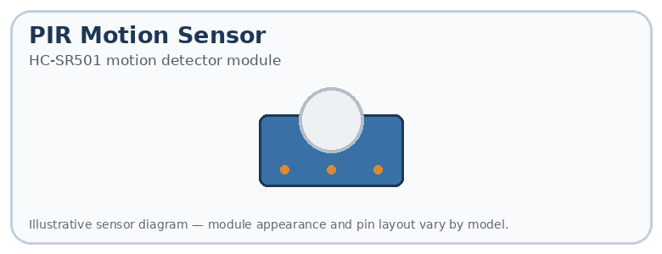

Connections
- VCC → 5V
- OUT → digital pin 2
- GND → GND

Arduino code
const int motionPin = 2;
void setup() {
pinMode(motionPin, INPUT);
Serial.begin(9600);
}
void loop() {
int motion = digitalRead(motionPin);
if (motion == HIGH) {
Serial.println("Motion detected!");
} else {
Serial.println("No motion");
}
delay(300);
}

Explanation
The PIR sensor outputs a digital HIGH when it detects motion and LOW when it does not, depending on its configuration.

5. Proximity/distance sensor (HC-SR04)
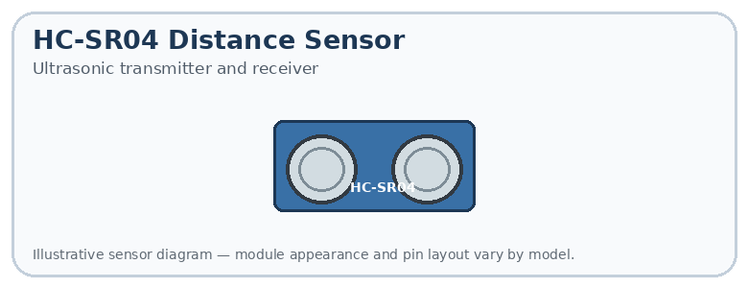

Connections
- VCC → 5V
- GND → GND
- TRIG → digital pin 3
- ECHO → digital pin 4

Arduino code
const int trigPin = 3;
const int echoPin = 4;
void setup() {
pinMode(trigPin, OUTPUT);
pinMode(echoPin, INPUT);
Serial.begin(9600);
}
void loop() {
digitalWrite(trigPin, LOW);
delayMicroseconds(2);
digitalWrite(trigPin, HIGH);
delayMicroseconds(10);
digitalWrite(trigPin, LOW);
long duration = pulseIn(echoPin, HIGH, 30000);
if (duration == 0) {
Serial.println("No echo received");
} else {
float distance = duration * 0.0343 / 2;
Serial.print("Distance: ");
Serial.print(distance);
Serial.println(" cm");
}
delay(500);
}

Explanation
The sensor sends out an ultrasonic sound pulse and measures how long its echo takes to return. The code converts that time into distance in centimetres.

6. Soil moisture sensor
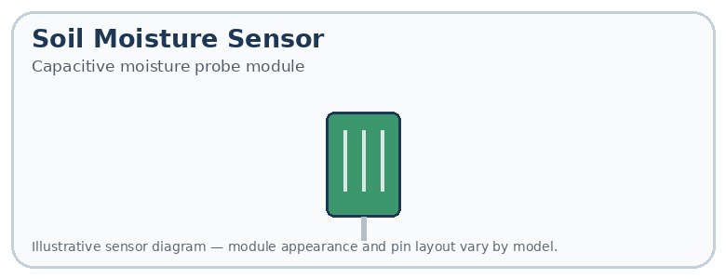

Connections
- VCC → appropriate supply
- GND → GND
- AOUT or AO → A0

Arduino code
const int moisturePin = A0;
void setup() {
Serial.begin(9600);
}
void loop() {
int moisture = analogRead(moisturePin);
Serial.print("Moisture reading: ");
Serial.println(moisture);
delay(1000);
}

Explanation
This displays the raw moisture reading. Calibrate your sensor in dry and wet soil before converting the reading into a percentage.

7. Pressure sensor (BMP280)
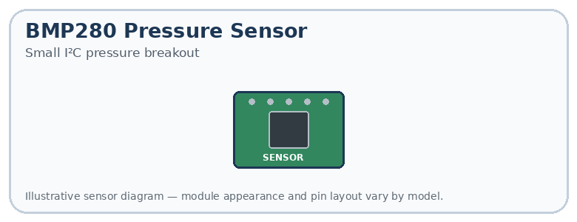

Connections
- VCC → supply supported by your module
- GND → GND
- SDA → A4 on Uno R3
- SCL → A5 on Uno R3
Install the Adafruit BMP280 Library and its required dependencies through Arduino IDE's Library Manager.

Arduino code
#include <Wire.h>
#include <Adafruit_BMP280.h>
Adafruit_BMP280 bmp;
void setup() {
Serial.begin(9600);
if (!bmp.begin(0x76) && !bmp.begin(0x77)) {
Serial.println("BMP280 not found");
while (1) {}
}
}
void loop() {
Serial.print("Pressure: ");
Serial.print(bmp.readPressure() / 100.0);
Serial.println(" hPa");
delay(1000);
}

Explanation
The code displays atmospheric pressure in hectopascals (hPa). The library is needed because the BMP280 communicates through a digital protocol.

8. Gas sensor (MQ-2)
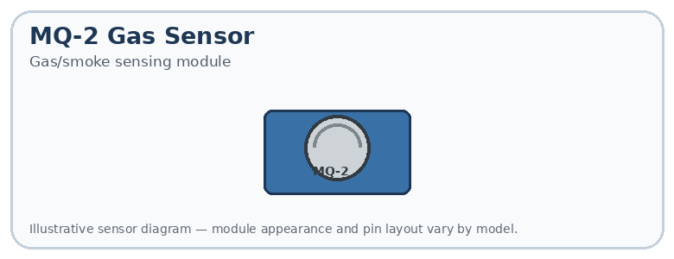

Connections
- VCC → 5V for a typical MQ-2 module
- GND → GND
- AO → A0

Arduino code
const int gasPin = A0;
void setup() {
Serial.begin(9600);
}
void loop() {
int gasValue = analogRead(gasPin);
Serial.print("Gas sensor reading: ");
Serial.println(gasValue);
delay(1000);
}

Explanation
This reads the sensor's raw output. MQ-2 sensors require warm-up and calibration; a raw reading is not a reliable gas concentration measurement or a certified safety alarm.

9. Water-level sensor
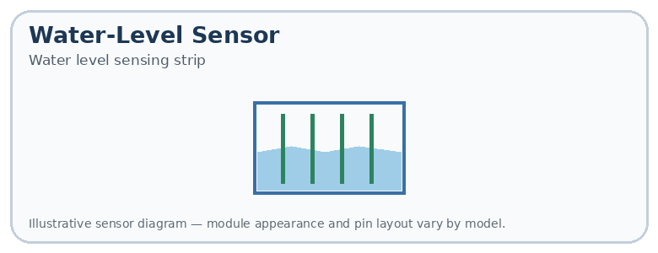

Connections
- + → module's supported supply
- − → GND
- S → A0

Arduino code
const int levelPin = A0;
void setup() {
Serial.begin(9600);
}
void loop() {
int level = analogRead(levelPin);
Serial.print("Water level reading: ");
Serial.println(level);
delay(1000);
}

Explanation
The sensor's reading usually changes as more of its sensing area comes into contact with water. This is not automatically a measurement in litres.

10. Force or weight sensor (load cell with HX711)
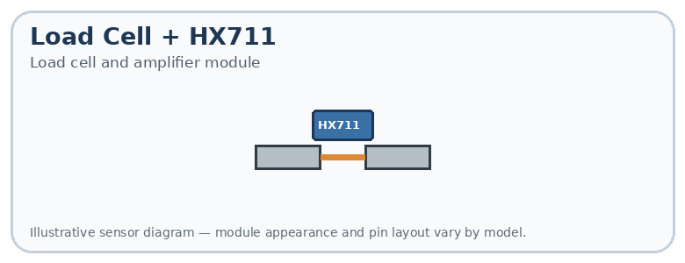

Connections
- VCC → supported supply
- GND → GND
- DT or DOUT → digital pin 3
- SCK or CLK → digital pin 2
- Connect the load cell wires to the HX711 terminals according to its wiring diagram.
Install the HX711 Arduino Library through Library Manager.

Arduino code
#include "HX711.h"
HX711 scale;
void setup() {
Serial.begin(9600);
scale.begin(3, 2); // DOUT, SCK
Serial.println("Place a weight on the load cell");
}
void loop() {
if (scale.is_ready()) {
Serial.print("Raw reading: ");
Serial.println(scale.read());
} else {
Serial.println("HX711 not ready");
}
delay(1000);
}

Explanation
This displays raw readings, not calibrated kilograms. You must calibrate the scale with a known weight before using it to measure weight accurately.

11. Sound sensor
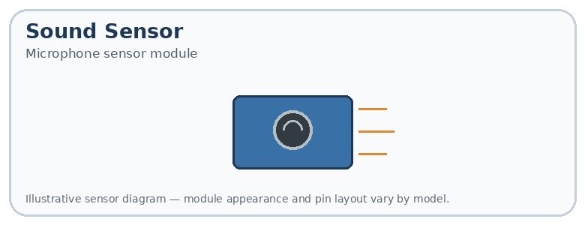

Connections
- VCC → supported supply
- GND → GND
- AO → A0 (if available)

Arduino code
const int soundPin = A0;
void setup() {
Serial.begin(9600);
}
void loop() {
int soundValue = analogRead(soundPin);
Serial.print("Sound reading: ");
Serial.println(soundValue);
delay(100);
}

Explanation
This shows the sensor's analog output. It does not directly measure sound in decibels (dB).

12. Humidity sensor (DHT11)
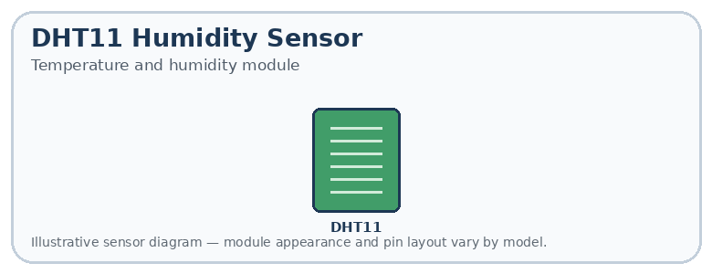

Connections
- VCC → 5V for a typical module
- GND → GND
- DATA → digital pin 2
Install the DHT sensor library by Adafruit and the Adafruit Unified Sensor dependency.

Arduino code
#include <DHT.h>
#define DHTPIN 2
#define DHTTYPE DHT11
DHT dht(DHTPIN, DHTTYPE);
void setup() {
Serial.begin(9600);
dht.begin();
}
void loop() {
float humidity = dht.readHumidity();
float temperature = dht.readTemperature();
if (isnan(humidity) || isnan(temperature)) {
Serial.println("Sensor reading failed");
} else {
Serial.print("Humidity: ");
Serial.print(humidity);
Serial.println(" %");
Serial.print("Temperature: ");
Serial.print(temperature);
Serial.println(" C");
}
delay(2000);
}

Explanation
This sensor measures both humidity and temperature. If you have a DHT22 instead, change DHT11 to DHT22.

13. Touch sensor (TTP223)
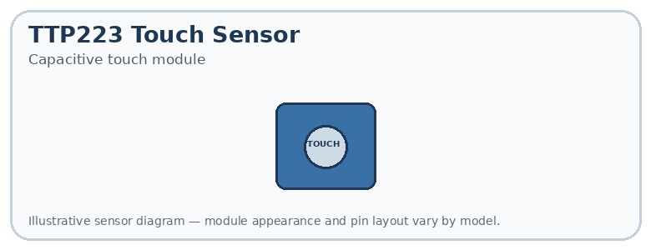

Connections
- VCC → supported supply
- GND → GND
- OUT → digital pin 2

Arduino code
const int touchPin = 2;
void setup() {
pinMode(touchPin, INPUT);
Serial.begin(9600);
}
void loop() {
if (digitalRead(touchPin) == HIGH) {
Serial.println("Touch detected");
} else {
Serial.println("No touch");
}
delay(200);
}

Explanation
The usual TTP223 module outputs HIGH when touched, but confirm the operating mode of your module.

14. Position sensor (potentiometer)
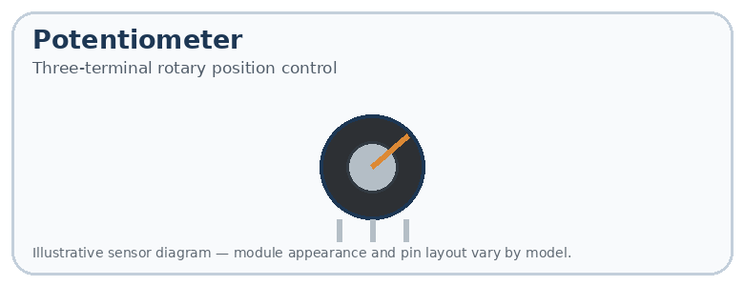

Connections
- One outer terminal → 5V
- Other outer terminal → GND
- Middle terminal → A0

Arduino code
const int positionPin = A0;
void setup() {
Serial.begin(9600);
}
void loop() {
int position = analogRead(positionPin);
Serial.print("Position reading: ");
Serial.println(position);
delay(200);
}

Explanation
The reading ranges approximately from 0 to 1023 on the classic Uno, depending on the shaft's position.

15. Speed sensor (slotted IR module)
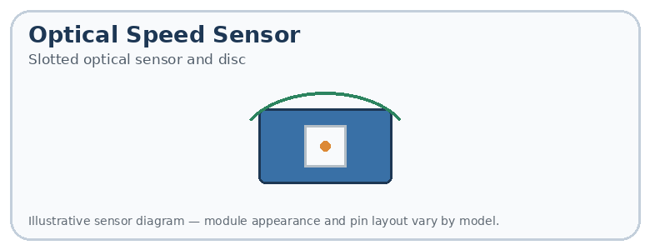

Connections
- VCC → supported supply
- GND → GND
- OUT → digital pin 2
The disc must pass through the sensor to produce pulses.

Arduino code
volatile unsigned long pulses = 0;
void countPulse() {
pulses++;
}
void setup() {
Serial.begin(9600);
pinMode(2, INPUT_PULLUP);
attachInterrupt(digitalPinToInterrupt(2),
countPulse, FALLING);
}
void loop() {
noInterrupts();
unsigned long count = pulses;
pulses = 0;
interrupts();
Serial.print("Pulses per second: ");
Serial.println(count);
delay(1000);
}

Explanation
If the disc produces one pulse per slot, the reading estimates slots passing per second. To calculate RPM (revolutions per minute), divide the pulses per second by the number of pulses per revolution and multiply by 60. The sensor's output polarity may require changing FALLING to RISING.

16. Accelerometer (ADXL335 analog module)
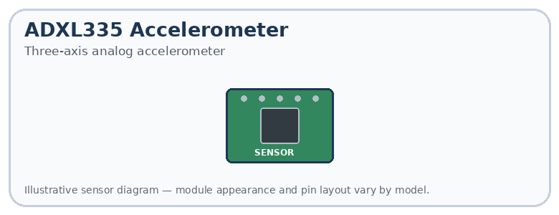

Connections
- VCC → supply supported by the module
- GND → GND
- X → A0
- Y → A1
- Z → A2

Arduino code
void setup() {
Serial.begin(9600);
}
void loop() {
int x = analogRead(A0);
int y = analogRead(A1);
int z = analogRead(A2);
Serial.print("X: ");
Serial.print(x);
Serial.print(" Y: ");
Serial.print(y);
Serial.print(" Z: ");
Serial.println(z);
delay(500);
}

Explanation
This displays the three axis readings. To convert them into acceleration in units of g, you need the sensor's sensitivity and zero-acceleration voltage.

17. Gyroscope (MPU6050)
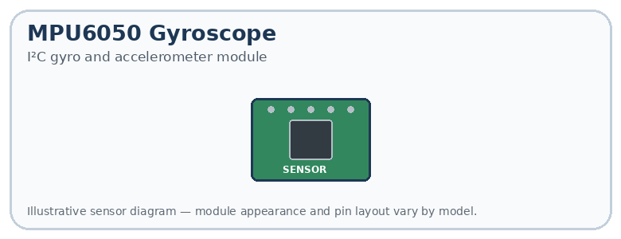

Connections
- VCC → supply supported by your module
- GND → GND
- SDA → A4
- SCL → A5
Install the Adafruit MPU6050 library and its dependencies using Library Manager.

Arduino code
#include <Wire.h>
#include <Adafruit_MPU6050.h>
#include <Adafruit_Sensor.h>
Adafruit_MPU6050 mpu;
void setup() {
Serial.begin(9600);
if (!mpu.begin()) {
Serial.println("MPU6050 not found");
while (1) {}
}
}
void loop() {
sensors_event_t a, g, temp;
mpu.getEvent(&a, &g, &temp);
Serial.print("Gyro X: ");
Serial.print(g.gyro.x);
Serial.print(" Y: ");
Serial.print(g.gyro.y);
Serial.print(" Z: ");
Serial.println(g.gyro.z);
delay(500);
}

Explanation
The gyroscope measures rotational speed in radians per second. The MPU6050 also contains an accelerometer, whose measurements can be accessed through a.

18. Infrared sensor (IR obstacle detection module)
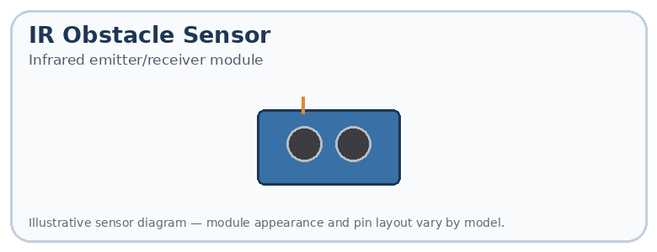

Connections
- VCC → supported supply
- GND → GND
- OUT → digital pin 2

Arduino code
const int irPin = 2;
void setup() {
pinMode(irPin, INPUT);
Serial.begin(9600);
}
void loop() {
int reading = digitalRead(irPin);
if (reading == LOW) {
Serial.println("Obstacle detected");
} else {
Serial.println("No obstacle detected");
}
delay(300);
}

Explanation
Many obstacle-detection modules output LOW when an object is detected, but some work differently. Test your module and reverse the condition if necessary.

19. pH sensor
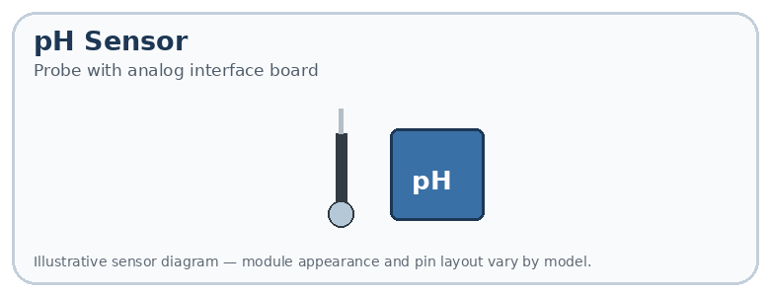

Connections
- VCC → supply specified by the interface board
- GND → GND
- PO or analog output → A0
- Connect the pH probe to the interface board's BNC socket.

Arduino code
const int phPin = A0;
void setup() {
Serial.begin(9600);
}
void loop() {
int reading = analogRead(phPin);
float voltage = reading * (5.0 / 1023.0);
Serial.print("Analog reading: ");
Serial.print(reading);
Serial.print(" Voltage: ");
Serial.println(voltage, 3);
delay(1000);
}

Explanation
This example reads the voltage only. It does not calculate the actual pH value. Accurate pH measurement requires calibration using known buffer solutions and the calibration formula for your particular interface board.

Summary: sensor connections and programming methods
Sensor | Arduino pin(s) | Main function
LM35 temperature | A0 | analogRead()
LDR light | A0 | analogRead()
PIR motion | D2 | digitalRead()
HC-SR04 distance | D3, D4 | pulseIn()
Soil moisture | A0 | analogRead()
BMP280 pressure | A4, A5 | I²C library
MQ-2 gas | A0 | analogRead()
Water level | A0 | analogRead()
Load cell + HX711 | D3, D2 | HX711 library
Sound | A0 | analogRead()
DHT11 humidity | D2 | DHT library
Touch | D2 | digitalRead()
Potentiometer position | A0 | analogRead()
Optical speed | D2 | Interrupts
ADXL335 acceleration | A0, A1, A2 | analogRead()
MPU6050 gyroscope | A4, A5 | I²C library
IR obstacle | D2 | digitalRead()
pH interface | A0 | analogRead()
The pin assignments above are example connections, not universal requirements. On an Arduino Uno R3, analogRead() typically returns values from 0 to 1023. digitalRead() reads HIGH or LOW, and Serial.begin(9600) starts communication with the Serial Monitor.
Recommendation: Start with the LDR, PIR motion sensor, and HC-SR04 distance sensor. They are useful beginner projects for learning analog readings, digital signals, and timing.
If you tell me which Arduino board and which sensors you physically have, I can help you connect them correctly and test each one step by step.

